Immunoassay a procedure for detecting or measuring specific proteins or other substances through their properties as antigens or antibodies, by measures the presence or concentration of a macromolecule or a small molecule in a solution through the use of an antibody (usually) or an antigen (sometimes).
Serology is the scientific study of fluid components of the blood, especially to detected either antigens or antibodies or studies the immune responses that are evident in serum in vitro, due to the antigen-antibody reaction and diagnosis of 1- infectious diseases, 2- autoimmune disorders 3- allergies 4-neoplastic diseases.
Antibody molecules combine reversibly with antigens to form immune complexes. The detection and measurements of these reactions form the basis of serology, a sub-discipline of immunology.
Application of serology tests
1- Antigen tests
Antigen tests often enable an early diagnosis or presumptive diagnosis of an infectious disease through:-
- Identification of a pathogen that has been isolated by culture
- Identification of pathogens in different samples of the patients, etc
2- Antibody tests
These tests are used mainly:-
- To diagnose a microbial disease when the pathogen or microbial antigen is not present in the routine specimen or if present is not easily isolated and identified by other available techniques.
- To screen donor blood for different infectious diseases
- To monitor the effectiveness of a given treatment by measuring antibody liter
- To diagnose autoimmune disorders, etc.
What is plasma? Plasma is a clear, straw-colored liquid portion of the blood in which the other cells are suspended. Importantly, plasma contains proteins for blood clotting and defending the body against infection.
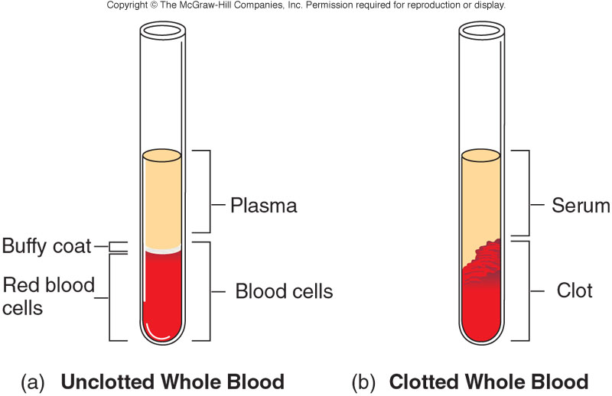
Preparation / Separation of plasma;-
1. The blood is mixed with an appropriate amount of anticoagulant like: - --Heparin, --Oxalate or --Ethylene Di-amine Tetra Acetic acid (EDTA) , This preparation should be mixed immediately and thoroughly to avoid clotting.
2. The solution is then centrifuged for 5-10 minutes at 2000 -2500 rpm. 3. The supernatant fluid is then separated and then labeled properly.
Plasma proteins are 1-Albumins = 60% 2-Globulins = 35% 3-Fibrinogen = 4% 4-The other 1% of blood protein content = regulatory proteins, lipoproteins, iron-binding proteins With anticoagulant Component Percent Water ~92 Proteins 6–8 Salts 0.8 Lipids 0.6 Glucose (blood sugar) 0.1.
Serum The clear liquid that can be separated from clotted blood; it contains about 90% water with dissolved proteins, minerals, hormones, and carbon dioxide and is an important source of electrolytes. In blood, the serum is the component that is neither a blood cell (serum does not contain white or red blood cells) nor a clotting factor; it is the blood plasma with the fibrinogens removed i.e.
Serum = Plasma - Clotting factors
Preparation / Separation of Serum, The blood is allowed to clot at room temperature for 15 to 30 minutes. When the blood has clotted completely, it is rimmed or ringed with an applicator stick, and then centrifuged for 5-10 minutes at 2,500 revolutions per minute (rpm). Finally, the supernatant fluid is then separated making use of a Pasteur pipette and labeled accordingly.
Dilution
Is the act of making a weaker solution from a stronger solution.
This is usually done by adding water or saline, which contains none of the material being diluted. Dilution is usually expressed as one unit of the original solution to the total number of units of final solution. Any volume of a dilution indicates the relative amounts of substances in a solution.
Serum may need to be diluted in a single or as a serial dilution if it contains a concentrated amount of antibody.
Serial Dilutions
Serial dilution is decreasing the volume of serum progressively by maintaining a constant volume of fluid. Most commonly serial dilutions are two-fold that is each dilution is half as concentrated as the preceding one. The total volume in each tube is the same.
A general rule for calculating the concentration of solutions (Patient serum in each tube) obtained by dilution in series is to multiply the original concentration by the first dilution (expressed as a fraction), this by the second dilution and so on until the desired concentration is known.
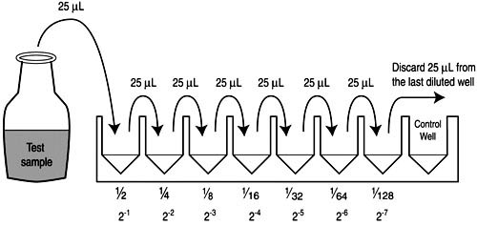
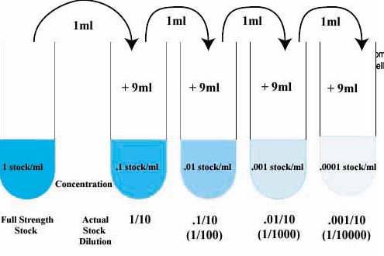
Determination of endpoint and titer
In the above example, after serially diluting the patient serum, an equal amount of an antigen is added to each dilution to observe the immunologic reaction. The last tube that shows a visible immunologic reaction is known as the end point of the test, the dilution of antiserum (antibody) at the endpoint is known as the titer. The reciprocal of the greatest reacting dilution of the serum is considered as the measure of titer or the concentration of the antibody. For example, if the highest dilution of the serum that shows a visible reaction is a 1:32 dilution, the titer of the test is expressed as 32.

Lab diagnosis of infectious diseases
1. Isolation and identification of causative agent by a. Morphological tests (microscopy) b. Biochemical reactions c. Cultural identification d. Serological reactions e. Biotechnology: PCR-DNA probe- DNA fingerprinting
2. Detection of specific Ab in sera of infected patients using serological techniques.

• Validity: A serological test should provide an indication of which individuals actually have the disease and which do not. الصلاحية: يجب أن يوفر الاختبار المصلي مؤشرا على الأفراد الذين يعانون بالفعل من المرض من الذين لا يعانون.
• Sensitivity: Ability of a test to identify correctly those who have the disease
- Analytical Sensitivity – the ability of a test to detect very small amounts of a substance
- Clinical Sensitivity – the ability of the test to give a positive result if the patient has the disease (no false negative results).
• Specificity: the ability of a test to identify correctly those who do not have the disease
- Analytical Specificity – the ability of the test to detect substance without interference from cross-reacting substances
- Clinical Specificity – the ability of the test to give negative result if the patient does not have the disease (no false-positive results).
Quantitative test: It measures the amount of Ag or Ab.
Qualitative test: It detects the presence or absence of Ag or Ab.
seroconversion is the time period during which a specific antibody develops and becomes detectable in the blood. After seroconversion has occurred, the disease can be detected in blood tests for the antibody. During infection or immunization, antigens enter the blood, and the immune system begins to produce antibodies in response. Before seroconversion, the antigen itself may or may not be detectable, but the antibody is, by definition, absent. During seroconversion, the antibody is present but not yet detectable. Any time after seroconversion, the antibodies can be detected in the blood, indicating a prior or current infection.
Sero reversion: is the opposite of seroconversion. This is when the test can no longer detect Ab or Ag in the patient's serum.
Antiserum is a human or nonhuman blood serum containing polyclonal antibodies that are used to spread passive immunity to many diseases. For example, convalescent serum, passive antibody transfusion from a previous human survivor, used to be the only known effective treatment for Ebola infection but with a poor success rate, also known as serotherapy or serum therapy.
A serotype or serovar is a distinct variation within a species of bacteria or virus or among immune cells of different individuals. These microorganisms, viruses, or cells are classified together based on their cell surface antigens, allowing the epidemiologic classification of organisms to the sub-species level. A group of serovars with common antigens is called aserogroup or sometimes serocomplex.
Cross-reactivity has a more narrow meaning of the reaction between an antibody and an antigen that differs from the immunogen. It is sometimes also referred to as cross immunity or cross-protective immunity.
Cross-reactivity is more likely to occur between antibodies and antigens that have low affinity or avidity. Affinity, which can be determined experimentally, is a measure of the binding strength between an antibody’s binding site and an epitope, whereas avidity is the total strength of all the interactions in an antibody-antigen complex (which may have more than one bonding site). Avidity is influenced by affinity as well as the structural arrangements of the epitope and the variable regions of the antibody. If an antibody has a high affinity/avidity for a specific antigen, it is less likely to cross-react with an antigen for which it has a lower affinity/avidity.
Nature of antigen-antibody reactions
A. Lock and Key Concept
The combining site of an antibody is located in the Fab portion of the molecule and is constructed from the hypervariable regions of the heavy and light chains. X-Ray crystallography studies of antigen-antibody interactions show that the antigenic determinant nestles in a cleft formed by the combining site of the antibody as illustrated in Figure 1. Thus, our concept of antigen-antibody reactions is one of a key (i.e. the antigen) which fits into a lock (i.e. the antibody).
B. Non-covalent Bonds
The bonds that hold the antigen to the antibody combining site are all non-covalent in nature. These include hydrogen bonds, electrostatic bonds, Van der Waals forces and hydrophobic bonds. Multiple bonding between the antigen and the antibody ensures that the antigen will be bound tightly to the antibody.
C. Reversibility
Since antigen-antibody reactions occur via non-covalent bonds, they are by their nature reversible.
Serological Reactions or Immunological Techniques
Three groups of immunological techniques are used to detect and measure antigen-antibody reaction; these are:
• Primary: It measures the direct interaction between Ag and Ab in Vitro ( test tube).
•Secondary: It measures the consequences of the interaction between Ag and Ab in Vitro.
• Tertiary It measures Ag and Ab interactions in Vivo (in the body).
Or
• Primary binding tests
• Secondary binding tests and
• Tertiary binding tests.
- Primary binding tests
Primary binding tests are tests that directly measure the binding of antigen and antibody (i.e.; directly measure the immune complex). They are the most sensitive techniques in terms of the amount of detectable antigen or antibody.
Example:
➢ Enzyme-linked Immunosorbent Assay (ELISA) tests
➢ Radioimmunoassay (RIA)
➢ Western blotting
Primary binding tests are performed by allowing antigen and antibody to combine and then measuring the amount of immune complex formed. It is usual to use
Radioisotopes, fluorescent dyes, or enzymes as labels to identify one of the reactants.
1- Immunofluorescence tests
They are widely used in the serological diagnosis of bacterial, viral, fungal, and parasitic diseases. They are usually sensitive and give reproducible results.
Disadvantages of these tests are:
1- Special training is needed to perform and read Immunofluorescence tests.
2- Fluorescence microscope and high quality reagents are required.
Principle
Fluorescent dyes (fluorochromes) illuminated by UV lights are used to show the specific combination of an antigen with its antibody. The antigen-antibody complexes are seen fluorescing against a dark background. Immunofluorescence tests are referred to as fluorescent antibody tests (FAT). There are two types of fluorescent antibody tests (FAT): Direct and Indirect.
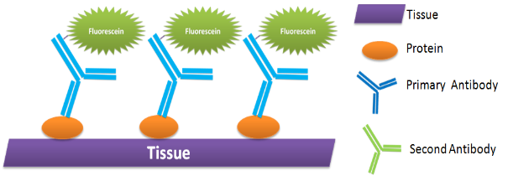
A. Direct fluorescent antibody tests
Direct FAT is used to detect and identify an unknown antigen in specimens, for example Viral, bacterial, and parasitic antigens. It is called direct test because the fluorescent dye is attached, or labeled, directly to the antibody. The fluorochrome used is usually fluorescein isothyocynate (FITC), which gives a yellow-green fluorescence. A fluorescent substance is one that, when absorbing light of one wavelength, emits light of another (longer) wavelength.
Procedure: Direct FAT
1. A tissue or smear containing the organism (antigen) is fixed to a glass slide and incubated with the fluorescent antibody (antibody chemically linked to fluorescein isothyocynate FITC).
2. It is then washed to remove the unbound antibody.
3. Examined by dark-field illumination under a microscope with UV light source.
4. The antigenic particles that have bound the labeled antibodies are seen to fluoresce brightly.
Interpretation of the results:
• Presence of fluorescence: positive test for particular antigen
• No fluorescence: negative or absence of particular antigen.
B. Indirect Fluorescent antibody test (IFAT)
IFAT, unlabelled antibody combines with antigen and the antigen-antibody complex is detected by attaching a fluorescent-labeled anti-species globulin to the antibody. The antibody, therefore, is labeled indirectly. Fluorescent-labeled antihuman globulin is used if the antibody is of human origin.
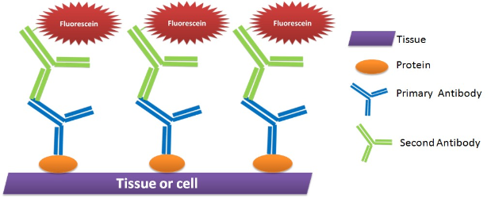
IFAT is used in two main ways:
➢ To detect and identify unknown antigen in specimens.
➢ To detect antibodies in patient serum using a known antigen (microorganism).
I. IFAT to detect antigen
A slide preparation of the specimen is made and the unlabelled specific antibody is added. After allowing time for the antigen and antibody to combine, the preparation is washed leaving the only antibody that has combined with the antigen on the slide. A fluorescent labeled anti-species globulin is added and allowed to combine with the antibody.
The excess is washed from the slide. The preparation is examined by fluorescence microscopy using the correct filters.
The antigen-antibody complex will be seen fluorescing brightly.
II. IFAT to detect Antibody
A known antigen is placed on the slide and the patient's serum is added.
The preparation is then washed and fluorescent-labeled antihuman globulin is added to demonstrate the antigen-antibody reaction. The preparation is examined by the fluorescence microscope using the correct filters.
- Enzyme-Linked Immunosorbent Assay (ELISA)
ELISA techniques are becoming increasingly used in the diagnosis of microbial infections. They are specific, sensitive, and require only a small amount of specimen. Reagents used in the ELISA are stable and have a long shelf life which makes for easy distribution to district laboratories. The results of qualitative ELISA techniques can be read visually. Large numbers of specimens can be tested at one time and the ELISA can be easily automated for use in epidemiological surveys and used for both diagnostic and research purposes.
According to how it works, ELISA can be divided into four major types: direct, indirect, sandwich, and competitive.

The principle
In ELISA, various antigen-antibody combinations are used, always including an enzyme-labeled antigen or antibody, and enzyme activity is measured colorimetrically.
The enzyme activity is measured using a substrate that changes color when modified by the enzyme. Light absorption of the product formed after substrate addition is measured and converted to numeric values.
Depending on the antigen-antibody combination, the assay is called a direct ELISA, indirect ELISA, sandwich ELISA, competitive ELISA etc.
Direct ELISA
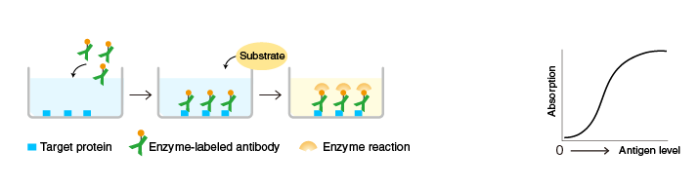
A target protein (or a target antibody) is immobilized on the surface of microplate wells and incubated with an enzyme-labeled antibody to the target protein (or a specific antigen to the target antibody). After washing, the activity of the microplate well-bound enzyme is measured.

Indirect ELISA
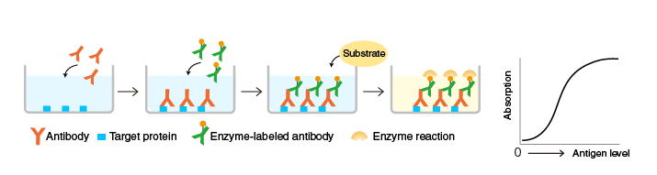A target protein is immobilized on the surface of microplate wells and incubated with an antibody to the target protein (the primary antibody), followed by a secondary antibody against the primary antibody. After washing, the activity of the microplate well-bound enzyme is measured.
Although indirect ELISA requires more steps than direct ELISA, labeled secondary antibodies are commercially available, eliminating the need to label the primary antibody.

Sandwich ELISA
An antibody to a target protein is immobilized on the surface of microplate wells and incubated first with the target protein and then with another target protein-specific antibody, which is labeled with an enzyme. After washing, the activity of the microplate well-bound enzyme is measured. The immobilized antibody (orange) and the enzyme-labeled antibody (green) must recognize different epitopes of the target protein. 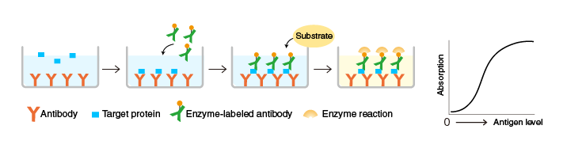
Compared to direct ELISA, the sandwich ELISA (combining antibodies to two different epitopes on the target protein) has a higher specificity.
Sandwich ELISA is useful for applications that require high accuracy.

Competitive ELISA
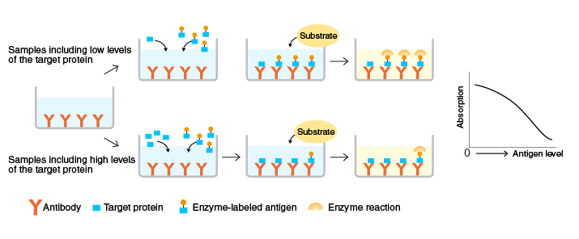An antibody specific for a target protein is immobilized on the surface of microplate wells and incubated with samples containing the target protein and a known amount of enzyme-labeled target protein.
After the reaction, the activity of the microplate well-bound enzyme is measured.
When the antigen level in the sample is high, the level of antibody-bound enzyme-labeled antigen is lower and the color is lighter. Conversely, when it is low, the level of antibody-bound enzyme-labeled antigen is higher and the color, darker. The graph above and to the right illustrates the correlation between absorption and antigen levels in samples.

Table Advantages and disadvantages of each ELISA type
 | Advantages | Disadvantages
Direct ELISA | - Simple protocol, time-saving, and reagents-saving.  - No cross-reactivity from secondary antibody. | - High background.  - No signal amplification, since only a primary antibody is used and a secondary antibody is not needed.  - Low flexibility, since the primary antibody must be labeled.
Indirect ELISA | - Signal amplification, since one or more secondary antibodies can be used to bind to the primary antibody.  - High flexibility, since the same secondary antibody can be used for various primary antibodies. | - Complex protocol compared with direct ELISA.  - Cross-reactivity from secondary antibody.
Sandwich ELISA | - High flexibility.  - High sensitivity.  - High specificity, since different antibodies bind to the same antigen for detection. | - The antigen of interest must be large enough so that two different antibodies can bind to it at different epitopes.  - It's sometimes difficult to find two different antibodies that recognize different epitopes on the antigen of interest and cooperate well in a sandwich format.
Competitive ELISA | - High flexibility.  - High sensitivity.  - Best for the detection of small antigens, even when they are present in low concentrations. | - Relatively complex protocol.  - Needs the use of inhibitor antigen.
Enzymes and substrates
Enzymes used in ELISA techniques must be stable and soluble; they must not be present in any quantity in the specimens being tested. The two commonly used enzymes are horseradish peroxidase and alkaline phosphatase.
A substrate is used to give a color change when acted on by the enzyme, for example, p-nitro phenol phosphate. This is hydrolyzed by alkaline phosphatase to inorganic phosphate and p-nitrophenol, which is yellow in color.
Reading ELISA results
♦ Many ELISA techniques, especially those that detect antigen, are qualitative and can be read by naked eye. The presence or absence of antigen is seen as a simple color change.
♦ Quantitative antibody techniques are read either by measuring the intensity of color in a spectrometer (spectrophotometer) or by testing dilutions of the test serum and determining the highest dilution that shows a color change.
- Radioimmune assay (RIA):
Radioimmunoassay (RIA) is a competitive immunologic procedure for measuring very low concentrations of antigens (or antibodies) by using radioactively labeled antigens as competitors. Radioactive isotopes such as 3H , 14C, 35S, 30P or 125I can be used for labeling. It is a highly sensitive method to detect low concentration of the unknown (unlabeled) antigen and is used to assay: Hormones, Drugs, Enzymes, Microbial antigens e.g. hepatitis B antigen, carcinoembryonic and α- feto proetein antigen. RIA can also be used for the detection of antibody.
Principle
The technique is based on the ability of an unlabelled form of the substance to inhibit competitively the binding of a radioactively labeled substance by specific antibodies.
RIA technique utilizes three components:-
1. Patient antigen, the specific compound we wish to determine.
2. Labeled antigen, the same compound patient antigen which is attached to a radioactive label.
3. The antibody, specific for the sample and labeled antigen.
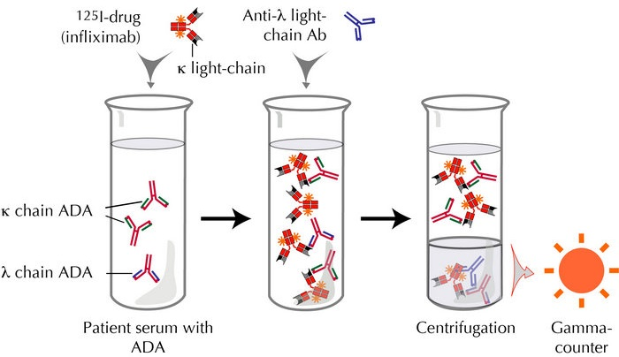
Competitive binding or competitive displacement reaction:
This is a phenomenon wherein when there are two antigens which can bind to the same antibody, the antigen with more concentration binds extensively with the limited antibody displacing other. So here in the experiment, the radiolabelled antigen is allowed to bind to high-affinity antibody. Then when patient serum is added unlabeled antigens in it start binding to the antibody displacing the labeled antigen.
Measurement of radio emission:
Once the incubation is over, then washings are done to remove any unbound antigens. Then radio emission of the antigen-antibody complex is taken, the gamma rays from radiolabeled antigen are measured.
The target antigen is labeled radioactively and bound to its specific antibodies (a limited and known amount of the specific antibody has to be added). A sample, for e.g. blood-serum, is added in order to initiate a competitive reaction of the labeled antigens from the preparation, and the unlabeled antigens from the serum-sample, with the specific antibodies. The competition for the antibodies will release a certain amount of labeled antigen. This amount is proportional to the ratio of labeled to unlabeled antigen.
That means as the concentration of unlabeled antigen is increased, more of it binds to the antibody, displacing the labeled variant. The bound antigens are then separated from the unbound ones, and the radioactivity of the free antigens remaining in the supernatant is measured.
Antigen-antibody complexes are precipitated either by crosslinking with a second antibody or by means of the addition of reagents that promote the precipitation of antigen-antibody complexes. Counting radioactivity in the precipitates allows the determination of the amount of radiolabeled antigen precipitated with the antibody. A standard curve is constructed by plotting the percentage of an antibody-bound radiolabeled antigen against known concentrations of a standardized unlabeled antigen, and the concentrations of antigen in patient samples are extrapolated from that curve.
The extremely high sensitivity of RIA is its major advantage.
Uses of RIA:
- The test can be used to determine very small quantities (e.g. nanogram) of antigens and antibodies in the serum.
- The test is used for quantitation of hormones, drugs, HBsAg, and other viral antigens.
- Analyze nanomolar and picomolar concentrations of hormones in biological fluids.
The limitations of the RIA include:
- The cost of equipment and reagents
- Short shelf-life of radiolabeled compounds
- The problems associated with the disposal of radioactive waste.
Western blotting technique:
Principle:
The western blotting technique is used for the identification of a particular protein from the mixture of protein.
In this method labeled antibody against a particular protein is used to identify the desired protein, so it is a specific test. Western blotting is also known as immunoblotting because it uses antibodies to detect the protein.
Procedure/Steps:
Extraction of protein
Gel electrophoresis: SDS PAGE
Blotting: electrical or capillary blotting
Blocking: BSA
Treatment with the primary antibody
Treatment with secondary antibody( enzyme-labeled anti-Ab)
Treatment with the specific substrate; if the enzyme is alkaline phosphatase, the substrate is p-nitrophenyl phosphate which gives color.

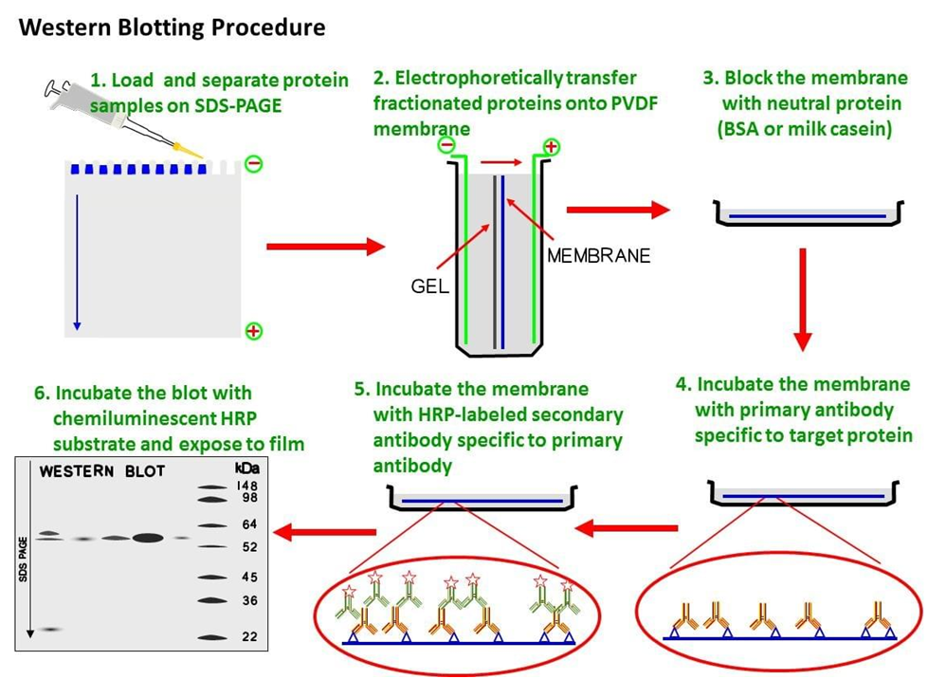
Step I: Extraction of Protein
Protein is extracted from the cell by mechanical or chemical lysis of cell. This step is also known as tissue preparation.
To prevent denaturing of protein protease inhibitor is used.
The concentration of protein is determined by spectroscopy.
When a sufficient amount of protein sample is obtained, it is diluted in loading buffer containing glycerol which helps to sink the sample in well.
Tracking dye (bromothymol blue) is also added in the sample to monitor the movement of proteins.
Step II: Gel electrophoresis
The sample is loaded in well of SDS-PAGE Sodium dodecyl sulfate-polyacrylamide gel electrophoresis.
The proteins are separated on the basis of the electric charge, isoelectric point, molecular weight, or combination of these all.
The small size protein moves faster than large size protein.
Protein is negatively charged, so they move toward positive (anode) pole as electric current is applied.
Step III: Blotting
The nitrocellulose membrane is placed on the gel. The separated protein from gel gets transferred to nitrocellulose paper by capillary action. This type of blotting is time-consuming and may take 1-2 days
For fast and more efficient transfer of the desired protein from the gel to nitrocellulose paper electro-blotting can be used.
In electro-blotting nitrocellulose membrane is sandwich between gel and cassette of filter paper and then electric current is passed through the gel causing transfer of protein to the membrane.
Step IV: Blocking
Blocking is a very important step in western blotting.
Antibodies are also protein so they are likely to bind the nitrocellulose paper. So before adding the primary antibody the membrane is non-specifically saturated or masked by using casein or Bovine serum albumin (BSA).
Step V: Treatment with Primary Antibody
The primary antibody (1° Ab) is specific to the desired protein so it forms Ag-Ab complex
Step VI: Treatment with the secondary antibody
The secondary antibody is an enzyme labeled. For eg., alkaline phosphatase or Horseradish peroxidase (HRP) is labeled with secondary antibody.
The secondary antibody (2° Ab) is an antibody against primary antibody (anti-antibody) so it can bind with Ag-Ab complex.
Step VII: Treatment with a suitable substrate
To visualize the enzyme action, the reaction mixture is incubated with a specific substrate.
The enzyme converts the substrate to give the visible colored product, so the band of color can be visualized in the membrane.
Western blotting is also a quantitative test to determine the amount of protein in the sample.
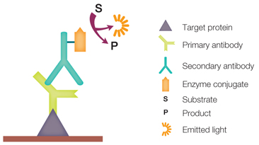
Application:
To determine the size and amount of protein in the given sample.
Disease diagnosis: detects antibody against virus or bacteria in serum.
2- Secondary binding tests
Secondary binding tests are tests that detect and measure the consequences (secondary effect) of antigen-antibody interaction.
These consequences include:
➢ Precipitation of soluble antigens
➢ Clumping (agglutination) of particulate antigens
➢ Neutralization of bacteria, viruses, or toxins; and
➢ Activation of the complement system.
They are usually less sensitive than primary binding tests but may be easier to perform.
1- Agglutination Tests
In district laboratories, agglutination tests are frequently used because compared with other serological tests, they are simpler to perform, require no special equipment and are usually less expensive.
Agglutination Reactions
The reaction between a particulate antigen and an antibody results in visible clumping called agglutination. Antibodies that produce such reactions are known as agglutinins. The principle of Agglutination reactions are similar to precipitation reactions; they depend on the cross-linking of polyvalent antigens. When the antigen is an erythrocyte it is called hemagglutination. Theoretically, all antibodies can agglutinate particulate antigens but IgM, due to its high specificity is a particularly good agglutinin.
***There is no agglutination can be observed when the concentration of the antibody is high, (lower dilutions), and then the sample is diluted, agglutination occurs. Prozone effect is defined as the invisibility of agglutination at high concentrations of antibodies. It is due to the reason that excess antibody forms very minute complexes that do not clump to form visible agglutination.
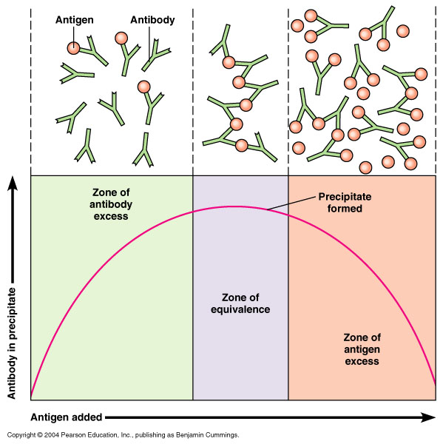
A - Qualitative agglutination test
Agglutination tests can be used in a qualitative manner to assay for the presence of an antigen or an antibody. The antibody is mixed with the particulate antigen and a positive test is indicated by the agglutination of the particulate antigen.
For example, to determine the patient’s blood type the red blood cells of the person can be mixed with an antibody to a blood group antigen. Another example is that to assay the presence of antibodies in a patient sample, the serum of the patient is mixed with the red blood cell (RBC) of a known blood type.
B - Quantitative agglutination test
To measure the level of antibodies to particulate antigens, agglutination test can be widely used. For this test, serial dilutions of the sample can be made and it is tested for the antibody. Then a fixed amount of particulate antigen or bacteria or red blood cells can be added to it. Determine the maximum dilution which forms agglutination and this maximum dilution which gives observable agglutination are known as the titer. The results are shown as the reciprocal of the maximum dilution that forms visible agglutination.
Types of Agglutination..
- Identification of an organism with known antibodies
- Identification of serum antibodies with known antigens.
  - Bacterial agglutination test
- Measure the antibody produced by the host against bacterial agglutinins
- Best performance when used in sterile physiologic saline

Slide Agglutination test
- Use of Antisera (Ab) to identify Salmonella and Shigella by causing agglutination of the organisms
  - Particle agglutination test
- Agglutination of an artificial carrier particle with specific antigen bound to its surface, Size of the carrier enhances the visibility of agglutination.
- Examples include
  - Latex particles: Latex agglutination test
  - Treated Red blood cells i.e. Hemagglutination
  - Whole bacterial cells.
- Reaction is dependent on
  - Amount and avidity of antigen bound to carrier
  - Time of the incubation with specimen
  - Environment of interaction (pH, Protein concentration etc)
- Hemagglutination
- Treated animal RBC is used as a carrier of antigen
- Passive hemagglutination: Ag that are being bound by Ab are not the Ag of RBC but are passively bound Ag.
- Latex agglutination test

For Ag detection Latex beads coated with specific antibody are agglutinated in the presence of homologous antigen (bacteria).

For Ab detection Latex particles coated with specific antigen.
- Coagglutination (COAG) Test
Specific antibody is bound to the surface protein A of staphylococci (Cowan type 1 strain of Staphylococcus aureus). Soluble microbial antigen in the specimen is mixed with the COAG reagent, resulting in the agglutination of the staphylococcal cells.
Antibody COAG Reagent + Antigen in specimen = Staphylococcal cells (Agglutinated).
    - Precipitation Reactions
Precipitation reactions are serological assays for the detection of immunoglobulin levels from the serum of a patient with infection.
Precipitation reactions are based on the interaction of antibodies and antigens. They are based on two soluble reactants that come together to make one insoluble product, the precipitate. These reactions depend on the formation of lattices (cross-links) when antigen and antibody exist in optimal proportions. Excess of either component reduces lattice formation and subsequent precipitation. Precipitation reactions differ from agglutination reactions in the size and solubility of the antigen and sensitivity. Antigens are soluble molecules and larger in size in precipitation reactions. There are several precipitation methods applied in the clinical laboratory for the diagnosis of disease. These can be performed in semisolid media such as agar or agarose, or non-gel support media such as cellulose acetate.
Precipitation methods include double immunodiffusion (qualitative gel technique that determines the relationship between antigen and antibody), radial immunodiffusion (semi-quantitation of proteins by gel diffusion using antibody incorporated in agar), and electroimmunodiffusion (variation of the double immunodiffusion method reaction that uses an electric current to enhance the mobility of the reactants toward each other). Precipitation reactions are less sensitive than agglutination reactions but remain gold standard serological techniques. The most commonly used serologic precipitation reactions are the Ouchterlony test (based on double immunodiffusion and named after the Swedish physician who invented it), and the Mancini method (based on single radial immunodiffusion). In the double immunodiffusion technique, three basic reaction patterns result from the relationship between antigens and antibodies. These patterns are identity, non-identity, and partial identity. The Mancini method results in precipitin ring formation on a thin agarose layer. The diameter of the ring correlates with the concentration of proteins in the precipitin.
    - Complement fixation test
The complete fixation test (CFT) is used to detect the presence of specific antibodies in the patient’s serum. This test is based on the use of complement, a Biologically labile serum factor that causes the immune cytolysis i.e. lysis of antibody coated cells.
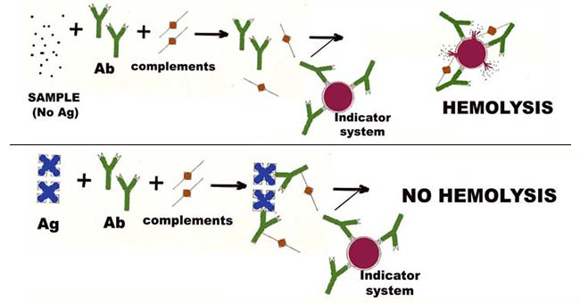
Principle
The principle that when antigen and antibodies of the IgM or the IgG classes are mixed, complement is “fixed” to the antigen-antibody complex.

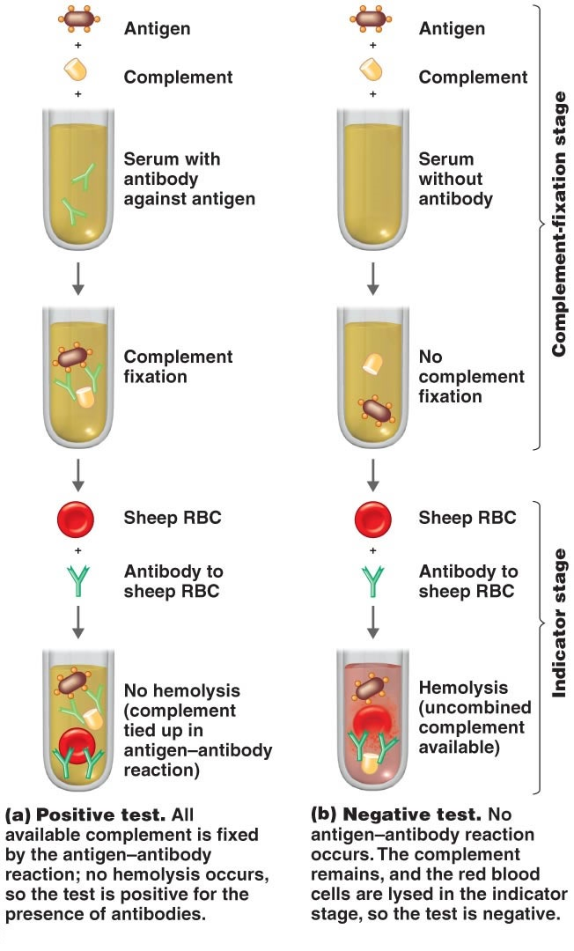
Interpretation
Positive test: The available complement is fixed by Ag-Ab complex and no hemolysis of sheep RBCs occurs. So the test is positive for the presence of antibodies.
Negative test: No Ag-Ab reaction occurs and the complement is free. This free complement binds to the complex of sheep RBC and it’s an antibody to cause hemolysis, causing the development of pink color.

3-Tertiary binding tests
Tertiary binding tests measure the consequences of immune responses in vivo. These tests are much more complex than primary and secondary tests, but their results reflect the practical significance of the immune response. E.g. measurement of the protective effects of the antibody.

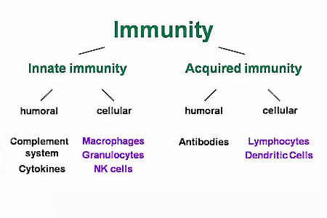
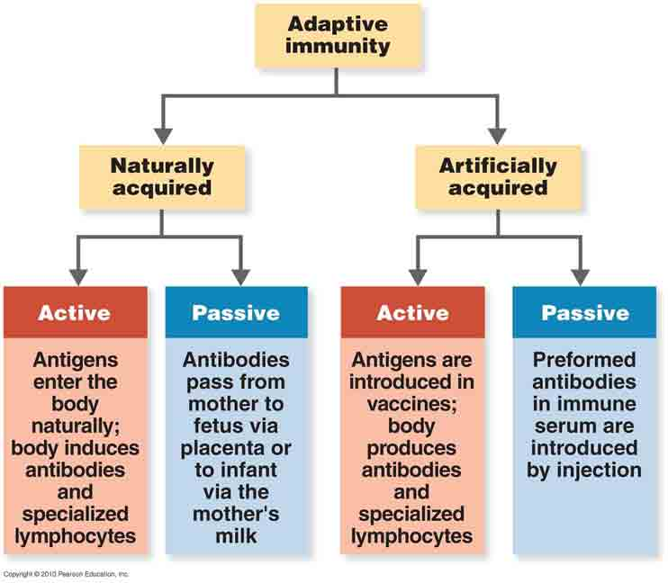
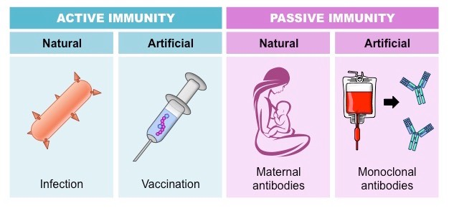
S.N. | Characteristics | Innate Immunity | Adaptive immunity
1. | Presence | Innate immunity is something already present in the body. | Adaptive immunity is created in response to exposure to a foreign substance.
2. | Specificity | Non-Specific | Specific
3. | Response | Fights any foreign invader | Fight only specific infection
4. | Response | Rapid | Slow (1-2 weeks)
5. | Potency | Limited and Lower potency | High potency
6. | Time span | Once activated against a specific type of antigen, the immunity remains throughout the life. | The span of developed immunity can be lifelong or short.
7. | Inheritance | Innate type of immunity is generally inherited from parents and passed to offspring. | Adaptive immunity is not passed from the parents to offspring, hence it cannot be inherited.
8. | Memory | Cannot react with equal potency upon repeated exposure to the same pathogen. | Adaptive system can remember the specific pathogens which have encountered before.
9. | Presence | Present at birth | Develops during a person’s lifetime and can be short-lived.
10. | Allergic Reaction | None | Immediate and Delay hypersensitivity
11. | Used Against | For microbes | Microbes and non-microbial substances called antigens
12. | Memory | No memory | Long term memory
13. | Diversity | Limited | High
14. | Speed | Faster response | Slower response
15. | Complement system activation | Alternative and lectin pathways | Classical pathway
16. | Anatomic and physiological barriers | Skin, Mucous membranes, Temp, pH, chemicals, etc. | Lymph nodes, spleen, mucosal associated lymphoid tissue.
17. | Composition | The innate immune system is composed of physical and chemical barriers, phagocytic leukocytes, dendritic cells, natural killer cells, and plasma proteins. | Adaptive immune system is composed of B cells and T cells.
18. | Development | Evolutionary, older and is found in both vertebrates and invertebrates. | Adaptive immunity system has been developed recently and is found only in the vertebrates.
19. | Example | White blood cells fighting bacteria, causing redness and swelling, when you have a cut. | Chickenpox vaccination so that we don’t get chickenpox because adaptive immunity system has remembered the foreign body.
Antigen: a substance, usually a protein, that stimulates the immune system to produce a set of specific antibodies and that combines with an antibody specific to itself, at a specific binding site; differs from immunogen in that it is not involved in eliciting cellular response and in that it can complex with antibodies.
Immunogen: a substance, usually a protein, that elicits a cellular immune response, and/or antibody production; differs from antigen in that it mainly elicits cellular response but does not complex with an antibody.
Hapten: a low-molecular weight non-protein molecule which contains an antigenic determinant but which is not itself antigenic unless it complexes with an antigenic carrier, such as a protein; once an antibody is available, it can readily recognise the hapten, even without the carrier, and bind with it. To be antigenic, the hapten must bind to an exogenous protein carrier.
Epitope: a part of a protein molecule that acts as an immunogenic/antigenic determinant, and so determines specificities; a macromolecule, such as a protein, may contain many different epitopes, each capable of stimulating the production of specific antibodies, each with a correspondingly specific binding site.
Some factors affecting immunization
- Adjuvants: a substance which enhances the body's immune response to an antigen.
The most effective experimental adjuvant known, Freund's Adjuvant, cannot be used in clinical medicine because of its severe side effects (inflammation, pain, and fever). Some human vaccines can be rendered more effective, however, by precipitating the antigen together with an aluminum hydroxide salt, a procedure known as alum precipitation; diphtheria toxoid is used in this form. Synthetic adjuvants usable in humans are currently being developed, some involving synthetic versions of the biologically active molecules of Freund's (including muramyl dipeptide).
In some cases one can take advantage of the natural adjuvant properties of certain vaccines, notably pertussis. The so-called triple vaccine, (DPT), consists of alumprecipitated diphtheria toxoid, killed pertussis organisms and tetanus toxoid. In this case, the pertussis organisms act as an adjuvant (much as Mycobacterium does in Freund's), which increases the immune response to the two purified protein antigens.

Immunologic adjuvants
Immunologic adjuvants are added to vaccines to stimulate the immune system's response to the target antigen, but do not provide immunity themselves. Adjuvants can act in various ways in presenting an antigen to the immune system. Adjuvants can act as a depot for the antigen, presenting the antigen over a longer period of time, thus maximizing the immune response before the body clears the antigen. Examples of depot type adjuvants are oil emulsions. An adjuvant can also act as an irritant, which engages and amplifies the body's immune response.

Mechanism
Proposed mechanisms of action of adjuvants.
(1) Some adjuvants presumably form a depot at the site of injection, which is associated with slow release of antigen. (2) Other adjuvants are associated with transient secretion of cytokines and chemokines. (3) Secreted cytokines and chemokines are involved in recruitment of various immune cells to the injection site. These recruited cells secrete cytokines and chemokines, in turn attract other immune cells. All these events lead to formation of a local immuno-competent environment at the injection site. (4) The recruited APCs express various PRRs both on the surface (TLRs, CLRs) and intracellularly (NLRs and RLRs), which are recognized and/or are activated by the adjuvants. (5) This leads to maturation and activation of recruited APCs. Mature APCs up-regulate the expression of MHC and co-stimulatory molecules. (6) They are also characterized by increased capacity for antigen processing and presentation. (7) Mature APCs then migrate to the draining lymph nodes to interact with antigen-specific B or T cell to (8) activate potent antibody secreting B cells and/or effector CD8⁺ T cell responses.

Adjuvants affect the immune response in various ways:
- To increase the immunogenicity of weak antigens
- To enhance speed and duration of immune response
- To stimulate and modulate humoral responses, including antibody isotype
- To stimulate cell-mediated immunity
- To improve induction of mucosal immunity
- Enhance immune responses in immunologically immature patients, particularly infants
- To decrease the dose of antigen required; reducing costs and eliminating inconvenient requirements for booster shots
Many molecules have been considered for use as an adjuvant, including mineral compounds (e.g. Alum), water-in-oil or oil-in-water emulsions (e.g. Freund’s adjuvant), as well as natural and synthetic toxins derived from bacteria (e.g. cholera toxin, CT and lymphotoxin, LT). Based on their mechanism of action, adjuvants have been categorised into two broad groups; the particulate vaccine-delivery systems that target antigen to antigen presenting cells (APCs) and the immunostimulatory adjuvants that directly activate such cells through specific receptors e.g. toll-like receptors (TLRs) resulting in inflammatory responses that amplify the innate immune response. The ultimate aim is to activate the innate immune system to respond more rapidly to infection and for the adaptive immune response to become more specific.
- The precise mechanisms of many adjuvants remain largely undefined due to the complexity of the immune response, but generalisations can be made to allow the design of more rational adjuvants aimed at particular arms of the immune system.

Summary of adjuvants approved for human use
Adjuvant | Description | Approved vaccine products
Aluminium-based mineral salts (Alum) | E.g. Aluminium phosphate,Calcium phosphate,Aluminium hydroxide | Eg. Anthrax ,Hepatitis and DTP
MF59 | Submicron oil-in-water emulsion | Influenza
Monophosphoryl lipid A (MPL) | Bacteria-derived immunostimulant | Hepatitis B
Virosomes | Spherical vesicles containing viral membrane proteins in the lipid membrane | Hepatitis and Influenza

ii)Route of immunization. While most vaccinations are introduced through the skin, either by scarification (e.g. smallpox) or by injection (e.g. Salk polio vaccine and many others), the Sabin polio vaccine is one notable exception. The attenuated viral organisms are administered orally, and they set up a chronic infection in the gut, stimulating a local IgA response. Since the normal mode of entry of polio virus is through the gut, this antibody response is precisely in the place where it should do the most good. (It should be noted, however, that the Sabin vaccine is no longer recommended for use in the U.S.) Similarly, one form of the influenza vaccine (Flumist) is administered as an intranasal mist, mimicking the normal route of entry of the infectious organism.
iii) Dose of antigen. The dose and time course of human vaccinations is largely determined empirically; whatever works is used.
iv) State of the host. The effectiveness of active immunization naturally depends on the ability of the host to mount a normal immune response. It can be dangerous, however, to introduce any live vaccine into a host with a T-cell deficiency, since even an attenuated organism can give rise to a lethal infection in such an environment. In the case of an immunologically healthy host, the degree of urgency may determine if passive or active immunization is appropriate. For tetanus, active immunization with the toxoid is generally used and is effective for ten years or more. However, in the case of a very severe wound, or a tetanus-prone wound which is several days old before being presented to the physician, passive immunization may be administered for immediate protection, together with active immunization for longer-lasting immunity. Similarly for rabies, passive immunization may be added to the standard active immunization in the case of a particularly severe rabies-prone wound, or one close to the head (since the brain is a major target of the virus).
Other issues associated with immunization
A) Antigenic variation. Influenza virus, for example, can rapidly alter its antigenic structure by mutation, so that it is no longer recognized by antibodies made against the original virus. Influenza can therefore give rise to repeated infection with variants of the same organism.
B) Antigenic competition. Two antigens given at the same site can sometimes each interfere with the immune response to the other. In general, therefore, different immunizations are given at different times and/or at different sites. But remember that DPT is a notable exception to this rule, and other routine multiple vaccination protocols exist (such as MMR).
C) Maternal immunoglobulin. The presence of specific antibodies at the time of vaccination may interfere with its success. Measles vaccine, for example, should not be given before 15 months of age, since the presence of maternal IgG antibodies may prevent active immunization .

Producing Polyclonal Antibodies
Antibodies used for research and diagnostic purposes are often obtained by injecting a lab animal such as a rabbit or a goat with a specific antigen. Within a few weeks, the animal’s immune system will produce high levels of antibodies specific for the antigen. These antibodies can be harvested in an antiserum, which is whole serum collected from an animal following exposure to an antigen. Because most antigens are complex structures with multiple epitopes, they result in the production of multiple antibodies in the lab animal. This so-called polyclonal antibody response is also typical of the response to infection by the human immune system. Antiserum drawn from an animal will thus contain antibodies from multiple clones of B cells, with each B cell responding to a specific epitope on the antigen.
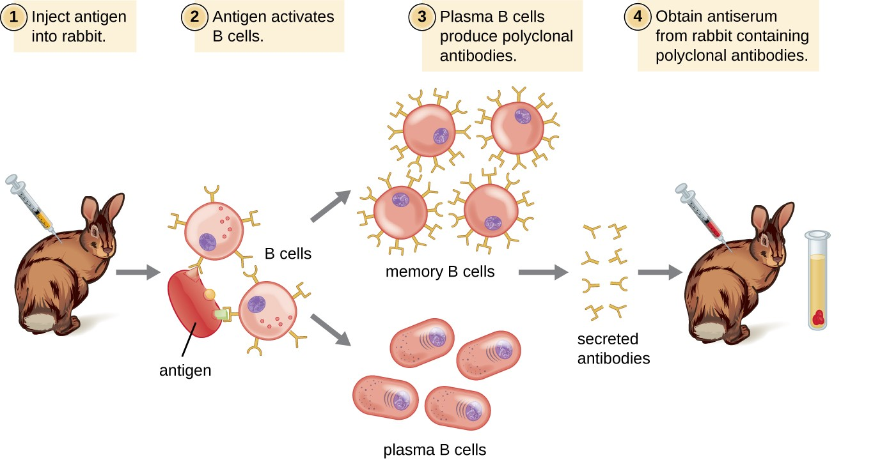
Lab animals are usually injected at least twice with antigen when being used to produce antiserum. The second injection will activate memory cells that make class IgG antibodies against the antigen. The memory cells also undergo affinity maturation, resulting in a pool of antibodies with higher average affinity. Affinity maturation occurs because of mutations in the immunoglobulin gene variable regions, resulting in B cells with slightly altered antigen-binding sites. On re-exposure to the antigen, those B cells capable of producing antibody with higher affinity antigen-binding sites will be stimulated to proliferate and produce more antibody than their lower-affinity peers. An adjuvant, which is a chemical that provokes a generalized activation of the immune system that stimulates greater antibody production, is often mixed with the antigen prior to injection.
Advantages:
- Inexpensive to produce.
- Quick to produce. Purified antibody ready to use in under four months.
- Easy to store.
- Highly stable and tolerant of pH or buffer changes.
- Higher overall antibody affinity against the antigen due to recognition of multiple epitopes.
- In general, ability to detect multiple epitopes gives more robust detection.
- Offers greater sensitivity for detecting proteins that are present in low quantities in a sample since multiple antibodies will bind to multiple epitopes on the protein.
- Ideal as the capture antibody in a Sandwich ELISA. Greater ability to quickly capture the target protein.
- Superior antibody affinity generally results in quicker binding to target antigen. Ideal in assays requiring quick capture of the protein such as IP or ChIP.
- Significantly more robust when assaying proteins that show slight variations in individual epitopes such as denaturation, polymorphism or conformational changes.
- Superior for use in detecting a native protein in multiple assay types.
- Much easier to couple with antibody labels. Less likely to affect binding capability.
Disadvantages:
- Variability between different batches produced in different animals at different times.
- Higher potential for cross-reactivity due to recognizing multiple epitopes.
- Affinity purification of the serum will typically be required to minimize cross-reactivity.
Producing Monoclonal Antibodies
Some types of assays require better antibody specificity and affinity than can be obtained using a polyclonal antiserum. To attain this high specificity, all of the antibodies must bind with high affinity to a single epitope. This high specificity can be provided by monoclonal antibodies (mAbs). Table 1 compares some of the important characteristics of monoclonal and polyclonal antibodies.
Unlike polyclonal antibodies, which are produced in live animals, monoclonal antibodies are produced in vitro using tissue-culture techniques. mAbs are produced by immunizing an animal, often a mouse, multiple times with a specific antigen.
B cells from the spleen of the immunized animal are then removed. Since normal B cells are unable to proliferate forever, they are fused with immortal, cancerous B cells called myeloma cells, to yield hybridoma cells. All of the cells are then placed in a selective medium that allows only the hybridomas to grow; unfused myeloma cells cannot grow, and any unfused B cells die off. The hybridomas, which are capable of growing continuously in culture while producing antibodies, are then screened for the desired mAb. Those producing the desired mAb are grown in tissue culture; the culture medium is harvested periodically and mAbs are purified from the medium. This is a very expensive and time-consuming process. It may take weeks of culturing and many liters of media to provide enough mAbs for an experiment or to treat a single patient. mAbs are expensive.

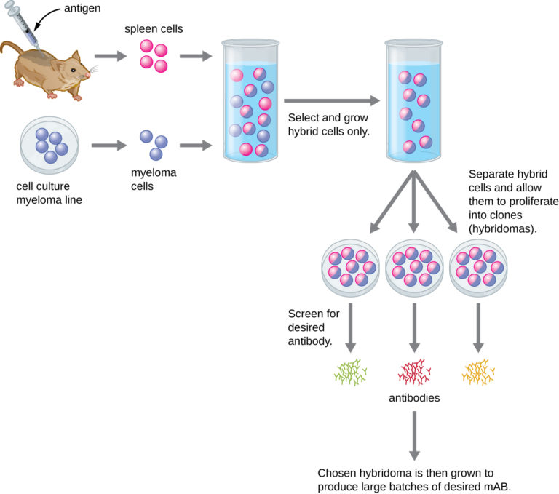
Advantages:
- Can produce large quantities of identical antibody. Batch to batch homogeneity.
- High specificity to a single epitope. Reduced probability of cross-reactivity.
- Can provide better results in assays requiring quantification of the protein levels.
Disadvantages:
- Significantly more expensive to produce.
- Requires significantly more time to produce and develop the hybridized clone.
- Small changes in the epitope’s structure often render the monoclonal antibody unable to detect the target protein.
- More demanding storage conditions for the clone.
- Cell culture and purification capabilities required.
- Less robust for detecting the protein in a denatured state or altered conformation.
- Less ideal for application requiring quick capture of the target protein.
- More sensitive to pH and buffer conditions.
- More susceptible to binding changes when labeled.
- To offset many of these disadvantages, it is necessary to produce a pool of several monoclonal antibodies. This is typically cost and time prohibitive.

Antibodies bind with high specificity to antigens used to challenge the immune system, but they may also show cross-reactivity by binding to other antigens that share chemical properties with the original antigen.
Injection of an antigen into an animal will result in a polyclonal antibody response in which different antibodies are produced that react with the various epitopes on the antigen.
Polyclonal antisera are useful for some types of laboratory assays, but other assays require more specificity. Diagnostic tests that use polyclonal antisera are typically only used for screening because of the possibility of false-positive and false-negative results.
Monoclonal antibodies provide higher specificity than polyclonal antisera because they bind to a single epitope and usually have high affinity.
Monoclonal antibodies are typically produced by culturing antibody-secreting hybridomas derived from mice. mAbs are currently used to treat cancer, but their exorbitant cost has prevented them from being used more widely to treat infectious diseases.

