Lec.1 Biotechnology Dr. SahiraNsayef

History of Biotechnology
Biotechnology is the accumulation of more than 8000 years of human experience using living organisms and the process of fermentation to make products. Today biotechnology is applied to manufacturing processes used in health care, food, agriculture, industrial and environmental cleanup, among other applications. In 1919,Karl Ereky, a Hungarian engineer, coined the term biotechnology for the first time to describe the interaction of biology and human technology.He envisioned a new era of technology based on using biology to turn raw materials into socially useful products.Nearly a century later, vision is being realized by thousands of companies and research institutions.Biotechnology composes of Bio that refers to the use of biological processes, and technologythat refers to solve problems or make useful products.
A widelyaccepted definition of Biotechnology is "Application of scientific and engineering principles to processing of materials by biological agents to provide goods and service". Some other definitions replace rather ambiguous word ‘biological agents’ with more specific words such as microorganisms, cells, plant and animal cells and enzymes. When a biotechnological process isimplemented on a commercial scale there is every reason to believe that it will make in some bioreactor or fermenter.

Biotechnology is the use of living systems and organisms to develop or make useful products. Or its any technological application that uses biological systems, living organisms or derivatives thereof, to make or modify products or processes for specific use.

Historical development of biotechnology

1- Stage1:Pre-Pasteur Era(before 1885)

● Discovering of microorganisms

● Traditional microbial industry(bread, cheese, beer and wine)

2- Stage2:Pasteur Era or fermentation Era(1885-1940)

● Production gunpowder by soil microorganisms

● The fermentative ability of microorganisms

● Production of chemicals like acetone, butanol, ethanol and organic acids

3- Stage3:Antibiotic Era(1940-1960)

● Production of antibiotics

● Production ofenzymes and vitamins

● Production ofgibberellins ,amino acids, nucleotides and steroids

●Tissue cultures techniques

4- Stage4:Post-antibiotic Era(1960-1975)

●Production of single cell protein (SCP)

●Production of sterilantsanddisinfectants

●Enhancement of microorganisms productivity by genetic engineering techniques

5-Stage5:Genetic engineering Era(1975-2000)

● Production of therapeutic proteins(insulin, interferon,....etc)

●Production of new sources of energy(Biogasand biodiesel)

● Production of monoclonal antibodies

● Production of hybrid antibodies

● Production of biodetergents

●Immobilization of enzymes and cells

6-Stage6:Transgenic organisms Era(2000-2025)

●Production of vaccines by plants

●Production of therapeutic proteins by animals

●Production of genetically modified foods.

●Production ofartificial chromosomes

Another division for biotechnology was included:
- Ancient Biotechnology (stage I)
- Classical Biotechnology (stages II , III and IV)
- Modern Biotechnology (stages V and VI )
Some important discoveries related to biotechnology have been shown in Figure 1.

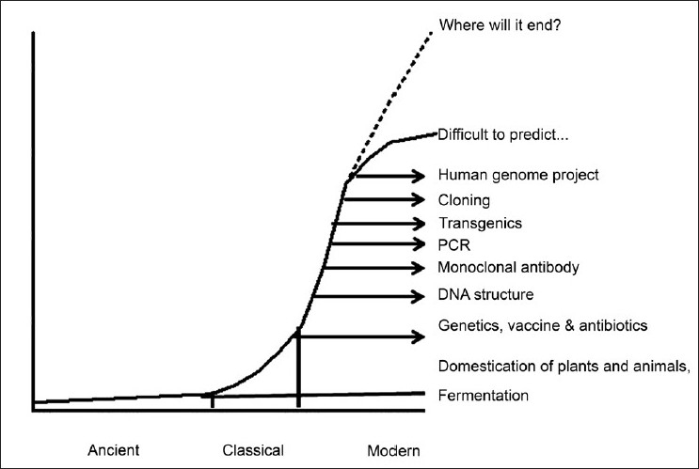
Figure 1:History of the development of biotechnology. Some of the important biotechnology discoveries have been plotted in this graph, with a possibility for its unlimited growth in the future.
Generations of biotechnology
1- Blue biotechnology: is a term that has been used to describe the marine and aquatic applications of biotechnology.
2-Green biotechnology:is biotechnology applied to agricultural processes.
3-Red biotechnology:is applied to medical processes.
4- White or grey biotechnology: is biotechnology applied to industrial processes or environment.
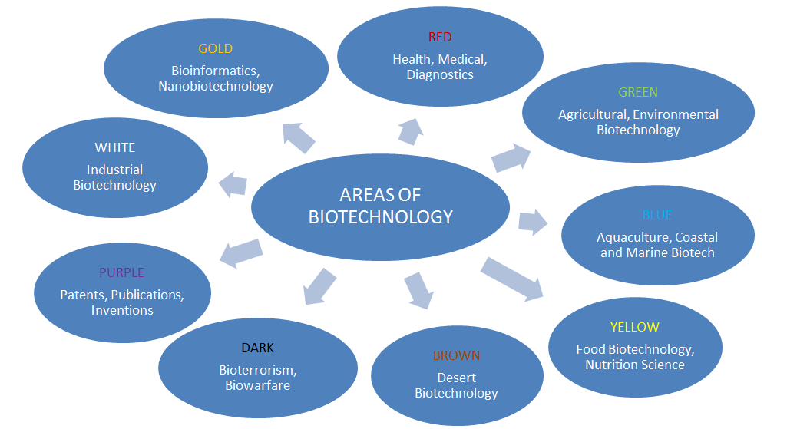
Figure 2: Generations of biotechnology
Biotechnology inputs
1-Monoclonal antibodies
Usingimmune system cellsthat buildantibodieswhich are characterized byveryhighly specializedand therefore candetermineand discover thevital elementsaccuratelyeven ifverysmall quantities, and its applications:
●Identify anddetectenvironmental pollutants.
●Todetectharmfulmicroorganismsinfood.
● differentiatebetweennormal cellsandcancer cells.
2- Tissue culture technology
It isthe cultivationof animal or plantcellsin vitro(in the laboratory), and their applications:
●Cellular therapy.
●the production ofdrugsfromplantcellsdirectly insteadof the plant.
●The use ofanimal cellsin the detectionefficiency ofdrugsinstead ofanimals, reflecting the safetyand accuracy.
●Propagationanddoubled of the plant tissuesin the laboratory.
3- Cloning
Productionnumbersand models ofgenetically identicalmolecules, cells and animals and plantswhichare of three types: Molecular or DNA cloning, cells cloningandanimal or reproductive cloning.
4- Genetic modification
It happensto modify thegenes ofthe same typeorthe transfer ofgenesfrom one species toanother andits applications:
●Production ofdrugs and vaccines.
●Treatment of certaingenetic diseases.
●To increase agricultural productionand reducecost.
● Increasethe value ofthe nutritional contentinfood.

5- Protein engineering
This technique dependson the concept ofgenetic modificationin order toproducespecific proteinsornew proteinshaveuseful applicationssuch asenzymesorbiocatalysts.
6- Hybrid technology
It is intendedto link biologicalsciences with other sciencestogiveuseful applicationssuch as:
a- Biosensors
This technologyconnectsbetweenbiology andmicroelectronics, and their applications:
•measuring thecontentand quality offoodand safety.
•measurement ofenvironmental contaminants.
•helping doctorsto measurespecific componentsin the blooddirectly.
b-Tissue engineering
This technologyconnectsbetweencytologyandmaterials scienceto produceartificial tissuesin the laboratorieswithitsscaffolds. Thesuccessful examples ofthis techniquethe building of skinand cartilage.
c-DNA chips
This technology connects between the semiconductor industry and the genes making it possible to analyze tens of thousands of genes in a single-chip area does not exceed per square centimeter, and their applications:
●detection of mutations in specific genes.
●measurement of gene activity.
●Identification of genes important for crop production.
●Studying the structural sequence of genetic material.
d- Bioinformatics
Thistechnology linkbetweencomputer scienceand the genetic material,especiallythe programsof statistical analysis, graphsimulation and databases and thatutilizedin the analysis ofthe vast amount ofinformation derived fromgenetic material, and their applications:
•Geneticmappingand identification ofsitesandthe number of genesineachmap.
•determination of the shapeandconstruction ofproteins.
•Simulation theway ofproteins workandthread.
•The discovery ofthe causesand locations ofgeneticmaladiesanddesignappropriate treatment.
Hybrid technology
- Biology + Microelectronics=Biosensors
- Cytology + Materials = Tissue engineering
- Genes + Semi conductive = DNA chips
- Genetic material + Computer science = Bioinformatics

Figure 3:Hybrid technology
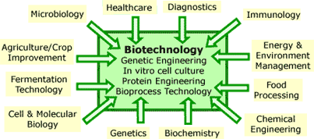
Figure 4: Inputs of biotechnology

