Morphology of the bacterial colony
    - Shape: circular, irregular, radiate orrhizoid.
    - Size: diameter inmm
    - Elevation: flat, raised, low convex, domeshaped
    - Margin: Entire, wavy, lobate,filiform
    - Surface: smooth, wavy, rough,granular,papillate, glisteningetc.

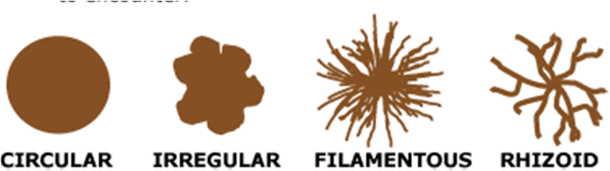Shape of the colony

Elevation of the colony

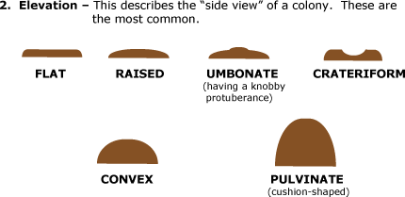

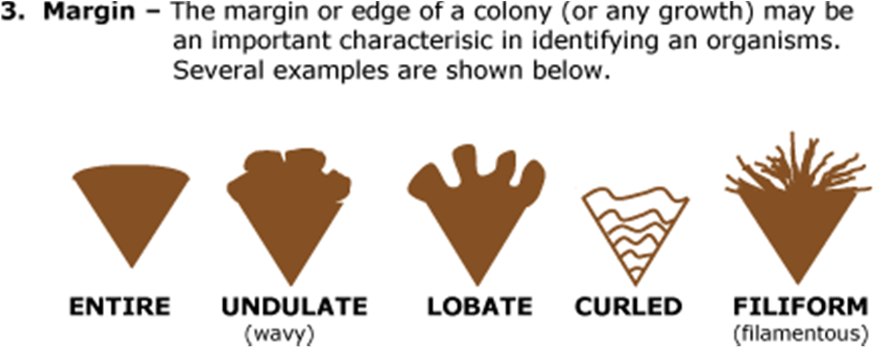Margins of the colony

On solid medium the following characters areobserved
  - Shape: circular, irregular, radiate orrhizoid.
  - Size:Thesizeof thecolonycanbeausefulcharacteristic for identification. The diameter of a representative colony may bemeasured.
  - Elevation:
  - Margin: Entire, wavy, lobate,filiform
  - Surface: smooth, wavy, rough,granular,papillate, glisteningetc.
  - Size inmm
  - Texture: dry, moist, mucoid, brittle,viscous,butyrous (buttery).
  - Color:colorless, pink, black, red,bluish‐green.

Mac Conkey Agar
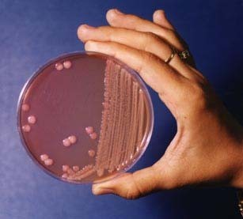

Eschericia coli on MacConkey Agar:
growth, with pink colonies
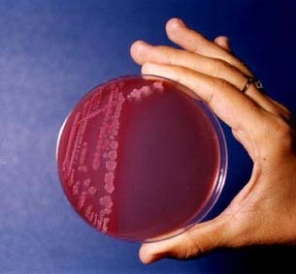

Enterobacter cloacae on MacConkey Agar:
growth with pinkcolonies

contd.

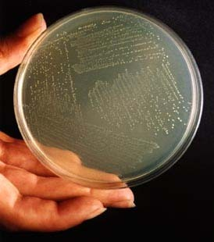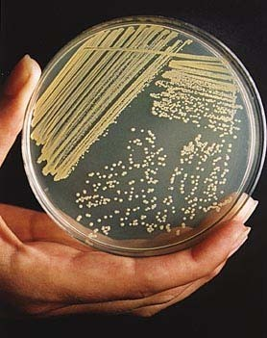

Staphylococcusaureus Streptococcuspyogens

contd
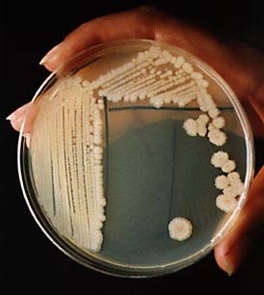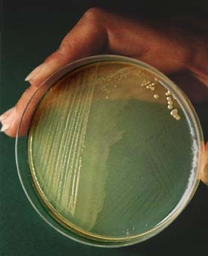

Bacillussubtilis Proteus spp.

IN A FLUID MEDIUMFOLLOWING CHARACTERS ARE OBSERVED

Degree of growth‐ Absence, scanty,moderate, abundantetc.
- Present of turbidityand its nature.
- Presence of deposit and itscharacter.
- Nature of surfacegrowth.
- Ease and disintegrationand odor

