Chapter –Five :The Reproductive (Genital) System
Reproduction is one of the most important biological processes for survival and producing generations for every species. This process depends on the reproductive cells produced from the primary reproductive organs which are known as “gonads”. Gonads are 2 types: male gonads called “testes” which produce sperms and female gonads called “ovaries” which produce ova.
Besides producing reproductive organs, the gonads also produce hormones into blood and lymph.
Most mammals have 2 gonads except some fish and female birds which have only one gonad as a result of infusion of both structures or degeneration of one of them.
In cartilaginous fish:
There is a pairs of testes that is oval in shape and located dorsal to the adjacent kidney, It is connected to the kidney through mesorchium. The non- functional part of mesonephrous in kidney is modified into vasa efferentia or efferent ducts that connect the testes to the kidney. These ducts transmit the sperms into other much coiled tubules that end into a sac like organ known as “seminal vesicle” that opens into the cloaca. The male pelvic fin in dog fish is modified into 2 claspers which are used to hold the female and transport the sperms.
In females, there is a pair of ovaries during larvae stage then they unite in adult stage forming one oval middle sized right ovary which is connected to the kidney by mesovarium. The ovary forms a specific number of large ova containing the yolk sac. The 2 right and left oviducts go along the peritoneum cavity to open into a cone opening at the anterior of the cavity. The anterior part of the oviduct is narrow but then it starts to dilate to form a spherical sac called “shell gland”. This gland leads to the “uterine chamber” to perform the first stages of embryo formation. Also the uterine chamber opens in the “urinogenital sinus” that opens into the cloaca.

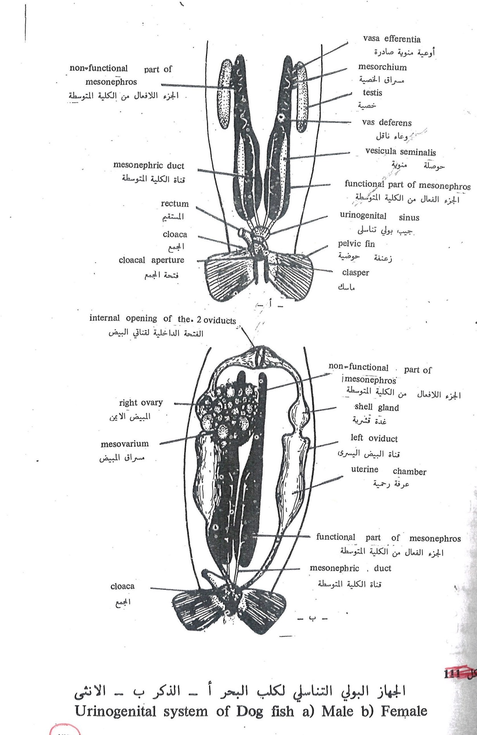
In dog fish, fertilization occurs internally as the sperms from the males is connected to the cloaca by the 2claspers, the sperms swims into the oviduct to reach the aits anterior part where the mature ova are found to be fertilized. The fertilized ovum is surrounded by a crust or a horny shell secreted by shell gland. This shell is elongated with 4 walls; each wall ends with a tendril.
Inside these shells the fertilized ovum turns into small embryos, each embryo has its own sac filled with salty solution to complete its growth before hatching from the shell. The female puts these eggs on aquatic weeds to be attached to them by the tendrils and the female keeps close to the eggs till the hatch. In some cartilaginous fish , the embryo completes its growth at the end of the oviduct inside the uterine chamber so they are called “viviparous” while the ones who lay their eggs are called “oviparous”, so generally cartilaginous fish are called “ovoviviparous”.
In bony fish:
In males it’s formed by a pair of testes, the testes is thin and long, whitish in color and closed at its anterior end while its posterior end is connected to 2 vas deferens (deferent duct) and both ducts unite forming a common vas deferens to meet with the urinogenital papilla behind the anus.
In females, there is a pair of ovaries which looks like the testes but it’s thicker and yellowish in color because they contain ova filled with salty solution. The posterior end for each ovary extends as a short oviduct so that the 2 ducts unite forming a common oviduct to open through a common opening behind the anus and in front of the urinary opening.
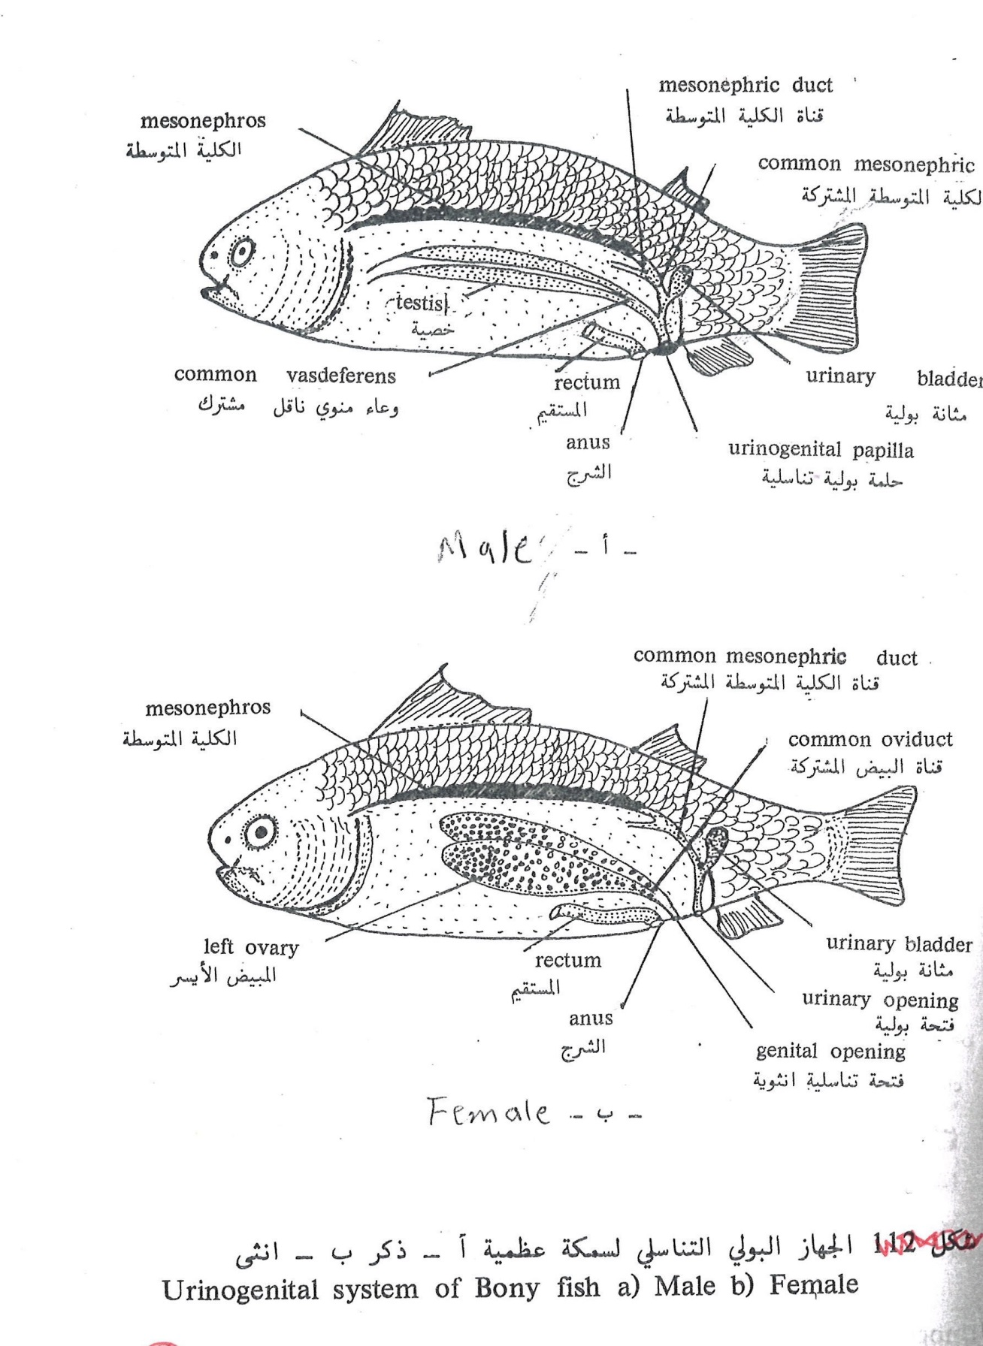

In amphibians:
Testes in most amphibians are oval in shape in front of the adjacent kidney that connects to it through vasa efferent that cross the mesorchium. The sperms is transferred from the testes to the non-functional part of mesonephrous then to the through the mesonephric duct along the side surface of kidney and just above the kidney it dilates to form a triangular sac like structure called “vesicular seminalis” that stores the sperms and finally opens in the cloaca.
Therefore mesonephric duct has an excretory and reproductive function and the amphibians don’t have external genitalia.
Ovaries in amphibians is lobar and large in size, ova are released into the peritoneal cavity then reaches the oviducts which starts by a conical shape in the peritoneal cavity posterior to the lungs and lead to a coiled loop that dilates forming ovisac to store ova before their release
Each ovisac has its own opening into the cloaca in most frogs while in toads the 2 ovisacs unites to open in the cloaca in one opening. Most amphibians have an organ called “Bidder’s organ” that is attached anteriorly to the testis or ovary, this organ could be transformed into a testis or ovary if the main reproductive organ was removed during growth. Fat bodies are attached to this organ anteriorly that are finger like thick bodies containing fat cells to be used for nutrition during hibernation.
During ovulation the oviduct dilates for the ova to pass then the ova are surrounded by viscous material secreted by the posterior part of the oviduct.
In caudate the ovum is fertilized internally while in anura fertilization is external as the male conjugate with the female to pour the sperms to the ova.
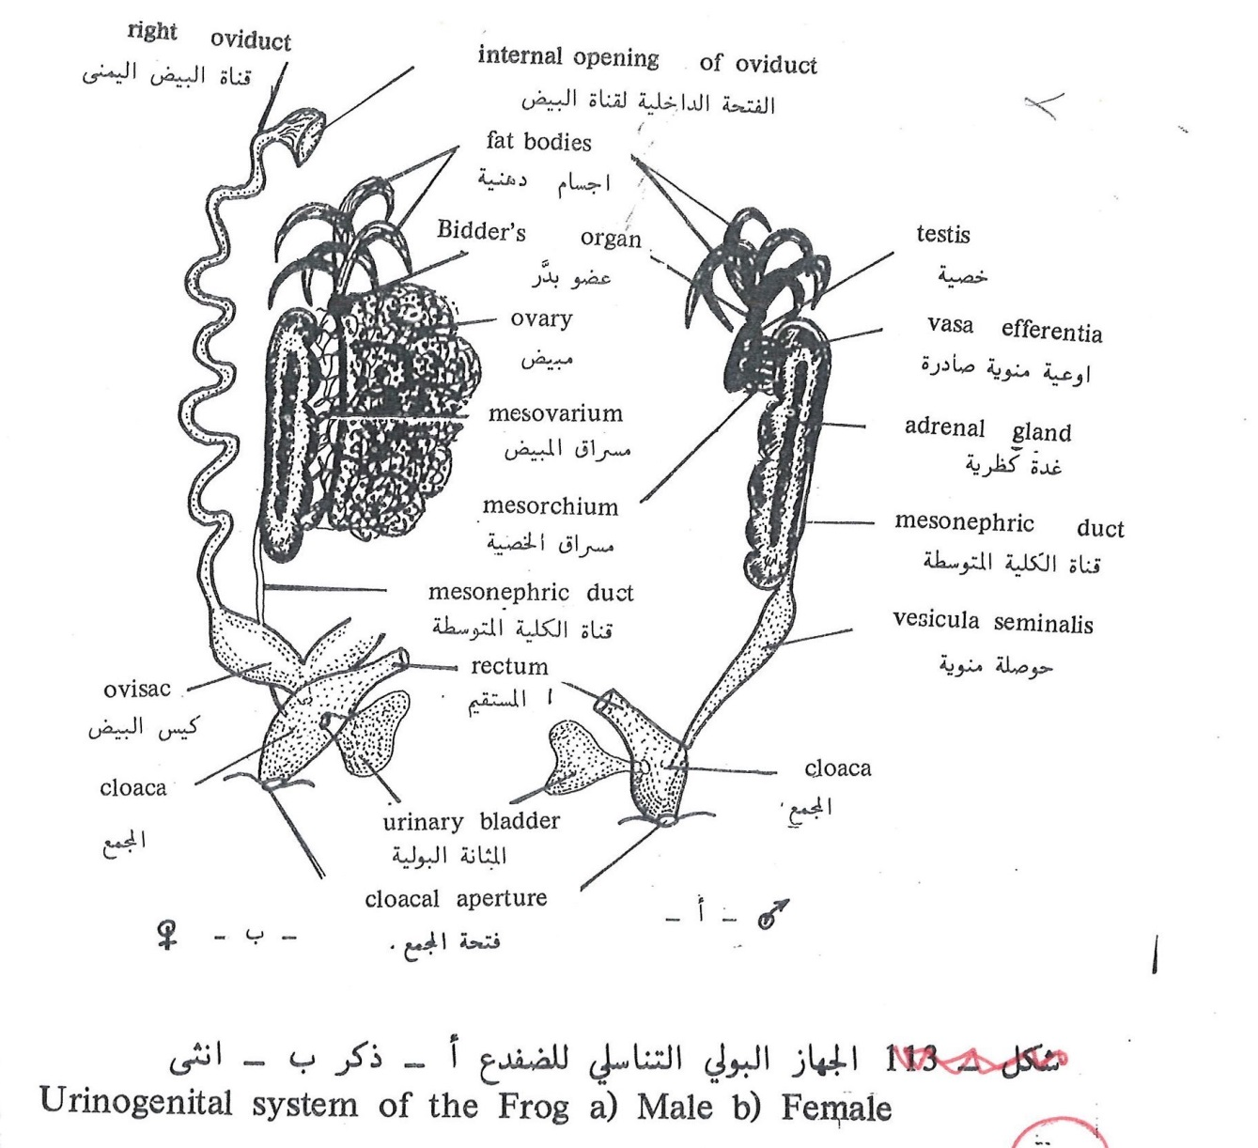
In reptiles:
Male reproductive system consist of a pair of testes oval in shape that maybe found in the middle of trunk as in lizards or posterior of trunk behind the kidney as in turtles, the right testis is more anterior than the left one. In reptiles , as all amniota, the matanephros disappear except for the posterior ones that remains to form vasa efferentia, while the mesonephric duct forms the vas deferens or deferent duct. The duct’s anterior part is coiled and forms the epididymis. In most reptiles the 2 deferent ducts fuse with the ureter to open finally in the cloaca.
The female reproductive system consist of a pair of ovaries. The ovary in reptiles is lobed with little number of ova in different growth stages and sizes. The right ovary also is more anterior than the left one. Beside each ovary there is an oviduct that is an elongated wide tube to open in the peritoneum through an opening called “ostium of oviduct”. When the ova pass through the oviduct, they are surrounded by albumin. In the posterior side of oviduct there a shell gland secrets a solid material to form the shell. Fertilization is internal at the beginning of oviduct before adding these materials. The end of oviduct opens in the cloaca near the ureter opening.
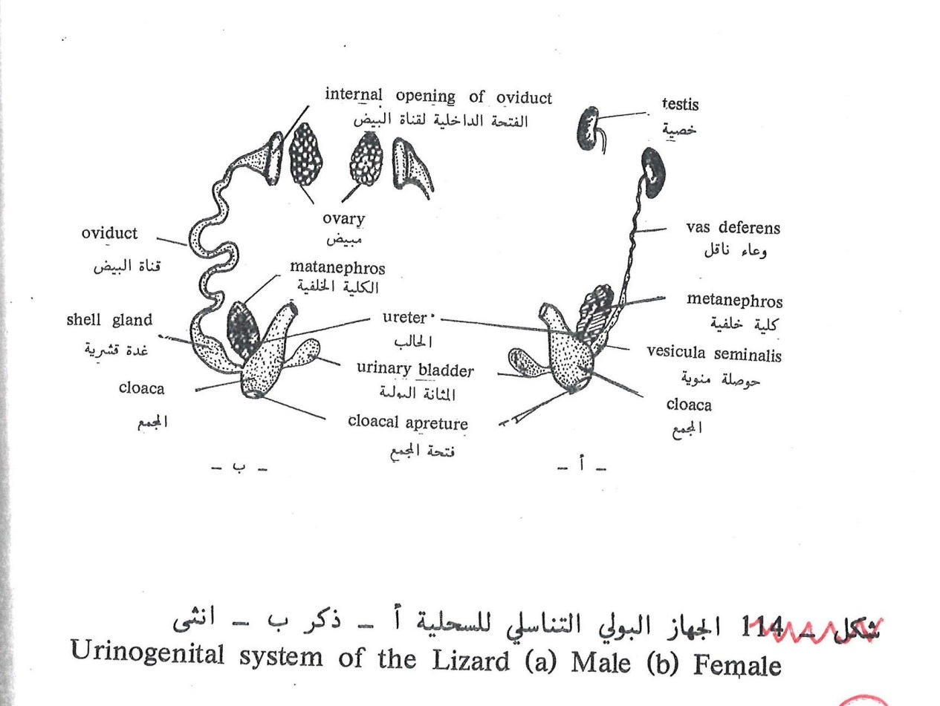
In birds:
The male reproductive system consist of a pair of testes which is oval in shape and smooth surface and its connected to the medial part of the anterior side of adjacent kidney through the mesorchium. From the medial side of each testis emerge the efferent ducts that fuse to form the deferent duct that extends posteriorly along with the ureter to open in the urodeum.
In females there is ONLY one left ovary because the right ovary degenerates during the embryonic life. The left ovary is long and coiled. Anteriorly there is an a wide funnel opening to receive mature ova while posteriorly it dilates to form the shell gland as in reptiles and finally opens in the urodeum of cloaca. When the ova become mature for fertilization they fall in the peritoneal cavity then to the oviduct, fertilization occurs in the anterior part of the duct. While passing through the duct the ovum is surrounded by many secretions from the walls of oviduct as albumen, internal and external shell membranes and finally the hard shell layer.
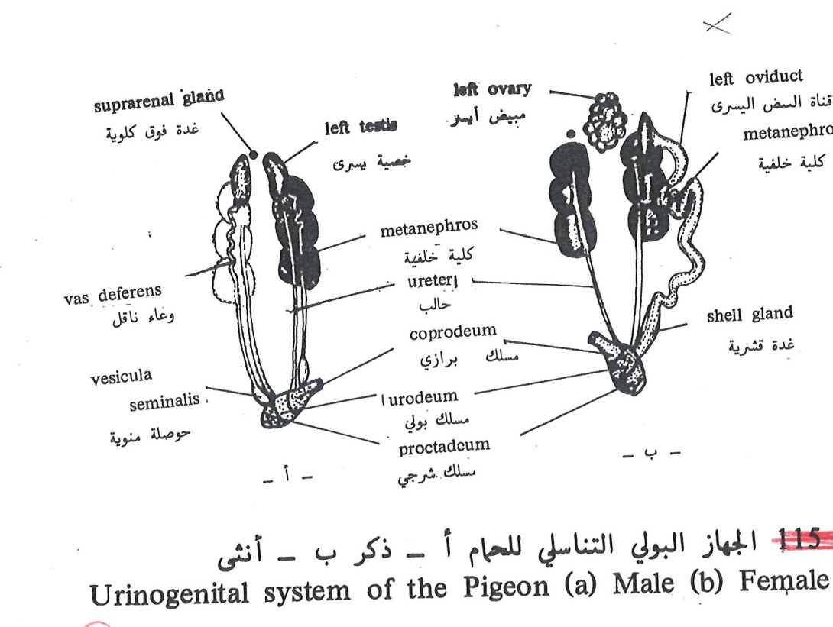
In mammals:
The male reproductive system in mammals consists of solid testes at the posterior end of trunk and outside body cavity. Each testis is surrounded by a sac originating from body cavity known as “scrotal sac”. The testis consists of a group of coiled tubules called “seminiferous tubule” that forms the sperms. The external wall of testes is made of a thick layer of connective tissue called “tunica albugenia”. The seminiferous tubules lead to collecting ducts that originate the vasa efferentia or efferent ducts that fuse to form the “epididymis”. Epididymis is a long coiled canal that could be differentiated into 2 components:
- An anterior large component called “caput epididymis”
- A posterior small component called “cauda epididymis”
The testis is connected posteriorly with the scrotal sac by connective tissue forming a rope like structure known as” gubernaculum”. The epididymis leads to the deferent ducts that extend anteriorly then bend or surround the 2 ureters then goes posteriorly to open separately in a wide room at the upper part of the posterior surface of the bladder that is called “uterus masculinus”. This room unites with the neck of bladder to form the “urethra” that is considered an ejection canal.
This pathway is surrounded by 3 pairs of glands:
Prostate gland, Cowper’s gland and perineal gland that gives the rabbit its special odor. Prostate and Cowper’s glands secrets a viscous fluid to be mixed with the sperms.
The urethra leads to the penis that is covered at its end by a fold called “prepuce”, at the anterior part of testes is connected to spermatic cord which extend anteriorly to the peritoneal cavity. This cord composed of an artery and a vein and a nerve to supply the testes.
Female reproductive system consists of a pair of ovaries behind the kidney in the body cavity. The ovaries are small because they have little number of ova or alecithal ova as the embryo depends on his mother for feeding during fetal life.
Ova are formed inside “Graafian follicle” , when the ovum matures , the graafian follicle ruptures to release the ovum ready for fertilization , then it goes through the oviduct that starts with the infundibulum then a narrow fallopian tube and finally into the uterus. The 2 uteri fuse together to form the vagina. The vagina fuses with the neck of bladder to form the vestibule or urethra that opens to the outside through the vulva. On both sides of vestibule there are 2 pairs of Cowper’s and perineal glands.
