Chapter - 3: Digestive System
The digestive system in all vertebrates with all its parts adapt to the nature of its food, the animals behavior and the kind of it takes by mouth according to the purpose of getting food and preparing it for swallowing. The glands lining the system secrets a moist material so that the animal can taste food and swallow it as: salivary glands in higher vertebrates. The tongue could be short with limited function as in fish or it could be long as in amphibians and reptiles to catch food, on the other hand it is muscular and glandular in mammals.
The digestive system in general is more complicated in higher mammals than lower ones. Vertebrates can’t use food (animal and plant tissue) directly without the digestive system converting these tissues into more simple substance to be absorbed by small intestine.
Digestive system in vertebrates consists of: the alimentary canal and the accessory glands. The alimentary canal in herbivores is longer than in carnivores. Digestive system contains many organs of specific function for example the mouth receive the food and grind it, the esophagus transport the food from the mouth to the stomach, the stomach stores the food, the first part of intestine secrets enzymes with the help of liver and pancreas while the other part absorbs digested food by villi and finally waste products are excreted by going into the rectum to outside the body through the anus.
Digestive system starts with mouth opening and ends with anal opening on the other side, most of the digestive lining is of endodermal origin while the anterior (mouth part and the posterior part (anus) are of ectodermal origin.

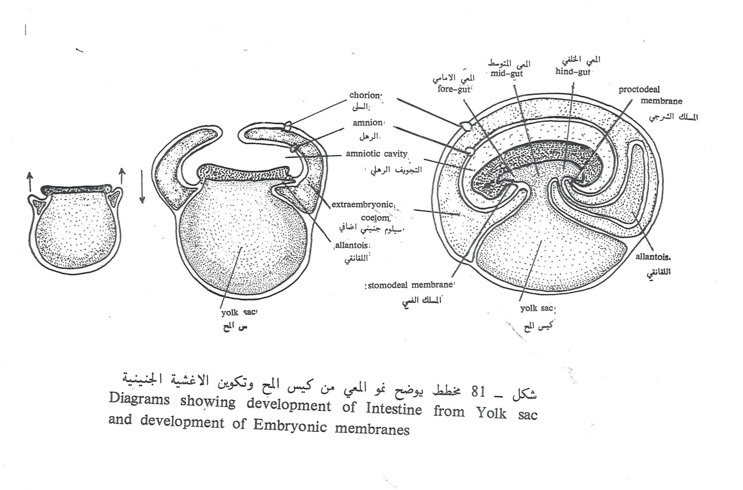
Digestive system in cartilaginous fish:
Starts with mouth opening that lies at the plantar side of the snag area. The buccal cavity has 2 jaws: the upper jaw and the lower jaw which contain short teeth called placoid teeth. Then comes the pharyngeal cavity whose wall consist of 5 pairs internal gill slits which opens in gills chambers on both sides, these chambers are connected to body surface through external gill slits.
Pharynx is followed by esophagus that leads to the stomach, stomach has 2 parts: an oval wide part called cardiac portion and a narrow tubular part called pyloric portion then its followed by the duodenum which is a short tube but wider than the cardiac part. Duodenum leads to a wider part called small intestine that is lined with a spiral lining called “spiral valve”. Small intestine is connected with the large intestine which a narrow part called “rectum”. Rectum is connected to the cloaca that opens into along opening between pelvic fins. Also, at the connection between the small intestine and rectum opens an appendicular papillary shaped gland called” rectal gland “
The accessory organs are pancreas lying just behind the cardiac potion of stomach and cover a part of duodenum; it has a pancreatic duct pouring into the duodenum. The liver consist of 2 lobes, the right one contains the gall bladder from which extend the biliary canal to open into the duodenum .the right lobe is larger than the left one. The spleen is a triangular organ attached to the posterior end of cardiac portion of stomach.

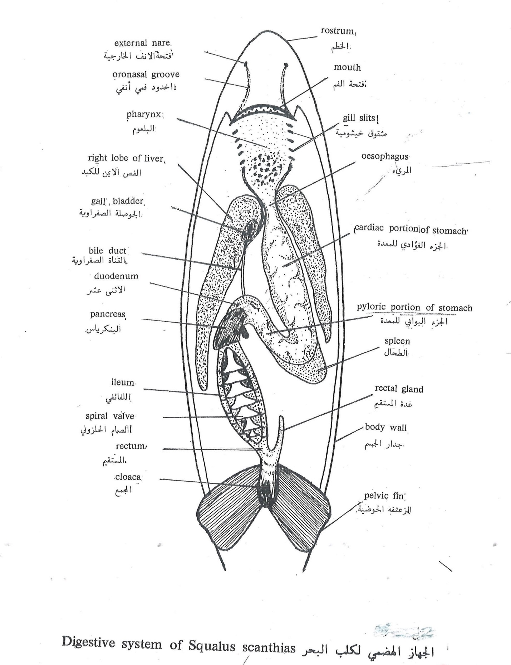

In bony fish:
It resembles that of the cartilaginous fish except that their mouth opening is laterally sited.
The mouth cavity contains mucus glands helps in swallowing and digesting food. Then it leads to the pharynx which is a sac like structure with the gills chambers on its sides, the gill rackers on the internal part of the gill arches selects the food particles from water which pass through the gill slits, Also there is a primitive tongue at the base of the mouth containing tasting buds.
The pharynx leads to the esophagus which is short with longitudinal folds to allow its expansion during swallowing a large pray.
The stomach here consist of 2 parts: a large closed from behind part called the cardiac portion and a tubular narrow part called pyloric portion that leads to the duodenum then the small intestine. The small intestine is long and coiled opening into the rectum then to the outside through the anus.
The liver is small in comparison with the cartilaginous fish consists of a big left lobe and a small right one containing a big sized gall bladder.
While the pancreas is distracted parts along the duodenum and the small intestine. Also there is the spleen, anterior to the stomach, is triangular in shape and red in color.

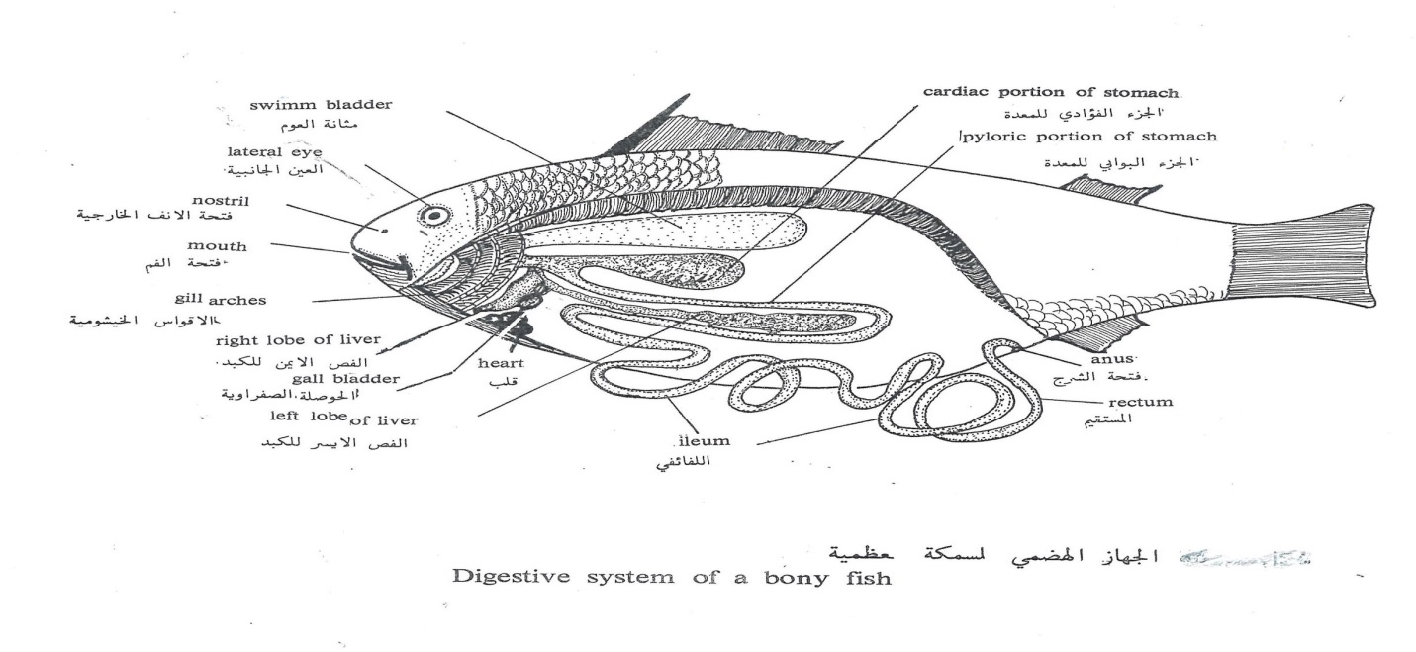
Q: NUMERATE 2 DIFFERENCES BETWEEN THE DIGESTIVE SYSTEM IN CARTILIGINOUS AND BONY FISH?
In amphibians:
The buccopharyngeal cavity consist of a lot of mucus glands to help the amphibians in catching their prays and swallow them easily.
What is the role of tongue?
The tongue plays a major role in catching those prays , the tongue is discoid shape fixed from the front and free from behind so it will be released anteriorly and return back rapidly surrounding the pray.
The mouth cavity leads to the pharynx then a short esophagus leading to the stomach. The stomach is a fusiform shaped structure, its anterior part (cardiac) is wide while the inferior part( pyloric) is narrow.
The small intestine is characterized by the presence of villi lining it. Then comes the rectum that opens in the cloaca.
The liver has a right and a divided left lobe; in addition the spleen is a small spherical structure near the rectum. Aglossa is losing the teeth as an adaptation to the environment where these aglossa are living.
In reptiles:
Buccopharyngeal cavity is divided , by the palate, into 2 passages; adorsal one which is a nasal pathway and the anterior one is the mouth cavity. The mouth cavity has 2 jaws with short tooth and a tongue which maybe short and inside the mouth cavity as in turtles and crocodiles or it may be long and divided anteriorly as in snakes which can also extend it to the outside.
The mouth cavity has a number of large variable mucus glands as: tongue glands, mandibular glands, glands under the tongue, and some of these glands transform into poisonous glands as in snakes.
Then comes the esophagus which is relatively long due to the elongation of neck region also the esophagus is lined with folds to allow the passage of their large prays during swallowing.
The stomach is discoid in shape and thick muscular walls leading to the small intestine which is longer than that of the amphibians and ends in the rectum through the rectal caecum.

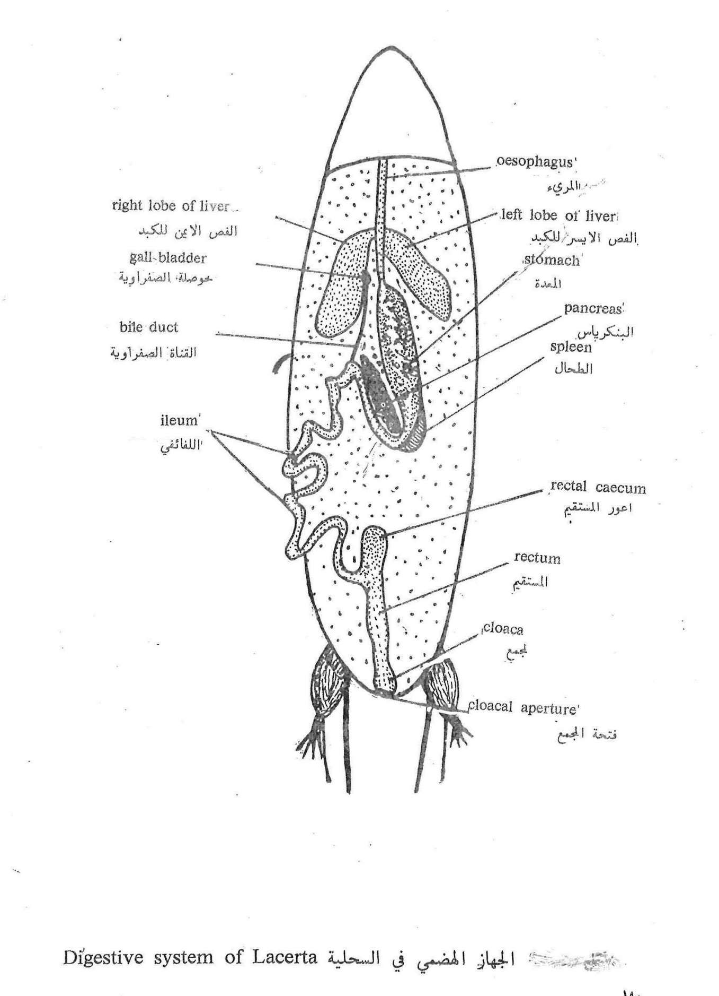

In birds:
It starts with the mouth opening at the base of the horny peak; the mouth cavity is supplied with mucus glands secreting mucus substance to help in swallowing.
The tongue is long with different sizes and shapes and there are no teeth.
The esophagus extends as long as the neck does then at its end it widens to form the crop which stores and soften the food before reaching the stomach. The stomach lies behind the crop and it is divided into the anterior part which is the digesting stomach or”proventriculus” which secrets digestive juices while the other part is the posterior part which is the gizzard , it has thick walls to crush food particles and mix it with digestive juices.
Then comes the small intestine that starts with the duodenum. Duodenum has a “U”shape receiving pancreatic juices. At the connection between the small intestine and rectum there are 2 appendages of rectal caeca , the rectum opens into the cloaca which could be divided into: “coprodaeum”along which opens the rectum and urodaeum and “proctodaeum” that opens to the outside through the cloaca opening.

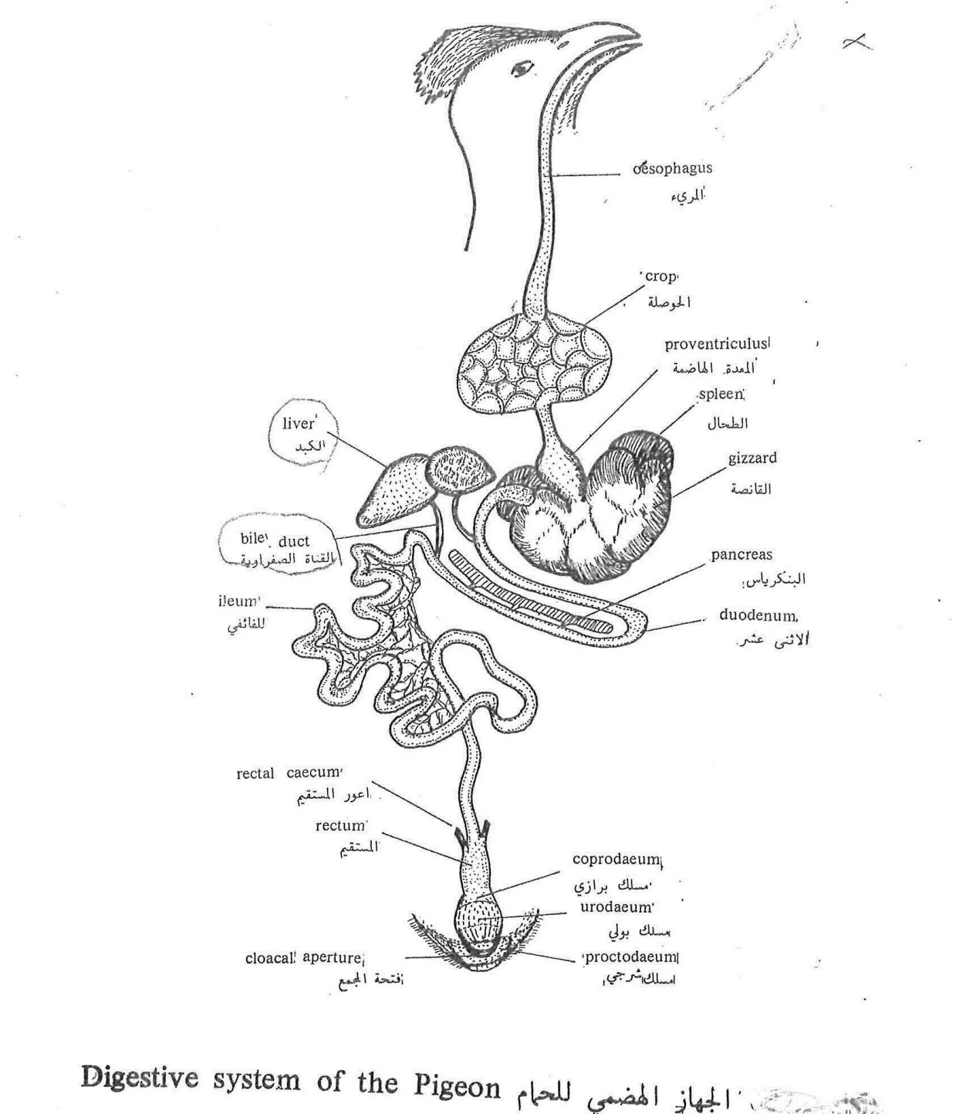
In mammals:
The mouth opening in mammals is characterized by presence of upper and lower lips and muscular cheeks, the lips determine the size of mouth opening and helps in keeping food inside the mouth cavity. There is 3 pairs of salivary glands inside the mouth and there is the muscular tongue that has different sizes and functions.
The mouth cavity is followed by short pharynx then comes the esophagus which is a narrow long tube runs posteriorly through the neck and chest ending into the abdominal cavity after penetrating the diaphragm to open into the stomach.
The shape of stomach differs in its shape between mammals; generally the stomach is a sac like organ. Most of the stomach lies in the left side.
The stomach consists of: the cardiac portion, fundus, pyloric portion.
Then comes the coiled small intestine which consist of : the duodenum ( along fold), ileum that ends into a circular sac called “sacculus rotandus”
The large intestine is composed of colon; it has many haustra and the rectum which opens to the outside through the anus. Rectum contains faecal pellets, also at the connection between the small and large intestine there is caecum and it ends with “vermiform appendix, this appendix is a finger like projection with a closed end also it is big sized in rabbits and this is the characteristic feature in herbivores mammals because it secrete an enzyme to digest cellulose.
Liver is large in size, red in color, consist of 5 lobes and there is a depression on its posterior surface containing the gallbladder. Pancreas lies between the two branches of duodenum. Spleen is a dark red organ lies near to the cardiac portion of stomach.
