Introduction
Anatomy comparison
This study concerns with anatomical composition of different vertebrates starting from simple animals to the more complicated ones as; rabbits.
Homologues and analogues organs:
-Organs with the same origin are called” homologous organs” even if they look the same or have the same function ,and if they play the same function they are mostly have the same components and structures
-For example; the forelimbs of both birds and mammalian fish have the same origin but different shape and components because of their different functions from swimming to walking to flying.
-“Analogous organs “ have different genetic origin however they play similar functions as their components and shape are the same.
- For example; the wing of bat and the wings of the other birds are apparently similar to do their flying job however the bat’s wing is formed by skin folding between the forelimb and the hindlimb but the birds’ wing formed by modifying the forelimb into wing.
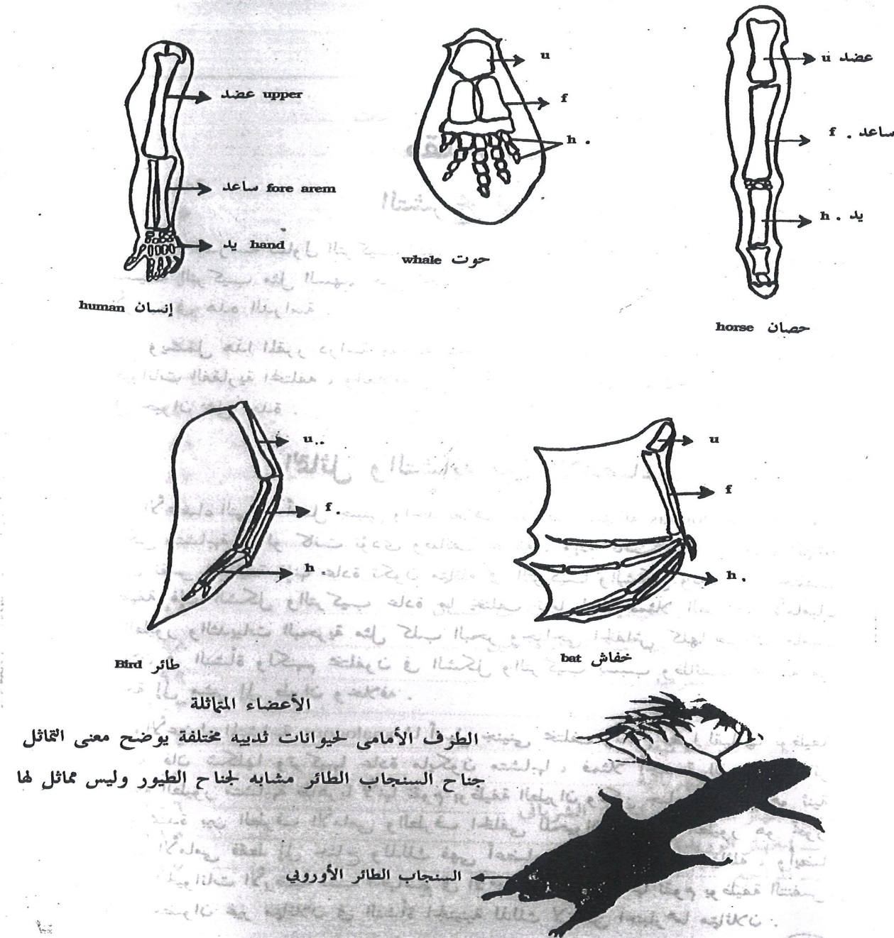

Chordates are animals characterized by the presence of a notochord. They are included in the phylum Chordata which is the last phylum among the 30 phyla of the animal kingdom. The animals which do not contain a notochord are called Non-chordates or Invertebrates.
The phylum Chordata comprises about 70,000 species where as, the non-chordates constitute about 1,024,410. Thus the chordates make up only about 7% of the animal kingdom. Though it is a small phylum, it is remarkable that man, the master of the present age, belongs to this phylum. Again phylum Chordata includes the largest and heaviest animals like blue whale (35 metres long and 120 tons in weight). The familiar chordates are fishes, frogs, toads, lizards, snakes, turtles, crocodiles, birds and mammals including man.
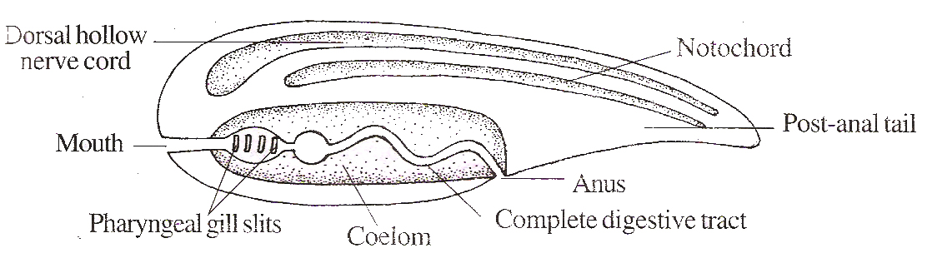

Fig.1.1: Diagrammatic representation of chordate characteristics

General Characters of Chordata
The animals containing a notochord, a dorsal tubular nerve cord and gill slits are called chordates.
Chordates have the following characteristics:
- Notochord : A dorsal longitudinal skeletal rod is located beneath the nerve cord. It is made up of vacuolated notochordal cells. In higher chordates, it is surrounded or replaced by a vertebral column.
- Nerve Cord: A single, tubular (hollow) nerve cord is located dorsal to the alimentary canal (Fig. 1.2). In the invertebrate, the nerve cord is often paired, solid and central to the alimentary canal.
- Pharyngeal Gill Slits: Paired openings are present on either side of the pharynx.
- Post-anal Tail: It is present at some age of the life cycle. May or may not persist in the adult.
- Closed Vascular System: The blood fever comes out of the blood vessels and it Contains capillaries.
- Haemoglobin: Haemoglobin is present in the RBC.
- Ventral Heart: The chordate heart is located on the ventral side of the body.
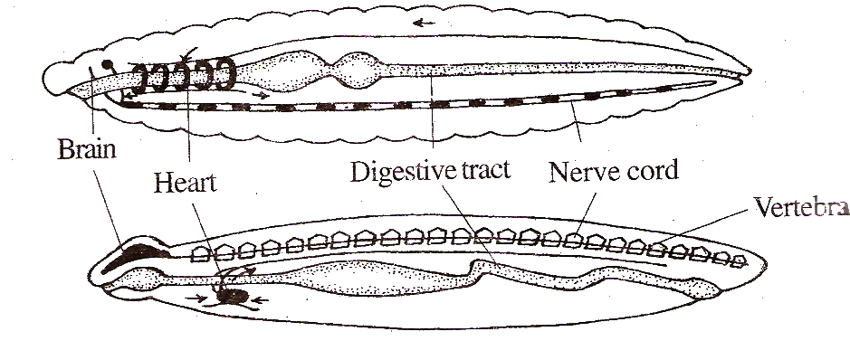

Fig.1.2: Fundamental differences in the body plan of (top) an invertebrate (annelid) and (bottom) a chordate. Note the location of heart nerve cord. The arrows indicate the direction of blood flow.

- Direction of Blood Flow : In Chordates, the blood is pumped anteriorly, then dorsally and posteriorly.
9. Hepatic Portal System : The food laden blood from the alimentary canal is carried to the liver through a hepatic portal vein.
- Bilateral Symmetry: All chordates are bilaterally symmetrical at least in the embryonic stage.
- Cephalization: In bilaterally symmetrical animals, there is a concentration of nervous tissue and sense organs in or toward the head. This is known as cephalization.
- Metamerism : Certain structures, that are repeated one after another are said to be metameric. Eg. Some nerves. blood vessels, vertebrae\ ribs, muscles. etc.
- Coelom: All chordates have a true body cavity (between the body wall and the gut wall) lined entirely with mesoderm. The coelom is eniero coelom developing from the gut.

Classification of Chordata
Chordata is a phylum comprising of animals with a notochord. Chordata is the last phylum in the Animal Kingdom. The remaining phyla include non-chordates (Invertebrates).
Phylum Chordata is sub-divided into 3 subphyla, namely:
Subphylum 1. Urochordata
Subphylum 2. Cephalochordata
Subphylum 3. Vertebrata
Urochordata includes chordates containing notochord in the tail region. Eg. Ascidian (Herdmania).
Cephalochordata includes chordates containing a notochord extending upto the tip of head. Eg. Amphioxus.

The subphylum Urochordata and Cephalochordata are together called Protochordata or Prochordata because they are the first chordates.
The protochordates do not possess a cranium (a part of skull enclosing brain) and a head. So they are called Acrania.
The Vertebrata possess a cranium and a head. So they are called Craniata.
The veitebrata includes animals containing a vertebral column. Vertebral column is the back bone formed of a series of ring-like vertebra arranged one behind the other. The vertebral column either develops around the notochord or replaces the notochord.
Subphylum Veitebrata is divided into two superclasses based on the presence or absence of jaws, namely :
Superclass 1. Agnatha
Superclass 2. Gnathostomata
Agnatha are vertebrates without jaws.
Agnatha is divided into two classes, namely:
Class 1. Ostracodermi Eg. Jamoytius.
Class 2. Cyclostomata Eg. Petromyzon.
Gnathostomata are vertebrates containing jaws.
Gnathostomata is divided into 7 classes, namely:
Class 1. Placodermi
Pisces
Class 2. Chondrichthyes
Class 3. Osteichthyes
Class 4. Amphibia
Class 5. Reptilia
Tetrapoda
Class 6. Aves
Class 7. Mammalia
Placodermi, Chondrichthyes and Osteichthyes include fishes. So they are together called class Pisces.
Amphibia, Reptilia, Aves and Mammalia contain 4 limbs. So they are together called Tetrapoda.

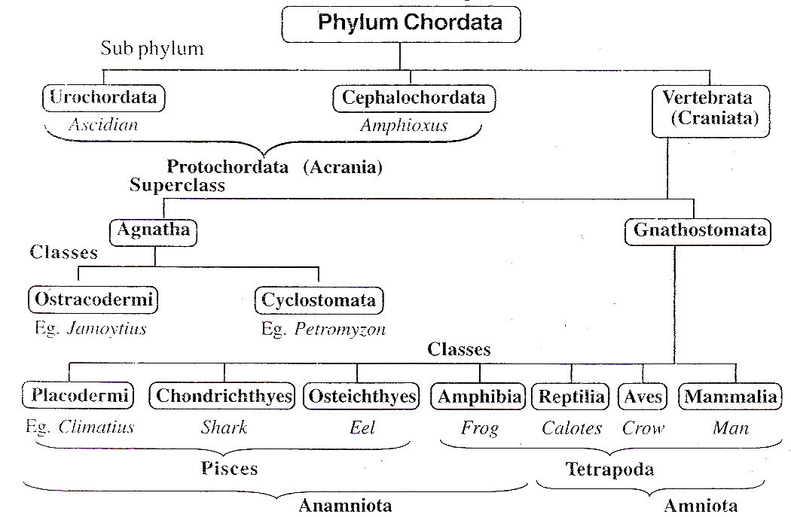

Fig.1.3: Synoptic classification of Chordates.

Vertebrata
Vertebrata is a group of chordates having vertebral column . This group is also called craniata because the animals included in this group contains a cranium and a head.
Vertebrata is the highest subphylum of the phylum Chordata.

General Characters
- A vertebral column is present.
- A distinct head is present.
- The brain is well developed.
- The brain is enclosed in a cranium.
- Two pairs of appendages in the form of fins or limbs are present.
- The integument is made up of epidermis and dermis.
- The endoskeleton is bony or cartilaginous in nature.

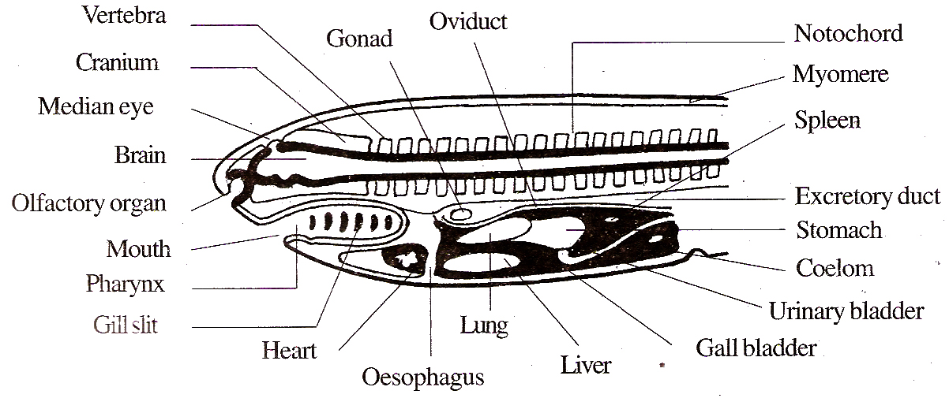

Fig.1.4: A longitudinal section of a generalized vertebrate showing the key characters.

- The digestive system is well developed and it includes liver and pancreas.
- The circulatory system is the closed type with capillaries.
- The heart lies ventral to the digestive tract.
- The blood flows backwards in the dorsal vessel and forwards in the ventral vessel. This is just reverse to that of invertebrates.
- Portal systems are well developed.
- The spinal nerves have two roots.
- A tail is present.
- Excretory system is made up of a pair of kidneys. A bladder is present for storing urine.
- The sexes are separate.
- In many vertebrates, the genital duct and the rectum join together to form a cloaca.
- Endocrine glands are well developed.

