Helminthes
The helminthes or worms unlike the protozoa are macroscopic and multicellular; Helminthes do not possess body cavity, they have digestive, excretory, reproductive and nervous systems, like the protozoa the worms can be categorized according to their habitat in the host, helminthes have an outer protective covering "cuticle" the month may be provided with teeth or cutting plates, many helminthes possess suckers or hook for attachment to host tissues they don't possess organ locomotion, but in some species the suckers assist in movement (locomotion is generally by muscular contraction and relaxation.
• The greatest development is seen the reproductive system may be
1-diecious (with two distinct male and female sexes) separate ,the male being smaller than the female)
2-Hermaphroditic helminthes, both male and female reproductive system are present in the same worm and self- fertilization
• The eggs or larvae are produced in enormous numbers
• Many helminthes require more than one intermediate host for completion of their life cycle.
Classification Based on their shape and other characteristics helminthes are classified into two broad groups
- The cylindrical worm belonging to the phylum Nematheliminthes (class Nematode) name-thread.
Nematodes (Round worms)
- intestinal round worms.
- blood or tissue round worms.
Nematodes are elongated cylindrical worms with an segmented body .they possess relatively well developed alimentary canal ,complete with the anus, the head does not have either suckers or hooks, but may have a buccal capsule with teeth or cutting plates "the sexes are separate
- Flat worms belonging to the phylum Platyhelminthes:-
- Characteristics:-
1) Bilaterally symmetrical.
2) Body having 3 layers of tissues with organs and organelles.
3) Body contains no internal cavity.
4) Possesses a blind gut (i.e. it has a mouth but no anus)
5) Has Protonephridial excretory organs instead of an anus.
6) Has normally a nervous system of longitudinal fibres rather than a net.
7) Generally dorsoventrally flattened.
8) Reproduction mostly sexual as hermaphrodites.
9) Mostly they feed on animals and other smaller life forms.
10) Some species occur in all major habitats, including many as parasites of other animals.

The flat worms in turn are classified into two categories:-
1-Trematoda (fluke worm)
2- Cestoda (tape worm)
1-Trematodes
-Have flat or leaf-like unsegmented helminthes which are flat and broad, resembling the leaf of a tree; they vary in size from the species just visible to the naked eye, like heterophyes to the large fleshy flukes like fasciala and fasciolopsis.
-The reproductive system is well developed, the sexes are separate in schistosomes, while the other flukes are hermaphroditic (monoecious), the hermaphroditic flukes have both male and female structure so that self –fertilization take place (in the shistosomes the sexes are separate but the male and female live in close apposition (in copula)).
So they can be classified as follows:-
- Diecious blood flukes or schistosomes which live inside veins in various location:
1-In the vesicle and pelvic venous plexuses ,schistosoma haematobium.
2-In the inferior mesenteric vein--- s.mansoni
3- In the supeeior mesentricvein ----s.japanicum
- monoecious, Hermaphroditic flukes which live in the lumen of various tracts.
- They have no body cavity & circulatory or respiratory organs.
- Presence of two muscular cup-shaped suckers the oral sucker surrounding the mouth at the anterior end and the ventral sucker in the middle ventrally
-The alimentary system consists of month surrounded by the oral suckers, a muscular pharynx and the esophagus which bifurcates anterior to the ventral sucker to form two blind caeca the anus absent.
subclass diagenea (require two hosts)
- Immature stages of flukes:
- The egg: operculated or spined it is agrem cell or miraciduim enclosed in a shell.
- The miracidium: a ciliated larva which may be free –swimming or may hatch inside a shell.
- Sporocyt :intromolluscan ,non ciliated suc-like containing germ balls.
- Redia :intra molluscan and develops from the gram balls of the sporocyst ; from it the cercaria emerges.
- Metacercaria . encysted cercaria ,with out a tail ,but with resisent cyst wall , it is usually formed on plants fish or other animals.
This includes
- Liver flukes fasciola hepatica , clonochis sinensis
- Intestinal flukes fasicolopis , heterophyes heterophyes.
- Lung flukes Paragonimus westermani.
- Blood flukes Schistosoma spp

1- Blood Flukes

Schistosoma
Schistosomiasis (also known as snail fever or bilharzia) is caused by blood flukes. More than 200 million people are infected worldwide. Mostly in freshwaters where there are many snails which are the intermediate host. There are three main species infecting humans: Schistosoma mansoni, S. haematobium, S. japonicum.
Life cycle
Depending on the Schistosoma species their eggs are shed either in the feces or urine of an infected human. Eggs can survive up to a week in dry land. If the feces end up in water, larvae called miracidia hatch and start finding of freshwater snails. When they find a snail they penetrate its foot and transform into sporocyst.
These primary sporocysts multiply asexually into secondary sporocysts. They multiply asexually producing hundreds of cercariae. Cercariae exit the snail and start waiting in the water. They can survive about 48 hours in favourable conditions. When they sense that human skin is near, they quickly swim and attach with suckers. As they enter they transform into schistosomulae. Only head parts enter, they leave tails behind. Each schistosomula stays a few days in the skin and then enters the bloodstream through dermal lymphatic vessels or blood venules. They travel in the bloodstream to get to specific blood veins. In humans Schistosoma reaches fertility in 6–8 weeks. The newly developed adult females and males find each other and pair up. Adult blood flukes are 1–2 cm long. Males make a gynaecophoric channel for the longer and thinner females to reside. The worm pair then travels to rectal or mesenteric veins. They attach to the venous wall with oral and ventral suckers and can live for many years. Females lay eggs on the endothelial lining of the venous capillary walls at the rate of 300–3000 eggs per day depending on the Schistosoma species. Some eggs are flushed by circulating blood ending up causing inflammation in organs such as liver or lungs. Most eggs however travel to the lumen of the intestinal tract (S. japonicum and S. mansoni) and of the ureters and bladder (S. haematobium), thus exiting the body in the feces or urine. Mature eggs produce special enzymes and can penetrate many membranes such as rectal veins or intestinal wall. The eggs get out of the body and the cycle starts again.
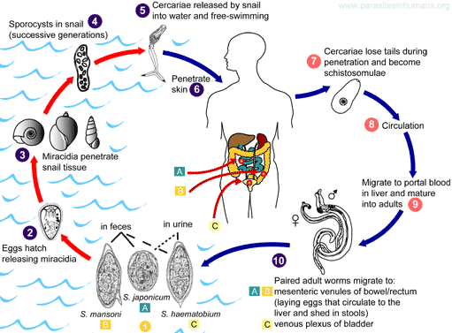
S. japonicum resides it drain the small intestine.
S. mansoni is found it drain the large intestine.
S. haematobium it in the venous plexus of bladder, but can also be found in the rectal venules.
Symptoms
Penetration of cercariae causes transient dermatitis 'swimmers' itch is due to physical damage to the skin by proteases and other toxic substances secreted by the cercaria. The host develops both type I and type IV hypersensitivity reactions to schistomal secretions and egg constituents.
Acute schistosomiasis (Katayama's fever) may occur weeks after the initial infection, especially by S. mansoni and S. japonicum. The symptoms of schistosomiasis are primarily due to a reaction against the eggs and include Hepatosplenomegaly (the enlargement of both the liver and the spleen), lymphadenopathy and diarrhea.
- Manifestations include:
- Abdominal pain
- Cough
- Eosinophilia — extremely high eosinophil granulocyte (white blood cell) count.
- Fever
- Fatigue
- Genital sores
Cystitis and ureteritis (S. haematobium) with hematuria, scarring, calcification, squamous cell carcinoma, which can progress to bladder cancer; Bladder Cancer diagnosis and mortality are generally elevated in affected areas.
Embryonated eggs cause collagenase-mediated damage to the vascular endothelium. Host immune responses, both humoral and cell mediated, have been shown to be of some protective value. IgE and eosinophil mediated cytotoxicity has been suggested as a mechanism of killing the adult worm. Above all, schistosomiasis is a chronic disease. Many infections are subclinically symptomatic, with mild anemia and malnutrition being common in endemic areas. Eggs are sometimes carried to the central nervous system and cause headache, disorientation, amnesia and coma, or spinal cord; they can cause paralysis, seizures or inflammation of the spinal cord. Eggs carried to the heart produce arteriolitis and fibrosis resulting in enlargement and failure of the right ventricle.
Diagnosis
- Microscopic identification of eggs in stool or urine is the most practical method for diagnosis. Eggs can be present in the feces in infections of all Schistosoma species and in the urine in infections of S. haematobium and S. japonicum. The eggs of S. haematobium are ellipsoidal with a terminal spine, S. mansoni eggs are also ellipsoidal but with a lateral spine, S. japonicum eggs are spheroidal with a small knob.
- Tissue biopsy (bladder or rectal biopsy) can also be used in finding eggs, if stool or urine samples are negative. It takes about two months for the parasite to mature into reproducing adult and only after that time will there be eggs present.
- Antibody detection can be useful in both clinical management and for epidemiologic surveys.
Prevention
Avoid freshwater lakes, rivers or streams in areas where schistosomiasis occurs. Drying your skin with a towel immediately after swimming might sweep some larval blood flukes away. Swimming in the salty ocean and in chlorinated swimming pools is quite safe. Human feces should be prevented of getting into water to prevent snails from getting infected. In addition to humans Schistosoma species infect many animals such as cats, dogs, horses, pigs, rodents and goats.
2-Liver flukes
Family Fasciolidae
Fasciola hepatica is a parasitic fluke that lives in the liver. In addition to humans it infects cows and sheep. It is known as the common liver fluke and causes a disease called fascioliasis. Adults reach a length of 3 cm and 1 cm width. Adult females can produce up to 25000 eggs per day.

Fasciola hepatica
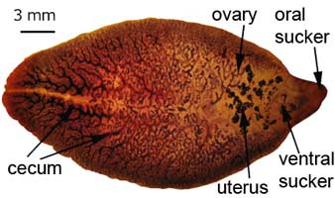
Life cycle
Fasciola hepatica starts when a female lays eggs in the liver of an infected human. Immature eggs are discharged in the biliary ducts and taken out in the feces. If landed in water, the eggs become embryonated and develop larvae called miracidia. A miracidium invades an aquatic snail and develops into cercaria, a larva that is capable of swimming with its large tail. The cercaria exits and finds aquatic vegetation where it forms a cyst called metacercaria. A human eats the raw freshwater plant containing the cyst. The metacercaria excysts in the first part of the small intestine, duodenum. 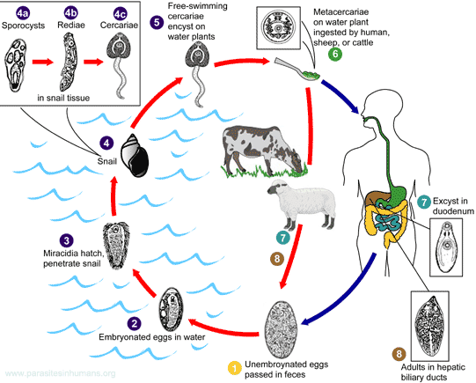
It then penetrates the intestinal wall and gets into the peritoneal cavity. It finds the liver and starts eating liver cells. This happens only a few days after the initial contact with the parasite. Usually the larva spends a few weeks just browsing and eating the liver. Then it relocates to the bile duct where it begins its final stage and becomes an adult. It takes about three months for the metacercaria to develop into an adult.

Clinical manifestations:
In the chronic phase of fascioliasis adults in the large biliary ducts cause liver inflammation and obstruction of the biliary fluid. During the migration of the larvae (this acute phase of the disease lasts many weeks) symptoms include:
- diarrhea
- eosinophilia (high number of white blood cells)
- fever
- nausea
- stomach ache
- vomiting.
- anaemia
- weight loss
Fasciola hepatica is found in areas where cattle and sheep are raised.
Diagnosis
Fasciola hepatica is identified from eggs in a stool sample. The eggs are very similar to those of Fasciolopsis buski. Early stage of the infection can be diagnosed from a blood sample, if antibodies are found.

Clonorchis sinensis

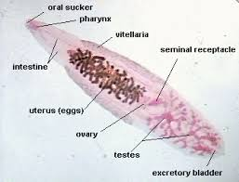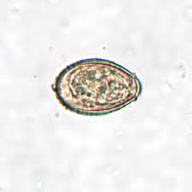
The Clonorchis sinensis is a human liver fluke , this parasite lives in the liver of humans, and is found mainly in the common bile duct and gall bladder, feeding on bile. These are spindloid flukes measuring about 16x4 mm. The eggs measure 29 x 16 µm.
Life cycle
Embryonated eggs are discharged in the biliary ducts and in the stool. Eggs are ingested by a suitable snail intermediate host; there are more than 100 species of snails that can serve as intermediate hosts. Each egg releases a miracidia , which go through several developmental stages (sporocysts , rediae , and cercariae ). The cercariae are released from the snail and after a short period of free-swimming time in water, they come in contact and penetrate the flesh of freshwater fish, where they encyst as metacercariae. Infection of humans occurs by ingestion of undercooked, salted, pickled, or smoked freshwater fish. After ingestion, the metacercariae excyst in the duodenum and ascend the biliary tract through the ampulla of Vaterقناة الصفراوية من خلال أمبولة فاتر. Maturation takes approximately 1 month. The adult flukes (measuring 10 to 25 mm by 3 to 5 mm) reside in small and medium sized biliary ducts. In addition to humans, carnivorous animals can serve as reservoir hosts
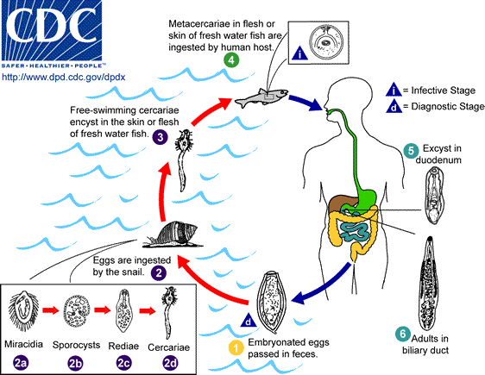

Effects on human health
Dwelling in the bile ducts, Clonorchis induces an inflammatory reaction, epithelial hyperplasia and sometimes even cholangiocarcinoma, the incidence of which is raised in fluke-infested areas. One adverse effect of Clonorchis is the possibility for the adult metacercaria to consume all bile created in the liver, which would inhibit the host human from digesting, especially fats. Another possibility is obstruction of the bile duct by the parasite or its eggs, leading to biliary obstruction.
Symptoms
The worm causes irritation of the bile ducts that become dilated and deviated. The liver may become enlarged (hepatomegaly), necrotic and tender and liver function may be impaired. Modest infections result in indigestion, epigastric discomfort, weakness and loss of weight. Heavier infections produce anemia, hepatomegaly, slight jaundice, edema, ascites and diarrhea.
Diagnosis
Diagnosis is based on symptoms and presence of endemic infection in the area. Definitive diagnosis is dependent on finding the characteristic yellow-brown eggs in the feces or biliary drainage.
Control Fish should be cooked well before consumption. Sewage must be treated before disposal.
3-Lung flukes
Paragonimus westermani
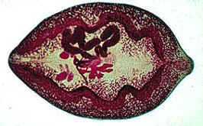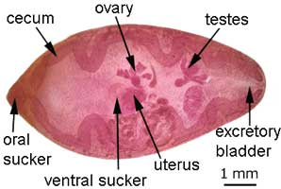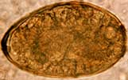
Human lung fluke, Paragonimus westermani, infects people how live near sea in particular is affected because raw seafood is very popular there, humans get infected with this disease, by eating raw crabs or fish that are carrying the parasite. Even properly cooked sushi can cause infection, if the cook or waiter is careless when preparing the food. It is a food-borne parasitic infection which can cause a sub-acute to chronic inflammatory disease of the lung known as paragonimiasis.
Size, shape, and color resemble a coffee bean when alive. The skin of the worm (tegument) is heavily covered with scale like spines. The oral and ventral suckers are similar in size. The excretory bladder extends from the posterior end to the pharynx. The lobed testes are adjacent from each other located at the posterior end, and the lobed ovaries are off-centered near the center of the worm (slightly postacetabular).
Life cycle
Life cycle of a lung fluke begins, when the female lays eggs that are carried out from the human lungs in the sputum by the motion of microvilli. Then the eggs are taken through the gastrointestinal tract and out of the body. If the feces get in contact with water, then after two weeks larvae called miracidia hatch and start to grow. A miracidium finds a snail and penetrates its skin. In 3–5 months miracidium develops further and produces another larval form called cercaria. The cercaria crawls out of the snail to find fresh water crayfish (a lobster-like creature) or crabs. It finds its way to the muscles of the crab and starts forming a cyst. Within two months it transforms into metacercaria which is the resting form of cercaria. If a human eats this infected crab raw, the metacercaria cyst gets into the stomach. Once inside the beginning of the small intestine, duodenum, the metacercaria excysts and penetrates the intestinal wall. It continues through abdominal wall and diaphragm into the lungs where it forms a capsule and develops into an adult. Male and female lung worms reproduce and the cycle starts again.
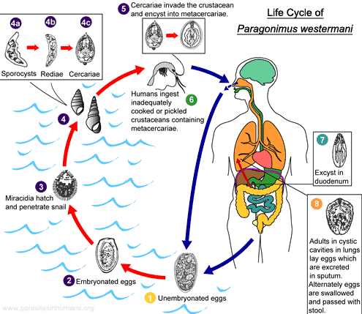
Symptoms
The fluke provokes the development of a fibrous tissue capsule with bloody purulent material containing eggs. There is inflammatory infiltrate around the capsule. The symptoms include a dry cough, bronchitis, followed by production of blood stained rusty brown sputum. Pulmonary pain and pleurisy may develop. Sometimes lung fluke larvae accidentally travel to the brain or other organs and reproduce but life cycle is blocked. In brain they lay eggs and cause a granulomatous abscess resulting in symptoms similar to epilepsy. If the worm goes to the spinal cord instead of the lungs, the host might become paralyzed. If it infects the heart, the host could die.
Salting food does not kill the parasite, cooking and freezing will. After ingestion it takes about three months for the lung fluke to start laying eggs. The host might stay infected up to 20 years.
In addition to humans, Paragonimus westermani infects other carnivores such as felids (cats etc.), canids (dogs etc.), rodents (rats etc.), weasels and pigs (zoonosis).

Diagnosis

Diagnosis is based on history and symptoms.

Examination of sputum and finding the eggs. Eggs are found in rust colored sputum. Sometimes eggs are shed in the feces.

Radiological methods can be used to X-ray the chest cavity and look for worms. This method is easily misdiagnosed, because pulmonary infections look like tuberculosis, pneumonia.

A lung biopsy can also be used to diagnose this parasite. An assay that detects worm antigens using monoclonal antibody can also be used for diagnosis.
Control
- Adequate cooking of crustaceans is a preventive measure.
- Improved sanitary conditions have lowered the infection rate in endemic areas.
4- Intestinal Fluke
Fasciolopsis Buski cause Fasciolopsiasis
Fasciolopsis buski is the largest intestinal fluke in humans. It causes a parasitic disease called fasciolopsiasis and is commonly known as the giant intestinal fluke.
Adult, about 20–75 mm long and 8–20 mm wide, flat, leaf-shaped, blunt anterior end, undulating, tandem, dendritic testes, poorly-developed oral and ventral suckers, branched ovaries, vast vitelline follicles, can be distinguished from other fasciolids by a lack of cephalic cone or "shoulders" and the unbranched ceca.
Egg, yellow-brown, ellipsoidal, thin shell, operculated, filled with yolk cells, microscopic, about 130–160 micrometers (µm) long and 70–90 µm wide.

Life cycle
It starts, when immature, unembryonated eggs are released into the intestine and stool of an infected human. If the feces end up in warm water (27–32 °C), the eggs become embryonated within two weeks and larvae called miracidia hatch after seven weeks. The miracidia find freshwater snails (the intermediate hosts) and penetrate their skin. In the snail the parasites develop and go through several larval stages: sporocysts, rediae, and cercariae. The cercariae exit the snail and encyst into metacercariae on aquatic, edible plants. If a human (or a pig) ingests water or raw vegetation contaminated with the cysts, the metacercariae excyst in the small intestine and attach to the intestinal wall. They develop into adults within three months. They feed on intestinal contents and live about one year. In large infestations they inhabit most of the gastrointestinal tract (starting from the stomach). Mature adults are hermaphroditic (having both male and female reproductive organs) and produce over 25,000 eggs per day.
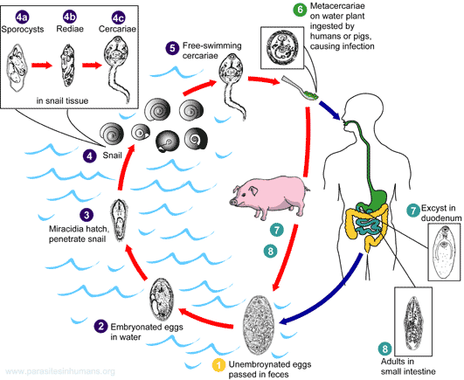
Minor infections are sometimes asymptomatic. Symptoms of heavy infections can include:
- allergic reactions
- anemia (pale skin etc.)
- ascites (accumulation of fluid in the peritoneal cavity)
- diarrhea
- fever
- obstruction of the bowel
- stomach ache
- swelling of the skin
- Toxemia (toxins in the bloodstream).
Diagnosis usually done by identifying eggs from a stool specimen under a microscope. Rarely adult flukes are found from the sample.Fasciolopsis buski and Fasciola hepatica have very similar eggs.
Prevention
Freezing vegetables below -10 °C for a few days or heating them above 60 °C kills most parasites and their eggs. Drinking water can be filtered or boiled (in areas of poor sanitation). Additionally human or pig feces should not be used as a fertilizer in agriculture.
Heterophyes heterophyes
This is a small fluke due to its dimensions (a minute intestinal fluke).It measures only 0.5 to 0.8 millimeters in width and 0.8 to 2 millimeters in length and has a broadly rounded posterior ending. It has an oral sucker that is subterminal and represents one third of the size that the ventral sucker has.

Life Cycle
Adults release embryonated eggs each with a fully-developed miracidium, and eggs are passed in the host’s feces . After ingestion by a suitable snail (first intermediate host), the eggs hatch and release miracidia which penetrate the snail’s intestine. Genera Cerithidia and Pironella are important snail hosts in Asia and the Middle East respectively. The miracidia undergo several developmental stages in the snail, i.e. sporocysts, rediae, and cercariae. Many cercariae are produced from each redia. The cercariae are released from the snail and encyst as metacercariae in the tissues of a suitable fresh/brackish water fish (second intermediate host). The definitive host becomes infected by ingesting undercooked or salted fish containing metacercariae. After ingestion, the metacercariae excyst, attach to the mucosa of the small intestine and mature into adults (measuring 1.0 to 1.7 mm by 0.3 to 0.4 mm). In addition to humans, various fish-eating mammals (e.g., cats and dogs) and birds can be infected by Heterophyes heterophyes .

Clinical Presentation
The main symptoms are diarrhea and colicky abdominal pain. Migration of the eggs to the heart, resulting in potentially fatal myocardial and valvular damage,
In a few cases penetration of the worm into the tissue of the intestine results in liberation of the eggs in lymph nodes from where they may migrate to the heart and brain causing sever cardiac and nervous symptoms, has been reported from the Philippines. Migration to other organs (e.g., brain) has also been reported.
Diagnosis: is made by finding eggs in the feaces.
Prevention involves not eating raw or undercooked fish that may contain these intestinal flukes.
Epidemiology: The life span of the worm is normally short and is about 6to 8 weeks. cercaria can live in the body of salted fish as long as
seven days.The number of Heterophyes worm is very high in the body of the host reaching sometimes to 4000.

