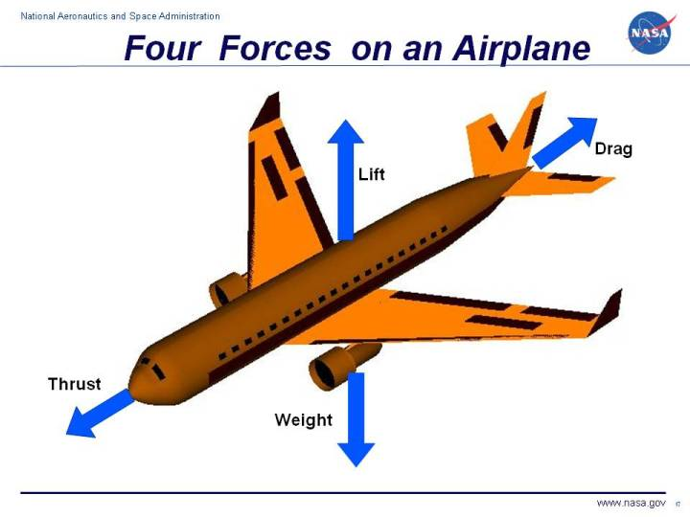

A force may be thought of as a push or pull in a specific direction. A force is a vector quantity so a force has both a magnitude and a direction. When describing forces, we have to specify both the magnitude and the direction. This slide shows the forces that act on an airplane in flight.
1-Weight
Weight is a force that is always directed toward the center of the earth. The magnitude of the weight depends on the mass of all the airplane parts, plus the amount of fuel, plus any payload on board (people, baggage, freight, etc.). The weight is distributed throughout the airplane. But we can often think of it as collected and acting through a single point called the center of gravity. In flight, the airplane rotates about the center of gravity.
Flying encompasses two major problems; overcoming the weight of an object by some opposing force, and controlling the object in flight. Both of these problems are related to the object's weight and the location of the center of gravity. During a flight, an airplane's weight constantly changes as the aircraft consumes fuel. The distribution of the weight and the center of gravity also changes. So the pilot must constantly adjust the controls to keep the airplane balanced, or trimmed. The dream remains that, if we could really understand gravity, we could create anti-gravity devices which would revolutionize travel through the sky. Unfortunately, anti-gravity devices only exist in science fiction
Weight is the force generated by the gravitational attraction of the earth on the airplane. We are more familiar with weight than with the other forces acting on an airplane, because each of us have our own weight which we can measure every morning on the bathroom scale. We know when one thing is heavy and when another thing is light. But weight, the gravitational force, is fundamentally different from the aerodynamic forces, lift and drag . Aerodynamic forces are mechanical forces and the airplane has to be in physical contact with the air, which generates the force. The gravitational force is a field force; the source of the force does not have to be in physical contact with the object to generate a pull on the object.
Newton developed his theory of gravitation when he was only 23 years old and published the theories with his laws of motion some years later. The gravitational force between two objects depends on the mass of the objects and the inverse of the square of the distance between the objects. Larger objects create greater forces and the farther apart the objects are the weaker the attraction. Newton was able to express the relationship in a single weight equation.
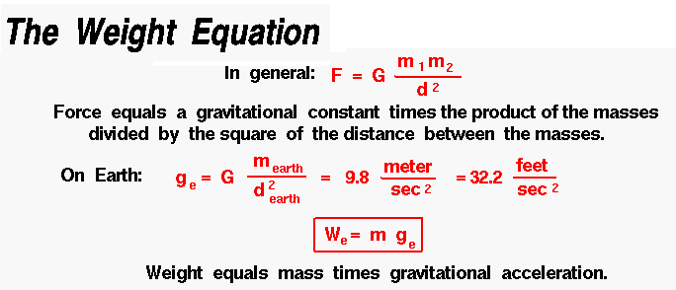

2-Lift
To overcome the weight force, airplanes generate an opposing force called lift. Lift is generated by the motion of the airplane through the air and is an aerodynamic force. "Aero" stands for the air, and "dynamic" denotes motion. Lift is directed perpendicular to the flight direction. The magnitude of the lift depends on several factors including the shape, size, and velocity of the aircraft. As with weight, each part of the aircraft contributes to the aircraft lift force. Most of the lift is generated by the wings. Aircraft lift acts through a single point called the center of pressure. The center of pressure is defined just like the center of gravity, but using the pressure distribution around the body instead of the weight distribution.
Lift is the force that directly opposes the weight of an airplane and holds the airplane in the air. Lift is generated by every part of the airplane, but most of the lift on a normal airliner is generated by the wings. Lift is a mechanical aerodynamic force produced by the motion of the airplane through the air. Because lift is a force, it is a vector quantity, having both a magnitude and a direction associated with it. Lift acts through the center of pressure of the object and is directed perpendicular to the flow direction. There are several factors which affect the magnitude of lift.
HOW IS LIFT GENERATED?
Lift occurs when a moving flow of gas is turned by a solid object. The flow is turned in one direction, and the lift is generated in the opposite direction, according to Newton's Third Law of action and reaction. Because air is a gas and the molecules are free to move about, any solid surface can deflect a flow. For an aircraft wing, both the upper and lower surfaces contribute to the flow turning. Neglecting the upper surface's part in turning the flow leads to an incorrect theory of lift.
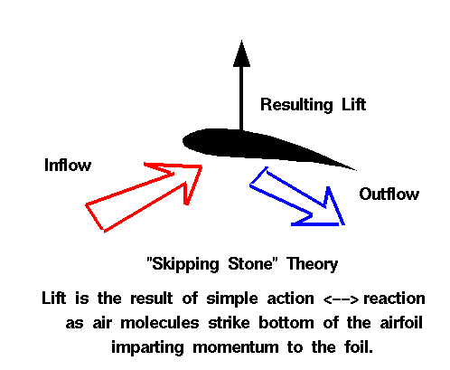
NO FLUID, NO LIFT
Lift is a mechanical force. It is generated by the interaction and contact of a solid body with a fluid (liquid or gas). It is not generated by a force field, in the sense of a gravitational field ,or an electromagnetic field, where one object can affect another object without being in physical contact. For lift to be generated, the solid body must be in contact with the fluid: no fluid, no lift. The Space Shuttle does not stay in space because of lift from its wings but because of orbital mechanics related to its speed. Space is nearly a vacuum. Without air, there is no lift generated by the wings.
NO MOTION, NO LIFT
Lift is generated by the difference in velocity between the solid object and the fluid. There must be motion between the object and the fluid: no motion, no lift. It makes no difference whether the object moves through a static fluid, or the fluid moves past a static solid object. Lift acts perpendicular to the motion. Drag acts in the direction opposed to the motion.
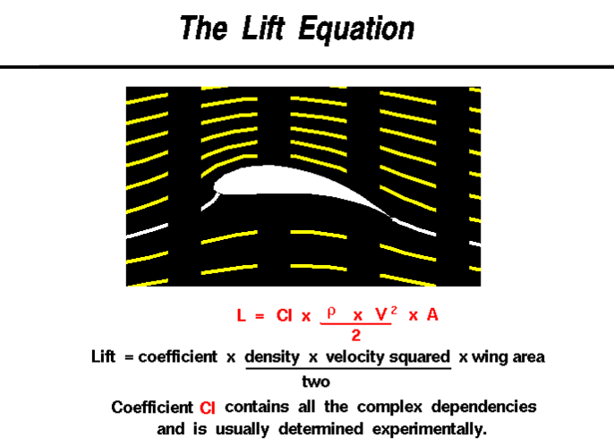
Lift depends on the density of the air, the square of the velocity, the air's viscosity and compressibility, the surface area over which the air flows, the shape of the body, and the body's inclination to the flow . In general, the dependence on body shape, inclination, air viscosity, and compressibility is very complex.
One way to deal with complex dependencies is to characterize the dependence by a single variable. For lift, this variable is called the lift coefficient, designated "Cl." This allows us to collect all the effects, simple and complex, into a single equation. The lift equation states that lift L is equal to the lift coefficient Cl times the density ρ times half of the velocity V squared times the wing area A.
L = Cl x A x 0.5 x ρ x V ²
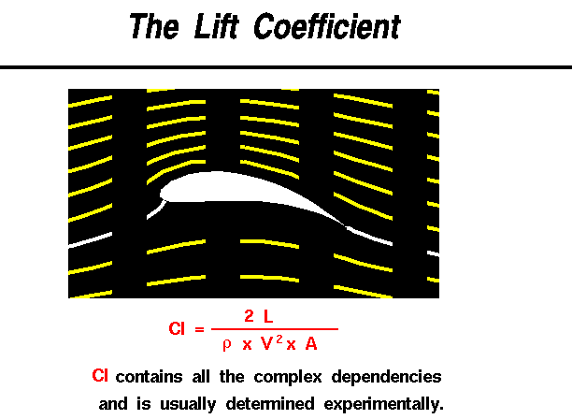
The lift coefficient is a number that aerodynamicists use to model all of the complex dependencies of shape, inclination, and some flow conditions on lift. This equation is simply a rearrangement of the lift equation where we solve for the lift coefficient in terms of the other variables. The lift coefficient Cl is equal to the lift L divided by the quantity: density ρ times half the velocity V squared times the wing area A.
Cl = L / (A x 0 .5 x ρ x V ²)
The quantity one half the density times the velocity squared is called the dynamic pressure q. So
Cl = L / (q x A)
The lift coefficient then expresses the ratio of the lift force to the force produced by the dynamic pressure times the area.
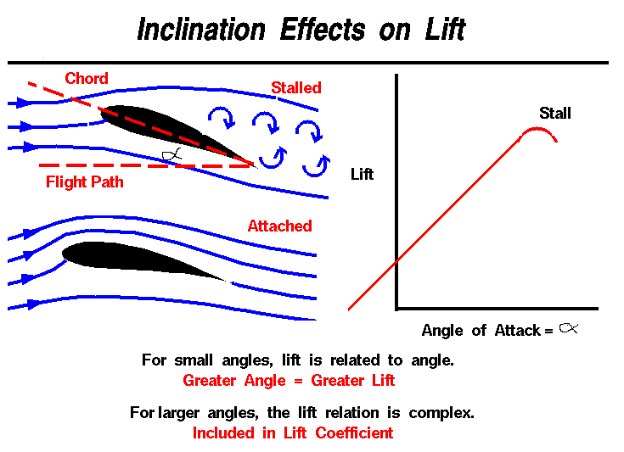

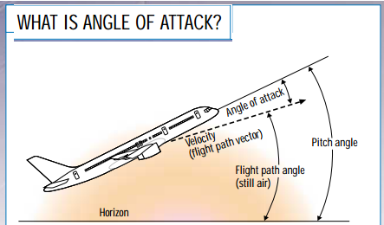

As a wing moves through the air, the wing is inclined to the flight direction at some angle. The angle between the chord line and the flight direction is called the angle of attack and has a large effect on the lift generated by a wing. When an airplane takes off, the pilot applies as much thrust as possible to make the airplane roll along the runway. But just before lifting off, the pilot "rotates" the aircraft. The nose of the airplane rises, increasing the angle of attack and producing the increased lift needed for takeoff.
The magnitude of the lift generated by an object depends on the shape of the object and how it moves through the air. For thin airfoils, the lift is directly proportional to the angle of attack for small angles (within +/- 10 degrees). For higher angles, however, the dependence is quite complex.
As an object moves through the air, air molecules stick to the surface. This creates a layer of air near the surface called a boundary layer that, in effect, changes the shape of the object. The flow turning reacts to the edge of the boundary layer just as it would to the physical surface of the object. To make things more confusing, the boundary layer may lift off or "separate" from the body and create an effective shape much different from the physical shape. The separation of the boundary layer explains why aircraft wings will abruptly lose lift at high angles to the flow. This condition is called a wing stall.
The distribution of lift around the aircraft is important for solving the control problem. Aerodynamic surfaces are used to control the aircraft in roll, pitch, and yaw.
WHAT FACTORS AFFECT LIFT?
The size and shape of the wing, the angle at which it meets the oncoming air, the speed at which it moves through the air, even the density of the air, all affect the amount of lift a wing creates. Let’s begin with the shape of a wing intended for subsonic flight.
WHY DOES A WING HAVE A ROUNDED FRONT?
Air divides smoothly around a wing’s rounded leading edge, and flows neatly off its tapered trailing edge. You might think a sharp leading edge would be better. However, air cannot turn a sharp corner, so tilting a sharp wing even slightly would disrupt the smooth airflow over the wing. This would cause a loss of lift and increase drag. A rounded leading edge divides the airflow smoothly, even as the wing is tilted up or down.
WHY DOES A WING HAVE A SHARP REAR EDGE?
If the trailing edge were rounded, the higher-pressure air flowing along the lower side would try to follow the rounded surface and spill upward into the lower-pressure air above the wing. A sharp trailing edge prevents this upward spill, because air cannot make a sharp turn. Instead, the air flowing off the top and bottom surfaces rejoins smoothly.
HOW DOES TILTING A WING AFFECT THE AIR FLOWING OVER IT?
Tilting the wing upward increases lift—to a point. If you tilt it too much, the airflow pulls away from the upper surface, and the smooth flow turns turbulent. The wing suddenly loses lift, a condition known as a stall. You can reestablish a smooth airflow by tilting the wing back to a more level position
3-Thrust
Thrust is the force, which moves an aircraft through the air. Thrust is used to overcome the drag of an airplane, and to overcome the weight of a rocket. Thrust generated by the engines of the aircraft through some kind of propulsion system.
Thrust is a mechanical force, so the propulsion system must be in physical contact with a working fluid to produce thrust. Thrust generated most often through the reaction of accelerating a mass of gas. Since thrust is a force, it is a vector quantity having both a magnitude and a direction. The engine does work on the gas and accelerates the gas to the rear of the engine; the thrust generated in the opposite direction from the accelerated gas. The magnitude of the thrust depends on the amount of gas that accelerated and on the difference in velocity of the gas through the engine.
The physics involved in the generation of thrust introduced in middle school and studied in some detail in high school and college. To accelerate the gas, we have to expend energy. The energy generated as heat by the combustion of some fuel. The thrust equation describes how the acceleration of the gas produces a force. The type of propulsion system used on an aircraft may vary from airplane to airplane and each device produces thrust in a slightly different way. We will discuss four principal propulsion systems at this web site; the propeller, the turbine, or jet, engine, the ramjet, and the rocket.
You can view a short movie of "Orville and Wilbur Wright" discussing the thrust force and how it affected the flight of their aircraft. The movie file can be saved to your computer and viewed as a Podcast on your podcast player .
4-Drag
Drag is the aerodynamic force that opposes an aircraft's motion through the air. Drag is generated by every part of the airplane (even the engines!).As the airplane moves through the air, there is another aerodynamic force present. The air resists the motion of the aircraft and the resistance force is called drag. Drag is directed along and opposed to the flight direction. Like lift, there are many factors that affect the magnitude of the drag force including the shape of the aircraft, the "stickiness" of the air, and the velocityof the aircraft. Like lift, we collect all of the individual components' drags and combine them into a single aircraft drag magnitude. And like lift, drag acts through the aircraft center of pressure.
Factors that affect drag
As with aircraft lift, there are many factors that affect drag. We can group these factors into (a) those associated with the object, (b) those associated with the motion of the object through the air, and (c) those associated with the air itself.
The Object
Geometry has a large effect on the amount of drag generated by an object. As with lift, the drag depends linearly on the size of the object moving through the air. The cross-sectional shape of an object determines the form drag created by the pressure variation around the object. The three dimensional plan form shape affects the induced drag of a lifting wing. If we think of drag as aerodynamic friction, the amount of drag depends on the surface roughness of the object; a smooth, waxed surface produces less drag than a roughened surface. This effect is called skin friction and is usually included in the measured drag coefficient of the object.
Motion of the Air
Drag is associated with the movement of the aircraft through the air, so drag depends on the velocity of the air. Like lift, drag actually varies with the square of the relative velocity between the object and the air. The inclination of the object to the flow also affects the amount of drag generated by a given shaped object. If the object moves through the air at speeds near the speed of sound, shock waves are formed on the object which create an additional drag component called wave drag. The motion of the object through the air also causes boundary layers to form on the object. A boundary layer is a region of very low speed flow near the surface which contributes to the skin friction.
Properties of the Air
Drag depends directly on the mass of the flow going past the aircraft. The drag also depends in a complex way on two other properties of the air: its viscosity and its compressibility. These factors affect the wave drag and skin friction which are described above.
We can gather all of this information on the factors that affect drag into a single mathematical equation called the Drag Equation. With the drag equation we can predict how much drag force is generated by a given body moving at a given speed through a given fluid.
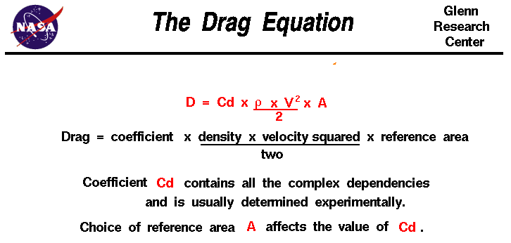
D = Cd x A x 0.5 x ρ x V ²
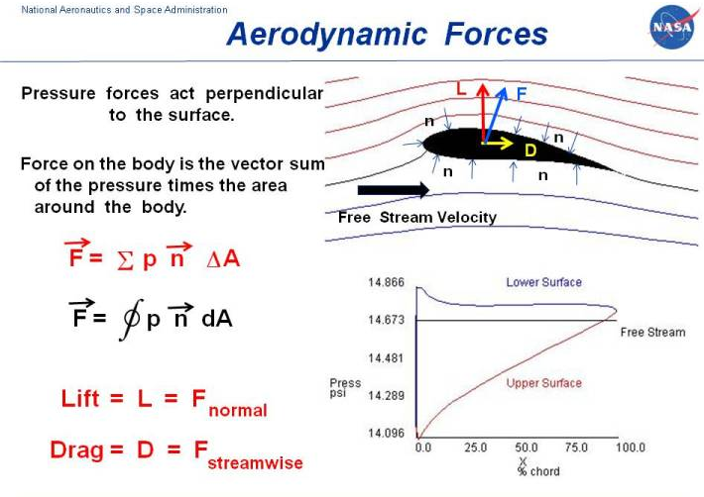
When two solid objects interact in a mechanical process, forces are transmitted, or applied, at the point of contact . But when a solid object interacts with a fluid, things are more difficult to describe because the fluid can change its shape. For a solid body immersed in a fluid, the "point of contact" is every point on the surface of the body. The fluid can flow around the body and maintain physical contact at all points. The transmission, or application, of mechanical forces between a solid body and a fluid occurs at every point on the surface of the body. And the transmission occurs through the fluid pressure.
The normal direction changes from the front of the airfoil to the rear and from the top to the bottom. We indicate this variation on the figure by several small arrows pointing perpendicular to the surface and labeled with an n. To obtain the net mechanical force over the entire solid object, we must sum the contributions from all the small sections. Mathematically, the summation is indicated by the Greek letter sigma () The net aerodynamic force F is equal to the sum of the product of the pressure p times the incremental area delta A in the normal direction n.
F = p * n * delta
An the limit of infinitely small sections, this gives the integral of the pressure times the area around the closed surface. Using the symbol S dA for integration, we have:
F = S (p * n) dA
where the integral is taken all around the body. On the figure, that is why the integral sign has a circle through it.
If the pressure on a closed surface is a constant, there is no net force produced because the summation of the directions of the normal adds up to zero. For every small section there is another small section whose normal points in exactly the opposite direction.
F = S (p * n) dA = p * S n dA = 0
For a fluid in motion, the velocity has different values at different locations around the body. The local pressure is related to the local velocity, so the pressure also varies around the closed surface and a net force is produced. On the figure at the lower right, we show the variation of the pressure around the airfoil as obtained by a solution of the Euler equations. The blue line shows the variation from front to back on the lower surface, while the red line shows the variation from front to back on the upper surface, The black line gives the reference free stream pressure. Summing the pressure perpendicular to the surface times the area around the body produces a net force.
F = S (p * n) dA
Summary
To summarize, for any object immersed in a fluid, the mechanical forces are transmitted at every point on the surface of the body. The forces are transmitted through the pressure, which acts perpendicular to the surface. The net force can be found by integrating (or summing) the pressure times the area around the entire surface. For a moving flow, the pressure will vary from point to point because the velocity varies from point to point. For some simple flow problems, we can determine the pressure distribution (and the net force) if we know the velocity distribution by using Bernoulli's equation.
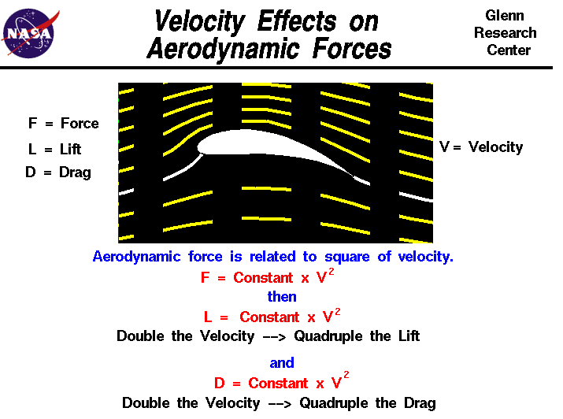

Lift is created by deflecting a flow of air and drag is generated on a body in a wide variety of ways. From Newton's second law of motion, the aerodynamic forces on the body (lift and drag) are directly related to the change in momentum of the fluid with time. The fluid momentum is equal to the mass times the velocity of the fluid. Since the air moves, defining the mass gets a little tricky and aerodynamicists usually relate the effect of mass on lift and drag to the air density. The mathematical derivation for this conversion is given on another slide dealing with momentum effects on lift. As a result of this derivation, we find that lift and drag depend on the square of the velocity.
The velocity used in the lift and drag equations is the relative velocity between an object and the flow. Since the aerodynamic force depends on the square of the velocity, doubling the velocity will quadruple the lift and Drag.

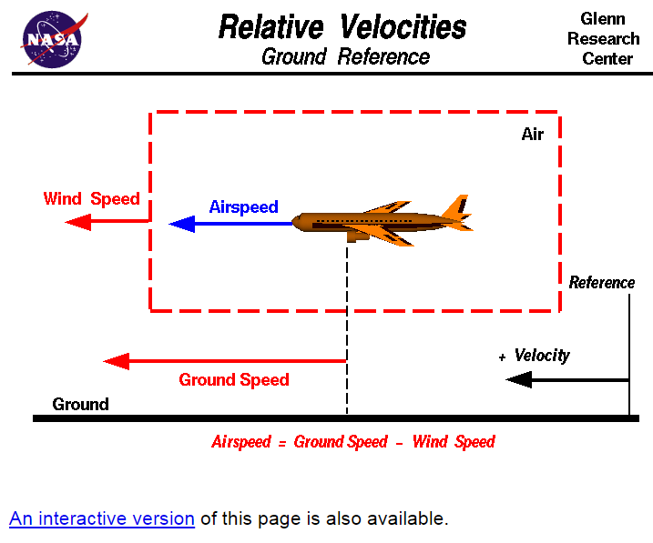

.
Thrust
To overcome drag, airplanes use a propulsion system to generate a force called thrust. The direction of the thrust force depends on how the engines are attached to the aircraft. In the figure shown above, two turbine engines are located under the wings, parallel to the body, with thrust acting along the body centerline. On some aircraft, such as the Harrier, the thrust direction can be varied to help the airplane take off in a very short distance. The magnitude of the thrust depends on many factors associated with the propulsion system including the type of engine, the number of engines, and the throttle setting.
For jet engines, it is often confusing to remember that aircraft thrust is a reaction to the hot gas rushing out of the nozzle. The hot gas goes out the back, but the thrust pushes towards the front. Action <--> reaction is explained by Newton's Third Law of Motion.
The motion of the airplane through the air depends on the relative strength and direction of the forces shown above. If the forces are balanced, the aircraft cruises at constant velocity. If the forces are unbalanced, the aircraft accelerates in the direction of the largest force.
Note that the job of the engine is just to overcome the drag of the airplane, not to lift the airplane. A 1 million pound airliner has 4 engines that produce a grand total of 200,000 of thrust. The wings are doing the lifting, not the engines. In fact, there are some aircraft, called gliders that have no engines at all, but fly just fine. Some external source of power has to be applied to initiate the motion necessary for the wings to produce lift. But during flight, the weight is opposed by both lift and drag. Paper airplanes are the most obvious example, but there are many kinds of gliders. Some gliders are piloted and are towed aloft by a powered aircraft, then cut free to glide for long distances before landing. During reentry and landing, the Space Shuttle is a glider; the rocket engines are used only to loft the Shuttle into space.

مقدمة:
تعتبر ظاهرة انكسار الرياح (او كما تعرف أيضا بالرياح القصية) احدى الظواهر الجوية المؤثرة في حركة و سلامة الطيران ،فقد سجلت سجلات حوادث الطيران أحداث حصلت و كان المتهم الرئيسي فيها هي هذه الظاهرة.
بعض التعاريف
انكسار الرياح (الرياح القصية) Wind Shear
هو تغير في اتجاه الرياح الموجهة على مسار الرحلة من خلال نمط،شدة و مدة لتزيح الطائرة بشكل مفاجئ يستلزم معه رد فعل كبيرة .
Variation in vector wind along the flight path of a pattern, intensity and duration to displace the aircraft abruptly necessitating substantial control action.
الرياح القصية المنخفضة الارتفاع Low Altitude Wind Shear
هي رياح قصية على مسار الاقتراب النهائي أو على المدرج أو على مسار الاقلاع و الصعود الأولي.
Wind Shear along the final approach path or along the runway and along the take-off and initial climb-out paths.
الرياح القصية العامودية Vertical Wind Shear
هو التغيير في الرياح الموجهة الأفقية مع الارتفاع ،على الاساس الذي يمكن قياسها باستخدام جهازين أو أكثر سرعة الرياح على السارية
The change of the horizontal wind vector with height, as might be determined by two or more anemometers at different heights on a mast.
الرياح القصية الأفقية Horizontal Wind Shear
التغيير في الرياح الموجهة الأفقية مع المسافة الأفقية ،على الأساس الذي يمكن قياسها باستخدام جهازين أو اكثر لسرعة الرياح مثبتين على نفس الارتفاع على المدرج.
The change of the horizontal wind vector with horizontal distance, as might be determined by two or more anemometers mounted at the same height along the runway
إذا أي تكمن الخطورة و إلى أي درجة هي الخطورة:
الخطورة الكبرى تكمن في الحالات التي تكون بها الطائرة على ارتفاعات منخفضة ،حيث (و كما يوضح التعريف) يكون التأثير قوي و عنيف مما يستلزم معه رد فعل سريعة على أجهزة التحكم لصد هذه المشكلة ،لذا فالرياح القصية تتمتع بديناميكية عالية قد يسبب عدم الارتياح و الخوف بشكل كبير .يمكن للرياح القصية أن تؤثر بشكل مفاجئ و مدمر يصل إلى مدى لا يمكن لأكثر الطيارين احترافا بمساعدة أحدث الطائرات و أقواها الخروج منها ،و بناء على ذلك فإن أول وسيلة للدفاع و أهمها هي الوقاية .

.

the greater the flow turning, the greater the lift generated by an airfoil.

Lift and Lift Coefficient
The aircraft generates lift by moving quickly through the air. The wings of the vehicle have aerofoil shaped cross-sections. For a given flow speed with the aerofoil set at an angle of attack to the oncoming airstream, a pressure difference between upper and lower wing surfaces will be created. There will be a high pressure region underneath and a very low pressure region on top. The difference in these pressure forces creates lift on the wing. The lift produced will be proportional to the size of the aircaft; the square of its velocity; the density of the surrounding air and the angle of attack of the wing to on-coming flow.
To simplify the problem, lift is typically measured as a non-dimensional coefficient.

