dinoflagellata toxicity
Dinoflagellate
Dinoflagellate, (division Dinoflagellata), any of numerous one-celled aquatic organisms and having characteristics of both plants and animals. Most are marine, though some live in freshwater habitats. The group is an important component of phytoplankton in all but the colder seas and is an important link in the food chain.
The principal Characteristics of the Dinoflagellate
1- Microscopic ,unicellular organisms.
2-The name "dinoflagellate" refers to the forward- spiraling swimming motion of these organisms.
3-Transverse and longitudinal flagella ;-transverse flagellum is flat and encircles the body ,works as a propelling device .-Longitudinal flagellum is perpendicular to the transverse and is responsible for swimming works as a rudder .- Beating flagellum produce a forward ,spiraling motion
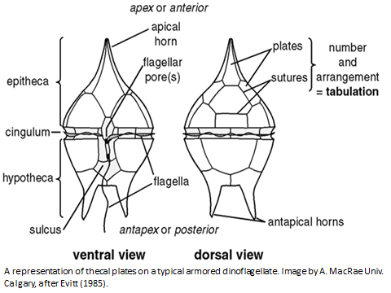

4-photosynthetic species possess green pigments, Chlorophylls a and c, and golden brown pigments, including peridinin.
5-Dinoflagellates primarily exhibit asexual cell division, some species reproduce sexually.
6- Nutrition among dinoflagellates is autotrophic, heterotrophic, or mixed; some species are parasitic or commensal. About one-half of the species are photosynthetic.
7-Storage food both starch grains, and lipids.
8-Dinoflagellates exhibit a wide variety in morphology and size (5 to 2,000 micrometres ) but some form visible colonies. They commonly have a cell covering structure (theca) that differentiates them from other algal groups.
9- Cells are either armored or unarmored. Armored species have thecae divided into plates composed of cellulose or polysaccharides which are key features used in their identification. The cell covering of unarmored species is comprised of a membrane complex. The theca can be smooth and simple or laced with spines, pores and/or grooves and can be highly ornamented
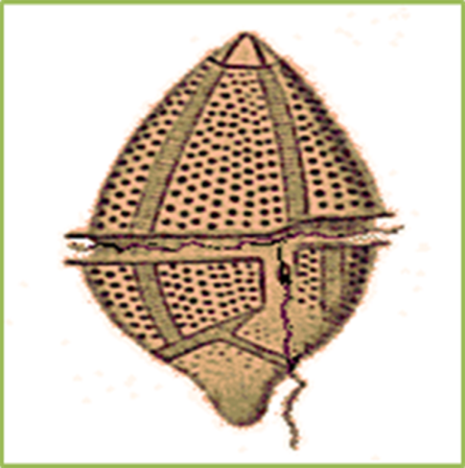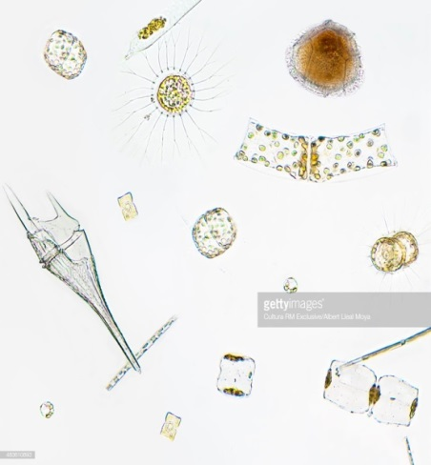

10- Most dinoflagellates have dinokaryon nucleus in which the chromosomes are attached to the nuclear membrane. These lack histones and remain condensed throughout inter phase.
11- Under certain conditions, several species can reproduce rapidly to form water blooms or red tides that discolour the water and may poison fish and other animals.
12-Dinoflagellates also produce some of the bioluminescence sometimes seen in the sea
The taxonomy of the group is contentious. Historically, botanists have placed them in the algal division Pyrrophyta or Pyrrophycophyta, and zoologists have claimed them as members of the protozoan order Dinoflagellida. Although they are often considered to be algae in the division Dinoflagellata, this placement is controversial because these organisms have unique nuclei and significantly larger genomes than other eukaryotic algae.
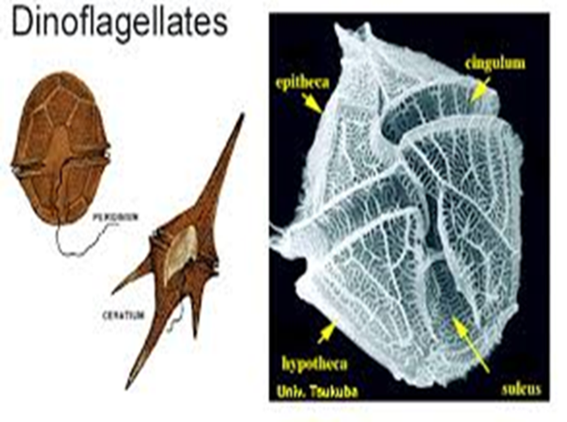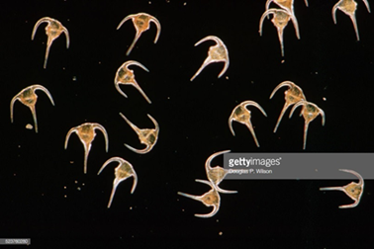
Dinoflagellate Plankton, Ceratium tripos
Although sexual processes have been demonstrated in a few genera, reproduction is largely by binary or multiple fission. Under favourable conditions, dinoflagellate populations may reach 60 million organisms per litre of water.For additional information on specific dinoflagellate genera, Ceratium, Gonyaulax, Gymnodinium, Noctiluca, and Peridinium.
Gymnodinium, genus of marine or freshwater dinoflagellates. are bilaterally symmetrical with pellicle (or envelope) and disk-shaped Chromatophores, when present, contain yellow, brown, green, or blue pigments. The genus is claimed by both botanists and zoologists, for, like all dinoflagellates, it has both plant-like and animal-like species. Some species are photosynthetic; others require solid food.
Dinoflagellate Bioluminescence
Marine dinoflagellates at night can emit blue light by bioluminescence, a process also called “the phosphorescence of the seas”. Light production in these single celled organisms is produced by small structures in the cytoplasm called scintillons (about 0.5 µm in diameter) . Among bioluminescent organisms, only dinoflagellates have scintillons.
They contain dinoflagellate luciferase and luciferin, the main enzyme involved in dinoflagellate bioluminescence. The luminescence occurs as a brief (0.1 sec) , usually by mechanical disturbance. Therefore, when mechanically stimulated—by boat, swimming, or waves, for example—a blue sparkling light can be seen emanating from the sea surface.
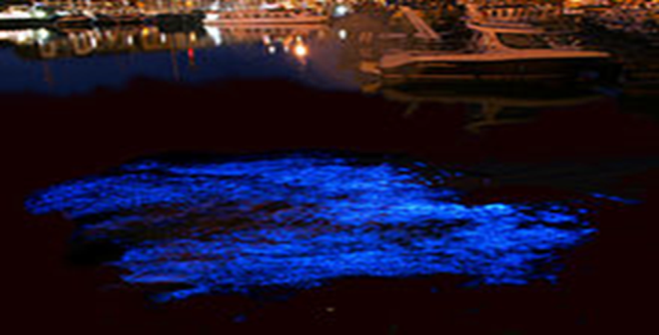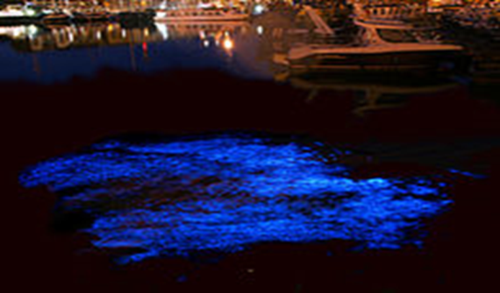

In the dinoflagellates, the biochemical reaction that produces light involves a luciferase-catalysed oxidation of a linear tetrapyrrole called luciferin. The dinoflagellate Lingulodinium polyedra (previously called Gonyaulax polyedra) also contains a second protein called luciferin binding protein (LBP). Luciferin is released from LBP by a decrease in pH, and the same decreased pH also activates the luciferase. light production in the dinoflagellates occurs in bioluminescent organelles called scintillons .
Dinoflagellates can use bioluminescence as a defense mechanism. They can startle their predators by their flashing light or they can ward off potential predators by an indirect effect such as the "burglar alarm". The bioluminescence attracts attention to the dinoflagellate and its attacker, making the predator more vulnerable to predation from higher trophic levels.
Poison produced by dinoflagellta
Red Tide poisoning is a result of toxins released from marine dinoflagellates and received its name from the discolored (reddish) water created by an algal bloom. It appears this event has occurred for centuries in many locations even before the occurrence of pollution, agricultural run-off and current observations of global warming.
Before 1987, the group of toxin-producing phytoplankton of concern to human health included mostly dinoflagellates; different species of these flagellated cells produce toxins causing paralytic shellfish poisoning (PSP; saxitoxins), diarrhetic shellfish poisoning (DSP; okadaic acid and dinophysis toxins), neurotoxic shellfish poisoning (NSP; brevetoxins) and ciguatera fish poisoning (CFP; ciguatoxin).
The most common dinoflagellate responsible for the Red Tide is Karenia brevis (Gymnodinium breve); although, there are a number of other species of algae (e.g., Karenia papillonacea, Chattonella species, Noctiluca scintillans) having been reported to produce toxins. Some colorless dinoflagellates may also form toxic blooms, such as Pfiesteria piscicida . Some dinoflagellate blooms are not dangerous. The most dramatic effect of dinoflagellates on their environment occurs in coastal waters during the warmer season, usually mid to late summer.
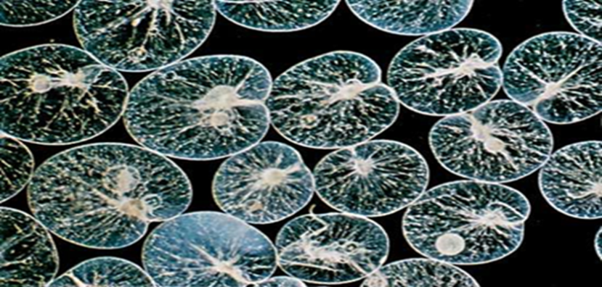
A species of dinoflagellate known as Noctiluca scintillans
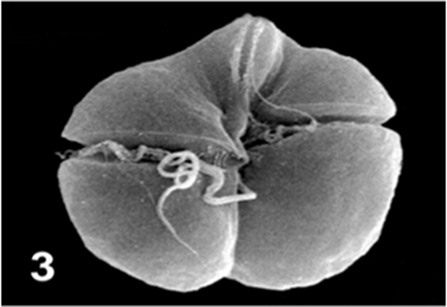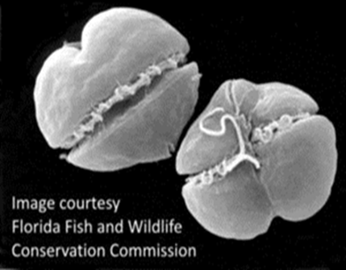
A species of dinoflagellate known as Karenia brevis
Besides these well-known poisonings, several new poisoning syndromes resulting from newly appearing dinoflagellate toxins, such as azaspiracid toxins, yessotoxin and palytoxin have been reported and characterized recently (Table )
Seafood poisonings caused by neurotoxins identified from marine dinoflagellate species
Type of poisoning | Toxins | Sources of toxins | Primary vector | Action target
PSP | Saxitoxins and gonyautoxins | Alexandrium spp., Gymnodinium spp., Pyrodinium spp. | Shellfish | Voltage-gated sodium channel
NSP | Brevetoxins | Kerenia brevis, Chatonella marina, C. antiqua, Fibrocapsa japonica, Heterosigma akashiwo | Shellfish | Voltage-gated sodium channel
CFP | Ciguatoxins | Gambierdiscus toxicus | Coral reef fish | Voltage-gated sodium channel
CFP | Maitotoxins | Gambierdiscus toxicus | Coral reef fish | Voltage-gated calcium channel
AZP | Azaspiracids | Protoperidinium crassipes | Shellfish | Voltage-gated calcium channel
Palytoxin poisoning | Palytoxins | Ostrepsis siamensis | Shellfish | Na+-K+ ATPase
Notes: PSP, paralytic shellfish poisoning; NSP, neurotoxic shellfish poisoning; CFP, ciguatera fish poisoning, AZP, azaspiracid poisoning
Fundamentally, these toxins result in three different types of events (a) fish kills (harm to wildlife), (b) toxicity from ingestion of an organism accumulating the toxin and (c) inhalation toxicity.
In some species these blooms are associated with the production of neurotoxins, poisons which injure the nerves of marine life that feed on the dinoflagellates. The result may be massive kills of fish and shellfish, as well as other forms of marine life. If animals containing these toxins are eaten by humans, the result may be illness or even death.
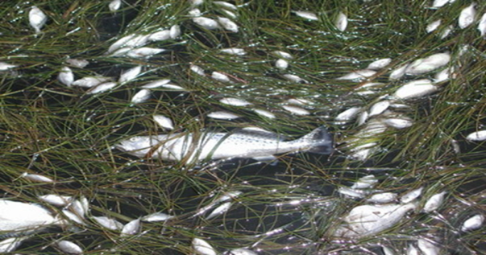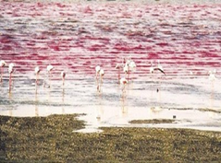
The neurotoxins affect muscle function, preventing normal transmission of electrochemical messages from the nerves to the muscles by interfering with the movement of sodium ions through the cellular membranes. Humans may be poisoned by eating fish, a condition known as ciguatera, or by eating shellfish, such as clams or mussels, and is then called paralytic shellfish poisoning, or PSP. The resulting condition is serious but is not usually fatal. Lethal concentrations lead to death from respiratory failure and cardiac arrest within twelve hours of consumption.
A second form of toxin, is a Brevetoxins produced naturally by a species of dinoflagellate ,found in the dinoflagellate belonging to the genus Karenia . Brevitoxin are a suite of cyclic polyether compounds and tasteless, lipid soluble, and both heat and acid stable , The toxins accumulate in filter-feeding such as clams, krill, and consumption of brevetoxin-contaminated shellfish is the major source of serious exposures to humans.

