Three main groups infect the blood and/or tissues of humans and animals causing severe clinical diseases:
1- Salivarian trypanosomes which undergo anterior station (foregut) development in the insect vector and are transmitted via saliva to the blood of vertebrate hosts (e.g. tsetse flies transmit T. brucei which causes sleeping sickness in humans and nagana in cattle)
2- Stercorarian trypanosomes which undergo posterior station (hindgut) development in vectors and are transmitted via faecal contamination of bite site to infect blood and tissues of vertebrate hosts (e.g. reduviid bugs transmit T. cruzi which causes Chagas’ disease in humans)
3- leishmanias which develop in the foregut of insect vectors and are transmitted via the bite to the tissues of vertebrate hosts (e.g. sandflies transmit Leishmania spp. causing 3 types of leishmaniasis in humans and animals).
Classification
Protista (unicellular eukaryotes)
Mastigophora (flagellates)
Zoomastigophora (zooflagellates, without chloroplasts)
Kinetoplastida (presence of extranuclear DNA, kinetoplast)

Class Flagellates
Subclass Kinetoplastida
Family Trypanosomatidae
Trypanosomes are hemoflagellates, live in the blood and tissues of their human hosts.
Genus Trypanosoma cruzi
Chagas’ Disease (Trypanosoma cruzi, American Trypanosomiasis) it is a zoonosis disease was discovered in the intestine of a triatomid bug in Brazil in 1909 by Carlos Chagas, who described the entire life cycle in reservoir hosts, transmitted by reduviid bugs living in close association with human reservoirs (dogs, cats, raccoons, and rodents) through blood meals. A significant reduction in transmission was noted in houses with walls made of plaster where cracks and crevices were covered, in contrast to houses with mud or thatch walls. Human infections occur mainly in rural areas where poor sanitary and socioeconomic conditions and poor housing provide excellent breeding places for reduviid bugs. These conditions allow maximum contact between the vector and humans.
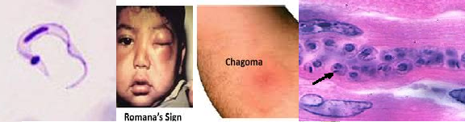

Life Cycle:
The disease is transmitted to humans through the bite wound caused by reduviid bugs (triatomids, -kissing bugs). Humans are infected when metacyclic trypomastigotes are released with the feces (it named posterior station) while the insect is taking a blood meal and the feces are scratched into the bite wound or onto mucosal surfaces such as eyes or mouth, an action stimulated by the allergic reaction to the insect’s saliva. The organisms can also be transmitted as congenital infections, by blood transfusion, or by organ transplantation and accidental ingestion of parasitized reduviid bugs. On entry into the body, the metacyclic forms invade local tissues, transform to the amastigote stage, and begin to multiply within the cells. The local inflammatory process continues, forming the primary lesion, the chagoma, which blocks the lymphatic capillaries and causes edema.
Clinical Features:
The clinical syndromes associated with Chagas’ disease can be broken down into acute, and chronic stages.
The acute stage is the result of the first encounter of the patient with the parasite, whereas the chronic phase is the result of late sequelae مضاعفات. In children younger than 5 years, the disease is seen in its severest form, whereas in older children and adults, the disease is milder and is commonly diagnosed in the subacute or chronic form rather than in the acute form. Overall, the incubation period in humans is about 7 to 14 days but is somewhat longer in some patients.
A localized inflammatory reaction at the infection site. An erythematous subcutaneous nodule (A chagoma is an inflammatory nodule at the bite site of the reduviid bug which transmits Chagas disease, not to be confused with Romana's sign which is periorbital soft tissue and lymphoid swelling which occurs when the T. cruzi protozoan that causes Chagas disease enters through the conjunctiva), seen most frequently on the face, the chagoma is painful and may take 2 to 3 months to subside. In early stages of infection, amastigotes or trypomastigotes may be aspirated from the chagoma; if the route of inoculation is the ocular mucosa, edema of the eyelids and conjunctivitis may occur (Romaña's sign is a medical term for the unilateral painless periorbital swelling associated with the acute stage of Chagas' disease.).
The infective stages spread to the regional lymph nodes, which become enlarged, hard, and tender. Similar chagoma lesions may develop in other body areas as the infection spreads hematogenously. Trypomastigotes appear in the blood about 10 days after infection and persist through the acute phase. These stages are rare or absent during the chronic phase.
Acute-Stage Acute systemic signs occur around week 2 to 3 of infection and are characterized by high fevers, which may be intermittent, remitting, or continuous; hepatosplenomegaly; myalgia; erythematous rash; acute myocarditis; lymphadenopathy; keratitis; and subcutaneous edema of the face, legs, and feet. There may be signs of CNS involvement including meningoencephalitis, which has a very poor prognosis. Myocarditis is manifested by electrocardiographic changes, tachycardia, chest pain, and weakness.
Chronic Stage it is demonstrates close interaction between the parasite and the host, causing a number of different clinical syndromes as cardiomyopathy, megacolon, and megaesophagus. Symptoms of the chronic stage are related to the damage during the acute stage of the disease, the state of the host’s immune system, and the inflammatory response. Other contributing factors include the host genetic background, environmental and social factors, the genetic composition of the parasite, mixed infections, and reinfections. Chronic Chagas’ disease may develop years or decades after undetected infection or after the diagnosis of acute disease. The most frequent clinical sign of chronic Chagas’ disease is cardiomyopathy manifested by cardiomegaly and conduction changes.
Laboratory Diagnosis:
Trypomastigote stages may be easily detected in the blood in young children; however, in chronic disease, this stage is rare or absent except during febrile exacerbations.
- Trypomastigotes may be detected in blood by using thin and thick blood films or by buffy coat concentration techniques.
- PCR
- Serologic tests by Immunoassays have been used to detect antigens in the urine and sera of patients with congenital infections and those with chronic Chagas’ disease, or by ELISA , complement fixation (Guerreiro-Machado test), indirect fluorescent-antibody tests, indirect hemagglutination tests to detect antibodies.
Control:
In endemic areas improved housing and spraying insecticide inside housing to eliminate triatomine bugs has significantly decreased the spread of Chagas disease. Further, screening of blood donations for Chagas is another important public health tool in helping to prevent transfusion-acquired disease. Early detection and treatment of new cases, including mother-to-baby (congenital) cases, will also help reduce the burden of disease and control strategies are focused on preventing transmission from blood transfusion, organ transplantation, and mother-to-baby.
African Sleeping Sickness (Trypanosoma brucei ssp., African Trypanosomiasis)
Organism:
Trypanosomes are hemoflagellates, which are transmitted by tsetse flies (Glossina spp.) to a wide range of mammalian hosts. They cause serious medical problems for humans and livestock. It is live in the blood and tissues of their human hosts. The African trypanosomes belong to the subgenus Trypanozoon and as a group are referred to as the Trypanosoma brucei complex. T. brucei brucei strains are parasites of domestic and wild animals and are not known to be infectious for humans. Human infections are caused by T. brucei gambiense (West African trypanosomiasis) and T. brucei rhodesiense (East African trypanosomiasis). Infections caused by T. brucei rhodesiense are much more fulminant than those caused by T. brucei gambiense, the parasitemia is much higher, and the disease has a much faster progression. It is not possible to differentiate the three trypomastigotes species on the basis of morphology, and all three organisms can be recovered in animal reservoir hosts.
The trypanosomal (trypomastigote) forms can be found in the blood, cerebrospinal fluid (CSF), lymph node aspirates, and fluid aspirated from the trypanosomal chancre (if one forms at the site of the tsetse fly bite). The trypomastigote forms multiply by longitudinal binary fission. The organism is highly pleomorphic, having a variety of trypanosomal forms in the same blood smear. The forms range from long, slender-bodied organisms with a long flagellum (trypomastigote) that attain a length of 30 µm or more to short, fat, stumpy forms without a free flagellum that are approximately 15 µm long. The short, stumpy forms do not divide in the bloodstream but are the infective stage for the tsetse fly.
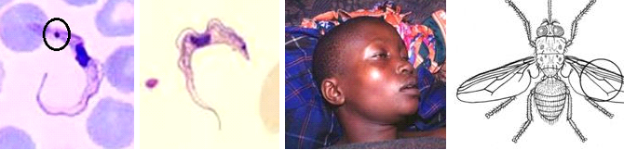
Life Cycle:
Trypanosomal forms are ingested by the tsetse fly (Glossina spp.) when a blood meal is taken, stumpy trypomastigote reaches the midgut of the tsetse fly, it transforms into a long, slender procyclic stage (it named anterior station transmission) and multiply in the lumen of the midgut and hindgut of the fly. After 2 weeks, the organisms migrate back to salivary glands through the hypopharynx and salivary ducts, where the organisms attach to the epithelial cells of the salivary ducts and then transform to their epimastigote forms. There is continued multiplication within the salivary gland, and metacyclic (infective) forms develop from the epimastigotes in 2 to 5 days. During the act of feeding, the fly introduces the metacyclic trypanosomal forms into the next victim in saliva injected into the puncture wound. The entire developmental cycle in the fly takes about 3 weeks, and once infected, the tsetse fly remains infected for life.
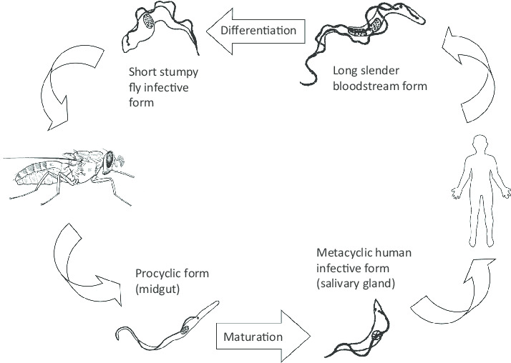

Antigenic Variation:
A unique feature of African trypanosomes is their ability to change the surface coat of the outer membrane of the trypomastigote form variant surface glycoprotein (VSG) (antigenic variation), helping to evade the host immune response. There are approximately 100 to 1,000 genes encoding as many as 1,000 different VSGs. More than 100 serotypes have been detected in a single infection. During antigenic switching, the shed VSG is most responsible for the immune dysfunctions noticed during infections. There are a(very high levels of IgM) why.
Epidemiology:
T. brucei gambiense is transmitted from person to person by the bite of the tsetse fly (G. palpalis) after infectivity develops within the insect. The development cycle in the fly, depending on temperature and moisture, in averages 20 days. G. palpalis can be found in areas of thick trees near the banks of rivers, streams, or water holes; therefore, transmission readily occurs when people frequent these areas. Both female and male tsetse flies can transmit the infection. In addition to biological transmission, the tsetse fly may mechanically transmit the infection with its proboscis if it bites an uninfected person within a few hours of biting an infected person. Congenital transmission in humans has also been documented.
Clinical Features:
In general, African trypanosomiasis caused by T. brucei gambiense (West African sleeping sickness) has a long, mild, chronic course that ends fatally with central nervous system (CNS) involvement after several years’ duration. This is unlike the disease caused by T. brucei rhodesiense (East African sleeping sickness), which has a short course and ends fatally within a year.
Stage I. After the host has been bitten by an infected tsetse fly, metacyclic trypomastigote stages are introduced into the skin, where they multiply and set up a local inflammatory reaction. A nodule or chancre at the site (3 to 4 cm) may develop after a few days. However, this primary lesion will resolve spontaneously within 1 to 2 weeks.
Stage II. Once trypomastigotes invade the CNS, the sleeping sickness stage of the infection is initiated (stage II disease). The trypomastigotes are found primarily in the frontal lobes, pons, and medulla. Behavioral and personality changes are seen during CNS invasion. Gambian trypanosomiasis is characterized by steady progressive meningoencephalitis, apathy, confusion, fatigue, coordination loss, and sleepiness. In the terminal phase of the disease, the patient becomes weakly and progresses to profound coma and death, usually from secondary infection.
Laboratory Diagnosis:
1- Physical findings and clinical history are very important in establishing the diagnosis, through symptoms which include irregular fever, enlargement of the lymph nodes (particularly those of the posterior triangle of the neck [Winterbottom’s sign is seen in the early phase of African trypanosomiasis, which is more commonly known as African sleeping sickness.]), delayed sensation to pain (Kerandel’s sign delayed sensation to pain indicative of African trypanosomiasis), and erythematous skin rashes.
2- Trypomastigotes may be detected in fluid aspirated from the ulcer or from the enlarged lymph nodes and by thick blood film examinations, multiple slides should be made for examination, and multiple blood examinations should be done, the spleen and liver become enlarged.
3- A simple and rapid test by detection of circulating antigens. The test is normally performed on a drop of freshly collected heparinized blood and is followed by a more specific confirmation test on diluted blood, plasma, or serum. 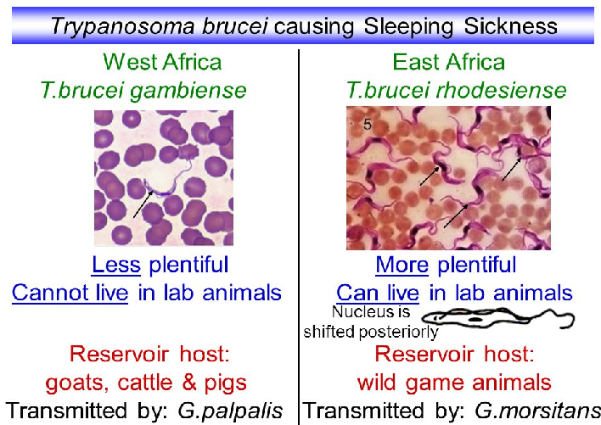
Control:
There is no vaccine or drug; preventive measures are aimed at minimizing contact with tsetse flies. The helpful measures include:
- In endemic should avoid tsetse fly bites by wearing protective clothing.
- Use of insect repellents, bed netting, and screens, are recommended.
- Reducing the disease reservoir and controlling the tsetse fly vector.

Trichomonas vaginalis
Organism Description:
Trophozoite: The trophozoite is pear-shaped, has a jerky, rapid motility; the undulating membrane extends half the length of the trophozoite with no free posterior flagellum; the axostyle is seen to protrude through the bottom of the organism
The trophozoite (usual size, 7-23 µm long and 5-15 µm wide) can be found in clinical specimens such as urine, urethral discharge, and vaginal smears.
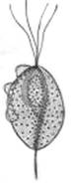 | 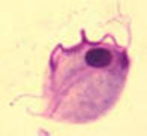 | 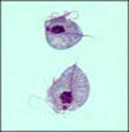
Life Cycle:
Urinary-genital system; no known cyst form.
Acquired: it is acquired to be by sexual transmission or rarely contaminated towels, underpants, etc. Humans are the only natural host for T. vaginalis, and normal body sites for these organisms include the vagina and prostate.
Clinical Features:
T. vaginalis is site specific and usually cannot survive outside the urogenital system, the organisms feed on the mucosal surface of the vagina, where bacteria and leukocytes are found, it preferred pH for good growth in females is slightly alkaline or acidic (6.0 to 6.3 optimal), not the normal pH of the healthy vagina.
The incubation period is not well-defined, in vitro studies provide a range of 4 to 28 days. After introduction, proliferation begins, with resulting inflammation and large numbers of trophozoites in the tissues and the secretions. As the infection becomes more chronic, the purulent discharge diminishes, with a decrease in the number of organisms. The onset of symptoms such as vaginal or vulval pruritus and discharge is often sudden and occurs during or after menstruation as a result of the increased vaginal acidity. In acute infections, diffuse vulvitis is seen and is due to copious leukorrhea. The discharge is frothy, yellow or green, and mucopurulent; however, only about 10 to 12% of women exhibit this frothy discharge. Small punctate hemorrhagic spots can be seen on the vaginal and cervical mucosa; this has been called a "strawberry appearance" and is seen in about 2% of patients. In general, symptoms include vaginal discharge,odor, and edema or erythema. Other complaints include dysuria and lower abdominal pain.
In chronic infections, symptoms may be very mild with pruritus and some pain during sexual intercourse, while the vaginal secretion may be scanty and mixed with mucus. Individuals with these symptoms are the major source of transmission. From 25 to 50% of infected women may be asymptomatic and have a normal vaginal pH of 3.8 to 4.2 and normal vaginal flora. Although there is a carrier form, about 50% of these women will develop clinical symptoms during the following six months.T. vaginalis may also cause neonatal pneumonia.

Clinical Specimen:
Urogenital System: Vaginal and urethral discharges, prostatic secretions. Since the morphology of nonpathogenic P. hominis from stool samples is very similar to that of pathogenic T. vaginalis, it is important to ensure that the specimen is not contaminated with fecal material.
Laboratory Diagnosis:
Urogenital System: Diagnosis is based on the recovery of the organisms from the appropriate clinical specimen. Wet mounts, stained smears, culture, and antigen detection are available. Recombinant DNA techniques are becoming more widely available.
Control:
Infection is acquired primarily through sexual intercourse, hence the need to diagnose and treat asymptomatic males. The organism can survive for some time in a moist environment such as damp towels and underclothes; however, this mode of transmission is thought to be very rare. Evidence continues to accumulate implicating T. vaginalis as a potential contributor to poor outcomes in both women and men. In women, this infection may play a role in development of cervical neoplasia, postoperative infections, and potential problems with pregnancy. It is also seen as a factor in atypical pelvic inflammatory disease and infertility. In men, trichomoniasis causes nongonoccocal urethritis and contributes to male infertility.
T. vaginalis does not produce long-term immunity. Although the antibody response to this organism is well documented, the antibodies provide only limited protection, and antibody titers disappear after therapy. Vaccine development has shown some promise; potential targets include a 100-k-Da protein that is immunogenic across a number of T. vaginalis isolates; and essential adherence molecules such as adhesins, mucinases, and cysteine proteinases.

Phylum Apicomplexa
Sub phylum sporozoa
They are unicellular, spore-forming; the spores are simple and have no polar filaments. There is a single type of nucleus.
NOTE:
Apicomplexa and Sporozoa are considered synonymous, but Sporozoa has the infective stage called (sporozoite) while Apicomplexa is a specialized complex of organelles at the apex of the cell which facilitates penetration of a host cell during its infective stage.
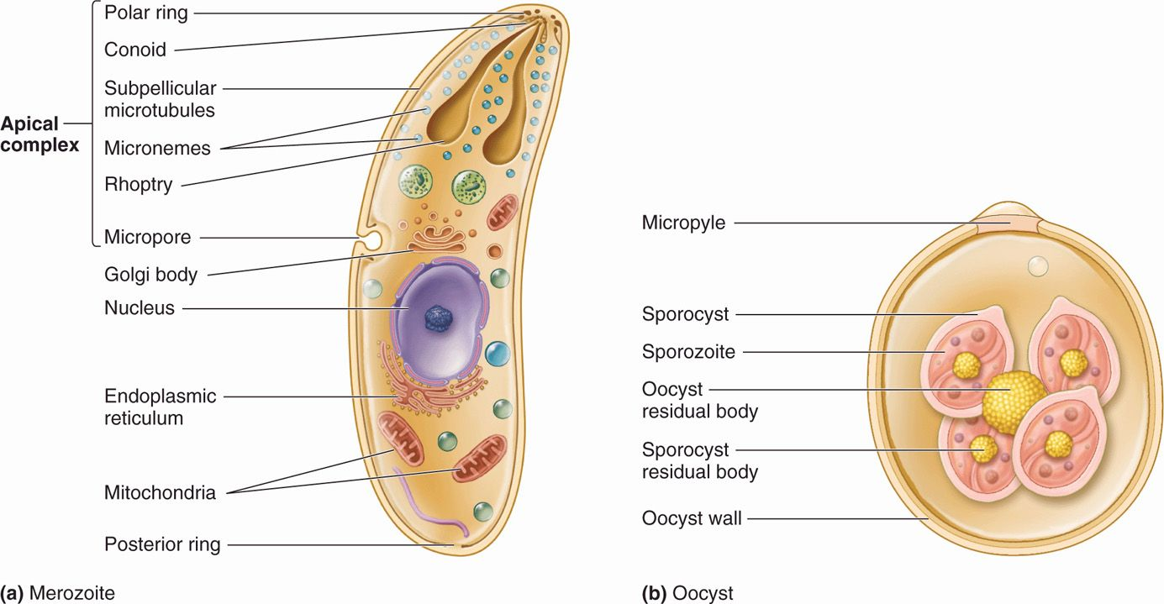

A defining characteristic a group of organelles found at one end--called the apical end--of the organism. This 'apical complex' includes secretory organelles known as micronemes and rhoptries, polar rings composed of microtubules, of the infective stages that allow the parasites to enter cells. The life cycle is characterized by an alternation of generations, sexual (gametogony) and asexual (schizogony) reproduction and most members of the group also share alternative hosts which including tow type of hosts: vertebrates (including humans) and invertebrate hosts.
Schizogony is a process of nuclear replication, during which the full complement of nuclei is first formed and then the daughter cells are formed one at a time through membrane formation around the nuclei.
There are 4 general components to apicomplexan development:
- Sporogony: the product of a large number of sporozoites
- Merogony: production of merozoites
- Gamogany: formation of gametes
- Syngamy: fertilization of gametes to produce a zygote
The sporont, meront, and gamont multiply asexually by schizogony.

  - Blood & Tissue sporozoa infection
Class Coccidia
- Order Eimeriida
family Toxoplasmatidae
Genus: Toxoplasma
Toxoplasma gondii: A single-celled parasite that causes toxoplasmosis, it is an intracellular, has very low host specificity, and will infect almost any mammal, and most nucleated cell types within a given tissue. Felines are the only known definitive hosts, many mammals serve as intermediate hosts, and causes toxoplasmosis.
Life Cycle: includes two phases called the intestinal (or enteroepithelial ) and extraintestinal phases.
The only known definitive hosts for Toxoplasma gondii are members of family Felidae (domestic cats and their relatives). Unsporulated oocysts are shed in the cat’s feces. Although oocysts are usually only shed for 1-2 weeks. Oocysts take 1-5 days to sporulate in the environment and become infective. Intermediate hosts in nature (including birds and rodents) and human become infected after ingesting soil, water or plant material contaminated with oocysts. Oocysts transform into tachyzoites shortly after ingestion. These tachyzoites localize in neural and muscle tissue and develop into tissue cyst bradyzoites . Cats become infected after consuming intermediate hosts harboring tissue cysts. Cats may also become infected directly by ingestion of sporulated oocysts. The parasite enters macrophages in the intestinal lining and is distributed via the blood stream throughout the body.
In the human host, the parasites form tissue cysts, most commonly in skeletal muscle, myocardium, brain, and eyes; these cysts may remain throughout the life of the host.
Both the tachyzoites (crescent shaped, 2-3 µm wide by 4-8 µm long) and cyst forms containing the bradyzoites (may contain few to hundreds of organisms, may reach 100 µm long and 7-10 µm wide) can be found in clinical specimens.
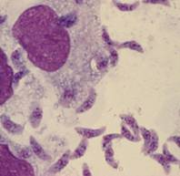 | 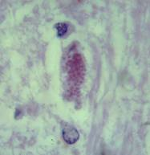 | 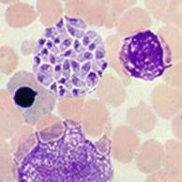

Tachyzoites | Bradyzoites | Tachyzoites in Bone Marrow
Symptoms
In most humans infected with Toxoplasma, the disease is asymptomatic. However, under some conditions, toxoplasmosis can cause serious pathology, including hepatitis, pneumonia, blindness, and severe neurological disorders.
Infection has two stages:
Acute toxoplasmosis during acute toxoplasmosis, symptoms are often influenza-like: swollen lymph nodes, or muscle aches and pains that last for a month or more. Rarely, a patient with a fully functioning immune system may develop eye damage or nasal lesions from toxoplasmosis. Only a small percentage of infected newborn babies have serious eye and brain damage or nasal malformations at birth.
Latent toxoplasmosis most patients who become infected with Toxoplasma gondii and develop toxoplasmosis do not know it. In most immunocompetent patients, the infection enters a latent phase, during which only bradyzoites are present, forming cysts in nervous and muscle tissue. Most infants who are infected while in the womb have no symptoms at birth but may develop symptoms later in life.
Transmission
Humans can become infected by any of several routes:
- Eating undercooked meat of animals harboring tissue cysts.
- Consuming food or water contaminated with cat feces or by contaminated environmental samples, such as fecal-contaminated soil.
- Blood transfusion or organ transplantation.
- Transplacentally from mother to fetus.
Diagnosis Detection of Toxoplasma gondii in human blood samples may be achieved by using the polymerase chain reaction (PCR), serology, biopsy of brain, blood smear.

Protection
- Health education.
- Adequately cooking meat before consumption at temperatures of at least 150 degrees F.
- Avoiding handling raw meat with ungloved hands.
- Avoiding accidental ingestion of oocysts from infected house cats by directly handling litter trays or soil that may be contaminated with cat feces, especially by the pregnant women.
- Cats that are fed commercial cat food are less likely to get infected than cats that hunt.
Laboratory Diagnosis:
Serologies; can also use PCR, biopsy specimens, buffy coat cells, CSF fluid, or isolation in tissue culture.

Order Haemospora:

Genus: Plasmodium
The most pathogenic parasites of man cause malaria which is characterized by intermittent fever associated with chills and rigors in the patient. There may be enlargement of the liver and spleen in the patient. Plasmodium are pigment producing amoeboid parasites of vertebrates. They live in red blood cells and hepatocytes. Transmission of parasite occurs through the bite of infected female anopheles mosquito.
Human malaria parasites have 5 species;
Plasmodium falciparum is responsible for the majority of malaria deaths globally. The remaining species are not typically as life-threatening as P. falciparum.
Plasmodium vivax is the second most significant species in Southeast Asia and Latin America. P. vivax and Plasmodium ovale have the added complication of a dormant liver stage, which can be reactivated in the absence of a mosquito bite, leading to clinical symptoms.
P. ovale and Plasmodium malariae represent only a small percentage of infections.
A fifth species Plasmodium knowlesi– a species that infects primates – has led to human malaria, but the exact mode of transmission remains unclear.
Life cycle
The malaria parasite life cycle involves two hosts. During a blood meal, a malaria-infected female Anopheles mosquito inoculates sporozoites into the human host.
- exoerythrocytic schizogony stage Liver Stage:-
Sporozoites infect liver cells and mature into schizonts, which rupture and release merozoites.
(Note, in P. vivax and P. ovale a dormant stage [hypnozoites] can persist in the liver and cause relapses by invading the bloodstream weeks, or even years later.) After this initial replication in the liver (exo-erythrocytic schizogony ), the parasites undergo asexual multiplication in the erythrocytes (erythrocytic schizogony ). Merozoites infect red blood cells . The ring stage trophozoites mature into schizonts, which rupture releasing merozoites. Merozoites continue to burst from RBCs and infect new RBCs in a periodic cycle of 48-72 hours depending on the species.
- Erythrocytic Cycle
Merozoites have two proteins at their apical pole (PvRBP-1 and PvRBP-2). The parasite uses the Duffy blood group antigens (Fya and Fyb) as receptors to penetrate red blood cells.
The parasitised red blood cell is up to twice as large as a normal red cell and granules is seen on the infected cell's surface, the spotted appearance of which varies in color from light pink, to red, to red-yellow, as coloured with Romanovsky stains. The parasite within it is often wildly irregular in shape (described as "amoeboid"). It is rare to see cells with more than one parasite within them.
Some parasites differentiate into sexual erythrocytic stages (gametocytes) . Blood stage parasites are responsible for the clinical manifestations of the disease.
The gametocytes, male (microgametocytes) and female (macrogametocytes) are ingested by an Anopheles mosquito during a blood meal.
  - Transfer to mosquito
  - Gametogenesis: a)Microgametes , b) Macrogametes
III) Fertilization IV) Ookinite V) Oocyst VI) Sporogony
The parasites’ multiplication in the mosquito is known as the sporogonic cycle. While in the mosquito’s stomach, the microgametes penetrate the macrogametes generating zygotes. The zygotes in turn become motile and elongated (ookinetes) which invade the midgut wall of the mosquito where they develop into oocysts. The oocysts grow, rupture, and release sporozoites, which make their way to the mosquito’s salivary glands. Inoculation of the sporozoites into a new human host perpetuates the malaria life cycle.
Symptoms/Pathology and immunology
Infection with Plasmodium species leads to chracteristic fever and chills, often accompanied by headaches, muscle soreness, weakness, vomiting and diarrhea.
Other symptoms include an enlarged spleen, anemia, lung or kidney dysfunction and neurological problems.
Infection with Plasmodium falciparum is often the most severe and involves infection in the brain (cerebral malaria), kidney failure, and severe anemia that may lead to death. Infection with P. vivax often leads to complications of the spleen or spleen rupture.
A dormant stage of P. ovale and P. vivax may remain in the liver for weeks or years after the intial infection. These parasites may then enter the bloodstream and cause relapses long afterwards.
Symptoms of malaria are due to the release of massive number of merozoites into the circulation. Infection results in the production of antibodies which are effective in containing the parasite load. These antibodies are against merozoites and schizonts. The infection also results in the activation of the reticuloendothelial system (phagocytes). The activated macrophages help in the destruction of infected (modified) erythrocytes and antibody-coated merozoites. Cell mediated immunity also may develop and help in the elimination of infected erythrocytes. Malarial infection is associated with immunosuppression.
Diagnosis
Diagnosis is based on symptoms (regularly intermittent fever ) and detection of parasite by thin, thick smears, in Giemsa stained blood smears. There are also antibody tests by antigen capture EIA, PCR etc.
Prevention and control
- Removing breeding sites, larvacides, insecticides
- Chemoprophylaxis
- Avoidance (nets, clothing)
Definitions
Erythrocytic schizont: multinucleated stage in a RBC resulting from asexual multiplication of trophozoite. Each schizont contains a species determined number of meroziotes.
Hepatic schizont The actively dividing, multinucleated, parasite form in hepatocytes; produces no inflammatory response.
Trophozoite: Metabolically active form of the malaria parasite living within the RBC; sometimes called the ring form.
Merozoite: the name given to infective schizont components (see within the schizonts above) that break out of RBC or hepatocyte and then adhere to and penetrate a new RBC.
Gametocyte: morphologically distinctive sexual (male or female) form of the parasite which develops from some trophozoites in RBCs. It is infective to mosquito.
Sporozoite: the morphological form which develops in the mosquito salivary gland and is injected when the mosquito feeds, infecting humans.
Exoerythrocytic cycle: (hepatic cycle) asexual reproduction within hepatocytes producing schizonts, which break out of the hepatocytes and invade other hepatocytes; occurs as a complete cycle only in P. vivax and P. ovale.
Intraerythrocytic cycle: (erythrocytic cycle) asexual reproduction within RBC's. Involves trophozoite to schizont, rupture of schizont, release of merozoites, invasion of new RBC, and production of new trophozoite.

Differences Between Plasmodium species with characters:-
Plasmodium vivax (benign tertian malaria)
1. 48-hour cycle
2. Tends to infect young cells
3. Enlarged RBCs
4. Schüffner's dots (true stippling) after 8-10 hours
5. Delicate ring
6. Very ameboid trophozoite
7. Mature schizont contains 12-24 merozoites
Plasmodium malariae (quartan malaria)
1. 72-hour cycle (long incubation period)
2. Tends to infect old cells
3. Normal size RBCs
4. No stippling
5. Thick ring, large nucleus
6. Trophozoite tends to form "bands" across the cell
7. Mature schizont contains 6-12 merozoites
Plasmodium ovale
1. 48-hour cycle
2. Tends to infect young cells
3. Enlarged RBCs with fimbriated edges (oval)
4. Schüffner's dots appear in the beginning (in RBCs with very young ring forms in contrast to P. vivax)
5. Smaller ring than P. vivax
6. Trophozoite less ameboid than that of P. vivax
7. Mature schizont contains average 8 merozoites
Plasmodium falciparum (malignant tertian malaria)
1. 36-48-hour cycle
2. Tends to infect any cell regardless of age, thus very heavy infection may result
3. All sizes of RBCs
4. No Schüffner's dots (Maurer's dots: may be larger, single dots, bluish)
5. Multiple rings/cell (only young rings, gametocytes, and occasional mature schizonts are seen in peripheral blood)
6. Delicate rings, may have two dots of chromatin/ring, appliqué or accolé forms
7. Crescent-shaped gametocytes
Plasmodium knowlesi (simian malaria)*
1. 24-hour cycle
2. Tends to infect any cell regardless of age, thus very heavy infection may result
3. All sizes of RBCs, but most tend to be normal size
4. No Schüffner’s dots (faint, clumpy dots later in cycle)
5. Multiple rings/cell (may have 2-3)
6. Delicate rings, may have two or three dots of chromatin/ring, appliqué forms
7. Band form trophozoites commonly seen
8. Mature schizont contains 16 merozoites, no rosettes
9. Gametocytes round, tend to fill the cell

*Early stages mimic P. falciparum; later stages mimic P. malariae
Plasmodium vivax  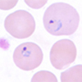 | P. falicparum  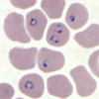
P. malariae  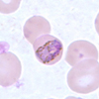 | P. ovale  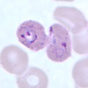  P. knowlesi
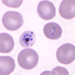

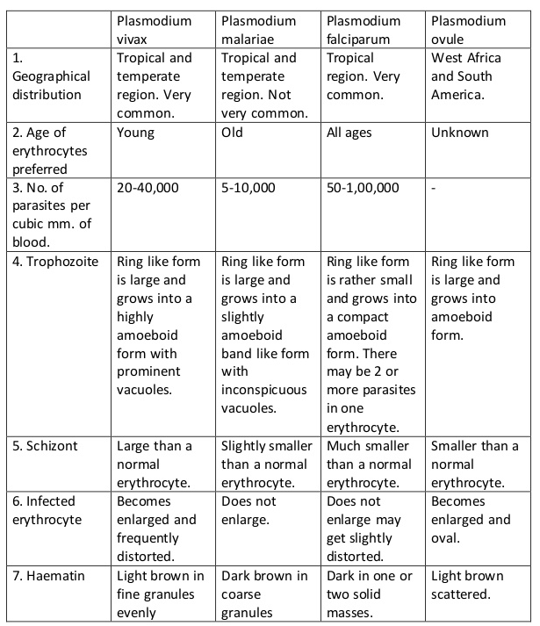

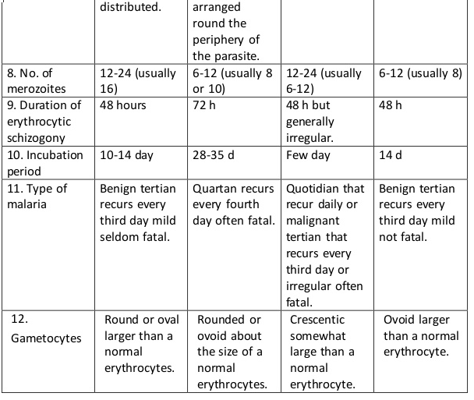

2- Intestinal sporozoa infection
Phylum: Apicomplex
Sub phylum:Sporozoa
Class: Sporozoea
Subclass: Coccidia
Order: Eucoccidia
Family: Cryptosporidae
Genus:
  - Cryptosporidium parvum

The morphological from detectable in feces is the oocyst measures 4-5 μ m in diameter, spherical or ovoidal in shape, containing four crescentic sporozoites and amylopectin like granules ( 1-6 large dark granules ) . It is the parasitic protozoan that causes human cryptosporidiosis, as well as in certain animals, including domestic livestock.
In humans it causes abdominal pain, profuse diarrhoea, weight loss, loss of appetite and anorexia, but in otherwise healthy individuals the infection is usually self-limiting and resolves within a few weeks .

Life cycle :

Cryptosporidium has a complex homogenous life cycle ( it is able to complete its cycle in a single host ) . An external period is not required for sporulation. Occysts are excreted from the gut in infective form . An incubation period 2-14 day follows ingestion of oocyst. The infective stage is mature oocyst containing four sporozoites . Excystation occurs in small intestine , sporozoites are released and invade the epithelial cells . The first intracellular stage is trophozoite. The trophozoite undergoes there nuclear divisions to form a group of eight merozoites , to become first generation schizont . The merozoite released from the schizont infect other epithelial cells and develop into second generation schizont which is composed of only 4 merozoites . The second generation merozoites invade other epithelial cells and form microgametocytes & macrogametocytes . A microgametocyte produces 12-16 microgametes . A macrogametocyte transforms into only one microgamete. After fertilization , azygote is formed and later develops into an oocyst . Oocysts exist in two forms , thin walled and thick walled . Thin walled oocysts reinfect the host ( autoinfection ) by attacking other epithelial cell where as thick walled oocysts are excreted out and infect new hosts. Laboratory Diagnosis :
- Direct microscopic examination of stool . Adirect wet mount of stool shows presence of oocycsts which measure ( 4-5 μ m ) in size and may contain (1-6) large dark granules . In a mature post – sporulation cyst , sausage – shaped sporozoites can be seen .
- Stool concentration smear , best result are obtained with a sugar flotation technique ( sheather's technique).
- Stained smear by using modified acid fast–stain cryptosporidium stains red, the back ground materials and yeast stained green.
- Intestinal biopsy. schizonts containing merozoites and micro and macrogametes can be identified . This is not commonly used method.
- Indirect Immunofluorescence test oocyst have been detected in faecal specimens.
- ELISA test for detection of faecal antigen.

7-PCR is used to detect C. parvum in stool specimens. Faecal material must be stored in potassium dichromate or be frozen for detecting the DNA the organism by PCR.

Pathology and clinical findings Cryptosporidium inhabits the brush border of mucosal epithelial cell of the gastrointestinal tract , especially the surface of villi of the lower small bowel . The prominent clinical feature of cryptosporidiosis is diarrhea , which is mild and self –limited (1-2 weeks ) in normal persons but may be severe and prolonged in immunocompromised or very young or old individuals . Source of infection & Transmission The transmission of cryptosporidium spp is through ingestion of a thick wall oocysts that excreted in feces . The transmission of oocyst is either directly from infected human & animals or indirectly by contamination of environment with fecal materials such as water , food , air contamination. The other source of infection is the sputum in pulmonary cryptosporidiosis . The most important routes of transmission are one of the following :
- Person to person transmission :Person to person spread of cryptosporidiosis is believed to be one of the most common modes of transmission , particularly in urban population . Close contact transmission has been reported in day–care facilities , hospitals , and household settings elsewhere in an urban environment .
- Zoonotic transmission : Cryptosporidium spp . is capable of infecting all species of mammals including human . Direct transmission from animal to human was considered the main route of cryptosporidium trans. Zoonotic transmission may occur from household pets ( puppies and kitten ) and from laboratory ( rodents , rabbits ) & farm animals (cows , sheep , cattle , horses ) .

3- Food borne transmission Food can also be a source of transmission when either an infected person or an a symptomatic carrier contaminate a food supply .
- Waterborne transmission Cryptosporidium has become the most important contaminant found in drinking water . Oocysts with their small size and thick outer wall are highly resistant to chemical disinfectant used in the treatment of drinking water. Physical removal of the parasite from contaminated water by filtration is an important of the water treatment process.

5-Airborne transmission Airborne is theoretically possible rout of trans. But have not been conclusively documented. Since oocysts were isolated from one patient sputum & the possible of airborne infection has been established .

6-Traveler's Diarrhea Cryptosporidiosis has also been recognized as a possible cause of traveler's diarrhea. Such cases often have mixed infection , especially with giardia .
- Insect transmission House flies (musca domestica ) are recognized as transport hosts for a variety of protozoan & metazoan parasite in addition to viral & bacterial pathogens of public health importance .
- Accidental infection Many accidental cryptosporidiosis can occur among researchers or laboratory workers during handling infected samples or lab animals.

9-Sexual transmission.

10- Nosocomial transmission.

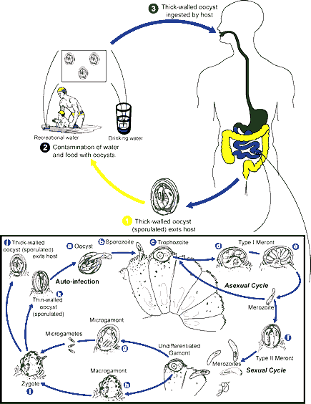

Balantidium coli
causes balantidiasis
Organism Description:
Trophozoite: Large (usual size, 50-100 µm long and 40-70 µm wide), oval shaped; two nuclei (bean-shaped macronucleus easily visible, very small micronucleus often not seen); cilia easily seen around the periphery of the trophozoite.
Cyst: Round (usual size, 5-70 µm in diameter), will contain the same 2 nuclei as seen in the trophozoite; cilia more difficult to see within the cyst wall.
Both and cyst forms can be found in clinical specimens.
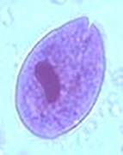 | 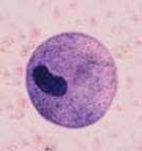 | 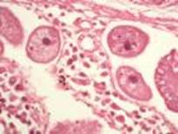
Trophozoite | Cyst | Trophozoites in tissue
Life Cycle:
Large bowel, trophozoites and cysts passed in stool AND/OR
Large bowel, tissue invasion (mucosal ulcers, abscess formation)
Acquired:
Fecal-oral transmission via cyst form; contaminated food and water
Epidemiology:
Worldwide, primarily human-to-human transmission, also pig-to-human transmission. Human infection is fairly rare in temperate areas, it can develop into an epidemic, particularly where poor environmental sanitation and personal hygiene are found.
Clinical Features:
Intestinal: Some individuals with B. coli infections are totally asymptomatic, whereas others have symptoms of severe dysentery similar to those seen in patients with amebiasis. Symptoms usually include diarrhea or dysentery, tenesmus, nausea, vomiting, anorexia, and headache. Insomnia, muscular weakness, and weight loss have also been reported. The diarrhea may persist for weeks to months prior to the development of dysentery. There may be tremendous fluid loss, with a type of diarrhea similar to that seen in cholera or in some coccidial or microsporidial infections.
Extraintestinal: B. coli have the potential to invade tissue. On contact with the mucosa, B. coli may penetrate the mucosa with cellular infiltration in the area of the developing ulcer. Some of the abscess formations may extend to the muscular layer. The ulcers may vary in shape, and the ulcer bed may be full of pus and necrotic debris. Although the number of cases is small, extraintestinal disease has been reported (peritonitis, urinary tract, inflammatory vaginitis).
Clinical Specimen:
Intestinal: Stool, examination of mucosal ulcers (scrapings, biopsy)
Extraintestinal: Fluids
Laboratory Diagnosis:
Intestinal: Ova and Parasite examination (concentration, permanent stained smear); organisms are so large, they may be missed on permanent stain (resemble helminth eggs or debris); the concentration sediment is the most appropriate way to visualize the organisms.
Extraintestinal: Trichrome, PAS stains, routine histology (H&E stain)
Control:
Improved hygiene, adequate disposal of fecal waste, adequate washing of contaminated fruits and vegetables; prevention of human-pig contact, hygienic rearing of pigs.

