Giardia lamblia-

Morphology
It exists in 2 forms:
  - Trophozoite (or vegetative form)
  - Cyst (or cystic form).

Trophozoite
The trophozoite is in the shape of a tennis racket (heart- shaped or pyriform shaped) and is rounded anteriorly and pointed posteriorly.
  - It measures 15 µm x 9 µm wide and 4 µm thick.
  - Dorsally, it is convex and ventrally, it has a concave sucking disc, which helps in its attachment to the intestinal mucosa.
  - It is bilaterally symmetrical and possesses.
    - 1 pair of nuclei
    - 4 pairs of flagella
    - Blepharoplast, from which the flagella arise
- pair of axostyles, running along the midline
Two sausage­shaped parabasal or median bodies, lying transversely posterior to the sucking disc.
- The trophozoite is motile, with a low oscillation about its long axis, often resembling falling leaf.

Cyst
It is the infective form of the parasite
- The cyst is small and oval, measuring 12 µm x 8 µm and is surrounded by a hyaline cyst wall.
- Its internal structure includes 2 pairs of nuclei grouped at one end. A young cyst contains 1 pair of nuclei.
- The axostyle lies diagnonally, forming a dividing line within cyst wall.
- Remnants of the flagella and the sucking disc may be seen in the young cyst.

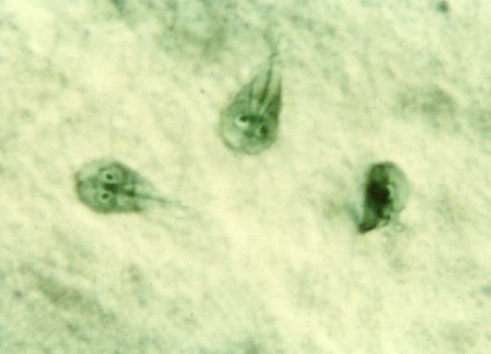
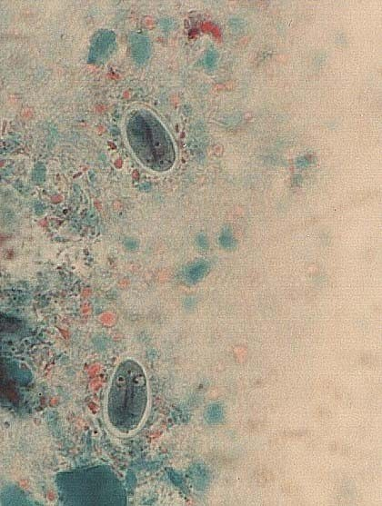
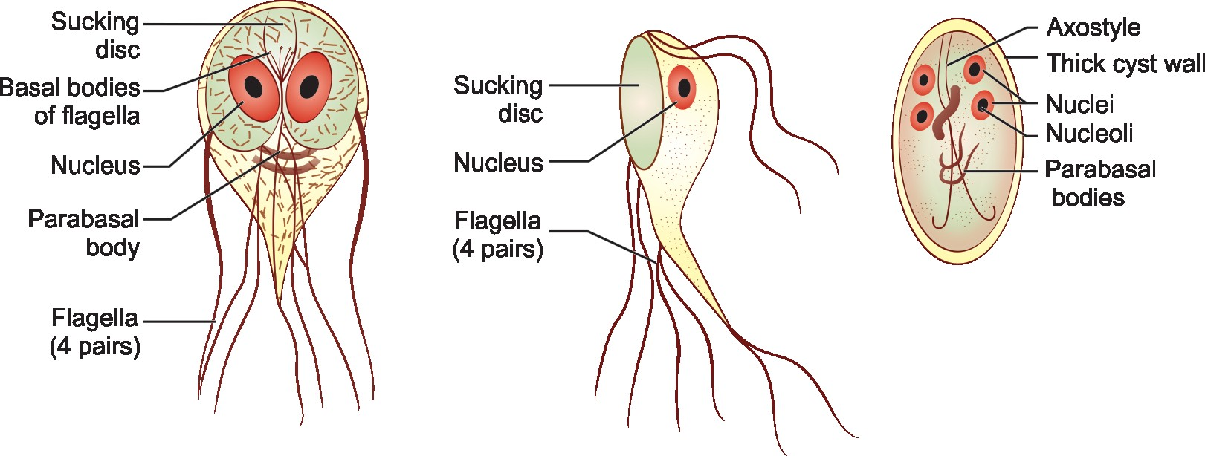

A B C

- Routes of transmission
  - Feco-oral:ingestion of contaminated water – most important
  - Ingestion of contaminated food
- Person to person – day care, nursing homes, mental asylums (poor hygiene)
- Sexual – sexually active homosexual males
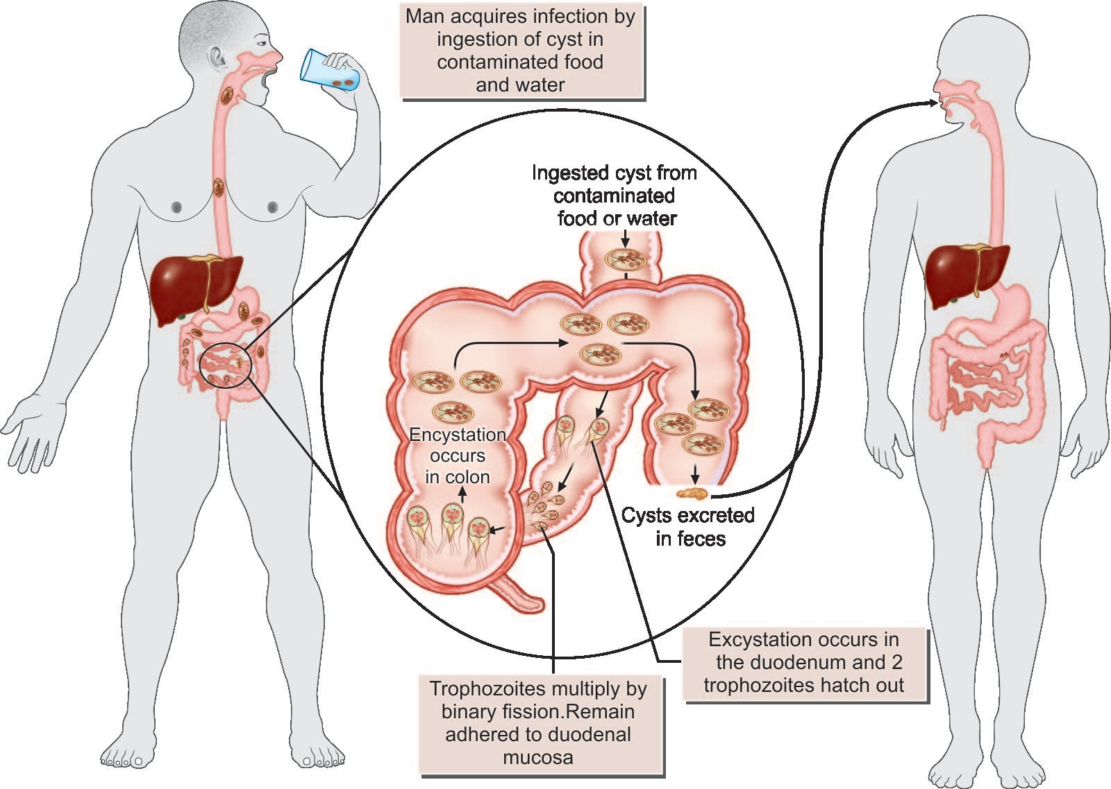

Pathogenicity and Clinical Features
G. lamblia is typically seen within the crypts of duodenal and jejunal mucosa. It does not invade the tissue, but remains tightly adhered to intestinal epithelium by means of the sucking disc.
- They may cause abnormalities of villous architecture by cell apoptosis and increased lymphatic infiltration of lamina propria.
- Variant specific surface proteins (VSSP) of giardia play an important role in virulence and infectivity of the parasite.
- Often they are asymptomatic, but in some cases, Giardia may lead to mucus diarrhea, fat malabsorption (steatorrhea), dull epigastric pain, and flatulence. The stool contains excess mucus and fat but no blood.
- Children may develop chronic diarrhea, malabsorption of fat, vitamin A, protein, sugars like xylose disaccharides, weight loss, and sprue­like syndrome.
- Occassionally, Giardia may colonize the gall bladder, causing biliary colic and jaundice.Incubation period is variable, but is usually about 2 weeks

- Note: Enhanced susceptibility to giardiasis is associated with blood group A, achlorhydria, use of cannabis, chronic pancreatitis, malnutrition, and immune defects such as 19A deficiency and hypogamma­ globulinemia.
- 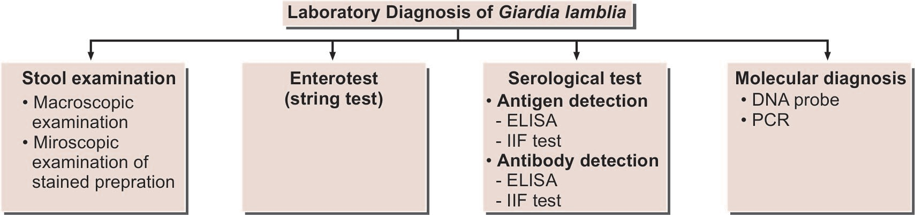
- Laboratory Diagnosis
- Stool Examination
Giardiasis can be diagnosed by identification of cysts of Giardia lamblia in the formed stools and the trophozoites and cysts of the parasite in diarrheal stools (Flowchart 4.1).
  - On macroscopic examination fecal specimens containing G. lamblia may have an offensive odor, are pale colored and fatty, and float in water.
  - On microscopic examination, cysts and trophozoites can be found in diarrheal stools by saline and iodine wet preparations.
  - Often multiple specimens need to be examined and concentration techniques like formal ether or zinc acetate are used. In asymptomatic carriers, only the cysts are seen.
  - Enterotest (String test
  - A useful method for obtaining duodenal specimen is enterotest. A coiled thread inside a small weighted gelatin capsule is swallowed by the patient, after attaching the free end of the thread in the check. The capsule passes through the stomach to the duodenum. After 2 hours, the thread is withdrawn, placed in saline, and is mechanically shaken. The centrifuged deposit of the saline is examined for Giardia. The use of enterotest is not recommended because of the very high cost of the test.

Serodiagnosis

Antigen detection
Enzyme­linked immunosorbent assay (ELISA), immuno­ chromatographic strip tests and indirect immunofluroscent (IIF) testsusingmonoclonalantibodieshavebeendeveloped for detection of Giardia antigens in feces (Flowchart 4.1).
- The presence of antigen indicates active infection.
  - Commercially available ELISA kits (ProSpec T/Giardia kit) detects Giardia-specific antigen 65 (GAS 65). The sensitivity of the test is 95% and specificity is 100%, when compared to conventional microscopy

Antibody detection
IIF test and ELISA are used to detect antibodies againstGiardia.
- Demonstration of antibodies is useful in the epidemio­ logical and pathophysiological studies.
- These tests cannot differentiates between recent and past infection and lack sensitivity and specificity.

Molecular Method
  - DNA probes and polymerase chain reaction (PCR) have been used to demonstrate parasitic genome in the stool specimen

Trichomonas
Trichomonas differs from other flagellates, as they exist only in trophozoite stage. Cystic stage is not seen.
  - Genus Trichomonas has 3 species, which occur in humans (
    - T. vaginalis (
    - T. hominis ()
  - T. tenax

Trichomonas Vaginalis

Morphology
It is pear-shaped or ovoid and measures 10–30 µm in length and 5–10 µm in breadth with a short undulating membrane reaching upto the middle of the body ().
- It has four anterior flagella and fifth running along the outer margin of the undulating membrane, which is supported at its base by a flexible rod, costa.
- A prominent axostyle runs throughout the length of the body and projects posteriorly like a tail.
- The cytoplasm shows prominent siderophillic granules, which are most numerous alongside the axostyle and costa.
- It is motile with a rapid jerky or twitching type movement.
- Habitat
- In females, it lives in vagina and cevix and may also be found in Bartholin’s glands, urethra, and urinary bladder. In males, it occurs mainly in the anterior urethra, but may also be found in the prostate and preputial sac.

Life Cycle
35
Life cycle of T. vaginalis is completed in a single host either male or female.

Mode of transmission:
- The trophozoite cannot survive outside and so infection has to be transmitted directly from person­ to­person. Sexual transmission is the usual mode of infection.
- Trichomoniasis often coexists with other sexually transmitted diseases; like candidiasis, gonorrhea, syphillis, or human immunodeficiency virus (HIV).
- Babies may get infected during birth.
- Fomites such as towels have been implicated in transmission.
  - Trophozoites divide by binary fission.
  - As cysts are not formed, the trophozite itself is the

infective form.Incubation period is roughly 10 days

Pathogenesis
T. vaginalis particularly infects squamous epithelium and not columnar epithelium. It secretes cystine proteases, lactic acid, and acetic acid, which disrupt the glycogen levels and lower the pH of the vaginal fluid.
  - It is an obligate parasite and cannot live without close association with the vaginal, urethral, or prostatic tissues.
  - Parasite causes petechial hemorrhage (strawberry mucosa), metaplastic changes, and desquamation of the vaginal epithelium.
  - Intracellular edema and so called chicken-likeepithelium, is the most characteristic feature of trichomoniasis.

Clinical Features
Infection is often asymptomatic, particularly in males, although some may develop urethritis, epididymitis, and prostatitis.
  - In females, it may produce severe pruritic vaginitis with an offensive, yellowish green, often frothy discharge, dysuria, and dyspareunia. Cervical erosion is common. Endometritis and pyosalpingitis are infrequent complications.
  - Rarely, neonatal pneumonia and conjunctivitis have been reported in infants born to infected mothers.
- The incubation period of trichomoniasis is 4 days to 4 weeks.

Laboratory Diagnosis

Microscopic examination
- Vaginal or urethral discharge is examined microscopically in saline wet mount preparation for characteristic jerky and twitching motility and shape. In males, trophozoites may be found in urine or prostatic secretions.
- Fixed smears may be stained with acridine orange, papanicolaou, and Giemsa stains.
- Direct fluroscent antibody (DFA) is another method of detection of parasite and is more sensitive than the wet mount.

Culture
Culture is recommended when direct microscopy is negative and is considered as a 'gold standard' as well as the most sensitive (95%) method for the diagnosis ofT. vaginalis infection.
- It grows best at 35°–37°C under anaerobic conditions.
The optimal pH for growth is 5.5–6.0.
- It can be grown in a variety of solid or liquid media, tissue culture, and eggs. Cysteine­peptone­liver­maltose (CPLM) medium and plastic envelope medium (PEM) are often used.

Serology
ELISA is used for demonstration of T. vaginalis antigen in vaginal smear using a monoclonal antibody for 65­KDA surface polypeptide of T. vaginalis.

Molecular method
DNA hybridization and PCR are also highly sensitive (97%) and specific (98%) tests for the diagnosis of trichomoniasis.

Trichomonas Tenax
T. tenax, also known as T. buccalis, is a harmless commensal which lives in mouth­in the periodontal pockets, carious tooth cavities, and less often in tonsillar crypts.
- It is smaller (5–10 µm) than T. vaginalis.
- It is transmitted by kissing, through salivary droplets, and fomites. There are sporadic reports of its involvement in respiratory infections and thoracic abcesses.
- Better oral hygine rapidly eliminates the infection and no therapy is indicated.

Trichomonas Hominis
T. hominis measures 8–12 µm, pyriform-shaped, and carries 5 anterior flagella and an undulating membrane that extends the full length of the body.
- It is a very harmless commensal of the caecum.
- Microscopic examination of stool will reveal motile trophozoite of T. hominis.
- Transmission occurs in trophic form by fecal­oral route.

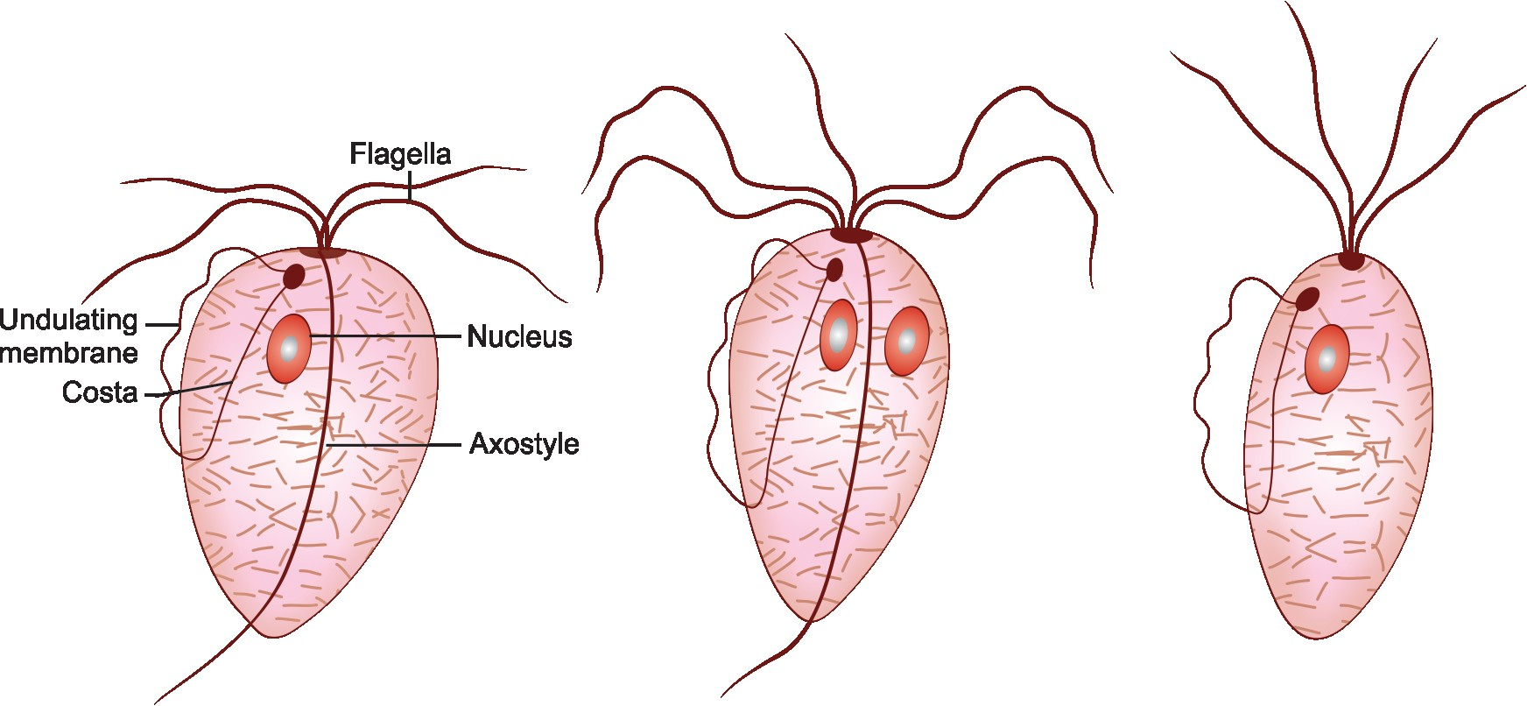

A B C

