Lec3: Diagnosis parasitology
1-Entamoeba
The genus Entamoeba contains many species, six of which(Entamoeba histolytica, Entamoeba dispar, Entamoeba moshkovskii,Entamoeba polecki, Entamoeba coli and Entamoeba hartmanni) reside in the human intestinal lumen. Entamoeba histolytica is the only species definitely associated with pathological sequelae in humans; the others are considered nonpathogenic. Although recent studies highlight the recovery of E. dispar and E. moshkovskii from patients with gastrointestinal symptoms, there is still no definitive evidence of a causal link between the presence of these two species and the symptoms of the host.Clinical features of amebiasis due to E.histolytica range from asymptomatic colonization to amebic dysentery and invasive extraintestinal amebiasis, which is manifested most commonly in the form of liver abscesses. New approaches to the identification of E. histolytica are based on detection of E. histolytica-specific antigen and DNA in stool and other clinical samples.

Morphology:
Parasite occurs in three stages; trophozoite, precyst and cyst

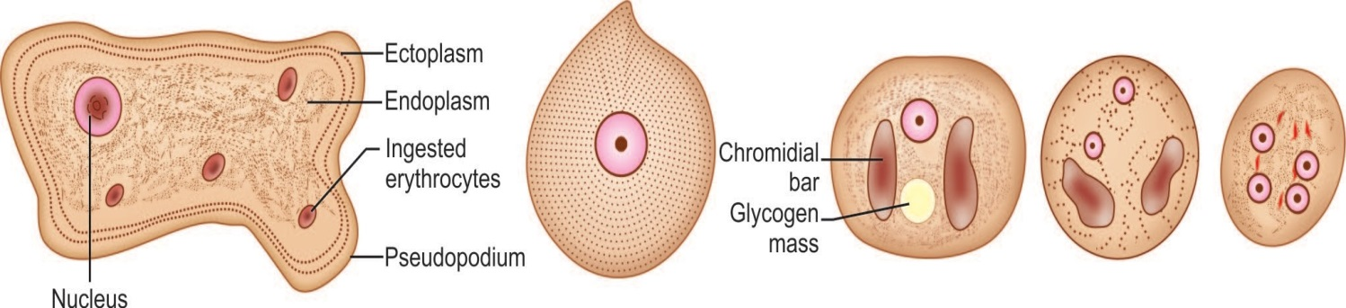

A B C D E

. 3.1: Entamoeba histolytica. A. Trophozoite; B. Precystic stage; C. Uninucleate cyst; D. Binucleate cyst; E. Mature quadrinucleate cyst

1. Trophozoite:
- It is the growing and feeding stage of parasite
- Sape; not fixed because of constantly changing position
- Size: ranging from 18-40 µm; average being 20-30 µm
- Cytoplasm: cytoplasm is divided into two portion; a clear transparent ectoplasm and a granular endoplasm. Ingested RBCs, tissue granules and food materials are also found in endoplasm
- Nucleus: It is single, spherical shape and size ranging from 4-6µ Nucleus contains central karyosome and fine peripheral chromatin.
- Trophozoites are actively motile with the help of pseudopodia.
- Trophozoites are anaerobic parasite, ( present in large intestine)

2. Pre cyst:
- It is the intermediate stage between trophozoite and cyst
- It is smaller in size; 10-20µ
- It is round or slightly ovoid with blunt pseudopodium projecting from periphery
- No RBC or food materials are found on its endoplasm.

3. Cyst:
- It is the infective form of parasite.
- Shape: It is round or round or oval in shape
- Size: 12-15 µm in diameter
- It is surrounded by a highly rectractile membrane called cyst wall. The cyst wall is resistant to digestion by gastric juice in human stomach
- Nucleus: A mature cyst is quadrinucleated.
- Cytoplasm: Cytoplasm shows chromatid bars and glycogen masses but no RBCs or food particles.
- Mature cyst passed out in stool from infected patient and remained without fouther development in soil for few days.

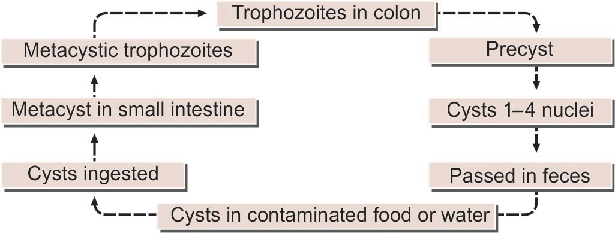
Life cycle:

Pathogenesis:

1. Mode of infection:
- Faeco-oral route
- Ingestion of cyst contaminated foods and water

2. Virulence factors:
i. Cyst wall: cyst wall is resistant to low pH and gastric juice of stomach.
ii. Lectin: Surface of trophozoite contains lectin that is specific to lingards (N-acetyl-galactosamine and galactose sugar) present in surface of intestinal epithelium.
iii. Ionophore like protein: It causes leakage of ions such as Na+, K+, Ca++ from target cells.
iv. Hydrolytic enzymes: Phosphatase, proteinease, glycosidase and RNase causes tissue destruction and necrosis.
v. Toxin and haemolysin

3. Pathogenesis;
The parasites express large number of virulence factors including lectin, lytic peptide, cysteine, proteineases and phospholipase.
. After adherence trophozoite lyse the target cell by its ionophore like protein that causes leakage of ions from cytoplasm. The proteolytic enzymes secreted by the amoeba causes tissue destruction giving flask shaped amoebic ulcer, is a typical feature of intestinal amoebiasis.
Trophozoites penetrates the columnar epithelium of mucosa causing lysis and moves deep inside till they reached submucosa layer and multiply rapidly. Ultimately amoeba destroy considerable area of the submucosa leading an abscess formation which breaks down to form ulcer. The ulcer is flask shaped with narrow neck and broad base. The ulcer may be localized in ileo-caecal region or generalized throughout the large intestine.
From intestine, the parasites may be carried to other vital organs such as liver, heart, brain etc through blood circulation. Pulmonary and hepatic amoebic abscesses are frequent and rarely cerebral, cutaneous and splenic amoebic abscesses.

Clinical manifestation:
Infection ranges from asymptomatic to invasive intestinal amoebiasis and extra-intestinal amoebiasis

1. Intestinal Amoebiasis
i. Asymptomatic infection: 90% of E. histolytica infection is mild or asymptomatic
ii. Symptomatic infection
- Non dysentric amoeboic colitis (mild diarrhea)
- Acute amoebic dysentery: it is more common and characterized by abdominal pain, fever and tenderness. Stool contains RBCs, charcot-leyden crystals and trophozoites.
Complications: toxic megacolon, fulminant amoebic colitis, amoebic peritonitis, perianal ulceration

2. Extra intestinal amoebiasis:
i. Hepatic infection: non supurative hepatitis, liver abscesses, other complications
ii. Pulmonary infection: chest pain, dyspnoea, non-productive cough
iii. Cerebral infection: it is rare and occurs as a complication of liver of pulmonary amoebiasis
iv. Genitourinary infection: involves kidney and genital organs
v. Spleenic infection
vi. Cutaneous amoebiasis and Amoebic pericarditis

Lab Diagnosis:
Specimen: stool, pus or liver abscesses, sputum and biopsy samples
i. Stool macroscopy: in amoebic dysentery stool is offensive, semi-solid, fark brown color and acidic in nature, mixed with blood, mucus and faecal materials.
ii. Microscopy: Normal saline preparation of fresh faecal material revels trophozoites with RBCs in its cytoplasm and its amoebic motility.
iii. Stool Ag detection: ELISA to detect 170KD lectin of E. histolytica
iv. Stool culture: Robinson’s medium and NH polyxenic culture medium are used to culture E. histolytica
v. Serology: IHA, IFA etc are used to detect antibody in serum against E. histolytica
vi. PCR: It is sensitive test , used to differentiate E. histolytica with other Entamoeba species
vii. Radiological finding: X-rays, MRI, CT scan, ultrasonography etcfor extra intestinal amoebiasis:
viii. Blood test: blood count, Liver function test, Kidney function test
ix. Intradermal test:skin test
LABORATORY DIAGNOSIS
Microscopy
Microscopic techniques employed in a diagnostic clinical laboratory include wet preparation, concentration, and permanently stained smears for the identification of E. histolytica/E.dispar/E. moshkovskii in feces.
Microscopic examination of a direct saline (wet) mount is a very insensitive method (_10%) which is performed on a fresh specimen. The sample should be examined within 1 h of collection to search for motile trophozoites which may contain RBCs. However, in patients who do not present with acute dysentery, trophozoites will not contain RBCs. Patients with asymptomatic carriage generally have only cysts in the fecal sample. Although the concentration technique is helpful in demonstrating cysts, the use of permanently stained smears (trichrome or iron hematoxylin) is an important method for recovery and identification of Entamoeba species. As Entamoeba trophozoites generally degenerate rapidly in unfixed fecal specimens and refrigeration is not recommended, specimens should be preserved with a fixative which prevents the degradation of the morphology of the parasite and allows concentration and permanent smears to be performed.Fixatives used for the concentration procedure includeSchaudinn’s fluid, merthiolate iodine-formalin, sodium acetate- acetic acid-formalin (SAF), or 5% or 10% formalin. The fixatives for the permanently stained smears include trichrome, iron hematoxylin, Ziehl-Neelsen stains, modified polyvinyl alcohol (PVA) (containing mercury compounds), and SAF.
Culture Methods
The xenic culture of E. histolytica was first introduced by Boeck and Drbohlavin a diphasic egg slant medium, and a modification of this medium (Locke-egg) is still used today. Different monophasic media that were developed for E. histolytica are the egg yolk infusion medium of Balamuth ,Jones’s medium), and TYSGM-9. Of the different media developed for the xenic cultivation of E. histolytica, only three media, diphasic Locke-egg, Robinson’s medium, and the monophasic TYSGM-9,
. Axenic cultivation involves the cultivation of parasites in the absence of any other metabolizing cells. The monophasic medium TP-S-1 was developed and used widely for culture of E. histolytica in different research laboratories). Currently TYI-S-33 and YI-S are the most widely used media for axenic cultivation of E. histolytica.
Culture of E. histolytica can be performed from fecal specimens, rectal biopsy specimens, or liver abscess aspirates., addition of a bacterium or a trypanosomatid is necessary before inoculation of amebae into xenic
Note: culture Parasite cultures are difficult, expensive, and labor-intensive to maintain in the diagnostic laboratory. Overgrowth of bacteria, fungi, orOther protozoans during culture is the main problem encountered, and therefore culture is not recommended as a routine diagnostic procedure for the detection of Entamoeba species.

Isoenzyme Analysis

A zymodeme is defined as a group of ameba strains that share the same electrophoretic pattern and mobilities for several enzymes. Zymodemes consist
of electrophoretic patterns of malic enzyme, hexokinase, glucose phosphate isomerase, and phosphoglucomutase isoenzyme.
The presence of starch in the medium influences the most variable zymodeme patterns, and many zymodemes “disappear” upon removal of bacterial floras, suggesting that at least some of the bands are of bacterial rather than amebal origin Many different assays have been developed for the detection of antibodies, including indirect hemagglutination (IHA), latexagglutination, immunoelectrophoresis, counterimmunoelectrophoresis (CIE), the amebic gel diffusion test, immunodiffusion,complement fixation, indirect immunofluorescence assay (IFA),
and enzyme-linked immunosorbent assay (ELISA). A variety of antibody assays for detection of E. histolytica antibodies in human serum are also commercially available.

Antigen Detection Tests
Several investigators have developed ELISAs for the detection of antigens in fecal samples. These antigen detection tests have a sensitivity approaching that of stool culture and are rapid to perform. Antigen-based ELISA kits that are specific for E. histolytica use monoclonal antibodies against the specific lectin of E. histolytica or monoclonal antibodies against serine-rich antigen of E. histolytica .
Immunochromatographic Assays
The Triage parasite panel (TPP) is the first immunochromatographic assay for
the simultaneous detection of antigens specific for Giardia lamblia, E. histolytica/E. dispar, and Cryptosporidium parvum.
The immunochromatographic strip used in this assay is coated with monoclonal antibodies specific for the 29-kDa surface antigen (E. histolytica/E. dispar), alpha-1-giardin (G. lamblia), and protein disulfide isomerase (C. parvum)
DNA-BASED DIAGNOSTIC TESTS, Real-Time PCR
- Not all strains of E. histolytica are pathogenic or invasive. Differentiation between pathogenic and non- pathogenic strains can be made by susceptibility to complement-mediated lysis and phagocytic activity or by the use of genetic markers or monoclonal antibodies and zymodeme analysis
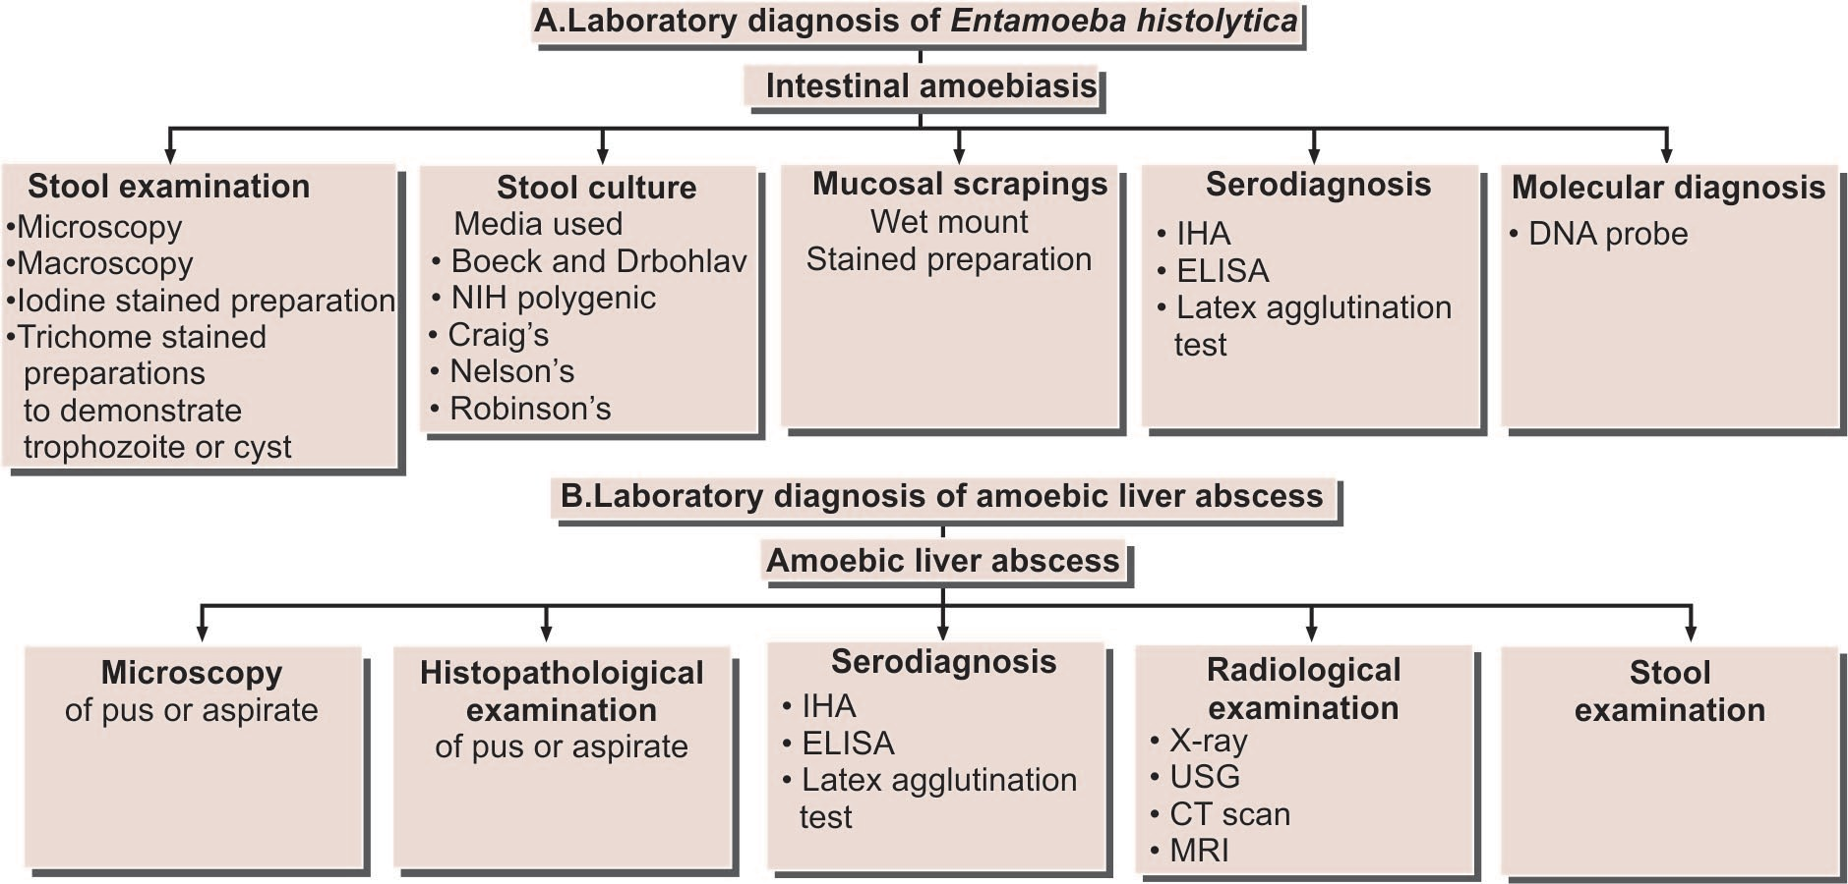

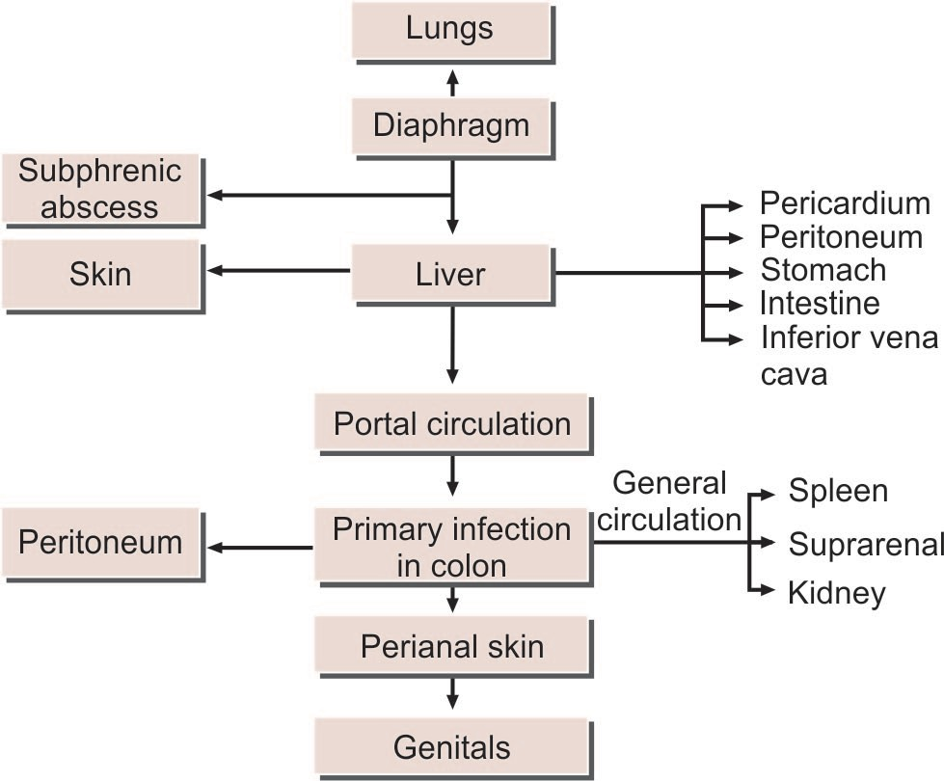

1-Entamoeba moshkovskii
Entamoeba moshkovskii is another species of Entamoeba and is morphologically indistinguishable from E. histolytica and E. dispar. E. moshkovskii as am sole potential enteropathogen in patients presenting with gastrointestinal symptoms and/or dysentery, highlighting the need for further study to investigate the pathogenic potential of this.

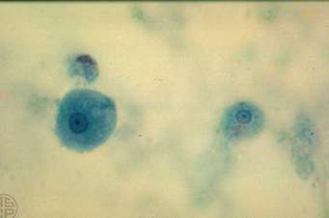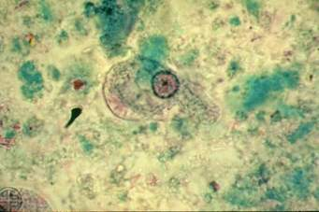

2-Entamoeba gingivalis
  - E gingivalis is a parasite of the human mouth and may be present as commensal especially in cases of pyorrhea alveolaris (infections of the gums).
- They are 10-20 µm in size
- It is actively motile
- Its cytoplasm is divided into a clear ectoplasm and a granular endoplasm.
- The cytoplasmic inclusions consist of bacteria, leucocytes and other materials but it never consists of red blood cells.
- The nucleus is spherical with central karyosome.
- The nuclear membrane is lined with closely packed chromatin granules
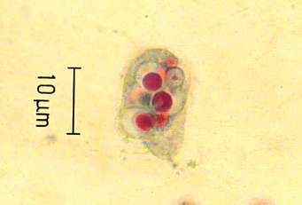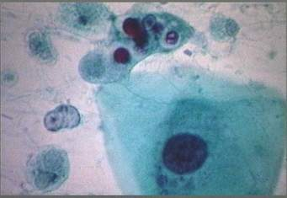

3-Entamoeba dispar:
  - It is a non-invasive and non pathogenic amoeba.
  - It is identical to E histolytica. The cysts are also similar.
  - However the red cells are not seen in the cytoplasm .

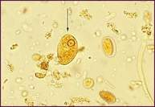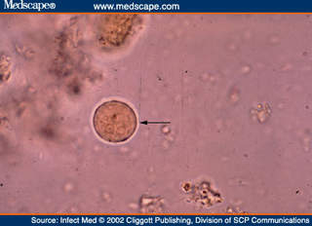

4-Entamoeba hartmanii
  - It is morphologically similar to E histolytica but is smaller in size.
  - The trophozoites never contain red blood cells in the cytoplasm.
  - It is non pathogenic

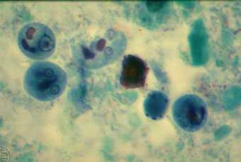

5-Endolimax nana
  - They are small amoeba which are found in large intestines of man and animals.
  - The trophozoites are small 6-15 µm in size.
  - The cytoplasm is demarcated into ectoplasm and endoplasm.
  - The cytoplasmic inclusions consist of bacteria, leucocytes and other materials but it never consists of red bloodcells.
  - The nucleus is spherical with large irregular karyosome lying eccentrically.
  - Several achromatic strands extend from karyosome to nuclear membrane
  - The cysts are oval in shape and measure 8-10 µm in diameter.
  - The mature cysts are quadrinucleate.
  - Chromatid bodies and glycogen are present in the cysts.

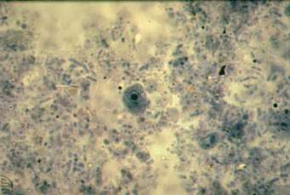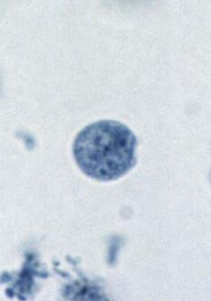

- Iodamoeba butschlii
This is widely distributed, though less common than E. coli and E. nana.
- The trophozoite is small, 6–12 µm, with conspicuous nucleus (Fig. 3.10A).
- The prominent karyosome is half the size of the nucleus, having bull’s eye appearance.
The cyst is oval, uniucleate, and has a prominent innn staining glycogen mass (iodophilic body). Hence, the name ‘Iodamoeba’. It is non-pathogenic
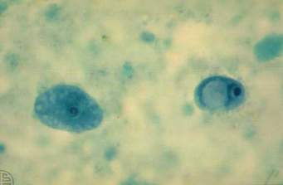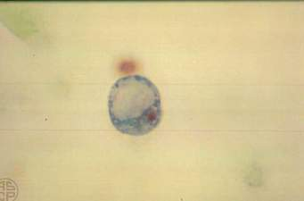
 | E. histolytica | E. coli | E. hartmanni
Trophozoite
Size (µm) | 12–60 | 20–50 | 4–12
Motility | Active | Sluggish | Active
Pseudopodia | Finger-shaped, rapidly extruded | Short, blunt slowly extruded | Finger-shaped, rapidly extruded
Cytoplasm | Clearly defined into ectoplasm and endoplasm | Differentiation not distinct | Clearly defined into ectoplasm and endoplasm
Inclusions | RBCs present, no bacteria | Bacteria and other particles, no RBCs | Bacteria and other particles, no RBCs
Nucleus | Not clearly visible in unstained films | Visible in unstained films | Not visible in unstained films
Karyosome | Small, central | Large, eccentric | Small, eccentric
Nuclear Membrance | Delicate, with fine chromatin dots | Thick, with coarse chromatin granules | Coarse chromatin granules
Cyst
Size (µm) | 10–15 | 10–30 | 5–10
Nuclei in mature cyst | 4 | 8 | 4
Glycogen mass | Seen in uninucleate, but not in quadinucleate stage | Seen up to quadrinucleate stage | Seen in uninucleate, but not in quadinucleate stage
chromidial | 1–4 with crounded ends | Splinter like with angular ends | Many with irregular shape

