Lab 3 TOTAL, DIFFERENTIAL AND ABSOLUTE
WHITE BLOOD CELL COUNT
Introduction:
The cells that circulate in the bloodstream are generally divided into three types: white blood cells (leukocytes), red blood cells (erythrocytes), and platelets (thrombocytes). White blood cells are cells of the immune system involved in defending the body against both infectious disease and foreign materials. Five different and diverse types of leukocytes exist, but they are all produced and derived from a multipotent cell in the bone marrow known as a hematopoietic stem cell ( Hemocytoblast) . They live for about three to four days in the average human body. Leukocytes are found throughout the body, including the blood and lymphatic system.The white blood cell count (WBC) and the differential count are common laboratory tests and they are almost a necessity in determining the nature and severity of systemic infections. Abnormally high or low counts may indicate the presence of many forms of disease.
BLOOD CELLS(Haematopoiesis)
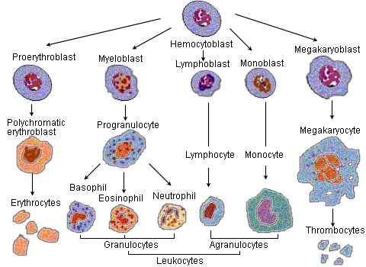

white blood cells are often divided as granulocytes or agranulocytes:
- Granulocytes (polymorphonuclear leukocytes): leukocytes characterized by the presence of differently staining granules in their cytoplasm when viewed under light microscopy. These granules are membrane-bound enzymes that act primarily in the digestion of endocytosed particles. There are three types of granulocytes: neutrophils, basophils, and eosinophils, which are named according to their staining properties.
- Agranulocytes (mononuclear leukocytes): leukocytes characterized by the apparent absence of granules in their cytoplasm. Although the name implies a lack of granules these cells do contain non-specific azurophilic granules, which are lysosomes.^{[4]} The cells include lymphocytes, monocytes, and macrophages.
Type | Microscopic Appearance | Diagram | Approx. %  in adults | Diameter  (μm) | Nucleus | Granules
Neutrophil |  |  | 62% | 10–12 | multilobed | fine, faintly pink
Eosinophil | 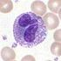 | 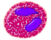 | 2.3% | 10–12 | bi-lobed | full of pink-orange
Basophil | 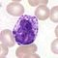 | 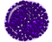 | 0.4% | 12–15 | bi-lobed or tri-lobed | large blue
Lymphocyte |  |  | 30% | Small lymphocytes 7–8  Large lymphocytes 12-15 | deeply staining, eccentric | None
Monocyte | 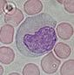 |  | 5.3% | 7.72–9.99 | kidney shaped | None

TOTAL WHITE BLOOD CELL COUNT
The total white blood cells (leukocytes) count determines the total number of white cells per cubic millimeter of blood regardless the type of W.B.C. The degree of increase or decrease in leukocytes depend on the type and severity of the infection and the response of the body.the manual method for total W.B.C count is by using Haemocytometer (A glass slide with a chamber for counting blood cells in a given volume.)
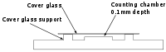
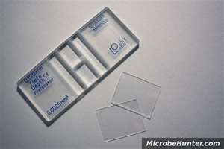
Procedure:
*Requirements
1. Microscope 2. Improved Neubauer Chamber 3. WBC pipette 4. WBC diluting solution: It is prepared as follows: a) Glacial acetic acid: 2.0 ml. b) 1 % (w/v) gentian violet (Methylin blue): 1.0 ml. c) Distilled water: 97 ml. This solution is stable at room temperature (25°C ± 5°C).
*Principle
The glacial acetic acid lyses the red cells while the gentian violet slightly stains the nuclei of the leukocytes. The blood specimen is diluted 1:20 in a WBC pipette with the diluting fluid and the cells are counted under low power of the micro scope by using a counting chamber. The number of cells in undiluted blood are reported per cu mm (µl) of whole blood.
* Procedure
- Make a 1:20 dilution of blood by adding 20 µl of blood to 0. 38 ml of diluting solution in a glass tube and mix for at least 1 min.
- Fill the Neubauer counting chamber by means of a Pasteur pipette or glass capillary.
- Focus on one of the ‘W’ marked areas (each having 16 small squares) by turning objective lense to low power. (10 X).
- Count cells in all four W marked corner
- The calculation formula for hemacytometer cell counts determines the number of cells within 1 m L (1 mm³) of blood . To make this determination, the total number of cells counted must be corrected for the initial dilution of blood and the volume of diluted blood used. The standard dilution of blood for leukocyte counts is 1:20; therefore the dilution factor is 20. The volume of diluted blood used is based on the area and depth of the counting area. The area counted is 4 mm² and the depth is 0.1 mm; therefore the volume factor is 0.4 mm³.
Total number of cells counted • dilution factor • 1/volume factor = cells/mm³
For example if 150 cells were counted in the four corner squares the WBC count is:
150 x 20 x 1/0.4 = 7,500 cells/mm³ or 7.5 x 10⁹/L
- The difference between the highest and lowest count for the eight squares should not exceed 10 cells.
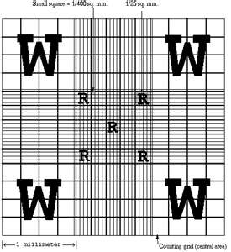
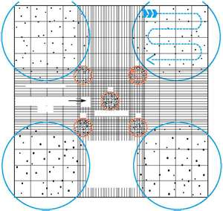

Normal values:
• Adults : 4,000-11,000/cu mm (µl)
• At birth : 10,000-25,000/cu mm (µl)
• 1 to 3 years : 6,000-18,000/cu mm (µl)
• 4 to 7 years : 6,000-15,000/cu mm (µl)
• 8 to 12 years: 4,500-13,500/cu mm (µl)

DIFFERENTIAL W.B.C COUNT

Differential count is the percent distribution of various white cells in the peripheral blood. It is determined from a blood smear stained with a polychromatic stain and after examination of the stained smear by using oil immersion objective (total magnification 1000 X). The number of each type of white cell is then expressed as a percentage of the total number of cells. The stained blood smear also helps to study abnormal morphology of leukocytes and red cells. Study of blood smear helps in the diagnosis of various anemias, leukemias and detection of blood parasites. Three major steps involved in differential count are:
a. preparation of blood smear
b. staining of the blood smear .
c. microscopic examination of the stained smear.

DIFFERENTIAL W.B.C COUNT TECHNIQUE

- Clean slide before used.
- Put a small drop of fresh blood on one edge of the slide.
- Spread the blood drop with another glass slide as in figures below.
- Leave the slide to dry.
- Stain ( for 5 min.) Wright stain which is a mixture of two dyes solved with red colour and methyline blue in methyl alcohol solution which consist of an acidic dye called eosin withan alkalin red c color and methyline b lue with blue colour.
- Wash gently with tab water an dry.
- Examine the stained slide under oil immersion lens and count a total of 100 cells and then calculate the relative count leukocytesh type of leukocytes
- The film should not be very thin and the tail of the film should be smooth .
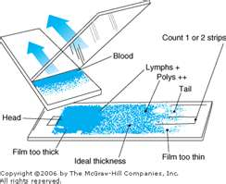
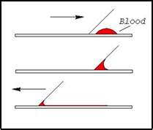

ABSOLUTE W.B.C COUNT
Counting the real number of each type of leukocytes and not the percentage , therefor it is more accurate than differential count because it gives the exact number of each type of W.B.C and not a percentage. Absolute cell count is calculated as following:
Absolute Cell Count = % of cells X Total w.B.C count
Example: patient has a total W.B.C count of 8000 c/mm3. Differential count shows 20% lymphocytes, calculate the absolute number of lymphocytes?
8000 X 0.20 (20%)= 1600 it means that this patents has 1600 lymphocytes in every mm3 of His blood
Normal value for absolute numbers of W.B.C :
- Neutrophile ( 2500 -7000)
- Eosinophils ( 100 -300 )
- Basophil (40 – 100)
- Lymphocytes ( 1700- 3500)

