Introduction

Marine and freshwater algae are recognized to produce a diverse array of toxic or otherwise bioactive metabolites. These toxic metabolites are globally widespread, and humans and other animals can be exposed to them through both direct routes, including contamination of drinking water and recreational exposure, and indirect routes, including accumulation of these toxins by (and consequent contamination of) various species of fish, shellfish and other animals used as food. Exposure to these toxins has been linked to both acute health effects, including numerous cases of severe illness and mortality, as well as possible long-term health effects, ranging from higher incidence of certain cancers and neurodegenerative disease to prenatal developmental dysfunction. As such algal toxins are emerging as a potentially important human and environmental health concern. Accordingly, a growing number of studies have likewise emerged to address this issue. Areas of investigation particularly include:

(1) Identification and characterization of new toxins

(2) Genes and pathways for biosynthesis

(3) Bioaccumulation in aquatic food-webs

(4) Environmental and ecological factors that contribute to toxin production

(5) Methods and technologies for effective detection and monitoring of toxins

(6) Epidemiological studies to evaluate the human health impacts of toxins

(7) Strategies and technologies for mitigation of these threats to human health.

In addition to their roles as toxins, a number of these bioactive metabolites have also been investigated with respect to possible development as drugs, or otherwise biometrically useful agents, addressing a range of pharmacological targets, as well as other applications with potential commercial importance, including herbicides and pesticides.

**Toxin definition**

A toxin (from Ancient Greek: τοξικόν, translit. toxikon) is a poisonous substance produced within living cells or organisms The term was first used by organic chemist Ludwig Brieger (1849–1919).Toxins can be small molecules, peptides, or proteins that are capable of causing disease on contact with or absorption by body tissues interacting with biological macromolecules such as enzymes or cellular receptors. Toxins vary greatly in their toxicity, ranging from usually minor (such as a bee sting) to almost immediately deadly (such as botulinum toxin).

**Define algal toxins**.

Algal toxins are broadly defined to represent the chemicals derived from many species of cyanobacteria (blue-green bacteria), dinoflagellates, and diatoms. The toxins produced by these freshwater and marine organisms often accumulate in fish and shellfish inhabiting the surrounding waters, causing both human and animal poisonings, as well as overt fish kills. Unlike many of the microbial toxins, algal toxins are generally heat stable and, not altered by cooking methods, which increases the probability of human exposures and toxicity.

**Cyanotoxins**

The word cyanotoxins refers to diverse groups of secondary metabolites produced by various genera of cyanobacteria which are highly toxic to many organisms including animals, plants, algae and humans.

Cyanotoxins are produced by bloom-forming cyanobacteria whose rapid proliferation is regulated by a combination of environmental and anthropogenic factors. A bloom is a natural phenomenon caused by a significant production of biomass and is often characterised by the formation of a dense layer of cells at the surface of the water. The massive growth of cyanobacteria can be induced by different physical, chemical and biological factors among which the warmer water temperature (25ᵒC or above), the light intensity (a species-specific necessity) and the trophic status of the water (understood as the increased input of nutrients in aquatic systems, mainly phosphorous and nitrogen). Under these increasingly recurring circumstances, both planktonic and benthic cyanobacteria can reach high concentrations and have severe impacts on the ecosystem so that the blooms formation process has become a worldwide environmental problem affecting aquatic ecosystems including freshwater and brackish water.

Blooms are not necessary related to toxicity since not all cyanobacteria strains are toxic. Each toxin is produced by cyanobacteria only when the appropriate toxin gene is carried by a particular strain and if its expression is activated by environmental conditions. In most cases, toxic and nontoxic species coexist during a bloom but the amount of toxins in the water body is not always directly correlated to the presence of toxin-producing cyanobacteria. A specific toxin, indeed, can be produced by different species and a single species is able to produce multiple types and variants of toxins.

The majority of cyanotoxins are found intracellularly, in the cytoplasm of the cells. Cyanobacteria usually release their intracellular content of toxins in the water when an algal bloom decays but in some species, toxins can be also secreted by live cells (extracellular toxins). All the toxins released into the water can bioaccumulate in the environment and in waterborne organisms which can transfer them to aquatic fauna and humans. When toxins accumulate in shellfish, their consumption by human populations may cause symptoms ranging from severe illnesses to death. Several studies are ongoing to understand the broad spectrum effects of cyanotoxins and more attention has been recently paid to investigation of their toxicity and possible impacts on human health.

**Classification of cyanotoxins**

Cyanotoxins are usually classified in four classes according to their toxicological target:

i) **Hepatotoxins** that act on liver (Microcystins and Nodularin)

ii) **Cytotoxins** that produce both hepatotoxic and neurotoxic effects (Cylindrospermopsin)

iii) **Neurotoxins** that cause injury on the nervous system (Anatoxins, Saxitoxins and β-Methylamino-LAlanine –BMAA-)

iv) **Dermatoxins** that cause irritant responses on contact (Lypopolysaccharide, Lyngbyatoxins and Aplysiatoxin) (Table 1).

In terms of their chemical structures, cyanotoxins fall into three groups: cyclic peptides (Microcystins and Nodularin), heterocyclin compounds (alkaloids) (Cylindrospermopsin, Anatoxins, Saxitoxins, Lyngbyatoxins, Aplysiatoxin) and lipidic compounds (Lypopolysaccharide).



**1)Hepatotoxins: Microcystins and Nodularins**

The hepatotoxins Microcystins (MCs) and Nodularins (NODs) are cyclic heptapeptides and pentapeptides with similar structures and mechanisms of action. These toxins possess in their molecules the unusual β-amino acid Adda (3-amino-9-methoxy-2, 6, 8- trimethyl-10-phenyldeca-4E, 6E dienoic acid), which is found only in cyanobacterial peptides and is often associated with the toxicity of these compounds. To date, more than 80 variants of MCs and 9 congeners of NODs have been identified. In MCs, each congener is determined by multiple combinations of the variable amino acids X and Z, while the NODs structure (Figure 1) shows only one variable amino acid Z.



Chemical structure of Microcystin-LR (MC-LR).



Chemical structure of Nodularin (NOD).

Microcystins are the most widespread and well-studied cyanotoxins. Among the MCs, the congener Microcystin-LR (MC-LR) (Figure 2), characterized by having the amino acid Leucine and Alanine respectively in the position X and Z, is the most toxic MCs variant and is also the most prevalent in brackish and freshwater blooms. Considering its high toxicity, the World Health Organization (WHO) has set a provisional guidance value, equal to 1μg/L, for the maximal acceptable concentration of MC-LR in drinking water.

Microcystins take their name from Microcystis, the first genera of cyanobacteria which have been identified to be responsible for their biosynthesis. Today, however, it is known that MCs are produced by many other species of cyanobacteria such as *Oscillatoria, Aphanizomenon, Anabaena, Planktothrix and Anabaenopsis*; the production of NODs, on the contrary, has been reported only for species *Nodularia spumigena*, *Nodularia sphaerocarpa* and for the genera *Nostoc*. The regulation of both MCs and NODs synthesis is influenced by environmental conditions but factors like nutrients concentration and light intensity are also deeply involved in their production.

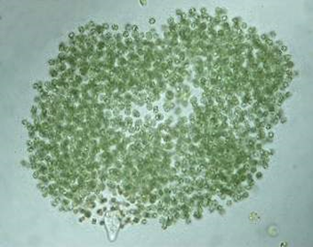

Microcystis

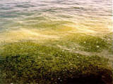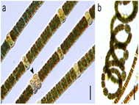

Nodularia

Microcystins are hydrophilic molecules and they are incapable of crossing passively the cell membrane but rather require active transport via specific transporters. The hepatocytes, the main target cells of MCs, are responsive to these toxins via the bile acid transportation system and the members of the Organic Anion Transporting Polypeptides (OATP). Microcystins toxicity is not restricted to the liver, indeed OATP are also localised in the kidney, gastrointestinal tract and they can also pass through the bloombrain barrier. The discovery of these new targets explains the damage caused by MCs on both renal and gastrointestinal functions and its hypothetical role in certain neurodegenerative diseases.

With regard to the mechanism of action, MC-LR and NODs are inhibitors of serine/threonine-specific Protein Phosphatases ,The inhibition results in the disruption of the cytoskeleton and the subsequent cytolysis and apoptosis involving mainly the hepatocytes. NODs, moreover, have a smaller ring-structure relative to the larger ring- structure of MC-LR which enables it to easily enter the hepatocytes and cause significant effects on the .

It has been reported that MCs and NODs can also induce the formation of Reactive Oxygen Species (ROS), reactive products belonging to the partial reduction of oxygen and involved in the induction of serious cellular damages such as genotoxicity and apoptosis.

Genotoxicity (genotoxicity describes the property of chemical agents that damages the genetic information within a cell causing mutations, which may lead to cancer.)Of cyanobacteria has been investigated both in bacterial and mammalian test systems.

In the environment, microcystin is stable during chemical hydrolysis and extremely high therefore, it may accumulate in water bodies from several days to years. However, microcystin is easily degraded through strong oxidation molecules, such as ozone and break down by aquatic bacteria, such as Sphingomonas and Pseudomonas aeruginosa

2) **Cytotoxins: Cylindrospermopsin**

Cytotoxin has various effects on human and animal cells. This toxin potentially causes hepatotoxic and neurotoxic effects and even leads to tumour development. The main cytotoxin produced by cyanobacteria is Cylindrospermopsin (CYN). This toxin is a polyketide-derived alkaloid, containing guanidine and sulfate groups. The toxicity of CYN depends on the inhibition of cytochrome P450, glutathione molecule, and protein synthesis.

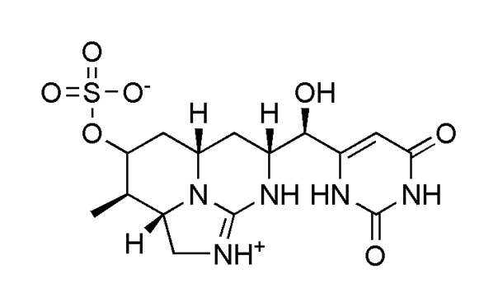

Chemical structure of Cylindrospermopsin (CYN).

Cylindrospermopsis raciborskii is the first cyanobacterium, identified as a CYN producer. Other cyanobacterial species, identified as CYN producers, include *Aphanizomenon ovalisporum, Anabaena bergii, Raphidiopsis curvata, Aphanizomenon flos-aquae, Anabaena lapponica, Lyngbya wollei, and Oscillatoria* sepcies . The release of toxins into the extracellular environment occurs mainly during declining blooms. The extracellular toxin is extremely susceptible to heat and sunlight and can be degraded easily, with90% of toxin broken down in 2 to 3 days when exposed to light . Therefore, detection of CYN toxin directly from the environment should be done immediately after toxin release.

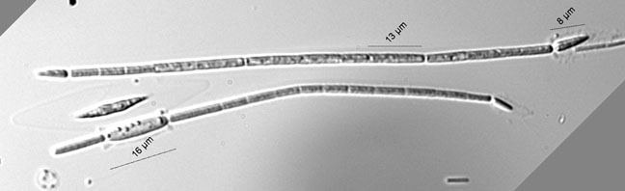

Cylindrospermopsis raciborskii

Cylindrospermopsin exerts its main action by inhibiting the protein synthesis, a mechanism which may lead to cell death. A genotoxicسمية الجينية , clastrogenicتكسر الكروموسومات and aneugenic تزايد كروموسومات activity for CYN has been also observed after the metabolic activation of the toxin by cytochrome P-450 enzymes. CYN exposure may leads to micronucleus induction, tumor initiation, fetal toxicity, (DNA) strand breaks and chromosome loss. In addition, CYN can induce stress responses in human cell lines, presumably due to the damage to cellular components, causing the activation of p53 target genes