Hypothalamus:

The hypothalamus is located near the center of the brain, above the brainstem and below the cerebrum composed of many small nuclei with diverse functions. Located above the midbrain and below the thalamus, the hypothalamus makes up the ventral diencephalon. The diencephalon is an embryologic region of the vertebrate neural tube that gives rise to posterior forebrain structures. By synthesizing and secreting neurohormones, the nuclei of the hypothalamus act as a conduit between the nervous and endocrine systems via the pituitary gland (hypophysis), regulating homeostatic functions such as hunger, thirst, body temperature, heart rate, blood pressure, and contractions of the urinary bladder.



**This diagram shows the hypothalamus and pituitary glands. The pituitary is attached to the underside of the brain at the hypothalamus by a thin stalk. The anterior pituitary receives blood  
that contains controlling factors directly from the hypothalamus. These factors either stimulate or inhibit the release of pituitary hormones. The posterior pituitary is controlled by nerves from the  
hypothalamus.**

**Hormones that are released by the hypothalamus**

Special neurons in the hypothalamus synthesize and secrete the ***hypothalamic releasing***and ***inhibitory hormones*** that control secretion of the anterior pituitary hormones. These neurons originate in various parts of the hypothalamus and send their nerve fibers to the ***median eminence*** and ***tuber cinereum****,* an extension of hypothalamic tissue into the pituitary stalk.  
The endings of these fibers are different from most endings in the central nervous system, in that their function is not to transmit signals from one neuron to another but rather to secrete the hypothalamic releasing and inhibitory hormones into the tissue fluids.  
These hormones are immediately absorbed into the hypothalamic-hypophysial portal system and carried directly to the sinuses of the anterior pituitary gland.

**The major Hypothalamic Releasing and Inhibitory Hormones Control Anterior Pituitary Secretion.**

***1.*** ***Thyrotropin-releasing hormone* (TRH),** which causes release of

thyroid-stimulating hormone  
***2.*** ***Corticotropin-releasing hormone* (CRH)**, which causes release of

adrenocorticotropin  
***3.*** ***Growth hormone–releasing hormone* (GHRH),** which causes release

of growth hormone, and ***growth hormone inhibitory hormone***

**(GHIH),** also called ***somatostatin,***which inhibits release of growth

hormone.  
***4.*** ***Gonadotropin-releasing hormone* (GnRH),** which causes release of

the two gonadotropic hormones, luteinizing hormone and follicle-

stimulating hormone  
***5. Prolactin inhibitory hormone* (PIH),** which causes inhibition of

prolactin secretion.  
There are some additional hypothalamic hormones, including one that stimulates prolactin secretion and perhaps others that inhibit release of the anterior pituitary hormones.

**the pituitary gland**:

is attached to the underside of the brain by a slender stalk. The  
pituitary gland, also called the **hypophysis,** itsits in a pocket of bone called the ***sella turcica*** which is located directly above the palate of the mouth and behind the bridge of the nose. It arises from two different tissue sources:

**Posterior pituitary** is nervous tissue (**neurohypophysis**) and **Anterior pituitary** is glandular (**adenohypophysis**).

**Posterior pituitary** -is the neural portion derived from an extension of the hypothalamus (median eminence) which remains connected throughout life by a stalk, called the infundibulum.

**Anterior pituitary** – is the glandular portion derived from the mouth epithelium (Rathke’s pouch) .It forms a cuff (pars tuberalis) around the infundibulum.

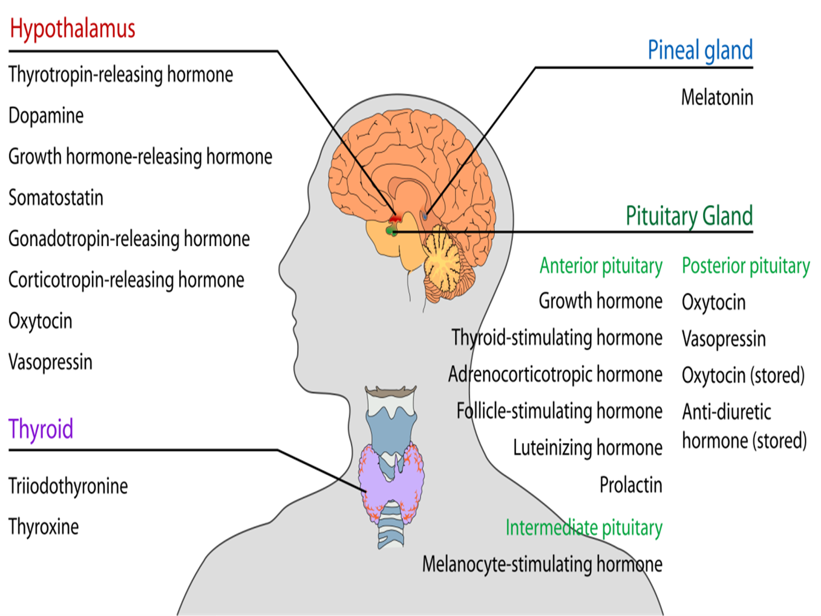

**The following hormones are released by the anterior pituitary:**

1. **Growth Hormone** stimulates bone and muscle cells to grow.
2. **Prolactin** causes the mammary glands to produce milk.
3. **Follicle Stimulating Hormone (FSH)** and **Luteinizing**

**Hormone (LH),** known collectively as **gonadotropins,** stimulate

hormone and gamete production by the **gonads (testes and ovaries).**

**4. Thyroid Stimulating Hormone (TSH)** causes the thyroid to produce

thyroid hormone.

1. **Adrenocorticotropic Hormone (ACTH)** stimulates the adrenal

cortex to produce corticosteroids, especially during periods of stress.

1. **Melanocyte Stimulating Hormone (MSH)** may have a role in fat

metabolism.

1. **Endorphins,** which are also produced by the brain, reduce the

perception of pain.

**The posterior pituitary**

is an extension of the brain. It releases two hormones—**oxytocin** and **antidiuretic hormone (ADH)**—that are made in specialized cells in the **hypothalamus**.  
The hormones are transported down nerve cells into the  
pituitary, where they are stored. The hypothalamus signals  
for their release by direct nerve signals to allow for quicker  
secretion. **Oxytocin** stimulates the uterus to contract during  
labor and stimulates the breast to start releasing milk when  
a baby nurses. **Antidiuretic hormone** reduces urine output by acting on the collecting ducts of the kidney.

**Factors That Stimulate or Inhibit Secretion of Growth Hormone**

**Stimulate Growth Hormone Secretion**

**Decreased blood glucose  
  
Decreased blood free fatty acids  
  
Increased blood amino acids (arginine)  
  
Starvation or fasting,protein deficiency  
  
Trauma, stress, excitement Exercise  
  
Testosterone, estrogen  
  
Deep sleep (stages II and IV)  
  
Growth hormone–releasing hormone  
  
Ghrelin**

**Inhibit Growth Hormone Secretion**

**Increased blood glucose**

**Increased blood free fatty acids**

**Aging**

**Obesity**

**Growth hormone inhibitory hormone (somatostatin)**

**Growth hormone (exogenous)**

**Somatomedins (insulin-like growth factors)**

**Increased blood glucose**

**Increased blood free fatty acids**

**Aging**

