Endocrine system
The endocrine system is the collection of glands of an organism that secrete hormones directly into the circulatory system to be carried towards distant target organs, The endocrine system is in contrast to the exocrine system, which secretes its hormones to the outside of the body using ducts. The endocrine system is an information signal system like the nervous system, Its’ effects are slow to initiate, and prolonged in their response, lasting from a few hours up to weeks.

The major endocrine glands include:
the hypothalamus, pineal gland , pituitary gland , pancreas, ovaries, testes,
thyroid gland, parathyroid gland, and adrenal glands.

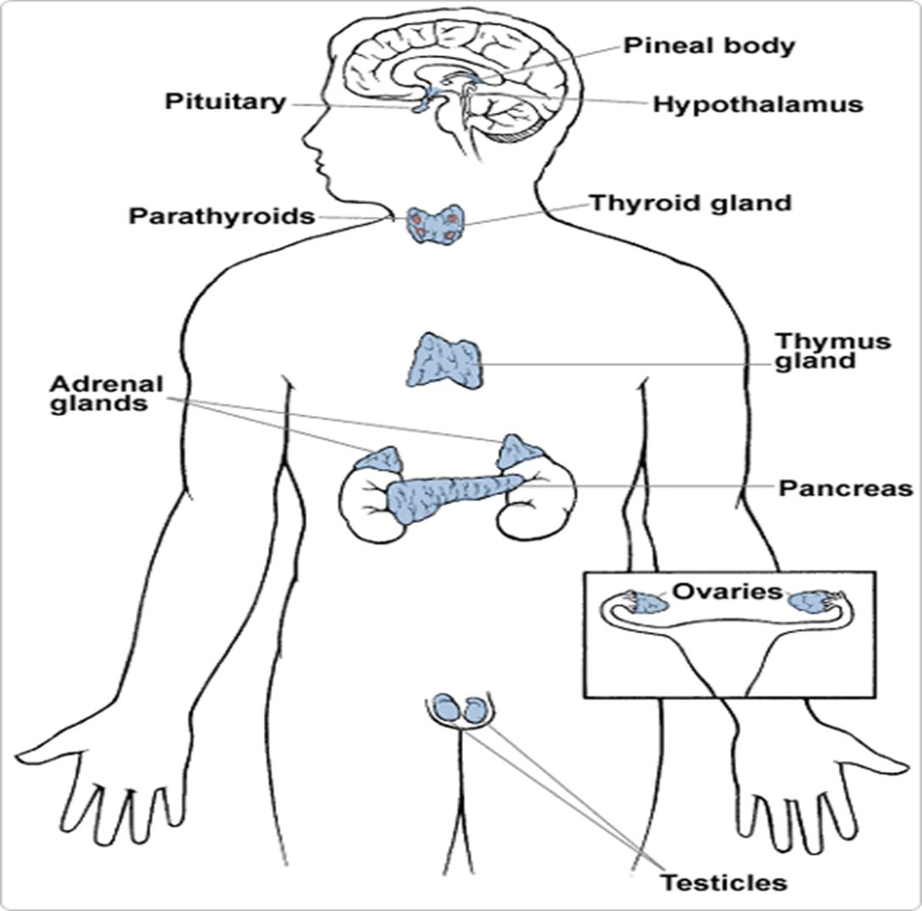
(Figure 1) shows the anatomical loci of the major endocrine glands and endocrine tissues of the body, except for the placenta, which is an additional source of the sex hormones.
A hormone is a signaling molecules produced by glands in multicellular organisms that are transported by the circulatory system to target distant organs to regulate physiology and behaviour, hormone is sometimes extended to include chemicals produced by cells that affect the same cell (autocrine or intracrine signalling) or nearby cells (paracrine signalling), Hormones are used to communicate between organs and tissues for physiological regulation and behavioral activities, such as digestion, metabolism, respiration, tissue function, sensory perception, sleep, excretion, lactation, stress, growth and development, movement, reproduction, and mood.
Target cell:
any cell that has a specific receptor for an antigen or antibody or hormone or drug.
Receptor:
a molecule on the cell surface (cell-surface or membrane receptor) or within a cell, usually in its nucleus (nuclear receptor) that recognizes and binds with specific molecules, producing some effect in the cell; e.g., the cell-surface receptors of immunocompetent cells that recognize antigens, complement components, or lymphokines; or those of neurons and target organs that recognize neurotransmitters or hormones.
Chemical Structures
Hormones can be grouped according to chemical structure, Structures dictate if the hormone prefers to be surrounded by water or fat (water or fat soluble):
1. Steroid hormones are fat-soluble molecules made from cholesterol. Among these are the three major sex hormones groups: estrogens, androgens and progesterones. Males and females make all three, just in different amounts. Steroids pass into a cell's nucleus, bind to specific receptors and genes and trigger the cell to make proteins.
2. Amino acid derivatives, such as epinephrine, are water-soluble molecules derived from amino acids (the building blocks of protein). These hormones are stored in endocrine cells until needed. They act by binding to protein receptors on the outside surface of the cell. The binding alerts a second messenger molecule inside the cell that activates enzymes and other cellular proteins or influences gene expression.

3. polypeptide hormones such as Insulin, growth hormone, prolactin and other water-soluble consist of long chains of amino acids, from several to 200 amino acids long. They are stored in endocrine cells until needed to regulate such processes as metabolism, lactation, growth and reproduction.

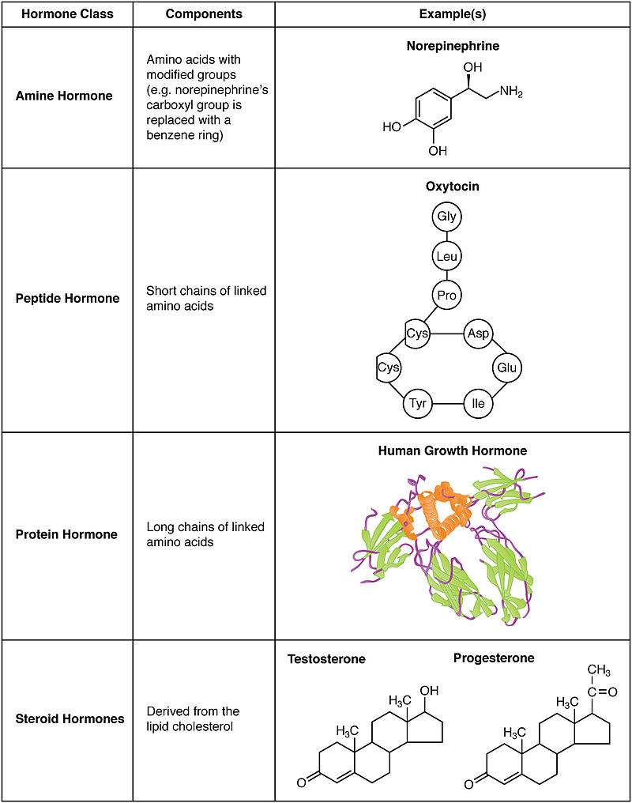

Type of receptors depending on the location:
Hormone receptors are large proteins, and each cell that is to be stimulated usually has some 2000 to 100,000 receptors. Also, each receptor is usually highly specific for a single hormone, which determines the type of hormone that will act on a particular tissue. The target tissues that are affected by a hormone are those that contain its specific receptors.

The locations for the different types of hormone receptors are generally the following:
1. In or on the surface of the cell membrane. The membrane
receptors are specific mostly for the protein,
peptide, and catecholamine hormones.
2. In the cell cytoplasm. The primary receptors for the
different steroid hormones are found mainly in the
cytoplasm.
3. In the cell nucleus. The receptors for the thyroid
hormones are found in the nucleus and are believed
to be located in direct association with one or more
of the chromosomes.

FEEDBACK CONTROL OF HORMONE SECRETION:
Negative Feedback: Prevents Overactivity of Hormone Systems. Although the plasma concentrations of many hormones fluctuate in response to various stimuli that occur throughout the day, all hormones studied thus far appear to be closely controlled. In most instances, this control is exerted through negative feedback mechanisms that ensure a proper level of hormone activity at the target tissue. After a stimulus causes release of the hormone, conditions or products resulting from the action of the hormone tend to suppress its further release. In other words, the hormone has a negative feedback effect to prevent oversecretion of the hormone or overactivity at the target tissue, only when the target tissue activity rises to an appropriate level will feedback signals to the endocrine gland become powerful enough to slow further
secretion of the hormone. The control of blood sugar(glucose) by insulin is a good example of a negative feedback mechanism. When blood sugar rises, receptors in the body sense a change. In turn, the control center (pancreas) secretes insulin into the blood effectively lowering blood sugar levels. Once blood sugar levels reach homeostasis, the pancreas stops releasing insulin.

Positive feedback: occurs when the biological action of the hormone causes additional secretion of the hormone. One example of positive feedback is the surge of luteinizing hormone (LH) that occurs as a result of the stimulatory effect of estrogen on the anterior pituitary before ovulation. The secreted LH then acts on the ovaries to stimulate additional secretion of estrogen, which in turn causes more secretion of LH. Eventually, LH reaches an appropriate concentration and
typical negative feedback control of hormone secretion is
then exerted.
