Electron Microscope (EM)
Electron microscopy (EM) is an electron beam which is focused into a small probe across the surface of a specimen. The first electromagnetic lens was developed in 1926 by Hans Busch. Electron microscope follows the same principle of compound microscope, but uses electrons beam as an illumination source instead of light.
Electron microscopes allow biologists to explore cells in more details. To observe the organelles such as: Mitochondria, Ribosomes, Endoplasmic reticulum (ER), Golgi apparatus and Lysosomes.
Heavy metals (such as lead) are used to stain cells prior to examine via EM. The stain is more visible in organelles than in the surrounding cytoplasm. Defects in a cell’s organelles are easily seen. Electron microscopes are used in the scientific laboratories and many industries, such as forensics, nanotechnology and mining.

Disadvantages of electron microscopes
1- It is a large machines
2- Training is required
3- It is very expensive
4- Specimens are required a lot of preparation.
5- The specimens are mounted in plastic, which means that only dead cells can be viewed.

There are two types of electron microscopes
- Scanning electron microscope (SEM)
The mode of action for the SEM is similar to compound microscope however, an electron beams behave like waves which focus via using a magnetic field rather than uses of ordinary lenses. Metallic coating is required for the biological specimens. The electron microscopes are used to achieve up to 100,000x magnification and more than 1000 x resolution than the light microscope.

Components of the SEM
1- Lens: It is an electrical field and are not the optical materials (like glass
Electron optics:
a- Condenser lens: It is focusing the electron beam to the objective lens.
b- Objective lens: It is responsible for size of electron beam impinging on sample surface
2- Electron beam.
3- Transducers (detectors).

2- Transmission Electron Microscope:
In transmission electron microscopy (TEM), a beam of highly focused electrons are directed toward a thinned sample (<200 nm). Normally no scanning required helps the high resolution, compared to SEM.
Advantages:
1- TEMs offer the most powerful magnification, potentially over one million times or more
2- Direct imaging of crystalline lattice.
3- No metallic stain-coating is needed, thus convenient for structural imaging of organic materials.
4- Images are high-quality and detailed.
5- Electrons can only travel through a vacuum, so the specimen must be completely dehydrated.
6- Electrons have poor penetrating ability which the image contrast results when electrons are scattered by the specimen. Therefore specimens are usually “stained” with a coat of heavy metal (uranium, osmium, and tungsten) to increase scattering ability.
Disadvantages:
- TEMs are large and very expensive
- Images are black and white
- The preparation is limited to an electron-transparent sample (due to the conductivity or electron density, and sample thickness).

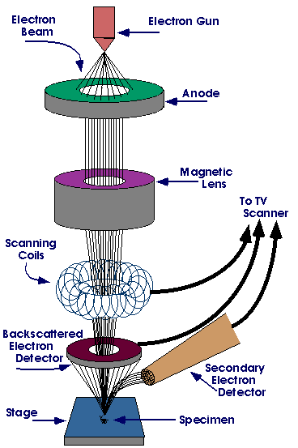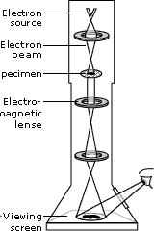

Figure (1) A. Scanning Electron microscope B. Transmission electron microscope

New Techniques in Microscopy:
- Confocal Microscopy (Confocal Scanning Laser Microscope)
Laser scanning confocal microscopy is an invaluable tool for a wide range of investigations in the biological and medical sciences for imaging thin optical sections in living and fixed specimens ranging in thickness up to 100 micrometers. The basic concept of confocal microscopy was originally developed by Marvin Minsky in the mid-1950s (patented in 1961) when he was a postdoctoral student at Harvard University as Minsky wanted to image neural networks in unstained preparations of brain tissue. The basic key to the confocal approach is the use of spatial filtering techniques to eliminate out-of-focus light or glare in specimens whose thickness exceeds the immediate plane of focus

Advantages of using confocal microscope
Confocal microscopy offers several advantages over conventional wide field optical microscopy:
- The ability to control depth of field, elimination or reduction of background information away from the focal plane.
- The capability to collect serial optical sections from thick specimens.

Transmission Electron Microscope (TEM) | Scanning Electron Microscope (SEM)
- Pass a beam of electrons through the specimen. The electrons that pass through the specimen are detected on a fluorescent screen on which the image is displayed.  - Thin sections of specimen are needed for transmission electron microscopy as the electrons have to pass through the specimen for the image to be produced.  - This is the most common form of electron microscope and has the best resolution  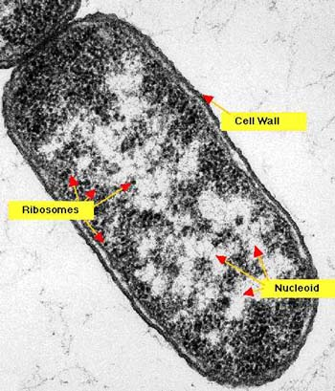  Bacterium (TEM) | - Pass a beam of electrons over the surface of the specimen in the form of a ‘scanning’ beam.  - Electrons are reflected off the surface of the specimen as it has been previously coated in heavy metals.  - It is these reflected electron beams that are focused of the fluorescent screen in order to make up the image.  - Larger, thicker structures can thus be seen under the SEM as the electrons do not have to pass through the sample in order to form the image. This gives excellent 3-dimensional images of surfaces  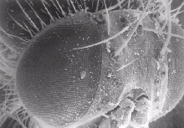  - However the resolution of the SEM is lower than that of the TEM.  A head and the right eye of a fly (SEM)

Light Microscope | Electron Microscope
Cheap to purchase | Expensive to buy
Cheap to operate. | Expensive to produce electron beam.
Small and portable. | Large and requires special rooms.
Simple and easy sample preparation. | Lengthy and complex sample prep.
Material rarely distorted by preparation. | Preparation distorts material.
Vacuum is not required. | Vacuum is required.
Natural color of sample maintained. | All images in black and white.

Reference
- Terence Allen. 2015. Microscopy: A Very Short Introduction. Oxford University Press

- Michael Hoppert, Cambridge University Press; 4 edition (April 13, 2000), Microscopic Techniques in Biotechnology 1st Edition

- ASM'S Curriculum Recommendations: Microbiology Majors Program.

