Cell counting

Cell counting is any of various methods for the counting or similar quantification of cells in the life sciences, including medical diagnosis and treatment. It is an important subset of cytometry, with applications in research and clinical practice. For example, the complete blood count can help a physician to determine why a patient feels unwell and what to do to help. Cell counts within liquid media (such as blood, plasma, lymph, or laboratory reinstate) are usually expressed as a number of cells per unit of volume, thus expressing a concentration (for example, 5,000 cells per millilitre). By the counting of cells in a known small volume, the concentration can be mediated. Examples of the need for cell counting include:

In medicine, the concentration of various blood cells, such as red blood cells and white blood cells, can give crucial information regarding the health situation of a person.

In cell therapy, to control the dose of cells administered to a patient.

Similarly, the concentration of bacteria, viruses and other pathogens in the blood or in other bodily fluids can reveal information about the progress of an infectious disease and about the degree of success with which the immune system is dealing with the infection.

The cell concentration needs to be known for many experiments in molecular biology, in order to adjust accordingly the amount of reagents and chemicals that are to be applied in the experiment.

Studies that examine the growth rate of microorganisms (in other words: how fast they divide to create new cells) require cell counting.

Measurements of cell viability, i.e. measuring and calculating the fraction of dead and live cells, for example of cells exposed to poison.
Cell counting types included to: direct and indirect ways. Direct cell counting divided to two ways: manual and automatically cell counting

Manual Cell Counting
There are several methods for cell counting. Some are primitive and do not require special equipment, thus can be done in any biological laboratory, whereas others rely on sophisticated electronic appliances.

Counting chamber
A counting chamber (also known as hemocytometer), is a microscope slide that is especially designed to enable cell counting. The hemocytometer has two gridded chambers in its middle, which are covered with a special glass slide when counting. A drop of cell culture is placed in the space between the chamber and the glass cover, filling it by capillarity. Looking at the sample under the microscope, the researcher uses the grid to manually count the number of cells in a certain area of known size. The separating distance between the chamber and the cover is predefined, thus the volume of the counted culture can be calculated and with it the concentration of cells. Cell viability can also be determined if viability dyes are added to the fluid.
Their advantage is being cheap and fast; this makes them the preferred counting method in fast biological experiments in which it needs to be merely determined whether a cell culture has grown as expected. Usually the culture examined needs to be diluted, otherwise the high density of cells would make counting impossible. The need for dilution is a disadvantage, as every dilution adds inaccuracy to the measurement.
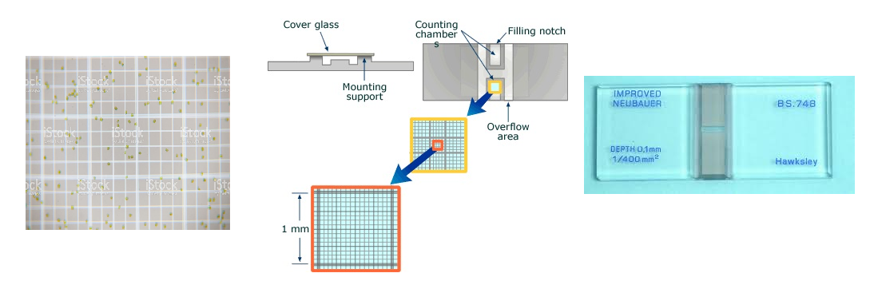

Plating and CFU counting
To quantify the number of cells in a culture, the cells can be simply plated on a petri dish with growth medium. If the cells are efficiently distributed on the plate, it can be generally assumed that each cell will give rise to a single colony or Colony Forming Unit (CFU). The colonies can then be counted, and based on the known volume of culture that was spread on the plate, the cell concentration can be calculated.
As is with counting chambers, cultures usually need to be heavily diluted prior to plating; otherwise, instead of obtaining single colonies that can be counted, a so-called "lawn" will form: thousands of colonies lying over each other. Additionally, plating is the slowest method of all: most microorganisms need at least 12 hours to form visible colonies.
Although this method can be time consuming, it gives an accurate estimate of the number of viable cells (because only they will be able to grow and form visible colonies). It is therefore extensively used in experiments aiming to quantify the number of cells resisting drugs or other external conditions (for instance the Luria–Delbrück experiment or the gentamicin protection assay). In addition, the enumeration of colonies on agar plates can be greatly facilitated by using colony counters.
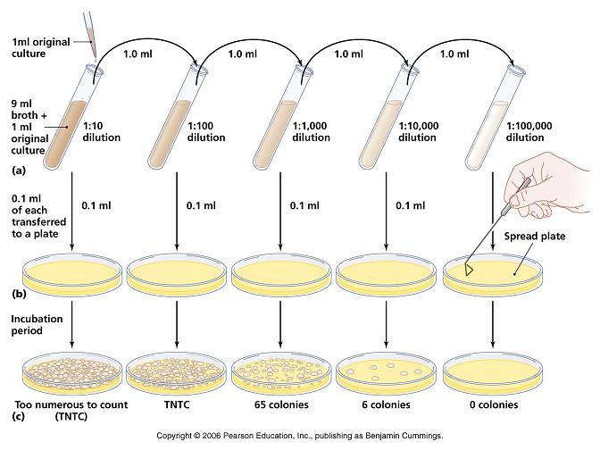

Automated Cell Counting

Electrical resistance
A Coulter counter is an appliance that can count cells as well as measure their volume. It is based on the fact that cells show great electrical resistance; in other words, they conduct almost no electricity. In a Coulter counter the cells, swimming in a solution that conducts electricity, are sucked one by one into a tiny gap. Flanking the gap are two electrodes that conduct electricity. When no cell is in the gap, electricity flows unabated, but when a cell is sucked into the gap the current is resisted. The Coulter counter counts the number of such events and also measures the current (and hence the resistance), which directly correlates to the volume of the cell trapped. A similar system is the CASY cell counting technology.
Coulter and CASY counters are much cheaper than flow cytometers, and for applications that require cell numbers and sizes, such as cell-cycle research, they are the method of choice. Its advantage over the methods above is the large number of cells that can be processed in a short time, namely: thousands of cells per second. This offers great accuracy and statistical significance.
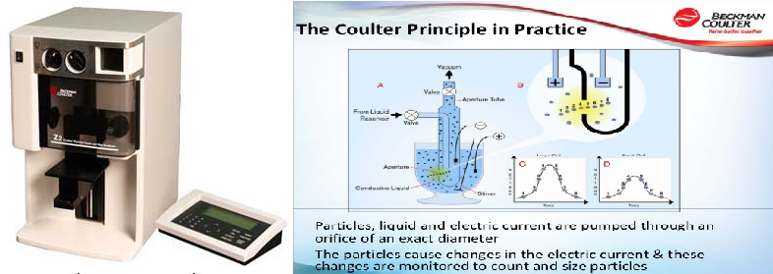
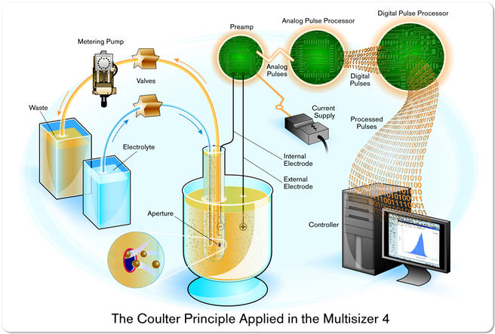

Flow cytometry
Flow cytometry is by far the most sophisticated and expensive method for cell counting. In a flow cytometer the cells flow in a narrow stream in front of a laser beam. The beam hits them one by one, and a light detector picks up the light that is reflected from the cells.
Flow cytometers have many other abilities, such as analyzing the shape of cells and their internal and external structures, as well as measuring the amount of specific proteins and other biochemicals in the cells. Therefore, flow cytometers are rarely purchased for the sole purpose of counting cells.
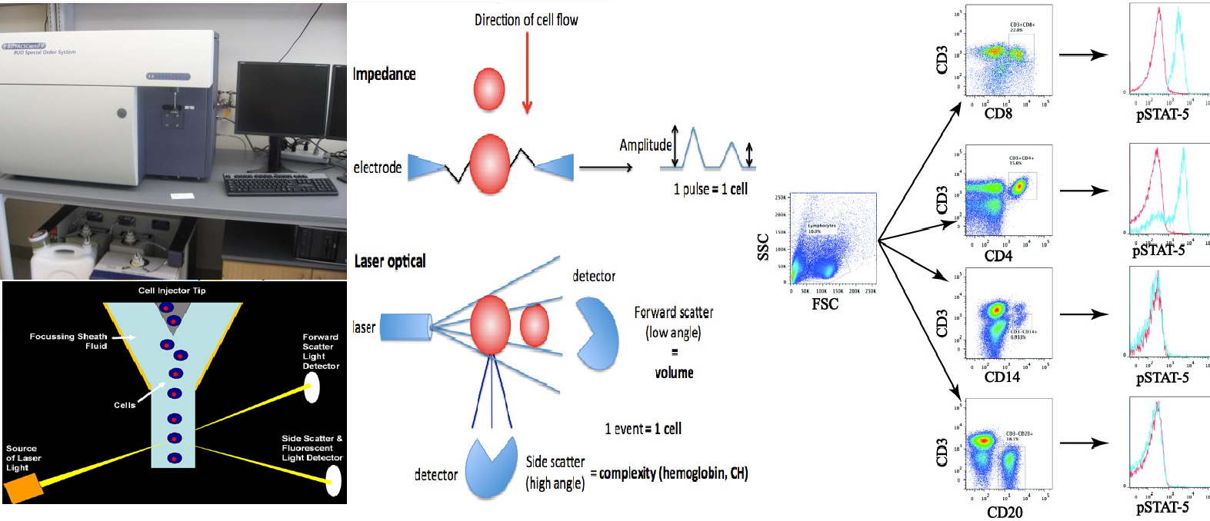

Image analysis
Recent approaches consider the use of high-quality microscopy images over which a statistical classification algorithm is used to perform automated cell detection and counting as an image analysis task. Generally performs with a constant error rate as an off-line (batch) type process. A range of image classification techniques can be employed for this purpose.
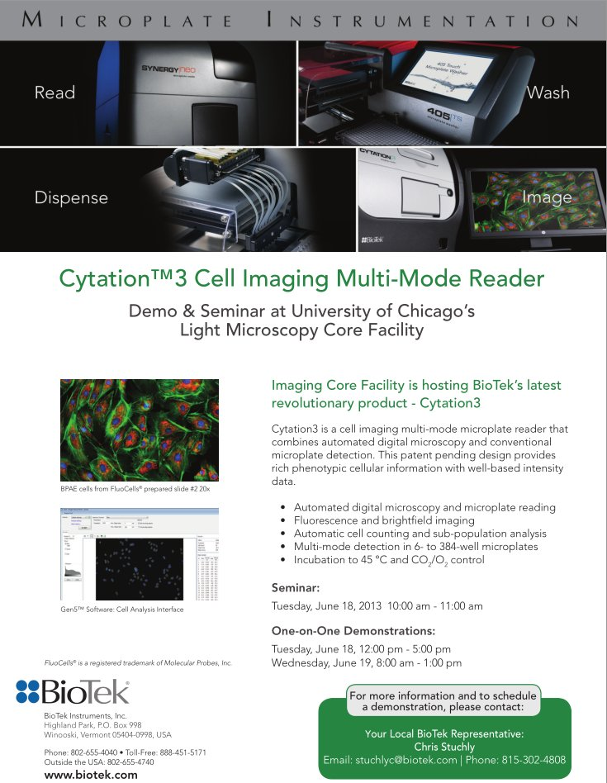

Indirect Cell Counting

Spectrophotometry
Cell suspensions are turbid. Cells absorb and scatter the light. The higher the cell concentration, the higher the turbidity. Spectrophotometer scan measure intensity of light very accurately. The cell culture is placed in a transparent cuvette and the absorption is measured relative to medium alone. Optical density (OD) is directly proportional to the biomass in the cell suspension in a given range that is specific to the cell type. Using spectrophotometry for measuring the turbidity of cultures is known as turbidometry.
This has made spectrophotometry the methods of choice for measurements of bacterial growth and related applications. Spectrophotometry's drawback is its inability to provide an absolute count or distinguish between living and dead cells.
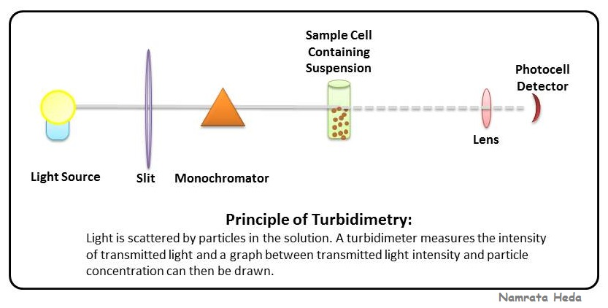

Impedance microbiology
Impedance microbiology is a rapid microbiological technique used to measure the microbial concentration (mainly bacteria but also yeasts) of a sample by monitoring the electrical parameters of the growth medium. It is based on the fact that bacteria metabolism transforms uncharged (or weakly charged) compounds into highly charged compounds thus changing the growth medium electrical properties. The microbial concentration is estimated on the time required for the monitored electrical parameters to deviate from the initial baseline value. Different instruments (either built in a laboratory or commercially available) to measure the bacterial concentration using Impedance Microbiology are available.
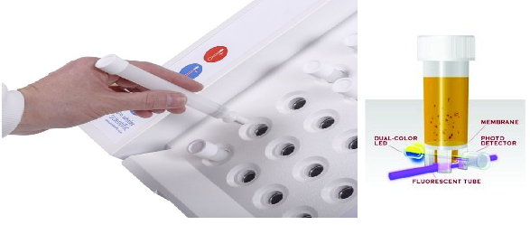
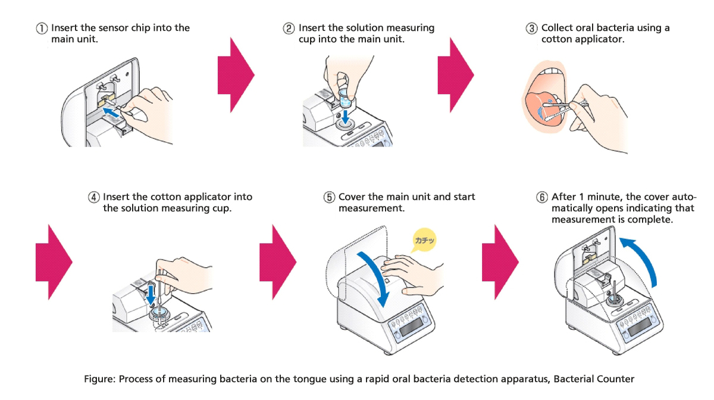

Cytometry
Cytometry is the measurement of the characteristics of cells. Variables that can be measured by cytometric methods include cell size, cell count, cell morphology (shape and structure), cell cycle phase, DNA content, and the existence or absence of specific proteins on the cell surface or in the cytoplasm. Cytometry is used to characterize and count blood cells in common blood tests such as the complete blood count. In a similar fashion, cytometry is also used in cell biology research and in medical diagnostics to characterize cells in a wide range of applications associated with diseases such as cancer and AIDS.
the early history of cytometry is closely associated with the development of the blood cell counting. Through the work of Karl von Vierordt, Louis-Charles Malassez, Karl Bürker and others blood cell concentration could by the late 19th century be accurately measured using a blood cell counting chamber, the hemocytometer, and an optical microscope.
Until the 1950s the hemocytometer was the standard method to count blood cells. In blood cell counting applications the hemocytometer has now been replaced by electronic cell counters. However, the hemocytometer is still being used to count cells in cell culture laboratories. Successively the manual task of counting, using a microscope, is taken over by small automated image cytometers.

Cytometric devices

Image cytometers
Image cytometry is the oldest form of cytometry. Image cytometers operate by statically imaging a large number of cells using optical microscopy. Prior to analysis, cells are commonly stained to enhance contrast or to detect specific molecules by labeling these with fluorochromes. Traditionally, cells are viewed within a hemocytometer to aid manual counting.
Since the introduction of the digital camera, in the mid-1990s, the automation level of image cytometers has steadily increased. This has led to the commercial availability of automated image cytometers, ranging from simple cell counters to sophisticated high-content screening systems.
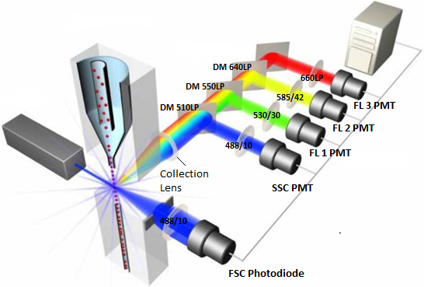

Flow cytometers
Due to the early difficulties of automating microscopy, the flow cytometer has since the mid-1950s been the dominating cytometric device. Flow cytometers operate by aligning single cells using flow techniques. The cells are characterized optically or by the use of an electrical impedance method called the Coulter principle. To detect specific molecules when optically characterized, cells are in most cases stained with the same type of fluorochromes that are used by image cytometers. Flow cytometers generally provide less data than image cytometers, but have a significantly higher throughput.

Cell sorters
Cell sorters are flow cytometers capable of sorting cells according to their characteristics. The sorting is achieved by using technology similar to what is used in inkjet printers. The fluid stream is broken up into droplets by a mechanical vibration. The droplets are then electrically charged according to the characteristics of the cell contained within the droplet. Depending on their charge, the droplets are finally deflected by an electric field into different containers.
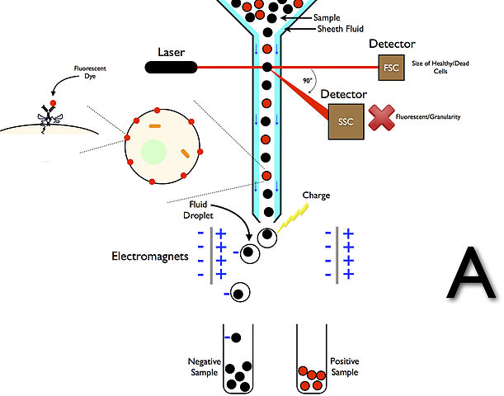

Time-lapse cytometers
Conventional flow and image cytometers have the disadvantage of not being able to observe cells over time. The rapid decrease in the cost of digitally storing and processing video information has led to the development of image cytometers which monitor cultured cells using time-lapse video recordings. After recording, the video is computer processed to track cytometric parameters over time. The historic information available for each cell allow time-lapse cytometers to predict the fate of a cell or to characterize its state without using the phototoxic fluorochromes that are commonly used by flow and image cytometers.
A key characteristic of time-lapse cytometers is their use of non heat-generating light sources such as light-emitting diodes. This allows a time-lapse cytometer to be placed inside a conventional cell culture incubator to facilitate continuous observation of cellular processes without heat building up inside the incubator.
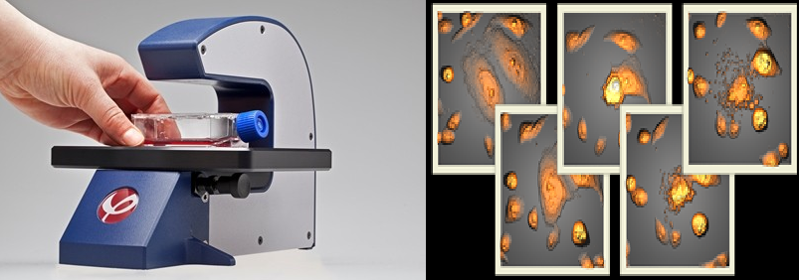
- Mass cytometry
Mass cytometry is a mass spectrometry technique based on inductively coupled plasma mass spectrometry and time of flight mass spectrometry used for the determination of the properties of cells (cytometry). In this approach, antibodies are conjugated with isotopically pure elements, and these antibodies are used to label cellular proteins. Cells are nebulized and sent through an argon plasma, which ionizes the metal-conjugated antibodies. The metal signals are then analyzed by a time-of-flight mass spectrometer. The approach overcomes limitations of spectral overlap in flow cytometry by utilizing discrete isotopes as a reporter system instead of traditional fluorophores which have broad emission spectra.
