Biology is a hand on science, and biology students are usually required to spend some time in the laboratory.
A laboratory (Lab) is a facility that provides controlled conditions in which scientific or technological research, experiments, and measurement may be performed. However, laboratory techniques are defined as all methods, procedures, and tests performed in the laboratory with an intended application to the diagnosis of disease or understanding of physiological functioning. These techniques include examination of microbiological, cytological, chemical, and biochemical specimens both normal and pathological.
The types of activities a student will perform vary depending on the exact field they are in. Even so, there are some basic techniques that all beginning lab students should understand such as Laboratory safety and understanding warning signs.
Laboratory safety and understanding warning signs
Conducting biological tests may result in serious diseases and injuries due to the following risks:
- The existence of highly infectious and deadly microbes (biological hazard).
- The presence of highly toxic substances to human cells causes death or mutations, drugs, and dangerous chemicals (chemical hazards).
- The presence of radioactive material (physical hazards).
- Sharp and conclusive materials for human tissues (tools hazards).
Biological hazard:
Biological hazards encompass microbes, recombinant organisms, viral vectors, and biological agents introduced into experimental animals. The most prevalent biological hazards are simple allergens associated with the use and care of laboratory animals. Health surveys of people working with laboratory animals show that up to 56% are affected by animal-related allergies. In a survey of 5,641 workers from 137 animal facilities, 23% had allergic symptoms related to laboratory animals. However, of the nearly 52 million deaths in the world each year, infectious diseases account for more than 17 million. The most prevalent of these infectious diseases include:
- Gastrointestinal infections (faeces and vomit) (Salmonella, Vibrio cholerae, Shigella, etc.).
- Respiratory infections (inhalation of air-born infectious microbes) (secretions and saliva) (TB, Pneumonia, SARS virus, and measles).
- Eye infections (Eye secretions) (Herpes virus )
- Skin infections (Pus) (Streptococcus, Staph.)
- Anthrax (Skin secretions) (Bacillus anthracis )
- Meningitis (Cerebrospinal fluid) (Neisseria meningitides)
- AIDS (Blood, sexual secretions, other body fluids)(HIV)
- Hemorrhagic fever (Blood and secretions)(Lassa, Ebola viruses)
- Hepatitis: Hepatitis A virus (Faeces), Hepatitis B and C ( Blood & other fluids)
- Avian influenza (Blood, feces) (H5N1 virus)
Some accidental exposure to blood & body fluids include viral infections such as: AIDS, Hepatitis B, and Hepatitis C. World health organization (WHO) estimated that at world level accidents caused by contaminated sharps accounted for 66,000 cases of infection with the hepatitis B virus, 16,000 cases of infection with hepatitis C virus, and 5,000 cases of HIV infection. The following table demonstrate the survival time of these pathogens:
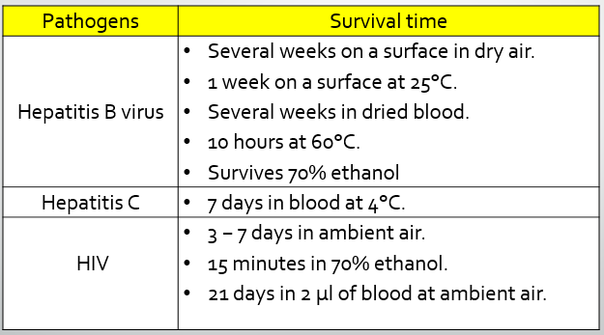

Infection ways
- Acupuncture and sharp tools contaminated: The fact that most of the injuries due to throw needles in black garbage bags and here must be applied classification system for medical and non-medical waste where the waste is divided as follows:
- General waste, such as (food scraps, leaves, plastic cans, cans of soft drinks, paper tissues or anything similar that not contaminated with the waste of patients), have to collect and place in their own bags.
- Medical waste or patient waste resulting from their care from various departments, such as (operating rooms, recovery rooms, specialized hospital sections, and analytical laboratories of all kinds), are placed in their own bags and assembled and handled with great care.
- The sharp substances and residues such as (needles, scalpels and broken glass) in both cases, contaminated and uncontaminated, are placed in boxes, not bags.
- Eating and drinking in contaminated places: Therefore, it is important to emphasize not to eat or drink in biological laboratories.
- infection by touch or breathing, although it is rare, so workers should wear gloves, gloves and sometimes gags if there was a risk of respiratory infection.
Chemical hazard:
It includes burns from chemicals used in some biological experiments such as acids and incineration bases, often through the dilution method used. Cleaning agents and disinfectants, drugs, anesthetic gases, solvents, paints, heavy metals (broken thermometers or manometers), and compressed gases are also examples of chemical hazards. Potential exposures to chemical hazards can occur both during use and with poor storage. The use of chemicals in research laboratories is inevitable, and the potential for harm or injury could be significant if they are misused or mishandled. Therefore, Occupational Safety and Health Administration (OSHA) has developed a standard known as the “OSHA Lab Standard,” for laboratories to identify hazards, determine employee exposures, and develop a chemical hygiene plan including standard operating procedures to identify the particular hazards and precautions required for safe use based on the specific personal protective equipment (PPE) such as; Gloves (protect hands), Gowns / aprons (protect skin and / or clothing), Masks (protect mouth / nose), Respirators (protect respiratory tract from airborne infectious agents), Goggles (protect eyes), Face shields (protect face, mouth, nose and eyes), Shoe covers (protect feet).

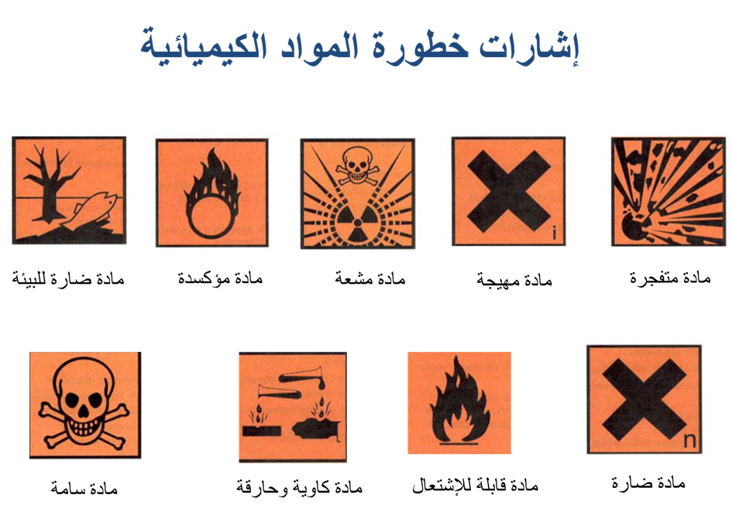
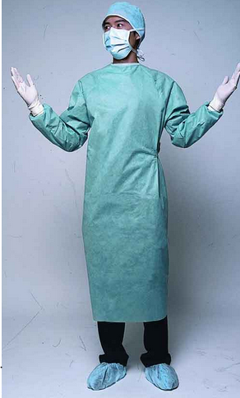
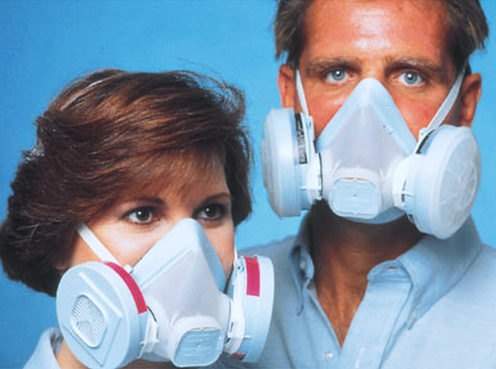
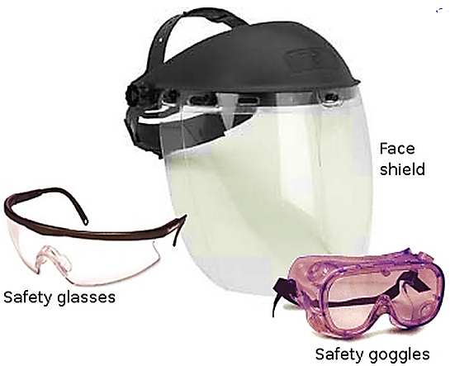

Physical hazard:
It includes the possibility of exposure to radioactive materials or carcinogenicity which can cause genetic mutations. These can easily be avoided by wearing a vest and gloves. Slips, trips, and falls are very common due to poor housekeeping and working in wet locations. Also the ergonomic hazards of lifting, pushing, pulling, and repetitive tasks such as working for extended periods in a biosafety cabinet, or looking at slides on a microscope for extended periods are the most obvious physical hazards. Therefore, ignoring these can have potentially serious consequences

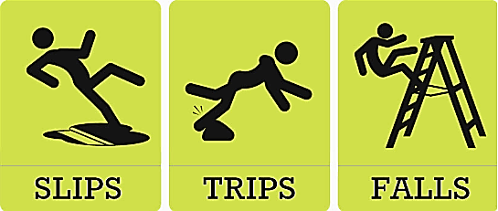
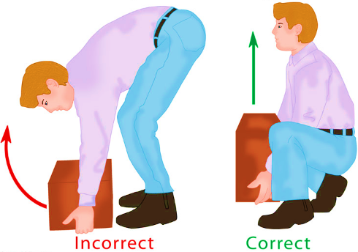
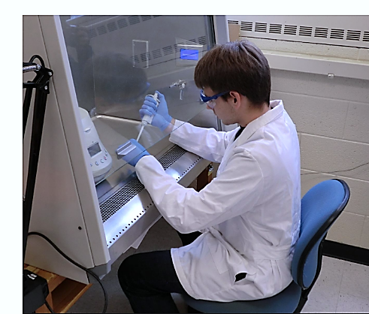
Tools hazard
It includes fires and wounds.
- Fire: the main causes of fires are:
- Ignorance, neglect and indifference.
- Poor storage of flammable materials
- Electrical faults that are next to inflammable materials
- Set fire near dangerous places
- The presence of liquid waste and flammable oils on the floor of the laboratory
- Occurrence of sparks or unusually high temperature
- Wounds: it results from wrong use of sharp substances which may cause bleeding.

