**Lecture 1 Invertebrates**

Animals species that do not develop a vertebral column includes many familiar like insects – worms – clams - carbs - octopus and other.

-The largest phylum or super-sub phylum is also included within Invertebrates:

1. protozoa

2. poriferan

3. Cnidaria (coelenterata)

4. Aschelminthes

5. Mollusca

6. Annelida

7. Echinodermata

8. Arthropoda

9. Chordata

The animal's kingdom can be classified according to cellular constriction to:

1. Protozoa … one cell animals.
2. Parazoa … multicellular animals which loosely aggregated cells
3. Metazoa … multicellular animals in which cells are arranged in germ layers.

Metazoa can be classified according to their germ layers to:

1. Diploblastea …. Have two germs layers' ectoderm and endoderm
2. Triploblastea …. Have three germs layers' ectoderm, mesoderm and endoderm.

* Animals also divided according to their **symmetry.**

The concept symmetry allow for division of a whole body into two or more equal portions by separation along lines or planes.

1. A symmetrical animal: There are no planes of regular symmetry like (sponges)
2. Spherical symmetry: the body halves in all direction and planes like (volvox).
3. Radial symmetry: lines of symmetry exist, but in the vertical planes only like (cnidaria).
4. Bilateral symmetry: found in freely mobile animals with consequent development of dorsal, ventral surface, anterior and posterior ends. only one plane of symmetry divides the animals into symmetrical halves like (Annelida).

* Coelom: it is space between the body wall and the alimentary canal
* Triploblast animals may be classified according to their Coelom into:

1. A coelomate: The body volume is filled with mesenchyme and other tissues.
2. Pseudo coelomate: there is space between the body wall and the alimentary canal

3. Eucoelomate: The space between the body wall and the alimentary canal filled with mesenchymal tissues.

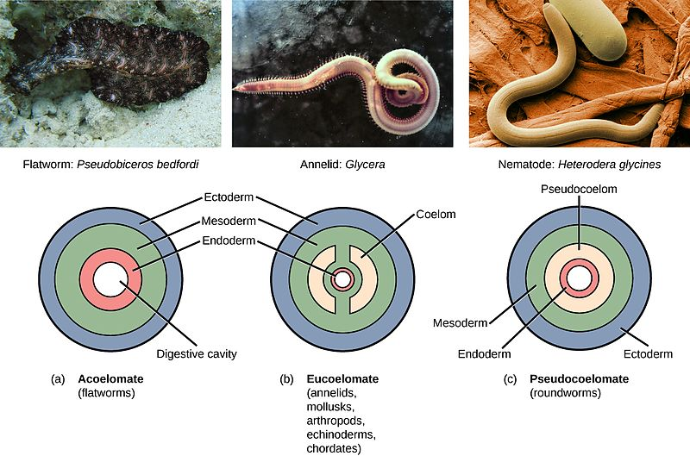

**Lecture 2 Invertebrates**

Phylum: protozoa

**General characters:**

1. Unicellular (or colonial) and microscopic animals.
2. Most are motile by flagella, cilia or pseudopodia.
3. Most protozoal species are aerobic, but some anaerobic species have been found in the human intestine and animal rumen
4. They occur in all habitats including marine, freshwater, and terrestrial including soil.
5. The food inters to the cell (body of animal) by mouth of cell or by body wall but the digestive happens in food vacuole in cytoplasm.
6. Osmoregulation in freshwater protozoans is accomplished by contractile vacuoles that pump hypoosmotic urine from the cytoplasm back into the environment.
7. Most protozoa reproduce by asexual methods such as : (Binary fission , budding , multiple fission , plasmotomy )

Sexual reproduction such as: (syngamy , conjugation).

1. Some species are parasites of plants and human.

**Classification of protozoa**

Phylum protozoa

1. Class :Flagellata
2. Order: cryptomonadina …… *Chilomonas*
3. Order: phytomonadina…….. *Volvox*
4. Order: Euglenoidina…………*Euglena*
5. Order: Diplomonadina………*Giardia*
6. Order: Opalinina……………. *Opalina*
7. Class: Sarcondina
8. Order: Amoebina……………*Amoeba*
9. Class: Sporozoa
10. Order: Gregarinida………*Gregarina*
11. Order: Coccidia ………… *plasmodium*
12. Class: Ciliata
13. Order: Holotricha………*Paramecium*

**Nuclei**

Contain from :

Nuclei membrane

Chromatin

Plastin

Nuclei juice

The nuclei divided into two kind

* Compact nuclei: contain a large amount of chromatin, these consists of a number of nucleoli
* Vesicular nuclei: contain a little amount of chromatin, may be one or more endosomes (Karyosomes) or (nucleolie) (nucleus like ball shape)



**Cytoplasm**

Protoplasm part located outside nuclei

Homogenous , contain many of vacuoles

Reticular, not color

It divided into : **ectoplasm** (near the cell membrane) the outer, transparent layer and **endoplasm** (near the nuclei membrane) the inner layer containing organelles

**Ectoplasm** : is a gel containing the basal bodies of cilia or flagella , microfilaments.

**Endoplasm**: (sol) more fluid than ectoplasm and contain organelles such as nuclei, mitochondria, vacuoles and vesicles of various types.

**Nutrition:**

Heterotrophic, microorganisms and most species obtain large food particle is ingested into a food vacuole. lysosomal enzyme digest the nutrients, and the product of digestion are distributed throughout the cell. some species have specialized structures called Cytosome, is a part of a cell specialized for phagocytosis. Food is directed into the cytosome, and sealed into vacuoles

