Lecture (7)
Phylum : Zygomycota

Zygomycota, or zygote fungi, is a second phylum in kingdom fungi. The name comes from forming special sexual spore is called zygospore, which is resistant spherical spores are formed during sexual reproduction. Approximately 1060 species are known. They are mostly terrestrial in habitat, living in soil or on decaying plant or animal material. Some are parasites on plants, insects, and small animals, while others are symbiotic relationships with plants.
They live close to plants, usually in soil and on decaying plant matter. Because they decompose soil, plant matter, and dung, they have a major role in the carbon cycle.
Zygomycota are also pathogens for animals, amebas, plants, and other fungi. They form symbiotic relationships with plants. In addition, they form commensalistic relationships with arthropods, inhabiting the gut of the organism and feeding on unused nutrients. However, Zygomycota can also be found in aquatic ecosystems. While Zygomycota are largely known to humans for the negative economic impact they have on fruit, they also have some practical use. For example, certain species are used in Asian food fermentations. In addition, people have used their pathogenic powers to control insect pests.
Characteristics of zygomycota
1-Zygomycota, like all true fungi, produce cell walls containing chitin.
2- somatic phase as mycelia, hyphae which are generally coenocytic because they lack cross walls or septa.. Unlike higher fungi comprising the Ascomycota and Basidiomycota which produce regularly septate mycelia.

3- Gametangial Copulation is a type of sexual reproduction in zygomycota in general the gametangia fuse with each other, lose their identity and develop into a zygospore
4-Most Zygomycota are thought to have a zygotic or haplontic life cycle .Thus; the only diploid phase takes place within the zygospore. Nuclei within the zygospore undergoes meiosis during germination,
5- Asexual reproduction They are formed in specialized structures are called Mitosporangia (sporangia) Mitosporangia that contain few to several thousand of sporangiospores (spores) depending on the species. Mitosporangia are carried by specialized hyphae is known (sporangiophores).
6- Chlamydospores are another type of asexual spores different from sporangiospores. It is naked not produce inside fruiting body ( sporangium ) and forming by dividing of hyphae into many parts by cross wall each part will surrounding by thick cell well in order to resist the severe environmental conditions . Chlamydospores have no mechanism for dispersal. In zygomycetes the formation of chlamydospores is usually intercalary. However, it may also be terminal. Each chlamydospore germinate to form primary mycelium like the germination of spore .

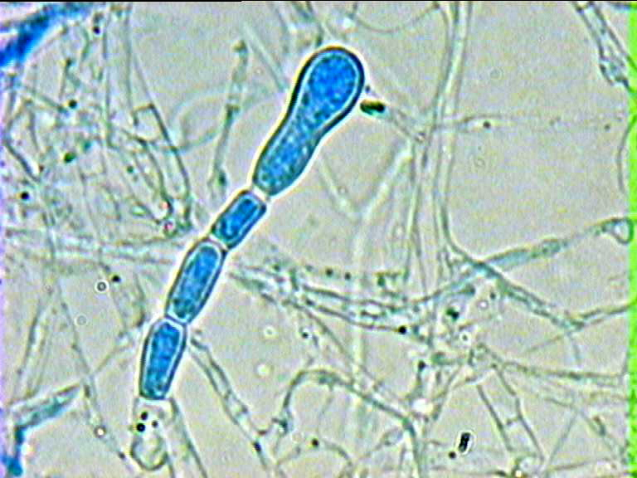
Figure -1- chlamydospores

This phylum include two class : 1-Trichomycetes (includes individuals parasite on insects and not very important economically for human being .
2-Zygomycetes has economic importance because they are causing plant diseases and loses economically .
The zygomycetes (Phylum Zygomycota) comprise about 1,060 species, including common bread molds, as well as both freshwater and marine species. Most have profuse, rapidly growing hyphae, but some are unicellular and yeast-like. Zygomycete hyphae may be coenocytic, forming septa only where reproductive structures ( sporangia , zygosporangia ) are formed. The zygomycetes are relatively ancient fungi, which probably diverged from other fungi after chytrids.
zygomycetes carry out asexual reproduction by means of spores produced in sporangia that are borne on the hyphae. They also produce thick-walled sexual structures called zygosporangia (singular zygosporangium), which can remain dormant for long periods. These sporangia, Many zygomycetes produce multiple sporangiospores inside a single sporangium. Some have multiple small sporangia that contain only a few sporangiospores, or even a single one.

Most species of zygomycetes live in soil, or on decaying plant and animal matter. Aquatic species are primarily found in sediments or algae, but some species are free-floating or attached to aquatic animals or decaying leaves. Some are parasites of plants, insects, or small soil animals, while others are symbiotic with plants. Still, others cause serious infections in humans and domestic animals.

The different genera may be distinguished based on the size and shape of the sporangia, the presence or absence of rhizoids and their location, presence or absence of branched sporangiophores, shape of the columella .

Parts of somatic phase in zygomycota
Rhizoid
Root-like structure , The benefit of rhizoids to confirm thallus on the surface of feed and increase surface area for absorption of nutrients ) .found especially in the somatic phase of chytridiomycota (chytrids ) and one of the parts of Zygomycota
Sporangia
A fruiting body (asexual unit ) having different shapes and sizes produce numerous a sexual spores .

Sporangiophore
A specialized hyphal element that bears the sporangium

Columella
The swollen, dome-shaped tip of a sporangiophore that extends into the sporangium under suitable temperature and humidity causing of rupture of sporangium to release spores .

Stolon
Horizontal hyphae growing along the surface of growth medium;
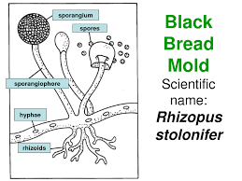

Comparsion between two genera of zygomycota
Mucor: no rhizoids, sporangiophores tend to branch
- Rhizopus: large rhizoids on stolon immediately adjacent to sporangiophore ("nodal" position)

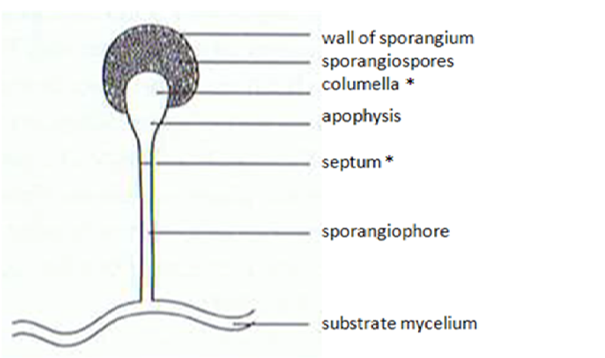

Mucor spp.
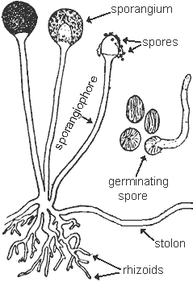
Rhizopus spp.

Characteristics of Rhizopus.
- Although this genera can cause disease, they are also commonly found as a contaminant.
- Colonies grow rapidly and resemble cotton candy. Colonies darken with age, becoming gray or yellow-brown. The reverse is white.
- Mycelia are marked by numerous stolons connecting groups of long sporangiophores.
- Sporangiophores are usually unbranched, long, and terminate in a columella and a dark round sporangium containing oval colorless to brown spores.
- Stolons bear large rhizoids which are found immediately adjacent to the sporangiophore in the nodal position.
- Columella and sporangium collapse easily after discharging spores.
Black bread mold (Rhizopus stolonifer)

Is a typical example of a zygomycete. It spreads over the surface of bread and other food sources (often soft fruits, such as bananas and grapes). It sends rhizoid inside the food to absorb nutrients. In its asexual phase, it develops bulbous black sporangia at the tips of hyphae, each containing hundreds of haploid spores. As in most zygomycetes, asexual reproduction is the most common form of reproduction. Sexual reproduction in Rhizopus stolonifera, as in other zygomycetes, occurs during adverse environmental conditions, and when haploid hyphae of different mating types come together. Plasmogamy occurs, followed by karyogamy, producing a thick-walled, diploid zygosporangium that is environmentally resistant and metabolically inert. When the environment becomes favorable, the zygosporangia germinate, undergo meiosis, and produce and release haploid spores.

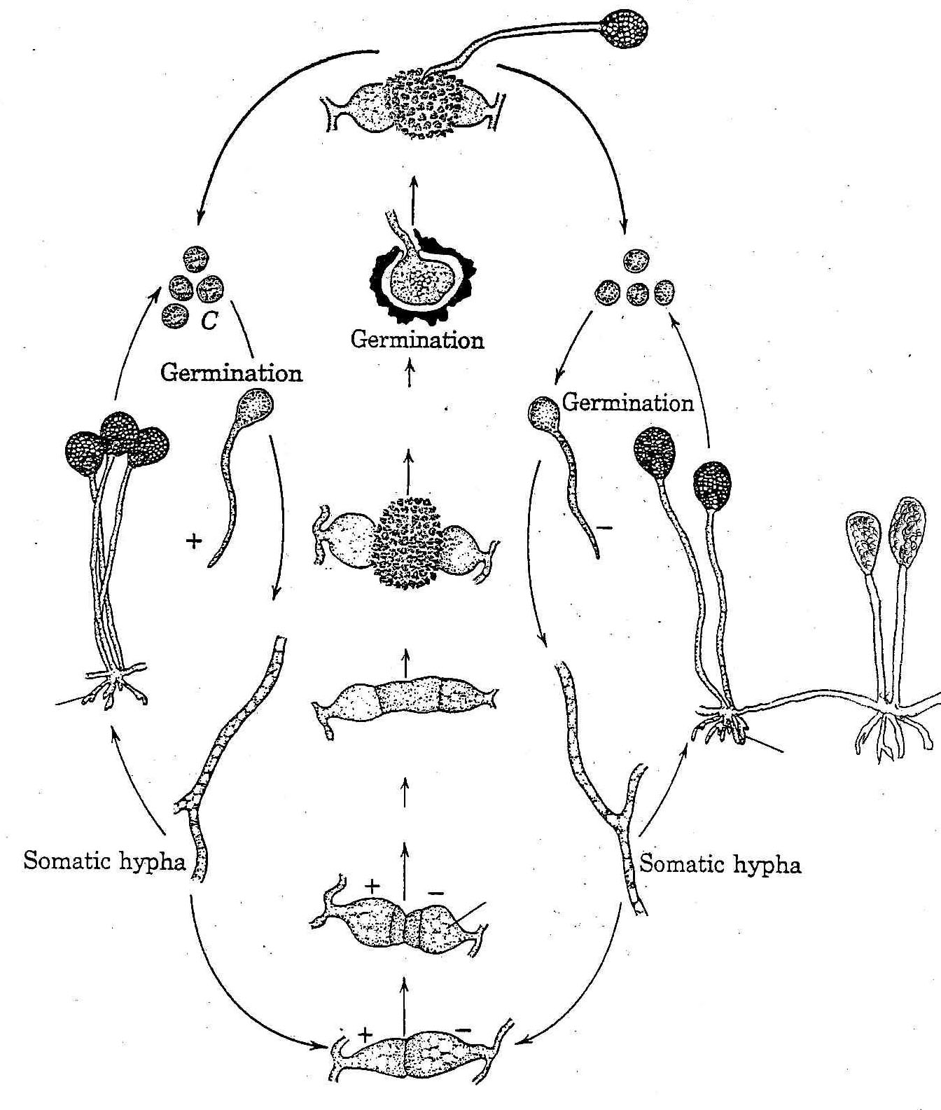

Life cycle of Rhizopus stolonifer

