Categories in Classification of fungi

Kingdom Fungi
Phylum Basidiomycota
Class Basidiomycetes
Order Agaricales
Family Agaricaceae
Genus Agaricus
Species: Agaricus campestris L.

According to Alexopolus 1996 can classified fungi and fungi like organism into 3 kingdoms depended upon the characteristics of fungi ( somatic phase , sexual and asexual spores )
1- Kingdom: Protista or Protozoa
Phylum: Myxomycota (slime molds )
Phylum: Plasmodiophoromycota
2- Kingdom: Straminpilia (Cromista )
Phylum Hyphochytriomycota
Phylum Labyrinthulomycota
Phylum: Oomycota
3- Kingdom: True Fungi (Fungi)
Phylum: Chytridiomycota
Phylum: Zygomycota
Phylum: Ascomycota
Phylum: Basidiomycota

Kingdom:Protista or Protozoa ( Phylum: Myxomycota) The Latin name Myxomycota comes from the Ancient Greek words μύξα (myxa), which means "mucus", and μύκης (myces), which means "fungus"..
Members of this division are commonly referred to as slime molds. Although presently classified as Protozoans, in the Kingdom Protista, slime molds were once thought to be fungi (kingdom Mycetae which includes lower and higher fungi) because they produce spores that are borne in sporangia, a characteristic common to some taxa of fungi. However, the assimilative stage in slime molds is morphologically similar to that of an amoeba. This assimilative stage has been designated a myxamoeba The myxamoeba, as is the case of the amoeba, is a uninucleate, haploid cell which is not enclosed in a rigid cell wall, and ingests its food by means of phagocytosis. In fungi, the assimilative stages are mycelium and yeast, both of which are surrounded by a rigid cell wall and obtain their food by means of absorption. These are some of the reasons why mycologists no longer recognize slime molds as being fungi.
1- lack cell wall
2- somatic phase is uninucleate flagellated swarm cell (1n) or an amoeba is called
myxoamoeba (1n) others multinucleate is called plasmodim a mass ameoboid protoplasm has many nuclei ( multinucleate ) , 2n cell wall less.
3-produce spores that are borne in sporangia,
4- Most of these individuals are saprophyte , and its nutrition phagotrophic .
5- life cycle:- spores are germinated to form myxamoebae(non flagellated) or swarm cells (flagellated cell). And fused swarm cells sexually to produce zygote (2N) , zygote germinate forming plasmodium (2N) During favorable conditions, the plasmodium will migrate and feed for a period of time before being converted to numerous sporangia

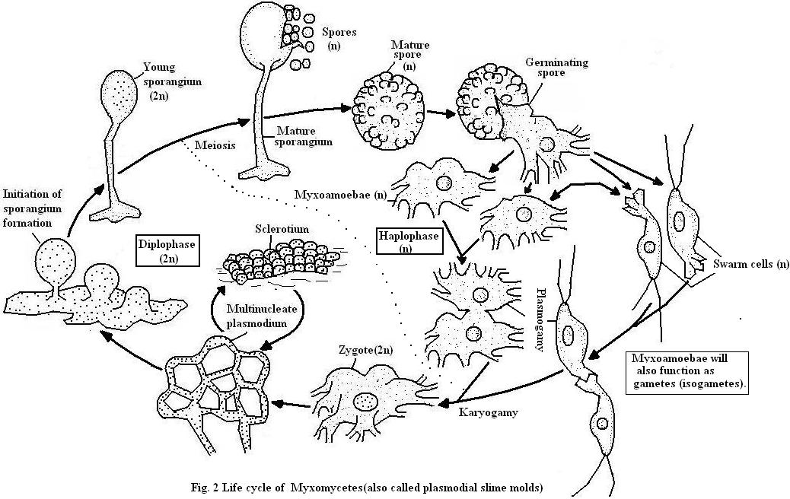

Phylum : Plasmodiophoromycota
are a group of obligate parasites commonly referred to as endoparasitic slime molds. Has the same characteristic of phylum myxomycota , All members are obligate parasites of algae, fungi, or plants, causing cell enlargement, especially of the roots. They are distinguished by the production of motile cells (zoospores) with two unequal anterior whiplash (flagella). The best-known examples attack higher plants, causing economically significant diseases such as club-root of brassica (Plasmodiophora brassicae), powdery scab of potato (Spongospora subterranea:

