B-Sexual Reproduction
In fungi, as in other organisms, sexual reproduction greatly increases variability in a species. In fungi, sexual reproduction often occurs in response to adverse environmental conditions. Sexual reproduction in fungi consists of three sequential stages: plasmogamy, karyogamy, and meiosis .
  - Plasmogamy, the fusion of two protoplasts (the contents of the two cells), brings together two compatible haploid nuclei
  - Karyogamy two nuclei types are present in the same cell, but the nuclei have not yet fused. Karyogamy results in the fusion of these haploid nuclei and the formation of a diploid nucleus (i.e., a nucleus containing two sets of chromosomes, one from each parent). The cell formed by karyogamy is called the zygote.

  - Meiosis (cell division that reduces the chromosome number to one set per cell) generally follows and restores the haploid phase. The haploid nuclei that result from meiosis are generally incorporated in spores called meiospore

In most of the lower fungi plasmogamy is immediately followed by karyogamy and meiosis. In higher fungi karyogamy is often delayed so that the hyphae remain dikaryotic. This phase of fungal life cycle is called dikaryophase. Such fungi complete their life cycle in three phases a haplophase, a dikaryophase and a diplophase. . Following are the types of sexual reproduction in different groups of fungi:

Planogametic Copulation
Here motile gametes called planogametes undergo fusion. When both the gametes are motile and morphologically similar, the fusion process is called isogamy. But Anisogamy two motile gametes are fused and morphologically different .

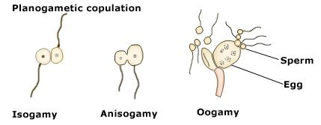

Gametangial Contact
Here, gamete bearing structures called gametangia (Antheridium male gametanium , Oogonium female gametangium ) come closer to each other and develop a fertilization tube through which the male gamete migrates into the female gametangium.
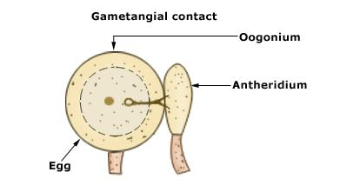

Gametangial Copulation
Here, the gametangia fuse with each other, lose their identity and develop into a zygospore
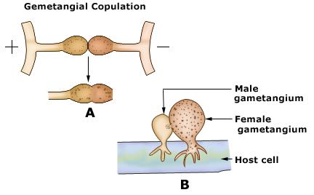

Spermatisation
In some fungi like Puccinia, tiny unicellular spore like structures (1n) called spermatia bearing on spermatophore and They get transferred to (receptive hypha) through various agencies (wind , insects , air ,water etc ) , A pore develops at the point of contact between the hypha and the spermatium then the contents of spermatium(including its nucleus) pass into the hyphal compartment, which as a result becomes dikaryotic. .

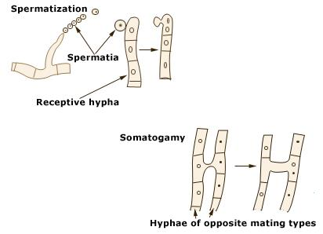
Somatogamy : this type occurs in higher fungi , The fusion of somatic hyphae of two compatible mycelia results in a dikaryon from which a dikaryotic mycelium may develop. the dikaryotic phase is limited to mycelium within the fruiting body
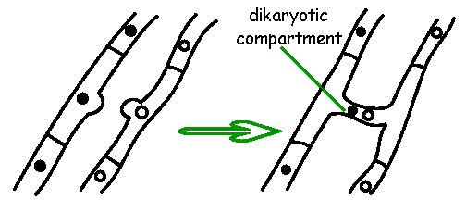
Life Cycle
In general, fungi begin their lives as a spore, then germinate and develop into mycelium. in the life cycle of a sexually reproducing fungus, a haploid phase alternates with a diploid phase. The haploid phase ends with nuclear fusion, and the diploid phase begins with the formation of the zygote (the diploid cell resulting from fusion of two haploid sex cells). Meiosis (reduction division) and initiates the haploid phase, which produces the gametes. In the majority of fungi, all structures are haploid except the zygote. Nuclear fusion takes place at the time of zygote formation, and meiosis follows immediately.
Fungi usually reproduce both sexually and asexually. The asexual cycle produces mitospores, and the sexual cycle produces meiospores. Even though both types of spores are produced by the same mycelium, they are very different in form and easily distinguished . The asexual phase usually precedes the sexual phase in the life cycle and may be repeated frequently before the sexual phase appears
