Composition of fungal cell
1-fungal cell has a rigid cell wall in chemical composition are composed mostly chitin ( N-acetyl glucose amine ) in addition to glucan and cellulose , surrounding the protoplast ( nucleus and cytoplasm).

2- Plasma membrane semi permeable contains protein and lipid.

3- nucleus most fungi have very small nuclei, with little repetitive DNA. Surrounding by nulear membrane.
4- Other organelles Mitochondria—flattened or plate-like mitochondrial cristae in Fungi (similar to animals)
Golgi bodies—consist of a single, tubular cisternal element (stacked, plate-like cisternae in animals and plants) . Other types: ribosomes, endoplasmic reticulum, vacuoles, lipid bodies, glycogen storage particles, microbodies, microtubules, vesicles
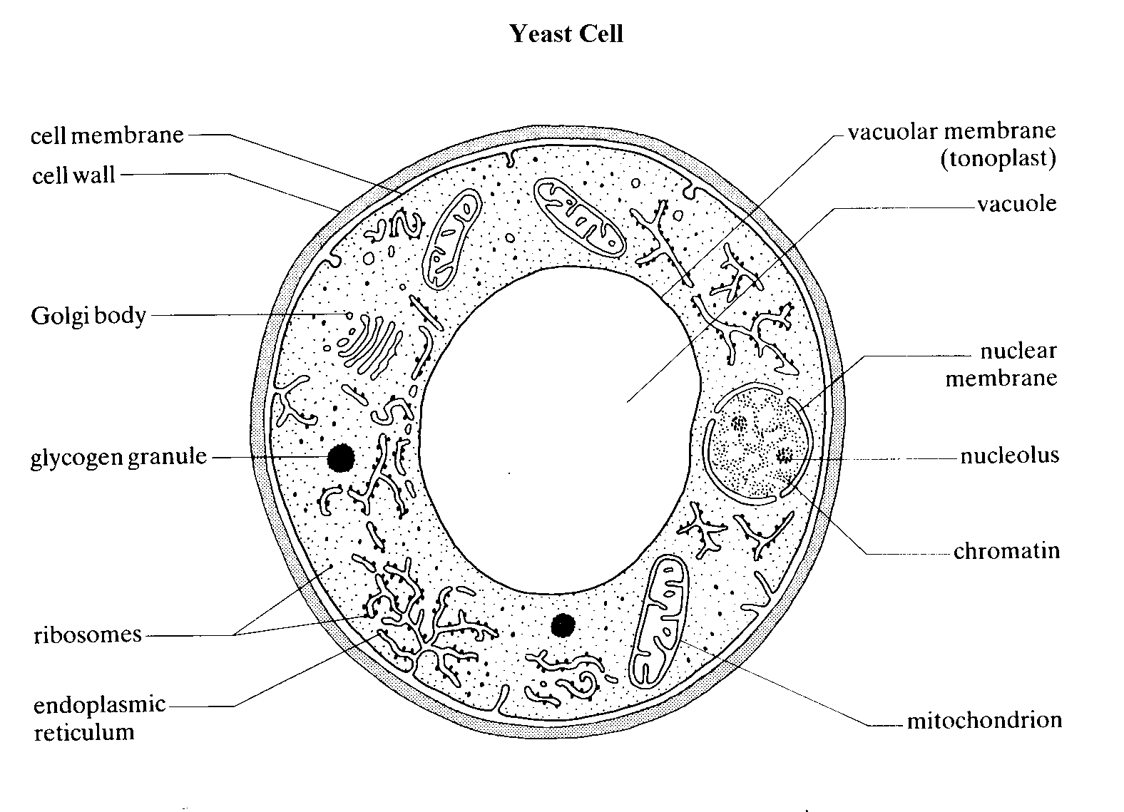

Diagram of yeast cell composition

Somatic phase of fungi
1-Yeasts are single-celled unicellular , ovaloid -all are facultative anaerobes .-in absence of oxygen will ferment carbohydrates into alcohol & carbon dioxide
2-Multicellular fungi are composed of filaments called hyphae (singular: hypha). contain from Cylindrical, branching filaments composed of a tubular cell wall filled with cytoplasm and organelles . Hyphae are divided into two types according to exist of internal crosswalls, called septa,
A-septate hyphae that divide the hyphae into separate cells
B-A septated hyphae or Coenocytic hyphae lack septa .
The septa of many species have pores, allowing cytoplasm to flow freely from one cell to the next. Cytoplasmic movement within the hypha provides a means to transport of materials. The hyphae may be branched. A mass of hyphae that is not a reproductive structure is called a mycelium
Nutritional status of fungi
According to the type of nutrition fungi are classified into three types:-
1-Saprophytic fungi :-feed on dead plant and animal remains. Many are extremely beneficial, breaking down this organic material into inorganic that can be utilized by plants. Without these fungi we would also disappear under a mountain of unrotted dead leaves and logs! , use non-living organic material. , important scavengers in ecosystems. , Along with bacteria, fungi are important in recycling Carbon, Nitrogen, and essential mineral nutrients.
2-Parasitic fungi or pathogenic fungi, fungi that use as a source of food live tissues of various organisms. cause diseases in plants, animals, and humans. use organic material from living organisms, harming them in some way. cause diseases in plants, animals, and humans.

3-symbiotic fungi

fungi that have a symbiotically beneficial relationship with other living organisms.

Like :Mycorrhizae: associations of fungi with plants roots
Lichens associations of fungi with algae or cyanobacteria

Fungi Reproduction
Fungi can reproduce either sexually or asexually. Reproductive structures of fungi that produce gametes are called gametangia, and those that produce asexual spores are sporangia. Fungal spores are nonmotile and are typically very tiny and dry. Spores which explode from a sporangium may travel up to two meters from their origin, a huge distance considering their tiny size. Other spores are slimy and are dispersed by adhering to the bodies of arthropods, such as insects.

A- Asexual reproduction (somatic or vegetative reproduction ) is very common in fungi and occurs by variety of mechanisms.
1. Budding :-The parent cell produces one or more projections called buds, which later develop necessary structures and separated to grow into new individuals. Budding is common in unicellular forms like yeast.

2- Fission :-In this process, the parent cell splits into two equal halves, each of which develop into a new individual. Fission is also common in yeast.
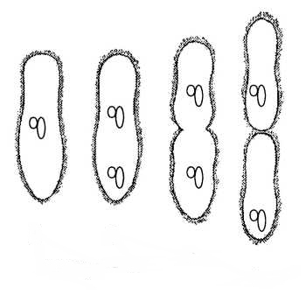
3- Fragmentation of hyphae (molds): - In this process, the mycelium breaks into two or more similar fragments either accidentally or due to some external force. Each fragment grows into a new mycelium.

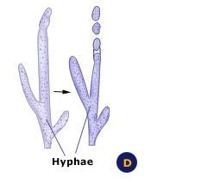
4- Asexual spores
-spores are produced by mitosis and cell division , formed on the ends of aerial hyphae (not endospores: reproductive) -germinate to form exact clones of the Parent .asexual spores are different in color , size and shape most of them are small or big , yellow , pink , unicellular or multicellular therefore fungi taxonomists are depended on asexual spore in classification of fungi . The fungal spores always result from mitosis and hence are described as mitospores. Following are the types of spores produced in different groups of fungi:

1-Zoospores :- They are flagellated, motile spores produced inside structures called zoosporangia. These spores do not have a cell wall. Such spores are produced in lower fungi such as water molds

2-Sporagiospores :-These are non-motile spores produced inside structures called sporangia in fungi such as Rhizopus (bread mold ). These spores are dispersed by wind.

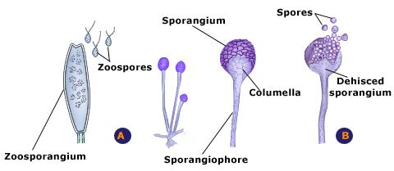

3-Conidia :- These are non-motile asexual unit produced singly or in chains at the tip of the hypha branches that are called conidiophores. Such conidia are produced in fungi like Aspergillus and Penicillium.

