An Introduction to Biological Control:

Biological control is a bioeffector-method of controlling pests (including insects, mites, weeds and plant diseases) using other living organisms.^{[1]} It relies on predation, parasitism, herbivory, or other natural mechanisms, but typically also involves an active human management role. It can be an important component of integrated pest management (IPM) programs.

and the agents that exert the control are frequently called natural enemies. Humans can exploit biological control in various ways to suppress pest populations.
The varied approaches for manipulating the activity of natural enemies to control
pests differ in how much effort is required, who is involved, and the
suitability of the approach for commercial development.
Biological control has been defined many times but a commonly
accepted definition is provided below
The use of living organisms to suppress the population of a specific pest
organism, making it less abundant or less damaging than it would
otherwise be.
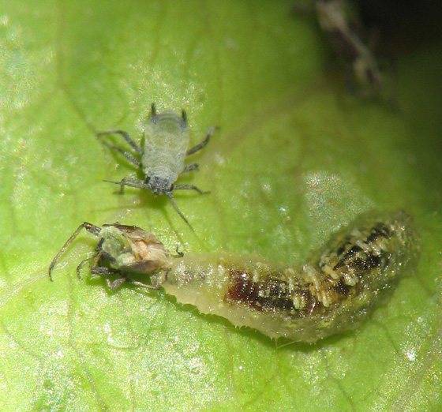

Natural enemies

Natural enemies of insect pests, also known as biological control agents, include predators, parasitoids, and pathogens. Biological control agents of plant diseases are most often referred to as antagonists. Biological control agents of weeds include seed predators, herbivores and plant pathogens.
Humans share the planet earth with some 10 million species of organisms.
Each species eats, grows and reproduces in different ways
in different locations around the world but virtually no species does
this in isolation. All species are interconnected to some extent, with
some organisms more dependent on others, especially those higher
in the food chain. Tigers would not live long without their prey being
available, just as rabbits would not survive for long without plants to
eat. Humans have quite a dominant position in many ecosystems and
they depend on many other species for food and shelter. Especially because
the influence of humans is so pervasive throughout the world,
humans also compete with many organisms and we generally think
of many of these competitors as ‘‘pests.”
Man has been plagued by ‘‘pests” since time began. A pest can
be formally defined as any organism that reduces the availability,
quality, or value of some human resource (Flint & van den Bosch,
1981). The definition of pest needs to be broad due to the great diversity
in the ways that pests affect humans. The resources in question
can be a plant or animal grown for food, fiber or pleasure (e.g.,
pets, plants in recreation areas). Another resource is human health
and well-being, making organisms directly affecting human health,
such as mosquitoes, pests too. Pests are as diverse taxonomically, ranging
from microorganisms to mammals, as they are in the ways that
they compete with humans. With such variability comes a variety of
adaptations, and some organisms competing with humans are tough
adversaries.
There are many different means for controlling pests but we
concerned only with methods using living organisms to control
pests, a strategy called biological control.
We will therefore not be covering all pests but only those specifically targeted by biological control.
The major types of pests that are addressed by biological control
include weedy plants, microorganisms attacking plants (often crop
plants or forest trees), invertebrates (especially arthropods that often
attack plants or animals), and vertebrates.

