Lec(4)
Dr. Ekhlass N. Ali Sera &Vaccine

Genetically engineerer sources
Recombinant technology is used increasingly for the manipulation and production of antibodies and their fragments.
For antibodies to be most effective when used as a therapeutic agent they should have a long serum half-life, low immunogenicity, a high affinity for the antigen, and be able to neutralize the antigenś activity these are all features that can be enhanced by genetic manipulation.to reduce immunogenicity,mouse-human chimeric antibodies have been produced, containing some constant region sequences along with the mouse V regions. Another approach to reducing immunogenicity is to produce humanized monoclonal antibodies that contain human sequences .Antibody phage libraries and breeding mice that contain parts of the human immune system provide alternative sources of therapeutic antibodies with a fully human sequence .figure 1 illustrates various modifications to monoclonal antibodies.
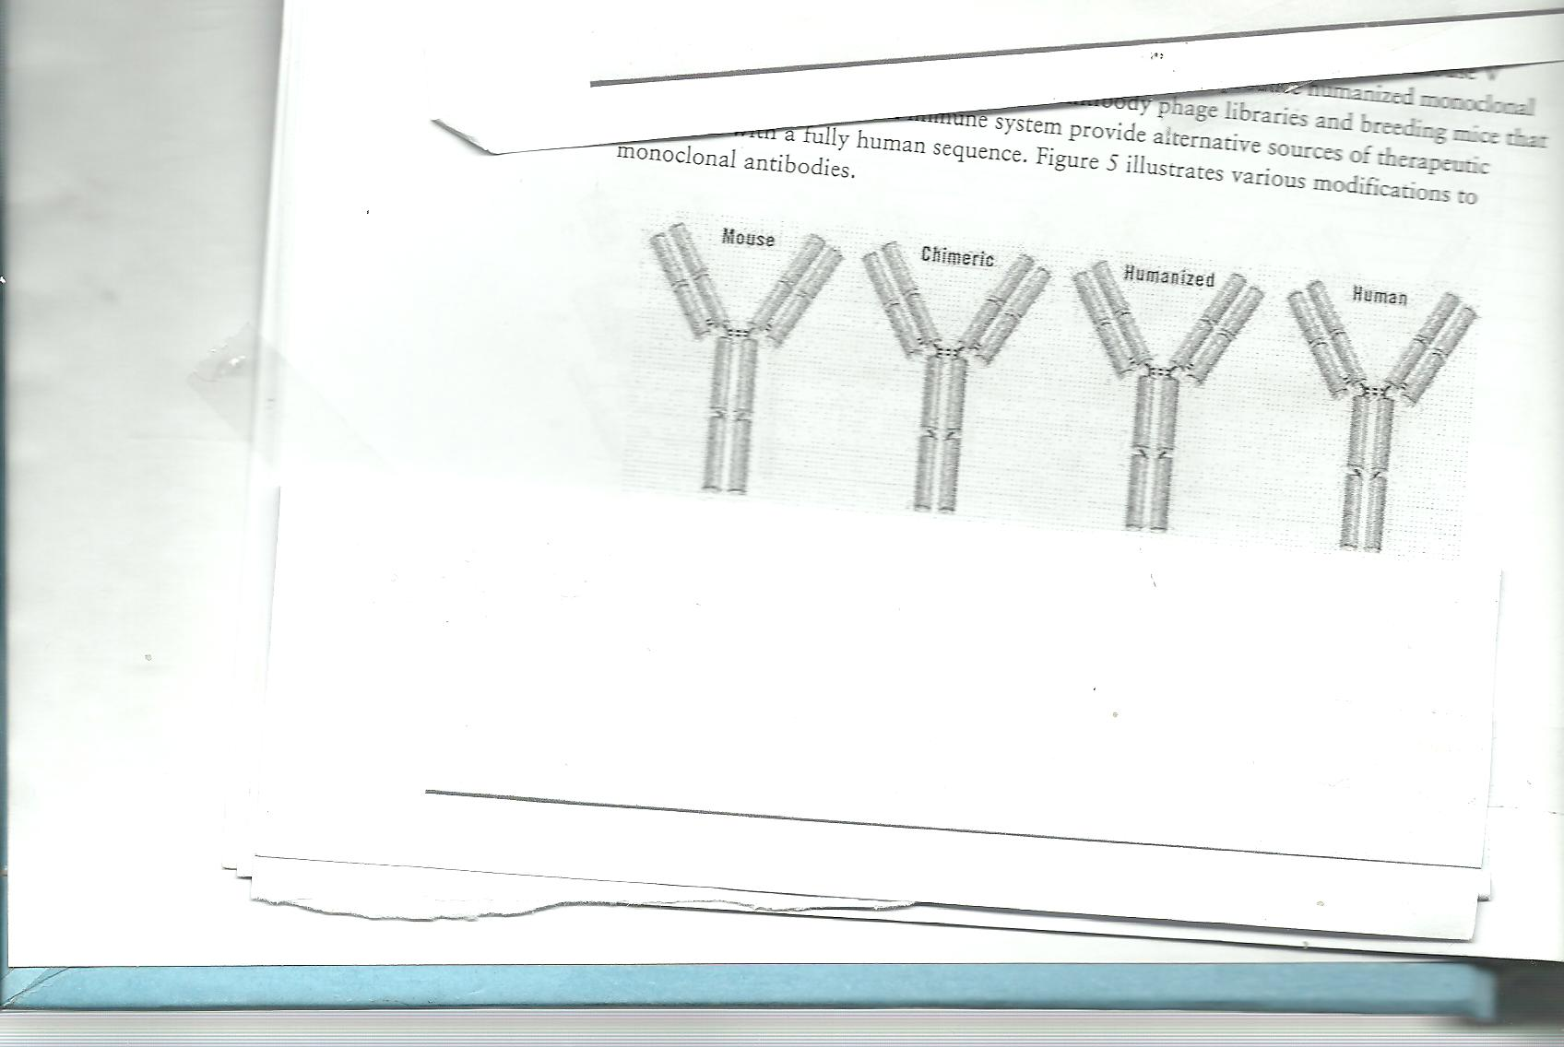

Active and Passive Immunization
Active immunization is achieved by inoculation with microbial pathogens that induce immunity but do not cause disease or with antigenic components from the pathogens.
Passive Immunization Involves Transfer of Performed Antibodies
Jenner and Pasteur are recognized as the pioneers of vaccination, or induction of active immunity, but similar recognition is due to Emil vov Behring and Hidesaburo Kitasato for their contributions to passive immunity .These investigators were the first to show that immunity elicited in one animal can be transferred to another by injecting it with serum from the first.
Passive immunization, in which performed antibodies are transferred to a recipient, occurs naturally by transfer of maternal antibodies to diphtheria,tetatococci , rubella,mumps, and poliovirus all afford passively acquired protection to the developing fetus.Maternal antibodies present in colostrums and milk also provide passive immunity to the infant.
Active Immunization Elicits Long-Term Protection
Immunization is successful, a subsequent exposure to the pathogenic agent elicits a heightened immune response that successfully eliminates the pathogen or prevents disease mediated by its products, Active immunization can be achieved by natural infection with microorganism, or it can be acquired artificially by administration of a vaccine .In active immunization, as the name implies,the immune systemplays an active role-proliferation of antigen-reactive T and B cells results in the formation of memory cells. Active immunization with various types of vaccines has played an important role in the reduction of deaths from infectious diseases, especially among children.

