Lec(2) Sera &Vaccine
Dr. Ekhlass N. Ali
Immunotherapy:The use of passive immunization immunotherapy(passive immunization)mean the use of serum or gamma globulin in the treatment or prevention of infectious disease by transferring to one host antibodies actively produced in another.Passive immunization provides immediate protection to individuals who have been exposed to an infectious organism and who lack active immunity to that pathogen.because passive immunization dose not activate the immune system,it generate no mmomry response. Passive immunity is not permanent,dissipate after a few weeks to months as the immunoglobulins are cleared from the recipientś serum.
Applications of immunotherapy
1- Protection and prevention(prophylaxis) against infectious disease e.g diphtheria, tetanus,rabies and treatment for snake bite.

2- immunosuppression this include prevention of maternal isoimmunization Rho sensitization and immunosuppression during tissue transplantation.
Antibody preparation (serum,antitoxin and gamma globulin). The use of Ab preparation in immunotherapy are shown in fig Ι and include such antimicrobial activity as toxin neutralization,viral nuntralization and antibacterial effects due to lysis or opsonization and phagocytosis.In addition,immuosuppresisive activity with antibody preparations has been successful in the prevention of maternal Rho isoimmunization and in immunosuppression during tissue transplantation.
Today in most case, passive immunization is achieved with immunoglobulin derived from pooled human plasma or serum but it such product are not available,gloulins sera from animal source,mostly equine are also used.Antibody of human origin are preferred.because these proteins do not elicite an immune response that could have an adverse effect e.g. serum sickness(as seen following the use of gamma globulins of animal origin.
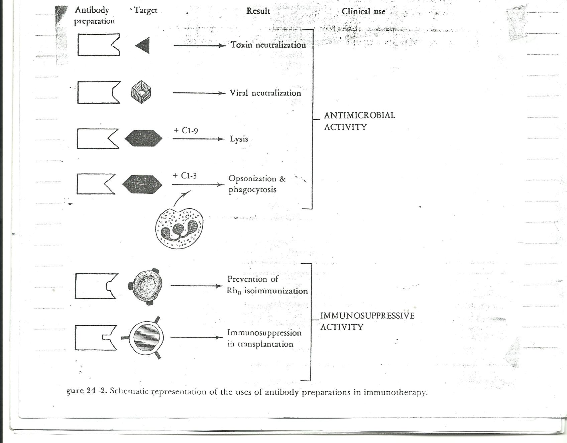

Second principle immediacy of action
The most important reason for the use of passive immunization its immediacy of action,its effect exert immediate on intraction with antigen.The delay of the latent period required by an active immune response is thereby avoided therefore passive immunization can be used in emergency situation when there is insufficient time. To achieve an active immune response or when vaccine is unavailable
The Ab may be given prior to exposure ,as in the use of gamma globulin for prevention of hepatitis A in individuals traveling to high-risk areas.
Passive immunization has important advantages for individuals who have deficiencies of Ab synthesis (primary or aguired).
Metabolism of Gamma Globulin
Also important in the use of passive immunization are the factors that govern the metabolism of the Ab preparation. Ab molecules like all other protein have alimited biological helf-like for example, if human (homologous) IgG immunoglobulin is adminstated to healthy human ,the biological helf-life(t1⁄2
will be 20-30 days-more rapidly)rates of degradat are observed with other isotypes e.g.IgA+1⁄2=4-8 days, IgM t1⁄2 =2-4 days.The half-life of hourse(heterologous) immunoglobulinadminstrated to humans.on other hand is shorter, the recognit of foreign horse gamma globulin by the human result in an active immune response leading to Ab mediated enhanced catabolism or immune eliminate.for immuno globulin ofanimal origin, these degradation process may vary.
Antitoxin of equine origin,such as diphtheria tetanus globulin,have been treated with pepsin to remove Fc fragment as possible ,The pepsin digested Ab are catabolized quit rapidly with an approximat half-life of 2-8 days.The duration of such protection of Ab is finite and determined by both the amount and the type of immunoglobulin administrated.
The pattern of elimination of gamma globulin (Ab) administrated IV to human occurs in three phases (fig-2).
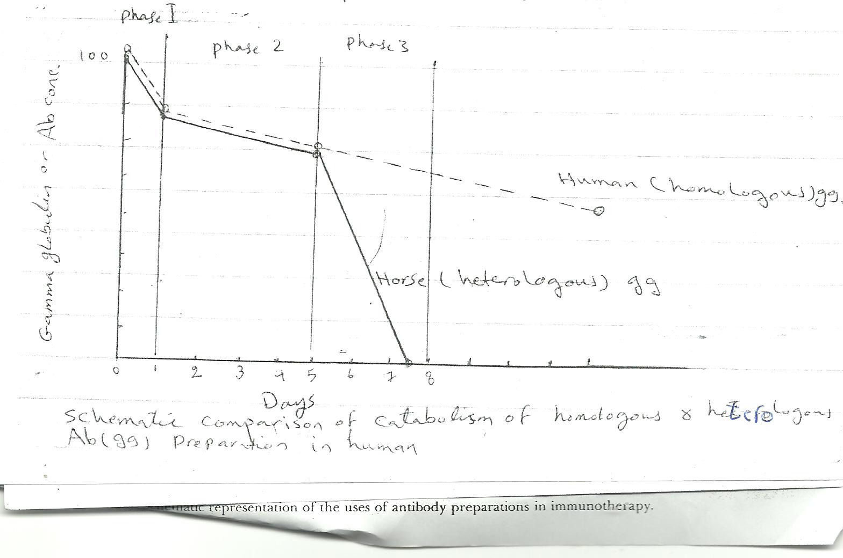
Phase -1 is a period of redistribution or equalization between vascular and extravascular spaces that results in a striking drop in peak titer shortly after administration of Ab.
Phase -2 is aslower,stendy drop in a serum level due to the metabolic (catabolic)half life of the gamma globulin. These diminutions in serum levels apply to both homologous &heterologous gamma globulin.
Phase-3 is an accelerated period of degradation occurring only in the case of heterologous gamma globulin, that takes place stimutaneously with the development of Ab of the forign gamma globulin .
These metabolic properties of gamma globulin also have relevance to the passive immunization that occurs as anatural event in every human the transplacental transfer of homologous IgG immunoglobulin from mother to fetus. There is a gradual degradation and diminished concentration of IgG immuno globulin following brith. (physiologic hypo gamma globulinemie).

