Biological Control

المرحلة الرابعة
العملي
ست آصال-استاذ زيد

A Pest :It is every thing plants or animal exist in large numbers and cause damage for human or human concerns such as agriculture or livestock production.
A pest can be formally defined as any organism that reduces the availability, quality, or value of some human resource.
Pest control: refers to the regulation or management of a species defined as a pest, usually because it is perceived to be detrimental to a person's health, the ecology or the economy.
Pest control is at least as old as agriculture, as there has always been a need to keep crops free from pests. In order to maximize food production, it is advantageous to protect crops from competing species of plants, as well as from herbivores competing with humans.
The conventional approach was probably the first to be use, since it is comparatively easy to destroy weeds by burning them or plowing them under, and to kill larger competing herbivores, such as crows and other birds eating seeds.
Techniques such as crop rotation, companion planting (also known as intercropping or mixed cropping) , and the selective breeding of pest-resistant have a long history.
General methods of pest control
is divided into two parts is the natural pest control and applied:
- Natural control
include factors that destroy or limit the spread of the scourge without human intervention, where natural conditions are working to reduce pests and can accomplish these factors are as follows:

1. food factors: such as lack of food due to drought or lack of breadwinner.
2.air condisions: such as high or low temperature and humidity and the activity of wind and precipitation.
3. Vital factors: Examples of natural enemies Predators and parasites on insects and diseases of fungal and bacterial and viral.
4. Topographic factors: such as the existence of deserts, mountains, lakes and oceans. These factors could limit the spread of pests

- Applide control:
A- Use of pest –destroying animal
Perhaps as far ago as 3000BC in Egypt, cats were being used to control pests of grain stores such as rodents. In 1939/40 a survey discovered that cats could keep a farm's population of rats down to a low level, but could not eliminate them completely. However, if the rats were cleared by trapping or poisoning, farm cats could stop them returning - at least from an area of 50 yards around a barn.
Ferrets were domesticated at least by 500 AD in Europe, being used as mousers. Mongooses have been introduced into homes to control rodents and snakes, probably at first by the ancient Egyptians.
Biological pest control b-
Biological pest control is the control of one through the control and management of natural predators and parasites. For example: mosquitoes are often controlled by putting Bt Bacillus thuringiensis ssp. israelensis, a bacterium that infects and kills mosquito larvae, in local water sources. The treatment has no known negative consequences on the remaining ecology and is safe for humans to drink. The point of biological pest control, or any natural pest control, is to eliminate a pest with minimal harm to the ecological balance of the environment in its present form.
Mechanical pest control c-
Mechanical pest control is the use of hands-on techniques as well as simple equipment, devices, and natural ingredients that provide a protective barrier between plants and insects. For example: weeds can be controlled by being physically removed from the ground. This is referred to as tillage and is one of the oldest methods of weed control
Hunting d-
Historically, in some European countries, when stray dogs and cats became too numerous, local populations gathered together to round up all animals that did not appear to have an owner and kill them. In some nations, teams of rat-catchers work at chasing rats from the field, and killing them with dogs and simple hand tools. Some communities have in the past employed a bounty system, where a town clerk will pay a set fee for every rat head brought in as proof of a rat killing.
e-pesticides
Spraying pesticides by planes, trucks or by hand is a common method of pest control. Crop dusters commonly fly over farmland and spray pesticides to kill off pests that would threaten the crops. However, some pesticides may cause cancer and other health problems, as well as harming wildlife.
Destruction of infected plants f-
Destruction of infected plants,people sometimes destroy all the trees in an area where some are infected with insects, if seen as necessary to prevent the insect species from spreading. Farms infested with certain insects, have been burned entirely, to prevent the pest from spreading elsewhere.
Lab 2
An Introduction to Biological Control:
Biological control is a bioeffector-method of controlling pests (including insects, mites, weeds and plant diseases) using other living organisms.^{[1]} It relies on predation, parasitism, herbivory, or other natural mechanisms, but typically also involves an active human management role. It can be an important component of integrated pest management (IPM) programs.

and the agents that exert the control are frequently called natural enemies. Humans can exploit biological control in various ways to suppress pest populations.
The varied approaches for manipulating the activity of natural enemies to control
pests differ in how much effort is required, who is involved, and the
suitability of the approach for commercial development.
The use of living organisms to suppress the population of a specific pest
organism, making it less abundant or less damaging than it would
otherwise be

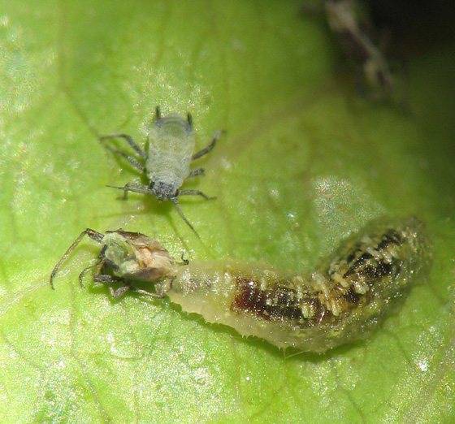

Natural enemies

Natural enemies of insect pests, also known as biological control agents, include predators, parasitoids, and pathogens. Biological control agents of plant diseases are most often referred to as antagonists. Biological control agents of weeds include seed predators, herbivores and plant pathogens.
Humans share the planet earth with some 10 million species of organisms.
Each species eats, grows and reproduces in different ways
in different locations around the world but virtually no species does
this in isolation. All species are interconnected to some extent, with
some organisms more dependent on others, especially those higher
in the food chain. Tigers would not live long without their prey being
available, just as rabbits would not survive for long without plants to
eat. Humans have quite a dominant position in many ecosystems and
they depend on many other species for food and shelter. Especially because
the influence of humans is so pervasive throughout the world,
humans also compete with many organisms and we generally think
of many of these competitors as ‘‘pests.”
human has been plagued by ‘‘pests” since time began. The definition of pest needs to be broad due to the great diversity
in the ways that pests affect humans. The resources in question
can be a plant or animal grown for food, fiber or pleasure (e.g.,
pets, plants in recreation areas). Another resource is human health
and well-being, making organisms directly affecting human health,
such as mosquitoes, pests too. Pests are as diverse taxonomically, ranging
from microorganisms to mammals, as they are in the ways that
they compete with humans. With such variability comes a variety of
adaptations, and some organisms competing with humans are tough
adversaries.
There are many different means for controlling pests but we
concerned only with methods using living organisms to control
pests, a strategy called biological control.
We will therefore not be covering all pests but only those specifically targeted by biological control.
The major types of pests that are addressed by biological control
include weedy plants, microorganisms attacking plants (often crop
plants or forest trees), invertebrates (especially arthropods that often
attack plants or animals), and vertebrates.

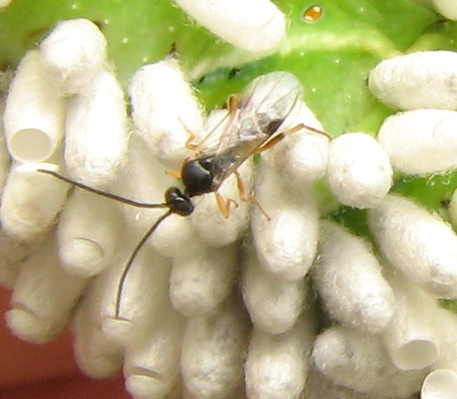

Advantages of using biological control strategies:
- Highly specialized in compact the pest.
- Natural enemies existing naturally in the nature so it is no need to manufacturing processes to be found.
- Ability of Natural enemies for increase and spreading naturally without human intervention.
- Ability of Natural enemies to looking about it is family or their pry in the nature Easley because their sensory perception toward the prey.
- Incapability of pest to stimulate immunity or resistance against the Natural enemies.
- Natural enemies dose not cause damage to the ecosystem.so it is safety for ecological balance.
- Natural enemies is not harm for human or human property.
- Biological control is not similar to chemical control because it is natural programs without human intervention.

disadvantages of using biological control strategies:
1-slow control and Incapability on extermination pests specially when occur increase rapidly in number of pest.
2-difficult to predict how much it is efficiency, may be don’t adapt with ecology of pest.
3-strategies of biological control need to specialists to work.
4- Natural enemies may bring pathogens to plant on their bodies so will appear a new problem.
5-may parasitize the Natural enemies which imported from a broad on local Natural enemies.

Historical perspective on chemical
pest control:

Humans have always needed to control pests affecting them directly,
such as mosquitoes or bed bugs, or competing with them for a great
diversity of resources. Through the ages pest control practices have
changed dramatically. The earliest known record for the use of naturally
occurring compounds for pest control was in ≈1000 BC, when
the Greek Homer mentioned using sulfur as a fumigant. In the 1800s,
tobacco extracts and nicotine smoke were applied for insect control.
In 1867, we see the first mention of a mixture concocted for pest
control that became widely used; Paris green, an arsenic-based compound,
was developed and applied against Colorado potato beetle in
the USA. Bordeaux mix, a combination of copper sulphate and hydrated
lime, was developed in 1882 in Bordeaux, France, for control of
plant pathogenic fungi on grapes and other fruits.

,,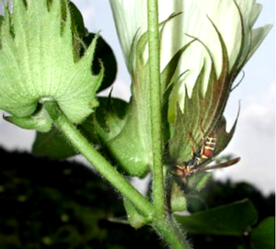

Table (1) comparison between chemical and biological control:
Biological control | Chemical control
1:10 | 1:2000,000 | Success ratio
2 million US$ | 150 million US$ | Developmental costs
10 years | 10 years | Developmental time
20:1 | 2:1 | Benefit/cost ratio
small | large | Risk of resistance
Very large | Very small | Specificity
Nil/few | many | Harmful side effects

Lab;3

Targets: include insects which have been most common target worldwide 550 sp.

Homopterans have been most successful target such as scale, aphids, and whitefly.

Several families of mites have been targets including Snails are the next most common invertebrate target either herbivorous sp. That are intermediated hosts for human, or domestic animal.

Types of biological pest control:
There are three basic types of biological pest control strategies: importation (so\metimes called classical biological control), augmentation and conservation:

Importation

Involves importation and establishment of new natural enemies an area, usually for exotic pests, occasionally for natives.
Importation (or "classical biological control") involves the introduction of a pest's natural enemies to a new locale where they do not occur naturally. This is usually done by government authorities. In many instances the complex of natural enemies associated with a pest may be inadequate, a situation that can occur when a pest is accidentally introduced into a new geographic area, without its associated natural enemies. These introduced pests are referred to as exotic pests and comprise about 40% of the insect pests in the United States.
The process of importation involves determining the origin of the introduced pest and then collecting appropriate natural enemies associated with the pest or closely related species.
Selected natural enemies are then passed through a rigorous assessment, testing and quarantine process, to ensure that they will work and that no unwanted organisms (such as hyperparasitoids) are introduced. If these procedures are passed, the selected natural enemies are mass-produced and then released. Follow-up studies are conducted to determine if the natural enemy becomes successfully established at the site of release, and to assess the long-term benefit of its presence.
To be most effective at controlling a pest, a biological control agent requires a colonizing ability which will allow it to keep pace with the spatial and temporal disruption of the habitat. Its control of the pest will also be greatest if it has temporal persistence, so that it can maintain its population even in the temporary absence of the target species, and if it is an opportunistic forager, enabling it to rapidly exploit a pest population. However an agent with such attributes is likely to be non-host specific, which is not ideal when considering its overall ecological impact, as it may have unintended effects on non-target organisms.
There are many examples of successful importation programs, including:
- Joseph Needham noted a Chinese text dating from 304AD, Records of the Plants and Trees of the Southern Regions, by Hsi Han, which describes mandarin oranges protected by biological pest control techniques that are still in use today
- One of the earliest successes in the west was in controlling Icerya purchasi, the cottony cushion scale, a pest that was devastating the California citrus industry in the late 19th century. A predatory insect Rodolia cardinalis (the Vedalia Beetle), and a parasitoid fly were introduced from Australia by Charles Valentine Riley. Within a few years the cottony cushion scale was completely controlled by these introduced natural enemies.
- Damage from Hypera postica Gyllenhal, the alfalfa weevil, a serious introduced pest of forage, was substantially reduced by the introduction of several natural enemies. 20 years after their introduction the population of weevils in the alfalfa area treated for alfalfa weevil in the Northeastern United States was reduced by 75 percent.
- A small wasp, Trichogramma ostriniae, was introduced from China to help control the European corn borer (Ostrinia nubilalis), one of the most destructive insects in North America, making it a recent example of a long history of classical biological control efforts for this major pest.
- The population of Levuana iridescens (the Levuana moth), a serious coconut pest in Fiji, was brought under control by a classical biological control program in the 1920s.
Classical biological control is long lasting and inexpensive. Other than the initial costs of collection, importation, and rearing, little expense is incurred. When a natural enemy is successfully established it rarely requires additional input and it continues to kill the pest with no direct help from humans and at no cost. However importation does not always work. It is usually most effective against exotic pests and less so against native insect pests. The reasons for failure are not often known but may include the release of too few individuals, poor adaptation of the natural enemy to environmental conditions at the release location, and lack of synchrony between the life cycle of the natural enemy and host pest.,

Augmentation:
Augmentation involves the supplemental release of natural enemies, boosting the naturally occurring population. Relatively few natural enemies may be released at a critical time of the season (inoculative release) or millions may be released (inundative release). An example of inoculative release occurs in greenhouse production of several crops. Periodic releases of the parasitoid, Encarsia formosa, are used to control greenhouse whitefly, and the predatory mite Phytoseiulus persimilis is used for control of the two-spotted spider mite. Lady beetles, lacewings, or parasitoids such as those from the genus Trichogramma are frequently released in large numbers (inundative release). Recommended release rates for Trichogramma in vegetable or field crops range from 5,000 to 200,000 per acre (1 to 50 per square metre) per week depending on level of pest infestation. Similarly, entomopathogenic nematodes are released at rates of millions and even billions per acre for control of certain soil-dwelling insect pests.
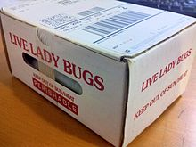
The spraying of octopamine analogs (such as 3-FMC) has been suggested as a way to boost the effectiveness of augmentation.
Octopamine, regarded as the invertebrate counterpart of dopamine plays a role in activating the insects' flight-or-fight response. The idea behind using octopamine analogues to augment biological control is that natural enemies will be more effective in their eradication of the pest, since the pest will be behaving in an unnatural way because its flight-or-fight mechanism has been activated., Octopamine analogues are purported to have two desirable characteristics for this type of application: (1) they affect insects at very low dosages (2) they do not have a physiological effect in humans (or other vertebrates).

Conservation
The conservation of existing natural enemies in an environment is the third method of biological pest control. Natural enemies are already adapted to the habitat and to the target pest, and their conservation can be simple and cost-effective. Lacewings, lady beetles, hover fly larvae, and parasitized aphid mummies are almost always present in aphid colonies.
,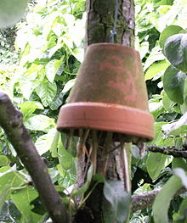
A turnaround flowerpot, filled with straw to attract Dermaptera-species
Cropping systems can be modified to favor the natural enemies, a practice sometimes referred to as habitat manipulation. Providing a suitable habitat, such as a shelterbelt, hedgerow, or beetle bank where beneficial insects can live and reproduce, can help ensure the survival of populations of natural enemies.

Biological control agents:
1- Predators
2- Parasitoid insects
3- Micro-organisms (bacteria , fungy ,viruses ,Protozoa, Nematode)
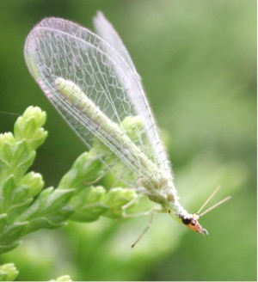
1- Predators
Predators are mainly free-living species that directly consume a large number of prey during their whole lifetime.
Ladybugs, and in particular their larvae which are active between May and July in the northern hemisphere, are voracious predators of aphids, and will also consume mites, scale insects and small caterpillars.
The larvae of many hoverfly species principally feed upon greenfly, one larva devouring up to fifty a day, or 1000 in its lifetime. They also eat fruit tree spider mites and small caterpillars. Adults feed on nectar and pollen, which they require for egg production.
Other useful garden predators include lacewings, pirate bugs, rove and ground beetles, aphid midge, centipedes, spiders, predatory mites, as well as larger fauna such as frogs, toads, lizards, hedgehogs, slow-worms and birds. Cats and rat terriers kill field mice, rats, June bugs, and birds. Dachshunds are bred specifically to fit inside tunnels underground to kill badgers.
Dragonflies are important predators of mosquitoes, both in the water, where the dragonfly naiads eat mosquito larvae, and in the air, where adult dragonflies capture and eat adult mosquitoes. Community-wide mosquito control programs that spray adult mosquitoes also kill dragonflies, thus reducing an important biocontrol agent.
2- Parasitoid insects
Parasitoids lay their eggs on or in the body of an insect host, which is then used as a food for developing larvae. The host is ultimately killed. Most insect parasitoids are wasps or flies, and usually have a very narrow host range.
Four of the most important groups are:
- Ichneumonid wasps: (5–10 mm). Prey mainly on caterpillars of butterflies and moths.
- Braconid wasps: Tiny wasps (up to 5 mm) attack caterpillars and a wide range of other insects including greenfly. A common parasite of the cabbage white caterpillar- seen as clusters of sulphur yellow cocoons bursting from collapsed caterpillar skin.
- Chalcid wasps: Among the smallest of insects (<3 mm). Parasitize eggs/larvae of greenfly, whitefly, cabbage caterpillars, scale insects and Strawberry Tortrix Moth (Acleris comariana).
- Tachinid flies: Parasitize a wide range of insects including caterpillars, adult and larval beetles, true bugs, and others.
Examples of parasitoids:

Encarsia formosa was one of the first biological control agents developed.
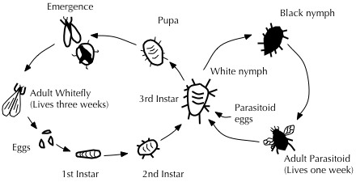
Diagram illustrating the life cycles of Greenhouse whitefly and its parasitoid wasp Encarsia formosa
- Encarsia formosa A small predatory chalcid wasp which is a parasitoid of whitefly, a sap-feeding insect which can cause wilting and black sooty moulds. It is most effective when dealing with low level infestations, giving protection over a long period of time. The wasp lays its eggs in young whitefly 'scales', turning them black as the parasite larvae pupates.
- Eretmocerus spp. (against white flies).

3- Pathogen (bacteria , fungi ,viruses, Protozoa, Nematoda):
Bacteria
Bacteria used for biological control infect insects via their digestive tracts, so they offer only limited options for controlling insects with sucking mouth parts such as aphids and scale insects.
Bacillus thuringiensis is the most widely applied species of bacteria used for biological control, with at least four sub-species used against Lepidopteran (moth, butterfly), Coleopteran (beetle) and Dipteran (true fly) insect pests. The bacterium is available in sachets of dried spores which are mixed with water and sprayed onto vulnerable plants such as brassicas and fruit trees. B. thuringiensis has also been incorporated into crops, making them resistant to these pests and thus reducing the use of pesticides.
The bacterium Paenibacillus popilliae causes milky spore disease has been found useful in the control of Japanese beetle, killing the larvae. It is very specific to its host species and is harmless to vertebrates and other invertebrates.

Fungi:
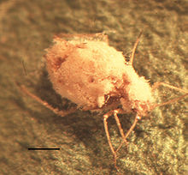
Green peach aphid, a pest in its own right and a vector of plant viruses, killed by the fungus Pandora neoaphidis
Entomopathogenic fungi, which cause disease in insects, include at least 14 species that attack aphids.
Beauveria bassiana is mass-produced and used to manage a wide variety of insect pests including whiteflies, thrips, aphids and weevils.
Lecanicillium spp. are deployed against white flies, thrips and aphids.
Metarhizium spp. are used against pests including beetles, locusts and other grasshoppers, Hemiptera, and spider mites. Paecilomyces fumosoroseus is effective against white flies, thrips and aphids;
Purpureocillium lilacinus is used against root-knot nematodes, and 89 Trichodermaspecies against certain plant pathogens.
Trichoderma viride has been used against Dutch elm disease, and has shown some effect in suppressing silver leaf, a disease of stone fruits caused by the pathogenic fungus Chondrostereum purpureum.
The fungi Cordyceps and Metacordyceps are deployed against a wide spectrum of arthropods. Entomophaga is effective against pests such as the green peach aphid.
Several members of Chytridiomycota and Blastocladiomycota have been explored as agents of biological control.From Chytridiomycota, Synchytrium solstitiale is being considered as a control agent of the yellow star thistle (Centaurea solstitialis) in the United States.

Viruses:
Baculoviruses are specific to individual insect host species and have been shown to be useful in biological pest control. For example, the Lymantria dispar multicapsid nuclear polyhedrosis virus has been used to spray large areas of forest in North America where larvae of the gypsy moth are causing serious defoliation. The moth larvae are killed by the virus they have eaten and die, the disintegrating cadavers leaving virus particles on the foliage to infect other larvae.
A mammalian virus, the rabbit haemorrhagic disease virus has been introduced to Australia and to New Zealand to attempt to control the European rabbit populations there.

Algae:
Lagenidium giganteum is a water-borne mould that parasitizes the larval stage of mosquitoes. When applied to water, the motile spores avoid unsuitable host species and search out suitable mosquito larval hosts. This alga has the advantages of a dormant phase, resistant to desiccation, with slow-release characteristics over several years. Unfortunately, it is susceptible to many chemicals used in mosquito abatement programmes.

Competitors:
The legume vine Mucuna pruriens is used in the countries of Benin and Vietnam as a biological control for problematic Imperata cylindrica grass: the vine is extremely vigorous and suppresses neighbouring plants by out-competing them for space and light. Mucuna pruriens is said not to be invasive outside its cultivated area.^{[58]} Desmodium uncinatum can be used in push-pull farming to stop the parasitic plant, witchweed (Striga).

Other methods:

Combined use of parasitoids and pathogens:
In cases of massive and severe infection of invasive pests, techniques of pest control are often used in combination. An example is the emerald ash borer, Agrilus planipennis, an invasive beetle from China, which has destroyed tens of millions of ash trees in its introduced range in North America. As part of the campaign against it, from 2003 American scientists and the Chinese Academy of Forestry searched for its natural enemies in the wild, leading to the discovery of several parasitoid wasps, namely Tetrastichus planipennisi, a gregarious larval endoparasitoid,Oobius agrili, a solitary, parthenogenic egg parasitoid, and Spathius agrili, a gregarious larval ectoparasitoid. These have been introduced and released into the United States of America as a possible biological control of the emerald ash borer. Initial results have shown promise with Tetrastichus planipennisi and it is now being released along with Beauveria bassiana, a fungal pathogen with known insecticidal properties.

Indirect control:
Pests may be controlled by biological control agents that do not prey directly upon them. For example, the Australian bush fly, Musca vetustissima, is a major nuisance pest in Australia, but native decomposers found in Australia are not adapted to feeding on cow dung, which is where bush flies breed. Therefore, the Australian Dung Beetle Project (1965–1985), led by Dr. George Bornemissza of the Commonwealth Scientific and Industrial Research Organisation, released forty-nine species of dung beetle, with the aim of reducing the amount of dung and therefore also the potential breeding sites of the fly.

Side-effects
Biological control can affect biodiversity through predation, parasitism, pathogenicity, competition, or other attacks on non-target species. An introduced control does not always target only the intended pest species; it can also target native species. In Hawaii during the 1940s parasitic wasps were introduced to control a lepidopteran pest and the wasps are still found there today. This may have a negative impact on the native ecosystem, however, host range and impacts need to be studied before declaring their impact on the environment.
Vertebrate animals tend to be generalist feeders, and seldom make good biological control agents; many of the classic cases of "biocontrol gone awry" involve vertebrates. For example, the cane toad (Bufo marinus) was intentionally introduced to Australia to control the greyback cane beetle (Dermolepida albohirtum), and other pests of sugar cane. 102 toads were obtained from Hawaii and bred in captivity to increase their numbers until they were released into the sugar cane fields of the tropic north in 1935. It was later discovered that the toads could not jump very high and so were unable to eat the cane beetles which stayed up on the upper stalks of the cane plants. However the toad thrived by feeding on other insects and it soon spread very rapidly; it took over native amphibian habitat and brought foreign disease to native toads and frogs, dramatically reducing their populations. Also when it is threatened or handled, the cane toad releases poison from parotoid glands on its shoulders; native Australian species such as goannas, tiger snakes, dingos and northern quolls that attempted to eat the toad were harmed or killed. However, there has been some recent evidence that native predators are adapting, both physiologically and through changing their behaviour, so in the long run, their populations may recover.
Rhinocyllus conicus, a seed-feeding weevil, was introduced to North America to control exotic musk thistle (Carduus nutans) and Canadian thistle (Cirsium arvense). However the weevil also attacks native thistles, harming such species as the endemic Platte thistle (Cirsium neomexicanum) by selecting larger plants (which reduced the gene pool), reducing seed production and ultimately threatening the species' survival.
The small Asian mongoose (Herpestus javanicus) was introduced to Hawaii in order to control the rat population. However it was diurnal and the rats emerged at night, and it preyed on the endemic birds of Hawaii, especially their eggs, more often than it ate the rats, and now both rats and mongooses threaten the birds. This introduction was undertaken without understanding the consequences of such an action. No regulations existed at the time, and more careful evaluation should prevent such releases now.
The sturdy and prolific eastern mosquitofish (Gambusia holbrooki) is a native of the southeastern United States and was introduced around the world in the 1930s and 40s to feed on mosquito larvae and thus combat malaria. However, it has thrived at the expense of local species, causing a decline of endemic fish and frogs through competition for food resources, as well as through eating their eggs and larvae. In Australia, the mosquitofish is the subject of discussion as to how best to control it; in 1989 it was said that "biological population control is well beyond present capabilities", and this remains the position.

Grower education
A potential obstacle to the adoption of biological pest control measures is growers sticking to the familiar use of pesticides. It has been claimed that many of the pests that are controlled today using pesticides, actually became pests because pesticide use reduced or eliminated natural predators. A method of increasing grower adoption of biocontrol involves is letting growers learn by doing, for example showing them simple field experiments, having observations of live predation of pests, or collections of parasitised pests. In the Philippines, early season sprays against leaf folder caterpillars were common practice, but growers were asked to follow a 'rule of thumb' of not spraying against leaf folders for the first 30 days after transplanting; participation in this resulted in a reduction of insecticide use by 1/3 and a change in grower perception of insecticide use.

