**Remote Sensing Lab**

**LAB 10: Physics of Satellite Orbits**

**Purpose:**

To understand the mathematical and physical concepts of satellite orbits.

**Theory:**

**Newton's Laws of Gravity is:**

 (1)

where the symbol represent:

F = gravitational force

m1 = mass of the first object

m2 = mass of the second object

r = distance between the centers of the objects

G = universal constant of gravitation = 6.673 × 10-11 Nm2/kg2

Using this equation and knowing the mass of the earth and the mass of GOES satellites, scientists launch GOES satellites to an elevation that locks them into a permanent orbit over the same location of the earth indefinitely.

**Kepler's Laws of Motion**

The motion of a satellite around earth is defined by Kepler's Laws of Motion. So, to better understand the GOES and POES observations, we need to review these laws. The physics of any object in orbit about a more massive body is best explained by Kepler's laws of motion. These laws are true for any orbit: a planet orbiting a star, a moon orbiting a planet, or an artificial satellite orbiting the Earth.

1. **The path of the object will be an ellipse, with the massive body at one focus**

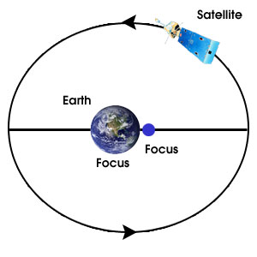

An ellipse is a closed, curved shape that looks like a flattened circle. An ellipse contains two foci and the sum of the distances to the foci from any point on the ellipse is a constant.

The Earth occupies one focus of the ellipse, not the center.

1. **A straight line joining the central body and the orbiting body will sweep out equal areas in equal times**

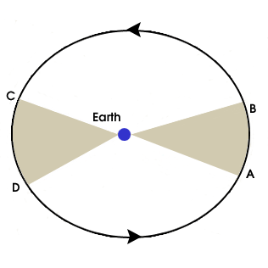

Satellites do not orbit at a constant speed -- they speed up and slow down. The time between points A and B is the same as the time between points C and D. The areas of the two wedges are the same.

Does this work for earth's orbit? Count the number of days between September 21 (Autumn Equinox) and March 21 (Spring Equinox) and the number of days between March 21 and September 21.

1. **The square of a planet's year always equals some multiple of the cube of the planet's distance from the sun**



P: is the orbital period in Earth years

a: is the length of the semi-major axis (average distance from the Sun) in Astronomical Units.

This means that if you know how much time a planet's orbit around the Sun takes, you can know it's average distance from the Sun, or vice-versa!

**Orbital Mechanics**

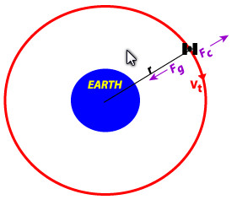

For a two body system comprising of the earth and a much smaller object such as a satellite, the motion of the body in the central gravitational field (equation 1) can be written as:

 (2)

where:

M: is the mass of earth

m: is the mass of satellite.

The centrifugal force which is an outward-directed force that normally balances the inward-directed centripetal force, given by:

 (3)

where

*v*: is the tangential velocity of the satellite.

These forces are required to help maintain the circular trajectory of an object, so $F_{g}=F_{c}$, i.e.



Then solving for *v* gives:



Since the tangential velocity *v* is equal to $2πr/T$, where *T* is the orbital period, then





or

 (4)

Equation (4) can be used to calculate *r* for a given *T*.

**Methodology**

**Calculations**

1. Calculate the altitude at which a satellite of mass 2105 kg orbits the Earth. The gravitational force is 649 N and the universal constant of gravitation G is 6.673×10-11 Nm2/kg2 . The mass of the Earth is 5.988×1024 kg.
2. Calculate the altitude at which a satellite of mass 2100 kg orbits a planet of mass 2.736× 1023 kg. The gravitational force is 450 N and the universal constant of gravitation G is 6.673 × 10-11 Nm2 /kg2.
3. When a falling meteor is a distance above the earth's surface of 3 times the Earth's radius, what is its free-fall acceleration due to the gravitational force exerted on it? The universal constant of gravitation G is 6.673×10-11 Nm2/kg2, the mass of the Earth is 5.988×1024 kg and the radius of earth is 6400 km.
4. If you and a friend are separated by 10 m and you both have a mass of 70 kg, and the universal constant of gravitation G is 6.673 × 10-11 Nm2 /kg2. what is the magnitude of the gravitational force you exert on each other?
5. For the geostationary orbit, the period of the satellite matches the rotational period of the earth so that the satellite appears to stay in the same spot in the sky. This implies that T = 24 hours. What is the radius of the orbit and is the height of satellite above the earth surface. The universal constant of gravitation G is 6.673×10-11 Nm2/kg2, the mass of the Earth is 5.988×1024 kg and the radius of earth is 6400 km.
6. Calculate the radius of orbit and height above the earth surface for a polar orbit satellite with orbital period of 100 minutes. The universal constant of gravitation G is 6.673×10-11 Nm2/kg2, the mass of the Earth is 5.988×1024 kg and the radius of earth is 6400 km.
7. The moon orbits the earth once every 27.3 days. The universal constant of gravitation G is 6.673×10-11 Nm2/kg2, the mass of the Earth is 5.988×1024 kg and the radius of earth is 6400 km. What is its radius of orbit and its height above the earth surface?