Influence of Environmental Factors on Growth
Microorganisms must be able to respond to variations in nutrient levels particularly for nutrient limitation. Growth of M.O also affected by the chemical and physical factors for their surrounding environment. Most important environmental factors that affect microbial growth are:
Solutes and water activity
The selectively permeable plasma membrane protect M.O from their environment, they can be affected by changes in the osmotic pressure. Many microorganisms keep the osmotic concentration of their protoplasm above that of the habitat by the use of compatible solutes, that are compatible with metabolism and growth at high intracellular concentrations. Because the osmotic concentration of a habitat has an effects on M.O, it is useful to be able to express quantitatively the degree of water availability or water activity(aw) ; has been used for this purpose also water availability may expressed as water potential .Highest aw found 1.00 in blood, vegetables, meat and fruit while, aw is 0.60 in honey ,chocolate and dried milk.
Hydrogen ion (pH)
pH measuring the hydrogen ion activity of a solution and is defined as the negative logarithm of the hydrogen ion concentration. the pH scale extends from pH 0.0 to pH 14 ; 0 as in concentrated nitric acid, 2 as in lemon juice, 3 as in vinegar, 4 as in tomatoes and orange juice. Neutral 7 as in pure water, milk, blood and saliva, 8 as in sea water ,10 for soap and 12 for calcium hydroxide as in figure below.
pH affects microbial growth, each M.O has a definite pH growth range and optimum pH value. M.O has been classified according to optimum pH values as below:
- Acidophiles: optimum pH range (0 - 5.5)
- Neutrophiles: optimum pH range (5.5 - 8)
- Alkalophiles: optimum pH range (8.5-11)
- Extreme alkalophiles:;have growth optima at pH 10 or higher.
Most bacteria are neutrophiles, with some exceptions changing in pH can harm M.O by disrupting the plasma membrane or inhibiting the activity of enzymes and membrane transport proteins. Several mechanisms for the maintenance of a neutral cytoplasmic pH have been proposed such as plasma membrane may be relatively impermeable to protons, some bacteria synthesize a new proteins to protect cells against acidic pH, m.o some times change the pH of their own habitat by producing acidic or basic metabolic waste products.

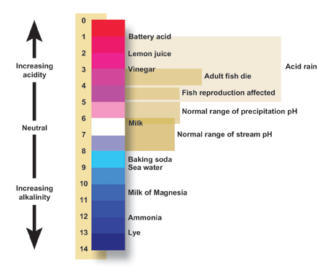
Temperature
Temperature factor affect on the susceptibility of microorganisms because they are unicellular and their temperature varies with external environment conditions. Temperature affect on growth because it affect on enzyme-catalyzed reactions ,temp. rise increases the growth rate because metabolism is more active at high temperatures, the velocity of an enzyme-catalyzed reaction is double for every 10° C rise in temp. High temp. damage M.O by denaturing enzymes, transport carriers and other proteins.
Microbial membranes are also disrupted by extreme temp. The lipid bilayer melts and disintegrates, the m.o may be damaged to such an extent that growth is inhibited and the damage cannot be repaired. At very low temp. membranes solidify and enzymes don’t work rapidly, the cardinal temp. depend on other environmental factors such as pH and the available nutrients. Microorganisms can be divided into 5 classes based on their temp. ranges for growth :
- Psychrophiles: grow well at 0°C and have an optimum temp. of 15°C or lower; the maximum around 20°C. They adapted to their environment in several ways; A. enzymes, transport systems and protein synthetic mechanisms function well at low temp. B. Cell membranes have high levels of unsaturated fatty acids and remain semi-fluid at the low temp.

- Psychrotrophs: can grow at (0-7 °C) they are major factors in the spoilage of refrigerated foods.
- Mesophiles: M.O growth optima around (20 -45°C). All human pathogens are mesophiles (37 °C ).
- Thermophiles: M.O that grow at temp. 55°C or higher, they have more heat-stable enzymes and protein synthetic systems, which can function properly at high temp. Thermophile DNA is stabilized by special histone like proteins. The membrane lipids of thermophiles are also quite temp. stable, they tend to be more saturated, more branched and higher molecular weight, which increasing the melting points of membrane lipids.
- Hyperthermophiles: M.O that have growth optima between 80-113° C.

Figure: Temperature range of microbial growth

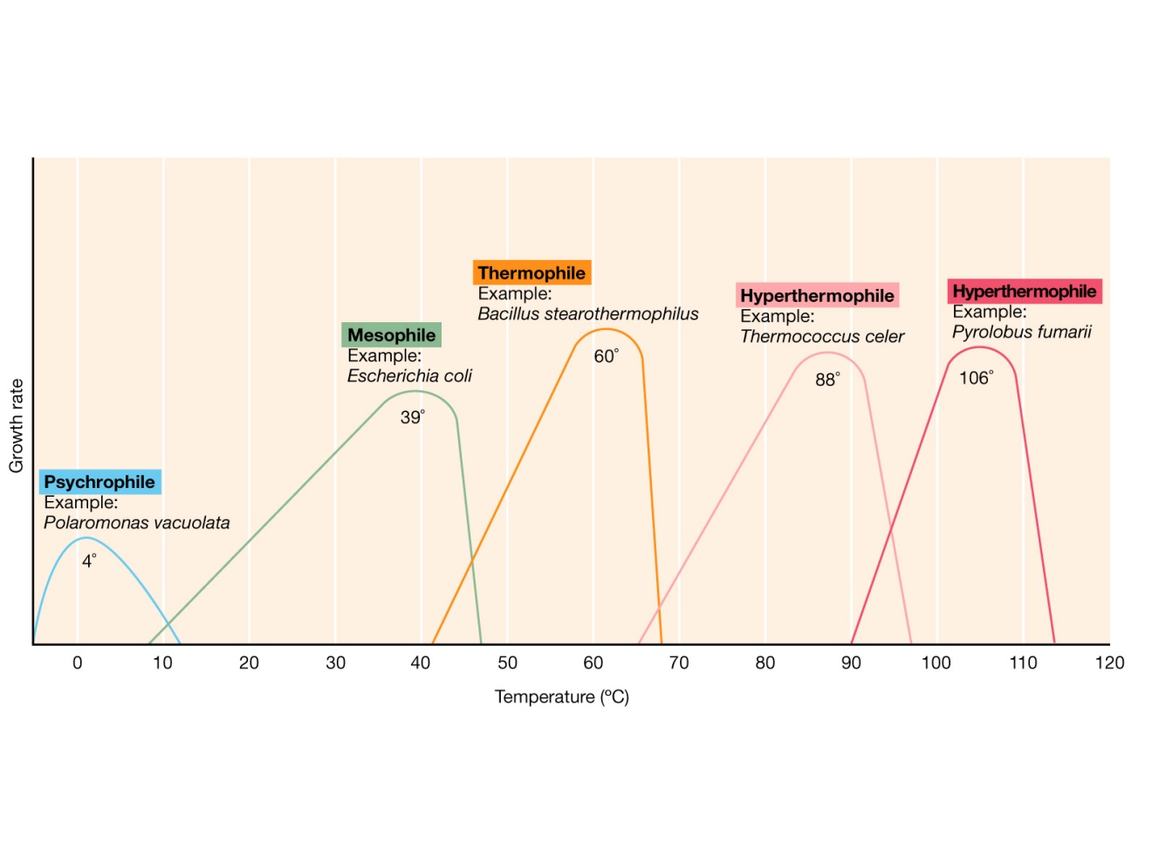
Oxygen concentration
Oxygen serves as the terminal electron acceptor for the electron-transport chain in aerobic respiration. Microorganisms are divided into 4 types according to their need to oxygen :
- Facultative anaerobes: does not require O₂ for growth but grow better in it’s present.
- Aerotolerant anaerobes: ignore O_{2 and grow equally} well whether it is present or not.
- Strict or obligate anaerobes: do not tolerant O2 at all and die in its presence. Aerotolerant and strict anaerobes can not generate energy through respiration and must emply fermentation or anaerobic respiration pathways for this purpose.
- Microaerophils: require only 2-10% of O2. It should be noted that the ability to grow in both aerobic and anaerobic environmental provides considerable flexibility and is an ecological advantage.
Oxygen accepts elections and is readily reduced because it’s two outer orbital electrons are unpaired. Flavoprotiens, several other cell constituents, and radiation; promote oxygen reduction; following products results from reduction: superoxide radical, hydrogen peroxide and hydroxyl radical:

O₂ +e⁻ O₂.Superoxide radical

O₂. +e⁻ + 2H⁺ H₂O₂Hydrogen peroxide

H₂O₂ +e⁻ + H⁺ H₂O +OH Hydroxyl radical

These products are extremely toxic because they are powerful oxidizing agents and rapidly destroy cellular constituents. M.O. must be able to protect itsel against such oxygen products or it will be killed. Neutrophils and macrophage use these toxic products to destroy invading pathogens.
Many M.O. possess enzymes that afford protection against toxic O₂ products.

Obligate aerobes and facultative anaerobes usually contain the enzymes superoxide dismutase (SOD) and catalase, which catalyze the destruction of superoxide radical and hydrogen peroxide, respectively. Peroxidase also can be used to destroy hydrogen peroxide:

2O₂. + 2H⁺ Superoxide dismutase O₂+H₂O₂

2H₂O₂ Catalase 2H₂O +O2

H₂O₂ +NADH + H⁺ Peroxidase 2H₂O + NAD⁺

Radiation
Sunlight is the major source of radiation, it is includes visible light, ultraviolet (UV) infrared ray and radio waves; these wave called electromagnetic radiation, as the wave length decrease, the energy of the radiation increase- gamma and X rays are much more energetic than visible light or infrared waves.

Visible light is a most important for life because of the ability of photosynthetic organisms to trap the light energy of the sun.

The ionizing radiation (e.g., X-rays, gamma rays) are very harmful to microbial growth. Low levels of these radiations may cause mutations and may indirectly result in death whereas high levels may directly cause death of the microbes. Ionizing radiation, however, destroys ring-structures, breaks hydrogen bonds, oxidizes double bonds and Sunlight is the major source of radiation, it is includes visible light, ultraviolet (UV) infrared ray and radio waves; these wave called electromagnetic radiation, as the wave length decrease, the energy of the radiation increase- gamma and X rays are much more energetic than visible light or infrared waves.

