“Compound Light Microscope”
*Microbiology:-It is the study of organisms that are too small to be seen with the naked eye .
These organisms are unicellular or multicellular ;they include prokaryotes(such as bacteria) & eukaryotes(such as fungi& protists) . viruses are also studied.
-Causative agents of the most common diseases are m.o which cannot be seen without using the microscope, therefore it is an important apparatus in the laboratory.

**Microscopic Parts:- In order to operate a microscope properly & effectively, it is necessary to have an understanding of some of the various parts of the microscope & their functions.
1)Base: It supports the microscope &give the apparatus stability.
2)Arm: the part of the microscope that you carry the mic roscope with.
3)Body tube: The long tube that holds the eyepiece & connects it to the objectives.
4)Ocular lenses(eyepieces):The lenses in the upper part of the microscope where you look through to see the image of your specimen.

There are 2 kinds of microscopes :-
a)Monocular microscopes: have one ocular lenses.
b)Binocular microscopes :have two oculars.

5)Revolving nose piece : The rotating part of the microscope at the bottom of the body tube ,it holds the objectives.
6)Objective lenses : The microscope may have 2,3 or more objective attached to the nose piece ,they vary in length (the shortest is the lowest power or magnification, the longest is the highest power or magnification).

A-Scanning lenses (4X)
B-Low power lenses(10X)
C-High power lenses(40X)
D-Oil immersion lenses(100X)

7) Coarse adjustment knob :- The large round knob on the side of the microscope used for focusing the specimen, it may move the stage up or down to correct distance from objective for viewing.
8)Fine adjustment knob : The small round on the side of the microscope used for focusing the specimen after using the coarse adjustment knob.

9)Stage: the large flat area under the objective ,it has a hole in it that allows light to pass through. The slide is placed on the stage for viewing.

10)Stage clips: The clips on the top of the stage which hold the slide in place.
11) Aperture :the hole in the stage that allows light to pass through for better viewing of the specimen.

12)Diaphragm & condenser: the parts of microscope that control the amount of light going through the apertures.

13)Light: the source of light usually found near the base of the microscope , the light source makes the specimen easier to see.

*Oil immersion lens: it is one of the objective which has the highest magnification ,it is used for the examination of the organisms that could not be seen without high magnification . a special oil is used with this objective which is called ((cedar oil)).

*the function of oil:-the oil contributes to 2 characteristics of the image viewed through the microscope:-
- Finer resolution.
- Finer brightness.

These characteristics are important when high magnification is used ,so it is only the higher power objective that is usually designed for oil immersion lens.

*the reason of using oil: when the light passes from a material of one refractive index to material of another ,as from glass to air or from air to glass ,it bends.
Placing a drop of oil with the same refractive index as glass between the slide & the objective lens eliminates 2 refractive surface &increase the clarity of the image.

- Cleaning the oil immersion lens:
a disadvantage of oil immersion viewing is that the oil must stay in contact with the glass & oil is viscous.

Oil immersion lenses used only with oil ,& oil cann’t be used with dry lenses ,such as:- low & high power lenses , therefore oil distorts image seen with dry lenses - so once you place oil on a slide ,it must be cleaned off thoroughly before using the high dry lens again. Oil on non –oil lenses will distort viewing & possibly damage the coatings.

Cleaning this lens is done by using:-
1-Dry “lens paper”
2-Wet lens paper with “xylole”
3-Dry lens paper.

*Calculating the total magnification:-

Objective lens magnification * Ocular lens magnification.
Example: 40X*10X=400X
-----------------------------------------------------------------

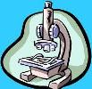

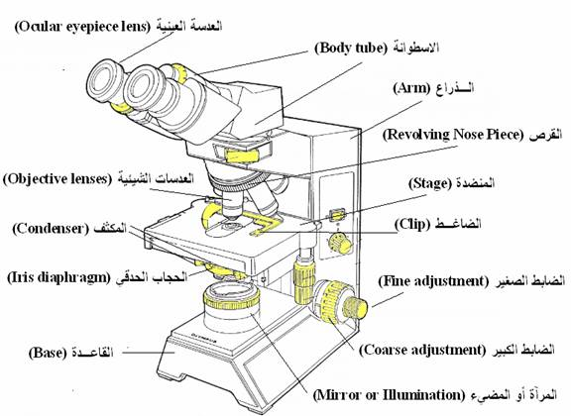
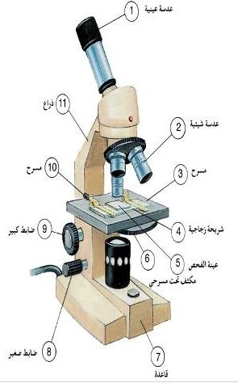

Laboratory Equipments & Apparatus

-test tube -lens paper -needle
-plane tube -triple holder -funnel
-universal tube -flask -pipette
-centrifugal tube -petridish -spreader
-benzen burner -rack -Pasteur pipette
-washing bottle -loop -slide
-filter paper -cylinder -cover slip
-swab -beaker (slide cover)

1*Autoclave
-components:-
1) jacket 2)chamber 3)door or cover 4)door handle
5)thermometer 6)pressure gauge 7)excessive water discharge
8)air discharge valve 9) safety valve valve

-Uses:-
1)sterilization of cultural media & lab. Equipments.
2)treatments of contaminated solutions & fluids.

Principle of work:-
1) heating water in a closed vessel which leads to the production of saturated steam under pressure, its temperature is more than 100Cْ & this is called “ moist heat sterilization”
In presence of pressure.
2)sterilization circumstances are ( 121) C for (15) min under pressure of ( 1) atmosphere ( which equal to 15 pound/inch²).
-working steps:-
1)fill the jacket with water to the level of holes & make sure that it does not reach the chamber.
2)put the chamber that contains materials & equipments to be sterilized in the jacket.
3)close the door by closing the door handle without doing that tightly.
4)open the air discharge valve.
5) switch on the electrical current for heating water inside the apparatus.
6)wait for 3-4 minutes until acontinuous homogenized flow of steam discharging valve indicating the elimination of all trapped (enclosed) air in the apparatus.
7)close the air discharging valve & tighten the door handle ,then monitor (watch) the temperature & pressure guage for reaching the required degrees ( 121C & 1 atmosphere respectively),so we calculate time at this point.

8-switch off the electrical current when time over( 15 minutes).
9- wait until temperature decreases under 100C ,then open air discharging valve for reaching equilibrium in pressure inside & outside the apparatus.
10-when the whistling voice (which indicate steam discharging) stops ,open the door handles then open the door & wait until the contents of the autoclave become cool, then raise the chamber which contains the sterilized materials& dry them from water drops formed on it.

*importance of air elimination (air removal):-
The impotance of the enclosed air removal inside the apparatus (when the operation starts) belongs to the necessity of exposing materials & equipments which we want to sterilize to the effect of steam only because:-
1)mixing air with steam lowers the temperature that is necessary for the required pressure.
2) as air density is more than of steam, it will form a separated cold layer at the lower part of the apparatus ,
This will delay the penetration of steam to the materials and equipment to be sterilized this preventing enough heating.

Electrical oven
-components :- 1) thermostste 2) thermometer 3)timer .
-uses:-sterilization of the lab. Equipments wether glass or metallic.
-principle of work:-
1)sterilization by using dry heat.
2)sterilization circumstance are ( 160-180) C for ( 1-2) hours.
- working steps:-
1)put the equipments to be sterilized in the apparatus (make sure of its dryness).
2)fix the thermostat at the required deqre & switch on the apparatus.
3) watch the thermometer which rasise gradually .
Calculation the time begins upon reaching the required heat.
4)switch off the apparatus when time over & wait until the heat decreases to (40) C , Then open the door of the oven & take out the sterilized equipments.
Incubator
-components :-
1) chamber of different size contains glass or metallic shelves
With two doors: outer metallic door & inner glass one.
2) thermostat 3) thermometer
USES:-
Incubation & encouragement of the growth of all M.O.kinds (types) like pathological & non –pathological bacteria ,parasites & fungi.
Pathological bacteria ------------< 37C
Fungi------------------------- <25 – 28C.
Centrifuge
-components:-
1)central head
2)wind shield or rotary piece fixed on the central head & branched into several branches called (pans) which carry a(bucket) at its end or number of buckets specialized to carry one tube or several tubes which contain the fluid to be centrifuged .
3)timer which stops the centrifuge spontaneously when time is over.
4) revolutions calculator which refers to the velocity of the apparatus during centrifugation (round per minute/revolution rpm).
Uses:-
Separations of fluids or suspended culture of M.O into two parts:-
1-sediment which is the lower part that is located at the bottom of the tube that contains the suspended particles in the fluid.
2- supernatant which is the upper part that lies above the sediment & contains the rest of the fluid.

-principle of work:-
Rotating the central head in a circular movement that lead to rotation of the tubes which contains the fluid to be centrifuged,
So it becomes subjected to a force that attracts it away from the center, called “centrifugal force “ & then fluid will be separated into sediment & supernatant.

-working steps:-
1)switch on the apparatus & elevate (increase)the velocity (speed) gradually until reaching the required velocity.
2)fix the timer at the required time & when time over ,
The velocity of the centrifuge will decrease gradually then take out the tubes slowly after opening the cover.

*Hood or Laminar (inoculation cabinet)

-components
1)small chamber closed from all sides by windows made of
glass with small front hole for entering hands in order to manipulate the laboratory work.
2)Front cover made of iron.
3) Door: it is a smooth sliding door used to close the front hole & it is made of safety glass.
4) gas valve: it controls the amount of gas.

5)ventilation hole (air filter): it contains filters & found at the roof of the chamber-
1. for sucking or filtering out air which contains microbes or air born particles .
2.for draining gas burning residues which formed because of using benzene burner during work.
This is done to prevent inner contamination.
6) inner ultra violet lamp (light) (U.V.L) located at the roof of the chamber & used for sterilization.
7)inner florescent or electrical lamp (light) (F.L) located at the roof of the chamber & used for lightening the chamber.
8) pressure gauge: it displays the contamination measure.
When the gauge indicates 25mm H₂O than the first use , replace the filter.

9)controller: composed of:

1.power switch.
2.F.L. lamp.
3.U.V.L. lamp.
4.blower switch.
5.blower power display.
6.blower speed adjuster.
7.blower display.

Uses:-
Performing laboratory culture in a sterilized circumstance away from air currents to prevent contamination

*hot plate with magnetic stirrer
-components
1)electrical motor
2)base for putting container( in which the fluid mixing done) on it.
3) heating guage.
4)speed guage.
Uses:-
Dissolving culture media powder in distilled water for preparation of that medium in order to convert it into homogenized solution.
To make that easy we use small magnetic bar which must be put in the medium to facilitated the homogenisity.

*water bath
It is used for dissolving solid culture medium after its solidification in order to convert into liquefied or melted agar to facilitate pouring it into plates or test tubes.

*colony counter
It is used for counting single colonies which are grown on the surface of solid medium after using some culturing isolation methods.
*vortex
It is used for converting the bacterial suspensions & other suspensions into homogenized solutions especially those that are cultured in test tubes.

*balance:-
It is used for weighing large quantities of materials or powders of cultural media.
*sensitive balance
It is used for weighing small quantities or few grams of materials or powders of cultural media.

Level 2

