Muscle tissue
Muscle tissue, the three basic tissue type with epithelia and connective tissues, is composed of cells that optimize the universal cell property of contractility. As in all cells, actin microfilaments and associated proteins generate the forces necessary for the muscle contraction, which drives movement within organ systems, of blood, and of the body as a whole. Essentially all muscle cells are of mesodermal origin and differentiate by a gradual process of cell lengthening with abundant synthesis of the myofibrillar proteins actin and myosin.
Three types of muscle tissue can be distinguished on the basis of morphologic and functional characteristics, with the structure of each adapted to its physiologic role:
- Skeletal muscle contains bundles of very long, multinucleated cells with cross-striations. Their contraction is quick, forceful, and usually under voluntary control.
- Cardiac muscle also has cross-striations and is composed of elongated, often branched cells bound to one another at structures called intercalated discs that are unique to cardiac muscle. Contraction is involuntary, vigorous, and rhythmic.
- Smooth muscle consists of collections of fusiform cells that lack striations and have slow, involuntary contractions.

In all types of muscle, contraction is caused by the sliding interaction of thick myosin filaments along thin actin filaments. The forces necessary for sliding are generated by other proteins affecting the weak interactions in the bridges between actin and myosin. Muscle specialist refer to certain muscle cell organelles with special names. The cytoplasm of muscle cells is often called sarcoplasm, the smooth ER is the sarcoplasmic reticulum, and the muscle cell membrane and its external lamina are the sarcolemma.

Skeletal muscle
Skeletal (or striated) muscle consists of muscle fibers, which are long, cylindrical multinucleated cells with diameters of 10 to 100 μm. Elongated nuclei are found peripherally just under the sarcolemma, a characteristic nuclear location unique to skeletal muscle fibers/cells. A small population of reserve progenitor cells called muscle satellite cells remains adjacent to most fibers of differentiated skeletal muscle.

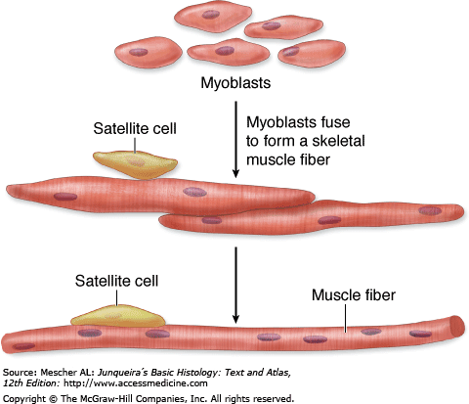
Skeletal muscle begins to differentiate when mesenchymal cells, called myoblasts, align and fuse together to make longer, multinucleated tubes called myotubes. Myotubes synthesize the proteins to make up myofilaments and gradually begin to show cross-striations by light microscopy. Myotubes continue differentiating to form functional myofilaments, and the nuclei are displaced against the sarcolemma. Part of the myoblast population does not fuse and differentiate but remains as a group of mesenchymal cells called muscle satellite cells located on the external surface of muscle fibers inside the developing external lamina. Satellite cells proliferate and produce new muscle fibers following muscle injury.
- The epimysium, an external sheath of dense connective tissue, surrounds the entire muscle. Septa of this tissue extend inward, carrying the larger nerves, blood vessels, and lymphatics of the muscle.
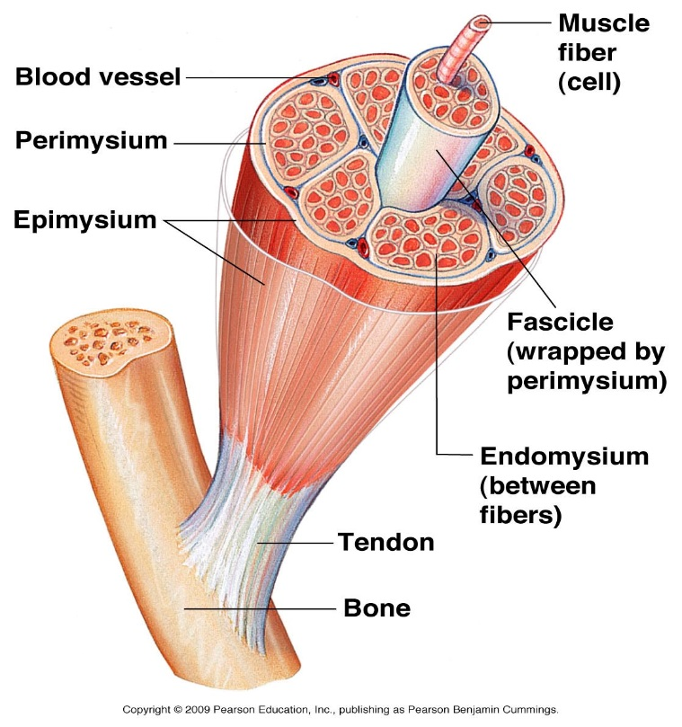
- The perimysium is a thin connective tissue layer that immediately surrounds each bundle of muscle fibers termed a fascicle. Each fascicle of muscle fibers makes up a functional unit in which the fibers work together. Nerves, blood vessels, and lymphatics penetrate the perimysium to supply each fascicle.
- The endomysium, within fascicles a very thin, delicate layer of reticular fibers and scattered fibroblasts, the endomysium, surrounds the external lamina of individual muscle fibers. In addition to nerve fibers, capillaries form a rich network in the endomysium bringing O2 to the muscle fibers.

Longitudinally sectioned skeletal muscle fibers show cross-striations of alternating light and dark bands. The dark bands are called A bands (anisotropic or birefringent in polarized light microscopy); the light bands are called I bands (isotropic, do not alter polarized light). In the TEM, each I band is seen to be bisected by a dark transverse line, the Z disc. The repetitive functional subunit of the contractile apparatus, the sarcomere, extends from Z disc to Z disc and is about 2.5 μm long in resting muscle. A bands bisected by a narrow, less electron-dense region called the H zone and in the I bands the presence of sarcoplasm with mitochondria (M), glycogen granules, and small cisternae of SER around the Z line.
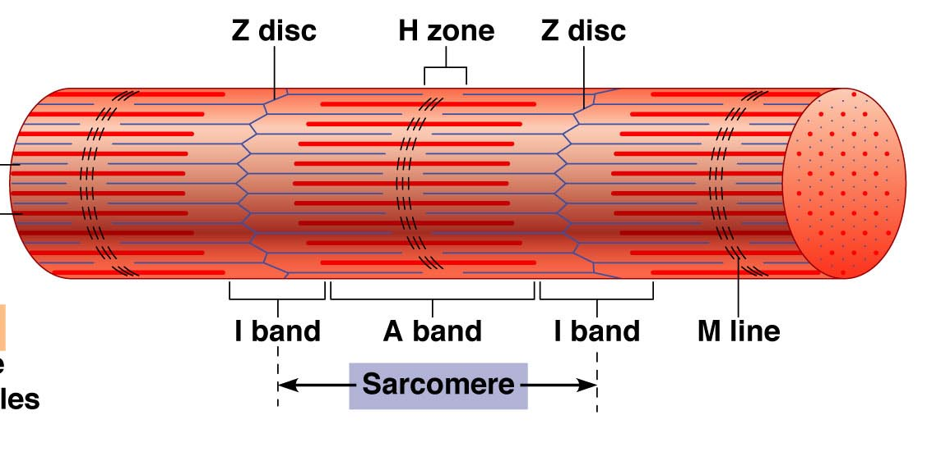

A muscle fiber is filled with longitudinally arrayed structural subunits called myofibrils. Myofibrils extend the entire length of muscle cell. Myofibrils are composed of bundles of myofilaments, which are two types:
- Thin filaments are composed primarily of the:
- Protein actin. Each thin filament of fibrous actin (F-actin) is a polymer formed from globular actin molecules (G-actin), which polymerizes to form a double stranded helix, the F-actin filament. The plus end of each filament is bound to the z line by α-actinin; the minus end extends toward the M line and protected by an actin-capping protein. Each G-actin molecule of the thin filament has a binding site for myosin.
- Tropomyosin, a 40-nm-long coil of two polypeptide chains located in the groove between the two twisted actin strands.
- Troponin, a complex of three subunits: TnT, which attaches to tropomyosin; TnC, which binds Ca2+; and TnI, which regulates the actin-myosin interaction.
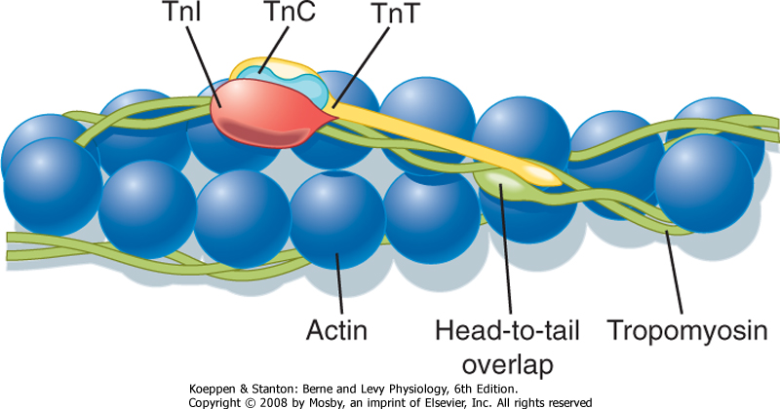
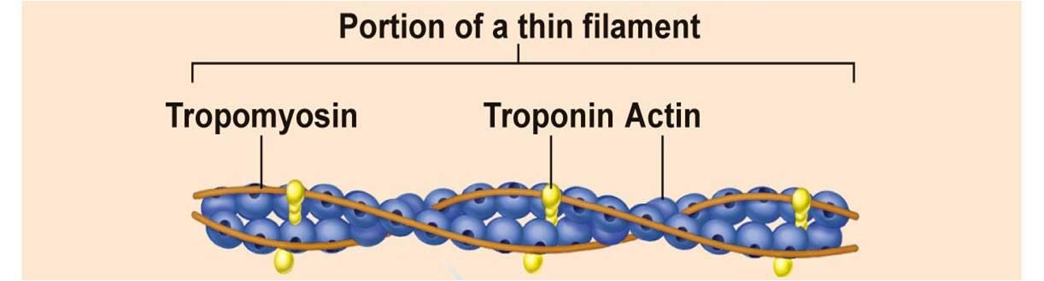

- Thick filaments are composed of the protein myosin. Each thick filament consists of 200-300 myosin molecules. The long, rod-shaped tail portion of each molecule aggregates in a regular parallel but staggered array, whereas the head portions project out in a regular helical pattern.
Myosin is composed of two polypeptide heavy chains and four light chains. Each heavy chain has a small globular head that projects at an approximately right angle at one end of the long rod shaped molecule. This globular head has two specific binding sites, one for ATP and one for actine. Myosin molecules in striated muscles aggregate tail to tail to form bipolar thick myosine filaments; the rod shaped segments overlap so that the globular heads project from the thick filament. H band is the portion of filament that does not have globular projection.
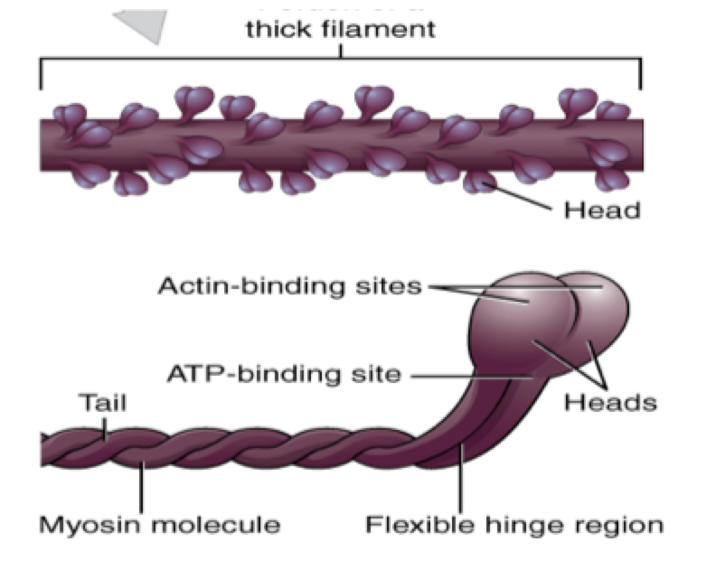

The projecting globular heads of the myosin molecules form cross-bridges between the thick and thin filaments on either side of the H band.
Skeletal muscle in longitudinal section shows:
- The sarcoplasmic reticulum is arranged as a repeating series of networks around the myofibrils. Each network extends from one A-I junction to next A-I junction within a sarcomere.
- The transverse tubular system (T system) consists of numerous tubular invaginations of the plasma membrane; each one is called a T tubule. T tubules
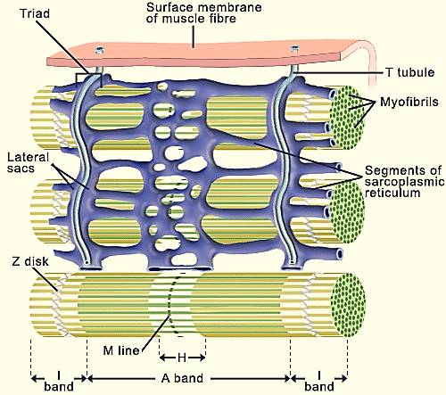
penetrate to all levels of the muscle fiber and are located between adjacent terminal cisternae at the A-I junctions. The complex of T tubule and the two adjacent terminal cisternae is called a triad.
After depolarization of the sarcoplasmic reticulum membrane, calcium ions concentrated within these cisternae are released through Ca2+ channels in the membrane into cytoplasm surrounding the thick and thin filaments. Ca2+ binds troponin and allows bridging between actin and myosin molecules. When the membrane depolarization ends, the sarcoplasmic reticulum pumps Ca2+ back into the cisternae, ending contractile activity. Together, the triad components make up a signaling apparatus for converting repeated cell membrane depolarizations into spikes of free, cytoplasmic Ca2+ that trigger contraction.
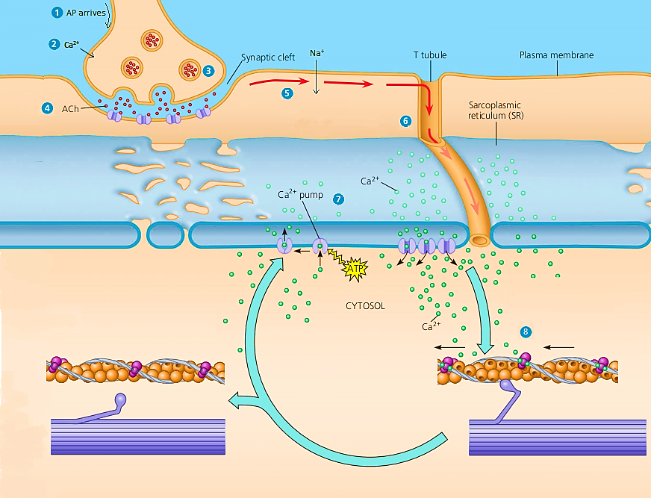

Innervation
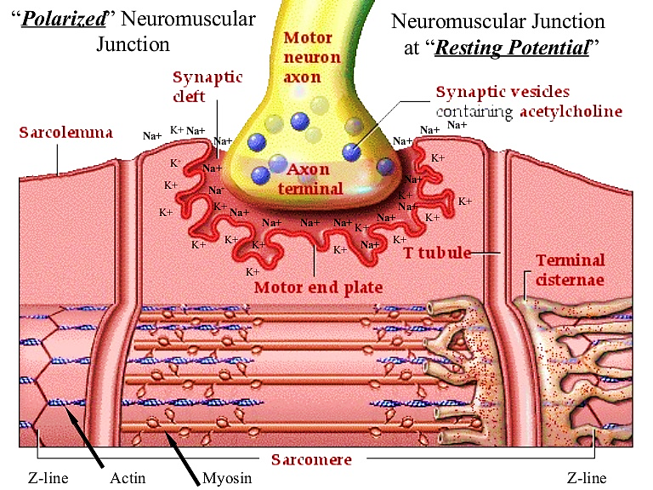
Myelinated motor nerves branch out within the perimysium connective tissue, where each nerve gives rise to several unmyelinated terminal twigs that pass through endomysium and form synapses with individual muscle fibers. Schwann cells enclose the small axon branches and cover their points of contact with the muscle cells; the external lamina of the Schwann cell fuses with that of the sarcolemma. Each axonal branch forms a dilated termination situated within a trough on the muscle cell surface.

This synaptic structure is called the motor end plate (MEP). Within the axon terminal are mitochondria and numerous synaptic vesicles, the latter containing the neurotransmitter acetylcholine. Between the axon and the muscle is a space, the synaptic cleft. Adjacent to the synaptic cleft, the sarcolemma is thrown into numerous deep junctional folds, which provide for greater postsynaptic surface area and more transmembrane acetylcholine receptors.

Cardiac muscle
The fibers consist of separate cells in a series with interdigitating processes where they are held together. These regions of contact are called the intercalated discs, which cross an entire fiber between two cells. The transverse regions of the steplike intercalated disc have abundant desmosomes and other adherent junctions for firm adhesion, while longitudinal regions of the discs contain many physiologically important gap junctions.
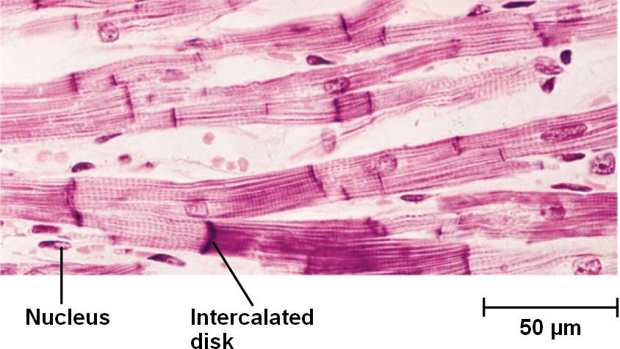
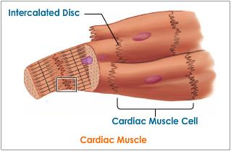
Cardiac muscle cells have central nuclei and myofibrils that are less dense and less well-organized than those of skeletal muscle. Also, the cells are often branched, allowing the muscle fibers to interweave in a more complicated arrangement within fascicles that produces an efficient contraction mechanism for emptying the heart.
Cardiac muscle has the same types and arrangement of contractile filaments as skeletal muscle. Therefore, cardiac muscle cells appear striated. It is unlike skeletal and visceral muscle:
1. Cardiac muscle fibers exhibit cross-bands, called intercalated disc, which represent highly specialized attachment sites between adjacent cells.
2. It consists of numerous cylindrical cells arranged end to end and may join with two or more cells through intercalated disc, thus creating a branched fiber.
3. Its nucleus lies in the center.

4. It has large mitochondria and glycogen granules that are densely packed between the myofibrils. Thus, glycogen granules store energy, mitochondria release and recapture energy. This energy drives contraction.
5. In cardiac muscle, there is only one T tubule per sarcomere. Small terminal cisternae of the sER are in close proximity to the T tubules to formed diad.
6. The T tubules are larger and more numerous in cardiac ventricular muscle than in skeletal muscle.

Smooth muscle
Smooth muscle is specialized for slow, steady contraction and is controlled by a variety of involuntary mechanisms. Fibers of smooth muscle (also called visceral muscle) are elongated, tapering, and nonstriated cells, each of which is enclosed by a thin basal lamina and a fine network of reticular fibers, the endomysium.
Smooth muscle cells are interconnected by gap junctions, which provide communication links that regulate contraction of entire bundle or sheet of smooth muscle. The nuclei of smooth muscle cells are located in the center of the cell. The remaining sarcoplasm is filled with thin filament that forms a part of the contractile apparatus. Thick myosin filaments are scattered throughout the sarcoplasm of a smooth muscle cells. The thin filaments are attached to cytoplasmic densities or dense bodies that are visible among the filaments.

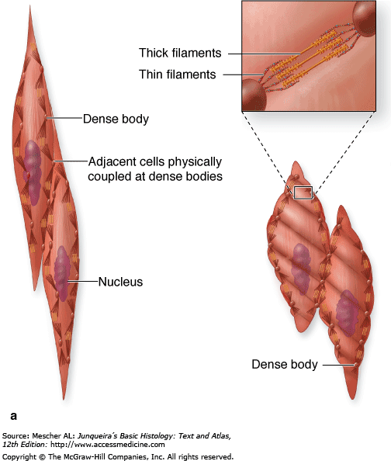

• Thin filaments contain actin, the smooth muscle isoform of tropomyosin. No troponin is associated with smooth muscle tropomyosin. Actin is involved in the force-generating interaction with myosin.
• Thick filaments containing myosin differ slightly from those found in skeletal muscle. They, too, are composed of two polypeptide heavy chains and four light chains. However, the structure of thick filaments in smooth muscle is different than in skeletal muscle. Rather than a bipolar arrangement, myosin molecules are oriented in one direction one side of the filament. In this arrangement, myosin molecules are staggered in parallel between tow immediate neighbors and are also bound to an antiparallel partner via a short overlap at the very tip of their tails. The polarity of the myosin heads is the same along the entire length of one side of the filament and the opposite on the opposite side, the side-polar myosin filament.
