Lec(2) Immunology

Cells of the Innate Immune System

Introduction
White blood cells or leukocytes serve as sentinels and defenders against infection by patrolling the tissues and organs of the body. They move around the body via the lymphatic and blood circulatory systems and can leave and reenter the circulation to move through body tissues. As “soldiers” of the immune system, leukocytes have specialized roles in defense of the body.
Leukocytes are classified by morphology, including the number of lobes that their nuclei possess and the presence or absence of microscopically visible granules in their cytoplasm (Fig. 2.1). Histologic structure is often a helpful clue to the cell's function. Some leukocytes may combat invasive organisms directly; others produce soluble molecules that serve as deterrents to microbial invasion throughout the body. Some leukocytes are autonomous, wielding lethal blows against invaders without intervention from other cells. Others are poised for “combat,” awaiting “orders” from their superiors. Still others serve as field marshals by regulating the assault. Leukocytes may be found as individual cells throughout the body or as accumulations at the sites of infection or inflammation. A knowledge of the role that each leukocyte plays is important to understanding immune function.
All blood-borne cells ultimately derive from pluripotent hematopoietic stem cells. They are called pluripotent because each stem cell has the capacity to produce all leukocytes as well as red blood cells (erythroid lineage) and platelets (thrombocytic lineage). Pluripotent stem cells resident in the bone marrow are the source of lymphocytes and plasma cells; macrophages, monocytes, and dendritic cells; neutrophils, eosinophils, and basophils (the three types of granulocytes—see below); and erythrocytes and platelets. Cells of the myeloid lineage, especially those containing cytoplasmic granules (eosinophils, basophils, and neutrophils), together with agranular phagocytic cells (monocytes, macrophages, and dendritic cells) are involved in innate defenses. Other myeloid lineage–derived cells are involved in gas transport (erythrocytes or red blood cells) and in clotting (platelets). Most of the cells derived from the lymphoid lineage (lymphocytes and plasma cells) are responsible for adaptive immune responses .Other cells (natural killer, or NK, cells and the phagocytes) bridge both innate and adaptive immune systems.
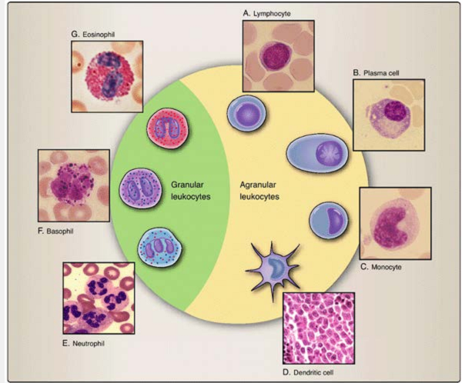
Figure 2.1 Types of leukocytes. White blood cells or leukocytes may be broadly classified by the absence (agranular) or presence (granular) of cytoplasmic inclusions or granules. A. Lymphocytes include T, B, and natural killer (NK) cells. B. B cells that enlarge and differentiate into immunoglobulin secretors are known as plasma cells. C. Monocytes are phagocytic cells in the circulation, and are called macrophages when they enter tissues. D. Dendritic cells are phagocytic cells that bear tree-like cytoplasmic processes. E. Neutrophils have multilobed nuclei and cytoplasmic granules that stain with neutral (pH) dyes. F. Basophils have bilobed nuclei and cytoplasmic granules that stain with basic (pH) dyes. G. Eosinophils have bilobed nuclei and cytoplasmic granules that stain with acidic (pH) dyes.
II. Agranular Leukocytes
White blood cells that have multilobed nuclei and contain conspicuous cytoplasmic granules are known as granulocytes. Others with a single, unlobed nucleus and cytoplasm that contains few or no granules are known as agranular leukocytes.
Agranular leukocytes derive from lymphoid or myeloid lineage precursors and account for approximately 35% to 38% of the leukocytes in circulation.
A. Lymphoid lineage cells
Cells that differentiate along the lymphocytic pathways are known as lymphocytes. Lymphocytes may differentiate along one of several different pathways (see Fig. 2.2). B lymphocytes or B cells reside in the bone marrow and are able to synthesize immunoglobulin molecules. In fact, B cells and their further differentiated progeny, plasma cells, are the only cells that are capable of immunoglobulin synthesis. Other lymphoid lineage cells of bone marrow origin migrate to, differentiate in, and are vetted within the environment of the thymus. Those cells (thymocytes) that exit the thymus are known as thymus-derived lymphocytes or T lymphocytes (T cells). We will address the differentiation and function of B cells, plasma cells, and T cells and their roles in adaptive immune
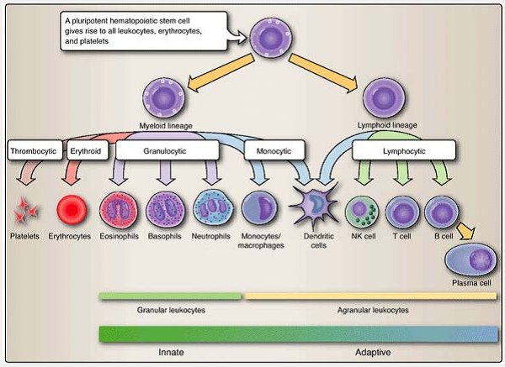
Figure 2.2 Hematopoietic lineages. Pluripotent stems cells within the bone marrow give rise to all the cells found in the blood. Cells of the myeloid lineage differentiate further into platelets, erythrocytes, eosinophils, basophils (and mast cells), neutrophils, monocytes/macrophages and some dendritic cells. Cells of the lymphoid lineage differentiate further into T and B lymphocytes, NK cells, and some dendritic cells.

A third lymphoid lineage cell distinct from B and T cells and their progeny is the natural killer (NK) cell. These large, nonphagocytic, granular lymphocytes are named for their ability to kill abnormal (e.g., infected or malignant) host cells (Fig. 2.3). They account for 5% to 10% of all lymphocytes in the circulation.
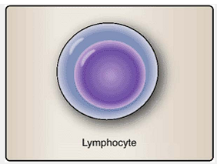
Figure 2.3 Lymphocytes. Except for differing in size (4- to 15-µm range), lymphocytes generally look alike, although they may vary functionally.

B. Monocytic lineage cells
Mononuclear cells that differentiate from myeloid precursors are known as monocytes in the circulation or macrophages once they leave the circulation and enter the tissues. These cells are the scavengers of the body. They phagocytose, or pick up cellular debris, foreign cells, and particles and degrade them enzymatically. Another group of phagocytic cells with both myeloid and lymphoid origins is collectively known as dendritic cells, so named for their branchlike cytoplasmic projections.
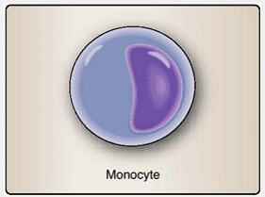
Figure2.4 Monocytes. Circulating mononuclear phagocytes are called monocytes. When the leave the circulation and enter tissues they are called macrophages.
1. Monocytes and macrophages: Monocytes are large mononuclear cells and account for approximately 5% to 7% of the leukocytes in the peripheral blood (Fig. 2.4). Monocytes spend 1 to 2 days in the circulation (their half-life is approximately 8.4 hours), then cross the endothelium to enter tissues throughout the body, where they reside for up to several months as macrophages. Both monocytes and macrophages actively sample their environment by phagocytosis and serve as scavengers to remove cellular debris. Ingested materials are enzymatically degraded.
2. Dendritic cells: Found throughout the body, but predominantly in potential portals of microbial entry (e.g., skin, lung, gastrointestinal tract), these cells are named for their branchlike cytoplasmic projections (Fig. 2.5). Like other phagocytes, dendritic cells
actively engulf cells and particles in their environment by phagocytosis (see Chapter 20). In addition, dendritic cells sample copious quantities of extracellular fluids by macropinocytosis, in which their cytoplasmic projections encircle and engulf tissue fluids and the molecules and particles contained within. Dendritic cells may arise from either myeloid or lymphoid (also called plasmacytoid) lineage cells. As actively phagocytic cells, dendritic cells are important in innate immune defenses.
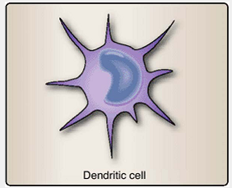
Figure 2.5 Dendritic cells. As professional phagocytes, dendritic cells utilize their cytoplasmic extensions to sample their environment.

III. Granular Leukocytes
Leukocytes that contain conspicuous cytoplasmic granules are known as granulocytes. These cells have multilobed nuclei and cytoplasmic granules that contain amines (stained by basic dyes), basic proteins (stained with acidophilic or eosinophilic dyes), or both (neutral staining).
A. Neutrophils
Comprising approximately 60% of the peripheral blood leukocytes, neutrophils are the most numerous leukocyte population. They are also called polymorphonuclear (PMN) cells because of their variable number of nuclear segments (two to five). With a half-life of approximately 7 hours, over 100 billion neutrophils enter the circulation daily in normal adults. It takes about two weeks for metamyelocytes (an intermediate stage neutrophil with a kidney-shaped nucleus) to differentiate from the juvenile or band form (with an elongating nucleus), to the staff or stab (German, meaning “staff”) form, and then to the segmented or mature stage (Fig 2.6). Neutrophils are very effective at killing bacteria. An increase in the number of peripheral blood neutrophils is often an indication of acute infection. As reserves of PMNs within the bone marrow become exhausted during an infectious disease, the number of metamyelocytes and juvenile forms increase in the circulation.
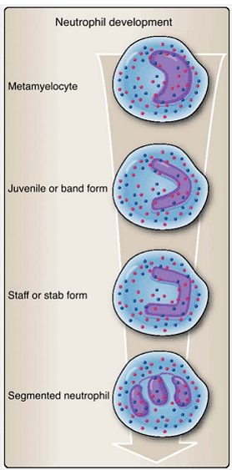
Figure 2.6 Neutrophil development. Neutrophils are the most numerous leukocytes and play a vital role in policing the body against microbial invasion. They require about two weeks to mature from metamyelocytes through intermediate stages and become mature segmented neutrophils.
B. Basophils and mast cells
The acidic cytoplasmic granules of basophils contain vasoactive amines (e.g., histamine) that cause smooth muscle contraction and are readily stained with “base-loving” dyes (Fig. 2.7). These bilobed cells are found in low numbers in the peripheral blood (0% to 1%) or in their tissue resident form, known as mast cells. Both basophils and mast cells are important in allergic reactions of the adaptive immune response .

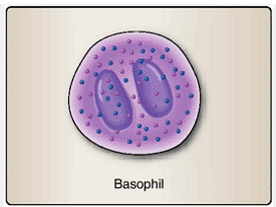
Figure 2.7 Basophils. Release of their cytoplasmic granules (degranulation) disseminates vasoactive amines and other molecules associated with allergic reactions.
C. Eosinophils
So named because of their “eosin-loving” granules (eosin is a dye used in histology), eosinophils are bilobed granulocytes with cytoplasmic granules that contain basic proteins. Although they comprise 0% to 5% of the peripheral blood leukocytes, eosinophils are active participants in innate and adaptive immune responses to parasitic helminth (worm) infections (Fig. 2.8).
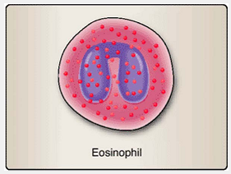
Figure 2.8 Eosinophils. Release of cytoplasmic granules by eosinophiles provides molecules that are potent weapons against parasitic worms.

Chapter Summary
- All blood-borne cells ultimately derive from pluripotent hematopoietic stem cells that have the capacity to produce all leukocytes, red blood cells, and platelets.
- Cells of the myeloid lineage (eosinophils, basophils, neutrophils, monocytes, macrophages, and some dendritic cells) are involved in innate immune defenses.
- Many of the cells derived from the lymphoid lineage (lymphocytes and plasma cells) are responsible for adaptive immune responses.
- Agranular leukocytes derive from lymphoid or myeloid lineage precursors and account for approximately 35% to 38% of the leukocytes in circulation.
- B cells and plasma cells are the only cells capable of immunoglobulin synthesis.
- Mononuclear cells (monocytes and macrophages) are the scavengers of the body. They phagocytose; that is, they pick up cellular debris, foreign cells, and particles and degrade them enzymatically.
- Natural killer cells large, nonphagocytic, granular lymphocytes that kill abnormal (e.g., infected or malignant) host cells and account for 5% to 10% of all lymphocytes in the circulation.
- Sixty percent of the peripheral blood leukocytes are neutrophils. These cells are very effective at killing bacteria.

Innate Immune Function
Introduction:
If microbes should penetrate the body's first line of defense—the mechanical, chemical, and biological barriers—the innate immune system provides the second line of defense (the first immunologic line of defense) against infection. Because its components are always in an activated or near-activated state, responses by the innate immune system occur much faster than those of the adaptive immune system that provides the third line of defense (the second immunologic line of defense). Once the adaptive system becomes involved, the innate and adaptive immune systems often interact with one another to coordinate their activities. To respond quickly, components of the innate immune system are genetically programmed to recognize molecules associated with broad classes of pathogens. Innate immune responses include the rapid destruction of an infectious organism, activation of phagocytic cells, and the localized protective response known as inflammation. In inflammation, innate (and sometimes adaptive) cells and molecules are stimulated to isolate and destroy infectious agents and trigger tissue repair.
II. Recognition
The innate immune system uses a limited number of pattern recognition receptors (PRRs) to recognize pathogen-associated molecular patterns (PAMPs)—conserved, structural features expressed by microbes but not by the host (see Fig.2.5). Unlike the epitope-specific somatically generated receptors of the adaptive immune system expressed by B and T lymphocytes, genes encoding PRRs are encoded within the genome and require no additional modification. Because the host does not produce PAMPs, the innate immune system is able to discriminate between self and nonself.

A. Pathogen-associated molecular patterns
The innate immune system distinguishes infectious microbes from noninfectious self cells by recognizing a limited number of widely expressed viral and bacterial molecular structures. PAMPs may be sugars, proteins, lipids, nucleic acids, or combinations of these types of molecules. PRRs on phagocytic cells recognize PAMPs either directly or indirectly by cell - surface PRRs or by soluble molecules that engage a microbe prior to cell -surface receptor contact (e.g., complement and complement receptors, discussed later in this chapter). PAMP binding immobilizes the infectious organism and may culminate in its ingestion by phagocytes. In addition, PRR engagement often leads to the activation of the host cell, causing it to alter its activity and increase its secretion of antimicrobial substances (Fig. 5.1).
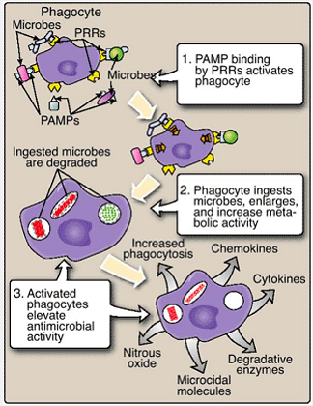
Figure 5.1 PAMP-PRR engagement activates phagocytes. Binding of PAMPs on microbial surfaces by PRRs on the surfaces of phagocytes activates the phagocytes to ingest and degrade the microbes.
Two common bacterial products that contain PAMPs are lipopolysaccharide and peptidoglycan. Bacterial lipopolysaccharide (LPS) is a major constituent of the outer cell membrane of Gram-negative bacteria. Cell-surface molecules on monocytes, macrophages, dendritic cells, mast cells, and intestinal epithelial cells bear toll-like receptor 4 (TLR4; see Table 2.2) and other cell -surface molecules that bind LPS. Peptidoglycans are major components of the cell walls of Gram-positive bacteria and are recognized by TLR2 receptors on host phagocytic cells (Fig. 5.2). Peptidoglycans are also expressed to a lesser degree and in a slightly different form on Gram-negative bacteria. As a result of receptor engagement, the microbes are ingested and degraded, the macrophage is activated, and cytokine production and inflammation result (see Section IV.A).
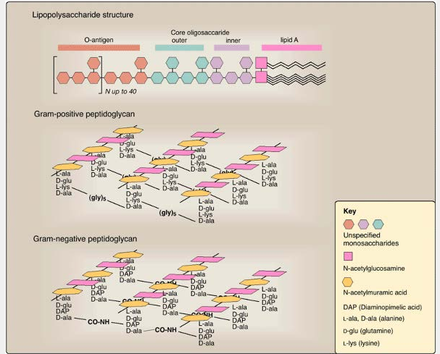
Figure 5.2 Lipopolysaccharide and peptidoglycan structures. Major bacterial PAMPs are found in lipopolysaccharides (carbohydrates + lipids) of Gram-negative bacteria and in peptidoglycans (carbohydrates + proteins) associated with both Gram-negative and Gram- positive bacteria.

B. Pattern recognition receptors
PRRs are divided into the categories described below and are present as extracellular proteins or as membrane-bound proteins on phagocytic cells in the bloodstream. During recognition of PAMPs, multiple receptors may be simultaneously engaged to mediate internalization, activate the killing of microbes, and induce the production of inflammatory cytokines and chemokines.
1. Toll-like receptors (TLRs) mediate recognition of diverse pathogens. After binding to PAMPs, signal transduction from a TLR to the nucleus leads to enhanced activation of genes encoding cytokines and other molecules involved in antimicrobial activity. The result is synthesis and secretion of the cytokines that promote inflammation and the recruitment of leukocytes to the site of infection.
2. Scavenger receptors are involved in binding of modified low-density lipoproteins, some polysaccharides, and some nucleic acids. They are involved in the internalization of bacteria and in the phagocytosis of host cells undergoing 14apoptosis. The mechanisms involved are currently being investigated.
3. Opsonins are molecules that, when attached to the surface of microbes, make them more attractive to phagocytic cells, thus facilitating microbe destruction. Opsonins bind to microbial surfaces. Receptors for opsonins are present on phagocytic cells, and the subsequent increased phagocytic destruction of microbes is termed opsonization.
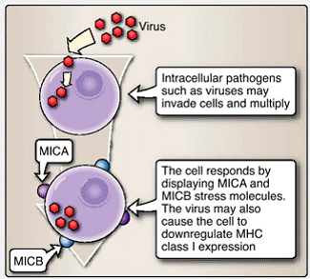
Figure 5.3 Infection of cells may lead to the surface expression of stress molecules. In response to viral infection, host cells may express stress molecules such as MICA and MICB on their surface and may also reduce their surface expression of MHC class I molecules. These surface changes can be detected by NK cells that seek to eliminate virally-infected cells.

C. Markers of abnormal self
An evasive maneuver that microorganisms sometimes employ to avoid recognition by the immune system is to subvert the host cells. Some viruses cause an infected host cell to reduce its expression of MHC class I molecules that are critical to the proper functioning of the adaptive immune system (discussed in Chapters 7 and 10). Similar changes sometimes occur in cells undergoing cancerous transformation. Host cells that become abnormal as a result of such events can alert the immune system to their situation by expressing molecules on their surfaces that act as stress signals. In humans, these include some heat shock proteins and two molecules known as MICA and MICB (Fig. 5.3). These stress signals are detected by various receptors, including some of the TLRs (e.g., TLR2 and TLR4; see Table 2-2) and the killer activation receptors (KARs) of natural killer (NK) cells (see Section IV.B).

III. Soluble Defense Mechanisms
In addition to the actions of whole cells, the innate immune system employs soluble molecules as weaponry for protection from viral infection, for lytic destruction of microbes, or for increasing the susceptibility of microbes to ingestion by phagocytic cells.

A. Type I interferons
Type I interferons (IFNs) are produced by a subset of dendritic cells (IFN-α), by nonleukocytes such as fibroblasts (IFN-β), and by other cells in response to viral infection (Fig. 5.4). IFN-α and -β are rapidly produced, within 5 minutes, by cells when viral PAMPs interact with certain PRRs. Very little is currently known about the signal transduction pathways responsible for expression and secretion of IFN-α and -β. Secreted type I IFNs induce both virally infected and non-infected cells to activate numerous antiviral defenses, including RNA-dependent protein kinase (PKR) and apoptotic (programmed cell death) pathways. In addition, IFN-α and -β influence the activities of macrophages and dendritic cells.

B. Microcidal molecules
A variety of cells, including epithelial cells, neutrophils, and macrophages, in the skin and mucous membranes secrete cysteine-rich peptides called defensins. These peptides form channels in the cell membranes of bacteria, which cause the influx of certain ions and eventually bacterial death. Other molecules with microcidal functions include cathelicidin, lysozyme, DNases and RNases, and others.

