Lec(3) Immunology

Complement system
Complement is a collective term for a system of enzymes and proteins that function in both the innate and adaptive branches of the immune system as soluble means of protection against pathogens that evade cellular contact. A series of circulating and self-cell -surface regulatory proteins keep the complement system in check. In the innate immune system, complement can be activated in two ways: via the alternative pathway, in which antigen is recognized by particular characteristics of its surface, or via the mannan-binding lectin (MBL) pathway. Complement can also be activated in the adaptive immune system via the classical pathway that begins with antigen-antibody complexes (which is described in subsequent chapters) (Fig. 3.1). Regardless of the pathway of activation, functions of complement include lysis of bacteria, cells, and viruses; promotion of phagocytosis (opsonization); triggering of inflammation and secretion of immunoregulatory molecules; and clearance of immune complexes from circulation.
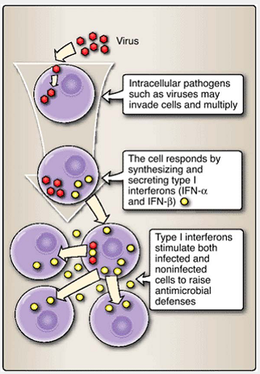
Figure 5.1 Type 1 interferon response to intracellular microbial invasion. Some cells respond to infection by producing and secreting type I interferons that signal adjacent cells to activate their antimicrobial defenses.

Complement nomenclature
- Components C1 through C9, B, D, and P are native complement (protein) components.
- Fragments of native complement components are indicted by lowercase letter (e.g., C4a, C5b, Bb). Smaller cleavage fragments are assigned the letter “a,” and major (larger) fragments are assigned the letter “b.”
- A horizontal bar above a component or complex indicates enzymatic activity, e.g., C4bC2b.

1. The alternative pathway is initiated by cell -surface constituents that are recognized as foreign to the host, such as LPS (Fig. 5.1). A variety of enzymes (e.g., kallikrein, plasmin, elastase) cleave C3, the most abundant (~1300 µg/ml) serum complement component, into several smaller fragments. One of these, the continuously present, short-lived, and unstable C3b fragment, is the major opsonin of the complement system and readily attaches to receptors on cell surfaces (Fig. 5.2).
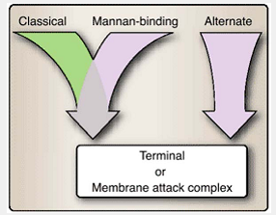
Figure 5.2 Three complement pathways lead to formation of the membrane attack complex.
1. C3b binds Factor B.
2. Factor B in the complex is cleaved by Factor D to produce C3bBb, an unstable C3 convertase.
3. Two proteins, C3b inactivator (I) and β1H-globulin (H), function as important negative regulators, making an inactive form of C3b (C3b) to prevent the unchecked overamplification of the alternative pathway.
4. Alternatively, C3bBb binds properdin (Factor P) to produce stabilized C3 convertase, C3bBbP.
5. Additional C3b fragments join the complex to make C3bBbP3b, also known as C5 convertase. C5 convertase cleaves C5 into C5a and C5b.
6. C5b inserts into the cell membrane and is the necessary step leading to formation of the membrane attack complex (MAC) and cell lysis.
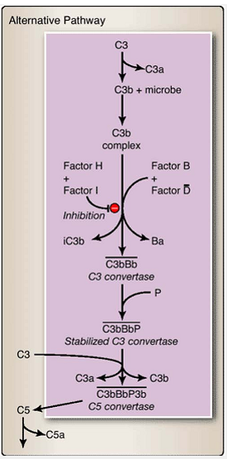
Figure 3.3 Alternative pathway of complement activation. Beginning with the binding of C3b to a microbial surface, this pathway results in an amplified production of C3b and formation of a C5 convertase.
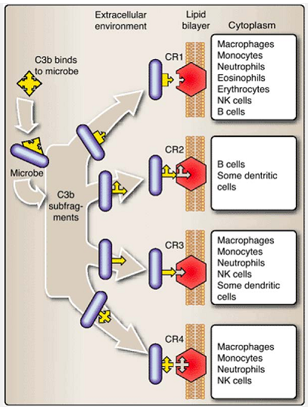
Figure 3.4 Multiple functional roles for complement fragment C3b.

2. The terminal or lytic pathway can be entered from the alternative, mannan-binding lectin, or classical pathway of complement activation. Attachment of C5b to the bacterial membranes initiates formation of the membrane attack complex (MAC) and lysis of the cell (Fig. 5.8). The attachment of C5b leads to the addition of components C6, C7, and C8. C8 provides a strong anchor into the membrane and facilitates the subsequent addition of multiple C9 molecules to form a pore in the membrane. Loss of membrane integrity results in the unregulated flow of electrolytes and causes the lytic death of the cell (Fig. 3.4).

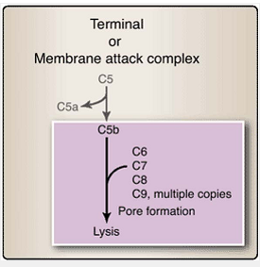
Figure 3.4 Terminal or membrane attack complex (MAC) of complement. The MAC forms a pore in the surfaces of microbes to which it is attached, causing lytic death of those microbes.
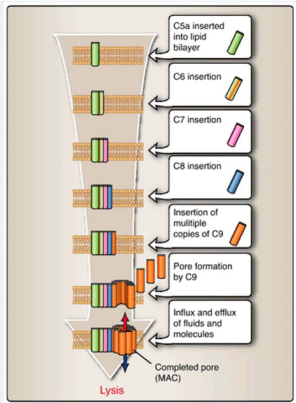
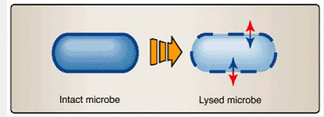
Figure 3. 5 Insertion of the membrane attack complex (MAC) components into a cell membrane. Formation of the MAC requires a sequential addition of several complement components, beginning with C5a and terminating with multiple C9 components, to form the pore in the microbial membrane.

3. Mannan-binding lectin pathway. Lectins are proteins that bind to specific carbohydrates. This pathway is activated by binding of mannan-binding lectin (MBL) to mannose-containing residues of glycoproteins on certain microbes (e.g., Listeria spp., Salmonella spp., Candida albicans). MBL is an acute phase protein, one of a series of serum proteins whose levels can rise rapidly in response to infection, inflammation, or other forms of stress. MBL, once bound to appropriate mannose-containing residues, can interact with MBL-activated serine protease (MASP). Activation of MASP leads to subsequent activation of components C2, C4, and C3 (Fig. 3.6).
4. Anaphylotoxins. The small fragments (C3a, C4a, C5a) generated by the cleavage of C3 and C5 in the alternative pathway and of C3, C4, and C5 in the MBL pathway act as anaphylotoxins. Anaphylotoxins attract and activate different types of leukocytes (Table 5.1). They draw additional cells to the site of infection to help eliminate the microbes. C5a has the most potent effect, followed by C3a and C4a.

D. Cytokines and chemokines
Cytokines are secreted by leukocytes and other cells and are involved in innate immunity, adaptive immunity, and inflammation (Table 3.2). Cytokines act in an antigen-nonspecific manner and are involved in a wide array of biologic activities ranging from chemotaxis to activation of specific cells to induction of broad physiologic changes. Chemokines are a subgroup of cytokines of low molecular weight and particular structural patterns that are involved in the chemotaxis (chemical-induced migration) of leukocytes. The roles of specific cytokines and chemokines are described in the contexts of the immune responses in which they participate .
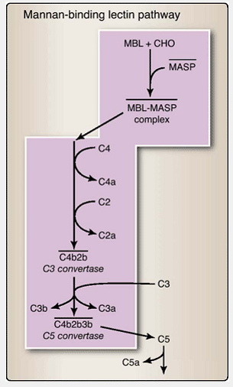
Figure 3.6 Mannan-binding lectin (MBL) pathway of complement activation. The lectin binding pathway is initiated by the binding of certain glycoproteins commonly found onmicrobial surfaces, and results in the formation of a C3 convertase (that acts to produce C3b) and a C5 convertase (that can lead to MAC formation).
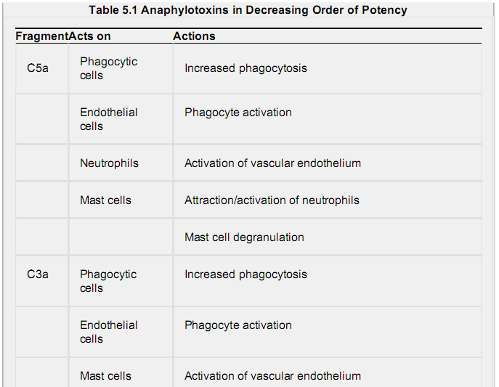
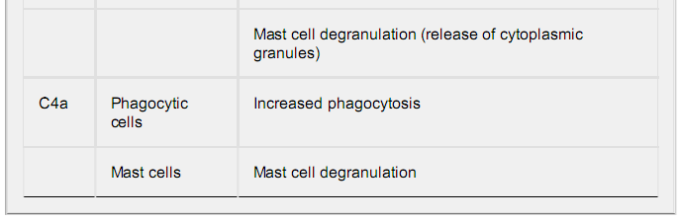
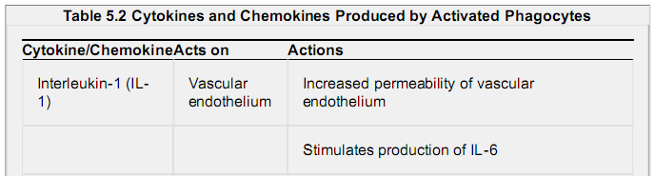
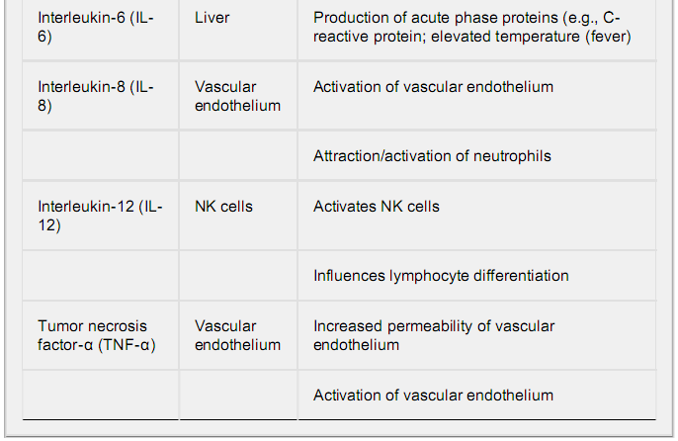
III. Classical Pathway of Complement Activation
Interaction of antibody with antigen initiates the classical pathway of complement activation. (Fig. 6.5). This biochemical cascade of enzymes and protein fragments facilitates destruction of microbes by the membrane attack complex, by increased opsonization through C3b binding of microbial surfaces, and by the production of anaphylotoxins C3a, C5a, and C4a. The cascade begins with the activation of component C1.
A. Activation of C1
Binding of IgM or IgG antibody to antigen causes a conformational change in the Fc region of the immunoglobulin molecule. This conformational change enables binding of the first component of the classic pathway, C1q. Each head of C1q may bind to a CH2 domain (within the Fc portion) of an antibody molecule. Upon binding to antibody, C1q undergoes a conformational change that leads to the sequential binding and activation of the serine proteases C1r and C1s. The C1qrs complex has enzymatic activity for both C4 and C2, indicated by a horizontal bar as either C1qrs or C1s.

B. Production of C3 convertase
Activation of C1qrs leads to the rapid cleavage and activation of components C4, C2, and C3. In fact, both the classical and mannan-binding lectin (MBL) pathways of complement activation are identical in the cleavage and activation of C4, C2, and C3 (Fig. 3.7.
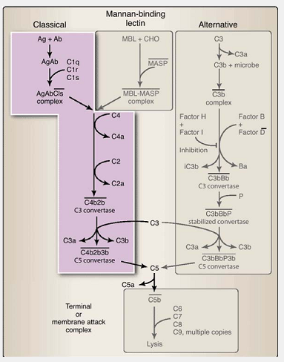
Figure3.7 Classical pathway of complement activation. The classical pathway is initiated by the binding of antibody (usually IgG or IgM) to an antigen and then to the C1 complement component. The pathway produces a C3 convertase (responsible for production of C3b) and a C5 convertase (that can lead to MAC formation).

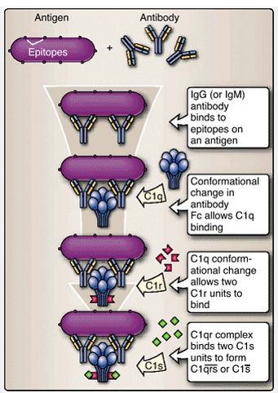
Figure3.6 Activation of complement component C1. Activation of C1 involves serial binding and activation of its three subunits (C1q, C1r, C1s).

C. Production of C5 convertase
The binding of C4b2b to C3b leads to the formation of the C4b2b3b complex. This complex, a C5 convertase initiates the construction of the membrane attack complex on the microbial surface (see Figs. 3.6, 3.7, and 8.9). Thus, as in the case of the alternative (see Fig. 3.7) and MBL pathways (see Fig. 3.7), production of C5 convertase by the classical pathway leads to the development and insertion of a structure that is capable of damaging the cell surfaces.

IV. Cellular Defense Mechanisms
In addition to soluble means of defense, the innate immune system employs cellular mechanisms to combat infection. Receptors that recognize ligands from pathogens trigger inflammation and destruction of microbes by phagocytes. In addition, NK cells detect and destroy host cells that have been infected, injured, or transformed. We will discuss each of these cellular actions.

A. Phagocytosis
Phagocytosis is the engulfment and degradation of microbes and other particulate matter by cells such as macrophages, dendritic cells, neutrophils, and even B lymphocytes (prior to their activation). These cells are part of the body's “cleansing” mechanism. They not only defend the body by ingesting microbes, but also remove cellular debris and particulate matter that arise from normal physiologic functions.
Phagocytosis involves cell -surface receptors associated with specialized regions of the plasma membrane called clathrin-coated pits. Dendritic cells use an additional mechanism to sample large amounts of soluble molecules, a process known as macropinocytosis. This process does not involve clathrin. Instead, plasma membrane “ruffles” or projections fold back upon the membrane to engulf extracellular fluids in large intracellular vesicles.
- Recognition and attachment of microbes by phagocytes: Phagocytosis is initiated when a phagocyte binds a cell or molecule that has penetrated the body's barriers. The binding occurs at various receptors on the phagocyte surface (Fig. 3.8). These include PRRs (including TLRs) that recognize microbe-related molecules, complement receptors (CR) that recognize certain fragments of complement (especially C3b) that adhere to microbial surfaces, Fc receptors that recognize immunoglobulins that have bound to microbial surfaces or other particles, scavenger receptors, and others.

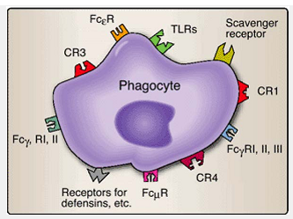
Figure 3.8 Phagocyte receptors. Phagocytosis is initiated when any of several types of receptors on the phagocyte surface recognize an appropriate molecule that indicates the presence of a foreign cell or molecule.

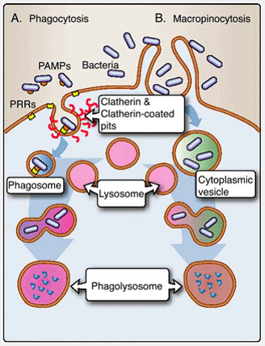
Figure 3.8Phagocytosis, phagosome, and phagolysosome formation. A. In phagocytosis, molecules and particles are captured and ingested by receptors associated with membrane regions called clathrin-coated pits. B. In macropino-cytosis, protrusions of the plasma membrane capture extracellular fluids whose contents are subsequently ingested. In both cases, the ingested material is degraded in phagolysosomes.

2. Ingestion of microbes and other material : Following attachment to the cell membrane, a microorganism or foreign particle is engulfed by extensions of the cytoplasm and cell membrane called pseudopodia and is drawn into the cell by internalization or endocytosis (Fig. 3.12). In addition to phagocytosis, dendritic cells can extend plasma membrane projections and encircle large amounts of extracellular fluids to form cytoplasmic vesicles independent of cell surface attachment. Once internalized, the bacteria are trapped within phagocytic vacuoles (phagosomes) or cytoplasmic vesicles within the cytoplasm. The attachment and ingestion of microbes trigger changes within the phagocyte. It increases in size, becomes more aggressive in seeking additional microbes to bind and ingest, and elevates production of certain molecules. Some of these molecules contribute to the destruction of the ingested microbes; others act as chemotactic agents and activators for other leukocytes.
3. Destruction of ingested microbes and other materials: Phagosomes, the membrane-bound organelles containing the ingested microbes/materials, fuse with lysosomes to form phagolysosomes. Lysosomes employ multiple
mechanisms for killing and degrading ingested matter. These include

- lysosomal acid hydrolases, including proteases and nucleases.
- several oxygen radicals, including superoxide radicals (O2 –), hypochlorite (HOCl –), hydrogen peroxide (H2O2), and hydroxyl radicals, that are highly toxic to microbes. The combined action of these molecules involves a period of heightened oxygen uptake known as the oxidative burst (Fig. 5.13).
- nitrous oxide (NO).
- decreased pH.
- other microcidal molecules.

4. Secretion of cytokines and chemokines: Once activated, phagocytes secrete cytokines and chemokines that attract and activate other cells involved in innate immune responses (see Table 3-2). Cytokines or chemical messengers such as interleukin-1 (IL-1) and interleukin-6 (IL-6) induce the production of proteins that lead to elevation of body temperature. Other cytokines, such as tumor necrosis factor-α (TNF-α), increase the permeability of local vascular epithelia to increase its permeability and enhance the movement of cells and soluble molecules from the vasculature into the tissues. Still others, such as interleukin-8 (IL-8) and interleukin-12 (IL-12), attract and activate leukocytes such as neutrophils and NK cells.
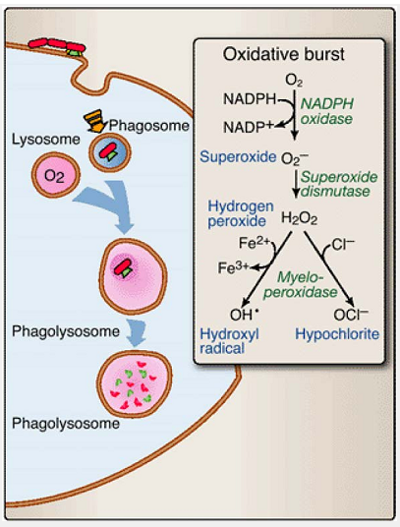

B. Natural killer cell responses
NK cells detect aberrant host cells and target them for destruction (Fig. 3.9). NK cells possess killer activation receptors (KAR) that recognize stress-associated molecules, including MICA and MICB in humans, that appear on the surface of infected and transformed host cells. Binding of KAR to MICA and MICB generates a kill signal. Before proceeding to kill the targeted cells, however, NK cells use killer inhibition receptors (KIR) to assess MHC I molecules on the target cell surface. Expression of these molecules is often depressed by some viruses and malignant events. If insufficient levels of KIR-MHC I binding occurs, the NK cell will kill the target host cell. Sufficient binding by the KIRs will override the KAR kill signal, and the host cell will be allowed to survive.

V. Inflammation
Components of both the innate and adaptive immune systems may respond to certain antigens to initiate a process known as inflammation. The cardinal signs of inflammation are pain (dolor), heat (calor), redness (rubor), swelling (tumor), and loss of function (functio laesa). Enlarged capillaries that result from vasodilation cause redness (erythema) and an increase in tissue temperature. Increased capillary permeability allows for an influx of fluid and cells, contributing to swelling (edema).
Phagocytic cells attracted to the site release lytic enzymes, damaging healthy cells. An accumulation of dead cells and fluid forms pus, while mediators released by phagocytic cells stimulate nerves and cause pain. The innate immune system contributes to inflammation by activating the alternative and lectin-binding complement pathways, attracting and activating phagocytic cells that secrete cytokines and chemokines, activating NK cells, altering vascular permeability and increasing body temperature. The adaptive immune system also plays a role in inflammation,
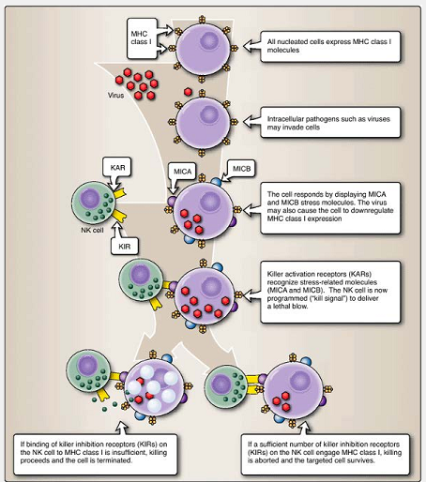
Figure3.12 NK cell recognition by KIR and KAR. NK cells have killer activation receptors (KARs) that recognize stress-associated molecules (e.g., MICA and MICB in humans) on the surface of abnormal host cells. Binding of KAR to MICA and MICB provides a kill signal. NK cells also use killer inhibition receptors (KIRs) to assess MHC I molecules on the target cell surface. If insufficient KIR-MHC I binding occurs, the NK cell will proceed to kill the target host cell. But sufficient binding by KIRs will override the KAR kill signal, sparing the life of the host cell.

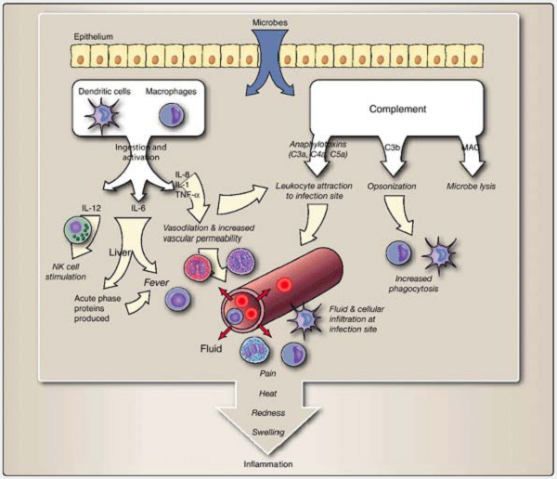

Figure 3.9 Inflammation. Inflammation results from the composite action of several immune responses to infection and injury, and results in pain, heat, redness, and swelling.

Chapter Summary
- The innate immune system provides a rapid, initial means of defense against infection using genetically programmed receptors that recognize structural features of microbes that are not found in the host.
- Pattern recognition receptors (PRRs) on or in phagocytic cells bind to pathogen-associated molecular patterns (PAMPs).
- PAMPS are conserved, microbe-specific carbohydrates, proteins, lipids, and/or nucleic acids.
- Common bacterial structures that contain PAMPs include lipopolysaccharides and peptidoglycans.
- PRR binding to PAMPs results in phagocytosis and enzymatic degradation of the infectious organism. PRR engagement can lead to the activation of the host cell and its secretion of antimicrobial substances.
- Toll-like receptors are PRRs that bind specific PAMPs. This binding signals the synthesis and secretion of the cytokines to promote inflammation and recruit leukocytes to the site of infection.
- Scavenger receptors are PRRs that are involved in internalization of bacteria and in the phagocytosis of host cells undergoing apoptosis.
- Opsonins bind to microbes to facilitate their phagocytosis.
- Infected or transformed host cells display stress molecules on their surfaces and sometimes show decreased MHC I expression.
- Stress molecules are recognized by killer activation receptors (KAR) on NK cells. Killer inhibition receptors (KIR) on NK cells assess MHC I molecules on the target cell surface.
- Soluble defense molecules include the type I interferons, defensins, complement, and cytokines.
- Complement is a system of enzymes and proteins that functions in both the innate and adaptive branches of the immune system. In the innate immune system, complement can be activated through either the alternative pathway or the mannan-binding lectin pathway.
- Phagocytosis, a direct mechanism to combat infection, is the engulfment and degradation of microbes by phagocytic cells that secrete cytokines and chemokines to attract and activate other cells of the innate immune system. The oxidative burst, producing several highly reactive oxygen metabolites, and a series of degradation enzymes are important means by which ingested microbes are destroyed.
- The innate immune system contributes to inflammation by activating complement pathways, attracting and activating phagocytic cells that secrete cytokines and chemokines, activating NK cells, altering vascular permeability, and increasing body temperature.
- Cardinal signs of inflammation are pain (dolor), heat (calor), redness (rubor), swelling (tumor), and loss of function (functio laesa).

