Lec(5) Immunology

Molecules of Adaptive Immunity
Introduction
The adaptive immune system uses a broad range of molecules for its activities. Some of these molecules are also used by the innate immune system (see Chapter 5). Others, including antigen-specific B cell receptors (BCR) and T cell receptors (TCR) of B and T lymphocytes, are unique to the adaptive immune system. Immunoglobulins are synthesized by and reside within the cytoplasm and are present on the surfaces of B lymphocytes. Each B cell synthesizes immunoglobulins of a single specificity that bind to a specific molecular structure (epi -tope). The immunoglobulins on the B cell surface serve as the BCRs.
Stimulated B cells may further differentiate into plasma cells that secrete soluble forms of these immunoglobulins. The immunoglobulins recognize and bind to the same epitopes that activate the classical complement pathway. T cells express a wide variety of membrane-bound TCRs. Each T cell produces single-specificity TCRs that recognize a specific peptide epitope contained within a major histocompati-bility complex (MHC) molecule. Epitope engagement of BCRs or TCRs leads to the initiation of signal transduction pathways and the expression of both soluble (cytokines and chemokines) and cell –surface (receptors and adhesion) molecules.
II. Immunoglobulins
Immunoglobulins are synthesized by B lymphocytes (B cells) and are both synthesized and secreted by plasma cells. Plasma cells are B cells that have terminally differentiated. The term antibody is applied to an immunoglobulin molecule with specificity for an epitope of the molecules that make up antigens (see Chapter 2). Antibodies nonco-valently bind to antigens to immobilize them, render them harmless, or “tag” the antigen for destruction and removal by other components of the immune system. In doing so, antibodies facilitate the ability of other cells and molecules in the immune system to identify and interact with antigens. Because antibodies are often in soluble form, they are important components of humoral (soluble) immune responses (see Chapter 11).
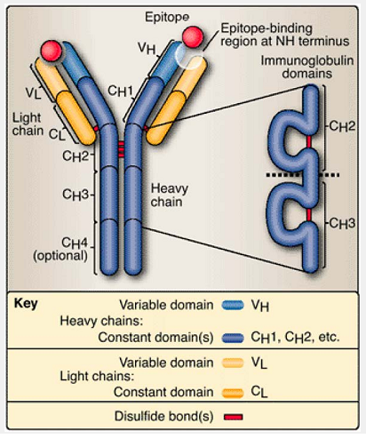
Figure 6.1 Immunoglobulin monomer. An immunoglobulin monomer contains 2 identical light (L) chains and two identical heavy (H) chains connected by disulfide bonds. Each chain contains a variable domain and one or more constant domains.
A. Basic structure
Human immunoglobulin contains four polypeptides: two identical light chains and two identical heavy chains linked by disulfide bonds (Fig. 6.1) to form a monomeric unit. Heavy and light chains are aligned such that the amino portion (NH terminus) of a single heavy and a single light chain form an epitope-binding site (more about this later in the chapter). Each heavy and light chain may be subdivided into homologous regions termed domains. Light chains, termed K (kappa) or X (lambda), are encoded on chromosomes 2 and 22, respectively. There are five types of heavy chains, all encoded on chromosome 14, termed mu (n), delta (8), gamma (Y), ep-silon (e), and alpha (a). The genetically different forms of light chains (K and X) and of heavy chains (n, 8, y, e, and a) are known as iso-types.
Immunoglobulin class or subclass is determined by the heavy chain isotype.
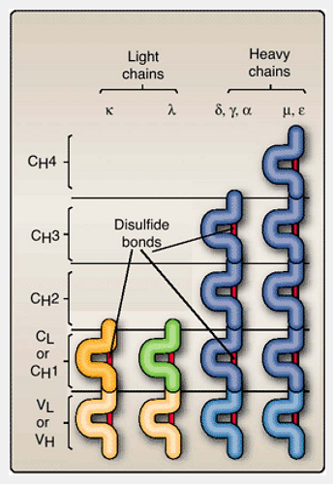
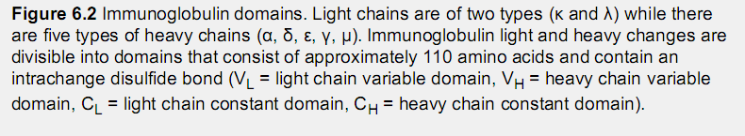
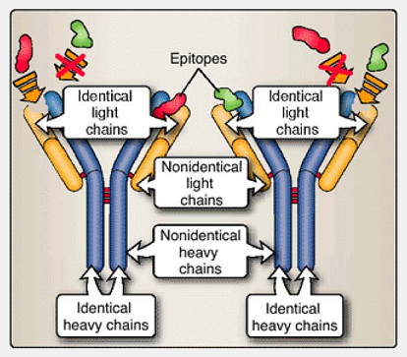
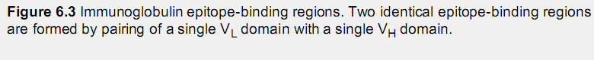
1. Light chains
An immunoglobulin monomer contains two identical K or two identical X light chains but never one of each. Light or L chains contain a variable (V_{L}) domain and a constant (C_{L}) domain (Fig. 6.2). Each domain contains about 110 amino acids and an intrachain disulfide bond. Variable regions (in both heavy and light chains) are so named for their variation in amino acid sequences between immunoglobulins synthesized by different B cells.
2. Heavy chains
Heavy chains contain one variable (V_{H}) and three or four constant (C_{H}) domains (Fig. 6.2). Heavy (H) chain variable domains (V_{H}) are extremely diverse, and constant domains (C_{H}) display a relatively limited variability for members of an isotype. The 8, y, and a heavy chains contain three constant domains (C_{H}1, C_{H}2, C_{H}3), and n and e heavy chains contain a fourth constant domain (C_{H}4), making them both longer and heavier than 8, Y, or a heavy chains.
3. Antigen-binding sites
A light chain variable domain and a heavy chain variable domain together form a pocket that constitutes the antigen (epitope)-binding region of the immunoglobulin molecule. Because an immunoglobulin monomer contains two identical light chains and two identical heavy chains, the two binding sites found in each monomeric immunoglobulin are also identical (Fig. 6.3). The variability in the amino acid sequences of the V_{L} and V_{H} domains, together with the random pairing of light and heavy chain that occurs from one B cell to another, creates a pool of binding sites capable of recognizing a very large number of different epitopes.
4. Immunoglobulin landmarks
Immunoglobulin molecules can be enzymatically cleaved into discrete fragments by either pepsin or papain (Fig. 6.4). Disulfide bonds join the heavy chains at or near a proline-rich hinge region, which confers flexibility on the immunoglobulin molecule.

The fragments of immunoglobulin are as follows:
- Fab or antigen (epitope)-binding fragment, produced by papain cleavage of the immunoglobulin molecule, contains V_{H}, C_{H}1, V_{L}, and C_{L}. Two Fab fragments are produced by papain cleavage of an immunoglobulin monomer; each fragment has an epitope-binding site.
- Fc or constant (crystallizable) fragment is produced by cleavage of the immunoglobulin molecule with papain. The Fc portion contains the C_{H}2, C_{H}3, and (sometimes) C_{H}4 regions of the immunoglobulin molecule. It is responsible for many biologic activities that occur following engagement of an epitope.
- Fd is the heavy chain (V_{H}, C_{H}1) portion of Fab.
- Fd' is a heavy chain (V_{H}, C_{H}1) portion of Fab. The prime (′) mark denotes extra amino acids due to a pepsin cleavage site.
- F(ab')2 is a dimeric molecule produced by pepsin cleavage. An immunoglobulin monomer will produce a single F(ab')2 fragment containing two (V_{H}, C_{H}1′) segments joined by disulfide bonds. An F(ab')₂ contains two epitope-binding sites.
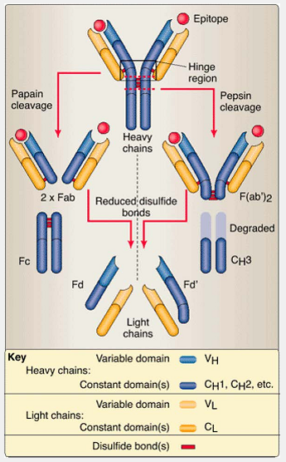
Figure 6.4 Enzyme cleavage of immunoglobulin determines landmarks. Papain cleaves heavy chains to form two identical Fab fragments (each containing one binding site) and one Fc fragment. Pepsin cleaves heavy chains at a point that produces an F(ab')₂ fragment containing two linked binding sites and remaining heavy chain material that is degraded and eliminated.

B. Isotypes
Heavy chain isotypes (µ, δ, γ, α, and ε) also determine immunoglobulin isotype or class (IgM, IgD, IgG, IgA, and IgE, respectively) (Table 6.1). Normally humans produce all five immunoglobulin isotypes. Of the two light chain isotypes, an individual B cell will produce only κ or λ chains, never both. B cells express surface-bound immunoglobulin monomers as epitope-specific receptors; B cells produce and display only one isotype, with the exception that unstimulated B cells express both IgM and IgD. When secreted into the body fluids, soluble IgG and IgE remain monomeric, soluble IgM forms a pentamer, and soluble IgA can be found in either a monomeric or dimeric form.
- IgM is found either as a cell -surface-bound monomer (2µ + 2κ or 2λ) or as a secreted pentamer with 10 H and L chains linked by disulfide bonds and a J (“joining”) chain [five monomers + J, i.e., 5 x (2µ + 2κ or 2λ) + J]. Most B cells display IgM on their cell surfaces. In general, IgM is the first immunoglobulin to be formed following antigenic stimulation. IgM is effective both at immobilizing antigen (agglutination; see Chapter 20, Fig. 20.2) and in activating the classical pathway of complement.
- IgD has a monomeric structure (2δ + 2κ or 2λ) and is almost exclusively displayed on B cell surfaces. Little is known of its function.
- IgG exists as both surface and secreted monomeric (2γ + 2κ or 2λ) molecules. Four subclasses (γ1, γ2, γ3, and γ4) of γ heavy chains account for the four human IgG subclasses, IgG1, IgG2, IgG3, and IgG4. Collectively, IgG subclasses make up the greatest amount of immunoglobulin in the serum. Many IgG antibodies are effective in activating complement (see below), opsonizing and neutralizing microorganisms and viruses, and initiating antibody-dependent cell -mediated cytotoxicity, and they function in a wide variety of hypersensitivity functions.
- IgA is present in both monomeric and dimeric forms. Monomeric IgA (2α + 2κ or 2λ) is found in the serum. The addition of a J or joining chain to two IgA monomers forms a dimer. Epithelial cells use a specialized receptor to transport the IgA dimer to mucosal surfaces. This specialized receptor becomes an accessory molecule that binds to the IgA dimers is known as secretory component (SC) [2 x (2α + 2κ or 2λ) + J + SC]. Secretory IgA dimers are found in mucus, saliva, tears, breast milk, and gastrointestinal secretions. The SC provides increased resistance to enzymatic degradation. Two isoforms of IgA (α1 and α2) show slightly different functions.
IgA1 predominates in the serum and in secretions above the diaphragm. Secretory IgA2 accounts for the majority of IgA found in the lumen of the lower portion of the gastrointestinal tract. Large amounts of IgA are synthesized and secreted daily at the mucosal surfaces of the GI tract, respiratory tracts, and other secretory ep-ithelia. More IgA is produced daily than all the other isotypes combined.

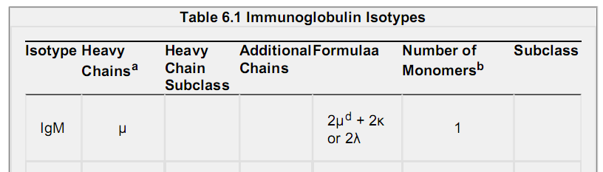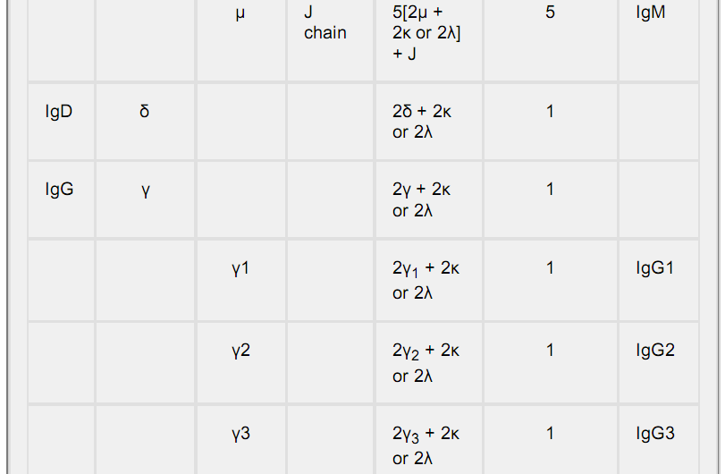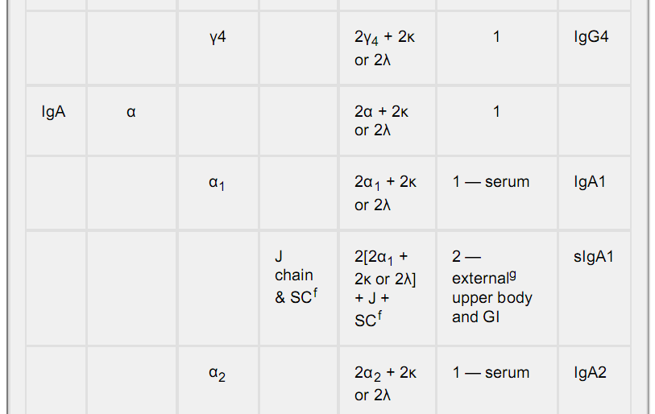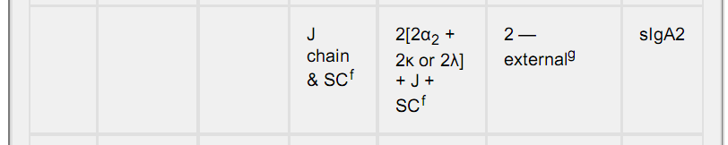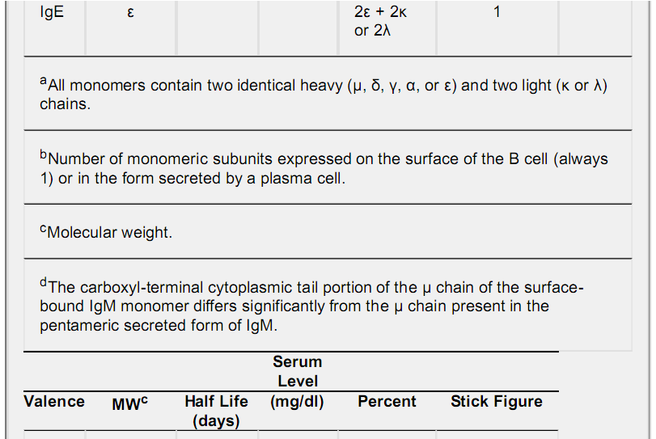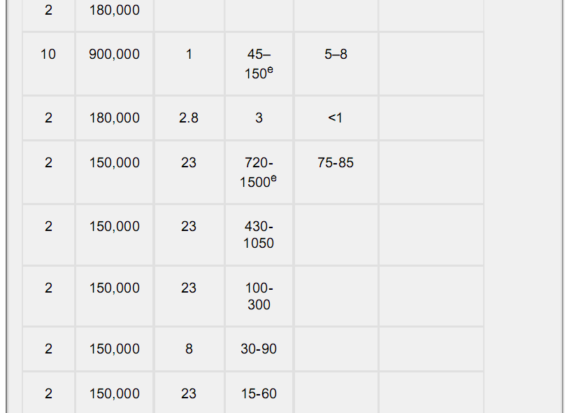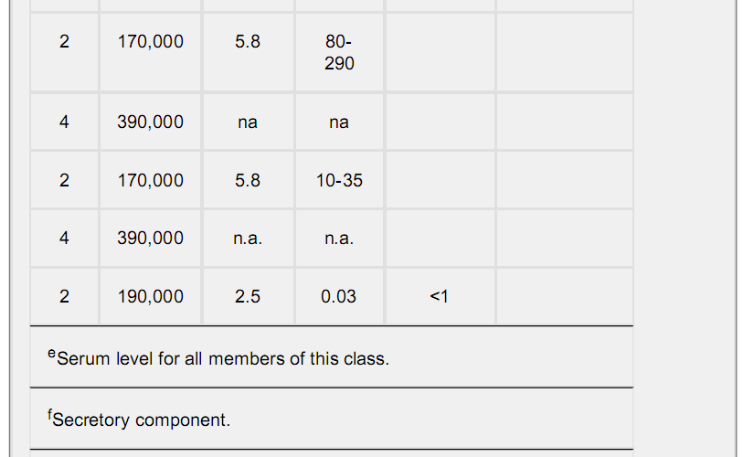
^{g}gThe dimeric form is transported across specialized epithelial cells to the external environment. sIgA1 is found in tears, nasal secretions, saliva and milk. sIgA2 is found in the gastrointestinal system.
IgE is present in relatively low serum concentration; most is adsorbed onto the surfaces of mast cells, monocytes, and eosinophils. Its basic structural formula is (2ε + 2κ or 2λ). Mast cells and basophils have isotype-specific receptors (FcRε, CD23) for the Fc portion of free IgE molecules. Cross-linking of IgE on mast cell surfaces by antigen triggers the release of histamine and other inflammatory mediators, leading to immediate hypersensitivity (allergic) responses.

IV. Major Histocompatibility Molecules
The major histocompatibility complex (MHC), also called the human leukocyte antigen (HLA) complex, is a segment of chromosome 6 containing several genes that are critical to immune function (Fig. 6.7). These include genes encoding a variety of enzymes and structural molecules needed for the activation and function of B and T cells. The encoded molecules fall into three groups or classes known as MHC (or HLA) class I, II, and III molecules. MHC class III molecules include complement components C4, Bf, and C2. MHC class I and II molecules serve entirely different functions.
A. MHC class I molecules
Codominantly expressed 45-kDa MHC class I molecules, in association with β2 microglobulin (β2m, 12 kDa), are found on the surfaces of all nucleated cells. Three genetic loci, HLA-A, -B, and -C, are highly polymorphic, with over 100 alleles at each locus (see Fig. 6.7). Altogether, up to six different class I molecules (if heterozygous at all three loci) can be displayed on each cell.
MHC class I molecules fold to form a cleft between the α1 and α2 domains that noncovalently binds an eight- to nine-amino-acid peptide (Fig. 6.8). Because of slight structural variations in the binding cleft (or binding groove) among the different allelic forms, different peptides may preferentially fit into clefts of some MHC class I molecules better than others. Additional (“nonclassical”) class I molecules (e.g., those encoded by the HLA-E, -F, -G, -H loci) show limited variability and tissue distribution and may function to present carbohydrate and peptide fragments to γδ T cells.
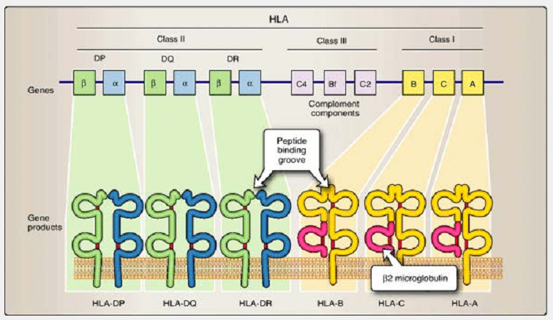
Figure 6.7 Genetic and protein organization of MHC class I, II, and III. Located on chromosome 6, HLA (human leukocyte antigen) genes are arranged as shown. They are grouped into Class I, Class II, and Class III based on structural and functional characteristics.
B. MHC class II molecules
MHC class II molecules are normally only expressed on dendritic-, macrophage-, and B cell surfaces; on some activated T cells; and on some specialized epithelial cells in the thymus and intestine. Codom-inantly expressed as noncovalent heterodimers, a 32- to 38-kDa α chain and a 29- to 32-kDa β chain form a binding groove (α1 and β1 domains) that can accommodate peptides of 18- to 20-amino-acid length (see Fig. 6.8). Encoded within the HLA-DP, -DQ, and -DR regions (see Fig. 6.7) are both α and β loci (DPα, DPβ, DQα, DQβ, etc.). After synthesis, MHC class II α and β chains combine only with others encoded within the same region (e.g., DPα associates only with DPβ but never with DQβ or DRβ). However, within each of these regions, α chains can combine with β chains encoded on the same chromosome (cis) or on the other member of the chromosome pair (trans). Termed cis-trans complementation, this allows individuals that are heterozygous at one or more of the class II loci to produce a greater variety of class II dimers than would be possible if they were homozygous. The range of different MHC class I and II molecules expressed can affect the overall immune capacity of an individual.
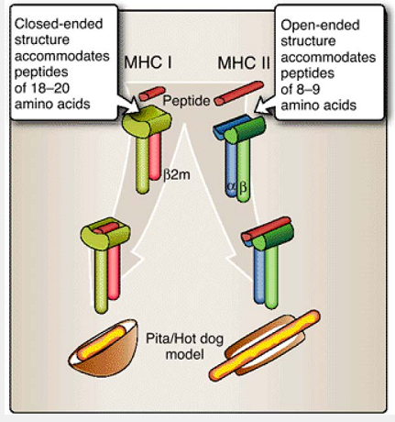
Figure 6.8 Peptide-binding clefts of MHC class I and class II molecules. MHC class I molecules (HLA-A, HLA-B, or HLA-C), in association with β2 microglobulin (β2m), form peptide binding clefts that are closed at the ends and bind peptides of 8-9 amino acids in length. MHC class II molecules (HLA-DP, HLA-DQ, or HLA-DR) are α chain - β chain heterodimers that form open-ended peptide binding clefts that bind peptides of 18-20 amino acids in length.

V. T Cell Receptors
The antigen-specific T cell receptor (TCR) is an αβ or a γδ heterodimer polypeptide pair. (Note: Despite the similarity in terminology, αβ TCR loci/molecules and MHC class II αβ loci/molecules are genetically and molecularly distinct.) Each polypeptide of the TCR contains variable and constant domains that are genetically and molecularly distinct from immunoglobulins. The choice of whether to express an αβ or γδ heterodimer is made early in T cell development, and clonal descendants retain the same type of TCR.
A. Basic structure
The TCR is bound to the membrane of the T cell. The short cytoplasmic tails of αβ or γδ polypeptide chains lack signaling sequences or immunoreceptor tyrosine activation motifs (ITAMs) to initiate activation signals to the nucleus (see Chapter 8). These signals are provided by the CD3 complex molecules [(CD3δ, CD3γ, CD3ε, and CD247 (ζ chain)] that noncovalently associate with the TCR. Unlike antibodies, TCRs cannot bind soluble epitopes. They bind only to fragments of larger molecules that fit within the binding grooves of MHC class I or class II molecules as peptide-MHC (pMHC) complexes.
Interaction of the TCR with pMHC is stabilized by the associated interaction of CD4 or CD8 with constant domains of MHC class II or MHC class I molecules, respectively (Fig. 6.9).
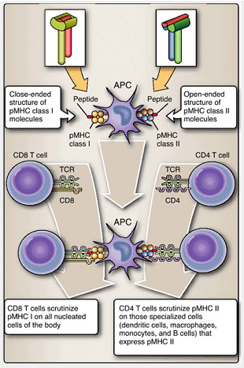
Figure 6.9 CD4+ and CD8+ T cells only interact with peptides bound to MHC class II or class I molecules.
B. Variable and constant regions
Each polypeptide chain of the TCR pair contains a variable (Vα or Vβ, Vγ or Vδ) and a constant (Cα or Cβ, Cγ or Cδ) region domain. Together, variable regions of α and β (or γ and δ) chains form hypervariable or complementarity-determining regions (CDRs) that interact with pMHC. Similar to immunoglobulins, each T cell expresses a unique TCR. Unlike immunoglobulins, T cells must “see” pMHC and do not recognize soluble peptides.
VI. Molecules of Cellular Interaction
Many adaptive and innate immune responses require leukocyte-to-leukocyte interaction. These interactions take place by direct cell -to-cell contact or by the sending and receiving of signals via soluble molecules. Leukocytes respond to these signals by upregulating or downregulating their functions, by migrating to specific anatomic sites, or by making life-or-death decisions about the fate of a cell within the body.

A. Cytokines
Cytokines are low-molecular -weight soluble protein messengers that are involved in all aspects of the innate and adaptive immune response, including cellular growth and differentiation, inflammation, and repair. Originally called lymphokines and monokines to reflect lymphocytic or monocytic origin, we now recognize that these substances are produced by a wide variety of leukocytes and nonleuko-cytes. A large number of cytokines have been identified, although the roles of many of them are not yet fully understood (Table 6.2). Many cytokines are crucial in regulating lymphocyte development and in determining the types of immune responses evoked by specific responses.
B. Chemokines
Low-molecular -weight cytokines known as chemokines (chemoat-tractant cytokines) stimulate leukocyte movement. Leukocytes are guided by chemokine concentration gradients to the site of an infection or inflammation (a process called homing). They are divided into four types based on the presence of certain structural motifs involving the numbers and intervals between cystine residues: C, CC, CXC, and CX3C (Table 6.3).

C. Adhesion molecules
Often, leukocytes must interact directly to contact other cells under somewhat adverse conditions, such as during rapid fluid flow within the circulatory system or under weak ligand-receptor binding. Adhesion molecules provide stable cell -to-cell contact necessary for both innate and adaptive immune responses as well as for many other intercellular activities. While a seemingly simple activity, the ability of cells to examine the surface of other cells and to establish stable contact with them is vital. For cells to communicate and for cell -surface receptors and ligands to interact, the cells must be able to establish and maintain relatively prolonged surface-to-surface contact.
Types of adhesion molecules include integrins, selectins, and addressins.
1. Integrins are found on the surfaces of many types of leukocytes. Integrins are heterodimers consisting of various combinations of α and β chains (e.g., α5β1 on monocytes and macrophages). They interact with other molecules that are based on the Ig su-perfamily motif (found on a wide variety of cells and has the generalized intrachain disulfide bond domain, e.g., Fig. 6.2) and with extracellular matrix. Their main function is to strengthen contact between leukocytes and many types of cells (e.g., vascular endothelium) so that more extensive interactions can then take place. Individual integrins and their activities are discussed in upcoming chapters in the more detailed descriptions of various immune responses
2. Selectins and addressins are limited in their tissue distribution and are designed to identify particular tissues and to facilitate the interactions of particular cell combinations. For example, newly differentiated lymphocytes need to migrate to lymph nodes to undergo their next stage of development. This migration is accomplished by interactions between selectin molecules found on the lymphocytes (e.g., CD62L, also known as L-selectin) and ad-dressin molecules (e.g., GlyCAM-1) located on the high vascular endothelium of blood vessels passing through lymph nodes. Other selectins and addressins assist in the movement of lymphocytes and other cells to the gut, epithelium, and sites of tissue inflammation. Individual selectins and adhesions and their activities are discussed in upcoming chapters in the more detailed descriptions of various immune responses.
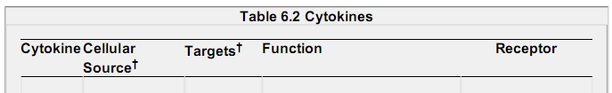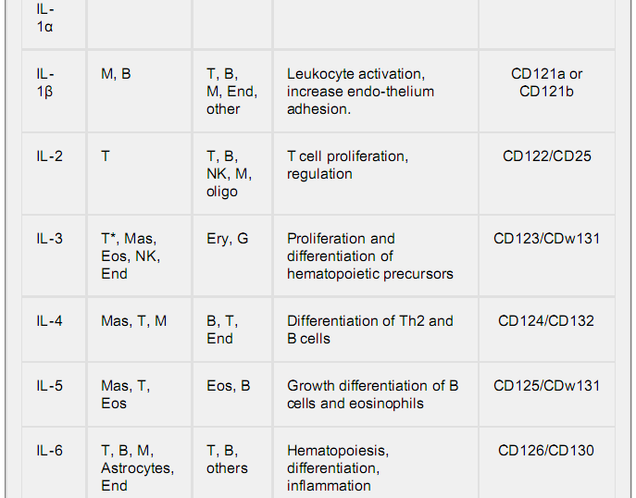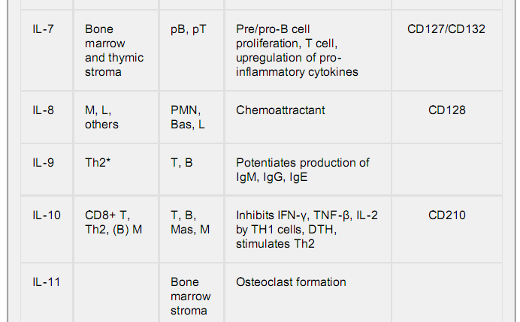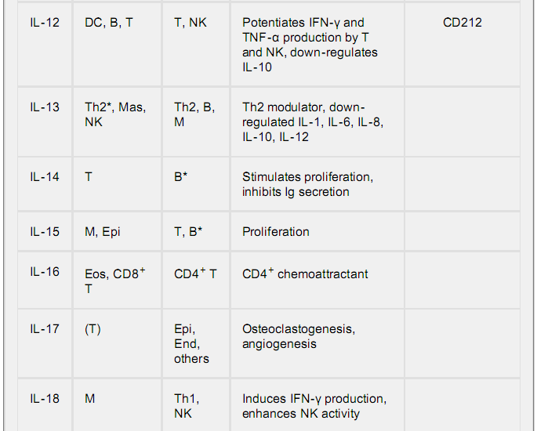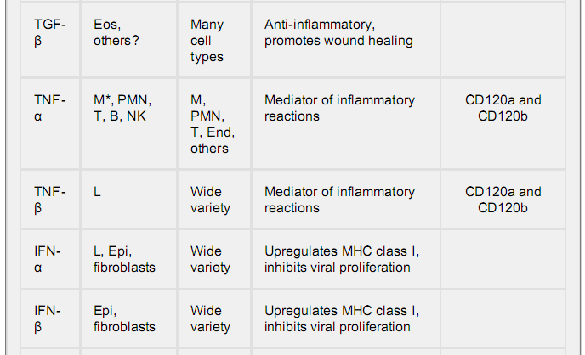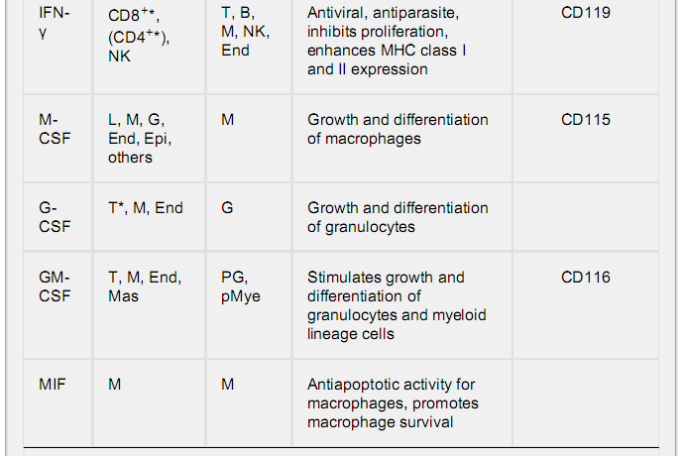
†Abbreviation key: Activated cells (*), B cells (B), basophils (Bas), dendritic cells (DC), endothelium (End), eosinophil (Eos), epithelium (Epi), erythrocytes (Ery), granulocytes (G), lymphocytes (L), macrophage (M), mast cells (Mas), myeloid (Mye), natural killer cells (NK), neutrophils (PMN), oligodendrocytes (oligo), parenthesis (cellular subset), and T cell (T). Within the table, parentheses are used to indicate when only a subset of the designated cell types produce the cytokine.
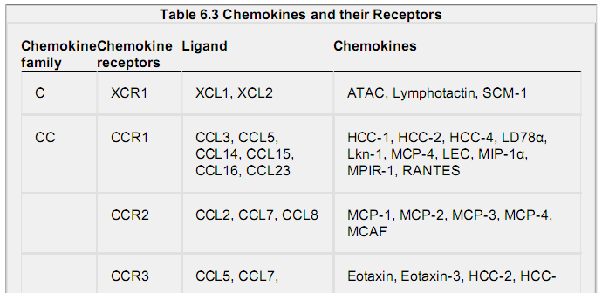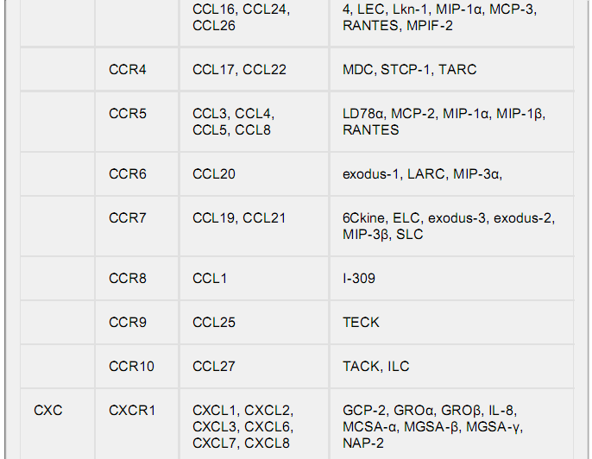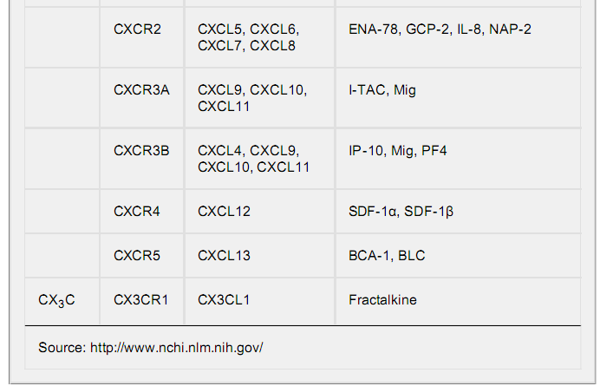
D. Cluster of differentiation molecules
Cluster of differentiation (CD) molecules populate the surfaces of many cell types and often serve as indicators of the functional capacities of leukocytes and other cells. It is beyond the scope of this book to describe more than just a few of the over 250 CD molecules that have been identified so far. Fortunately, for a basic understanding of the underlying mechanisms of the adaptive immune response, you need to know only a few of these. Among those that you will frequently encounter are the following:
- CD3 complex contains several molecules associated with the TCR. It is composed of six polypeptides (2 CD3ε + 1CD3γ + 1 CD3δ + 1 CD247 ζ-ζ homodimer). Its functions are to support the TCR and to transduce transmembrane signaling when the TCR is engaged.
- CD4 is a single-chain member of the immunoglobulin supergene family and is expressed on the surfaces of approximately two thirds of mature T cells. CD4 molecules recognize a nonpeptide-binding portion of MHC class II molecules. As a result, CD4+ T cells, also known as helper T (Th) cells, are “restricted” to the recognition of pMHC class II complexes.
- CD8 is a two-chain cell -surface molecule expressed as a homodimer (αα) or heterodimer (αβ) by about one third of mature T cells. CD8 molecules recognize the nonpeptide-binding portion of MHC class I molecules. CD8+ T cells, “restricted” to the recognition of pMHC I complexes, are also known as cytotoxic T (Tc) and suppressor T (Ts) cells.

E. Signal transduction molecules
Leukocytes use their cell -surface receptors to sense their extracellular environment. Binding of certain ligands causes a conformational change in the receptor or its accessory molecules. This change is then communicated inside the cell via the receptor's cytoplasmic tail (the part that is inside the cell), initiating a signal transduction cascade within the cell. Such cascades usually involve the binding of one or more specific intracellular signal transduction proteins. Receptor engagement often initiates a series of chemical signals that regulate gene transcription in the nucleus and alteration of cellular activity. Two stylized, tyrosine-kinase pathways cascades are described.

