Lec(9) Immunity

Hypersensitivity
The term hypersensitivity is used to describe immune responses which are damaging rather than helpful to the host. Nearly 40 years ago Gell and Coombs proposed a classification scheme which defined 4 types of hypersensitivity reactions. The first 3 are mediated by antibody, the fourth by T cells.

Type I Hypersensitivity
This will be familiar to most people and describes the rapid ('Immediate') allergic reaction. The symptoms produced by exposure of a sensitised person to antigen depend upon the site of contact. Hayfever (allergic rhinitis), eczema, asthma and urticaria all result from type I hypersensitivity. It is caused upon contact with antigen against which the host has pre-existing IgE antibody. IgE is present in very low levels in serum in most people (see on) - c.50ng (ie 5 × 10⁸gm) per ml. Its' half life in serum is only 2-3 days but much of the IgE in the body is bound to high affinity receptors (Fc epsilonRI), in the bound state the half-life is ~3 weeks. The high affinity Fc epsilonRI receptors are found on mast cells and basophils. Each cell has a high density of these receptors (40-250,000 per cell) so that a wide spectrum of antigen specificities is represented. The cells are activated by the cross-linking of the Fc epsilonRI receptors via antigen binding to the bound IgE molecules.
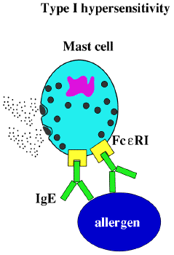
Such cross-linking leads to rapid degranulation (60-300 secs) of the mast cells and the release of primary inflammatory mediators stored in the granules. These mediators cause all the normal consequences of an acute inflammatory reaction - increased vascular permeability, smooth muscle contraction, granulocyte chaemotaxis and extravasation etc. Mast cell activation via Fc epsilonRI also leads to the production of two other type of mediators. These secondary mediators, unlike the stored granule contents, must be synthesised de novo and comprise arachadonic acid metabolites (prostaglandins and leukotrienes) and proteins (cytokines and enzymes).

molecule | SOME SPACES | effects
 | Primary mediators
Histamine |  | Vascular permeability, sm contraction
Serotonin |  | vascular permeability, sm contraction
ECF-A |  | eosinophil chaemotaxis
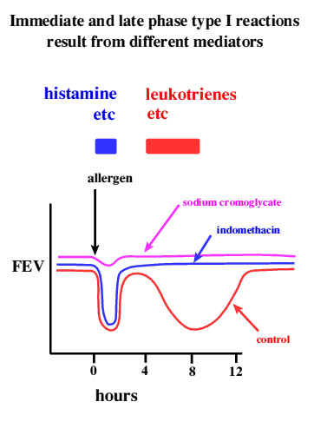  NCF-A |  | neutrophil chaemotaxis
proteases |  | mucus secretion, connective tissue degradation
 | Secondary mediators
Leukotrienes |  | vascular permeability, sm contraction
Prostaglandins |  | vasodilation, sm contraction, platelet activation
Bradykinin |  | vascular permeability, sm contraction
Cytokines |  | numerous effects inc. activation of vascular endothelium, eosinophil recruitment and activation

The type I response has an early and a late component.

Mirroring the two types of mediators, one can see two components to the type I response.A very rapid early response occurs when you are challenged with an antigen to which you are sensitised which is apparent within a few minutes and maximal after about 20 minutes. If the challenge is cutaneous it produces the so-called 'wheal and flare' - raised patch surrounded by a pink effusion. The late response seen after some hours is characterised by cellular infiltrate which gives a hard but barely pigmented nodule in the case of skin.
That these responses are caused by distinct mediators can be shown with inhibitory drugs. Arachadonic acid metabolism inhibitors, such as indomethacin, block only the late response. Sodium cromoglycate which blocks mast cell activation and degranulation blocks both early and late responses.

Systemic anaphylaxis
While we are probably all familiar with the consequences of a localised type I reaction (anaphylaxis) which are unpleasant and annoying, the consequences of a generalised reaction are potentially fatal. Ingestion of nuts or seafood, insect bites (venom), and drug injection may all cause life-threatening reactions in highly sensitised individuals. Death in such cases is due to systemic release of vasoactive mediators leading to general vasodilation and smooth muscle contraction resulting in sudden loss of blood pressure, massive oedema and severe bronchiole constriction (systemic anaphylaxis).

Type II Hypersensitivity(Cytotoxicity)
The second class of damaging reactions is caused by specific antibody binding to cells or tissue antigens. The antibodies are of the IgM or IgG classes and cause cell destruction by Fc dependent mechanisms either directly or by recruiting complement via the classical pathway. Except where the reaction is autoimmune, the target cells are foreign to the host. In practise this means type II hypersensitivity reactions are usually only seen in blood transfusion recipients and patients with certain autoimmune diseases. The classic ABO incompatibility reaction is a type II, with IgM antibodies causing complement lysis of erythrocytes. Rhesus disease (or haemolytic disease of the newborn) is a special example since the IgG antibodies which cause destruction of foetal red blood cells by antibody dependent cellular cytotoxicity (ADCC) are passively acquired by the host via the placenta .
Because of cross-matching transfusion reactions are now rare, nevertheless sometimes IgG can exist for minor blood group antigens at a level sufficient to cause destruction of the transfused cells but too low to detect in vitro.
Type III 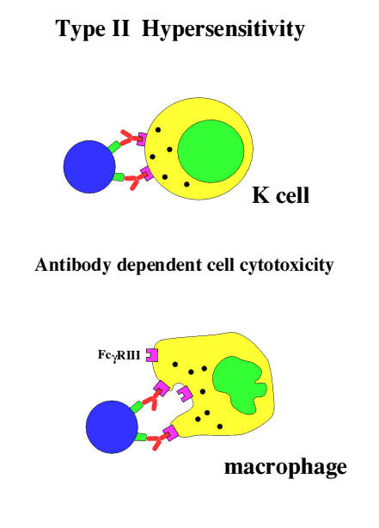

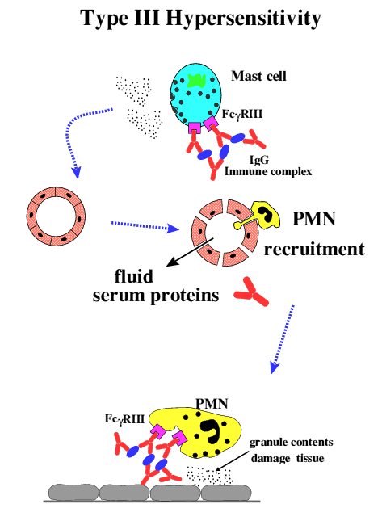

Type III Hypersensitivity:
Type III hypersensitivity is mediated by immune complexes essentially of IgG antibodies with soluble antigens. Recent experimental work has overturned longstanding assumptions about the mechanism of this form of reaction so you will find that almost all the textbooks are out of date. It is now thought that this form of hypersensitivity has a lot in common with type I except that the antibody involved is IgG and therefore not prebound to mast cells, so that only preformed complexes can bind to the low affinity FcgammaRIII.

The Arthus reaction:
The Arthus reaction is the name given to a local type III hypersensitivity reaction. It is easy to demonstrate experimentally by subcutaneous injection of any soluble antigen for which the host has a significant IgG titre. Because the FcgammaRIII is a low affinity receptor ,typically maximal at 4-8hrs, and consequently more diffuse. The condition extrinsic allergic alveolitis occurs when inhaled antigen complexes with specific IgG in the alveoli, triggering a type III reaction in the lung, for example in 'pigeon fanciers lung' where the antigen is pigeon proteins inhaled via dried faeces. Complement is not required for the Arthus reaction, but may modify the symptoms.

Generalised or systemic reactions:
The presence of sufficient quantities of soluble antigen in circulation to produce a condition of antigen excess leads to the formation of small antigen-antibody complexes which are soluble and poorly cleared. In the normal animal these complexes fix complement but experiments in animals genetically deficient in C3 or C4 have shown that complement is not required for pathology to be observed following antibody-antigen complex challenge. The major pathology is due to complex deposition which seems to be exacerbated by increased vascular permeability caused by mast cell activation via FcgammaRIII as above. The deposited immune complexes trigger neutrophils to discharge their granule contents with consequent damage to the surrounding endothelium and basement membranes. The complexes may be deposited in a variety of sites such as skin, kidney and joints. Common examples of generalised type III reactions are post-infection complications such as arthritis and glomerulonephritis.

Type IV Hypersensitivity
This is the only class of hypersensitive reactions to be triggered by antigen-specific T cells. were originally termed T_{DTH} for this reaction - delayed type hypersensitivity.
Delayed type hypersensitivity results when an antigen presenting cell, typically a tissue dendritic cell which has picked up antigen, processed it and displayed appropriate peptide fragments bound to class II MHC The resulting activation of the T cell produces cytokines such as chemokines for macrophages, other T cells and, to a lesser extent, neutrophils as well as TNFbeta and IFNgamma. The consequences are a cellular infiltrate in which mononuclear cells (T cells and macrophages) tend to predominate. It is usually maximal in 48-72 hours.
The classical example of delayed type hypersensitivity is in tuberculosis but this will be covered in the Lent term. A more familiar example is contact hypersensitivity which results from exposure of certain individuals to metal salts and small reactive chemicals. It is important to note that in such cases the antigen must be a complex of the hapten and a self peptide .

Summary of Hypersensitivity classification

TYPE | DESCRIPTIVE | INITIATION | MECHANISM | EXAMPLES
 | NAME | TIME
I | IgE-mediated hypersensitivity | 2-30 mins | Ag induces cross-linking of IgE bound to mast cells with release of vasoactive mediators | Systemic anaphylaxis, Local anaphylaxis, Hay fever, Asthma, Eczema
II | Antibody-mediated cytotoxic hypersensitivity | 5-8hrs | Ab directed against cell-surface antigens mediates cell destruction via ADCC or complement | Blood transfusion reactions, Haemolytic disease of the newborn, Autoimmune Haemolytic anaemia
III | Immune-complex mediated hypersensitivity | 2-8hrs | Ag-Ab complexes deposited at various sites induces mast cell degranulation via FcgammaRIII, PMN degranulation damages tissue | Arthus reaction (Localised); Systemic reactions disseminated rash, arthritis, glomerulonephritis
IV | cell-mediated hypersensitivity | 24-72hrs | Memory TH1 cells release cytokines that recruit and activate macrophages | Contact dermatitis, Tubercular lesions

