Centrifugation
Centrifugation: is a separation technique where different components of mixture are separated based on their density or particle size. The separation of different substances is based on centrifugal force that is produced by high speed rotation.
Centrifugation is one of the most important and widely applied research techniques in biochemistry, cellular and molecular biology, and in medicine. Current research applications rely on isolation of cells, subcellular organelles, and macromolecules, often in high yields.

Centrifuge used to separate bacteria, and can be used efficiently in the case of significant differences in density between the solid particles and liquid portion.
There are many applications of centrifugation include:
1) Sedimentation of cells, bacteria and viruses.
2) Separation of sub cellular organeles
3) Isolation of macromolecules such us RNA, DNA and proteins.
The purpose of using centrifuge is to increase the effect of gravity, when a suspension is rotated at a certain speed or revolutions per minute(RPM), centrifugal force causes the particles to move radially away from the axis of rotation.
Relative centrifugal force(RCF): The force on the particles (compared to gravity) For example, an RCF of (500 х g) indicates that the centrifugal force applied is 500 times greater than earth gravitational force.
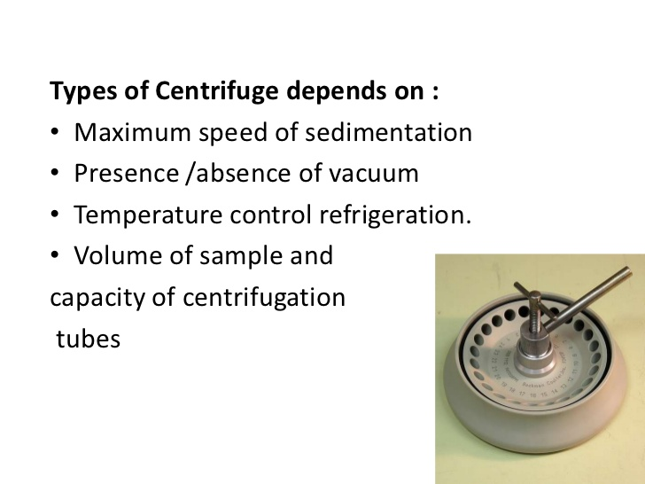

1. Small Benchtop – with or without refrigeration
– Slow speed (eg up to 4000 RPM)
– Common in clinical labs (blood/plasma/serum separation
– Can take approx (up to) 100 tubes, depending on diameter

2. Microcentrifuges (microfuge, Eppendorf)
– Take tubes of small vols (up to 2 mL)
– Very common in biochemistry/molecular biology/ biological labs
– Can generate forces up to ~15,000RPM
– With or without refrigeration

3. High Speed centrifuges
– 15,000 – 20,000 RPM
– Large sample capacity depending on rotor
– Normally refrigerated
– Research applications

4. Ultracentrifuges → 65,000 RPM (100,000’s x g)
– Limited lifetime
– Expensive
– Require special rotors
– Care in use – balance critical
– Research applications

Sample Containers:
- Centrifuge tubes and bottles are available in different range of sizes, thickness and rigidity from different variety of materials including glass, cellulose, esters, polyallomer, polycarbonate, polyethylene, nylon and stainless steel.
- The type of container used will depend upon nature and volume of sample to be centrifuged along with centrifugal forces to be withstood.
- Glass centrifuge tubes are suitable only for centrifugation at low speeds as they disintegrate at higher centrifugal fields. Thin walled tubes may be used in swinging bucket rotors; however, thick walled tubes are required with fixed angle and vertical tube rotors.
- The centrifuge tubes should be filled to accurate level and need to cap the tube or bottle depends upon the speed and type of the container used.
All modifications of centrifuges can be distinguished into two main types: sedimentation and filtering centrifuges.
In sedimentation centrifuges the centrifugal force is used to Separate solids from liquids or two liquids with different densities.
Filtering centrifuges use centrifugal force to pass a liquid through a filtration media, such as a screen or cloth while solids are captured by the filtering media.

Classes of centrifuges and their applications
Maximum speed(RPM х10³ | Centrifuge classes
 | Low speed (10) | High speed (28) | Ultra/microultra(100/150)
Maximum RCF)(х10³) | 7 | 100 | 800/900
Pelleting applications
Bacteria | yes | yes | Yes
Animal and plant cells | yes | yes | Yes
nuclei | yes | yes | Yes
precipitates | some | most | Yes
Membrane fractions | some | some | Yes
Ribosomes/polysoms | - | - | Yes
macromolecules | - | - | Yes
viruses | - | some | Yes

