Lec.1 Biotechnology Dr. Sahira Nsayef
Introduction into biotechnology
In 1919, Karl Ereky, a Hungarian engineer, coined the term biotechnology for the first time to describe the interaction of biology and human technology. Or to describe processes using living organisms to make a product or run a process, such as industrial fermentations.
Biotechnology is not a single technology, it is a group of technologies.
- Bio: the use of biological processes, and technology: to solve problems or make useful products = biotechnology.
What is biotechnology?
Biotechnology can be defined as :
- using organisms or their products for commercial purposes.
- A collection of technologies that use living cells, living systems, organisms and/or biological molecules to solve problems and develop or make useful products.
The United Nations Convention on Biological Diversity defines biotechnology as
- any technological application that uses biological systems, living organisms, or derivatives thereof, to make or modify products or processes for specific use.
What is microbial biotechnology ?
• Practical application of microbiology
• Use of microorganisms to produce valuable commercial products
• Also called “microbial technology” or “industrial microbiology”
Historical development of biotechnology

1- Stage1:Pre-Pasteur Era(before 1885)

● Discovering of microorganisms

● Traditional microbial industry(bread, cheese, beer and wine)

2- Stage2:Pasteur Era or fermentation Era(1885-1940)

● Production gunpowder by soil microorganisms

● The fermentative ability of microorganisms

● Production of chemicals like acetone, butanol, ethanol and organic acids

3- Stage3:Antibiotic Era(1940-1960)

● Production of antibiotics

● Production of enzymes and vitamins

● Production of gibberellins ,amino acids, nucleotides and steroids

●Tissue cultures techniques

4- Stage4:Post-antibiotic Era(1960-1975)

●Production of single cell protein

●Production of sterilants and disinfectants

●Enhancement of microorganisms productivity by genetic engineering techniques

5-Stage5:Genetic engineering Era(1975-2000)

● Production of therapeutic proteins(insulin, interferon,....etc)

●Production of new sources of energy(Biogas and biodiesel)

● Production of monoclonal antibodies

● Production of hybrid antibodies

● Production of biodetergents

●Immobilization of enzymes and cells

6-Stage6:Transgenic organisms Era(2000-2025)

●Production of vaccines by plants

●Production of therapeutic proteins by animals

●Production of genetically modified foods.

●Production of artificial chromosomes

Another division for biotechnology was included:
- Ancient Biotechnology (stage I)
- Classical Biotechnology (stages II , III and IV)
- Modern Biotechnology (stages V and VI )
Some important discoveries related to biotechnology have been shown in Figure 1.

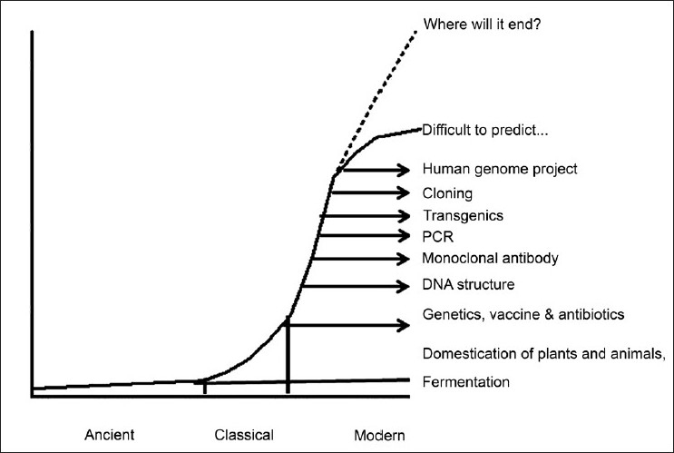
Figure 1: History of the development of biotechnology. Some of the important biotechnology discoveries have been plotted in this graph, with a possibility for its unlimited growth in the future.
Generations of biotechnology
1- Blue biotechnology is a term that has been used to describe the marine and aquatic applications of biotechnology.
2-Green biotechnology is biotechnology applied to agricultural processes.
3-Red biotechnology is applied to medical processes.
4- White or grey biotechnology , is biotechnology applied to industrial processes or environment.
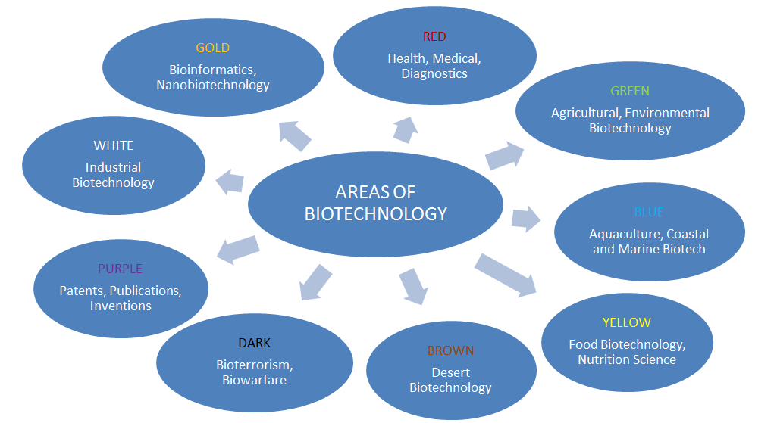
Figure 2: Generations of biotechnology
Biotechnology inputs
1- Monoclonal antibodies
Using immune system cells that build antibodies which are characterized by very highly specialized and therefore can determine and discover the vital elements accurately even if very small quantities, and its applications:
● identify and detect environmental pollutants.
● To detect harmful microorganisms in food.
● differentiate between normal cells and cancer cells.
2- Tissue culture technology
It is the cultivation of animal or plant cells in vitro (in the laboratory), and their applications:
●Cellular therapy.
● the production of drugs from plant cells directly instead of the plant.
● The use of animal cells in the detection efficiency of drugs instead of animals, reflecting the safety and accuracy.
● Propagation and doubled of the plant tissues in the laboratory.
3- Cloning
Production numbers and models of genetically identical molecules, cells and animals and plants which are of three types: Molecular or DNA cloning, cells cloning and animal or reproductive cloning.
4- Genetic modification
It happens to modify the genes of the same type or the transfer of genes from one species to another and its applications:
●The production of drugs and vaccines.
●Treatment of certain genetic diseases.
●To increase agricultural production and reduce cost.
● Increase the value of the nutritional content in food.
5- Protein engineering
This technique depends on the concept of genetic modification in order to produce specific proteins or new proteins have useful applications such as enzymes or bio-catalysts.
6- Hybrid technology
It is intended to link biological sciences with other sciences to give useful applications such as:
a- Biosensors
This technology connects between biology and microelectronics, and their applications:
• measuring the content and quality of food and safety.
• measurement of environmental contaminants.
• helping doctors to measure specific components in the blood and directly.
b-Tissue engineering
This technology connects between cytology and materials science to produce artificial tissues in the laboratories with its scaffolds. The successful examples of this technique the building of skin and cartilage.
c-DNA chips
This technology connects between the semiconductor industry and the genes making it possible to analyze tens of thousands of genes in a single-chip area does not exceed per square centimeter, and their applications:
●detection of mutations in specific genes.
● measurement of gene activity.
●Identification of genes important for crop production.
● Studying the structural sequence of genetic material.
d- Bioinformatics
This technology links between computer science and the genetic material, especially the programs of statistical analysis, graph simulation and databases and that utilized in the analysis of the vast amount of information derived from genetic material, and their applications:
● Genetic mapping and identification of sites and the number of genes in each map.
● Determination of the shape and construction of proteins.
● Simulation of the way proteins work and thread.
● The discovery of the causes and locations of genetic maladies and design appropriate treatment.
Hybrid technology
- Biology + Microelectronics=Biosensors
- Cytology + Materials = Tissue engineering
- Genes + Semi conductive = DNA chips
- Genetic material + Computer science = Bioinformatics

Figure 3: Hybrid technology
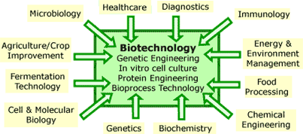
Figure 4: Inputs of biotechnology

Biotechnology outputs
1- Outputs the medical field:
The most important outputs areas of medical biotechnology are:
• The treatment of certain diseases such as cancer.
• The production of vaccines and immunizations.
• Diagnosis of diseases.
• Gene therapy.
• Stem cell research.
• Proteins and genes
2- Outputs of the agricultural field:
The most important outcomes in this area are:
• Food production, such as genetically modified foods.
• Hybridization between plant species.
• Biocides.
• Natural protection for plants.
• Production of food additives.
• Reducing the use of herbicides.
• The production of drugs and medicines for the treatment of animals used as food for the people.
3- industrial outputs:
An enzymes are the most important outputs in this area and there are currently more than 450 enzyme works as a catalyst in various industrial applications, such as: carbohydrases, proteases, peptidases, lipases, oxireductases and transferases.
4- Outputs the environmental field:
Some techniques are used for removing of pollutants from an environment and useful thing is that genetically modified organisms are used for this purpose can be left to live naturally in the environment, especially places of contaminants and in turn without a problem or an additional cost, and examples rid the gasoline from a substance Methyl tertiary butyl ether (MTBE) using bacteria, are also used in biotechnology to get rid from the remnants of the oil in the reservoirs of oil in the Gulf states.
5- For aerospace applications:
The U.S. space agency NASA in 2000 signed agreement with the biotechnology industry Organization and the National Institute of Cancer Research for the use of biotechnology in space exploration, as well as micro-gravity research.
6-Other uses:
Biotechnology applications exceeded the key areas mentioned earlier have to other areas such as:
• Aquaculture
• Fingerprint
• Criminal tests
• Establish paternity
• Anthropology
• Biological weapons

