Chemistry : Is a whole branch of science about matter, which is anything that has mass and occupies space. Chemistry is the study of the composition and properties of matter and the changes it undergoes.

Branches of Chemistry
1- Organic Chemistry involves the study of the structure, properties, and preparation of chemical compounds that consist primarily of carbon and hydrogen.
2-Inorganic Chemistry is the study of the properties and behaviour of inorganic compounds. It covers all chemical compounds except organic compounds. Inorganic chemists study things such as crystal structures, metals, catalysts, and most elements in the Periodic Table.
3- Analytical Chemistry: involves the qualitative and quantitative determination of the chemical components of substances.
4- Physical Chemistry —the study of the effect of chemical structure on the physical properties of a substance.
5- Biochemistry is the study of chemical reactions that take place in living things. It tries to explain them in chemical terms.
MATTER : Is anything that occupies space and has weight. If you look around you, you will see matter. The table, books, walls, and your body are all composed of matter.
Physical States of Matter. In general, we can group all matter into three groups called states of matter.
(1) Solids. Solids have a definite shape and volume. Examples of solids are books, rocks, pieces of steel, and sand.
(2) Liquids. Liquids have a definite volume but indefinite shape. That is, they take the shape of their container. Water, mercury, alcohol, and oils are liquids.
(3) Gases. Gases have neither a definite shape nor a definite volume. They assume not only the shape of their container, but also the volume of their container. Gases may be expanded or compressed to fit the container in which they are being placed. Therefore, the air in an automobile tire would, if released, expand to fill a large weather balloon.
** Properties of Matter.
Matter possesses two types of properties, physical and chemical. . From the physical and chemical properties exhibited by a substance, it is possible to isolate, identify, and classify the particular substance.
Physical properties can be observed or measured without changing the composition of matter. Physical properties are used to observe and describe matter.
Physical properties include: smell, color, shape, melting point, boiling point, density, solubility, and polarity.
Chemical properties are any of the properties of matter that may only be observed and measured by performing chemical reaction.
Examples of Chemical Properties
- reactivity with other chemicals
- toxicity
- coordination number
- flammability (is the ability of a substance to burn or ignite.
- heat of combustion (The heat of combustion is the total energy released as heat when a substance undergoes complete combustion with oxygen under standard conditions)

Energy : is the capacity of a physical system to perform work. However, it's important to keep in mind that just because energy exists, it doesn't means it's necessarily available to do work. So there are two types of energies: Kinetic Energy and Potential Energy.
Atom : the smallest component of an element having the chemical properties of the element, consisting of a nucleus containing combinations of neutrons and protons and one or more electrons bound to the nucleus by electrical attraction.
Compound: It is a substance made of more than one type of atoms. They are usually formed by a chemical process and atoms are bound together by chemical bonds.
Molecules - This is the smallest unit of a compound. For example, water is dihydrogen oxide.
Atomic number (Z): The number of protons in the nucleus of an atom. In electrically neutral atoms, this number is also equal to the number of electrons orbiting about the atom's nucleus.
For example H =1, Br=35, Cl= 17
Mass numbers (A): is the total number of protons and neutrons in an atomic nucleus.for example

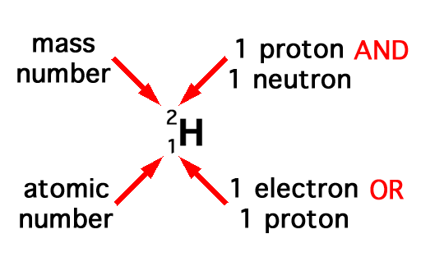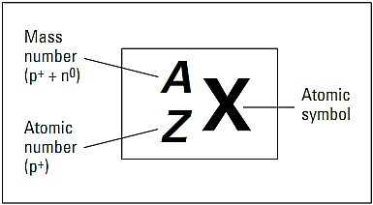
the iron nucleus which has 26 protons and 30 neutrons, is denoted as
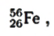
Where the total atomic number is ( Z = 26) and the mass number (A = 56). The number of neutrons is simply the difference (N = A – Z)
56-26 =30

Isotopes :-
The atoms of a particular element can have an identical number of protons and electrons but varying numbers of neutrons. If they have different numbers of neutrons, then the atoms are called isotopes (Atoms of the same element that have same atomic number but different numbers of neutrons). The figure below shows the three hydrogen isotopes, Hydrogen or (Protium) which has (1p + 0N), Deuterium which has (1p + 1N) and Tritium which has (1p +2N).

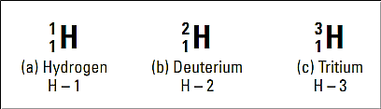
^{Hydrogen Isotopes}
Other examples
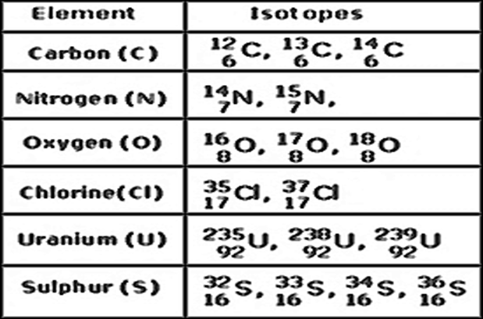
Each of these isotopes have different abundance in nature. The table below outlines the average isotopic abundances of elements that are most commonly measured for stable isotope measurements
Hydrogen | Carbon | Nitrogen | Oxygen
¹H – 99.984% | ¹²C – 98.89% | ¹⁴N – 99.64% | ¹⁶O – 99.763%
²D – 0.0156% | ¹³C – 1.11% | ¹⁵N – 0.36% | ¹⁷O – 0.0375%
---- | ---- | ---- | ¹⁸O – 0.1995%

Stable vs. Unstable Isotopes
In chemistry an isotope is a different form of an element which will have different neutron number and thus has a different mass number as well. But the chemical properties and other related characteristics remain same as that of the element. There are two types of isotopes, one which is found in nature, stable and not radioactive, the second type is the one which is naturally radioactive and not stable. Any element having excess of neutrons in the nucleus as compared to the stable form of atom tends to be unstable in nature. These elements tend to be radioactive and undergo radioactive decay by emitting energy.
*Unstable nuclei decay by giving off Alpha particles (helium nuclei), Beta particles (electrons or antielectrons) or Gamma particles (photons of high energy electromagnetic radiation).
The examples of naturally occurring stable and radioactive or unstable isotopes are mentioned below:
Naturally occurring stable isotopes | Radioactive unstable isotopes
Carbon 12 | Carbon 14
Calcium40  Calcium43  Calcium 46 | Calcium 48
Vanadium 51 | Vanadium 50
Germanium70  Germanium72  Germanium 74 | Germanium 76
Selenium74  Selenium76  Selenium78  Selenium 80 | Selenium 82
Krypton80  Krypton82  Krypton84  Krypton 86 | Krypton 78
Rubidium 85 | Rubidium 87

Average Atomic Mass
The calculation of the average atomic mass of an atom is performed using the relative abundance data from the isotope of each atom
The average atomic mass of an element is the sum of the masses of its isotopes, each multiplied by its natural abundance (the decimal associated with percent of atoms of that element that are of a given isotope).
[(% abundance of isotope) (mass of isotope)] + [(% abundance of isotope) (mass of isotope)] + [...]
100
For example
the natural abundance for chloro isotopes is 75.78% ³⁵Cl (34.968853amu*) and 24.22% ³⁷Cl (36.9659033amu*). Calculate the atomic mass of Cl

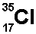, 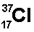
75.78%, 24.22%
Average atomic mass = [ (75.78) (34.968853)] + [(24.22)(36.9659033)]
-----------------------------------------------------------
100
= 35.45
Example 2
The natural abundance for boron isotopes is 19.9% ¹⁰B (10.013 amu*) and 80.1% ¹¹B (11.009 amu*). Calculate the atomic mass of boron.
Average atomic mass = [(19.9%) (10.013)] + [(80.1%) (11.009)]
100
= 10.811 (note that this is the value of atomic mass given on the periodic table)
*amu is the atomic mass unit, which is defined as 1/12th the mass of a carbon-12 atom. This value provides a reference point for measuring relative atomic masses.
* The average atomic mass also known as the molar mass or relative atomic mass (RAM).

Tables of Isotopic Masses and Natural Abundances
These tables list the mass and percent natural abundance for the stable nuclides.




