**Molecular Techniques**

**Typing and Genotyping**

**Genotyping**

Genotyping is the process of determining differences in the genetic make-up (genotype) of an individual by examining the individual's DNA sequence using biological assays and comparing it to another individual's sequence or a reference sequence. It reveals the alleles an individual has inherited from their parents. Traditionally genotyping is the use of DNA sequences to define biological populations by use of molecular tools. It does not usually involve defining the genes of an individual.

Current methods of genotyping include :

1. Pulsed-field gel electrophoresis (PFGE) – a technique that allows the electrophoretic separation of low numbers of large DNA restriction fragments produced using restriction enzymes to generate a highly discriminatory genetic fingerprint.
2. Multilocus sequence typing (MLST) – sequencing 400-500 base pair fragments of DNA at seven different conserved genes allows small variations within a species to be detected
3. Multilocus variable number of tandem repeats analysis (MLVA) - a technique related to MLST based on PCR amplification and sequencing of rapidly mutating repetitive DNA sequences called tandem repeats.
4. Ribotyping – this technique relies on the relative stability of the 16S and 23S rRNA genes coding for ribosomal RNA.
5. Repetitive sequence-based PCR (rep-PCR) – bacterial and fungal genomes contain numerous non-coding, repetitive DNA sequences separating longer, single copy, sequences and their arrangement varies between strains.
6. DNA Microarrays - a microarray is a collection of DNA probes attached in an ordered pattern onto a solid surface.

**Antbiogram typing and ERIC-PCR genotyping** :

ERIC-PCR involves the use of oligonucleotides targeting short repetitive sequences dispersed throughout various bacterial genomes.ERIC sequences are dispersed throughout the genome of enterobacteriaceae indifferent orientations thus enable their location in bacterial genomes allows discrimination at genus and serovars level based on their electrophoretic amplification products. To obtain information on the genetic diversity .

**Requirements of genotyping:**

1. **DNA extraction:**

All strains were grown on nutrient broth for 24 h at 37°C and checked for purity on nutrient agar plates. Approximately two loops worth of biomass were scraped off the agar plates, suspended in 100 μl of sterile distilled water, and boiled for 10 min. After centrifugation at 12000×g for 10 min at 4°C, the supernatants were recovered and 5 μl was directly used as the template for PCR .

1. **DNA amplification by ERIC-PCR**

The forward primer (5’-ATGTAAGCTCCTGGGGATTCAC-3’) and reverse primer (5-AAGTAAGTGACTGGGGTGAGCG-3’) . were used to amplify repetitive sequences present in the chromosomal DNA of E. coli isolates. ERIC-PCR was carried in 25 μl, volume comprising of 100 ng of E. coli DNA, 1.5 μl (10 pmol) of each primer and 12.5 μl Mastermixe. Filtered water was added to the mixture to make a final volume of 25 μl.

Table: The conditions used for the amplification of ERIC gene.

|  |  |  |  |  |  |
| --- | --- | --- | --- | --- | --- |
| Final extension | Primers extension | Annealing | Denaturation in each cycle | No. of cycles | Initial denaturation |
| 72°C for 15 minutes. | 72°C for 5 minutes | 38°C for 1 minute | 94°c 30 seconds | 34 cycles | 94°C for 7 minutes |

1. **Gel electrophoresis**

Lab2

1. **Result Reading :**

**33 34 35 36 37 38 L 39 26 19 30**

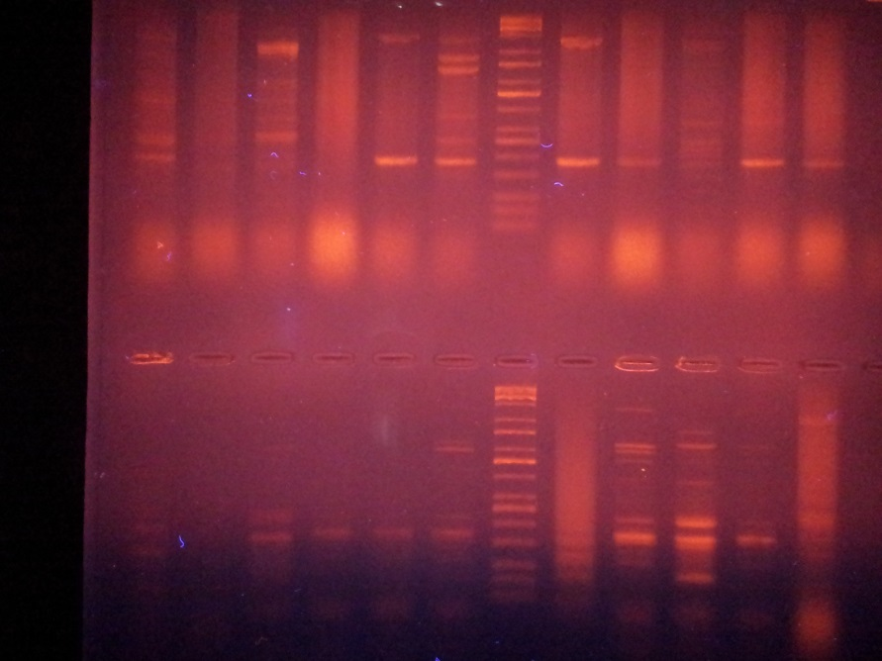

|  |  |  |
| --- | --- | --- |
| **NO.of isolates** | **bp** | **ERIC1** |
| **33** | 300  400 | 700 |
| **34** |  | X |
| **35** | 300  400 | 700 |
| **36** |  | 300 |
| **37** |  | 300 |
| **38** | 900  300  400 | 1600 |
| **39** |  | X |
| **26** | 1200  900  600  300  400 | 3400 |
| **19** | 900  300  400 | 1600 |
| **30** |  | 300 |



**Figure:Dendrogram obtained from antibiogram data for all E. coli isolates.**