Type of the Relationships
1- Competition-Organisms struggle, fight or search for the same basic needs and become more intense when basic needs become limited. Normally, they will compete for shelter, nesting sites, food, sunlight, minerals, and breeding partners. Organisms that are stronger, fitter, and better adapted to environmental changes will be successful and survive. For example: The maize plants competing with weeds for water and minerals. / The owl and the snake competing with each other for food (the rat).
2-Symbiosis:- relationships in which one organism lives in another , Symbiotic relationships may be either
- Obligate, necessary for the survival of at least one of the organisms involved.
- facultative, where the relationship is beneficial but not essential for survival of the organisms.
- Endosymbiosis is any symbiotic relationship in which one symbiote lives within the tissues of the other, either in the intracellular space or extracellularly.
- Ectosymbiosis, also referred to as exosymbiosis, is any symbiotic relationship in which the symbiont lives on the body surface of the host, including the inner surface of the digestive tract or the ducts of exocrine glands. Examples of this include ectoparasites such as lice.
3- Mutualism :- any relationship between individuals of different species where both individuals derive a benefit. Generally, only lifelong interactions involving close physical and biochemical contact can properly be considered symbiotic. Mutualistic relationships may be either
- obligate for both species, obligate for one but facultative for the other,
- facultative for both. Many biologists restrict the definition of symbiosis to close mutualist relationships.
A large percentage of herbivores have mutualistic gut fauna that help them digest plant matter, which is more difficult to digest than animal prey. Coral reefs are the result of mutualisms between coral organisms and various types of algae that live inside them. Most land plants and land ecosystems rely on mutualisms between the plants, which fix carbon from the air, and mycorrhyzal fungi, which help in extracting minerals from the ground.
4-Commensalism :- describes a relationship between two living organisms where one benefits and the other is not significantly harmed or helped. It is derived from the English word commensal, meaning "sharing food" "sharing a table"and used of human social interaction. May involve one organism using another for transportation (phoresy) or for housing (inquilinism), or it may also involve one organism using something another created, after its death (metabiosis). Examples of metabiosis are hermit crabs using gastropod shells to protect their bodies and spiders building their webs on plants.
5- Prey-predator relationship- In this relationship, the predator which is normally bigger in size, hunts, kills and feeds on the smaller, hunted animals called prey. Generally, the predator population is smaller than the prey population. For example: Lions (predators) hunting deer (prey) for food.

6-Parasitism:- a parasitic relationship is one in which one member of the association benefits while the other is harmed. Parasitism is a type of symbiotic relationship between two different organisms where one organism, the parasite, takes favor from the host, sometimes for a prolonged time. In general, parasites are much smaller than their hosts, show a high degree of specialization for their mode of life, and reproduce more quickly and in greater numbers than their hosts. Classic examples of parasitism include interactions between vertebrate hosts and diverse organisms such as tapeworms, flukes, the Plasmodium species, and scabs.
7-Parasitoids:- are organisms whose larval development occurs within another organism's body, resulting in the death of the host. Thus, the interaction between the parasitoid and the host is fundamentally different from true parasites and their host, and shares some characteristics with predation.
8-Hyperparasitism:- or (epiparasite )is one that feeds on another parasite. as which may be exemplified by a protozoan living in the digestive tract of a flea living on a dog.
Parasites are everywhere, and they are very easy to contract from our food, water, animals, even from other people. A parasite is an organism which feeds off, and usually within, a host body, such as our own body, or other living organisms, like plants and animals. They feed on the nutrients, cells, blood and organs of the host. They reproduce by depositing thousands of eggs, or simply by cell division, within the host's tissues and cells. They can travel around the body. They can easily traveling around the blood stream when small and find a suitable place to grow and develop. Parasites are often mobile, "grazing" in one area of the body after another, eating the host's cells directly or draining the best of the nutrients directly from the host's tissues. Another nasty side effect of parasites are their fecal secretions, direct into our own bodies. These can be quite toxic and affect a person in different ways.These can also have an affect on the immune system and further weaken the bodies defences and make it even more susceptible to illness and disease.
Most parasitic infections come from our food and water sources but can also be transmitted by human or animal contact. Simply petting and grooming our pets can increase the chances of infection, the parasites' eggs passing from their fur to our hands, nose and mouth. Quite a number of parasites common to cats and dogs can also survive quite happily inside a human body. Some parasites (e.g. pinworms) can even be transmitted through the air and are in the dust we breath. It's likely, therefore, that those who live in the same household will all have the same parasitic infections, whether they currently show symptoms or not.

Types of parasitism
Parasites are classified based on their interactions with their hosts and on their life cycles.
1-Ectoparasites:- Those that live on its surface of a human host and attach or burrow into the skin. (e.g. some mites)
2-Endoparasites:- those that live inside the host (e.g. hookworms).
Endoparasites can exist in one of two forms:
- Intercellular:- (inhabiting spaces in the host’s body)
- Intracellular:- (inhabiting cells in the host’s body). Intracellular parasites, such as plasmodium,
- An epiparasite:- is one that feeds on another parasite. This relationship is also sometimes referred to as hyperparasitism which may be exemplified by a protozoan (the hyperparasite) living in the digestive tract of a flea living on a dog.
Medical parasitology: the study of the parasites of man and their medical consequences.
Parasite: living organism requiring intimate(basically) prolonged contact with another living organism to meet some of its basic nutritional needs. In a more restricted definition, it refers to organisms that are not viruses, bacteria, fungi, rickettsia, or chlamydia and obviously include organisms of varying complexity from a unicellular protozoa to a complex multicellular helminths.
Parasitic infection: invasion by endoparasites (protozoa and helminths).
Parasitic infestation: invasion by external parasitism by ectoparasites (arthropods).
Type of host
Host: organism harboring a parasite.
- Definitive host: animal harboring the adult or sexually mature stage of the parasite.
- Intermediate host: animal in which development occurs but in which adulthood is not reached.
- Reservoir host: an animal that harbors a species of parasite that can be transmitted to and infect man.
- Vector: an arthropod or other living carrier that transports a pathogenic organism from an infected to a non-infected host. This can be passive transport or as an essential host in the life cycle of the pathogenic organism (i.e. a biologic vector).
- Carrier: a host that harbors a parasite but exhibits no clinical signs or symptoms.
Zoonosis: a disease involving a parasite for which the normal host is an animal, and wherein man can also be infected.

A number of seemingly unrelated factors occurring in the late 20th century appear to have contributed to an increased risk of parasitic infection. The major factors are:
1. International travel--Increased travel to parts of Asia, Africa, and Latin America has boosted the risk of acquiring foreign born parasites.
2. Municipal and rural water supplies--Giardia lambia, a microscopic organism, is the prime culprit in water-borne disease. (It is introduced to water supplies by animals via mountain streams and by human sewage entering public water supplies.)
3. Influx of immigrant populations--Many immigrants are asymptomatic carriers of parasites that produce
4. Household pets--Pets are hosts to numerous parasites (harbored in their fur and saliva). Around 240 different infectious diseases are transmitted from aimals to humans.
5. Exotic regional foods--Raw, rare, or undercooked meat and fish dishes, and even water-grown vegetables like watercress and lotus root, may harbor parasites.
6. Antibiotics and immune-suppressing drugs--The reduction in beneficial intestinal flora following the use of these drugs weakens the body's defenses against hidden invaders.
7. The sexual revolution--Parasites become another type of sexually transmitted disease
Prevention
1. Keep hands clean and fingernails trimmed.
2. Wash hands properly with soap and water before eating or handling food, and after toilet or changing diapers.
3. Discourage children from sucking fingers or scratching anal area.
4. Wear foot wears when working in fields.
5. Drinking water should be from the mains and preferably boiled.
6. Purchase fresh food from reliable sources. Do not patronize illegal hawkers.
7. Avoid high-risk food like raw or semi-cooked beef, pork and fish.
8. Clean and wash food thoroughly.& Clean anything that may be contaminated with feces such as bathroom fixtures, changing tables, diaper pails and toys regularly .
9. Cook food thoroughly especially when preparing food by barbecue or hot pot. Fish has to be cooked thoroughly. Avoid eating raw fish congee.
10. Do not handle cooked food with bare hands; wear gloves if necessary
11.Change litter boxes daily and avoid getting a new cat or cleaning a cat's litter box if you are pregnant.
12- Do not swim if you are infected or are experiencing diarrhea to protect others
13- Avoid drinking unpasteurized milk or dairy products , Avoid eating food from street vendors , Cook beef, lamb, veal roasts and steaks to 145°F; pork, ground meat, and wild game to 160°F, and poultry to 180°F in the thigh (can also freeze meat for a few weeks) , Do not taste meat until it is fully cooked.
Life cycle: for survival and reproduction reasons many parasites evolve through a number of morphologic stages and several environments or different hosts. The sequence of morphologic and environmental stages is referred to as the life cycle.

- Protozoa – one-celled organisms that live and multiply in the blood or tissue of humans. They infect the body via mosquitoes and flies, and are found in soil and water.
- Helminths – parasitic flatworms, flukes, tapeworms, thorny-headed worms, roundworms and pinworms. They live in the gastrointestinal tract, blood, lymphatic system and other tissues.

.. ررجل إستيقظ مبكرا ليصلي صلاه الفجر في المسجد لبس وتوضأ وذهب إلى المسجد وفي منتصف الطريق تعثر ووقع وتوسخت ملابسه قام ورجع إلى بيته وغير ملابسه وتوضأ وذهب ليصلي وفي نفس المكان تعثر ووقع وتوسخت ملابسه قام ورجع إلى بيته وغير ملابسه وتوضأ وخرج من البيت لقي شخص معه مصباح سأله : من أنت ؟ قال : انا رأيتك وقعت مرتين وقلت انور لك الطريق إلى المسجد .. ونور له الطريق للمسجد وعند باب المسجد قال له : أدخل لنصلي .. رفض الدخول وكرر طلبه لكنه رفض وبشده الدخول للصلاة سأله : لماذا لاتحب أن تصلي ؟ قال له: انا الشيطان انا أوقعتك المره الاولى لكي ترجع البيت ولاتصلي بالمسجد ولكنك رجعت ولما رجعت إلى البيت غفر الله لك ذنوبك ،، ولما أوقعتك المرة الثانية ورجعت إلى البيت غفر الله لأهل بيتك ،، وفي المرة الثالثة خفت أن أوقعك فيغفر الله لاهل قريتك. فلا تجعلوا للشيطان عليكم سبيلا ... الله لا إلَه إلا هُو الحَيُّ القَيّومُ لا اله الا الله الحليم الكريم لا اله الا الله العلى العظيم لا اله الا الله رب السماوات السبع ورب العرش العظيم

Entamoeba histolytica

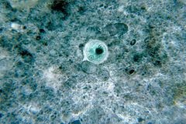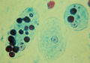
It is an anaerobic parasitic protozoan, Predominantly infecting humans and other primates, Mammals such as dogs and cats can become infected transiently, but are not thought to contribute significantly to transmission.
Trophozoite Stage Pathognomonic/Diagnostic Feature ما معنه الكتابة السابقة افضل Ingested RBC; distinctive nucleus
Cyst Stage Chromatoidal Body’ Cigar' shaped bodies (made up of crystalline ribosomes.
Number of Nuclei 1 in early stages, 4 when mature Pathognomonic/Diagnostic Feature'Ring and dot' nucleus and chromatoid bodies.
Transmission The active (trophozoite) stage exists only in the host and in fresh loose feces; cysts survive outside the host in water, soils and on foods, especially under moist conditions on the latter. The cysts are readily killed by heat and by freezing temperatures, and survive for only a few months outside of the host .When cysts are swallowed they cause infections by excysting (releasing the trophozoite stage) in the digestive tract. The trophozoite stage is readily killed in the environment and cannot survive passage through the acidic stomach to cause infection.
Pathogenesis
E. histolytica, as its name suggests (histo–lytic = tissue destroying), is pathogenic; infection can lead to amoebic dysentery or amoebic liver abscess.
Symptoms:- can include fulminating dysentery, bloody diarrhea, weight loss, fatigue, and abdominal pain. The amoeba can actually 'bore' into the intestinal wall, causing lesions and intestinal symptoms, and it may reach the blood stream. From there, it can reach different vital organs of the human body, usually the liver, but sometimes the lungs, brain, spleen, etc. A common outcome of this invasion of tissues is a liver abscess, which can be fatal if untreated. Ingested red blood cells are sometimes seen in the amoeba cell cytoplasm.
Diagnosis
It can be diagnosed by stool samples but it is important to note that certain other species are impossible to distinguish by microscopy alone. Trophozoites may be seen in a fresh fecal smear and cysts in an ordinary stool sample. ELISA or RIA can also be used .but Most common is Direct Fecal Smear (DFS) and staining (but does not allow identification to species level.
Treatment by Metronidazole
Life cycle
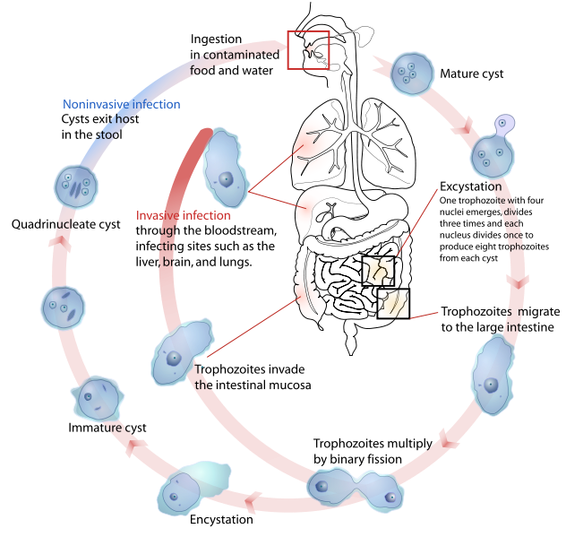

Entamoeba coli

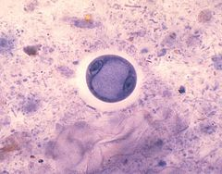
It is a non-pathogenic species of Entamoeba that frequently exists as a commensal parasite in the human gastrointestinal tract. The trophozoite and cyst of E. coli are both slightly larger than E. histolytica. Entamoeba coli trophozoites measure 20-30 µm and have a vescicolous nucleus with a large eccentric karyosome and an irregulary distributed peripheral chromatin. The cytoplasm is vacuolated containing bacteria and yeast.
E.coli cysts are spherical and measure 14-30 µm (usually 15-20). Mature cysts have 8 nuclei with a large karyosome (central or eccentric) and an irregular (sometimes regular) chromatin. The nuclei can be numerated with careful focusing.
In the wet mount it is usually impossible to differentiate between E. coli trophozoites and those of E. histolytica. A stained smear is required. Due to the size of the cyst and its density in a permanent stained smear it usually shrinks considerably. . Cysts of the mature pathogenic E. histolytica contain four nuclei while those of the non-pathogenic E. coli contain up to eight nuclei, Hypernucleation is possible with as many as 16 or more nuclei present in one cyst; new methods using molecular biology techniques have been developed.
Clinical significance The presence of E.coli is not cause in and of itself to seek treatment as it is considered harmless. However it should be noted that when a person becomes infected with this benign entamoeba, other pathogenic organisms may have been consumed at the same time.The ability to identify amoeba based on nuclear structure in iodine wet mount preparations is limited.
The single nucleus of the trophozoite is often visible in unstained preparations with the non-compact karyosome that is eccentrically located.
Entamoeba gingivalis
It is a non-pathogenic protozoa and is known to be the first amoeba in humans to be described. Entamoeba gingivalis is an Entamoeba histolytica-like amoebae that lives in/on the teeth, gums, and sometimes tonsils. It is found in 95% of people with gum disease and in 50% of people with healthy gums. It measures 10-35 micrometers in length. Endocytotic vacuoles are often numerous and the parasite will ingest bacteria, leukocytes, and erythrocytes (dark circles in trophozoites, above) although it is not itself invasive. No cysts are formed and transmission is entirely by oral-oral contact(by kissing) , or by sharing eating utensils. Multiple samplings reveal the parasite to colonize the oral cavity of nearly all adult humans. Cause gingivitis.Only the trophozoites are formed and the size is usually 10 micrometer to 20 micrometer in diameter. Entamoeba gingivalis have pseudopodia that allow them to move quickly. Their spheroid nucleus is 2 micrometer to 4 micrometer in diameter and contains a small central endosome. There are numerous food vacuoles and contain cellular debris, blood cells and bacteria.
Dientamoeba fragilis
It is a single celled parasite found in the gastrointestinal tract of some humans. In some people it causes gastrointestinal upset while in others it does not. Infection with Dientamoeba fragilis is called Dientamoebiasis To date, a cyst stage has not been identified and the trophozoite is the only stage found in stools of infected individuals . transmitted by the fecal-oral route . Replicates by binary fission and moves by pseudopodia. Feeds by phagocytosis.The cytoplasm typically contains numerous food vacuoles that contain ingested debris, including bacteria.Waste materials are eliminated from the cell through digestive vacuoles by exocytosis.
Life Cycle:
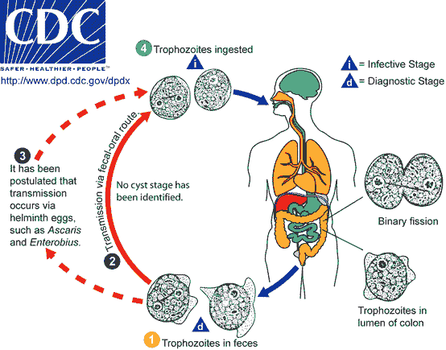
The complete life cycle of this parasite has not yet been determined, but assumptions were made based on clinical data. To date, the cyst stage has not been identified in D. fragilis life cycle, and the trophozoite is the only stage found in stools of infected individuals . D. fragilis is probably transmitted by fecal-oral route and transmission via helminth eggs (e.g., Ascaris, Enterobius spp.) has been postulated . Trophozoites of D. fragilis have characteristically one or two nuclei (, ), and it is found in children complaining of intestinal (e.g., intermittent diarrhea, abdominal pain) and other symptoms (e.g., nausea, anorexia, fatigue, malaise, poor weight gain
Clinical Features:
It cause dientamoebiasis, Many infected people do not have any symptoms. The most common symptoms are diarrhea, stomach pain, and stomach cramping. Loss of appetite and weight, nausea, and fatigue also are common. The infection does not spread from the intestines to other parts of the body.
Laboratory Diagnosis:
Infection is diagnosed through detection of trophozoites in permanently stained fecal smears (e.g., trichrome). This parasite is not detectable by stool concentration methods. Dientamoeba fragilis trophozoites can be easily overlooked because they are pale-staining and their nuclei may resemble those of Endolimax nana or Entamoeba hartmanni.
Diagnostic findings
- Microscopy
- Morphologic comparison with other intestinal parasites.
Endolimax nana
It is found in the intestines of various animals including humans , causes no known disease and is most significant in medicine because it can provide false positives for other tests, notably the similar species Entamoeba histolytica responsible for amoebic dysentery, and because its presence indicates the host has consumed fecal material. Endolimax nana have tow stages :1- trophozoite is small ,the single nucleus a large endosome somewhat off-center and small amounts of visible chromatin . sometimes is visible in unstained preparations. In stained organisms, the karyosome usually is large and irregularly shaped, but occasionally it may be fragmented or placed against one side of the nuclear membrane. There is no peripheral chromatin on the nuclear membrane. The cytoplasm, which is coarsely granular and often highly vacuolated, may contain bacteria.2- Cyst is small, with a spherical to ellipsoidal shape, Mature cysts contain four nuclei; immature cysts are rarely seen, The cytoplasm may contain diffuse glycogen, and chromatid bodies are absent. It has a world-wide distribution and is considered an harmless commensal of the intestine.
Iodamoeba bütschlii
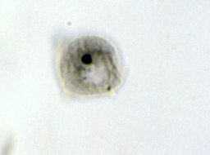
Iodamoeba butsclii is a non-pathogenic amoeba present in the human large intestine, pigs and other mammals. It gets its name from its appearance when stained with iodine. The trophozoites are 9–14 mcm in diameter, the cysts are 8–10 mcm in diameter, with a thick wall and a large glycogen vacuole that stains darkly with iodine. Usually harmless, it may cause amebiasis in immunologically compromised individuals. The amoebae contain no recognisable mitochondria. Both the trophozoite and cyst have one nucleus with a large endosome cysts ovoid in shape contain glycogen filled so-called vacuoles that stains brown with Iodine, and these cysts were therefore called "I-cysts" before they were known to be the cysts of an amoeba hence the name "Iodamoeba".
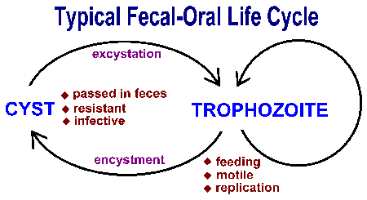
Class:-Mastigophora

The class is composed of two subclasses, the Phytomastigophora and the Zoomastigophora. The Phytomastigophora have chlorophyll and are free-living in the sea, fresh water, and soil. They include Euglena and Volvox. Possessing chlorophyll, they are able to synthesize organic compounds from inorganic ones using the energy of sunlight; some, however, are colourless, and thus require organic matter to survive. This difference occurs within the members of one genus, Euglena, and illustrates the difficulties of deciding whether they are plants or animals.
Members of the Zoomastigophora have no chlorophyll and require organic food particles. Some species, such as Peranema, obtain these by engulfing large living prey such as Euglena. Members of the order Choanoflagellida are filter feeders. They are sessile (fixed) and feed by setting up a current with the flagellum. This current is drawn through the collar, which encloses the base of their flagellum. Here any particles are filtered off and move down through the base of the collar to form food vacuoles. Some Zoomastigophora are parasitic and cause economically important diseases such as leishmaniasis, malaria and trypanosomiasis (sleeping sickness). Asexual reproduction by binary fission is the norm, but some species reproduce sexually by a process called syngamy, the fusion of two gametes produced by meiosis (i.e., fertilization).

- Intestinal flagellate
Giardia lamblia
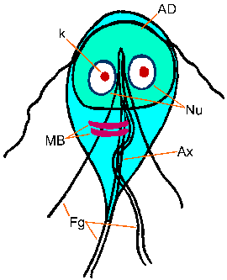
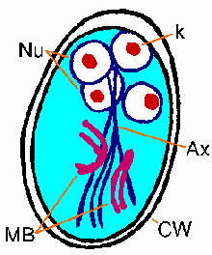

GIARDIASIS (lambliasis)
Morphology
Trophozoite: Giardia is a 12 to 15 micrometer, half pear-shaped organism with 8 flagella and 2 axostyles arranged in a bilateral symmetry. There are two anteriorly located large suction discs. The cytoplasm contains two nuclei and two parabasal bodies (Figure 7).
Cyst: Giardia cysts are 9 to 12 micrometer ellipsoidal cells with a smooth well-defined wall. The cytoplasm contains four nuclei and many of the structures seen in the trophozoite.
Life cycle The life cycle begins with a noninfective cyst being excreted with the faeces of an infected individual. The cyst is hardy, providing protection from various degrees of heat and cold, desiccation, and infection from other organisms. A distinguishing characteristic of the cyst is four nuclei and a retracted cytoplasm. Once ingested by a host, the trophozoite emerges to an active state of feeding and motility. After the feeding stage, the trophozoite undergoes asexual replication through longitudinal binary fission. The resulting trophozoites and cysts then pass through the digestive system in the faeces. While the trophozoites may be found in the faeces, only the cysts are capable of surviving outside of the host.
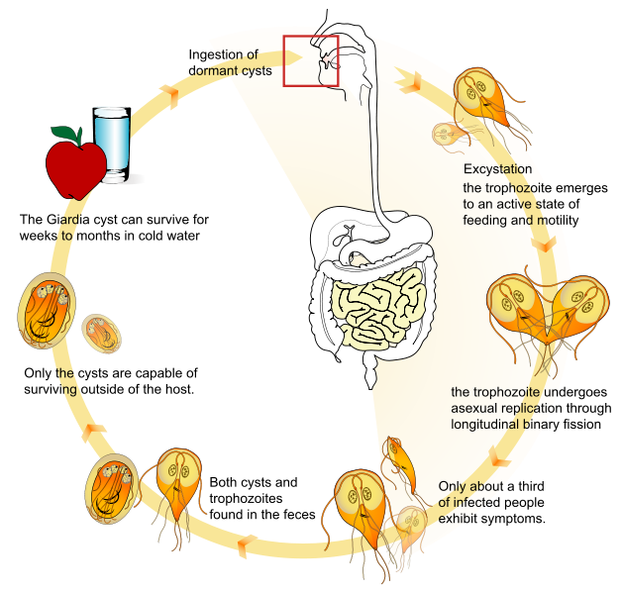
Symptoms Early symptoms include flatulence, abdominal distension, nausea and foul-smelling bulky, explosive, often watery, diarrhea. The stool contains excessive lipids but very rarely any blood or necrotic tissue. The more chronic stage is associated with vitamin B₁₂ malabsorption, disaccharidase deficiency and lactose intolerance.
Pathology Covering of the intestinal epithelium by the trophozoite and flattening of the mucosal surface results in malabsorption of nutrients.
Immunology There is some role for IgA and IgM and there is increased incidence of infection in immunodeficient patients (e.g. AIDS).

Transmission Giardia is found in soil, food, water, or surfaces that have been contaminated with the feces from infected humans or animals. Giardia transmission can occur by accidentally swallowing the parasite; a person cannot become infected through contact with blood.
PreventionTreatment of drinking water by :- 1- filtration with a filter .2- chemical treatment methods.
Diagnosis Symptoms, history, epidemiology are used in diagnosis. Giardia caused dysentery is distinct from other dysenteries due to lack of mucus and blood in the stool, lack of increased PMN leukocytes in the stool and lack of high fever. Cysts in the stool and trophs in the duodenum can be identified microscopically after content has been obtained using a string device (Enterotest).
Trichomonas vaginalis
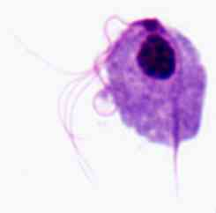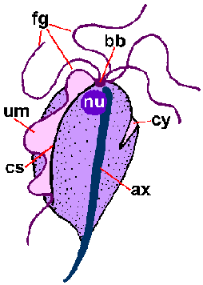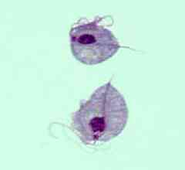
It is an anaerobic, parasitic flagellated protozoan, is the causative agent of trichomoniasis, and is the most common pathogenic protozoan infection of humans .
Morphology A unicellular trophozoite is oval as well as flagellated, Five flagella arise near the cytosome, In addition, a conspicuous barb-like axostyle used for attachment to surfaces and may also cause the tissue damage noted in trichomoniasis infections. lives in close association with vaginal, urethral and prostatic tissue. While T. vaginalis does not have a cyst form, T. vaginalis obtains nutrients by transport through the cell membrane and by phagocytosis. The organism is able to maintain energy requirements by the use of a small amount of enzymes to provide energy via glycolysis. multiples by binary fision. There is no cyst in the life cycle, so transmission is via the trophozoite stage.
Life cycle T. vaginalis colonizes the vagina of women and the urethra (sometimes prostate) of men. Infection occurs primarily via sexual contact, although non-venereal infections are possible. The organism does not encyst and divides by binary fission which is favored by low acidity (pH > 5.9; the normal pH is 3.5 to 4.5). There is no non-human reservoir.Trichomonads reproduce by a special form of longitudinal fission, leading to large numbers of trophozoites in a relatively short time.
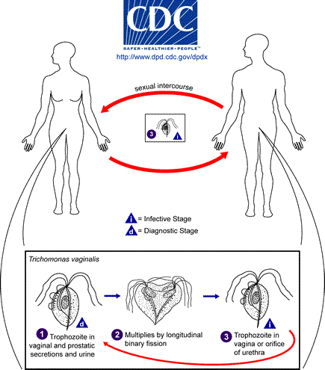
Epidemiology
only in humans; no animal reservoir,sexual transmission, can persist for 2 years in host. There is no cyst in the life cycle, so transmission is via the trophozoite stage.
Manifestation of infection The main signs of a Trichomonas infection in women are abdominal pain, itching, and presence of a foul-smelling discharge with abundant leukocytes, while in men the infection is mostly asymptomatic, although it can sometimes lead to urethritis, prostatitis, and epididymitis. Infection with this organism is also associated with severe complications, such as infertility and enhanced predisposition to neoplastic transformation in cervical tissues
asymptomatic - vast majority . symptomatic - vaginitis, prostatitis, urethritis.Pathogenesis of Trichomonas infections occurs by cytopathogenicity against vaginal epithelial cells. Adhesion of the parasite to the target cell is essential for the maintenance of infection and for cytopathogenicity.
Diagnosis depends on finding trophozoites in secretions of the genital tract from men or women. In cases where the numbers of organisms are very low, the trophozoites can be cultured to increase their numbers.



Blood and tissue flagellate

The most important trypanosomal diseases are trypanosomiasis (African Sleeping Sickness and South American Chagas Disease); these are caused by species of Trypanosoma. The Leishmaniases are a set of trypanosomal diseases caused by various species of Leishmania.show specific cellular forms named polymorphism phenomenon:-

These names are derived from the Greek mastig- meaning whip, referring to the trypanosome's whip-like flagellum

Amastigote - Basal body anterior of nucleus, with a short, essentially non-functional, flagellum

Promastigote - Basal body anterior of nucleus, with a long detached flagellum

Epimastigote - Basal body anterior of nucleus, with a long flagellum attached along the cell body

Trypomastigote - Basal body posterior of nucleus, with a long flagellum attached along the cell body.

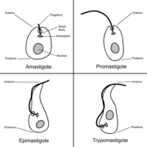

Leishmania

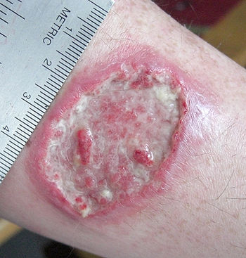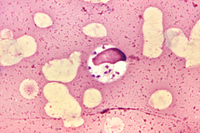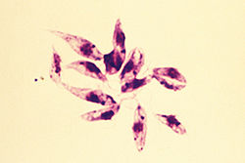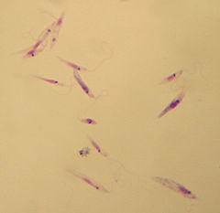
Leishmania is a genus of trypanosome protozoa, and is the parasite responsible for the disease leishmaniasis. It is spread through sandflies of the genus Phlebotomus in the Old World. Their primary hosts are vertebrates; Leishmania commonly infects hyraxes, canids, rodents, and humans. Leishmania currently affects 12 million people in 88 countries.
Infections are regarded as cutaneous, mucocutaneous, or visceral.
They are dimorphic parasites which present as two principal morphological stages : the intracellular amastigote, within the mononuclear phagocytic system of the mammalian host, and the flagellated promastigote within the intestinal tract of the insect vector and in culture medium.
The amastigote stage is a round or oval body about 2-6 µm in diameter, containing a nucleus, a kinetoplast and an internal flagellum seen clearly in electron micrographs. The amastigotes multiply within the parasitophorous vacuoles of macrophages.
The promastigote stage has a long and slender body (about 15-30 µm by 2-3 µm), with a central nucleus, a kinetoplast and a long free anterior flagellum.

Type | Pathogen | Location
Cutaneous leishmaniasis (localized and diffuse) infections appear as obvious skin reactions. | The most common is the Oriental Sore, Baghdad boil (caused by L. tropica, | Cutaneous infections are most common in Afghanistan, Brazil, Iran, Peru, Saudi Arabia, Iraq and Syria.
Mucocutaneous leishmaniasis (espundia) infections will start off as a reaction at the bite, and can go via metastasis into the mucous membrane and become fatal. | L. braziliensis | Mucocutaneous infections are most common in Bolivia, Brazil and Peru. Mucocutaneous infections are also found in Karamay, China Xinjiang Uygur Autonomous Region.
Visceral leishmaniasis infections are often recognized by fever, swelling of the liver and spleen, and anemia. They are known by many local names, of which the most common is probably Kala azar, | Caused exclusively by species of the L. donovani complex (L. donovani, L. infantum syn. L. chagasi). | Found in tropical and subtropical areas of all continents except Australia, visceral infections are most common in Bangladesh, Brazil, India, Nepal and Sudan. Visceral leishmaniasis also found in part of China, such as Sichuan Province, Gansu Province and Xinjiang Uygur Autonomous Region.

Life cycle
Leishmania cells have two morphological forms: promastigote (with an anterior flagellum) in the insect host, and amastigote (without flagella) in the vertebrate host.
The organism is transmitted by the bite of several species of blood-feeding sand flies (Phlebotomus) which carry the promastigote in the anterior gut and pharynx. The parasites gain access to mononuclear phagocytes where they transform into amastigotes and divide until the infected cell ruptures. The released organisms infect other cells. The sandfly acquires the organisms during the blood meal; the amastigotes transform into flagellate promastigotes and multiply in the gut until the anterior gut and pharynx are packed. Dogs and rodents are common reservoir. Leishmania is spread through an insect vector, the sandfly of the Phlebotomus genus. Sandflies are found in tropical or temperate regions throughout the world. Sand fly larvae grow in warm, moist organic matter, such as old trees, house walls or waste — making them hard to eradicate. The adult female sand fly is a bloodsucker, usually feeding at night on sleeping prey. When the fly bites an animal infected with L. donovani, the pathogen is ingested along with the prey’s blood. At this point the protozoan is in the smaller of its two forms, called an amastigote — round, non-motile. Taken into the stomach of the sandfly, the amastigotes quickly transform into a second L. donovani form, called the promastigote. This form is spindle-shaped, triple the size of the amastigote, and has a single flagellum that allows for motility. The promastigotes live extracellularly in the sandfly’s alimentary canal, reproducing asexually, then migrate to the proximal end of the gut where they become poised for a regurgitational transmission. This is their means of transmission back into a mammalian host, as the fly injects its saliva into prey when it bites. The promastigotes are introduced locally at the bite site along with the fly’s saliva.
Once inside the new host, promastigotes invade macrophages. ,they transform back into the smaller amastigote form. As an amastigote, can only reproduce intracellularly — and the amastigotes replicate in the most hostile part of the macrophage cell, inside the phagolysosome, whose normal defensive response they are able to prevent. After they have reproduced to a certain extent, the Leishmania lyse their host cell by sheer pressure of mass, but there is some recent speculation that they are able to leave the cell by triggering the exocytosis response of the macrophage. The daughter cell protozoans then migrate through the bloodstream to find new macrophage hosts.
They use the willingly phagocytosing polymorphonuclear neutrophil granulocytes (PMN) rigorously as a tricky hideout, where they proliferate unrecognized from the immune system and enter the long-lived macrophages to establish a “hidden” infection. The promastigote forms also release LCF (Leishmania chemotactic factor) to recruit actively neutrophils but not other leukocytes , for instance monocytes or NK cells. The pathogens stay viable during phagocytosis since their primary hosts, Microbial pathogens have been reported to influence cellular apoptosis by different strategies. The strategy of this "silent phagocytosis" has following advantage for the parasite:
- Taking up apoptotic cells silences macrophage killing activity leading to a survival of the pathogens.
- Pathogens inside of PMN have no direct contact to the macrophage surface receptors, because they can not see the parasite inside the apoptotic cell. So the activation of the phagocyte for immune activation does not occur.

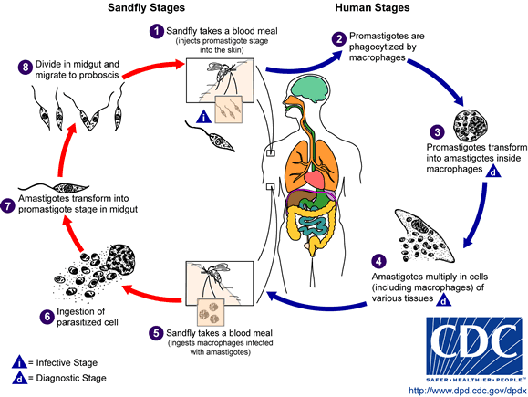
Pathophysiology
In the medical field, leishmaniasis is one of the famous causes of a markedly enlarged spleen, which may become larger even than the liver. The symptoms of leishmaniasis are skin sores which erupt weeks to months after the person affected is bitten by sand flies. Other consequences, which can become manifest anywhere from a few months to years after infection, include fever, damage to the spleen and liver, and anaemia.
There are three main forms of leishmaniasis:
- Cutaneous leishmaniasis –cause by L. tropica, the most common form which causes a sore at the bite site, which heal in a few months to a year, leaving an unpleasant looking scar. This form can progress to any of the other three forms. It is a skin infection, The lesion then ulcerates and may become secondarily infected with bacteria. the lesion often spontaneously heals with atrophic scarring or with scarring .
- Mucocutaneous leishmaniasis –cause by L. braziliensis, commences with skin ulcers which spread causing tissue damage to (particularly) nose and mouth. (also known as "Espundia," ) the lesion may spontaneously heal, but then re-appear elsewhere (especially as destructive mucocutaneous lesions).
- Visceral leishmaniasis – the most serious form and potentially fatal if untreated. Cause by L. donovani becomes a systemic infection, spreading to all the host’s organs, particularly the spleen and , also known as kala-azar, black fever, and Dumdum fever,is the most severe form of leishmaniasis. The parasite migrates to the internal organs such as liver, spleen (hence 'visceral)' and bone marrow and if left untreated will almost always result in the death of the host. Signs and symptoms include fever, weight loss, mucosal ulcers, fatigue, anemia and substantial swelling of the liver and spleen.

Diagnosi Leishmaniasis is diagnosed in the haematology laboratory by Buffy-coat preparations of peripheral blood or aspirates from marrow, spleen, lymph nodes or skin lesions should be spread on a slide to make a thin smear, and stained with Leishman's or Giemsa's stain (pH 7.2) for 20 minutes. Amastigotes are seen with monocytes or, less commonly in neutrophil in peripheral blood and in macrophages in aspirates. They are small, round bodies 2-4μm in diameter with indistinct cytoplasm, a nucleus and a small rod-shaped kinetoplast. Occasionally amastigotes may be seen lying free between cells.
Serological testing is much more frequently used in areas where leishmaniasis is endemic, include a latex agglutination test.

B-Trypanosome
The genus Trypanosoma is divided into several subgenera based on subtle morphological differences. However, the most important subdivision is into the groups Salivaria and Stercoraria, the latter involving species the development of which is terminated in the rear part of the digestive tract of the vector, here triatomine bugs.
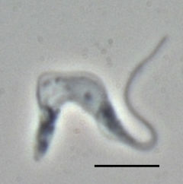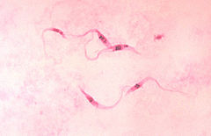
Trypanosomes are a group of kinetoplastid protozoa distinguished by having only a single flagellum. All members are exclusively parasitic, found primarily in insects. A few genera have life-cycles involving a secondary host, which may be a vertebrate or a plant. These include several species that cause major diseases in humans. A variety of different forms appear in the life-cycles of trypanosomes, distinguished mainly by the position of the flagellum.
Most trypanosomes have at least amastigote and promastigote stages. Trypanosoma appears in all four forms, with the trypanosomal stage occurring in the vertebrate host.
These obligate parasites have two hosts - an insect vector ,( The transmission is therefore contaminative by excrements containing metacyclic trypomastigotes), and mammalian host. Because of the large difference between these hosts the trypanosome undergoes complex changes during its life cycle to facilitate its survival in the insect gut and the mammalian bloodstream.
Trypanosoma cruzi
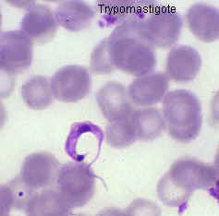
This species causes the trypanosomiasis diseases in humans and animals in America. Transmission occurs when the reduviid bug(kissing” bug) deposits feces on the skin surface and subsequently bites; the human host then scratches the bite area which facilitates penetration of the infected feces.Human American trypanosomiasis, or Chagas disease, is a potentially fatal disease of humans. The parasite has two forms, a trypomastigote found in human blood and an amastigote found in tissues. The acute form usually goes unnoticed and may present as a localized swelling at the site of entry. The chronic form may develop 10 to 20 years after infection. This form affects internal organs (e.g. the heart, esophagus, colon and the peripheral nervous system). Affected people may die from heart failure.
Life cycle
Trypanosoma cruzi's life cycle starts in an animal reservoir. These reservoirs are usually mammals, wild or domestic, and include humans. A triatomine bug serves as the vector. While taking a blood meal, the triatomine sucks up the T. cruzi. In the triatomine bug, they go into the epimastigote stage. This makes it possible to reproduce. After reproducing through mitosis, the epimastigotes move onto the rectal cell wall. There, they become infectious. Infectious T. cruzi are called trypomastigotes. Then, while the triatomine bug is taking a blood meal from a human, it defecates. The trypomastigotes are in the feces. The trypomastigotes enter the human host through the bite wound or by crossing mucous membranes (this method of transmission called posterior station). When they enter a human cell, they become amastigotes. This is another reproductive stage. After reproducing through mitosis until a large amount of amastigotes are in a cell, pseudocysts are formed in infected cells. The amastigotes then turn back into trypomastigotes, and the cell bursts. The trypomastigotes swim along to either infect other cells or get sucked up by other triatomine bugs.
Pathophysiology
Acute: local inflammation at site of innoculation (chagoma) generalized lymphadenopathy, hepatosplenomegaly fever.
It is true that all inflammatory and non-inflammatory heart disease may display forms of parasympathetic denervation, this denervation presents in a descriptive fashion in Chagas’ disease. It has also been indicated that the loss of parasympathetic innervations can lead to sudden death. This sudden death is due to a severe cardiac failure that occurs during the acute stage of infection.
Chronic: up to several decades after acute stage myocardopathy - heart failure, arrhythmias megaintestine - megaoesophagus, achalasia, megacolon
Chagas’ disease can affect myocardial function by causing heart failure syndrome. Depending on which side of the heart is affected by chagasic cardiomypopathies there will be different clinical manifestations throughout the body. Associated with right side damage will be edema, ascites, hepatomegaly, and pathologic jugular turgor. The previously mentioned symptoms are due to inadequate removal of venous blood. Associated with left side damage will be pulmonary congestion and low cardiac output. Also observed in heart failure syndrome is apical aneurysm, sometimes with a diameter between 2-5 cm, weakening the endocardial-pericardial junction.Arrhythmic syndrome is also a cardiomyopathy clinically associated with Chagas’ disease.
There is some evidence that chronic Chagas disease also can cause autonomic disfunction, including impaired regulation of heart rate in response to various physiological stresses such as orthostatic testing
cardiomyopathy found in nearly all cases of chronic Chagas’ disease is Thromoembolic syndrome. Thromboembolism describes thrombosis, the formation of a clot, and its main complication –embolism, the carrying of a clot to a distal section of the vessel and causing blockage. This occurrence contributes to the death of a patient by four means: arrhythmias, stasis secondary to cardiac dilation, mural endocarditis, and cardiac fibrosis. These thrombi also affect other organs such as the brain, spleen and kidney.
Diagnosis: - blood smear for trypanosomes (Giemsa stain)
- serology, PCR
- biopsy
- xenodiagnosis
Control: - Concrete walls and floors prevent reduvid bug infestations - antiparasitic agents added to transfused blood products.
Trypanosoma brucei
Trypanosoma brucei spp. is a parasitic causes African trypanosomiasis (or sleeping sickness) in humans and nagana in animals in Africa. There are 3 sub-species of T. brucei; T. b. brucei, T. b. gambiense and T. b. rhodesiense.
The insect vector for T. brucei is the tsetse fly. The parasite lives in the midgut of the fly (procyclic form), whereupon it migrates to the salivary glands for injection to the mammalian host on biting (this method of transmission called anterior station). The parasite lives within the bloodstream (bloodstream form) where it can reinfect the fly vector after biting. Later during a T. brucei infection the parasite may migrate to other areas of the host. A T. brucei infection may be transferred human to human via bodily fluid exchange, primarily blood transfer. There are three different sub-species of T. brucei, which cause different variants of trypanosomiasis
- T. brucei gambiense - Causes slow onset chronic trypanosomiasis in humans. Most common in central and western Africa, where humans are thought to be the primary reservoir
- T. brucei rhodesiense - Causes fast onset acute trypanosomiasis in humans. Most common in southern and eastern Africa, where game animals and livestock are thought to be the primary reservoir
- T. brucei brucei - Causes animal African trypanosomiasis, along with several other species of trypanosoma. T. b. brucei is not human infective due to its susceptibility to lysis by human apolipoprotein L1. However, as it shares many features with T. b. gambiense and T. b. rhodesiense (such as antigenic variation) it is used as a model for human infections in laboratory and animal studies. Which produce disease in cows making cattle raising in a quarter of Africa impossible.
A hemoflagylate found only in Africa, a zoonosis with a resevoir, in the East African form of disease, of bovines (antelope, cattle) where transmitted from resevoir animal to man by the vector tsetse fly (e.g. Glossina palpalis). In west African form it is transmitted by tsetse human to human.
LIFE CYCLE
1) Infection of a human host occurs when a tsetse fly bites a human and transmits from its salivary glands the metacylic stage (the infective state) of the trypanosome.
2) This metacylic stage quickly gives way to a blood-borne stage that begins a series of binary fission divisions at the site of inoculation. This process leads to the formation of a primary chancre.
3) The trypanosomes enter the bloodstream via the lymphatics and continue to multiply. They also enter the CNS from here.
4) A subsequent tsetse fly becomes infected by ingesting a blood meal that contains the trypanosomes from the infected host.
5) In the gut of the fly, the trypanosomes transform into procyclic trypmastigotes that divide for 10 days.
6) The organisms then migrate to the salivary glands and transform into epimastigotes, which later transform into metacyclic trypanosomes that can infect a new host.
Pathogenesis Tsetse bites man and injects saliva containing trypanosomes into the wound. These multiply locally producing a local lesion and then invade intravascular space where the trypanosome multiplies by binary fision extracellularly producing fever and lymphadenopathy and then eventually reaches the central nervous system producing a meningoencephalitis. Pathology and clinical symptoms. The disease varies in severity from a mild type to a severe fulminating type resembling that of T. rhodesiense. There may be a local inflammatory sign on the biting site. The acute disease lasts a year and is characterized by irregular fever, headache, joint and muscle pains, and a rash. The lymph nodes including postcervical group are enlarged (Winterbottom's sign). Gradually the chronic phase of the disease ensues, with the development of characteristic central nervous system changes. Diffuse meningoencephalitis and meningomyelitis develop. Evidence of nervous impairment becomes prominent, and develops a terminal sleeping stage. Death ensues either from the disease or from intercurrent infections.

INFECTION AND SYMPTOMS
The disease is transmitted through the bite of an infected tsetse fly. At first the trypanosomes multiply in subcutaneous tissues, blood and lymph. In time, the parasites cross the blood-brain barrier to infect the central nervous system. The process can take years with T.b. gambiense, rhodesiense.
- Mother-to-child infection: the trypanosome can cross the placenta and infect the fetus.
- Mechanical transmission is possible. However, it is difficult to assess the epidemiological impact of transmission through other blood-sucking insects.
- Accidental infections have occurred in laboratories due to pricks from contaminated needles.
The first stage of the disease, known as a haemolymphatic phase, entails bouts of fever, headaches, joint pains and itching. The second stage, known as the neurological phase, begins when the parasite crosses the blood-brain barrier and invades the central nervous system. In general this is when the signs and symptoms of the disease appear: confusion, sensory disturbances and poor coordination. Disturbance of the sleep cycle, which gives the disease its name, is an important feature of the second stage of the disease. Without treatment, sleeping sickness is fatal.

DISEASE MANAGEMENT
Disease management is performed in three steps:
- Screening for potential infection. This involves the use of serological tests and/or checking for clinical signs - generally swollen cervical glands.
- Diagnosis shows whether the parasite is present.
- Staging to determine the state of progression of the disease entails examination of cerebro-spinal fluid obtained by lumbar puncture and is used to determine the course of treatment.
Diagnosis must be made as early as possible and before the neurological stage in order to avoid complicated, difficult and risky treatment procedures.
The long, asymptomatic first stage of T.b. gambiense , rhodesiense sleeping sickness is one of the factors that requires the use of exhaustive active screening of the population at risk in order to identify patients at an early stage and reduce transmission. Exhaustive screening of exposed populations requires a major investment in human and material resources. In Africa such resources are often scarce, particularly in remote areas where the disease is mostly found. As a result, many infected individuals may die before they can ever be diagnosed and treated.
Prevention. Prevention include the reduction of sources of infection, the protection of people from infection, the control of riverine tsetse flies, and chemoprophylaxis with pentamidine.
Comments. A succession of antigenic variants occur in T. gambiense infection. This phenomenon stimulates the output of large quantities of immunoglobulin from the host, most of it is non-specific IgM, with no affinity for the infecting parasite. It may be useful for the presumptive diagnosis of African trypanosomiasis.
Class:-Ciliophora
The ciliates are a group of protists characterized by the presence of hair-like organelles called cilia, which are identical in structure to flagella but typically shorter and present in much larger numbers with a different undulating pattern than flagella. Cilia occur in all members of the group and are variously used in swimming, crawling, attachment, feeding, and sensation. Ciliophora can be classified under Protozoa. Ciliates are one of the most important groups of protists, common almost everywhere there is water — in lakes, ponds, oceans, rivers, and soils. Ciliates have many ectosymbiotic and endosymbiotic members, as well as some obligate and opportunistic parasites. Ciliates tend to be large protozoa, a few reach 2 mm in length, and are some of the most complex protozoans in structure.
Balantidium coli
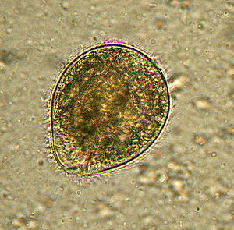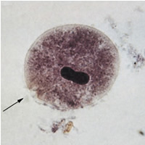
It is a parasitic species of ciliate protozoan that causes the disease Balantidiasis. It is the only member of the ciliate phylum known to be pathogenic to humans. Balantidium coli exists in either of two developmental stages: Trophozoites and Cysts. It is its size at this stage that allows Balantidium coli to be characterized as the largest protozoan parasite of humans. Trophozoites possess both a macronucleus and a micronucleus, and both are usually visible. The macronucleus is large and sausage-shaped while the micronucleus is less prominent. At this stage, the organism is not infective but it can replicate by transverse binary fission
In its cyst stage, the parasite takes on a smaller, more spherical shape, Unlike the trophozoite, whose surface is covered only with cilia, the cyst form has a tough wall made of one or more layers. The cyst form also differs from the trophozoite form because it is non-motile and does not undergo reproduction. Instead, the cyst is the form that the parasite takes when it causes infection.
The infection occurs mostly in farm workers and other rural dwellers by ingestion of cysts in fecal material of farm animals. Man-to-man transmission is rare but possible. Symptoms and pathogenesis of balantidiasis are similar to those seen in entamebiasis, including intestinal epithelial erosion. However, liver, lung and brain abscesses are not seen.
Symptoms can be local due to involvement of the intestinal mucosa, or systemic in nature and include either diarrhea or constipation.
Life Cycle
Balantidium coli has 2 developmental stages: a trophozoite stage and a cyst stage.
The cyst is the infective stage of Balantium coli life cycle. Once the cyst is ingested via feces-contaminated food or water, it passes through the host digestive system. The tough cyst wall allows the cyst to resist degradation in the acidic environment of the stomach and the basic environment of the small intestine until it reaches the large intestine. There, excystation takes place. Excystation produces a trophozoite from the cyst stage.
The motile trophozoite then resides in the lumen of the large intestine, feeding on intestinal bacterial flora and intestinal nutrients. Trophozoites multiply by asexual binary fission or sexual conjugation (with the exchange of nuclear material). The trophozoite may become invasive and penetrate the mucosa of the large intestine (See Clinical Presentation). Trophozoites are released with the feces, and encyst to form new cysts. Encystation takes place in the rectum of the host as feces are dehydrated or soon after the feces have been excreted.
Cysts in the environment are then ready to infect another host.
Diagnosis
The diagnosis of Balantidiasis can be considered when a patient has diarrhea combined with a probable history of current exposure to amebiasis through travel, contact with infected persons, or anal intercourse. In addition, the diagnosis of Balantidiasis can be made by microscopic examination of stool or tissue samples.
Prevention
Preventative measures require effective personal and community hygiene. Some specific safeguards include the following:
- Purification of drinking water
- Proper handling of food
- Careful disposal of human feces
- Monitoring the contacts of balantidiasis patients.



Class:-Microsporidia (Apicomplexa)
The microsporidia constitute of spore-forming unicellular parasites. Loosely 1500 of the probably more than one million species are named now. Microsporidia are restricted to animal hosts, and all major groups of animals host microsporidia. Most infect insects, but they are also responsible for common diseases of crustaceans and fish. The distinguished species of microsporidia usually infect one specific host or a related group of hosts. Several species, most of which are opportunistic, also infect humans. Approximately 10 per cent of the species are parasites of vertebrates, including in humans. Approximately 10 per cent of the species are parasites of vertebrates, including in humans. After infection they influence their hosts in various ways and all organs and tissues are invaded. Some species are lethal, and a few are used in biological control of insect pests. Parasitic castration, gigantism, change of host sex are effects of microsporidian parasitism. In the most advanced cases of parasitism the microsporidium rules the host cell completely and controls its metabolism and reproduction, forming a xenoma.
They are unicellular, spore-forming, and exclusively parasites of animals.The spores are simple and have no polar filaments. There is a single type of nucleus. There are no cilia or flagella except for flagellated microgametes in some groups. In most Sporozoa there is an alternation of sexual and asexual stages in the life cycle. In the sexual stage, fertilization is by syngamy, that is, the union of male and female gametes. All Sporozoa are parasitic.
1-Toxoplasma gondii
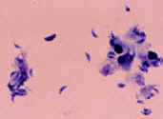
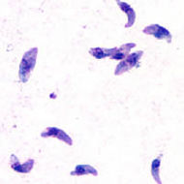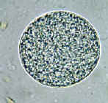
Toxoplasma gondii is a species of parasitic protozoa in the genus Toxoplasma. The definitive host of T. gondii is the cat, but the parasite can be carried by all known mammals. Toxoplasmosis, the disease of which T. gondii is the causative agent, is usually minor and self-limiting but can have serious or even fatal effects on a fetus whose mother first contracts the disease during pregnancy or on an immunocompromised human or cat.
Prevention of toxoplasmosis during pregnancy involves avoiding eating undercooked or cured meat, thoroughly washing fruit and vegetables before eating, and avoiding soil contact. Gardeners are usually advised to wear protective rubber gloves and wash hands thoroughly afterwards. Avoidance of cats is commonly recommended to uninfected pregnant women, but the contribution of this risk factor is controversial Some studies have identified cat ownership or contact as a minor source of risk, while several other major studies have failed to identify exposure to cats as a significant risk factor for Toxoplasma infection.
Toxoplasmosis is a parasitic disease caused by the protozoan Toxoplasma gondii , The parasite infects most genera of warm-blooded animals, including humans, but the primary host is the felid (cat) family. Animals are infected by eating infected meat, by ingestion of feces of a cat that has itself recently been infected, or by transmission from mother to fetus. Cats have been shown as a major reservoir of this infection. After the first few weeks of infection have passed, the parasite rarely causes any symptoms in otherwise healthy adults The parasite can cause encephalitis (inflammation of the brain) and neurologic diseases and can affect the heart, liver, and eyes (chorioretinitis).
Life cycle
A sexual multiplication by cell division can occur in virtually any host cell.
The life cycle of T. gondii has two phases. The sexual part of the life cycle takes place only in members of the domestic and wild cats, which makes these animals the parasite's primary host. The asexual part of the life cycle can take place in any warm-blooded animal, like other mammals and birds.
In the intermediate hosts (as well the definitive host), the parasite invades cells, forming intracellular so-called parasitophorous vacuoles containing bradyzoites, the slowly replicating form of the parasite. Vacuoles form tissue cysts mainly within the muscles and brain. Since they are within cells, the host's immune system does not detect these cysts. Resistance to antibiotics varies, but the cysts are very difficult to eradicate entirely. Within these vacuoles T. gondii propagates by a endodyogeny until the infected cell eventually bursts and tachyzoites are released. Tachyzoites are the motile, asexually reproducing form of the parasite. Unlike the bradyzoites, the free tachyzoites are usually efficiently cleared by the host's immune response, although some manage to infect cells and form bradyzoites, thus maintaining the infection.
Tissue cysts are ingested by a cat (e.g., by feeding on an infected mouse). The cysts survive passage through the stomach of the cat and the parasites infect epithelial cells of the small intestine where they undergo sexual reproduction and oocyst formation. Oocysts are shed with the feces. Animals and humans that ingest oocysts (e.g., by eating unwashed vegetables etc.) or tissue cysts in improperly cooked meat become infected. The parasite enters macrophages in the intestinal lining and is distributed via the blood stream throughout the body.
If infection with T. gondii occurs for the first time during pregnancy, the parasite can cross the placenta, possibly leading to hydrocephalus or microcephaly, intracranial calcification, and chorioretinitis, with the possibility of spontaneous abortion (miscarriage) or intrauterine death.
Symptoms
Infection has two stages:
Acute toxoplasmosis During acute toxoplasmosis, symptoms are often influenza-like: swollen lymph nodes, or muscle aches and pains that last for a month or more. Rarely, a patient with a fully functioning immune system may develop eye damage or nasal lesions from toxoplasmosis. Only a small percentage of infected newborn babies have serious eye and brain damage or nasal malformations at birth.
Latent toxoplasmosis Most patients who become infected with Toxoplasma gondii and develop toxoplasmosis do not know it. In most immunocompetent patients, the infection enters a latent phase, during which only bradyzoites are present, forming cysts in nervous and muscle tissue. Most infants who are infected while in the womb have no symptoms at birth but may develop symptoms later in life.
Transmission
by : 1- Ingestion of contaminated cat [feces]., Transplacental infection in utero , Ingestion of raw or partly cooked meat, Drinking water contaminated with Toxoplasma.
Toxoplasma-specific IgG antibodies, indicating that they had been infected with the organism. Receiving an infected organ transplant or blood transfusion
2-Ingestion of raw or partly cooked meat, especially pork, lamb, or venison containing Toxoplasma cysts. Infection prevalence in countries where undercooked meat is traditionally eaten has been related to this transmission method. Oocysts may also be ingested during hand-to-mouth contact after handling undercooked meat, or from using knives, utensils, or cutting boards contaminated by raw meat.
3- Drinking water contaminated with Toxoplasma.
Two risk factors for contracting toxoplasmosis are:
Infants born to mothers who became infected with Toxoplasma for the first time during or just before pregnancy
Persons with severely weakened immune systems, such as those with AIDS. Illness may result from an acute Toxoplasma infection or reactivation of an infection that occurred earlier in life.
Diagnosis Detection of Toxoplasma gondii in human blood samples may be achieved by using the polymerase chain reaction (PCR), serology, biopsy of brain, blood smear.

Protection
In healthy individuals who are not pregnant, a severe case of toxoplasmosis is treated with antibiotics, and chances of recovery are good. Many people suffer infections without ever knowing they have done so and proceed to lead their lives in safe immunity. Precautionary measures are still a good idea. Avoiding cats is not specifically recommended these days. The likely period in which a cat might prove infectious is so brief as to be statistically irrelevant. Of greater concern is exposure to feces, sanitary habits in food handling and care to cook meats thoroughly. Clean cat pans well and often and sterilize them with boiling water. Prevent cats from preying on wildlife: Prey is the primary source of infection. Do not feed cats raw meat--many domestic animals pick up oocysts when grazing on the soil or eating prepared fodders. Wash hands often, and don't handle soil barehanded. Wash hands carefully after gardening. Keep rodent populations down to ensure that cats (yours and other people's) are not offered an extra "snack."
2- Plasmodium
Plasmodium is a genus of parasitic protozoa. Infection with these parasites is known to cause malaria. Malarial parasite trophozoites are generally ring shaped, 1-2 microns in size, although other forms (ameboid and band) may also exist. The sexual forms of the parasite (gametocytes) are much larger and 7-14 microns in size. P. falciparum is the largest and is banana shaped while others are smaller and round. P. vivax causes stippling of infected red cells.
The species: - Plasmodium malariae, Plasmodium ovale, Plasmodium falciparum and Plasmodium vivax .
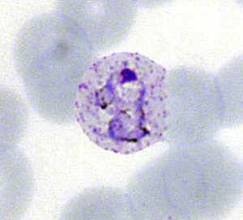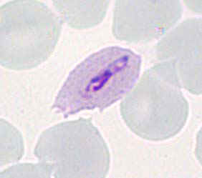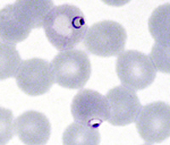
Plasmodium vivax ,Plasmodium ovale, Plasmodium falciparum
Life cycleThe incubation period for the infection usually change depended on the species, Malarial parasites are transmitted by the infected female anopheline mosquito which injects sporozoites present in the saliva of the insect . Sporozoites infect the liver parenchymal cells where they may remain dormant (hypnozoites) or undergo stages of schizogony to produce schizonts and merogony to produce merozoites (meronts). When parenchymal cells rupture, thousands of meronts are released into blood and infect the red cells. P. ovale and P. vivax infect immature red blood cells whereas P. malariae infects mature red cells. P. falciparum infects both. In red cells, the parasites mature into trophozoites. These trophozoites undergo schizogony and merogony in red cells which ultimately burst and release daughter merozoites. Some of the merozoites transform into male and female gametocytes while others enter red cells to continue the erythrocytic cycle. The gametocytes are ingested by the female mosquito, the female gametocyte transforms into ookinete, is fertilized, and forms an oocyst in the gut. The oocyte produces sporozoites (sporogony) which migrate to the salivary gland and are ready to infect another host. The liver (extraerythrocytic) cycle takes 5-15 days whereas the erythrocytic cycle takes 48 hours or 72 hours (P. malariae). Malaria can be transmitted by transfusion and transplacentally.
Human Infection
The infection takes place in human when an infected female anopheles mosquito sucks blood from a healthy person. During feeding, mosquito injects saliva to prevent clotting of blood and along with the saliva, thousands of Sporozoites are inoculated into human blood and reproduce asexually giving rise to thousands of merozoites(Plasmodium daughter cells) in the circulatory system including liver.
Liver Stage
The sporozoite enters a hepatocyte and begins its exoerythrocytic schizogony stage. This is characterized by multiple rounds of nuclear division without cellular segmentation. After a certain number of nuclear divisions, the parasite cell will segment and merozoites are formed.
There are situations where some of the sporozoites do not immediately start to grow and divide after entering the hepatocyte, but remain in a dormant, hypnozoite stage for weeks or months. The duration of latency is variable from one hypnozoite to another and the factors that will eventually trigger growth are not known; this explains how a single infection can be responsible for a series of waves of parasitaemia or "relapses".
Erythrocytic Cycle
Plasmodium preferentially penetrates young red blood cells (reticulocytes). In order to achieve this, merozoites have two proteins at their apical pole (PvRBP-1 and PvRBP-2). The parasite uses the Duffy blood group antigens (Fya and Fyb) as receptors to penetrate red blood cells.
The parasitised red blood cell is up to twice as large as a normal red cell and Schüffner's stippling (also known as Schüffner's dots or Schüffner's granules) is seen on the infected cell's surface, the spotted appearance of which varies in color from light pink, to red, to red-yellow, as coloured with Romanovsky stains. The parasite within it is often wildly irregular in shape (described as "amoeboid"). It is rare to see cells with more than one parasite within them. Merozoites will only attach to immature blood cell (reticulocytes) and therefore it is unusual to see more than 3% of all circulating erythrocytes parasitised.
Sexual Stage
The sexual stage includes following processes by which Plasmodium reproduces sexually:
  - Transfer to mosquito
  - Gametogenesis: a)Microgametes , b) Macrogametes
III) Fertilization IV) Ookinite V) Oocyst VI) Sporogony
In the mosquito's midgut, the gametocytes develop into gametes and fertilize each other, forming motile zygotes called ookinetes. The ookinetes penetrate and escape the midgut, then embed themselves onto the exterior of the gut membrane. Here they divide many times to produce large numbers of tiny elongated sporozoites. These sporozoites migrate to the salivary glands of the mosquito where they are injected into the blood and subcutaneous tissue of the next host the mosquito bites. The majority appear to be injected into the subcutaneous tissue from which they migrate into the capillaries. A proportion are ingested by macrophages and still others are taken up by the lymphatic system where they are presumably destroyed. The sporozoites which successfully enter the blood stream move to the liver where they begin the cycle again.
Transferring to a new host or in times of stress, sexual reproduction is generally superior as this produces a shuffling of genes which on average at a population level will produce individuals better adapted to the new environment.
Symptoms The symptomatology of malaria depends on the parasitemia, the presence of the organism in different organs and the parasite burden. The incubation period varies generally between 10-30 days. As the parasite load becomes significant, the patient develops headache, lassitude, vague pains in the bones and joints, chilly sensations and fever. As the disease progresses, the chills and fever become more prominent. The chill and fever follow a cyclic pattern (paroxysm) with the symptomatic period lasting 8-12 hours. In between the symptomatic periods, there is a period of relative normalcy, the duration of which depends upon the species of the infecting parasite. This interval is about 34-36 hours in the case of P. vivax and P. ovale (tertian malaria), and 58-60 hours in the case of P. malariae (quartan malaria). Classical tertian paroxysm is rarely seen in P. falciparum and persistent spiking or a daily paroxysm is more usual.
The malarial paroxysm is most dramatic and frightening. It begins with a chilly sensation that progresses to teeth chattering, overtly shaking chill and peripheral vasoconstriction resulting in cyanotic lips and nails (cold stage). This lasts for about an hour. At the end of this period, the body temperature begins to climb and reaches 103-106 degrees F (39- 41degrees C). Fever is associated with severe headache, nausea (vomiting) and convulsions. The patient experiences euphoria, and profuse perspiration and the temperature begins to drop. Within a few hours the patient feels exhausted but symptom-less and remains symptomatic until the next paroxysm. Each paroxysm is due to the rupture of infected erythrocytes and release of parasites.
Without treatment, all species of human malaria may ultimately result in spontaneous cure except with P. falciparum which becomes more severe progressively and results in death. This organism causes sequestration of capillary vasculature in the brain, gastrointestinal and renal tissues. Chronic malaria results in splenomegaly, hepatomegaly and nephritic syndromes.
Pathology and immunology
Symptoms of malaria are due to the release of massive number of merozoites into the circulation. Infection results in the production of antibodies which are effective in containing the parasite load. These antibodies are against merozoites and schizonts. The infection also results in the activation of the reticuloendothelial system (phagocytes). The activated macrophages help in the destruction of infected (modified) erythrocytes and antibody-coated merozoites. Cell mediated immunity also may develop and help in the elimination of infected erythrocytes. Malarial infection is associated with immunosuppression.
Diagnosis
Diagnosis is based on symptoms and detection of parasite in Giemsa stained blood smears. There are also antibody tests .
Treatment and Control
Treatment is effective with various quinine derivatives (quinine sulphate, chloroquine, meflaquine and primaquine, etc.). Drug resistance, particularly in P. falciparum and to some extent in P. vivax is a major problem. Control measures are eradication of infected anopheline mosquitos. Vaccines are being developed and tried but none is available yet for routine use
Definitions
Erythrocytic schizont: multinucleated stage in a RBC resulting from asexual multiplication of trophozoite. Each schizont contains a species determined number of meroziotes.
Hepatic schizont The actively dividing, multinucleated, parasite form in hepatocytes; produces no inflammatory response.
Trophozoite: Metabolically active form of the malaria parasite living within the RBC; sometimes called the ring form.
Merozoite: the name given to infective schizont components (see within the schizonts above) that break out of RBC or hepatocyte and then adhere to and penetrate a new RBC.
Gametocyte: morphologically distinctive sexual (male or female) form of the parasite which develops from some trophozoites in RBCs. It is infective to mosquito.
Sporozoite: the morphological form which develops in the mosquito salivary gland and is injected when the mosquito feeds, infecting humans.
Exoerythrocytic cycle: (hepatic cycle) asexual reproduction within hepatocytes producing schizonts, which break out of the hepatocytes and invade other hepatocytes; occurs as a complete cycle only in P. vivax and P. ovale.
Intraerythrocytic cycle: (erythrocytic cycle) asexual reproduction within RBC's. Involves trophozoite to schizont, rupture of schizont, release of merozoites, invasion of new RBC, and production of new trophozoite.
Diagnosis - Laboratory - thin, thick smears, antigen capture EIA, PCR etc.
- Clinical - platelets, regularly intermittent fever
Prevention and control
- Removing breeding sites, larvacides, insecticides
- Chemoprophylaxis
- Avoidance (nets, clothing)

Diagnostic characteristics of the genus Plasmodium
- Merogony occurs both in erythrocytes and other tissues
- Merozoites, schizonts or gametocytes can be seen within erythrocytes and may displace the host nucleus
- Merozoites have a “signet-ring” appearance due to a large vacuole that forces the parasite’s nucleus to one pole
- Schizonts are round to oval inclusions that contain the deeply staining merozoites
- Forms gamonts in erythrocytes
- Gametocytes are 'halter-shaped' similar to Haemoproteus but the pigment granules are more confined
- Hemozoin is present
- Vectors are either mosquitos or sandflies
- Vertebrate hosts include mammals, birds and reptiles

3-Cryptosporidium parvum

Cryptosporidium parvum is the parasitic protozoan that causes human cryptosporidiosis, as well as in certain animals, including domestic livestock.
In humans it causes abdominal pain, profuse diarrhoea, weight loss, loss of appetite and anorexia, but in otherwise healthy individuals the infection is usually self-limiting and resolves within a few weeks .
In immunocompromised patients the infection is more serious; it can become chronic and is sometimes fatal. There is no definitive cure for the disease.
These protozoa complete their life cycles in a single host, and their oocysts are highly infectious. These oocysts are usually transmitted by contaminated water, fecal transmission from infected animals, person-to-person spread or contaminated food.
Water treatment plants cannot usually guarantee to remove all C. parvum from water because the oocysts are very small (4-5 micrometers in diameter) and are resistant to chlorine and other disinfectants.
At present, control of water supplies depends on limiting contamination of input water by animals, manure or sewage, and by careful maintenance of water treatment systems.
Cryptosporidium does not utilize an insect vector and is capable of completing its life cycle within a single host, resulting in cyst stages which are excreted in feces and are capable of transmission to a new host.
A number of Cryptosporidium infect mammals. In humans, the main causes of disease are C. parvum and C. hominis (previously C. parvum genotype 1). C. canis, C. felis, C. meleagridis, and C. muris can also cause disease in humans.
Cryptosporidiosis is typically an acute short-term infection but can become severe and non-resolving in children and immunocompromised individuals. In humans, it remains in the lower intestine and may remain for up to five weeks. The parasite is transmitted by environmentally hardy cysts (oocysts) that, once ingested, excyst in the small intestine and result in an infection of intestinal epithelial tissue.

Life cycle
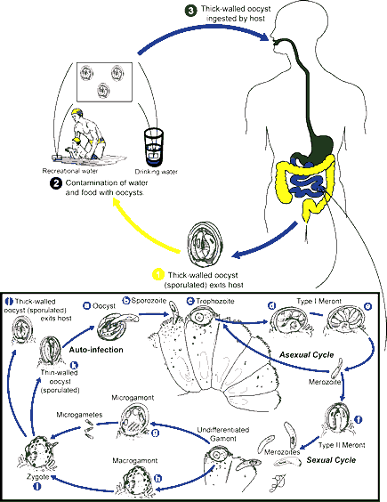

Crypto begins its life cycle as sporulated oocysts (1) which enter the environment through the feces of the infected host. There is some evidence that it can also be spread by respiratory secretions.
The infective oocysts reside in food and water (2). Most transmission occurs through recreational water use, such as in pools and lakes. Crypto has also entered drinking water supplies, causing major outbreaks in cities around the world. Oocysts are resistant to chlorine treatment, presenting a major water purification problem during outbreaks. They can also withstand freezing temperatures.
Infection occurs when the oocysts are ingested by a suitable host (3). While in the intestines, the oocyst releases sporozoites which invade the epithelial linings of the intestines or the lungs (depending on the method of transmission). Within these cells, the sporozoites undergo schizogony, or asexual reproduction. The sporozoites then enter a sexual reproductive stage. Female macrogamonts and male microgamonts develop, and fertilization occurs. The resulting zygote can develop into: a) a thick-walled oocyst that will exit the host, or b) a thin-walled oocyst which will autoinfect the host.
The infectious oocysts are passed through the feces (1). These oocysts enter the environment to await ingestion by the next host.
Note that there are several stages in the cryptosporidium life cycle where the parasite multiplies within the host: when the original sporozoites multiply asexually, when the merozoites continue asexual multiplication, and when oocysts mature quickly and excyst releasing more sporozoites. This is why a symptomatic cryptosporidium infection can develop after a person swallows just a handful of oocysts.
A person with cryptosporidiosis passes millions of infective Cryptosporidium parvum oocysts—it’s easy to see how even minimal contamination of a swimming pool or filtration problems at a water treatment facility can result in a cryptosporidium outbreak involving hundreds or even thousands of people. Large scale cryptosporidium outbreaks seem to be occurring more and more often.
Pathogenesis
Cryptosporidiosis, also known as crypto, is a parasitic disease caused by Cryptosporidium, a protozoan parasite in the phylum Apicomplexa. It affects the intestines of mammals and is typically an acute short-term infection. It is spread through the fecal-oral route, often through contaminated water;^{[1]} the main symptom is self-limiting diarrhea in people with intact immune systems. In immunocompromised individuals, such as AIDS patients, the symptoms are particularly severe and often fatal. Cryptosporidium is the organism most commonly isolated in HIV positive patients presenting with diarrhea. Treatment is symptomatic, with fluid rehydration, electrolyte correction and management of any pain. Despite not being identified until 1976, it is one of the most common waterborne diseases and is found worldwide. The parasite is transmitted by environmentally hardy cysts (oocysts) that, once ingested, exist in the small intestine and result in an infection of intestinal epithelial tissue.
The oocysts are ovoid or spherical and measure 5 to 6 micrometers across. When in flotation preparations they appear highly refractile. The oocysts contains up to 4 sporozoites that are bow-shaped.
As few as 10 to 100 oocysts can initiate an infection. The parasite is located in the brush border of the epithelial cells of the small intestine. They are mainly located in the jejunum. When the sporozoites attach the epithelial cells’ membrane envelops them. Thus, they are “intracellular but extracytoplasmic”. The parasite can cause damage to the microvilli where it attaches. The infected human excretes the most oocysts during the first week.^{[9]} Oocysts can be excreted for weeks after the diarrhea subsides.
The immune system reduces the formation of Type 1 merozoites as well as the number of thin-walled oocysts. This helps prevent autoinfection. B cells do not help with the initial response or the fight to eliminate the parasite.
Symptoms appear from two to ten days after infection, with an average of 7 days , and last for up to two weeks, or in some cases, up to one month. There are 3 possible forms of the illness in immunocompetent people. The disease can be asymptomatic or cause acute diarrhea or persistent diarrhea that can last for a few weeks. Diarrhea is usually watery with mucus. It is very rare to find blood or leukocytes in the diarrhea . As well as watery diarrhea, there is often stomach pains or cramps and a low fever. Other symptoms include nausea, vomiting.
malabsorption and dehydration. Anorexia can occur, as can weight loss. The individuals who are asymptomatic (have no symptoms) are nevertheless infective, and thus can pass on the infection to others. Even after symptoms have finally subsided an individual is still infective for some weeks.
Severe diseases, including pancreatitis, can occur
Immunocompromised people, as well as very young or very old people, can develop a more severe form of cryptosporidiosis. ^{[11]} There are 4 clinical presentations for patients with AIDS. 4% have no symptoms, 29% have a transient infection, 60% have chronic diarrhea, and 8% have a severe, cholera-like infection. With transient infections diarrhea ends within 2 months and Cryptosporidium is no longer found in the feces. Chronic diarrhea is diarrhea that lasts for 2 or more months. The most severe form results in the patients excreting at least 2 liters of watery diarrhea per day. They can lose up to 25 liters per day. AIDS patients can have up to 10 stools per day. They experience severe malabsorption and can have 10% weight loss. Many of them never completely eliminate Cryptosporidium from their bodies. When Cryptosporidium spreads beyond the intestine, as it can predominantly in patients with AIDS, it can reach the lungs, middle ear, pancreas, and stomach. Thus, one symptom is pain in the right upper quadrant. The parasite can infect the biliary tract, causing biliary cryptosporidiosis. This can result in cholecystitis and cholangitis.
Transmission
Infection is through contaminated material such as earth, water, uncooked or cross-contaminated food that has been in contact with the feces of an infected individual or animal. Contact must then be transferred to the mouth and swallowed. It is especially prevalent amongst those in regular contact with bodies of fresh water including recreational water such as swimming pools. Other potential sources include insufficiently treated water supplies, contaminated food, or exposure to feces. The high resistance of Cryptosporidium oocysts to disinfectants such as chlorine bleach enables them to survive for long periods and still remain infective. Some outbreaks have happened in day care related to diaper changes.
Diagnostic tests
There are many diagnostic tests for Cryptosporidium. They include microscopy, staining, and detection of antibodies. Microscopy can help identify oocysts in fecal matter. To increase the chance of finding the oocysts the diagnostician should inspect at least 3 stool samples. There are several techniques to concentrate either the stool sample or the oocysts. The modified formalin-ethyl acetate (FEA) concentration method concentrates the stool. Both the modified zinc sulfate centrifugal flotation technique and the Sheather’s sugar flotation procedure can concentrate the oocysts by causing them to float. Another form of microscopy is fluorescent microscopy done by staining with auramine.
Other staining techniques include acid-fast staining, which will stain the oocysts red. One type of acid-fast stain is the Kinyoun technique. Giemsa staining can also be performed. Part of the small intestine can be stained with hematoxylin and eosin (H & E), which will show oocysts attached to the epithelial cells
Detecting antigens is yet another way to diagnose the disease. This can be done with direct fluorescent antibody (DFA). It can also be achieved through indirect immunofluorescence assay.^{[14]} Enzyme-Linked ImmunoSorbent Assay (ELISA) also detects antigens.
Polymerase chain reaction (PCR) is another way to diagnose cryptosporidiosis. It can even identify the specific species of Cryptosporidium. If the patient is thought to have biliary
cryptosporidiosis then an appropriate diagnostic technique is ultrasonography. If that returns normal results the next step would be to perform endoscopic retrograde cholangiopancreatography.

