
الجامعة المستنصرية

كلية العلوم

قسم علوم الحياة

المرحلة الثالثة

الطفيليات النظري
Medical parasitology

د. سبأ طاهر &د شذى خضير

للعام الدراسي
2016.2017
يطلب من
Hassanein Library مكتبة حسنين

مع التمنيات
بالأستفادة من المادة العلمية

Parasitology

Introduction to Parasitology:

Definitions:-

1. Parasite: - is an organism that obtains food and shelter from another organism and derives all benefits from this association

2. Parasitology :- the science or study of host-parasite relationships.

3. Medical parasitology: - study of parasites which infect humans.

4.Vector: - “carrier” of a parasite from one host to another. Often an insect.

5. Host: - the partner providing food and/or protection. Some parasites require more than one host to complete their life cycle; or may not require a host during some stage(s).

-Types of host:

- definitive host: - the host in which sexual maturity and reproduction takes place. Man is usually a definitive host.

b. intermediate host :- the host in which the parasite undergoes essential development. More than one intermediate host may be required by some parasites. Man sometimes serves as an intermediate host (malaria).

c-Reservoir (carrier) host: - the host harboring a parasite in nature, serving as a source of infection for other susceptible hosts. Reservoir hosts show no sign or symptom of disease.
d-Natural host: – a host that is naturally infected with certain species of parasite.
e- Accidental host: – a host that is under normal circumstances not infected with the
parasite.

Symbiosis: - “living together,” a close association between two organisms.

This relationship may be characterized as:-

a. mutualism: - both organisms are benefited (bacteria in bowel)

b. commensalism: - “eating at the same table”; one organism is benefited, the other is unaffected.

- Parasitism: - one organism is benefited at the expense of another (host).

DIFFERENT KINDS OF PARASITES:-

Ectoparasite :– a parasitic organism that lives on the outer surface of its host, e.g.
lice, ticks, mites etc.
• Endoparasites: – parasites that live inside the body of their host, e.g. Entamoeba
histolytica.
• Obligate Parasite: - This parasite is completely dependent on the host during a
segment or all of its life cycle, e.g. Plasmodium spp.

• Facultative parasite :– an organism that exhibits both parasitic and non-parasitic

modes of living and hence does not absolutely depend on the parasitic way of
life, but is capable of adapting to it if placed on a host. E.g. Naegleria fowleri
• Accidental parasite : when a parasite attacks an unnatural host and survives. E.g.
Hymenolepis diminuta (rat tapeworm).
• Erratic parasite :is one that wanders in to an organ in which it is not usually found.
E.g. Entamoeba histolytica in the liver or lung of humans.

Effects of the parasite on the host:

A- direct effects

- Mechanical injury: skin -» hair» bladder» intestine.
-  Feeds on host cells and tissues:»Epithelial cells & R.B.C
-  Deprive the host essential substances:»Iron
4- Toxic effect:» nervous system
- Allergic effect:» rash
- Obstruction of vital organs:» portal system» intestinal obstruction
- Mechanical pressure on vital organs :» liver» lungs
7- Abortion
8-Blindness
B-Indirect effects:»Mental & physical growth»Secondary infection»Effect on productivity

SOURCES OF PARASITIC INFECTIONS

1. filth-borne or contaminative: - serious where personal hygiene and community sanitation lacking. Cysts or eggs remain infective for long periods in contaminated soil.

2. soil or water-borne :- difficult to control. Children eat dirt which can contain eggs, etc.; certain larvae can penetrate skin of bare feet or enter skin in infested water. Education & sanitary control of waste is best means of prevention.

3. food-borne :- inadequately cooked beef, pork, fish, shell fish & some vegetables can be sources of infection.

4. arthropod-borne: - the most difficult of all to control; often produces diseases that are fatal. More commonly found in moist tropical areas of world. Mosquitoes transmit malaria, etc.

Methods or mode of infection

1-Mouth

2-Skin (Touch, Penetration).

3-Inhalation of contaminate dust

4-Placental.

5-Vaginal or Anal.

6-Blood.

Types of specimens which can be examined for diagnosis of parasites: -

      - "Natural secretions" - feces, sputum, and urine are used to detect lumen dwelling parasites of GI, pulmonary and genitourinary tracts.

      - Blood is usual specimen for detection of blood and tissue parasites, along with tissue biopsies, aspirates, etc.

Specimen Collection

    - Collect in a clean container - without urine or water (these may be damaging to trophozoites. The entire passage is desirable (this allows for a thorough macroscopic examination).

    - Minimum number of specimens - due to irregular shedding patterns of parasites, a series of three normally passed specimens is preferred.

    - Time frame of collection - Collect on alternate days. Never on same day.

    - Use of laxatives is not permitted - these can mask infection or damage organisms.

    - Exact date and time of collection - important, required information.

    - Proper performance of diagnostic testing is critical - no shortcuts! Follow the procedure, do not modify it for convenience.

Techniques of Stool Examination:

A. Gross examination.
B. Direct Wet Mounts (fresh or formalin preserved specimens).
C. Stained Wet Mounts.
D. Concentration Techniques.
C. Identification by Molecular Methods.
E. In Vitro Cultivation of Parasites - primarily used for blood & tissue protozoa. Can culture intestinal protozoa, but not generally done.
F. Animal Inoculation.

Use of Other Specimens:

A. Anal Swabs / Scotch Tape Preparation for Enterobius vermicularis - must be collected in the morning prior to bathing or bowel movement.

B. Genital Specimens for Trichomonas vaginalis - vaginal, urethral, prostatic exudates are examined via wet mounts, looking for motile organisms.

C. Urine Specimens - T. vaginalis .
D. Sputum Specimens.
E. Aspirates and Biopsies.
G. Abscess aspirates - usually for extra-intestinal amoebiasis - wall of abscess is best area to examine.

    - Procedures for Detecting Blood Parasites:

  - Collection of Blood Samples

  - Examination of Blood Samples

- Wet Mounts - screening for motile organisms (trypanosomes & filariae)

    - Permanent Stained Smears

a. Stains used -
        - Wright's - alcohol based.

        - Giemsa - water based, preferred stain, all things considered.

      - Thick Blood Films

1) Used in the identification of malaria parasites, trypanosomes, and microfilariae.
.
      - Thin Blood Films

1) Used in the identification of malaria parasites, trypanosomes, and microfilariae.

Concentration Techniques - Thick Blood smears; fractional

The Intestinal Protozoa

Introduction

The Phylum Protozoa is classified into four major subdivisions according to the methods of locomotion and reproduction.

a-The amoebae (Superclass Sarcodina, Class Rhizopodea: move by means of pseudopodia and reproduce exclusively by asexual binary division.
b-The flagellates (Superclass Mastigophora, Class Zoomasitgophorea) typically move by long, whiplike flagella and reproduce by binary fission.

c-The ciliates (Subphylum Ciliophora, Class Ciliata) are propelled by rows of cilia that beat with a synchronized wavelike motion.

d-The sporozoans (Subphylum Sporozoa)lack specialized organelles of motility but have a unique type of life cycle, alternating between sexual and asexual reproductive cycles (alternation of generations).

Number of species - there are about 45,000 protozoan species; around 8000 are parasitic, and around 25 species are important to humans.

    - Diagnosis - must learn to differentiate between the harmless and the medically important. This is most often based upon the morphology of respective organisms.

    - Transmission - mostly person-to-person, via fecal-oral route; fecally contaminated food or water important (organisms remain viable for around 30 days in cool moist environment with few bacteria; other means of transmission include sexual, insects, animals (zoonoses).

- Structures

    - trophozoite - the motile vegetative stage; multiplies via binary fission; colonizes host.
    - cyst - the inactive, non-motile, infective stage; survives the environment due to the presence of a cyst wall.
    - diagnostic features

      - size - helpful in identifying organisms; must have calibrated objectives on the microscope in order to measure accurately.

      - type of motility - directional or non-directional; sluggish or fast.

      - cytoplasmic inclusions - chromatoid bars (coalesced RNA); red blood cells; food vacuoles containing bacteria, yeast, etc.

      - appearance of cytoplasm - smooth & clean or vacuolated.

      - nuclear structure - important in the identification of organisms and species differentiation.
f- endosome - also called the “karyosome,” this is a mass of chromatin within nucleus. The size, shape, and location of this structure are helpful in identification of organisms.

g -chromatin - nuclear DNA

h-chromatoid body or “bar” - coalesced RNA within the cytoplasm in the cyst stage. This is not always present, but when it is, its size and shape are helpful in determining species identification.

- Class: Lobosea - The Amoebae

  - Life cycle -

    - The definitive host ingests the infective cyst stage from fecal contamination in environment.
    - The cyst passes into the small intestine & excystation occurs with transformation to the trophozoite stage.
    - Trophozoites in the large intestine colonize the host by multiplying asexually via binary fission. They can remain in the lumen or invade the wall of the intestine (pathogenic species only) & multiply, from here they can be transported via the circulation to other organs (liver, lungs, etc.).
    - Cysts and trophozoites are passed in the feces of the infected host.

    - Infective stage - the mature cyst.
    - Diagnostic stage - the trophozoite or cyst in stool or tissue specimens.

- Genus Entamoeba

- contains the most important of the amoebae causing disease in humans.

    - Entamoeba histolytica

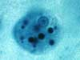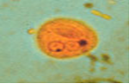
Entamoeba histolytica trophozoite
with ingested red blood cells

      - Epidemiology:- Occurs worldwide; the highest incidence and prevalence is found in areas with poor sanitation where as many as 80% of a population may be infected. Highest in children >5 years of age; more prevalent in males than in females; common in mental hospitals, prisons, orphanages.

      - Pathology and Clinical Manifestations:- the most pathogenic of all; causes amoebic dysentery; can become extra-intestinal (liver, lungs, etc.; can be fatal.
      - Morphology & Laboratory Identification .
the trophozoite: ranges between 12 and 30 microns in diameter. Its nucleus has an even distribution of peripheral chromatin and a small, compact, centrally located karyosome. The cytoplasm is typically smooth and granular with inclusions, if present, containing red blood cells.

The cyst ranges between 10 and 30 microns in diameter and contains four nuclei when mature. Cigar-shaped chromatoid bars may be present in some cysts.

      - Treatment - depends upon location of infection (lumen vs. tissue)

      - Distribution - worldwide, mostly in tropics and sub-tropics.
      - Note - chronic infections may last for years; they are often confused with other conditions (colitis, cancer). Hepatic abscess is the most common and dangerous complication.
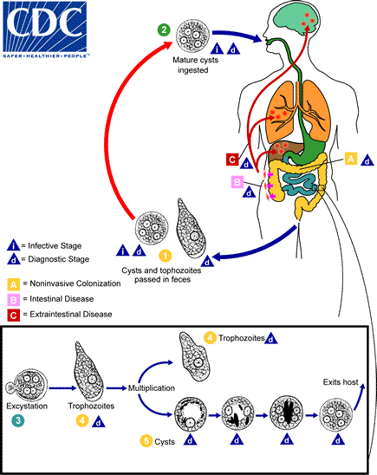

Cysts and trophozoites are passed in feces . Cysts are typically found in formed stool, whereas trophozoites are typically found in diarrheal stool. Infection by Entamoeba histolytica occurs by ingestion of mature cysts in fecally contaminated food, water, or hands. Excystation occurs in the small intestine and trophozoites are released, which migrate to the large intestine. The trophozoites multiply by binary fission and produce cysts , and both stages are passed in the fec

    - Entamoeba hartmanni
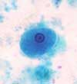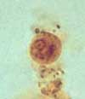
Entamoeba hartmanni rophozoitet
Entamoeba hartmanni cyst (iodine stain)

Formerly called the “small race” of Entamoeba histolytica.
Technologists must be able to differentiate this organism from E. histolytica because E. hartmanni is non-pathogenic.

Morphology & Laboratory Identification –
this organism is very similar to E. histolytica. The difference lies in the respective sizes of the organisms.
Trophozoites of Entamoeba hartmanni will measure less than 12 microns, while cysts will measure less than 10 microns. It is strongly recommended that more than one organism be measured when determining size.

3-Entamoeba coli

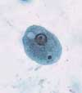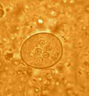
E. coli cyst (iodine)
Entamoeba coli trophozoite

Morphology :-
Trophozoites:- range from 10 to 35 microns in diameter the nucleus exhibits an eccentric karyosome with irregular, coarse chromatin. The cytoplasm is heavily vacuolated, containing yeast, bacteria, and debris.;
cysts :-range from 10 to 30 microns in diameter and contain 8 to 16 nuclei when mature;

Significance :- this is a harmless commensal but must be differentiated from the pathogens.

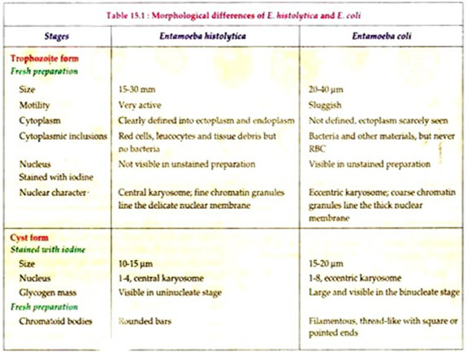

4-Endolimax nana:-

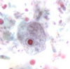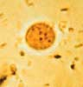
Endolimax nana trophozoite E. nana cyst (iodine)

Occurrence: - occurs in about 14% of the US population; 21% worldwide.
Pathogenicity: - none.

Morphology: –

Trophozoites: range from 5 to 10 microns in diameter. The nucleus contains a large, blot-like karyosome and has little or no peripheral chromatin.
Cysts: are usually Spherical or oval in shape, mature cyst contain 4 nuclei measuring 4 to 6 by 6 to 10 microns.
Diagnosis: by demonstrate troph. or cyst stage in stool specimen.

6-Iodamoeba butschlii:-
Iodamoeba butschlii trophozoite I. Butschlii cyst

It is cosmopolitan amoeba, but it is less common than E. coli, it is non pathogenic commensal living in the lumen of large intestine. This amoeba has trophozoite and cyst stages

Pathogenicity: - none.

Morphology: –

Trophozoite:- small, sluggish, ectoplasm no well differentiated from endoplasm. The nucleus spherical, characterized by having central large karyosome surrounded by achromatic granules. There are 1 or 2 glycogen mass in cytoplasm.

The cyst:- is irregular in shape with single nucleus only, cyst contain well distinct glycogen mass which stain golden brown with iodine solution so this
amoeba called Iodamoeba. The nucleus has large compact eccentric karyosome and around this karyosome there are achromatic granules.

Life Cycles:-
Entamoeba coli, E. hartmanni, E. polecki, Endolimax nana, and Iodamoeba buetschlii

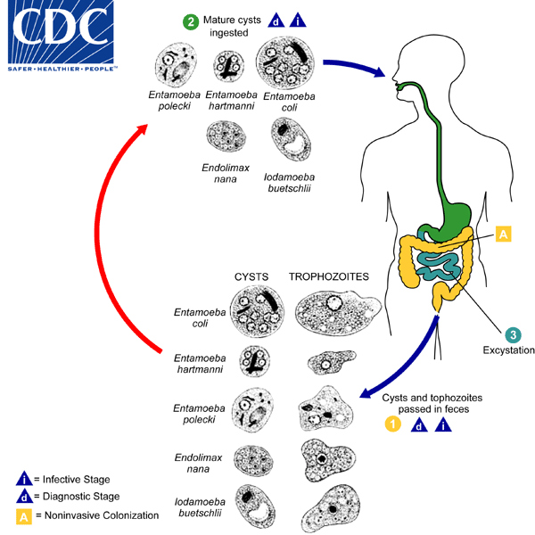
Entamoeba coli, E. hartmanni, , Endolimax nana, and Iodamoeba buetschlii are generally considered nonpathogenic and reside in the large intestine of the human host . Both cysts and trophozoites of these species are passed in stool and considered diagnostic . Cysts are typically found in formed stool, whereas trophozoites are typically found in diarrheal stool. Colonization of the nonpathogenic amebae occurs after ingestion of mature cysts in fecally-contaminated food, water, or fomites . Excystation occurs in the small intestine and trophozoites are released, which migrate to the large intestine. The trophozoites multiply by binary fission and produce cysts, and both stages are passed in the feces .

6-Entamoeba gingivalis

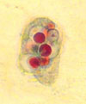
Entamoeba gingivalis trophozoite

Infective site: - in the mouth; the organism thrives in diseased gums, but is not considered a causal agent or pathogen. If swallowed, it is destroyed in stomach.

Transmission: - contact with fomites (drinking glasses, eating utensils, etc.; kissing.

Morphology: - resembles E. histolytica, but has no cyst stage. It is the only species, which ingests leucocytes. Ectoplasm is clear, well differentiated from granular endoplasm. Endoplasm contain many food vacuoles, some of them with diagnostic rounded dark – staining bodies represent the nuclei of ingested white blood cells and epithelia cells.
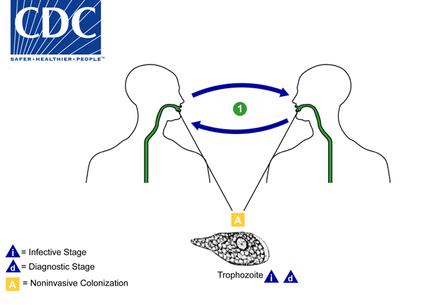
There is no known cyst stage for Entamoeba gingivalis; trophozoites live in the oral cavity of humans, residing in the gingival pockets near the base of the teeth . They are not considered pathogenic, and feed on bacteria and other debris. Trophozoites are transmitted person-to-person orally by kissing or fomites (such as eating utensils) .

7- Dientamoeba fragilis:-

It is only known in trophozoite stage, it lives in mucosal crypts of cecum and rectum. It was generally regarded as an amoeba, but it is placed with flagellates because it has some characters of Trichomonads. It is cosmopolitan parasite, but because of its small size, it might sometimes overlook in fresh Preparation.

It is only known in trophozoite stage, it lives in mucosal crypts of cecum and rectum.
Trophozoite is small, sluggishly motile, it has 2 nuclei, the nucleus characterized by having central karyosome consisting of 4 – 8 granules. The mode of transmission is unknown, possiblly may be achieved by direct or indirect contact with the trophozoite. Also it has been suggested that this amoeba may be transmitteda through the ova of certain helminthes.
Pathogenicity: In most persons it causes no harmful effects. Pathogenicity has been suspected when it has been the only organism identified in case of anorexia, abdominal pain and diarrhea.
Diagnosis: by demonstrate trophozoites in formed or diarrhic stool.

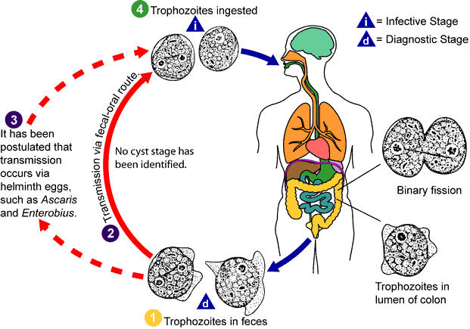

Free – Living Pathogenic amoebae:-

Some free-living amoebae (facultative) can cause serious even fatal disease if reach human body. These amoebae has found to have the ability to live in the tissues of mammals.
It can invade human nervous system, usually result in the death of the patient.
Naegleria fowleri (brain – eating amoeba):-
It causes primary amoebic meningoencephalitis (PAM) in humans. It is
cosmopolitan, mainly in North America, Western Europe, Africa, Japan andAustralia.The amoebae found in warm fresh water of ponds, lakes, pools and moist
soil.
Morphology: It is the only amoebae which is found in 3 forms; flagellate trophozoite, amoeboid trophozoite and cyst stages.
Amoeboid Trophozoite: It is the only form known to exist in humans. It ischaracterized by having single nucleus surrounded by halo and it move bypseudopodia. The pseudopodia form at different points along the cell, thusallowing the change direction,it contain contractile vacuole and food vacuoles .
In their free – living state, the trophozoite feed on bacteria, in tissues,
trophozoite phagocytize RBCs, white blood cells and destroyed tissues

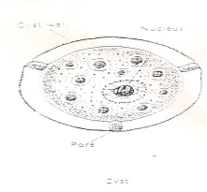Flagellate Trophozoite:- Pear shape biflagellated form, occurring when the amoeboid trophozoite exposed to a change in ionic concentration such as in distilled water. The transformation of amoeboid form to flagellated form occurs within few minutes.

Cyst Stage: Amoeboid trophozoite encyst due to unfavorable conditions e.g., crowding, desiccation and cold tempreture below 10oc. the cyst has thick cystic wall and there are pores in cystic wall, the nucleus is similar to amoeboid form

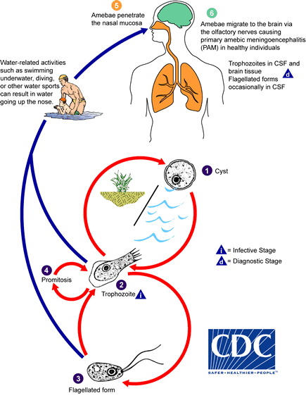

Naegleria fowleri has 3 stages in its life cycle: , cyst , trophozoite, and flagellate. The only infective stage of the ameba is the trophozoite. Trophozoites are 10-35 µm long with a granular appearance and a single nucleus. The trophozoites replicate by binary division during which the nuclear membrane remains intact (a process called promitosis) . Trophozoites infect humans or animals by penetrating the nasal tissue and migrating to the brain via the olfactory nerves causing primary amebic meningoencephalitis (PAM).
Pathogensis:-
Early in the infection the patient complains of upper respiratory tract symptoms e.g. raning nose, sore throat, fever and headache. Within 2 – 3 days the headache becomes more sever and there may be vomiting, stiff neck, mental confusion, coma as a result of intracranial pressure. Death usually with 10 days of the onset of symptoms.
Diagnosis:-
1- Direct demonstration of motile amoebae in unstained CSF or nasal discharge.
2- Stained smear of CSF.
3- Stained section of brain tissue at autopsy.
4- Culture on non-nutrient agar medium coated with E. coli bacteria.
5- Serological tests.
2-Acanthamoeba spp.

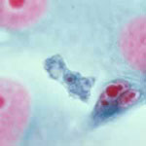
Acanthamoeba spp. Trophozoite

it is found in moist soil and in the air and water. It is found in only two form; the trophozoite and cyst, and either of these can be a source of infection.
Amoeboid trophozoite has spikey pseudopodia and a nucleus with large, central karyosome similar to the nucleus of Naegleria.

Life Cycle:-
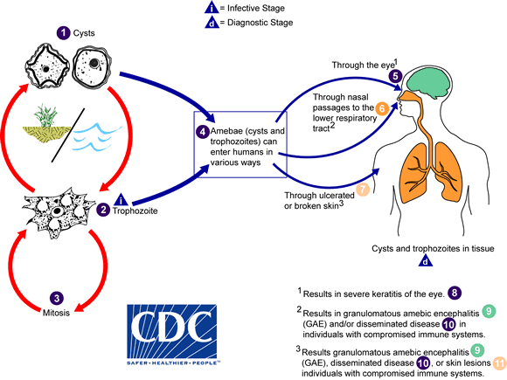
Acanthamoeba spp. have been found in soil; fresh, water; sewage; swimming pools; contact lens equipment;, Acanthamoeba has only two stages, cysts and trophozoites ,. The trophozoites replicate by mitosis (nuclear membrane does not remain intact). Entry can occur through the eye , the nasal passages to the lower respiratory tract , or ulcerated or broken skin . When Acanthamoeba spp. enters the eye it can cause severe keratitis in otherwise healthy individuals, particularly contact lens users .

Symptoms: - slow onset (10 or more days). Presents as chronic, granulomatous lesions in brain. In eye lesions, the infection resembles a herpes virus infection.

Diagnosis:
1- By finding amoebae in wet mounte (10% KOH) of corneal ulcer scraping or in stained smear.
2- By isolation of amoebae form contact lenses or washing solutions.

- Superclass Mastigophora
the flagellates; members of this group can inhabit mouth, bloodstream, tissues, gastrointestinal, or urogenital tracts.

Morphological Characteristics:-

    - Flagellum(ae) - characteristic organelle of locomotion. It is an extension of ectoplasm and resembles a tail; moves with a whip-like motion.

    - Axostyle - a supporting mechanism; a rod-shaped structure; not all Genera exhibit these.

    - Undulating membrane - a protoplasmic membrane with a flagellar rim extending out like a fin along the outer edge of the body of some flagellates. Moves in a wave-like motion.

    - Costa - a thin, firm rod-like structure running along the base of the undulating membrane in some flagellates.

    - Cytosome - a rudimentary mouth; also referred to as a gullet.
Note: Identification of a flagellate is based upon:-

    - Size
    - Shape
    - Motility
    - Number and morphology of nuclei
    - Number and location of flagellae
    - Location in the body of the host.

  - Intestinal flagellates:-

    - Giardia lamblia :- probably the first described protozoan pathogen of humans.

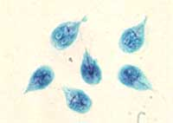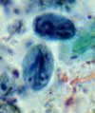
Giardia lamblia trophozoites G. lamblia cysts

Most common protozoan parasite in the U.S.A.

Morphology : - very distinctive. Dorsal-ventrally flattened, and Bi-laterally symmetrical.

Cyst: - Measures 9 x 12 micrometers and contain 2 to 4 nuclei; the karyosome is centrally located, with little or no peripheral chromatin; parabasal bodies are present.

Trophozoite : - Four pairs of flagella - one pair located anterior, two pair located ventral, and one pair located posterior. An axostyle and parabasal bodies are present. motility resembles a “falling leaf” uses “sucking discs” to adhere to intestinal wall; interferes with absorption of nutrients.
Life cycle : - man ingests cysts from fecally contaminated environment; the organism excysts in the upper intestine; trophozoites multiply and attach to the intestinal mucosa, sometimes entering secretory tubes, even the gall bladder. Trophozoites and cysts are passed in the feces.

G. intestinalis Lifecycle:-

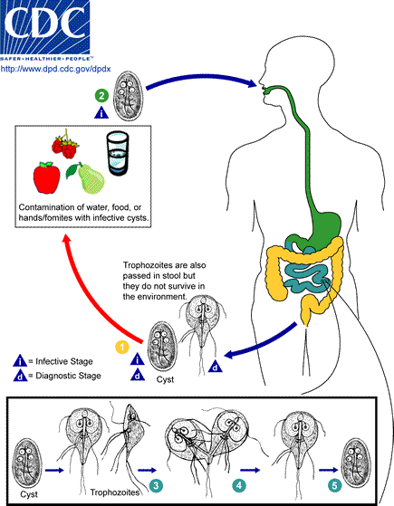

Diagnosis: - identification of cysts or trophozoites in stool specimens or duodenal contents. Irregular shedding pattern results in a “showering” of organisms at times, while being difficult to detect at other times.

Epidemiology: - prevalence 1 to 30%, depending upon the population surveyed; often occurs in epidemics, especially in children’s day care centers; can be transmitted in water. Cysts remain viable as long as 3 months when protected from direct sunlight and excess heat; resistant to chlorination.

Pathology and Clinical Manifestations: - symptoms can be severe; diarrhea, foul - smelling, greasy, mucus-laden stools, flatulence, nausea, cramps. Most infections are asymptomatic; chronic cases experience weight loss, malabsorption of fat, protein, folic acid, and fat-soluble vitamins.

- Chilomastix mesnili

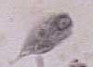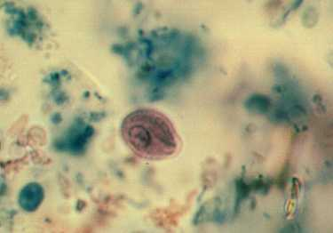
Chilomastix mesnili trophozoite C. mesnili cyst

Chilomastix mesnili is cosmopolitan in distribution although found more frequently in warm climates. It is thought to be non-pathogenic although the trophozoite has been associated with diarrhoeic stool. This is the largest flagellate found in man with an incidence of 1-10% being in the large intestine. Found in cecum and colon Transmission - by ingestion of mature cysts.
Morphology of the Trophozoite:-

The trophozoites of C. mesnili are pear shaped and measure 6-20m m in length. They have 1 large nucleus with a small karyosome and 3 flagella that extend from the nucleus at the anterior end of the parasite. A distinct oral groove or cytosome can be seen near the nucleus with its sides being supported by two filaments. They are known to move in a directional manner.

The cysts:- are 6-9m m, they have a large single nucleus with a large karyosome. They also have a prominent side knob giving it a characteristic lemon shape. The cytosome is evident with a curved shepherds crook fibril. It also has a characteristically coiled filament which when stained is darker in color.

Laboratory Diagnosis:-
The characteristic lemon shaped cysts can be seen in a formol-ether concentrate.

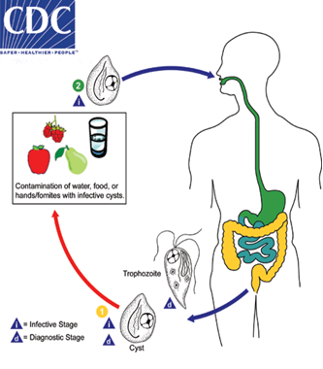

Life Cycle
The cyst stage is resistant to environmental pressures and is responsible for transmission of Chilomastix. Both cysts and trophozoites can be found in the feces (diagnostic stages) . Infection occurs by the ingestion of cysts in contaminated water, food, or by the fecal-oral route (hands or fomites) . In the large (and possibly small) intestine, excystation releases trophozoites. Chilomastix resides in the cecum and/or colon; it is generally considered a commensal whose contribution to pathogenesis is uncertain. Animals may serve as a reservoir for Chilomastix.

Clinical Presentation:-
Chilomastix mesnili is considered nonpathogenic. The presence of cysts and/or trophozoites in stool specimens can however be an indicator of fecal contamination of a food or water source, and thus does not rule-out other parasitic infections.

- The Trichomonads:-

a. Characteristics:

1) Undulating membrane - protoplasmic membrane with flagellar rim extending out like a fin along outer edge of body. Moves in a wave-like fashion.

- Flagella - several in a tuft, provides locomotion

- Axostyle - functions for support

- Costa - firm rod-like structure running along base of the undulating membrane.

- Cytostome - rudimentary mouth

1-Trichomonas vaginalis:-

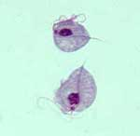
Trichomonas vaginalis trophozoites

Morphology: - exists only in trophozoite stage has an axostyle and short undulating membrane that extends less than half the body length; exhibits 4 flagellae, arranged in a tuft.

Mode of infection: - sexual or fomites.

Life cycle: - trophozoite lives in the vagina, urethra, epididymis, and prostate; multiplies via longitudinal fission; no cyst stage.

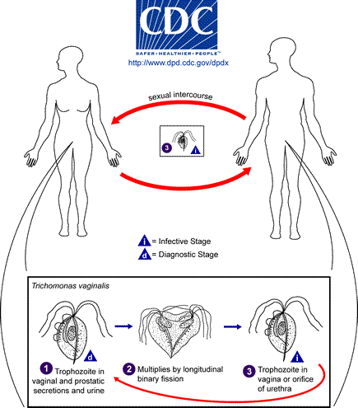

Pathology and Clinical Manifestations: –
females:- vaginal discharge; burning, Itching, or chafing. Frequency of urination or dysuria. Relationship between trichomoniasis & cervical cancer.
Males: frequently asymptomatic. If the prostate is involved, the patient may develop discharge, dysuria, and enlargement of prostate with tenderness. There are reports of infections (acquired during vaginal birth) of upper respiratory tract and conjunctiva of newborns from infected mothers.
Diagnosis - ID of trophs in body fluids - wet mounts of discharges or on PAP smears.

2. Trichomonas hominis: – a non-pathogen

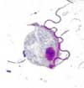
Trichomonas hominis trophozoite

1) Commensal - must differentiate from pathogens
2) Transmission - direct person-to-person fecal transmission.
3) No cyst stage
4) Must differentiate from T. vaginalis - in instances where feces is contaminated with urine.
5) Morphology - “arc-shaped” exhibiting a wobbly, jerky, yet progressive motility.

3.Trichomanas tenax – was first recovered from the mouth, specifically in tartar from the
teeth. There is no known cyst stage. The trophozoite has a pyriform shape and is
smaller and more slender than that of T.hominis. Diagnosis is based on the recovery of
the organism from the teeth, gums, or tonsillar crypts, and no therapy is indicated.

IV. Class Kinetofragminophora:- The Ciliate
1-Balantidium coli

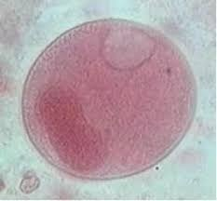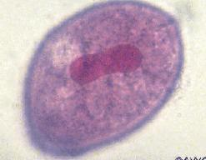
Balantidium coli cyst Balantidium coli trophozoite)

Morphology:-
Large, ovoid shape. Contains two nuclei, 1 large kidney shaped (macronucleus) & 1 small subspherical micronucleus adjacent to the macronucleus. Micronucleus is difficult to see, if seen at all.Body surface covered by spiral, longitudinal rows of cilia that provide rotary, boring motility.

Largest parasitic protozoan - the trophozoite is 30-120 x 25-125 microns; the cyst averages 50 - 70 microns in diameter.
Epidemiology:-

Rarely found in USA. This is the only ciliate parasite of humans. It is prevalent in tropical areas, or where poor sanitation, hygiene, and crowding occur. Increase numbers of infections are expected in those with close, continuing contact with swine.
Pathology & Symptoms:-

Many infections are asymptomatic, with organism feeding on bacteria at surface of mucosa.
Severe intestinal infections - with aid of hyaluronidase secretions, organism burrows into submucosa, producing ulcers like those of E. histolytica. Symptoms include dysentery, abdominal pain, nausea & vomiting, fever, headache.

Life cycle:- similar to that of E. histolytica.

The cyst is ingested via person-to-person transmission, or fecal contamination in environment.The cyst excysts in the small intestine.Trophozoites migrate to large intestine.

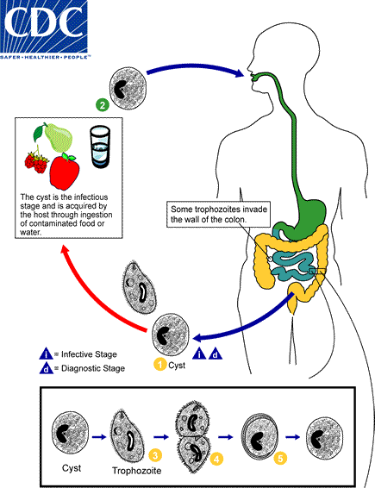
Diagnosis:-

Diagnosed by observing cysts & trophs in fecal samples. Cysts are easily missed – cysts stain very dark with iodine, so the structures used in identification (buccal cavity & macronucleus) are not always readily visible.

Disease names:-

Balantidiasis, balantidial dysentery

Primary animal reservoir - pigs; monkeys probably of secondary importance.

V. Intestinal Coccidia

Introduction:-

    - A number of species parasitize humans: Isospora, Sarcocystis, Cryptosporidium, & Toxoplasma
    - Have complex life cycles - most have 2-host life cycle.
    - Schizogony:- asexual binary fission.
    - Sporogony: - sexual reproduction

    - Diagnostic stages are often difficult to locate. They are easily overlooked due to their nearly transparent appearance. Permanently stained smears not helpful. Acid fast and giemsa stains are more often used. Oocysts do not stain with iodine.
- Sarcocystis:-
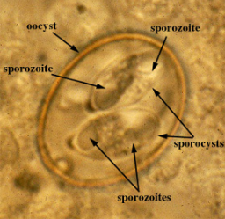

Sarcocystis spp. oocysts

Morphology: There are three distinct stages of this parasite :
1. Oocyst : contains a pair of sporocysts,the wall of oocysts rupture and the
sporocysts are passed in the feces of human .
2. Sporocyst : It is oval shaped ,each sprocyst contains four banana-shaped
sporozoites. Mature sporocysts are infective stage to other susceptible hosts.
3. Sarcocyst or Miescher's tube: This is spindle shaped structure with thick
striated wall ( are present in the bovine skeletal muscles), In the middle of the
Miescher's tube there are large numbers of merozoites called bradyzoites
,which are fusiform, elongated &cylindrical .The tube is divided into many
compartment by septa.While in the periphery ,there is usually a rounded fully
developed cells called metrocystes.

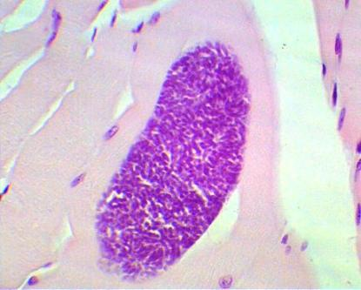
Sarcocyst in the bovine skeletal muscles
Pathology: - Sarcocystis bovihominis & S. suihominis are intestinal infections similar to Isospora belli. Sarcocystis lindemanni is the name given to the organism, which causes infection of the muscle.

Definitive host: - humans. Pig (sui-) and cow (bovi-) are intermediate hosts.

Infective stage: - ingestion of sarcocysts in meat (intestinal); ingestion of oocysts from animal feces (muscle).

Life cycle:-

Asexual reproduction:-. Sporozoites excyst from the sporocysts and invade the intestinal mucosa to reach endothelial cells. An asexual cycle begins, whereby initial reproduction forms schizonts.
Within the schizonts are merozoites, which are released and eventually find their way to muscle tissue, where they form sarcocysts. The merozoites divide into pairs within the tissues of the cyst, forming metrocytes. Metrocytes continue to undergo maturations, until finally forming mature, banana-shaped bradyzoites, which are slowly dividing, and also infective to definitive hosts.
When the muscle tissue containing sarcocysts with infective bradyzoites is consumed by the definitive host (a carnivore), the bradyzoites penetrate the mucosa and transform into macrogametes and micrgametocytes in the cells of the intestinal epithelium. The microgametocytes produce flagellated microgametes, which penetrate the macrogametes. The zygote lays down a resistant wall and sporulates endogenously.

Diagnostics
- Finding sporulated oocysts or sporocysts in fresh stool sample by flotation method (Intestinal Sarcocystosis)
- Excisional biopsy of area around muscle with most pain (Muscular Sarccystosis)
- Complete blood count to reveal eosinophilia
- PCR techniques to exclude Toxoplasma gondii infection

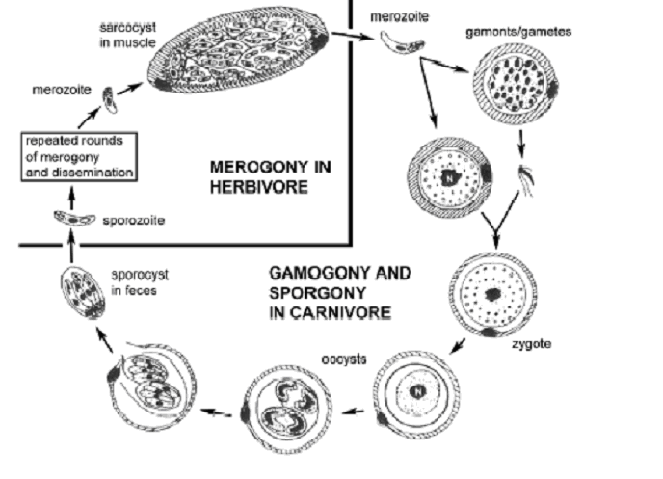

2-Isospora belli

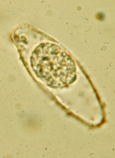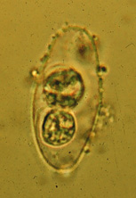

Isospora belli oocyst (mature) --- Isospora belli oocyst (immature)

Morphology:
The Isospora belli parasite is 30 micrometers long by 12 micrometers wide. Immature oocysts are ellipsoid or spindle shaped with tapered ends. An undivided mass of protoplasm exists inside the immature oocysts. This protoplasm divides to form two sporoblasts. The oocyst forms heavy cyst walls and the sporoblasts are now called sporocysts. These are 11 by 9 micrometers and within each sporocyst develop four curved, sausage shaped sporozoites. Throughout the oocyst’s development, the sporoblast and sporocysts are surrounded by a two-layered, colorless, smooth cell wall.

Definitive host: - humans.

Schizogony and sporogony:-

Schizogony:- takes place upon initial infection when sporozoites escaping from ingested oocysts invade the intestinal epithelium and multiply. The resulting schizont releases trophozoites which invade other epithelial cells, and so the infection progresses.

Sporogony:- sexual reproduction in which some of the progeny of asexual reproduction initiate development into gametes (male & female); microgametes migrate into lumen of bowel, and fertilize macrogametes within epithelial cells; fertilized macrogametes develop into oocysts which are passed as the infectious stage in the feces.

Diagnostic/infective stage:-

      - Immature oocysts - contain only one sporocyst, do not stain with iodine; measure 12 x 30 microns.
      - Mature oocysts - contain two sporocysts, each of which contain four sporozoites. Similarly, do not stain with iodine.
Life cycle:

1-The sporozoites are released when the oocyst wall is digested away in the small intestine, they then invade the epithelial cells.
2-They develop into trophozoites that multiply by binary fission (schizogony) and are released when the infected epithelial cell ruptures.
3-This process can be repeated, or the organisms can undergo a transformation into macrogametocytes & microgametocytes and initiate a cycle of sexual reproduction.

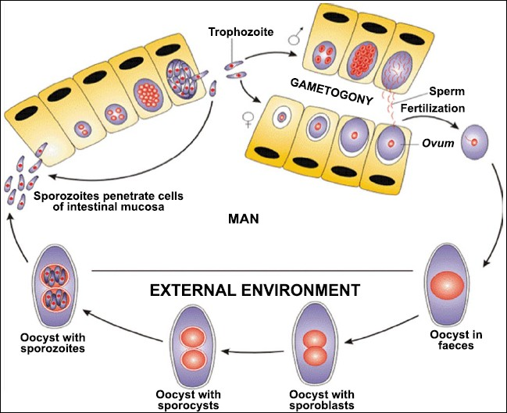
Intermediate hosts : - none.

Pathology: - ranges from asymptomatic to acute, severe dysentery.

3- Cryptosporidium parvum:-

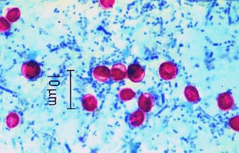
Cryptosporidium parvum oocysts
(acid-fast stain)

Morphology :
The morphological from detectablt in faeces is the oocyst
measures 4-5  m in diameter , spherical or ovoidal in shape ,
containing four crescentic sporozoites and amylopectin like
granules ( 1-6 large dark granules ) .

Life cycle:
Crypto begins its life cycle as sporulated oocysts (1) which enter the environment through the feces of the infected host. There is some evidence that it can also be spread by respiratory secretions.The infective oocysts reside in food and water , While in the intestines, the oocyst releases sporozoites which invade the epithelial linings of the intestines or the lungs (depending on the method of transmission). Within these cells, the sporozoites undergo schizogony, or asexual reproduction. The sporozoites then enter a sexual reproductive stage. Female macrogamonts and male microgamonts develop, and fertilization occurs. The resulting zygote can develop into: a) a thick-walled oocyst that will exit the host, or b) a thin-walled oocyst which will autoinfect the host.
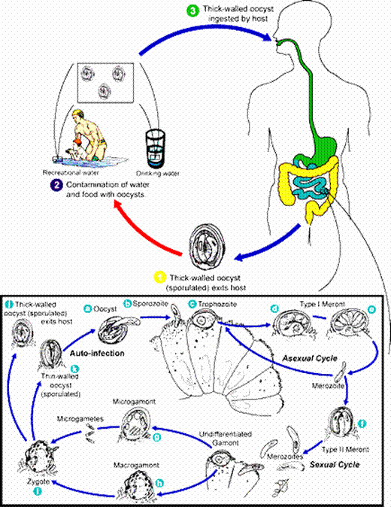

Site of infection: - primarily an intestinal infection, cryptosporidiosis can become systemic in AIDS patients. Organisms develop within the microvillous region of epithelial cells lining the small intestine.
Originally considered an animal parasite (rodents, cattle and sheep), it is now known that a wide variety of animals are naturally infected. Organisms from some (fish, fowl and reptiles) are not believed to be able to infect humans.
Transmission: - an endemic cycle is maintained via person-to-person, fecal-oral route transmission. The parasite is a relatively common finding in “day-care” diarrhea. It can be sexually transmitted. It exhibits a marked potential for being waterborne due to significant resistance to disinfection. The potential for animal-to-person transmission should not be underestimated.
Infections occur primarily in people with compromised immune systems. These can be serious infections. It is readily accepted that the organism will readily infect immunocompetent persons also. It is rapidly becoming a pediatric disease.
Pathology:- although the condition can be asymptomatic, most infections cause moderate to severe diarrhea of one to two weeks in the immunocompetent patient. In the immunosuppressed patient, the condition is protracted and life threatening. At this time, there is no drug effective against this parasite.

Identification: - oocysts are 2 - 5 microns in diameter; do not stain with iodine; and are acid-fast.ElIS

4- Cyclospora cayetanensis

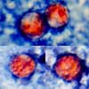
Cyclospora cayetanensis oocysts
(acid-fast stain)

General - Relatively new to this country, this parasite has been detected in the stools of infected individuals in the tropics for quite some time.

Morphology:

The oocyst of Cyclospora cayetanensis is a spherical shape, and can range from 8 to 10 μm, and after sporulation each oocyst contains four sporozoites ready for invasion of the host.

Animal reservoirs:- not known. Other Cyclospora species are known to infect a variety of animals, but C. cayetanensis is the name designated for the only one known to infect humans (at this time).

Life cycle:

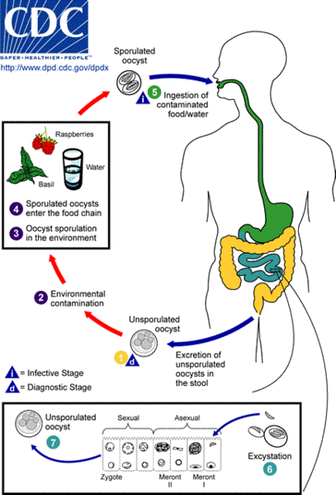

Transmission:- Contaminated food or water , person-to-person.
Pathology: - Infected individuals experience a diarrhea similar to that experienced with Cryptosporidium infections. While some cases were less debilitating than others, asymptomatic cases were not thought to have occurred.

Identification:- Oocysts are spherical, 7 - 10 microns in diameter, and present as variably acid-fast. Acid-fast procedures utilizing carbol-basic fuschin proved superior in demonstrating this parasite.

5-Microsporidium:-

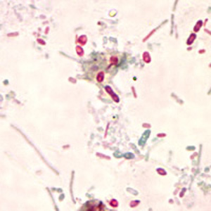
Microsporidium spp. spores

General – as of this time, infections are thought to be limited to AIDS patients.
Morphology:- Microsporidia are primitive eukaryotes with well defined nuclei and plasma membrane but lack some typical organelles found in more typical eukaryotes mainly mitochondria and stacked golgi. Microsporidia spores are all round and oblong and those associated with human infection tend to be about 1-4 µm in size (an important feature for diagnosis as some species are often mistaken for bacteria). All have a characteristic coiled polar tube, tubule or filament, layered polarplast, a posterior vacuole (thought to function as golgi) and a protective exospore made of proteins and chitin.
Life cycle:-
The infective form of microsporidia is the resistant spore and it can survive for a long time in the environment . The spore extrudes its polar tubule and infects the host cell . The spore injects the infective sporoplasm into the eukaryotic host cell through the polar tubule . Inside the cell, the sporoplasm undergoes extensive multiplication either by merogony (binary fission) or schizogony (multiple fission) . This development can occur either in direct contact with the host cell cytoplasm or inside a vacuole termed parasitophorous vacuole. microsporidia develop by sporogony to mature spores . During sporogony, a thick wall is formed around the spore, which provides resistance to adverse environmental conditions. When the spores increase in number and completely fill the host cell cytoplasm, the cell membrane is disrupted and releases the spores to the surroundings . These free mature spores can infect new cells thus continuing the cycle.

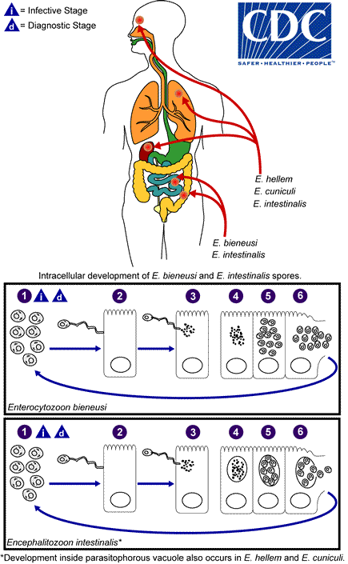

Clinical Presentation:-
Human microsporidiosis represents an important and rapidly emerging opportunistic disease, occurring mainly, but not exclusively, in severely immunocompromised patients with AIDS.. The clinical manifestations of microsporidiosis are very diverse, varying according to the causal species with diarrhea being the most common.
Blood & Tissue Protozoa – The Hemoflagellates

Introduction

    - The family Trypanosomatidae, (includes hemoflagellates) contain only two genera that parasitize humans.

      - Genus Leishmania are always intracellular, principally in cells of the reticuloendothelial system.

      - Genus Trypanosoma contains members that may be found both in the circulating blood and intracellularly in cardiac muscle. African - blood; American - cardiac muscle.

    - In all probability, the hemoflagellates were originally parasites of insects. They are transmitted by insects, and in them undergo a developmental cycle (the arthropod serves as intermediate host).

      - "Old World” leishmaniasis - transmitted by the bite of various species of sandflies of the genus Phlebotomus.

      - South American leishmaniasis - carried by Lutzomyia spp. sandflies.

      - American trypanosomiasis - transmitted by reduviid bugs; transmission occurs when infective feces of the bug contaminates the wound made by the insect's bite or an abrasion of the skin.

      - African trypanosomiasis - transmitted by Glossina spp. tsetse flies.

Morphological forms of hemoflagellates

1- Amastigotes :-
It is Roundish to oval in shape ,Consist of a nucleus and kinetoplast .
The large single nucleus is typically located off-center .The dotlike
blepharoplast is attached to a small axoneme, this axoneme extends to
the edge of the organism.The single parabasal body is located adjacent to
the blepharoplast .

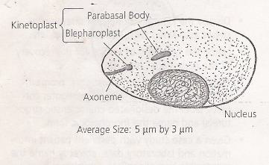

2– Promastigotes :-
It is Long and slender in appearance .The large single nucleus is
located in or near the center .The kinetoplast is located in the anterior end
of the organism .A single free flagellum extends anteriorly from the
axoneme .

3– Epimastigotes :-
It is Long and slightly wider than promastigote form.The large single
nucleus is located in posterior end .The kinetoplast located anterior to the
nucleus .Undulating membrane extending half of the body length .A single
free flagellum extends anteriorly from the axoneme .

4– Trypomastigotes :-
It is C or U shape in stained blood films .Long and slender in
appearance .One nucleus located anterior to the kinetoplast .The
kinetoplast is located in the posterior end of the organism .Undulating
membrane extending entire body length .A single free flagellum extends
anteriorly from the axoneme when present .

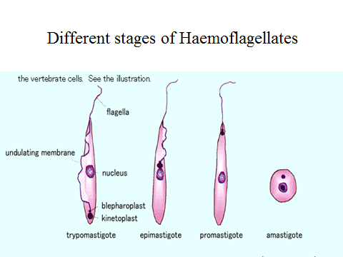

1- Trypanosoma:-

Clinical disease | Trypanosome species | Vector
African trypanosomiasis  1- Gamian type (west an  sleeping skiness)  2- Rhodesian type  (east African  sleeping sickness) | -T.b.gambiense  -T. b.rhodesiense | -Tsetse fly (Glossinia)  -Tsetse fly (Glossinia)
-American  trypanomiasis | T. cruzi | Reduviid or kissing  bug (Triatomid bug)

A-Trypanosoma brucei :-

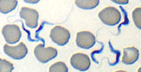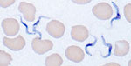
Trypanosoma b. rhodesiense Trypanosoma b. gambiense

    - Two subspecies: T. brucei rhodesiense & T. brucei gambiense
    - Transmission - Life cycles are essentially identical.
      - Rhodesian form: - primarily an animal pathogen, this is a zoonosis which reservoirs in wild grazing animals of East Africa. Parasite progresses rapidly into the central nervous system when occasionally transmitted to humans by Glossina morsitans species of tsetse flies.

      - Gambian form :- transmitted by Glossina palpalis group of tsetse fly. Although pathogenic in humans, an asymptomatic reservoir can be found in domestic pigs. progresses slowly.

      - Transmission: - by bite of tsetse fly. Organisms are in the salivary glands of the fly.

      - Site of infection: - organisms multiply in blood early in disease; later in lymph nodes and in the CNS.

      - Disease: - febrile episodes, night sweats, malaise, headache; enlarged cervical lymph nodes - “Winter bottom’s sign”; final stages- uncontrolled desire to sleep - thus the common name “sleeping sickness.”

      - Diagnosis: - examine wet mounts of aspirates from chancre (insect bite sight), or blood (buffy coat) for presence of trypanosomes (numbers of organisms peak during fever spikes).

      - Morphology - Epimastigote is the developmental form in flies; trypomastigote is the infective stage. It is present in the salivary gland of the fly and is the stage seen in the human bloodstream.

Life Cycle

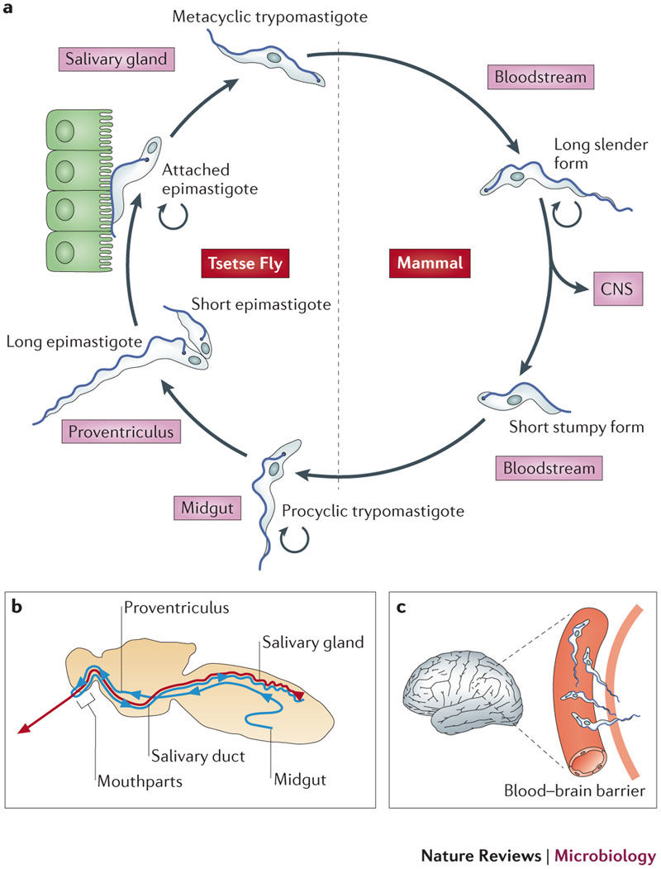

  - Uninfected tsetse fly (Glossina) bites an infected vertebrate host and ingests trypomastigote circulating in the blood strem.
  - Trypomastigotes multiply by longitudinal binary fission in fly gut.
  - Trypomastigotes migrate to the salivary glands and transform into epimastigotes and multiply for several generation.
  - Epimastigotes transform back into Metacyclic Trypomastigotes (short stumpy forms) in the salivary glands. These form the infective stage.
  - Tsetse fly bites a human or ruminant host and inoculates metacyclic trypomastigotes into bloodstream.
6,Trypomastigotes live and multiply in the blood and lymph. In some cases, trypomastigotes migrate to the central nervous system.
Note: For our purposes we will consider only two life cycle stages trypomastigotes in vertebrate host and epimastigote in Glossina which will be transmitted anterior station or salivarian transmission to the vertebrate host.

*African Trypanosomiasis Course of Infection
1- Phase I: Incubation Period: Red lesion, Itching and inflammation of skin.Duration one to two weeks.
2- Phase II: Trypomastigotes enter circulation: Fever,Headache
Skin rash.
3- Phase III: Trypomastigotes collect in lymph nodes and channels:
Cells not invaded but there is proliferation of endothelial cells
Infiltration of leukocytes,Enlargement of lymph nodes
4- Phase IV: Invasion of Central Nervous System-African Sleeping Sickness.: Headaches are severe,Mental dullness and coma Death from asthenia, heart failure, meningitis,

B. Trypanosoma cruzi:-

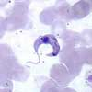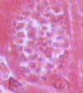
Trypanosoma cruzi trypomastigote Trypanosoma cruzi amastigotes

    - Distinctly different form of genus Trypanosoma than that associated with African sleeping sickness.

    - Disease: - American trypanosomiasis. Chagas' disease.

    - Transmission: - Metacyclic trypomastigote in reduviid bug feces is introduced through the skin following the bug's bite. Ingestion of the bug is also a mode of infection.

    - Trypomastigote and epimastigote (amastigote stage) forms may be found in hum an tissue & blood - the amastigote is a tissue stage; trypomastigote is blood stage; the epimastigote is the developmental stage in the bug.

    - Morphology :- the trypomastigote has a characteristic “U” or “C” shape with an undulating membrane and anteriorly extending flagellum; the amastigote is oval to suboval, averages 3 to 5 microns in diameter and contains a nucleus and rod-shaped kinetoplast.
    - Pathogenesis: - acute phase - shortly after infection (1-4 month’s duration; chronic phase - decades long. Edema of eyelids (Romana’s sign). Fever, headache, malaise, myalgia, megacolon, megaesophagus. Cardiac manifestations.
    - Reservoir hosts: - many animals- dogs, opossums, cat, , etc.
    - Epidemiology notes: Limited geographic range - most prevalent in South America especially Brazil, Argentina, Uruguay, Chile, and Venezuela. Has been found in Central America, and in a few immigrants or travelers in the Southwest. Five cases have been confirmed in Texas; one in California. There is great concern about transfusion-induced cases in the blood banking industry.
    - Note: In American trypanosomiasis transmission is Stercorarian or Posterior Station!
Life cycle:

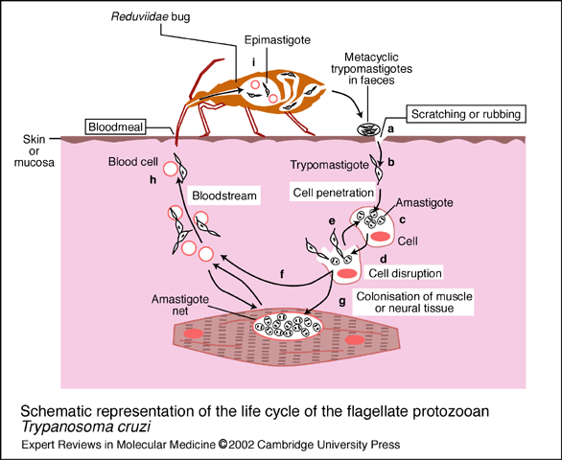

Infective metacyclic trypomastigotes are deposited on human skin when the reduviid bug takes a blood meal. Trypomastigotes enter the body when the feces are either rubbed into the bite wound or the eye. Trypomastigotes invade cells, where they reproduce asexually as amastigotes. The cell dies and amastigotes are released. Some will infect other cells and continue the amastigote reproductive cycle, while others will circulate in the blood, where they develop into nondividing trypomastigotes. The vector ingests the circulating parasites during a blood meal. The trypomastigotes travel to the bug’s gut, where they transform into epimastigotes and undergo asexual reproduction by binary fission. From here, the parasites travel to the hindgut, where they develop into metacyclic trypomastigotes and migrate to the rectum, ready to be excreted

Prevention:
Most effective approach.
Insecticides
Improving housing conditions
Testing of blood donors
No vaccine

Genus Leishmania:-

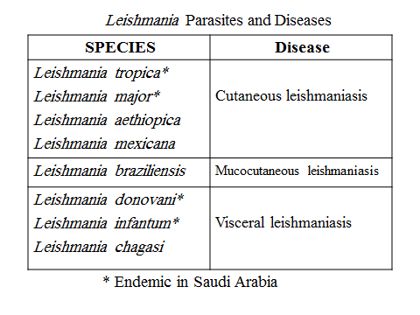

Notes :
* Leishmania occurs as an intracellular amastigote in the mammalian
host and as promastigote in the intestine of the sandfly vector.
* Vector : sandfly ( phlebotomus).
* Reservoir : digs and rodents .

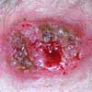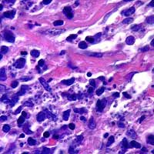
Leishmania lesion (cutaneous) Leishmania amastigotes in tissue

    - Four pathogenic species.
Morphology:
Leishmaniasis disease caused by lishmania parasites , and transmitted by sand fly bite as promastigotes ( infective stage ) inside humand they found in macrophages ( intracellular ) and tissue as Amastigotes ( diagnostic phase )

1- Leishmania tropica

- Mediterranean basin, India, Middle East, Asia & Africa.

      - Disease: -- Old World cutaneous leishmaniasis; “Baghdad boil”, “Oriental sore”. A viscerotropic form of this organism is thought to be one cause of the “Desert Storm” syndrome.
      - Site of infection: skin
      - Moist ulcers associated with L. tropica major - Incubation period of several weeks to months is followed by rapid development of weeping ulcers that heal within 6 months.
      - Dry ulcers:- associated with L. tropica minor - Incubation period may last for several years before appearance of slowly developing ulcer that is covered with a scaly crust that may take years to heal. Ulcers resemble those produced by the New World form.
      - Healing of lesions of cutaneous leishmaniasis signifies cell-mediated, species-specific, lifelong immunity. Secondary bacterial infections represent significant complications of the ulcer site. These can advance into diffuse cutaneous leishmaniasis in persons with inadequate cellular immunity.
      - Diagnosis: - identification of intracellular amastigotes in macrophages from active lesions.-Clinical diagnosis:
  - history of origin specifying the endemic area of residence at the time of development of symptoms
  - morphology of the lesions .immunological and molecular tests

-Differences between dry and wet cutaneous leishmaniasis :

Subspecies | L. tropica | L. major
Distribution | Urban | Rural  Rural
Incubationperiod | 2~8 mths | 1~4 wks
Papule | Brown, 1~3 mm | Red, 5~10 mm
Rupture | 3~6 wks | 1~3 wks
. Lesions | Dry, | Wet,
Site | Face | Lower limbs
Healing | 1~2 yrs | 3~6 mths

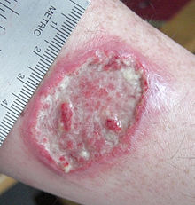

2-Leishmania braziliensis:-

      - Disease: - Mucocutaneous leishmaniasis, espundia.
      - Site of infection (oral-nose mucocutaneous tissue)- erosion of oral, nasal structures. Organism spread via bloodstream to other areas, especially the mucous membranes and cartilaginous areas of the nasal and oral structures. Erosion and disfigurement of these areas was called “, Espundia, Uta, chiclero ulcer)

Clinical Manifestations:-
- inital symptoms are similar to that of cutanous leishmaniasis
- single or multpile lesions and ulcers develop at the mucosal regions (nose, mouth, throat cavities) and in the adjacent tissue
- extensive disfiguring of the nasal septum, lips, and palate (does not include the bones)

- extensive disfiguring of the nasal septum, lips, and palate (does not include the bones)
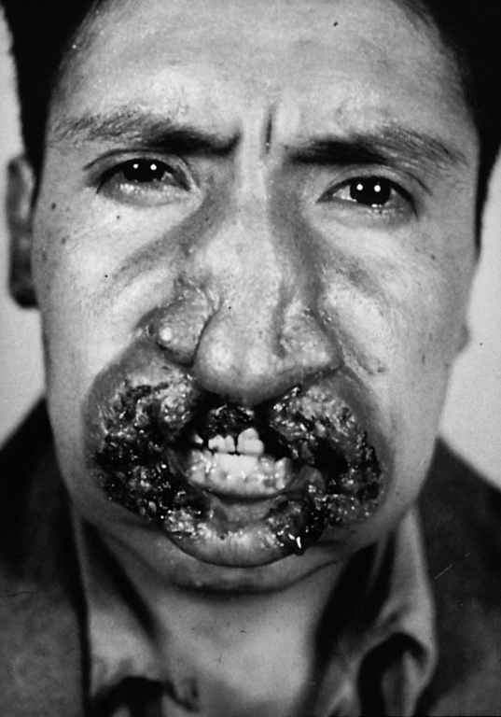

3-Leishmania donovani:-

-Disease: - visceral leishmaniasis, kala-azar. Kala-azar is Hindi for “black fever” - a symptom of hyperpigmentation of hands, feet & abdomen.

Site of infection: reticuloendothelial system
-Pathogenesis: - Traditionally the viscerotropic form, skin lesion seldom noticed; in reticuloendothelial system, organisms multiply; extensive hyperplasia of parasitized tissue impairs function of organs. Patients die from acute infections, or from a wide variety of secondary infections. Asymptomatic and long-term chronic infections exist also.

- Symptoms of visceral leishmaniasis:-
  - Fever-Weight loss-Enlarged spleen-Enlarged liver-Swollen glands
  - Bone marrow symptoms-Low blood counts-Anemia
  - Low white blood cell count-Low platelet count

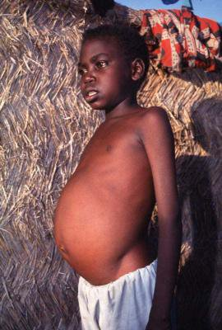

Preventation:(for all)
  - usage of insect repellents such as DEET
  - cover the exposed skin
  - staying on higher floors of buildings in the evening or at night
  - usage of fans
  - insecticidal sprays
  - Insecticide-treated bed nets, sheets and window curtains
  - pumping of insecticides in rodent burrows to kill rodents
  - treatment can also be considered a preventive measure Vaccines....

Life Cycle: :(for all)

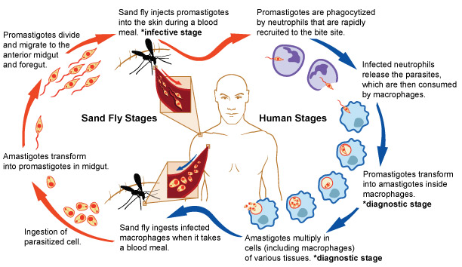

Leishmaniasis is transmitted by the bite of infected female phlebotomine sandflies. The sandflies inject the infective stage (i.e., promastigotes) from their proboscis during blood meals . Promastigotes that reach the puncture wound are phagocytized by macrophages and other types of mononuclear phagocytic cells. Promastigotes transform in these cells into the tissue stage of the parasite (i.e., amastigotes) , which multiply by simple division and proceed to infect other mononuclear phagocytic cells . Parasite, host, and other factors affect whether the infection becomes symptomatic and whether cutaneous or visceral leishmaniasis results. Sandflies become infected by ingesting infected cells during blood meals (, ). In sandflies, amastigotes transform into promastigotes, develop in the gut in the midgut for organisms in the and migrate to the proboscis .

- Blood and tissue the Coccidia

1-. Have complex life cycles - most have 2-host life cycle.

2-. Schizogony - asexual binary fission.

3-. Sporogony -sexual reproduction

1-Toxoplasma gondii

- Toxoplasma gondii has very low host specificity, and it will probably infect almost any mammal. It invades all kinds of cells except RBC
- Cats (both domestic and wild) are the only definitive hosts and can also be the intermediate hosts
- The disease that Toxoplasma gondii caused (toxoplasmosis) has been found in virtually every country of the world
- Toxoplasmosis is a significant cause of morbidity and mortality in AIDS patients and congenitally infected infants -- opportunistic infection for human.

Morphology:-

- Trophozoite:-
  - The intracellular parasites (tachyzoite) are 3x6µm, crescent shaped organisms that are enclosed in a cell membrane to form a pseudocyst measuring 10-100 µm in size.
  - 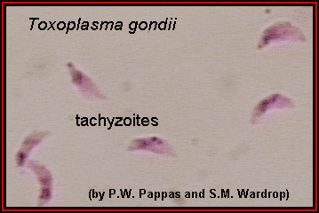

-A cyst: (of Toxoplasma gondii filled with bradyzoites

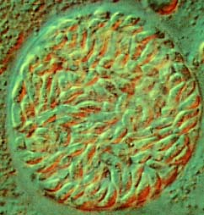

- A sporulated oocyst of Toxoplasma gondii.
- The oocyst contains two sporocysts ,each of which contain four crescent-shaped sporozoites ,Only cats produce and pass Toxoplasma oocysts; approximate diameter = 10 µm
- 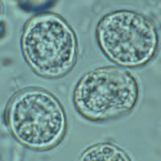

Congenital infections:- can occur. Signs and symptoms include severe brain damage or vision problems.
Toxoplasmosis can be identified by serological tests, but interpretation of the results is uncertain.
Life Cycle of Toxoplasma gondii:-
- Two host pattern with alternation of generations----mammal ←→ mammal
- Toxoplasma gondii is a serious zoonotic parasite that has almost all the warm blooded animals as the reservior hosts (intermediate hosts)
- Life cycle includes two phases called the intestinal (or enteroepithelial) and extraintestinal phases.
- The intestinal phase occurs in cats only and produces "oocysts" (___ hosts)
  - Schizogony – schizont →merozoite asexual reproduction
  - Gametogony – male & female gamete fertilize → oocyst sexual reproduction
  - Sporogony – sporocyst →sporozoites asexual reproduction
- The extraintestinal phase occurs in all infected animals (including cats) and produces trophozoites -- asexual reproduction (__ hosts)
  - Tachyzoites – pseudocysts- Bradyzoites -- cysts
Toxoplasmosis can be transmitted by ingestion of oocysts (in cat feces) or “pseudocysts" or “cysts"(in raw or undercooked meat)
Shedding of oocysts in faeces is most common in kittens, but can occur in any age of cat Oocysts can remain infectious for several months and are quite resistant to disinfectants, drying and freezing. Tissue cysts are less resistant, and are destroyed by proper cooking of food

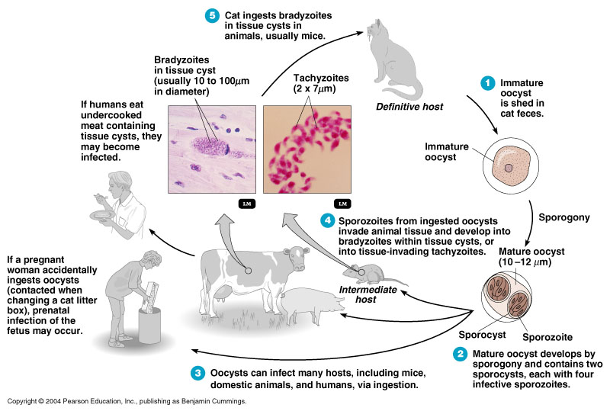

How do people get toxoplasmosis?
•Eating undercooked, contaminated meat (especially pork, lamb, and venison).
•Accidental ingestion of undercooked, contaminated meat after handling it and not washing hands thoroughly (Toxoplasma cannot be absorbed through intact skin).
•Eating food that was contaminated by knives, utensils, cutting boards and other foods that have had contact with raw, contaminated meat.
•Drinking water contaminated with Toxoplasma gondii.

•Mother-to-child (congenital) transmission.
•Receiving an infected organ transplant or infected blood via transfusion, though this is rare.

- Organ transplantation or blood transfusion from an infected person.

Symptoms of toxoplasmosis:-

-Flu-like symptoms:such as:
- a high temperature (fever) of 38C (100.4F) or over-aching muscles
- feeling sick-sore throat -swollen glands.These symptoms are usually mild and will normally pass within a few weeks
- Problems in pregnancy: Very dangerous in pregnant women - the organism can cross the placental barrier and infect the fetus. Result can range from asymptomatic infection to microcephaly, hydrocephaly, or stillborn fetus.

- miscarriage or stillbirth

-If your immune system is weak, the infection could spread to organs such as the eyes, heart, lungs and brain. This can cause problems such as headaches, confusion, , seizures (fits), difficulty breathing and vision problems.

Prevention:
- Wear gloves when you garden or handle soil.
- Don't eat raw or undercooked meat.
- Wash kitchen utensils thoroughly.
- Wash all fruits and vegetables.
- Don't drink unpasteurized milk.
- Cover children's sandboxes.

Diagnosis:-

- Microscopic Examination
-Smears and Sections
  - Specimens
-Blood, Sputum, CSF, bone marrow
-Tissue Biopsy
- Animal Inoculation
- Serological tests – IHA, IFA, ELISA (IgM/IgG)
- PCR & DNA probes

  - Babesia:-

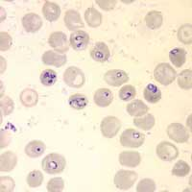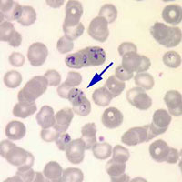
Babesia sp. rings in red blood cells Babesia sp. “maltese cross” (arrow)

    - Introduction - a widespread zoonosis,
    - Disease name: babesiosis is transmitted via the bite of infected hard ticks. Most cases in USA currently are diagnosed in northeast; the condition can be fatal in splenectomized patients.

    - Definitive hosts: - sexual reproduction takes place in ticks. Asexual reproduction takes place in a variety of mammalian hosts.

Morphology:-
Babesia enters erythrocytes at the sporozoite stage. Within the red blood cell, the protozoa become cyclical and develop into a trophozoite ring seen in the second cell of Image 3.
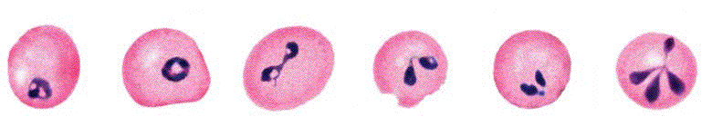
The trophozoites morph into merozoites, which have a tetrad structure coined a Maltese-cross form. The tetrad morphology, which can be seen with Geimsa staining of a thin blood smear, is unique to Babesia and serves as a distinguishing feature from Plasmodium falciparum, a protozoan of similar morphology that causes Malaria. Trophozoite and merozoite growth ruptures the host erythrocyte leading to the release of vermicules, the infectious parasitic bodies, which rapidly spread the protozoa throughout the blood.

    - Multiplies within red blood cells; can be confused with malaria ring forms, especially those of Plasmodium falciparum. Babesia rings are more pyriform (tear-shaped); multiplication gives rise to pairs and tetrads resembling a “maltese cross”. No pigment is formed (digestion of hemoglobin to hematin).

    - Pathology: - very similar to malaria, but without synchronization of paroxysms. Hemolysis is common, resulting in anemia and jaundice. Severe cases progress to renal failure, hypotension, coma and death.

    - Disease name: - babesiosis, piroplasmosis. “Piro” from “pyro”- Latin for “fire”. Because the disease is fever (fire) inducing. The “piroplasms” are a group of fever-inducing organisms or infections. Malaria is a piroplasm also.

Life Cycle:

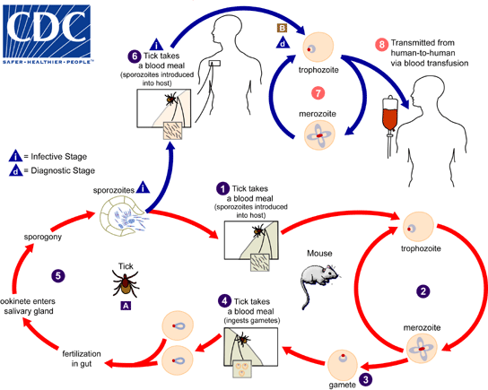

The Babesia microti life cycle involves two hosts, which include a rodent, primarily the white-footed mouse, , and a tick in the genus. During a blood meal, a Babesia-infected tick introduces sporozoites into the mouse host . Sporozoites enter erythrocytes and undergo asexual reproduction (budding) . In the blood, some parasites differentiate into male and female gametes, although these cannot be distinguished by light microscopy . The definitive host is the tick. Once ingested by an appropriate tick , gametes unite and undergo a sporogonic cycle resulting in sporozoites .
Humans enter the cycle when bitten by infected ticks. During a blood meal, a Babesia-infected tick introduces sporozoites into the human host . Sporozoites enter erythrocytes and undergo asexual replication (budding) . Multiplication of the blood-stage parasites is responsible for the clinical manifestations of the disease. Humans usually are dead-end hosts. However, human-to-human transmission is well recognized to occur via contaminated blood transfusions .

Symptoms:
- Headache,Muscle pain,Anorexia
- Nonproductive cough (mucus is not coughed up)
- Arthralgias (noninflammatory joint pain, unlike arthritis, which is inflammatory)
- Nausea,Vomiting,Sore throat,Abdominal pain
Diagnosis:
Molecular techniques, including qPCR on EDTA blood
Serological testing, microscopic examination for blood film

Preventionp:-
Avoidance of known tick areas, particularly during “tick seasons”, use of an effective anti-tick product and daily checking for/effective removal of ticks may help reduce the risk of disease transmission.

Subphylum Sporozoa - Malaria

Introduction

Four species of malaria parasites infect humans, Plasmodium vivax, P. ovale, P.malariae, and P. falciparum. All are transmitted by female Anopheles sp. mosquitoes.
1.5 – 2.7 million deaths annually . Every 10 - 30 seconds a child dies of malaria

Terms:

    - Ring stage: - a young trophozoite, it still contains a vacuole.

    - Developing trophozoite: – the vacuole is filled in as the organism feeds, adding to its bulk of cytoplasm; pigment begins to show up.

    - Pigment: - product of the digestion of haemoglobin to hematin.

    - Schizont: - the stage in which asexual reproduction takes place with the production of merozoites. Characterized by nuclear division and differentiation of cytoplasm around the nuclei.

    - Gametocyte: - the stage picked up by the mosquito vector. This stage initiates sexual reproduction in the mosquito.

    - Sporozoite: - the infective stage, a product of sexual reproduction; is present in the salivary gland of the vector mosquito
    - Schuffner’s stippling: - a fine, granular eosinophilic stippling seen on the infected red blood cell. Seen only in P. vivax and P. ovale infections.

    - Maurer’s clefts: - heavy, clefts of eosinophilic stippling sometimes seen on infected red blood cells in P. falciparum infections. They are sparse in number.

    - Prepatent period: – time from infection until first discovery of parasites in a blood film.

    - Incubation period: – time from infection until first symptoms appear

Caused by a protozoal blood parasite
▪Plasmodium vivax
▪Plasmodium ovale
▪Plasmodium malaria
•Plasmodium falciparum
•Plasmodium knowlesi
▪*Often cause severe malaria

Transmission: Anopheles mosquito
•Wide spectrum symptoms▪Fever

Life cycle:

Liver stage: Asmptomatic. With P. vivax and P. ovale, has dormant form (hypnozoite) that can relapse much later. This form is not killed by most malaria medications.

- Blood stage: Symptomatic. Notice the continuous circle. This will continue until medication or immune system eradicates (1-5+ years untreated). Once cycle 3-4 days, except P. falciparum.

The mosquito injects sporozoites while feeding; these enter hepatocytes within 30 minutes and multiply asexually forming merozoites. Upon rupture of the infected hepatic cell, merozoites invade red blood cells and begin an erythrocytic cycle - rings to trophozoites to schizonts or gametocytes. Schizonts continue the erythrocytic cycle, whereas, gametocytes are picked up by female Anopleles spp. mosquitoes. In the mosquito, sexual reproduction takes place. Gametes are fertilized; the resulting motile ookinete penetrates the mosquito’s stomach wall forming a zygote on the hemocele side of the stomach. Sporozoites develop within the zygote; this structure ruptures and escaping sporozoites invade the salivary gland of the mosquito.

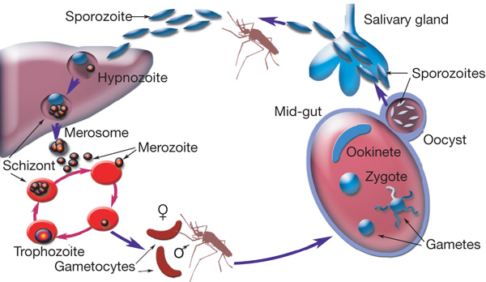

Diagnostic Features seen in Thin Blood Films:

    - Appearance of the Red Blood Cell:

      - Size :- normal or enlarged.

      - Stippling: - present or absent.

  - Characteristics of Plasmodium vivax (“benign tertian malaria”)

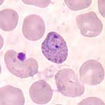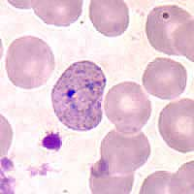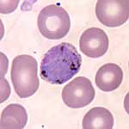
Plasmodium vivax old ring P. vivax developing trophozoite P. vivax gametocyte (female)

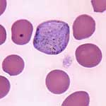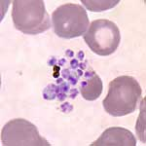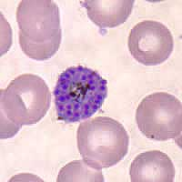
P. vivax gametocyte (male) P. vivax mature schizont P. vivax schizont (breaking up)

    - Stages present in peripheral blood films: - all can be present.

    - Size of infected red blood cells: - usually enlarged.

    - Stippling: - usually present if stained at a pH of 7.0 - 7.2.

    - Density of cytoplasm: - diffuse, light staining

    - Pigment: - usually present in older organisms, brownish-black to yellowish-black.

    - Number of merozoites:- in the mature schizont - average of 16.

    - Length of asexual cycle :- 48 hours.

    - Prepatent period: – 8 to 17 days.

    - Incubation period :– 14 days.

  - Characteristics of Plasmodium ovale (benign tertian malaria)

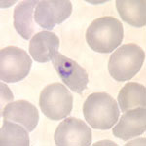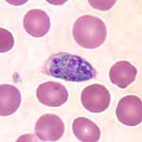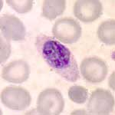
Plasmodium ovale ring P. ovale immature schizont P. ovale immature schizont

    - Stages present in peripheral blood films: - all can be present, but one stage usually is predominant.

    - Size of infected red blood cells: - usually enlarged, often oval with fimbrated edges.

    - Stippling :- usually present if stained at pH 7.0 - 7.2.

    - Density of cytoplasm: - rounded and compact, therefore dark staining.

    - Pigment: - usually present in older organisms, black to brownish-black.

    - Number of merozoites:- in the mature schizont - average of 9.

    - Length of asexual cycle: - 48 hrs.

    - Prepatent period: – 8 to 17 days.

    - Incubation period: – 14 days.

- Characteristics of Plasmodium malariae (Quartan malaria)

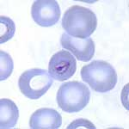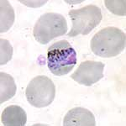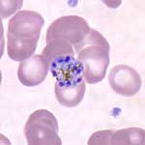
Plasmodium malariae ring P. malariae trophozoite (band) P. malariae mature schizont

    - Stages present in peripheral blood films: - all can be present, but one stage usually is predominant.

    - Size of infected red blood cells: - normal or slightly smaller.

    - Stippling: - none.

    - Density of cytoplasm: - rounded and compact, therefore dark staining.

    - Pigment: - usually present in older organisms, dark black.

    - Number of merozoites:- in the mature schizont - average of 9.

    - Length:- of asexual cycle - 72 hrs.

    - Prepatent period: – 14 to 30 days.

    - Incubation period: – 30 days.

- Characteristics of Plasmodium falciparum (Malignant tertian malaria)

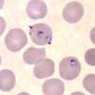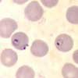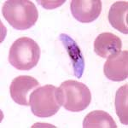
Plasmodium falciparum rings P. falciparum gametocyte

    - Stages present in peripheral blood films: - usually only rings and gametocytes; rarely other stages.

    - Size of infected red blood cells: - normal.

    - Stippling :- rarely, Maurer’s clefts can be seen.

    - Density of cytoplasm :- compact.

    - Pigment: - black.

    - Number of merozoites in the mature schizont: - average of 24.

    - Shape of the gametocyte: - banana or sausage shaped.

    - Length of asexual cycle: - 48 hrs.

    - Prepatent period :– 5 to 15 days.

    - Incubation period :– 12 days.

- Collection of Blood for Malaria Confirmation:

    - Venous: - acceptable, but a “red-top” tube is best and smears need to be made as close to the time of collection as possible.

    - Finger stick: - the preferred specimen. Wipe off first drop of blood in order to avoid “tissue juices”. Avoid making contact of slide with finger.

    - Anticoagulants: - can alter morphology somewhat, but can be used. EDTA (purple-top) is best.

    - Timing of collection: - midway between fever peaks, if infection is synchronized; every six to eight hours otherwise. Collection at the fever peak may reveal more organisms, but they will be immature and difficult to speciate.

- Epidemiology of Malaria:

    - Geographical distribution :- malaria is present worldwide in tropical and subtropical areas.

    - Transmission: - naturally acquired infections are via the bite of infected female Anopheles mosquitoes. Malaria is also transmitted via blood transfusion, sharing of contaminated needles among IV drug abusers, and congenital transmission also has been documented.

    - Relapse versus Recrudesence: - P. vivax is, traditionally, the “relapsing” malaria. All others can recrudesce (“bloom”) due to incomplete therapy. Relapse is due to dormant stages (hypnozoites) in liver cells. These are from the initial infection. Only sporozoite induced malaria can relapse.

    - Prevention: - detect and treat infected individuals; mosquito control.

    - Immunity: - incomplete immunity follows infection. Some persons get reinfected over and over.

a. Sickle cell trait: - the malaria parasite is not successful at utilizing the “S” haemoglobin. This trait does not confer immunity to infection, but does offer resistance to infection.

- Duffy factor :- represents the “portal of entry” antigen for P. vivax. Persons without the factor are immune to this species (but not the others).

Pathology/Pathogenesis:

    - Prodromal stage :– a time period which can include premonitory symptoms such as headache, myalgia, anorexia & nausea prior to the paroxysm.

    - Paroxysm: - period of chills & fever followed by profuse sweating.

    - Blackwater Fever: – a complication of P. falciparum malaria. Hemolysis and hematuria are due to a severe immune reaction.

Comparison of Plasmodium spp.
 | P. vivax | P. ovale | P. malariae | P. falciparum
Presence of Schuffner's dots? | Yes, fine | Yes, large | No | No
Size of infected cells | Enlarged | Enlarged | Smaller to Normal | Normal
# of merozoites in schizont | 16-24 | 4-16 | 6-12 | 8-24
Gametocyte | Round or oval | Round | Round | Crescent
Fever periodicity | 48 hours | 48 hours | 72 hours | ~48 hours

