General definition:
- Medical parasitology: the study and medical implications of parasites that infect humans

- Parasites may be simple unicellular protozoa or complex multicellular metazoa
- Protozoa: unicellular organisms, e.g. Plasmodium (malaria)
- Metazoa: multicellular organisms, e.g. helminths (worms) and arthropods (ticks, lice)'

- Eukaryote: a cell with a well-defined chromosome in a membrane-bound nucleus. All parasitic organisms are eukaryotes.

- Zoonosis: “a parasitic disease in which an animal is normally the host but which also that can be transmitted to people and infects man”

- Vector: “a living carrier (e.g.an arthropod) that transports a pathogenic organism from an infected to a non-infected host”. A typical example is the female Anopheles mosquito that transmits malaria

Relationships
In biology, the relationship between the two different species of organisms live closely together for an extended period of time , is mainly in the form of
1-Symbiosis:- defined as "life together"; two different species of organisms live together and involve protection or other advantages to one or both partner.
2-Commensalism :both partners are able to lead independent lives, but one may gain advantage from the association when they are together and least not damage to the other.
3-Mutualism-:-An association which is beneficial to both living things.
4-Parasitism :-An association which is beneficial to one partner and harmful to the other partner. The former that is beneficial to is called parasite, the latter that is harmful to is called host.
Parasite and the type of parasites
Parasite: It is an animal that is dependent on another animal (host) for its survival.
1-Endoparasite and ectoparasite: A parasite which lives in or on the body of the host is called endoparasite (protozoa and heminthes) or ectoparasite(arthropod e.g. lice, ticks).
2-Temporary or intermittent parasite: visits the host from time to time for food.
3-Permanent parasite: remains on or in the body of the host for its entire life.
4-Facultative parasite: organism that can exist in a free living state or as a parasite.
5-Obligatory parasite: cannot survive without a host i.e. completely adapted for parasitic existence.
6-Opportunistic parasite: produces disease only in immunodeficient or immuno-suppressed patients (AIDS). In immunocompetent individuals the organisms may exist in latent form producing no symptoms.
7-Coprozoic or spurious parasite :foreign organisms which have been swallowed merely pass along alimentary canal of man (without establishment) to be recovered in faces.
Host and type of host
•Host: the organism in, or on, which the parasite lives and causes harm , harbors the parasite usually larger than the parasite.
1- Intermediate host: The host harboring the larvae or asexual stage of parasite.
2- Final host (Definitive host) : The host harboring adult or sexual stage of parasite.
3-Reservoir host: Animals harboring the same species of parasites as man.
Type of life cycle
Life cycle: The whole process of parasite growing and developing.
A- The direct life-cycle: Only one host (no intermediate host).
B-The indirect life cycle: Life cycle with more than one host (intermediate host and final host).

EFFECT OF PARASITES ON THE HOST:
The damage which pathogenic parasites produce in the tissues of the host may be described in the following two ways;
(a) Direct effects of the parasite on the host
1- Mechanical injury - may be inflicted by a parasite by means of pressure as it grows larger, e.g. Hydatid cyst causes blockage of ducts such as blood vessels producing infraction.
2- Deleterious effect of toxic substances- in Plasmodium falciparum production of toxic substances may cause rigors and other symptoms.
3- Deprivation of nutrients, fluids and metabolites -parasite may produce disease by competing with the host for nutrients.
(b) Indirect effects of the parasite on the host:
1- Immunological reaction: Tissue damage may be caused by immunological response of the host, e.g. nephritic syndrome following Plasmodium infections.
Excessive proliferation of certain tissues due to invasion by some parasites can also cause tissue damage in man, e.g. fibrosis of liver after deposition of the ova of Schistosoma.
Effects of the host on the parasites
The host can produce certain degree resistance to parasites in human body . The resistance (Immunity) is not very strong. In general, it don’t wipe out parasites completely, but may limit the number of parasites and establish balance with parasites.
1- Innate immunity
a- Barrier : Prevent parasites to invade in certain degree. Skin/Mucous membrance/Placenta.
b- Acid in skin or stomach can cause damage of the parasites.
c- Phagocytosis of phagocyte.
2-Acquired immunity Mechanism:
a- cellular and humoral immunity.
b- Sterilizing immunity: Wipe out the parasites completely; meanwhile get a long-term specific resistance to re-infection.
The basic factor of transmission of parasitic diseases
1- The source of the infection
2- The routes of transmission
3- The susceptible host
The combined effect of those factors determine the dispersibility and the prevalence of the parasites at a given time and place and regulate the incidence of the parasitic diseases in certain local population.

The source of the infection
1- Patient: Persons who have parasites in their body and show clinical symptoms.
2- Carrier: Persons, who have parasites in their body, not show symptoms.
3- Reservoir host: Animals that harbors the same species of parasites as man. Sometimes, the parasites in animals can transmit into human.

The routes of transmission
1- Congenital transmission: From mother to infant. Toxoplasmosis
2- Contact transmission: Directcontact---Trichomonas vaginalis; Indirect contact---Ascaris lumbricodes
3- Food transmission: The infectious stage of parasites contaminated food/ The meat of the intermediate hosts containing infectious stage of parasites.
The routes of transmission II
4- Water transmission: Drink or contact the water contaminated the infectious stage of parasites.
5- Soil transmission : Contamination of the soil by feces containing the certain stage of parasites and this stage can develop into other stage.
6- Arthropod transmission: Vectors of certain parasitic diseases.

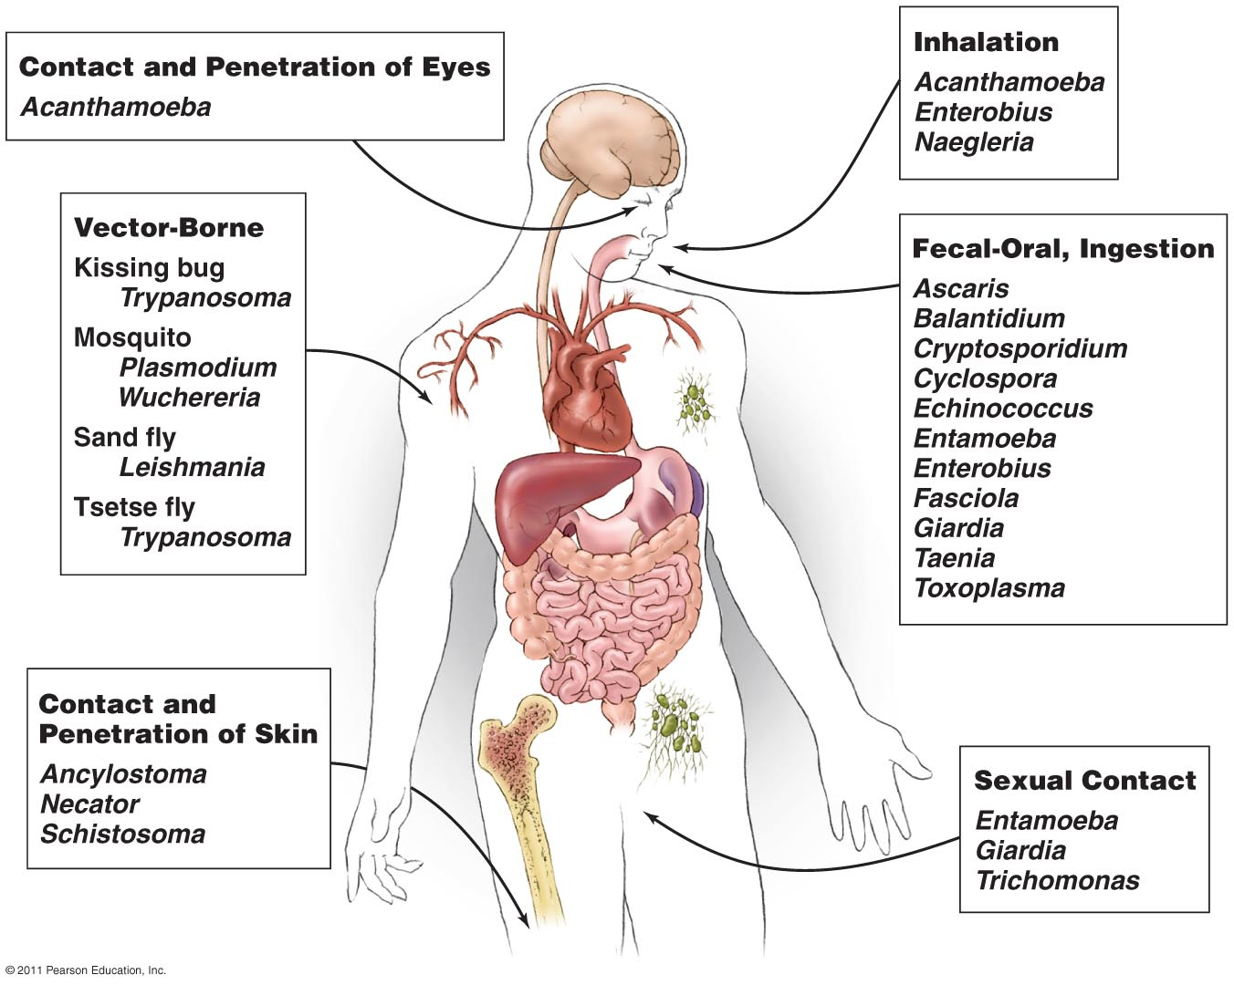

Distribution of parasites depends upon:
a. The presence and food habits of a suitable host:
• Host specificity, for example, Ancylostoma duodenale requires man as a host where Ancylostoma caninum requires a dog.
• Food habits, e.g. consumption of raw or undercooked meat or vegetables predisposes to Taeniasis
b. Easy escape of the parasite from the host- the different developmental stages of a parasite which are released from the body along with faces and urine are widely distributed in many parts of the world as compared to those parasites which require a vector or direct body fluid contact for transmission.
c. Environmental conditions favoring survival outside the body of the host, i.e. temperature, the presence of water, humidity etc.
d. The presence of an appropriate vector or intermediate host – parasites that do not require an intermediate host (vector) for transmission are more widely distributed than those that do require vectors.

Specimens are selected for laboratory diagnosis:

a) Blood – in those parasitic infections where the parasite itself in any stage of its development circulates in the blood stream, examination of blood film forms one of the main procedures for specific diagnosis. For example, in malaria the parasites are found inside the red blood cells.

b) Stool – examination of the stool forms an important part in the diagnosis of intestinal parasitic infections and also for those helminthic parasites . In protozoan infections, either trophozoites or cystic forms may be detected; Example, Amoebiasis, Giardiasis, etc.
In the case of helmithic infections, the adult worms, their eggs, or larvae are
found in the stool.

c) Urine – when the parasite localizes in the urinary tract, examination of the urine will be of help in establishing the parasitological diagnosis. For example in urinary Schistosomiasis, eggs of Schistosoma haematobium are found in the urine.
d) Sputum – examination of the sputum is useful in the following:
• In cases where the habitat of the parasite is in the respiratory tract, as in Paragonimiasis, the eggs of Paragonimus westermani are found.
• In amoebic abscess of lung or in the case of amoebic liver abscess bursting into the lungs, the trophozoites of E. histolytica are detected in the sputum.

e) Biopsy material - varies with different parasitic infections. For example spleen punctures in cases of kala-azar, muscle biopsy in cases of Cysticercosis,
f) Urethral or vaginal discharge – for Trichomonas vaginalis.

Prevention and control
measures may be taken against every parasite infective humans. Preventive measures designed to break the transmission cycle are crucial to successful parasitic eradication. Such measures include:
􀂃 Reduction of the source of infection- the parasite is attacked within the host, thereby preventing the dissemination of the infecting agent. Therefore, a prompt diagnosis and treatment of parasitic diseases is an important component in the prevention of dissemination.
􀂃 Sanitary control of drinking water and food.
􀂃 Proper waste disposal – through establishing safe sewage systems, use of screened latrines, and treatment of night soil.
􀂃 The use of insecticides and other chemicals used to control the vector population.
􀂃 Protective clothing that would prevent vectors from resting in the surface of the body and inoculate pathogens during their blood meal.
􀂃 Good personal hygiene.
􀂃 Avoidance of unprotected sexual practices.

PROTOZOA
Protozoa (singular, protozoan), from the Greek ‘protos’ and ‘zoon’ meaning “first animal”, are members of eukaryotic protists. They may be distinguished from other eukaryotic protists by their ability to move at some stage of their life cycle and by their lack of cell wall.

Protozoans are unicellular, eukaryotic chemoheterotrophic organisms.
Most protozoa have two stages
▪ Trophozoite – the feeding and growing stage
▪ Some protozoa will produce a protective capsule called a cyst.
 A cyst allows the parasite to exist outside of the host and be the infective stage allowing the parasite to get to another host.

Protozoa reproduce sexually and asexually
▪ Asexually : Fission (mitosis), Budding, Schizogony
▪ Sexually : Conjugation, Gamete formation
 Definitive Host harbors the sexually reproducing stage
of parasite
 Intermediate Host harbors asexually reproducing portion of the parasite’s life cycle
❑ Movement:
• A single or multiple flagella
• Cilia, Balantidium
• Pseudopodia, Entamoeba
• No obvious means of locomotion, Eimeria

Morphology of protozoa
Protozoa are predominantly microscopic, ranging in size from 2 to more than 100μm. Morphologically, they are within a mass of protoplasm, consisting of a true membrane –bound nucleus and cytoplasm.
The nucleus contains clumped or dispersed chromatin and central nucleolus or karyosome, which are useful structures to distinguish protozoan species from one another based on the shape, size and distribution of these structures.
CLASSIFICATION OF PROTOZOA
Protozoa of medical importance are classified based on their morphology and locomotive system as described below:
1-Sarcodina - Entamoeba histolytica
2-Flagellates - Giarda lamblia, Trichomonas vaginalis, Trypanosoma spp, Leishmania spp
3-Cliliophora - Balantidium coli
4-Coccidian - Isospora belli, Cryptosporidium parvum, Toxoplasma gondii, Plasmodium species
Protozoan pathogens can also be grouped according to the location in the body where they most frequently cause disease.

1- Sarcodina (Amoebas)
primitive unicellular microorganisms with a relatively simple life cycle which can be divided into two stages:
• Trophozoite – actively motile feeding stage.
• Cyst – quiescent, resistant, infective stage.
Their reproduction is through binary fission, e.g. splitting of the trophozoite or through the development of numerous trophozoites with in the mature multinucleated cyst.
Motility is accomplished by extension of pseudopodia (“false foot”)
1-Entamoeba histolytica
Morphological features
(a) Trophozoites
Viable trophozoites vary in size from about 10-60μm in diameter. Motility is rapid, progressive, and unidirectional, through pseudopods. The nucleus is characterized by evenly arranged chromatin on the nuclear membrane and the presence of a small, compact, centrally located karyosome. The cytoplasm is usually described as finely granular with few ingested bacteria or debris in vacuoles. In the case of dysentery, however, RBCs may be visible in the cytoplasm, and this feature is diagnostic for E.histolytica.
(b) Cyst
Cysts range in size from 10-20μm. The immature cyst has inclusions namely; glycogen mass and chromatoidal bars. As the cyst matures, the glycogen completely disappears; the chromotiodials may also be absent in the mature cyst.
Life cycle
1-Intestinal infections occur through the ingestion of a mature quadric nucleate infective cyst, contaminated food or drink and also by hand to mouth contact.
2-It is then passed unaltered through the stomach, as the cyst wall is resistant to gastric juice. In terminal ileum (with alkaline pH), excystation takes place.
3-Trophozoites being actively motile invade the tissues and ultimately lodge in the submucous layer of the large bowel. Here they grow and multiply by binary fission.
4-Trophozoites are responsible for producing lesions in amoebiasis.
Invasion of blood vessels leads to secondary extra intestinal lesions.
Gradually the effect of the parasite on the host is toned down together with concomitant increase in host tolerance, making it difficult for the parasite to continue its life cycle in the trophozoite phase.
5-A certain number of trophozoites come from tissues into lumen of bowel and are first transformed into pre-cyst forms.
6-Pre-cysts secret a cyst wall and become a uninucleate cyst. Eventually, mature quadric nucleate cysts form. These are the infective forms.
Both mature and immature cysts may be passed in faeces. Immature cysts can mature in external environments and become infective.
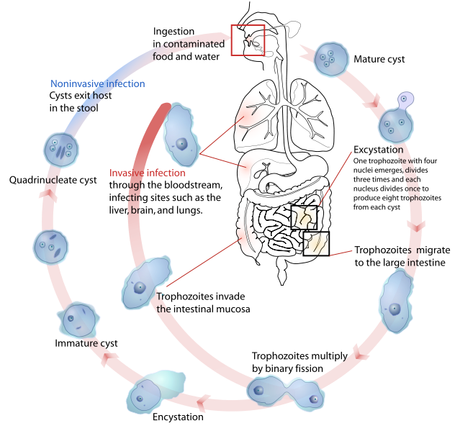Pathogenesis
Trophozoites divide and produce extensive local necrosis in the large intestine. Invasion into the deeper mucosa with extension into the peritoneal cavity may occur. This can lead to secondary involvement of other organs, primarily the liver but also the lungs, brain, and heart. Extraintestinal amebiasis is associated with trophozoites. Amoebas multiply rapidly in an anaerobic environment, because the trophozites are killed by ambient oxygen concentration.
Clinical features
The outcome of infection may result in a carrier state, intestinal amebiasis, or exteraintestinal amebiasis. Diarrhoea, flatulence, and cramping are complaints of symptomatic patients. More severe disease is characterised by the passing of numerous bloody stools in a day. Systemic signs of infection (fever, leukocytosis, rigors) are present in patients with extraintestinal amebiasis. The liver is primarily involved, because trophozoites in the blood are removed from the blood by the portal veins. The right lobe is most commonly involved, thus pain over the liver with hepatomegaly and elevation of the diaphragm is observed.
Laboratory diagnosis
In intestinal amoebiasis:
• Examination of a fresh dysenteric fecal specimen or rectal scraping for
trophozoite stage. (Motile amoebae containing red cells are diagnostic of amoebic dysentery).
• Examination of formed or semiformed faeces for cyst stage. (Cysts indicate infection with either a pathogenic E.histolytica or non-pathogenic E.dispar.)
Extraintestinal amoebiasis
• Diagnosed by the use of scanning procedures for liver and other organs.
• Specific serologic tests, together with microscopic examination of the abscess material, can confirm the diagnosis.
Prevention
Introduction of adequate sanitation measures and education about the routes of transmission. Avoid eating raw vegetables grown by sewerage irrigation and night soil
OTHER AMEBAE INHABITING THE ALIMENTARY CANAL
Most of these amoebae are commensal organisms that can parasitize the human gastrointestinal tract.
Entamoeba hartmanni:
In all of its life–cycle stage, E.hartmanni resembles E.histolytica except in size, yet there is a slight overlap in the size range. The trophozoites do not ingest red blood cells, and their motility is generally less vigorous than that of E.histolytica. As in other amebae, infection is acquired by ingestion of food or water contaminated with cyst-bearing faeces. Identification is based on examination of small amebae in unstained or iodine-stained preparations. Usually no treatment is indicated, measures generally effective against faecal-borne infections will control this amoebic infection.
Entamoeba coli:
The life cycle stages include; trophozoite, precyst, cyst, metacyst, and metacystic trophozoite. Typically the movements of trophozoites are sluggish, with broad short pseudopodia and little locomotion, but at a focus the living specimen cannot be distinguished from the active trophotozoite of E.histolytica. However, the cysts are remarkably variable in size. Entamoeba coli is transmitted in its viable cystic stage through faecal contamination. Ε.coli as a lumen parasite is non-pathogenic and produces no symptoms. The mature cyst (with more than four nuclei) is the distinctive stage to differentiate E.coli from the pathogenic E.histolytica. Specific treatment is not indicated since this amoeba is non-pathogenic. The presence of E.coli in stool specimen is evidence for fecal contamination. Prevention depends on better personal hygiene and sanitary disposal of human excreta.
Endolimax nana:
Is a lumen dweller in the large intestine, primarily at the cecal level, where it feeds on bacteria. The life cycle is similar to E.histolytica. Motility is typically sluggish (slug-like) with blunt hyaline pseudopodia, Projects shortly. Human infection results from ingestion of viable cysts in polluted water or contaminated food. Typical ovoid cysts of E.nana are confirmative. Rounded cysts and living trophozoites are often confused with E.hartmanni and E.histolytica. No treatment is indicated for this nonpathogenic infection. Prevention can be achieved through personal cleanliness and community sanitation.
Iodamoeba buetschlii:
- the natural habitat is the lumen of the large intestine, the principal site probably being the caecum. The trophozoite feeds on enteric bacteria; it is a natural parasite of man and lower primates. It is generally regarded as a nonpathogenic lumen parasite. No treatment is ordinarily indicated. Prevention is based on good personal hygiene and sanitation in the community.
Entamoeba gingivalis
- Only the trophozoite stage presents, and encystation probably does not occur. E.gingivalis is a commensal, living primarily on exudate from the margins of the gums, and thrives best on unhealthy gums. No specific treatment is indicated. However the presence of E.giingivalis suggests a need for better oral hygiene. The infection can be prevented by proper care of the teeth and gums.
Blastocystis hominis- is an inhabitant of the human intestinal tract previously regarded as non-pathogenic yeast. Its pathogenecity remains controversial. The organism is found in stool specimen from asymptomatic people as well as from people with persistent diarrhoea. B.hominis is capable of pseudopodia extension and retraction, and reproduces by binary fission or sporulation. The classic form that is usually seen in the human stool specimen varies tremendously in size, from 6-40μm. There are thin –walled cysts involved in autoinfection, and thick–walled cysts responsible for external transmission via the fecal-oral route.. The organism may be detected in wet mounts or trichome–stained smears of fecal specimens.
2-FLAGELLATES
Flagellates are unicellular microorganisms. Their locomotion is by lashing a tail-like appendage called a flagellum or flagella and reproduction is by simple binary fission.
There are three groups of flagellates:
A- Luminal flagellates
Giardia lamblia
Dientmoeab fragilis
B- Hemoflagellates
Trypanosoma species.
Leishmania species.
C- Genital flagellates
Trichomonas vaginalis
A- Luminal flagellates
Giardia lamblia
The life cycle consists of two stages, the trophozoite and cyst. The trophozoite is 9-12 μm long and 5-15μm wide anteriorly. It is bilaterally symmetrical, pear-shaped with two nuclei (large central karyosome), four pairs of flagella, two axonemes, and a suction disc with which it attaches to the intestinal wall. The oval cyst is 8-12μm long and7-10μm wide, thick-walled with four nucleus and several internal fibera? Each cyst gives rise to two trophozoites during excystation in the intestinal tract.
Transmission is by ingestion of the infective cyst.
Pathogenesis
Infection with G.lamblia is initiated by ingestion of cysts. Gastric acid stimulates excystation, with the release of trophozoites in duodenum and jejunum. The trophozoites can attach to the intestinal villi by the ventral sucking discs without penetration of the mucosa lining, but they only feed on the mucous secretions. In symptomatic patients, however, mucosa-lining irritation may cause increased mucous secretion and dehydration. Metastatic spread of disease beyond the GIT is very rare. 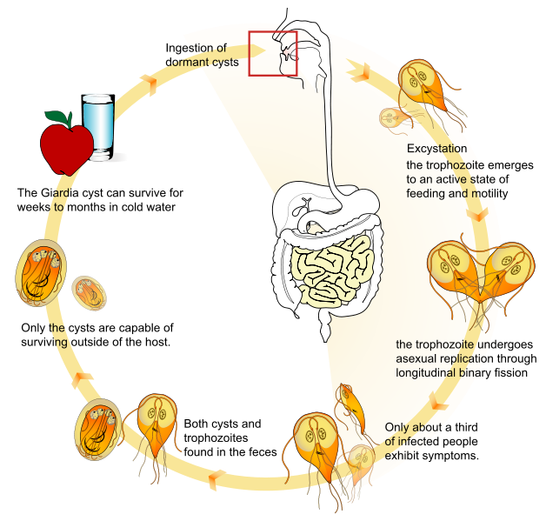Clinical features
Clinical disease: Giardiasis
Symptomatic giardiasis ranges from mild diarrhea to severe malabsorption syndrome. Usually, the onset of the disease is sudden and consists of foul smelling, watery diarrhea, abdominal cramps, flatulence, and streatorrhoea. Blood & pus are rarely present in stool specimens, a feature consistent with the absence of tissue destruction.
Laboratory diagnosis
Examination of diarrhoeal stool- trophozoite or cyst, or both may be recovered in wet preparation. In examinations of formed stool (e.g. in asymptomatic carriers) only cysts are seen. Giardia species may occur in “showers”, i.e. many organisms may be present in the stool on a given day and few or none may be detected the next day. Therefore one stool specimen per day for 3 days is important. If microscopic examination of the stool is negative in a patient in whom giardiasis is highly suspected duodenal aspiration, string test (entero-test), or biopsy of the upper small intestine can be examined.
In addition to conventional microscopy, several immunologic tests can be implemented for the detection of parasitic antigens.
Prevention
- Asymptomatic reservoirs of infection should be identified & treated.
- Avoidance of contaminated food and water.
- Drinking water from lakes and streams should be boiled, filtered and/or iodine treated.
- Proper waste disposal and use of latrine.
Trichomonas vaginalis
Important features-
it is a pear-shaped organism with a central nucleus and four anterior flagella; and undulating membrane extends about two-thirds of its length. It exists only as a trophozoite form, and measured 7-23μm long & 5-15μm wide. Transmission is by sexual intercourse.
Pathogenesis
The trophozoite is found in the urethra & vagina of women and the urethra & prostate gland of men. After introduction by sexual intercourse, proliferation begins which results in inflammation & large numbers of trophozoites in the tissues and the secretions. The onset of symptoms such as vaginal or vulval pruritus and discharge is often sudden and occurs during or after menstruation as a result of the increased vaginal acidity. The vaginal secretions are liquors, greenish or yellowish, sometimes frothy, and foul smelling. Infection in the male may be latent, with no symptoms, or may be present as self limited, persistent, or recurring urethritis.
Clinical features
Clinical disease - trichomoniasis.
Most infected women at the acute stage are asymptomatic or have a scanty, watery vaginal discharge. In symptomatic cases vaginitis occurs with more extensive inflammation, along with erosion of epithelial lining, and painful urination, and results in symptomatic vaginal discharge, vulvitis and dysuria.
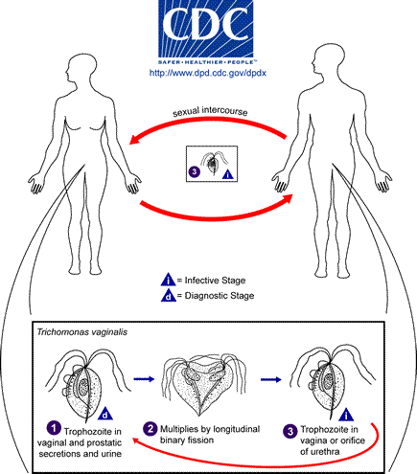
Laboratory diagnosis
• In females, T.vaginalis may be found in urine sediment, wet preparations of vaginal secretions or vaginal scrapings.
• In males it may be found in urine, wet preparations of prostatic secretions or following massage of the prostate gland.
• Contamination of the specimen with feces may confuse T.vaginalis with T.hominis.
Prevention
- Both male & female sex partners must be treated to avoid reinfection
- Good personal hygiene, avoidance of shared toilet articles & clothing.
- Safe sexual practice.
Dientamoeba fragilis
Dientamoeba fragilis was initially classified as an amoeba; however, the internal structures of the trophoziote are typical of a flagellate. No cyst stage has been described. The life cycle and mode of transmission of D. fragilis are not known. It has worldwide distribution. The transmission is postulated, via helminthes egg such as those of Ascaris and Enterobius species. Transmission by fecal- oral routes does occur.
Most infection with D. fragilis is asymptomatic, with colonization of the cecum and upper colon. However, some patients may develop symptomatic disease, consisting of abdominal discomfort, flatulence, intermittent diarrhea, anorexia, and weight loss. The reservoir for this flagellate and lifecycle are unknown. Thus, specific recommendation for prevention is difficult. However, infection can be avoided by maintenance of adequate sanitary conditions.
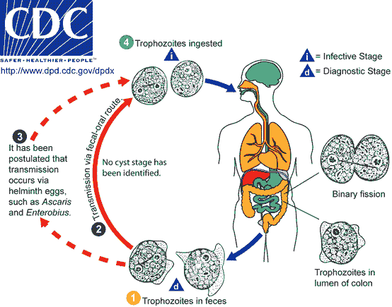
2- Haemoflagelates
Leishmania Species
Clinical disease
- Visceral leishmaniasis
- Cutaneous leishmaniasis
- Mucocutaneous leishmaniasis
The species of leishmania exist in two forms, amastigote (aflagellar) and
promastigote (flagellated) in their life cycle. They are transmitted by certain species of sand flies (Phlebotomus & Lutzomyia)
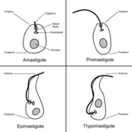
Morphological forms of hemoflagellates
1-Amastigote form Round or oval in shape, surrounded by delicate cell membrane, have single vesicular nucleus with large central karyosome, the kinetoplast lies at right angle to the nucleus. Closely located nucleus and kinetoplast known as torpedo form. This form (amastigote) has no flagellum.
2-Promastigote form Elongated (spindle in shape) , have centrally located nucleus and the kinetoplast situated at the anterior end. The vacuole lying in front of the kinetoplast. From blepharoplast, single free flagellum projects from the anterior end, equal or longer than the body length.This form has no undulating membrane.
3-Epimastigote form Elongated form, slightly wider than promastigote, nucleus near middle, kinetoplast is anterior to the nucleus. From blepharoplast flagellum arise forming the undulating membrane extending half of the body length, and project from the anterior end as a free flagellum.
4-Trypomastigote form Elongated form with highly polymorphism from rather short and stumpy . In stained blood film, Trypanosoma cruzi appears as C or U shape. Nucleus near middle, kinetoplast is at the posterior end, the flagellum and undulating membrane pass anteriorly along entire body length and free flagellum extends from anterior end when present. 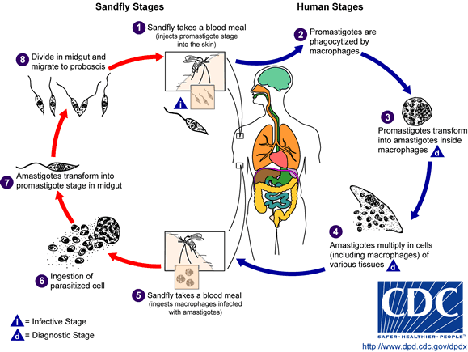
Visceral leishmaniasis
Leishmania donovani
Important features-
The natural habitat of L.donovani in man is the reticuloendothelial system of the viscera, in which the amastigote multiplies by simple binary fission until the host cells are destroyed, whereupon new macrophages are parasitized. In the digestive tract of appropriate insects, the developmental cycle is also simple by longitudinal fission of promastigote forms. The amastigote stage appears as an ovoidal or rounded body, measuring about 2-3μm in length; and the promastigotes are 15-25μm lengths by 1.5-3.5μm breadths.
Pathogenesis
In visceral leishmaniasis, the organs of the reticuloendothelial system (liver, spleen and bone marrow) are the most severely affected organs. Reduced bone marrow activity, coupled with cellular distraction in the spleen, results in anemia, leukopenia and thrombocytopenia. This leads to secondary infections and a tendency to bleed. The spleen and liver become markedly enlarged, and hypersplenism contributes to the development of anemia and lymphadenopathy also occurs. Increased production of globulin results in hyperglobulinemia, and reversal of the albumin-to-globulin ratio.
Clinical features
Symptoms begin with intermittent fever, weakness, and diarrhea; chills and sweating that may resemble malaria symptoms are also common early in the infection. As organisms proliferate & invade cells of the liver and spleen, marked enlargement of the organs, weight loss, anemia, and emaciation occurs. With persistence of the disease, deeply pigmented, granulomatous lesion of skin, referred to as post-kala-azar dermal leishmaniasis, occurs.
Untreated visceral leishmaniasis is nearly always fatal as a result of secondary infection.
Laboratory diagnosis
• Examination of tissue biopsy, spleen aspiration, bone marrow aspiration or lymph node aspiration in properly stained smear (e.g. Giemsa stain).
• The amastigotes appear as intracellular & extra cellular L. donovan (LD) bodies.
• Culture of blood, bone marrow, and other tissue often demonstrates the
promastigote stage of the organisms.
• Serologic testing is also available.
Prevention
• Prompt treatment of human infections and control of reservoir hosts.
• Protection from sand flies by screening and insect repellents.

Old World Cutaneous Leishmaniasis (Oriental sore)
Clinical disease
L.tropica minor - dry or urban cutaneous leishmaniasis
L.tropica major - wet or rural cutaneous leishmaniasis
L.aethiopica - cutaneous leishmaniasis
Important features
These are parasites of the skin found in endothelial cells of the capillaries of the infected site, nearby lymph nodes, within large mononuclear cells, in neutrophilic leukocytes, and free in the serum exuding from the ulcerative site. Metastasis to other site or invasion of the viscera is rare.
Pathogenesis
In neutrophilic leukocytes, phagocytosis is usually successful, but in macrophages the introduced parasites round up to form amastigote and multiply.
In the early stage, the lesion is characterized by the proliferation of macrophages that contain numerous amastigotes. There is a variable infiltration of lymphocytes and plasma cell. The overlying epithelium shows acanthosis and hyperkeratosis, which is usually followed by necrosis and ulceration.
Clinical features
The first sign, a red papule, appears at the site of the fly’s bite. This lesion becomes irritated, with intense itching, and begins to enlarge & ulcerate.
Gradually the ulcer becomes hard and crusted and exudes a thin, serous material. At this stage, secondary bacterial infection may complicate the disease.
In the case of the Ethiopian cutaneous leishmaniasis, there are similar developments of lesions, but they may also give rise to diffuse cutaneous
leishmaniasis (DCL) in patients who produce little or no cell mediated immunity against the parasite. This leads to the formation of disfiguring nodules over the surface of the body.
Prevention
- Prompt treatment & eradication of ulcers
- Control of sand flies & reservoir hosts.

New World Cutaneous and Mucocutaneous Leishmaniasis(American cutaneous leishmaniasis)
Clinical disease:
Leishmania braziliensis complex- mucocutaneous or cutaneous leishmaniasis
Important features:
The American cutaneous leishmeniasis is the same as oriental sore. But some of the strains tend to invade the mucous membranes of the mouth, nose, pharynx, and larynx either initially by direct extension or by metastasis. The metastasis is usually via lymphatic channels but occasionally may be the bloodstream.
Pathogenesis
The lesions are confined to the skin in cutaneous leishmaiasis and to the mucous membranes, cartilage, and skin in mucocutaneous leishmaniasis. A granulomatous response occurs, and a necrotic ulcer forms at the bite site. The lesions tend to become superinfected with bacteria. Secondary lesions occur on the skin as well as in mucous membranes. Nasal, oral, and pharyngeal lesions may be poly poid initially, and then erode to form ulcers that expand to destroy the soft tissue and cartilage about the face and larynx. Regional lymphadenopathy is common.
Clinical features
The types of lesions are more varied than those of oriental sore and include Chiclero ulcer, Uta, Espundia, and Disseminated Cutaneous Leishmaniasis.
Laboratory diagnosis
• Demonstration of the amastigotes in properly stained smears from touch preparations of ulcer biopsy specimen.
• Serological tests based on fluorescent antibody tests.
• Leishman skin test in some species.
Prevention
• Avoiding endemic areas especially during times when local vectors are most active.
• Prompt treatment of infected individuals.
2- Trypanosomiasis
Etiologic agents
Trypanosoma brucei complex – African trypanosomiasis (sleeping sickness)
Trypanosoma cruzi – American trypanosomiasis (Chagas’ disease)
Important features
These species may have amastigote, promastigote, epimastigote, and
trypomastigote stages in their life cycle. In human trypanosomes of the African form, however, the amastigote and promastigote stages of development are absent. Typical trypanosome structure is an elongated spindle-shaped body that more or less tapers at both ends, a centrally situated nucleus, a kinetoplast posterior to nucleus, an undulating membrane arising from the kinetoplast and proceeding forward along the margin of the cell membrane and a single free flagellum at the anterior end.

African trypanosomiasis
Trypanosoma gambiense & Trypanosoma rhodesiene are causative agents of the African typanosomiasis, transmitted by insect bites. The vector for both is the tsetse fly.
Pathogenesis
The trypomastigotes spread from the skin through the blood to the lymph node and the brain. The typical somnolence (sleeping sickness) usually progresses to coma as a result of demyelinating encephalitis. In acute form, cyclical fever spike (approximately every 2 weeks) occurs that is related to antigenic variation. As antibody mediated agglutination and lysis of the trypomastigotes occurs, the fever subsides. With a few remains of antigenic variants new fever spike occurs and the cycle repeats itself over a long period.
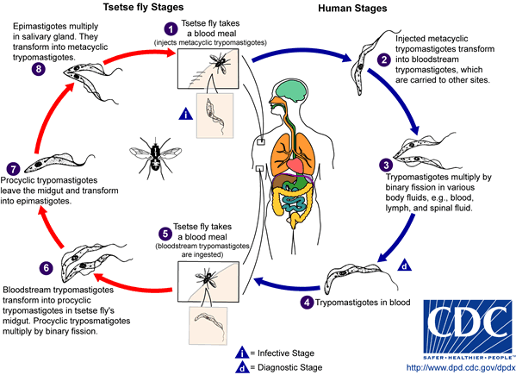Clinical features
Although both species cause sleeping sickness, the progress of the disease is different. T.gambiense induced disease runs a low-grade chronic course over a few years. One of the earliest signs of disease is an occasional ulcer at the site of the fly bite. As reproduction of organisms continues, the lymph nodes are invaded, and fever, myalgia, arthralgia, and lymph node enlargement results. Swelling of the posterior cervical lymph nodes is characteristic of Gambian sleeping sickness and is called winterbottom’s sign.
Chronic disease progresses to CNS involvement with lethargy, tremors, meningoencephalitis, mental retardation, and general deterioration. In the final stages, convulsions, hemiplegia, and incontinence occur. The patient becomes difficult to arouse or obtain a response from, eventually progressing to a comatose state. Death is the result of CNS damage and other infections, such as pneumonia. In T.rhodesiense, the disease caused is a more acute, rapidly progressive disease that is usually fatal.
Laboratory
Examination of thin and thick films, in concentrated anticoagulated blood preparations , and in aspiration from lymph nodes and concentrated spinal fluid.
Methods for concentrating parasites in blood may be helpful approaches including centrifugation of heparinized samples and an ion–exchange chromatography.
Prevention
• Control of breeding sites of tsetse flies and use of insecticides.
• Treatment of human cases to reduce transmission to flies.
• Avoiding insect bite by wearing protective clothing & use of screen, bed netting and insect repellants.

American trypanosomiasis
Trypanosoma cruzi is a pleomorphic trypanosome that includes an additional form of amastigote in its life cycle. The vector for transmission are reduviid bugs.
Pathogenesis
During the acute phase, the organism occurs in blood as a typical trypomastigote and in the reticuloendothelial cells as a typical amastigote. The amastigotes can kill cells and cause inflammation, consisting mainly of mononuclear cells. Cardiac muscle is the most frequently and severely affected tissue. In addition, neuronal damage leads to cardiac arrhythmias and loss of tone in the colon (megacolon) and esophagus (megaesophagus). In the chronic phase, the organism persists in the amastigote form.
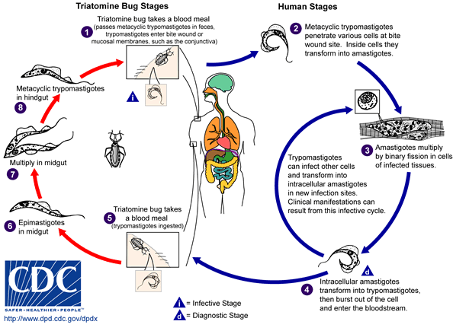
Clinical features
Chagas’ disease may be asymptomatic acute or chronic disease. One of the earliest signs is development at the site of the bug bite of an erythematous and indurated area called a chagoma. This is often followed by a rash and edema around the eyes and face; in young children frequently an acute process with CNS involvement may occur. Acute infection is also characterized by fever, chills, malaise, myalgia, and fatigue. The chronic Chagas’ disease is characterized by hepatosplenomegaly, myocarditis, and enlargement of the esophagus and colon. Death from chronic Chagas’ disease results from tissue destruction in the many areas invaded by the organisms, and sudden death results from complete heart block and brain damage.
Laboratory diagnosis
Examine thin or thick stained preparations for trypomastigotes. Wet preparations should also be examined to look for motile organisms that leave the blood stream and become difficult to find. Biopsy of lymph nodes, liver, spleen, or bone marrow may demonstrate organisms in amastigote stage.
Xenodiagnosis - which consists of allowing an uninfected, laboratory-raised
reduviid bug to feed on the patient and, after several weeks, examining the intestinal contents of the bug for the organism.
Prevention
• Bug control, eradication of nests
• Treating infected person & exclusion of donors by screening blood.
• Development of vaccine.
Medically important ciliates
Balantidium coli Balantidiasis
The intestinal protozoan is the only member of the ciliate group that is pathogenic for humans. Disease produced by B. coli is similar to
amebiasis, because the organisms elaborate proteolytic and cytotoxic substances that mediate tissue invasion and intestinal ulceration.
Life cycle
The life cycle of B. coli is simple, involving ingestion of infectious cysts,
excystation, and invasion of trophozoites into the mucosal lining of the large intestine, caecum, and terminal ileum. The trophozoite is covered with rows of hair like cilia that aid in motility. Morphologically more complex than amebae, B. coli has a funnel-like primitive mouth called a cytostome, a large (macro) nucleus and a small (micro) nucleus involved in reproduction.
Person-to-person spread, including through food handlers, has been implicated in outbreaks. Risk factors associated with human disease include contact with swine and substandard hygienic conditions.

Clinical features
As with other protozoan parasites, asymptomatic carriage of B. coli can exist.
Symptomatic disease is characterized by abdominal pain, tenderness, tenesmus, nausea, anorexia, and watery stools with blood and pus. Ulceration of the intestinal mucosa, as with amebiasis, can be seen; a secondary complication caused by bacterial invasion into the eroded intestinal mucosa can occur. Extra intestinal invasion of organs is extremely rare in balantidiasis.
Laboratory Diagnosis
Microscopic examination of faeces for trophozoite and cysts is performed. The trophozoite is very large, varying in length from 50 to 200μm and in width from to 70μm. The surface is covered with cilia.

COCCIDIA (SPOROZOA)
Coccidia are members of the class sporozoa,. The life cycle is characterized by an alternation of generations, i.e. sexual (gametogony) and asexual (schizogony) reproduction and most members of the group also share alternative hosts.
The locomotion of a mature organism is by body flexion, gliding, or undulation of longitudinal ridges. The genus Plasmodium that are the causes of malaria is the prototype of this class.
Plasmodium spp.
disease name: Malaria
There are four species normally infecting humans, namely, Plasmodium falciparum, Plasmodium vivax, Plasmodium ovale, and Plasmodium malariae.
Life cycle
The life cycle of malaria is passed in two hosts (alternation of hosts) and has sexual and asexual stage (alternation of generations).
Vertebrate host - man (intermediate host), where the asexual cycle takes place.The parasite multiplies by schizogony and there is formation of male and female gametocytes (gametogony).
Invertebrate host - mosquito (definitive host) where the sexual cycle takes place. Union of male and female gametes ends in the formation of sporozoites (sporogony).
The life cycle passes in four stages:
Three in man:
- Pre - erythrocytic schizogony
- Erythrocytic schizogony
- Exo- erythrocytic schizogony
One in mosquito - Sporogony
Introduction into humans - when an infective female Anopheles mosquito bites man, it inoculates saliva containing sporozoites (infective stage).
Pre- Erythrocytic schizogony - sporozoites reach the blood stream and within 30 minutes enter the parenchymal cells of the liver, initiating a cycle of schizogony. Multiplication occurs in tissue schizonts, to form thousands of tiny merozoites.
Merozoites are then liberated on rupture of schizonts about 7th – 9th day of the bites and enter into the blood stream. These merozoites either invade the RBC’s or other parenchymal liver cells.
Note: In case of P. falciparum and possibly P. malariae, all merozoites invade RBC’s without re-invading liver cells. However, for P. vivax and P. ovale, some merozoites invade RBC’s and some re-invade liver cells initiating further Exo-erythrocytic schizogony, which is responsible for relapses. Some of the merozoites remain dormant (hypnozoites) becoming active later on.
Erythrocytic schizogony (blood phase) is completed in 48 hrs in P. vivax, P.ovale, and P. falciparum, and 72 hrs in P. malariae. The merozoites reinvade fresh RBC’s repeating the schizogonic cycles
Erythrocytic merozoites do not reinvade the liver cells. So malaria transmitted by blood transfusion reproduces only erythrocytic cycle
Gametogony Some merozoites that invade RBC’s develop into sexual stages (male and female gametocytes). These undergo no further development until taken by the mosquito.
Sporogony (extrinsic cycle in mosquito)
When a female Anopheles mosquito vector bites an infected person, it sucks blood containing the different stages of malaria parasite. All stages other than gametocytes are digested in the stomach.
The microgametocyte undergoes ex-flagellation. The nucleus divides by reduction division into 6-8 pieces, which migrate to the periphery. At the same, time 6-8 thin filaments of cytoplasm are thrust out, in each passes a piece of chromatin. These filaments, the microgametes, are actively motile and separate from the gametocyte. The macrogametocyte by reduction division becomes a macrogamete. Fertilization occurs by entry of a micro gamete into the macro gamete forming a zygote.
The zygote changes into a worm like form, the ookinete, which penetrates the wall of the stomach to develop into a spherical oocyst between the epithelium and basement membrane. The oocystes increase in size. Thousands of
sporozoites develop inside the oocysts.
Oocysts rupture and sporozoites are liberated in the body cavity and migrate everywhere particularly to the salivary glands. Now the mosquito is infective
The sporogonous cycle in the mosquito takes 8-12 days depending on temperature
Plasmodium falciparum
Plasmodium falciparum demonstrates no selectivity in host erythrocytes, i.e. it invades young and old RBCs cells. The infected red blood cells also do not enlarge and become distorted.
• Multiple sporozoites can infect a single erythrocyte, and show multiple infections of cells with small ring forms.
• The trophozoite is often seen in the host cells at the very edge or periphery of cell membrane.
• Occasionally, reddish granules known as Maurer’s dots are observed
• Mature (large) trophozoite stages and schizonts are rarely seen in blood films, because their forms are sequestered in deep capillaries, liver and spleen.
• Peripheral blood smears characteristically contain only young ring forms and occasionally crescent shaped gametocytes.
Clinical features
Of all the four Plasmodia, P. falciparum has the shortest incubation period, which ranges from 7 to 10 days. After the early flu-like symptoms, P.falciparum rapidly produces daily (quotidian) chills and fever as well as severe nausea, vomiting and diarrhea. The periodicity of the attacks then becomes tertian (36 to 48 hours), and fulminating disease develops. Involvement of the brain (cerebral malaria) is most often seen in P.falciparum infection. Capillary plugging from an adhesion of infected red blood cells with each other and endothelial linings of capillaries causes hypoxic injury to the brain that can result in coma and death. Kidney damage is also associated with P.falciparum malaria, resulting in an illness called “black water” fever. Intravascular hemolysis with rapid destruction of red blood cells produces a marked hemoglobinuria and can result in acute renal failure, tubular necrosis, nephrotic syndrome, and death. Liver involvement is characterized by abdominal pain, vomiting of bile, hepatosplenomegally, severe diarrhea, and rapid dehydration.
Plasmodium vivax
P.vivax is selective in that it invades only young immature erythrocytes.
Infections of P. vivax have the following characteristics:
• Infected red blood cells are usually enlarged and contain numerous pink granules or schuffner’s dots.
• The trophozoite is ring-shaped but amoeboid in appearance.
• More mature trophozoites and erythrocytic schizonts containing up to 24 merozoites are present.
• The gametocytes are round
Clinical features
After an incubation period (usually 10 to 17 days), the patient experiences vague flu-like symptoms, such as headache, muscle pains, photophobia, anorexia, nausea and vomiting. As the infection progresses, increased numbers of rupturing erythrocytes liberate merozoites as well as toxic cellular debris and hemoglobin in to circulation. In combination, these substances produce the typical pattern chills, fever and malarial rigors. These paroxysms usually reappear periodically (generally every 48 hours) as the cycle of infection, replication, and cell lyses progresses.
Plasmodium malariae
In contrast with P.vivax and P.ovale, P.malariae can infect only mature erythrocytes with relatively rigid cell membranes. As a result, the parasite’s growth must conform to the size and shape of red blood cell.
This requirement produces no red cell enlargement or distortion, but it results in distinctive shapes of the parasite seen in the host cell, “band and bar forms” as well as very compact dark staining forms. The schizont of P.malariae is usually composed of eight merozoites appearing in a rosette.

Clinical features
The incubation period for P. malariae is the longest of the plasmodia, usually 18 to 40 days, but possibly several months to years. The early symptoms are flu-like with fever patterns of 72 hours (quartan or malarial) in periodicity.
Plasmodium ovale
P. ovale is similar to P. vivax in many respects, including its selectivity for young, pliable erythrocytes. As a consequence the classical characteristics include:
• The host cell becomes enlarged and distorted, usually in an oval form.
• Schiffner’s dots appear as pale pink granules.
• The infected cell border is commonly fimbriated or ragged
• Mature schizonts contain about 10 merozoites.
Clinical features
The incubation period for P.ovale is 16-18 days but can be longer. Clinically, ovale malaria resembles vivax malaria with attacks recurring every 48-50 hours. There are however, fewer relapses with P.ovale. Less than 2% of RBCs usually become infected.
Laboratory diagnosis
Microscopic examination of thick and thin films of blood is the method of choice for confirming the clinical diagnosis of malaria and identifying the specific species responsible for disease.
Malaria parasites in thick and thin blood films are best stained at pH 7.1 – 7.2 using a Romanowsky stain
The thick film is a concentration method that may be used to detect the presence of organisms. The thin film is most useful for establishing species identification.
Serologic procedures are available but they are used primarily for epidemiological surveys or for screening blood donors.
Prevention
• Chemoprophylaxis and prompt diagnosis and treatment.
• Control of mosquito breeding
• Protection of insect bite by screening, netting and protective clothing
• Use of insect repellents.
Toxoplasma gondii –
causes toxoplasmosis. The definitive host is the domestic cat and other felines. Humans and other mammals are intermediate hosts. T.gondii is usually acquired by ingestion and transplacental transmission from an infected mother to the fetus can occur. Human–to–human transmission, other than transplacental transmission, does not occur. After infection of the intestinal epithelium, the organisms spread to other organs, especially the brain, lungs, liver, and eyes. Most primary infections in immunocompetent adults are asymptomatic. Congenital infection can result in abortion, stillbirth, or neonatal disease with encephalitis, chorioretinitis and hepatosplenomegaly. Fever, jaundice, and intracranial calcifications are also seen. For the diagnosis of acute and congenital infections, an immunofluorescence assay for detection of antibody is used. Microscopic examination of Giemsa–stained preparations shows crescent–shaped trophozoite. Cysts may be seen in the tissue.
Cryptosporidium parvum –
causes cryptosporidiosis, the main symptom of which is diarrhea. It is most severe in immunocompromized patients, e.g., those with AIDS. The organism is acquired by faecal-oral transmission of Oocysts from either human or animal sources. The oocysts excyst in the small intestine, where the trophozoite (and other forms) attach to the gut wall. Invasion does not occur.
The jejunum is the site most heavily infested. The pathogenesis of the diarrhea is unknown; no toxin has been identified.
The disease in immunocompromized patients presents primarily as a watery, non-bloody diarrhea causing large fluid loss. Symptoms persist for long periods in immunocompromized patients, whereas self-limited in
immunocompetent individuals. Although immunocompromized patients usually do not die of cryptosporidiosis, the fluid loss and malnutrition are severely debilitating.
Diagnosis is made by finding oocysts in fecal smears when using a modified
acid–fast stain. Serological tests are not available. There is no effective drug therapy.

HELMINTHOLOGY
INTRODUCTION
Helminthes are trophoblastic metazoa (multi-cellular organisms).
They are the cause of high morbidity and mortality of people worldwide and cause different diseases in humans. Helminthes also cause economic loss as a result of infections of domestic animals.
The sources of the parasites are different. Exposure of humans to the parasites may occur in one of the following ways:
1. Contaminated soil (Geo-helminthes), water (cercariae of blood flukes) and food (Taenia in raw meat).
2. Blood sucking insects or arthropods (as in filarial worms).
3. Domestic or wild animals harboring the parasite (as in echinococcus in dogs).
4. Person to person (as in Enterobius vermicularis, Hymenolopis nana).
5. auto-infection as in Enterobius vermicularis.
They enter the body through different routes including: mouth, skin and the respiratory tract by means of inhalation of airborne eggs.
The helminthes are classified into three major groups.
These are:
A-Phylum Platyhelminthes (flat worms) contain tow classes
1. Trematodes (Flukes)
2. Cestodes (Tape worms)

B-Phylum Nemathelminthes: contain one class Nematodes (Round worms)
Trematodes (Flukes)
They are found in a wide range of habitats. The great majority inhabit the alimentary canal, liver, bile duct, ureter and bladder of vertebrate animals.
According to the sites they inhabit, there are four groups of flukes. These are:
1-Blood flukes
2- Intestinal flukes,
3- Liver flukes,
4-Lung flukes.
Characteristic
1. Most adult trematodes are dorsoventrally flattened, bilaterally symmetric, leaf-shaped or tongue-like.
2. All of them have two suckers, an oral and a ventral sucker.
3. The digestive tract is degenerate. The end of intestine is a cecum without anus.
4. The reproductive system is developed and hermaphroditic.
5. Excretory system includes flame cells, capillaries, collecting tubules and an excretory bladder.
6. Eggs of most species have an operculum (lid) and/or a small spine (knob). The developed egg contains a miracidium.
7. They are biohelminths. Only getting into fresh water can eggs develop. Their intermediate hosts are in water. 1st intermediate hosts are all snails and 2nd intermediate hosts varies from species.
8 Alternation of generations is present in their life cycles.9. Life cycle model: adult ---------- eggs---------- lay--------- hatch out----------miracidia------sporocysts--------- rediae-------cercariae------- metacercariae -------adult
10. Infetive stage is usually a metacercria
11. They have their reservoir hosts. The fluke diseases are zoonoses.

A. BLOOD FLUKES
These are flukes that reside mainly in the blood vessels of various organs and the schistosomes are the prototype and the commonest flukes in our country.
Schistosoma spp.
Disease name :SCHISTOSOMIASIS (BILHARZIASIS)
The schistosomes cause intestinal, hepatosplenic, pulmonary, urogenital, cerebral and other forms of schistosomiasis.
Schistosome is the only fluke with separate sexes. The female worm lies in the gynecophoral canal of the male. This condition is important for transportation.
There are five medically important species:
1. Schistosoma mansoni: causes intestinal schistosomiasis.
2. Schistosoma haematobium: causes vesical (urinary) schistosomiasis.
3. Schistosoma japonicum: causes intestinal schistosomiasis.
1- Schistosoma Mansoni
Habitat - This species lives in the veins of the intestine.
Morphology
Male: The male ranges in size from 1-1.4 cm in length and the body is covered by coarse tubercles. It has 6-9 testes
Female:The female is 1.5-2.0 cm in length. The ovary is present in the anterior third and Vitelline glands occupy the posterior two-thirds. It lays about 100-300 eggs daily. The uterus is short containing few ova.
2- Schistosoma haematobium (Urinary Scistosomiasis)
Habitat - The worm lives in the veins of the bladder of humans.
Male:The male ranges in size from 1-1.5 cm in length. The body is covered by fine tubercles. It has 4-5 testes.
Female:The female ranges in size from 2-2.5 cm in length. The ovary is present in the posterior third. Vitelline glands occupy the posterior thirds. Uterus is long containing many ova. It lays about 20-200 eggs daily.
3-Schistosoma Japonicum
The female adult worm lays about 500-3500 eggs daily. The eggs are ovoid, bearing only a minute lateral spine or a small knob postero-laterally. It is found in Japan, China, and Philippines, etc.
Life cycle of schistosomes
Adult worms reside in pairs: the female lying in the gynecophoral canal of the male. After fertilization, eggs are passed into the venules. A larval form – the miracidium - develops within the egg. Its lytic enzymes and the contraction of the venule rupture the wall of the venule liberating the egg into the perivascular tissues of the intestine (S. mansoni) or urinary bladder (S. haematobium). The eggs pass into the lumens and organs and are evacuated in the feces (S.mansoni) or the urine (S. haematobium). On contact with fresh water the miracidia hatch from the eggs and swim about until they find the appropriate snail, which they penetrate. After two generations of sporocyst development and multiplication within the snail, the fork-tailed cercariae emerge. Infection to man takes place during bathing or swimming. The cercariae penetrate the skin, are carried into the systemic circulation and pass through to the portal vessels.
Within the intrahepatic portion of the portal system, the worms feed and grow to maturity.
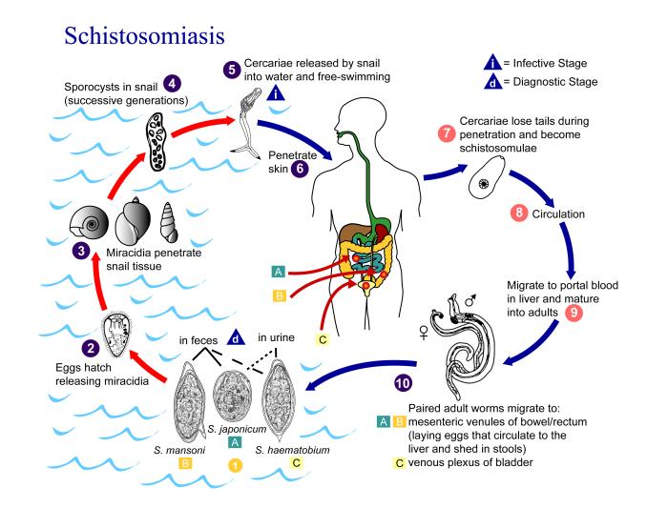
Symptoms and complications
Patients infected with S. haematobium suffer from terminal haematuria and painful micturition. There is inflammation of the urinary bladder (cystitis), and enlargement of spleen and liver.
Patients infected with S. mansoni suffer from cercarial dermatitis (swimmers itch) and dysentery (mucus and blood in stool with tenesmus) as well as enlargements of the spleen and liver.
S. haematobium causes squamous cell carcinoma in the bladder.
Laboratory Diagnosis
S. mansoni
♦ Microscopic examination of the stool for eggs after concentration by sedimentation method. The egg has characteristic lateral spine.
♦ Rectal snip
S. haematobium:
♦ Examination of the urine after allowing it to sediment in a conical urinalysis glass. A drop from the sediment is taken and examined for eggs. Egg has terminal spine.
♦ Biopsy from bladder
Prevention:
1. Health education:
A. On use of clean latrines and safe water supply B. Avoid urination and defecation in canals, avoid contact with canal water
2. Snail control:
A. Physical methods:
i. Periodic clearance of canals from vegetations.
ii. Manual removal of snails and their destruction.
B. Biological methods: Use of natural enemies to the snails such as
Marisa.
C. Chemical methods: Molluscides are applied in the canals to kill the snails. e.g. Endod
B- INTESTINAL FLUKES
Most intestinal flukes are hermaphroditic and most of the body consists of reproductive organs and their associated structures. The digestive system is well developed; they generally feed on intestinal debris, blood, mucus and other tissues, depending on the host environment.
♦ Fasciolopsis buski:
These giant intestinal flukes (2-7.5 cm in length) are found in some Asian countries. The Giant Intestinal Fluke
- Epidemiology - Found in orient Asian country.
- Life cycle - Humans infected through ingestion of metacercaria on uncooked water plants. Encysted metacercariae hatch & attach to intestinal wall, develop into adult worms; eggs pass in feces .
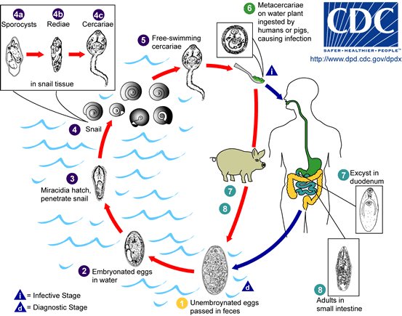
- Diagnosis - Demonstrating eggs in feces specimens. Eggs are difficult to differentiate from those of Fasciola hepatica.
- Morphology of eggs:Oval, yellow-brown eggs measure 150 x 90 microns. Operculum - the transparent shell has an operculum (sometimes seen “popped open”).
- Major pathology - adult worms attach to the intestinal wall, producing local inflammation possibly leading to hemorrhage, ulceration and abscess formation. Absorption of worm metabolites can produce toxic or allergic reactions (edema, ascites).
♦ Heterophyes heterophyes: Minute flukes acquired by ingestion of raw fresh water fish.
Life cycle:
- Humans eat undercooked fish containing the metacercaria.
- Adults develop in the intestine, mature and lay eggs.
- Eggs in water are consumed by first intermediate host (snail). Cercariae develop in the snail.
- Released cercariae penetrate the second intermediate host (fish), migrate to muscles and transform into infective metacercariae.
Diagnosis: Recovery and identification of eggs in feces.
Pathology - Asymptomatic in light infections. Chronic mucous diarrhea and abdominal pain in heavy infections. Eggs may travel into tissue causing granulomas and other tissue disorders.

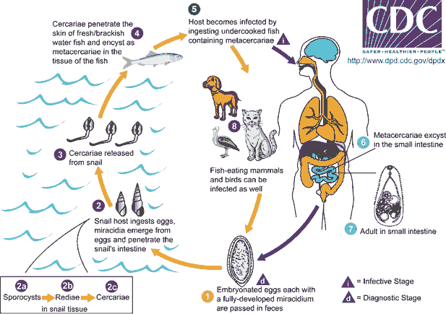

C- LIVER FLUKES
♦ Clonorchis sinensis: Chinese liver fluke - adult worms live in bile ducts. The infections result from eating raw or half-cooked fresh water fish and shrimps. The worms blocking the bile passages cause clonorchiasis, which finally may become the biliary cirrhosis.
Symptoms and complications
(1) Light infection: no symptoms
(2) General case: poor appetite, fullness in abdomen, diarrhea, physical weakness, hepatic pain, hepatomegaly.
(3) Severe case: icterus (jaundice), systemic toxemia, chill, fever, vomiting, vertigo, mental disorder, emaciation, ascites. The patients die of coma, infective complications, hemorrhage of upper part of digestive tract.
(4) In child case: physical and mental growths are retarded (dwarf).
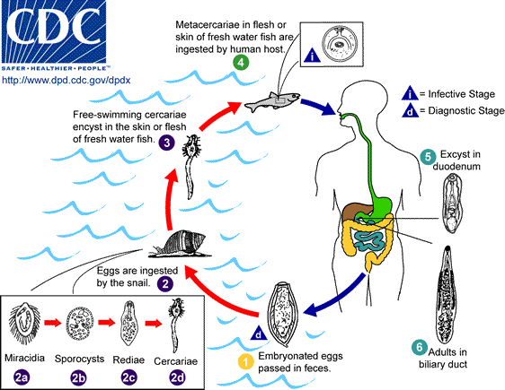
♦ Faciola hepatica:
Sheep liver fluke - is a common parasite, cosmopolitan in distribution. It is large (3 cm in length). Adult worms reside in the large biliary passages and gall bladder.
Distribution: endemic in Far East.
Localization: bile ducts, gallbladder, and pancreas.
Morphology: large size (3-5 cm) and conical form of the body
sucking disks (oral and abdominal)
Multibranched uterus is situated under the abdominal sucking disk.
Testis are branched too and located in the middle part of the body.
Life-cycle:
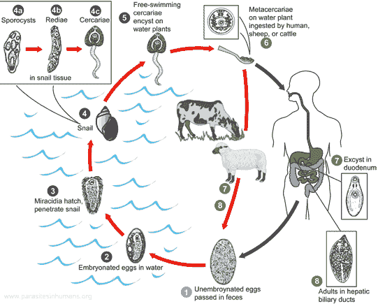
Final host - herbivorous mammals (horses) and humans.
Intermediate host — the snail Limnea truncatula.
Transmission: fecal-oral
Invasive stage: adolescariae.
Clinical disease: Parasites obstruct bile ducts and lay eggs within them, leading to cholelithiasis (gallstones).
Biliary obstruction can occur, sometimes causing biliary cirrhosis.
Diagnosis: immature eggs in feces.
Prevention: involves not eating wild aquatic vegetables.

D-LUNG FLUKES
Paragonimus westermani,
Best known species, affects man causing paragonimiasis (lung disease). It is found in Asia .
Morphology: an egg-like form of the body, from 7,5 to 16 mm.
Mode of transmission: ingestion of metacercarial cysts in crabs or crayfish.
Final hosts: carnivorous mammals, pigs, humans.
Intermediate hosts:
1) snail (sporocyst, redia, cercaria);
2) crabs or crayfish (metacercaria).
Infective stage: metacercariae
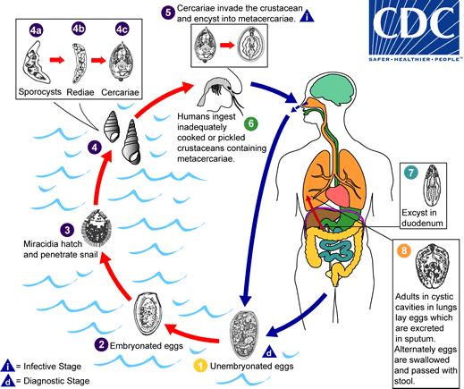
Clinical disease: a chronic cough with bloody sputum, dyspnea, pleuritic chest pain, and pneumonia.
Laboratory diagnosis: eggs in sputum or feces.
Prevention: cooking crabs and crayfish properly.
The general Life cycle of trematoda
The life cycles of Fasciolopsis , Heterophysis, Fasciola, Clonorchis, Paragonimus species are complex, requiring more than one intermediate host.
Adult worms inhabit the intestine liver or bile ducts and lung respectively of the definitive host (human), where they lay many eggs which are deposited into the environment in the feces. They are immature when passed. If they are passed into water they become mature in nine to 15 days at the optimum temperature of 22-25°C.
While the details vary with each species, the general life cycle stages are:
- Egg – discharged either in open water or in intestine of definitive host
- Miracidium (plural miracidia) – a free-living motile form, ciliated larva, and settles in the Mollusca (snail intermediate host) to become a sporocyst.
- Sporocyst – an elongated sac, it produces either rediae or more sporocysts.
- Redia (plural rediae) – a larval form with an oral sucker, it will produce either more rediae, or cercariae.
- Cercaria (plural cercariae) – the larval form of the parasite, it develops within the germinal cells of the sporocyst or redia. A cercaria has a tapering head with large penetration glands. It may or may not have a long swimming "tail", depending on the species. The motile cercaria finds and settles in a host where it will become either an adult, or a metacercaria, according to species.
  - Metacercaria – a cercaria encysted and resting
Then they penetrate the skin of another intermediate host may encyst in muscle and wait to be consumed by the definitive host or may leave the intermediate host to actively search for the definitive host.
  - Adult – the fully developed mature stage, it is capable of sexual reproduction and produces eggs.
The immature eggs pass in their feces. The next part of the life cycle occurs in freshwater. After several weeks, the eggs hatch, producing a parasite form known as the miracidium, which then infects a snail host. Under optimal conditions, the development process in the snail may be completed in 5 to 7 weeks; cercariae are then shed in the water around the snail. The cercariae lose their tails when they encyst as metacercariae (infective larvae) on water plants or fishes or crecetian . In contrast to cercariae, metacercariae have a hard outer cyst wall and can survive for prolonged periods in wet environments.

Class: Cestodes (Tapeworms)
Introduction
1-The tape worms are hermaphroditic and require an intermediate host.
2- The adult tapeworms found in humans have flat body, white or grayish in color.
3- They consist of an anterior attachment organ or scolex and a chain of segments
(proglottids) also called strobilla.
4-The strobilla is the entire body except thescolex.
5- The scolex has suckers or grooves. It has rosetellum, which has 1 or 2 rows of hooks situated on the center of the scolex.
Adult tapeworms inhabit the small intestine, where they live attached to the mucosa.
6-Tapeworms do not have a digestive system. Their food is absorbed from the host’s intestine.
Have tow order

1-Order:-Cyclophyllidea
Cyclophyllidea are the most important cestode parasites of humans and domesticated animals. All have multiple proglottid "segments," and all have four suckers on their scolex ("head"), though some may have other structures as well. Proglottids of this order have genital openings on one side (except in the family Dilepididae, which has genital openings on both sides),
Families include:
- Dipylidiidae the most important member of which is Dipylidium caninum, also called the "cucumber tapeworm" or the "double-pore tapeworm"
- Hymenolepididae, with the most important genus being Hymenolepis.
- Taeniidae, which consists of livestock parasites in the genus Taenia and parasites that encyst in humans of the genus Echinococcus.

2-Order:-Pseudophyllidea
Pseudophyllidea are a kind of flatworm with multiple "segments" (proglottids) and two bothria or "sucking grooves" as adults. Proglottids are identifiably pseudophyllid as the genital pore and uterine pore are located on the mid-ventral surface, and the ovary is bilobed ("dumbbell-shaped").
Eggs have one flat end (the operculum). All pseudophyllid cestodes have a procercoid stage in their life cycle, and most also have a plerocercoid stage.

Dipylidium caninum
A Dipylidium caninum also called the cucumber tapeworm or the double-pore tapeworm ,adult is a long flat worm, around 40 to 50 cm. The body is made up of the head or scolex, the neck, and a segmented section called the strobilus
Most common tapeworm of dogs and cats (Worldwide) ,
- Scolex with retractable armed rostellumand (scolex has a rostellum with four rows of hooks)4 suckers .
- Strobila made of oval proglottids with bilateral genital pores .
- The body is made up of the head or scolex, the neck, and a segmented section called the strobilus.

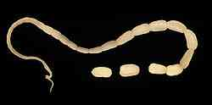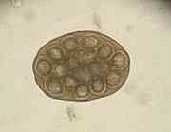
Life cycle
lives in the small intestine of the definite host (Canids & Felids ).
Gravid proglottidspassed in feces
Ova disseminated in the environment by the motile proglottid, each proglottids contains eggs packets enveloped by an outer embryonic membrane; each packet contains about 20 embryonated eggs.
■ Larval fleas become infected by ingesting the eggs. Following ingestion an hexacanth embryo is releases and cysticercoid develops in the body cavity of the flea.
■ When the dog (or human) ingests an infected flea, after the evertion of the scolex the parasite attaches to the small intestine and develop to the adult worm forming proglottids in about 1 month.
The worm produces proglottids. The gravid proglottids detach and migrate to the anus or are passed in the stool.
Mild gastrointestinal symptoms and eosinophilia are the common findings.

Clinical Manifestations In children, infection causes diarrhea and restlessness.
Diagnosis:
1- Detection The egg or gravid segment in feces

2-Detection of antigens in feces by ELISA is currently the best available technique.

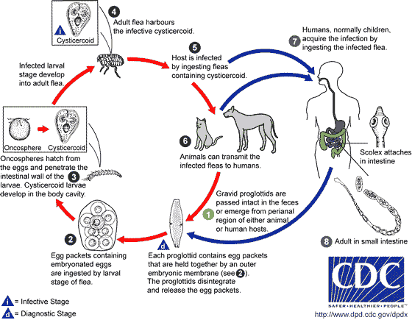

Hymenolepis Nana (Dwarf Tapeworm)
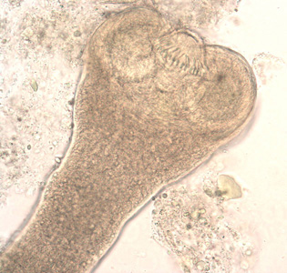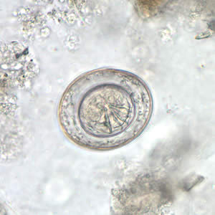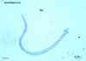
Morphology
Adult worm measures 1-3 cm in length. It is made up of head (scolex), neck and segmented body. The head carries four suckers and a rostellum armed with one row of hooks. The segments of the body are divided into mature and gravid segments. In the mature segment, there are three testes in the middle.
Life cycle:
The egg, which is immediately infective when passed by the patient, it contains a six- hooked oncosphere within a rigid membrane (the embryosphere). This embryo sphere has two polar thickening or knobs from thin filaments called polar filaments. Eggs of Hymenolepis nana are immediately infective when passed with the stool and cannot survive more than 10 days in the external environment . When eggs are ingested by an arthropod intermediate host (various species of beetles and fleas may serve as intermediate hosts), they develop into cysticercoids, which can infect humans or rodents upon ingestion and develop into adults in the small intestine. When eggs are ingested (in contaminated food or water or from hands contaminated with feces), the oncospheres contained in the eggs are released. The oncospheres (hexacanth larvae) penetrate the intestinal villus and develop into cysticercoid larvae . Upon rupture of the villus, the cysticercoids return to the intestinal lumen, evaginate their scoleces , attach to the intestinal mucosa and develop into adults that reside in the ileal portion of the small intestine producing gravid proglottids . Eggs are passed in the stool when released from proglottids through its genital atrium or when proglottids disintegrate in the small intestine. The life span of adult worms is 4 to 6 weeks, but internal autoinfection allows the infection to persist for years.

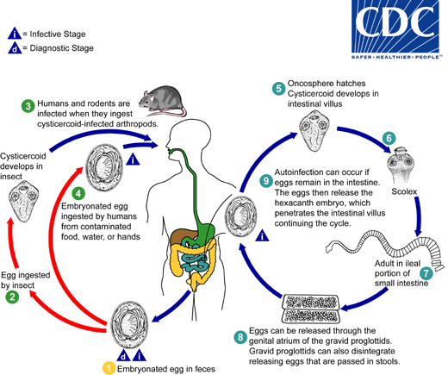
Infective stage and mode of infection
Infection takes place by:
1. Ingestion of egg with contaminated raw vegetables.
2. Direct infection from a patient
3. Auto infection: the eggs of H. nana are infective as soon as they are passed with feces by the patient. If the hands of the patient are contaminated by these eggs, she/he infects herself/himself again and again.
Pathogenecity
Light infections produce no symptoms. In fairly heavy infections, children may show lack of appetite, abdominal pain and diarrhea.
Hymenolepis diminuta (Rat Tapeworm)
Hymenolepis diminuta differs from Hymenolepis nana in that:
♦ The adult worm measures about 10-60 cm
♦ The rosetellum on the head has no hooks
♦ In the mature segment, there are two testes at one side and another testis on the other side.
Pathogenecity
Most infections are asymptomatic, but occasionally, patients may present with nausea, anorexia and diarrhea.
Egg of H. diminuta in an unstained wet mount. Four hooks are clearly visible at this level of focus
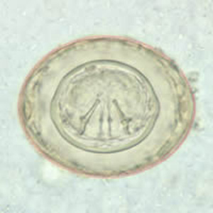
ECHINOCOCCUS
There are two different species. These are: Echinococcus granulosus and
Echinococcus multilocularis
Echinococcus granulosus (dog tape worm)
Responsible for most cases of echinococcosis. Echinococcosis is caused by larval tapeworms.
Morphology
The adult worm measures 3-6 mm in length (up to 1 cm). It has scolex, neck and strobilla. Adult worms live in small intestine of definitive host (dog). Man is an intermediate host - carrying the hydatid cyst (larva). Man contracts infection by swallowing eggs in excreta of definitive host.
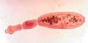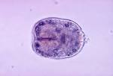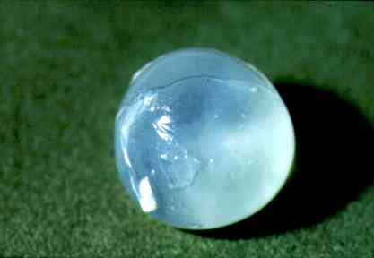
Life cycle
The adult Echinococcus granulosus (3 to 6 mm long) resides in the small bowel of the definitive hosts, dogs or other canids. Gravid proglottids release eggs that are passed in the feces. After ingestion by a suitable intermediate host (under natural conditions: sheep, goat, swine, cattle, horses, camel), the egg hatches in the small bowel and releases an oncosphere that penetrates the intestinal wall and migrates through the circulatory system into various organs, especially the liver and lungs. In these organs, the oncosphere develops into a cyst that enlarges gradually, producing protoscolices and daughter cysts that fill the cyst interior. The definitive host becomes infected by ingesting the cyst-containing organs of the infected intermediate host. After ingestion, the protoscolices evaginate, attach to the intestinal mucosa , and develop into adult stages in 32 to 80 days.
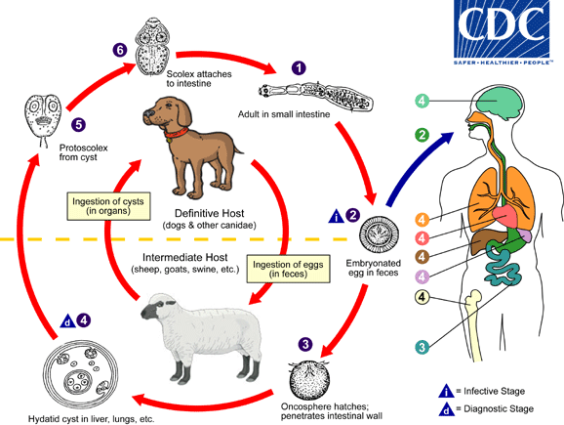
Pathogenecity
Oncosphere hatch in duodenum or small intestine into embryos (oncosphere) which:
♦ Penetrate wall
♦ Enter portal veins
♦ Migrate via portal blood supply to organs: eg: lungs, liver, brain etc., thus, causing extra intestinal infections. In these organs, larvae develop into hydatid cysts. The cysts may be large, filled with clear fluid and contain characteristic protoscolices (immature forms of the head of the parasite). These mature into developed scolices, which are infective for dogs.

Mode of human infection
Ingestion of eggs by the following ways:
i) Ingestion of water or vegetables polluted by infected dog feces.
ii) Handling or caressing infected dogs where the hairs are usually contaminated with eggs.
Clinical features
Asymptomatic infection is common, but in symptomatic patients
♦ It may cause cough - with hemoptysis in lung hydatid disease.
♦ Hepatomegaly - with abdominal pain and discomfort
♦ Pressure -from expanding cyst
♦ Rupture of cyst - severe allergic reaction - anaphylaxis.
Diagnosis:
♦ X-ray or other body scans
♦ Demonstration of protoscolices in cyst after operation
♦ Serology
Echinococcus multilocularis
Foxes are the definitive hosts, while various rodents such as mice serve as intermediate hosts.
Taenia saginata (Beef Tapeworm)
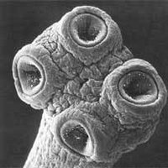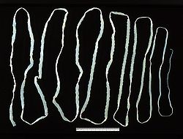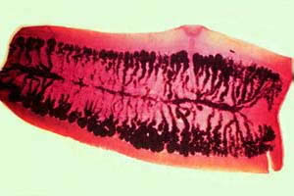
In adult stage, T. saginata inhabits the upper jejunum where it may survive for as long as 25 years. It causes intestinal infection, Taeniasis. It has worldwide distribution.
These are one of the true and segmented tapeworms. Their body is divided into three regions;
1. Scolex: the hold fast organ
2. Neck: posterior to the scolex
3. Stobilla: the main bulk, made up of proglottids.
Morphology:
Adult worm measures 5-10 meters in length. The pyriform scolex has 4 suckers but no rostellum. The mature segments have irregularly alternate lateral genital pores. Each of the terminal segments contains only a uterus made up of a median stem with 15-30 lateral branches.
Life cycle
The adult worm lives in the small intestine of man. Gravid segments pass out in the stool and become disintegrated and eggs come out to the soil. The gravid proglottid uterus contains about 100,000 eggs. The egg of T. saginata is round, about 40 microns in diameter. The 6-hooked embryo is enclosed in a radially striated embryophore. Eggs are ingested by an intermediate host, cattle. The 6- hooked embryo escapes from its shell, penetrates through the intestinal wall into the blood vessels and is carried to the muscles where it develops into a larval stage, cysticercus bovis (made up of an invaginated /inverted head and spherical body). Infection to man takes place by the ingestion of raw or insufficiently cooked beef. In the small intestine of man, the head of the cysticercus gets invaginated and the body becomes segmented.
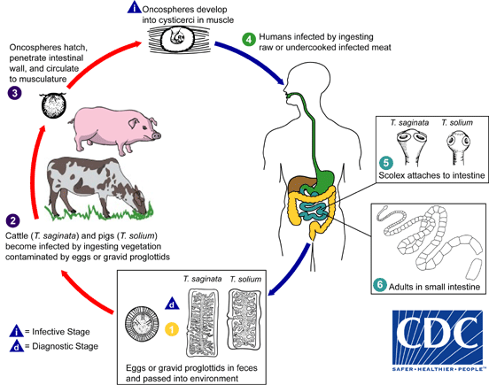
Pathogenecity
Infected persons may complain of epigastric pain, abdominal discomfort, diarrhea, weight loss, hunger sensation, vomiting, etc.
Diagnosis
Recovery of the gravid segments or the eggs from the stool
Prevention:
♦ Thorough cooking of meat (above 570C).
♦ Proper disposal of human excret
Taenia solium (Pork Tapeworm)
The adult worms of T. solium reside or inhabit the upper jejunum. Infection has worldwide distribution.
Morphology: Adult worm measures about 3 meters in length. The globular scolex has rostellum with 2 rows of hooklets. There are <1000 proglottids. Gravid proglottid liberates about 30,000-50,000 eggs.
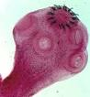
Life cycle Embryonated eggs passed with stool are ingested by pig and the embryo is released. It penetrates the intestinal wall and is carried by vascular channels to all parts of the body. After a period of 2-3 months of development the encysted larval stage called cysticerci or bladder worm occurs in the striated muscles of the tongue, neck, trunk brain, eye, and the nervous system. The cysticercus survives for 5 years. Humans become infected by eating pork containing larvae, cysticercus cellulosae. When improperly cooked cysticercus infected meat is eaten by man, the scolex remains undigested and attaches itself to the intestinal wall and chain of proglottids begin to grow to adult worm.
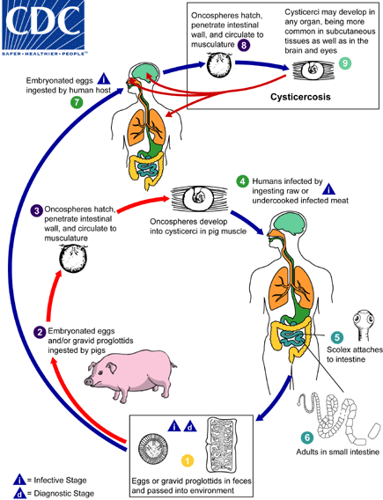
Clinical manifestations
Resembles that of T. saginata infection
Diagnosis
Demonstration of eggs in stool specimen
Prevention:
♦ Treatment of infected persons.
♦ Thorough cooking of pork and proper processing
♦ Proper disposal of human excreta (good hygiene/sanitation).
Comparison between Taenia saginata and Taenia solium species
Taenia saginata Taenia solium
Length (m) 5-10 2-3
Proglottid number 1000-2000 800-900
Hooklets Absent Present
Suckers Pigmented Non- Pigmented
Uterus branch 15-30 5-10

Multiceps multiceps
The body of Multiceps multiceps, which is 4–10 cm long and as wide as 5 mm, consists of 200–250 segments. The scolex has four suckers and a proboscis with 22–32 hooks arranged in two rows. Sexually mature multicepses parasitize in the intestines of dogs and other canines. It is a cestode of cosmopolitan distribution and causes coenuriasis in man. The dog is the common definitive host in the USA and UK. With the intermediate stages developing in many ungulates, especially sheep.
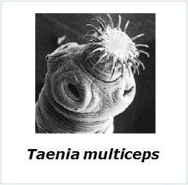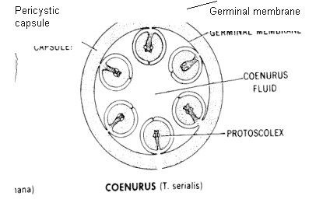
The last segments of the body, which contain the uterus with 20,000–60,000 eggs with developing larvae (oncospheres), fall off upon maturing and are excreted with the dog’s feces. In the alimentary tract of the intermediate host (sheep or, less commonly, other animals or man), the oncosphere emerges from the egg, enters the blood, and is carried by the blood to the brain, where it changes into one of the larval forms of the taeniids, the coenurus. The coenurus causes a serious disease called coenurosis (gid) in sheep and in dogs that have eaten the brains of these sheep.
. Eggs and gravid proglottids are shed in feces into the environment , where they are ingested by an intermediate host . Many animals may serve as intermediate hosts, including rodents, rabbits, horses, cattle, sheep and goats. Eggs hatch in the intestine, and oncospheres are released that circulate in blood until they lodge in suitable organs (including skeletal muscle, eyes, brain and subcutaneous tissue). After about three months, oncospheres develop into coenuri. The definitive host becomes infected by ingesting the tissue of an infected intermediate host containing a coenurus . The adult cestodes reside in the small intestine of the definitive host, . Humans become infected after the accidental ingestion of eggs on fomites or in food and water contaminated with dog feces . Eggs hatch in the intestine, and oncospheres are released that circulate in blood until they lodge in suitable organs and after about three months develop into coenuri .

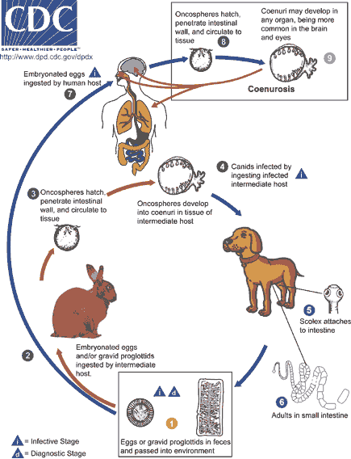

Clinical Disease In humans, coenuri are most frequently found in the brain and spinal cord but also in the subcutaneous tissue. Symptoms include headache, vomiting, paraplegia seizures and eye problems. The coenurus may cause serious damage or even death, but only a few have ever been reported.

Diagnosis There are no serological tests available.
Diphylobotrium latum (fish tapeworm or broad tapeworm
The broad tapeworm infecting man has worldwide distribution, occurring in areas where improperly cooked or raw fresh water fish is prominent in diet.
Morphology
Diphylobotrium latum is the broadest and longest tapeworm. The adult worm measures up to 30 feet with 3000-4000 proglottids, which are wider than they are long. The tapeworm has no rostellum hooks or suckers.
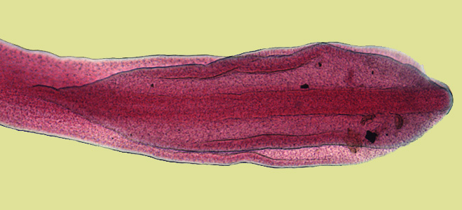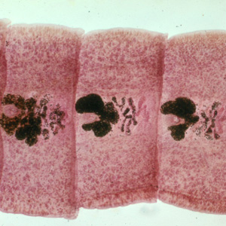
Life cycle
Unlike Taenia, the gravid segments are retained by the worm. Operculated eggs passed in feces hatch into small ciliated coracidium larvae which swim about freely. These are eaten by crustaceans -Cyclops or Diaptomus - in which the larvae develop into second stage larvae- the procercoid. When the crustaceans are swallowed by fresh water fish, the larvae migrate into the flesh of the muscle fish and develop to pleurocercoid or sparganum larvae. Humans are infected by ingesting raw or improperly cooked fish. The tapeworm matures in the intestine and after 3 weeks, the adult worm discharges eggs. The life cycle requires two intermediate hosts.
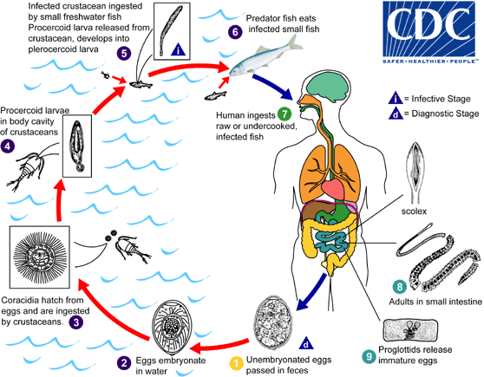

Clinical manifestation
Most infections are asymptomatic. Rarely, it causes severe cramping, abdominal pain, vomiting, weakness and weight loss. Pernicious anemia can also result, due to interference of vitamin B12 absorption in jejunum.
Diagnosis
Eggs in stool: Single shell with operculum at one end and a knob on the other.
Prevention:
Prohibiting the disposal of untreated sewage into fresh water /lakes.
Personal protection: cooking of all fresh water fish.

Nematodes (Round Worms)
All the important human parasites of the Phylum Nemathelminthes
(Aschelminthes) belong to the Class Nematoda.
General characteristics of nematodes
They are :-
1- un-segmented, elongated and cylindrical.
2- They have separate sexeswith separate appearances.
3-They have a tough protective covering or cuticle.
4-They have a complete digestive tract with both oral and anal openings.
5-The nematodes are free living (Majority) or parasites of humans, plants or animals.
The parasitic nematodes:
The nematodes are generally light cream-white colored. Their life cycle includes: egg, larvae and adult.
The parasitic nematodes are divided into:
1. Intestinal nematodes
1.1. Intestinal nematodes with tissue stage
A. Ascaris lumbricoides
B. Hookworms
C. Strongyloides stercoralis
1.2. Intestinal nematodes without tissue stage
A. Enterobius vermicularis
B. Trichuris trichuira.
2. Tissue and blood dwelling nematodes
2.1. Filarial worms
2.2. Dracunculus medinensis
2.3. Trichinella
2.4. Larva migrans.
1. Intestinal nematodes with tissue stage:
Ascaris lumbricoides
These are common roundworms infecting more than 700 million people worldwide.
Morphology:
Male adult worm measures 15-20 cm in length. The posterior end is curved ventrally. The female worm measures 20-40 cm in length. Its posterior end is straight.
Infective stage and modes of infection:
The egg containing larva when ingested with contaminated raw vegetables causes ascariasis.
Life cycle:
Ingested eggs hatch in the duodenum. The larvae penetrate the intestinal wall and circulate in the blood. From the heart they migrate to the lungs, ascend to the trachea, descend to the esophagus and finally reach the small intestine to become adult. The female pass immature eggs which pass to the soil and mature in 2 weeks.
Life Cycle

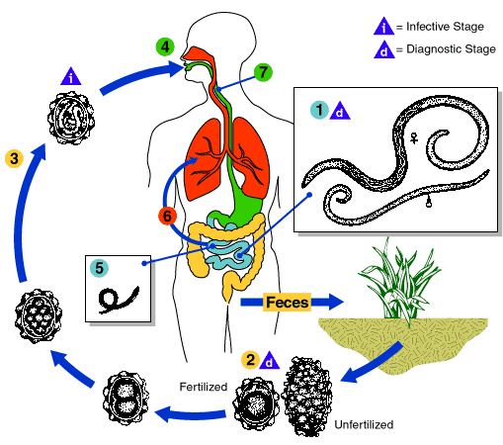

Adult worms live in the lumen of the small intestine. A female may produce up to 240,000 eggs per day, which are passed with the feces . Fertile eggs embryonate and become infective after 18 days to several weeks , depending on the environmental conditions (optimum: moist, warm, shaded soil). After infective eggs are swallowed , the larvae hatch , invade the intestinal mucosa, and are carried via the portal, then systemic circulation to the lungs . The larvae mature further in the lungs (10-14 days), penetrate the alveolar walls, ascend the bronchial tree to the throat, and are swallowed . Upon reaching the small intestine, they develop into adult worms . Between 2 and 3 months are required from ingestion of the infective eggs to oviposition by the adult female. Adult worms can live 1 to 2 years.
Pathogenecity and clinical features
1-Adult worm
- Light infection asymptomatic.
- Heavy infection may cause intestinal obstruction
- Migrating adult to bile duct may cause jaundice
2-Larvae: Loefflers syndrome :
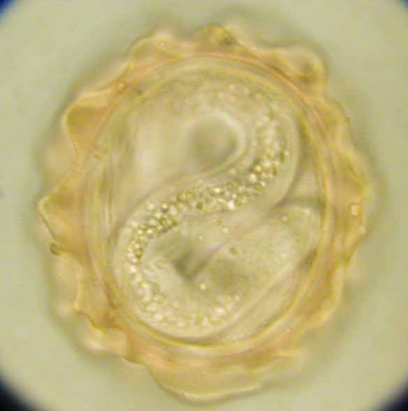
Pneumonia,cough with bloody sputum, Eosinophilia, urticaria
Diagnosis
1. Examination of stool for eggs by direct saline smear method. The egg is
ovoidal, 75x60 microns, covered by albuminous mamillatins.
2. Demonstration of adult worms
Hook Worms
There are two species of hookworm:
1. Ancylostoma duodenale
2. Necator americanus
The adults are found in the small intestines of man. Mixed infection is common.
Both of the species are found in Ethiopia, but N. americanus is more common.
1. Ancylostoma duodenale:
Grayish-white in color. The body is slightly ventrally curved. The anterior end follows the body curvature. The buccal cavity is provided ventrally with pairs of teeth and dorsally with a notched dental plate.
Morphology
Male: The male measures 10 cm in length. The posterior end is broadened into a membraneous copulatory bursa that is provided with two long spicules.
Female: The female measures 12 cm in length. The posterior end is straight.
2. Necator americanus
This species, so called American hookworm, is found in predominantly the tropics. The anterior end is hooked against the body curvature. The mouth is provided ventrally and dorsally with cutting plate.
Morphology
Male: The male measures 8 cm in length. The posterior end is broadened into a membraneous copulatory bursa, which is provided with two long spicules fused distally.
Female: The female measures 10 cm in length. The posterior end is straight
Infective stage and methods of infection:
The filariform larva infects by skin penetration.
Life cycle
Eggs are passed in the stool , and under favorable conditions (moisture, warmth, shade), larvae hatch in 1 to 2 days. The released rhabditiform larvae grow in the feces and/or the soil , and after 5 to 10 days (and two molts) they become filariform (third-stage) larvae that are infective . These infective larvae can survive 3 to 4 weeks in favorable environmental conditions. On contact with the human host, the larvae penetrate the skin and are carried through the blood vessels to the heart and then to the lungs. They penetrate into the pulmonary alveoli, ascend the bronchial tree to the pharynx, and are swallowed . The larvae reach the small intestine, where they reside and mature into adults. Adult worms live in the lumen of the small intestine, where they attach to the intestinal wall with resultant blood loss by the host . Most adult worms are eliminated in 1 to 2 years, but the longevity may reach several years.
Pathogenecity
1. Larval migration
(1) Dermatitis, known as "ground itch" or "stool poison".The larvae penetrating the skin cause allergic reaction, petechiae 0r papule with itching and burning sensation. Scratching leads to secondary infection.
(2) pneumonitis (allergic reaction), Loeffier's syndrome: cough, asthma, low fever, biood-tinged sputum or hemoptysis, chest-pain, inflammation shadows in lungs under X-ray. These manifestations go on about 2 weeks.
2. Adults in small intestine
(1) Epigastric pain as that of a duodenal ulcer.
(2) A large worm burden results in microcytic hypochromatic anemia (character manifestation). The symptoms are lassitude, edema, palpitation of the heart. In severe case, death may result from cardiac failure or physical exhaustion.
(3) Allotriophagy (orpica) is due to the lack of trace element iron .
(4) Amenorrhea, sterility, abortionmay take place in women.
(5) Gastrointestinal bleeding
(6) Infantile hookworm disease

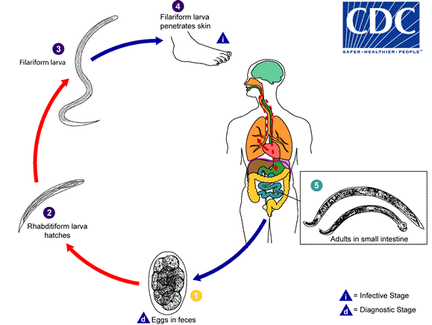

Diagnosis: Examination of stool by direct saline smear to detect the eggs.
A. duodenale N. americanus
______________________________________________________
Size larger smaller
______________________________________________________
Shape single curve, looks like C double curves, looks like S
______________________________________________________
Mouth 2 pairs of ventral teeth 1peir of ventral cutting plates
____________________________________________________________
Copulatory circle in shape oval in shape
Bursa (a top view) (a top view)
____________________________________________________________
Copulatory 1pair with separate 1pair of which unite to form
spicule endings a terminal hooklet
_______________________________________________________
caudal spine present no
_______________________________________________________
vulva position post-equatorial pre-equatorial
_______________________________________________________

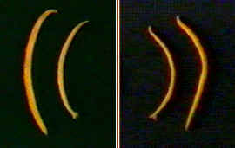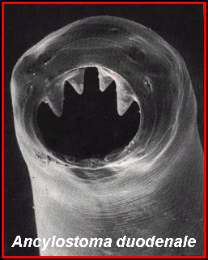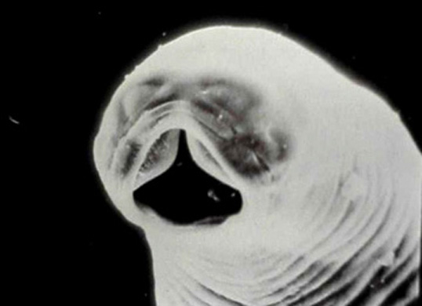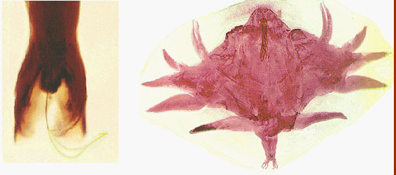
Prevention
Unified measures: 1. sanitary disposal of night soil, 2. individual protection, 3. health education, 4. cultivate hygienic habits, 5. treat the patients and carriers.
Strongyloides stercoralis
The worms may be present as parasitic in the host or free living in the soil.
Morphology:
Male: The male measures1 mm in length with curved posterior end and carries two spicules
Female: The female measures 2.5 mm in length with straight posterior end.
Infection: follows skin penetration by filariform larvae.
Life cycle
-Larvae passed into soil in human feces where mature in several days to skin invasive (filariform) larvae.
- Larvae penetrate skin, move via blood vessels to lung, invade airspace, move up bronchi, are swallowed, and then penetrate small intestinal mucosa where they mature to adults in submucosa.
- They deposit eggs in submucosa and these hatch and migrate into intestinal lumen.
- Small numbers of larvae get into blood vessels and circulate again to produce more adults (internal autoinfective cycle) or invade perianal skin and enter blood vessels to eventually produce new adults (external autoinfective cycle).
Note: - Can exist for months in soil "free living" by completing life cycle without contact with human host man.
If the environmental conditions are favorable, the larvae will come out with the stool to the soil. They transform into adults male and female worms live in the soil, after fertilization, the female lay eggs, and hatching larvae get transformed to adults and so on.
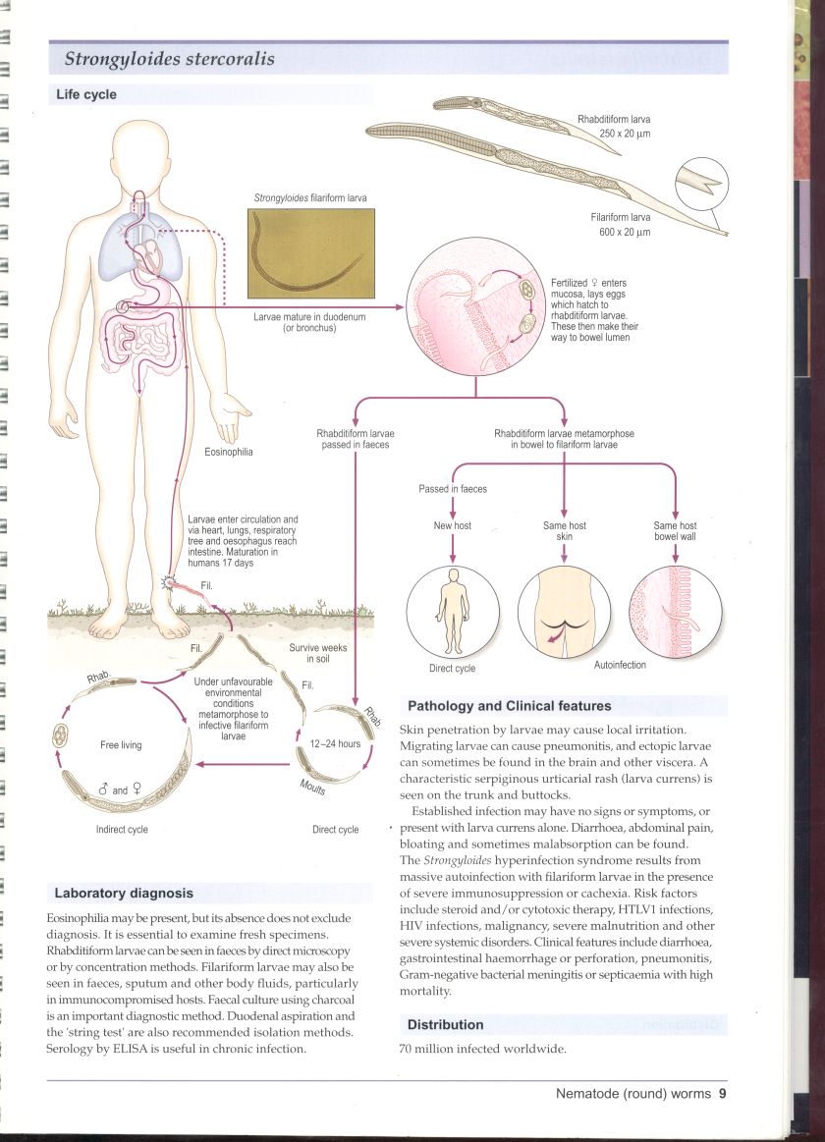
If the environmental conditions are not favorable, the larvae in the stool will moult and transform into infective filariform larvae, which pierce the intestine (auto-infection). Larvae penetrating the skin from the soil or by autoinfection are carried by the blood to the lungs, ascend to the trachea, descend to the esophagus and mature in the small intestine.

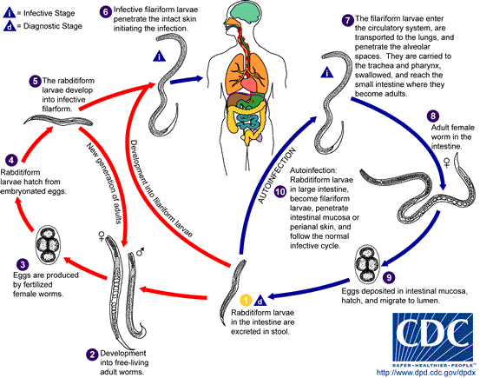
Pathology and clinical picture:
- 1-Cutaneous little reaction on penetration.
- Sever dermatitis at perianal region in case of external autoinfection.
- 2- Migration :same as hook worms .
- 3- Intestinal: inflammation of upper intestinal mucosa, diarrhea, upper abdominal pain colicky in nature.
Disseminated strongyloidiasis
-in patient with immuno-deficiency
-uncontrolled diarrhea , granulomatus changes , necrosis, perforation, peritonitis, death.
- Invation of liver, lung and brain
Diagnosis - Detection of rhabditiform larvae of strongyloides in stool.

2. Intestinal nematodes without tissue stage
Enterobius vermicularis (pin worm or thread worm or seat worm)
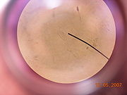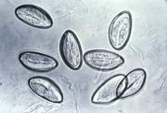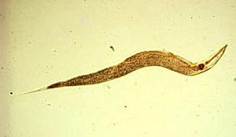
It is a small white worm with thread-like appearance. The worm causes enterobiasis , or sometimes oxyuriasis. Infection is common in children.
Morphology
Male: The male measures 5 cm in length. The posterior end is curved and carries a single copulatory spicule.
Female: The female measures 13 cm in length. The posterior end is straight.
Infective stage
Infection is by ingestion of eggs containing larvae with contaminated raw vegetables.
Life cycle
Adult worm lives in the large intestine. After fertilization, the male dies and the female moves out through the anus to glue its eggs on the peri-anal skin. This takes place by night. The egg is 50x25 microns, plano-convex and contains larva. When the eggs are swallowed, they hatch in the small intestine and the larvae migrate to the large intestine to become adult.
Mode of infection
• By direct infection from a patient (Fecal-oral route).
• Autoinfection: the eggs are infective as soon as they are passed by the female worm. If the hands of the patient get contaminated with these eggs, he/she will infect him/herself again and again.
• Aerosol inhalation from contaminated sheets and dust.

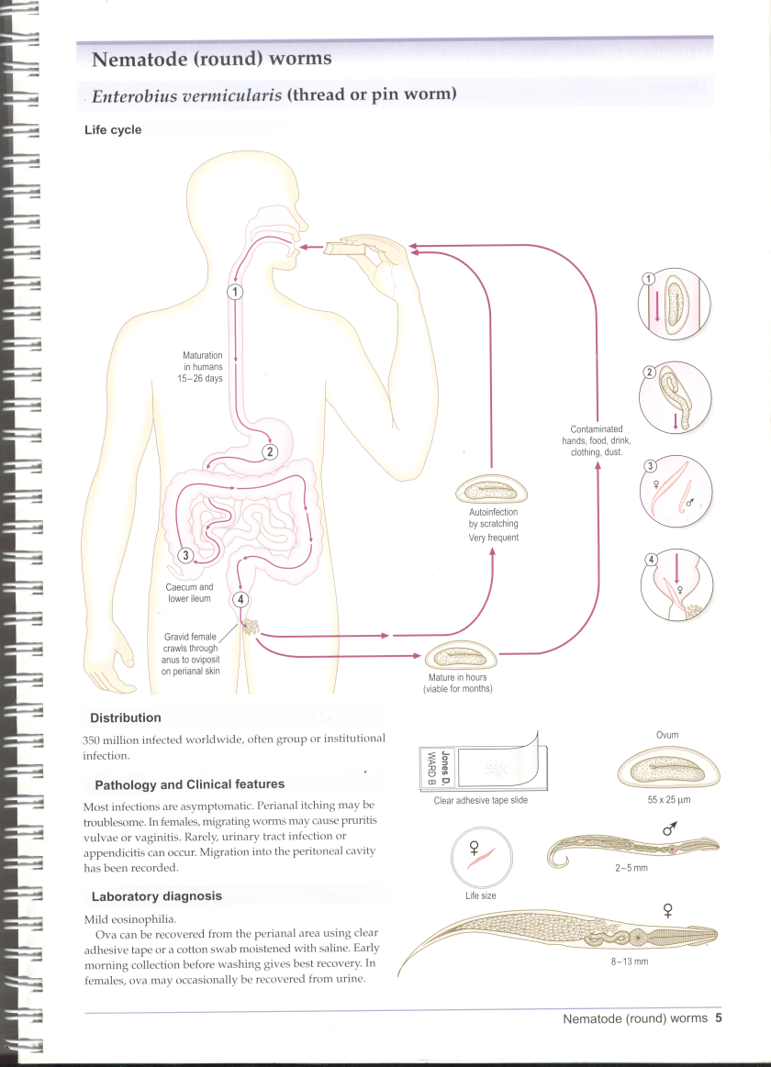
Pathology
- Majority of infection is asymptomatic
Except for itching, pinworm infestation does not usually cause any direct
- damage to the body. However, the unsanitary scratching of the itch can spread germs from the fingers to other parts of the body. This scratching occurs even as the person is asleep and can easily contribute to unhealthy skin conditions or infections. Frequent bathing; clean underclothing, night clothes, and bed sheets; and routine hand washing, particularly after using the bathroom, will help prevent pinworm infection or reinfection.Many cases presented by appendicitis.
- Ectopic enterobiasis occurs in female when invade valva and vagina result in valvovagintis
- Usually accompanied by insomnia, anorexia,loss of weight and concentration
Diagnosis
Diagnosis is often made clinically by observing the female worm (or many worms) in the peri-anal region, but can also be made using the "scotch-tape" test, in which the sticky side of a strip of cellophane tape is pressed against the peri-anal skin, and then examined under a microscope for pinworm eggs.
The pinworms may be seen in the host's faeces; however the eggs are invisible to the naked eye.

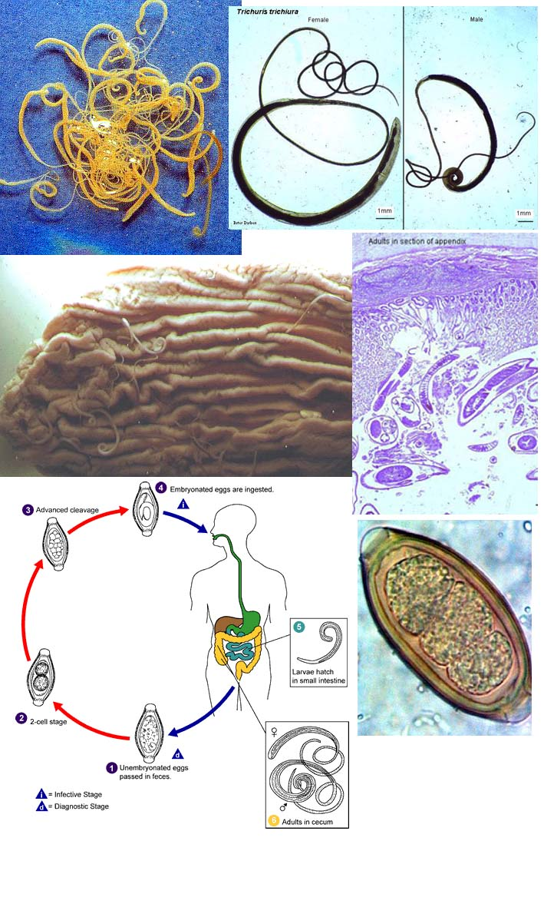
Trichuris trichiurs (Whipworm)
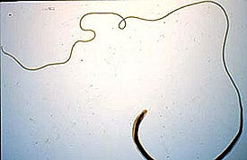
World wide ,common in poor sanitation.
- It coexists with Ascaris because of similar requirement.
- Adult live in large intestine especially caecum and appendix – in heavy infection the whole length of large intestine affected.
The worm is divided into a thin whip-like anterior part measuring 3/5 of the worm and a thick fleshy posterior part of 2/5 the length.
Male: The male measures 3-4.5 cm in length. Its posterior end is coiled and possesses a single cubicle.
Female: The female measures 4-5 cm in length. Its posterior end is straight
Infective stage and mode of infection
Infection is by ingestion of eggs containing larvae with contaminated raw vegetables.
Life cycle:
Ingested eggs hatch in the small intestine and the larvae migrate to the large intestine to become adult. After mating, the female lays immature eggs, which pass with the stool to the soil and mature in 2 weeks.

Pathology
- light infection : asymptomatic
- heavy infection :abdominal pain ,bloody diarrhea.
- Rectal prolapse in children is a common complication. imp
Diagnosis: egg in stool characterized by its barrel shape with mucoid plugs at each pole.
2. Tissue and blood dwelling nematodes
This group includes the filarial worms; the filarial worms have complex life cycles involving a developmental stage in an insect vector. They require an arthropod vector for their transmission. The worms inhabit either the lymphatic system or the subcutaneous tissues of man. The female worm gives rise to a young worm called microfilaria. The microfilariae, when taken by the arthropod intermediate host during biting, develop into
filariform larvae, which are the infective stages. Humans get infected when bitten by the infected arthropod intermediate host.
1-Wuchereria bancrofti
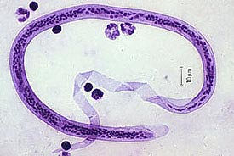
This is a parasite of lymph nodes and lymphatic vessels- causing lymphatic
filariasis. This filarial worm is transmitted by the bite of various species of mosquitoes. It is believed that over 100 million people are infected. The microfilariae are nocturnal – seen in greatest numbers in peripheral blood in the night between 10 PM -2 AM. The physiological basis of this nocturnal periodicity is not understood.
Definitive Host
Humans are the definitive host for the worms that cause lymphatic filariasis .There are no known reservoirs for W.bancrofti.
Intermediate Host
W.bancrofti is transmitted by Culex, Aedes, and Anopheles species
Morphology - W.bancrofti
W.bancrofti is a sexually dimorphic species.
The adult male worm is long and slender, between four and five centimeters in length, a tenth of a centimeter in diameter, and has a curved tail.
The female is six to ten centimeters long, and three times larger in diameter than the male.
Microfilariae are sheathed, and approximately 245 to 300 µm in length.
Life cycle:
Different species of the following genera of mosquitoes are vectors of W. bancrofti filariasis depending on geographical distribution. Among them are: Culex Anopheles Aedes. During a blood meal, an infected mosquito introduces third-stage filarial larvae onto the skin of the human host, where they penetrate into the bite wound . They develop in adults that commonly reside in the lymphatics . Adults produce microfilariae, which are sheathed and have nocturnal periodicity, except the South Pacific microfilariae which have the absence of marked periodicity. The microfilariae migrate into lymph and blood channels moving actively through lymph and blood . A mosquito ingests the microfilariae during a blood meal . After ingestion, the microfilariae lose their sheaths and some of them work their way through the wall of the proventriculus and cardiac portion of the mosquito's midgut and reach the thoracic muscles . There the microfilariae develop into first-stage larvae and subsequently into third-stage infective larvae . The third-stage infective larvae migrate through the hemocoel to the mosquito's prosbocis and can infect another human when the mosquito takes a blood meal .

Pathogenecity and clinical features:
1. Asymptomatic: patients have hidden damage to the lymphatic system and kidneys.
2. Acute: attacks of ‘filarial fever’ (pain and inflammation of lymph nodes and ducts, often accompanied by fever, nausea and vomiting) increase with severity of chronic disease.
3. Chronic: may cause elephantiasis and hydrocoele (swelling of the scrotum) in males or enlarged breasts in females.
Diagnosis Blood film examination after staining by Giemsa or Leishman stain to detect microfilaria. The film should be taken by night.
2. Onchocerca volvulus
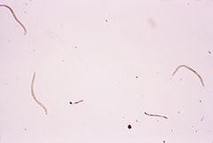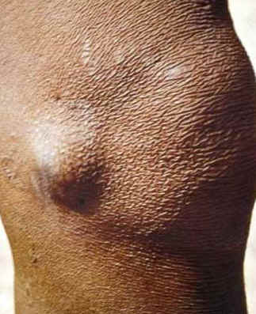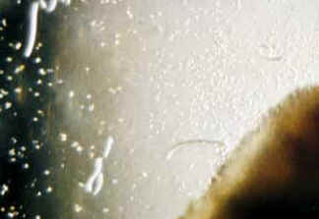
Morphology:
Male: Similar to that of Wuchereria bancrofti.
Female: The female measures 30-50 cm in length. It is present inside of a fibrous nodule (onchocercomata or onchocerca tumor).
Intermediate Host and vector
, Black fly, Female Simulium found around plantations following rivers or river basins.
Microfilaria Measures 300 microns in length. It is non-sheathed microfilaria. It is present in the subcutaneous tissue fluids and not in blood.
Life cycle
During a blood meal, an infected blackfly (genus Simulium) introduces third-stage filarial larvae onto the skin of the human host, where they penetrate into the bite wound . In subcutaneous tissues the larvae develop into adult filariae, which commonly reside in nodules in subcutaneous connective tissues . Adults can live in the nodules for approximately 15 years. Some nodules may contain numerous male and female worms. In the subcutaneous nodules, the female worms are capable of producing microfilariae for approximately 9 years. The microfilariae, measuring 220 to 360 µm by 5 to 9 µm and unsheathed, have a life span that may reach 2 years. They are occasionally found in peripheral blood, urine, and sputum but are typically found in the skin and in the lymphatics of connective tissues . A blackfly ingests the microfilariae during a blood meal . After ingestion, the microfilariae migrate from the blackfly's midgut through the hemocoel to the thoracic muscles . There the microfilariae develop into first-stage larvae and subsequently into third-stage infective larvae . The third-stage infective larvae migrate to the blackfly's proboscis and can infect another human when the fly takes a blood meal .
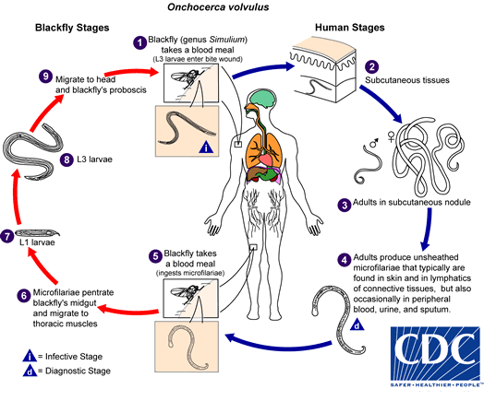

Infective stage and mode of infection is similar to that of Wuchereria bancrofti.
Pathogenecity and clinical manifestations:
The disease, onchocerciasis or river blindness includes:
• Skin fibrous nodules (onchocercomata) enclosing female worms. The nodules are common in neck, iliac crest and the coccyx.
• Skin hypo- or hyper- pigmentation. Dermatitis is present. In advanced cases, the skin becomes thickened and wrinkled, showing lizard or leopard skin appearance.
• Elephantiasis of the external genitalia and corneal opacity and optic atrophy may finally cause blindness.
Diagnosis
Superficial biopsy (skin snip) is taken from the skin using sharp razor blade. The specimen is allowed to stand for 30 minutes in saline before it is examined microscopically for microfilariae.
Prevention
• Vector control
• Mass treatment
• Establishment of villages away from Simulium breeding places.
• Use of repellents
• Protective clothing
3. Loa loa

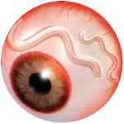
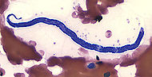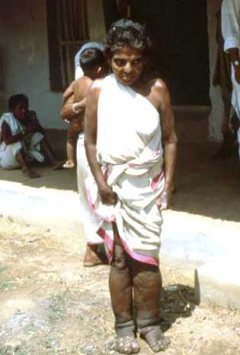
The eye worm, Loa loa, causes Loiasis. The insect vectors include mango flies of Chrysops -. The abundant rubber plantations provide a favorable environment for the vector to transmit the disease.
Morphology
Adult male worms: 30-34 mm in length
Adult female worms: 40-70 mm in length
Life cycle
The vector for Loa loa filariasis are flies from two species of the genus Chrysops,. During a blood meal, an infected fly (genus Chrysops, day-biting flies) introduces third-stage filarial larvae onto the skin of the human host, where they penetrate into the bite wound . The larvae develop into adults that commonly reside in subcutaneous tissue .. Adults produce microfilariae measuring 250 to 300 μm by 6 to 8 μm, which are sheathed and have diurnal periodicity. Microfilariae have been recovered from spinal fluids, urine, and sputum. During the day they are found in peripheral blood, but during the noncirculation phase, they are found in the lungs . The fly ingests microfilariae during a blood meal . After ingestion, the microfilariae lose their sheaths and migrate from the fly's midgut through the hemocoel to the thoracic muscles of the arthropod . There the microfilariae develop into first-stage larvae and subsequently into third-stage infective larvae . The third-stage infective larvae migrate to the fly's proboscis and can infect another human when the fly takes a blood meal .
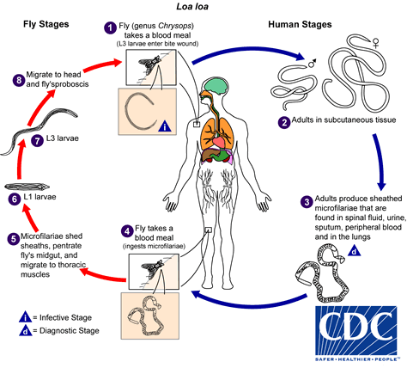
Pathogenesis
The microfilaria has a sheath. Their diurnal periodicity corresponds to the feeding pattern of the insect vector, which bites humans from 10:00 AM to 4:00 PM.
Clinical Features Incubation period is about one year. It causes calabar swelling beneath the skin due to parasites. There is fever, pain, pruritus, urticaria, allergic reactions, retinopathy, glomerulonephritis, meningo-encephalitis etc.
Laboratory diagnosis
• Detection of microfilaria in peripheral blood, urine, sputum, CSF - stained with Giemsa or unstained
• Eosinophilia

Dracunculus medinensis Dracunculiasis (Guinea worm disease)
Morphology –
One of the largest nematodes known. Longest male: 1.6 in.
Longest female: 31 in.
Life cycle
Humans become infected by drinking unfiltered water containing copepods (small crustaceans) which are infected with larvae of D. medinensis. Following ingestion, the copepods die and release the larvae, which penetrate the host stomach and intestinal wall and enter the abdominal cavity and retroperitoneal space. After maturation into adults and copulation, the male worms die and the females (length: 70 to 120 cm) migrate in the subcutaneous tissues towards the skin surface. Approximately one year after infection, the female worm induces a blister on the skin, generally on the distal lower extremity, which ruptures. When this lesion comes into contact with water, a contact that the patient seeks to relieve the local discomfort, the female worm emerges and releases larvae. The larvae are ingested by a copepod and after two weeks (and two molts) have developed into infective larvae. Ingestion of the copepods closes the cycle.

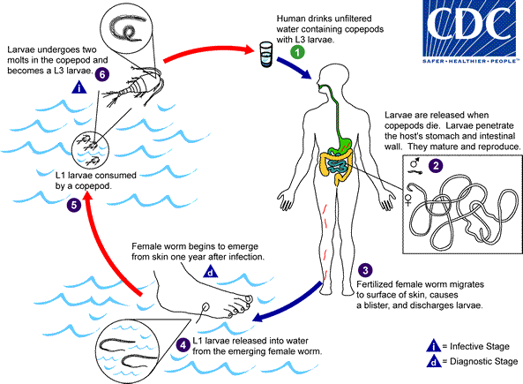
Major pathology and symptoms –
- Mild allergic symptoms such as urticaria during the migration phase.
- A papule develops into a blister with localized erythrema and tenderness.
- Generalized symptoms include nausea, vomiting, diarrhea, and possibly asthma attacks.
- Additional complications include secondary bacterial infections, permanent damage to joints.

Laboratory Diagnosis
The clinical presentation of dracunculiasis is so typical, and well known to the local population, that it does not need laboratory confirmation. In addition, the disease occurs in areas where such confirmation is unlikely to be available. Examination of the fluid discharged by the worm can show rhabditiform larvae. No serologic test is available.
Visual observation of skin blister. The worm’s serpentine presence beneath skin can be seen. Induce release of larvae from the skin ulcer by applying cold water.
Larva migrans
There are three types of larva migrans:
- Cutaneous larva migrans (Creeping eruption)
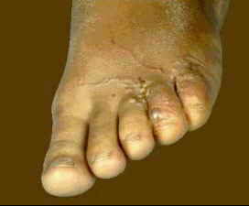
Various animals harbor hookworms. Two species of dogs and cats are important.
1. Ancylostoma braziliens: infects both dogs and cats.
2. Ancylostoma caninum: infects only dogs.
Both of these are common in the tropics and subtropical regions where human hookworms can best complete their life cycles. If man comes in contact with infective larvae, penetration of the skin may take place; ), in humans they are only able to penetrate the outer layers of the skin and thus create the typical wormlike burrows visible underneath the skin ; but the larvae are then unable to complete their migratory cycle. Trapped larvae may survive for weeks or even months, migrating through the subcutaneous tissues. They may evoke a fairly severe reaction - pruritus and dermatitis. The dermatitis leads to scratching and then bacterial superinfection.

b. Visceral larva migrans
A syndrome caused by the migration of parasitic larvae in the viscera of a host for months or years. It may be caused by transient larval migration in the life cycles of several parasites such as hookworm, Ascaris lumbricoides, T.spiralis, S. strecoralis and other filarial worms.
Toxocariasis
This is a kind of visceral larva migrans caused by
♦ Toxocara canis (Dog ascarid) and ♦ Toxocara catis (Cat ascarid).
These cause persistent larval migration and thus the visceral larva migrans is called toxocariasis.
Morphology
♦ The larvae of Toxocara canis and Toxocara catis measure about 400 μm in length.
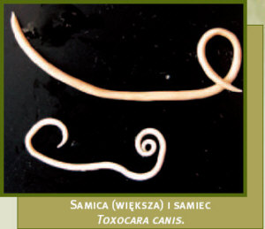

- Dogs
  - Found in Intestines
  - Ingest Egg
  - Transplacenta
  - Transmammary
  - Puppies Born Infected with T. cannis
  - Puppies less than 5 weeks
- Humans
  - Can be found in liver, lung, brain, heart, muscle, or eye
- Accidental Host
  - Infected by ingestion of infective eggs
  - Eggs hatch and larvae penetrate the intestinal wall
  - Carried by Circulatory System to various tissues
  - Larvae don’t undergo further development but can cause reactions in tissue (toxocariasis)

Life cycle
♦ The life cycle of these parasites in their respective hosts is similar to that of A.
lumbricoides in humans.
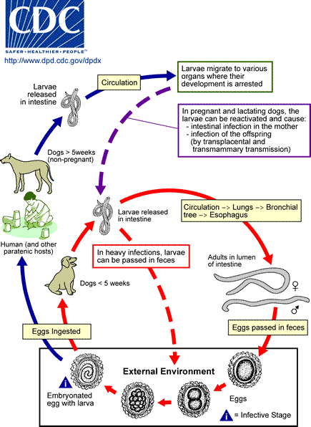

Toxocara canis accomplishes its life cycle in dogs, with humans acquiring the infection as accidental hosts. Unembryonated eggs are shed in the feces of the definitive host . Eggs embryonate and become infective in the environment . Following ingestion by dogs , the infective eggs hatch and larvae penetrate the gut wall. In younger dogs, the larvae migrate through the lungs, bronchial tree, and esophagus; adult worms develop and oviposit in the small intestine . In older dogs, patent infections can also occur, but larval encystment in tissues is more common. Encysted stages are reactivated in female dogs during late pregnancy and infect by the transplacental and transmammary routes the puppies , in whose small intestine adult worms become established . Puppies are a major source of environmental egg contamination. Toxocara canis can also be transmitted through ingestion of paratenic hosts: eggs ingested by small mammals (e.g. rabbits) hatch and larvae penetrate the gut wall and migrate into various tissues where they encyst . The life cycle is completed when dogs eat these hosts and the larvae develop into egg-laying adult worms in the small intestine. Humans are accidental hosts who become infected by ingesting infective eggs in contaminated soil or infected paratenic hosts . After ingestion, the eggs hatch and larvae penetrate the intestinal wall and are carried by the circulation to a wide variety of tissues (liver, heart, lungs, brain, muscle, eyes) . While the larvae do not undergo any further development in these sites, they can cause severe local reactions that are the basis of toxocariasis. The two main clinical presentations of toxocariasis are visceral larva migrans and ocular larva migrans. Diagnosis is usually made by serology or the finding of larvae in biopsy or autopsy specimens.
Transmission:
Ingestion of eggs of Toxocara species in contaminated food or soil or direct contact with infected patients. Children are more at risk.
Clinical features:
♦ Majority are asymptomatic.
♦ Eosinophilia
♦ Cerebral, myocardial and pulmonary involvement may cause death.
Hepatomegaly, pneumonitis, encephalitis, fever and eosinophilia in heavy infections
Retinal lesion (similar to retinoblastoma) or focal retinitis when single larva reaches retina
Diagnosis
- Identification of larvae in tissue.
Clinical syndrome with very high eosinophilia
Serology
Nothing in stools
C. Intestinal larva migrans
This is an extremely rare kind of larva migrans

