College of Science Al-Mustanseiriyah University Dep.: Biology
Academic year: 2014-2015 Subject: Plant taxonomy Class: Third Grade
Lecturer:Dr.Hadeel R.,Dr.Rana A.,Dr.Aseel M.,Dr.Zena K.
Lecture: 9
Plantae Kingdom:
Monocotyledon (monocot) Clade : -
One of the two great groups of flowering plants. There are approximately 60,000 species of monocots, including the most economically important of all plant families, Poaceae , Orchidaceae , Liliaceae.

.Characteristics of monocot
1- The roots are adventitious
2- The leaves are parallel-veined
3- Flowers of monocots most often have the parts in sets of three or four of the sepals and petal , but almost never five.
4- It has single cotyledon in the seed.

Description of selected families of monocots:
Order : Poales
Family:(poaceae) Gramineae
The Poaceae ( Gramineae or true grasses) are the second larger family in Iraq and constitute the most economically important plant family in modern times, providing forage, building materials and fuel (ethanol), as well as food.

Poaceae have the following characteristics:
1- Grasses are perennial or annual.
2- The root system consists of fibrous roots. Corms and bulbs are sometimes present .
3- Stems of grasses are called culms and usually hollow.
4- Grass leaves are nearly always alternate and are arranged in two vertical ranks , consist of blade and sheath which is usually open.
5-The perianth is reduced to two scales, called lodicules
6-Flowers of Poaceae are arranged in spikelets which closed by overlapping scales, each spikelet having one or more florets. There are three kinds of scales.
A- The glumes: It is the lowermost are usually two in number, and they enclose some or all of the other scales.
B- The lemma
C- The palea. The lemma and palea occur in pairs. Generally the lemma is larger than the palea, which is hidden between the lemma and the spikelet axis. Grass spikelets then simply consist of usually 2 glumes and 1 to about 50 florets, depending on the species.
7- The flowers are hermaphroditic and anemophilous or wind-pollinated.

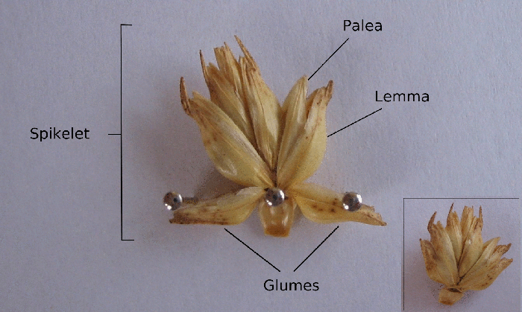
parts of a spikelet

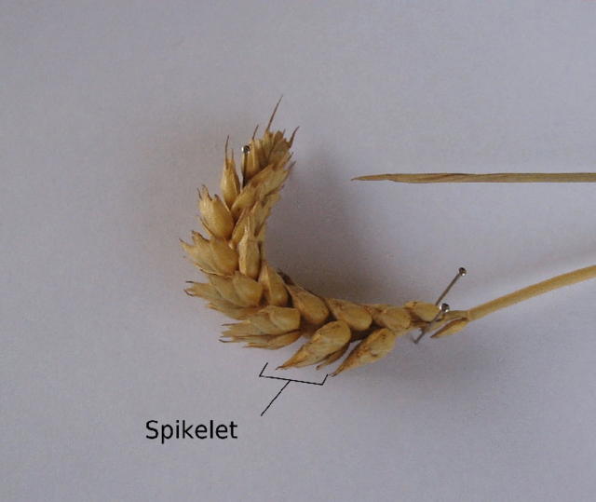
Wheat spike and spikelet

8- The fruit of Poaceae is a caryopsis, in which the seed coat is fused to the fruit wall.
This family is represented by 101 genera with 270 species widely in Iraq. Poa and Bromus from the biggest in Iraq.
Order: Cyperales
Family: Cyperaceae
The Cyperaceae is one of monocots families which known also as sedges, this family is represented with some 5,500 species described in about 109 genera and 13 genera with 57 species in Iraq.
sedges may be found growing in almost all environments, many are associated with wetlands, or with poor soils. Ecological communities dominated by sedges are known as sedgelands.

Features distinguishing of the sedge family from grasses
1-They are monoecious herbs with fibrous annuals or rhizomous perennials.
2- Stems are often triangular and mostly solid.
3- All sedges have sheathing leaves, usually with blades and the sheaths are uniformly closed.
4- Culms are solids while ligule is absent
5- The perianth (the calyx and corolla or the tepals) is either absent altogether or represented by up to six (though sometimes one) hairlike to stiff, sometimes barbed bristles.
6- The flowers in Cyperaceae are highly reduced in size and complexity and are either unisexual or bisexual.
7- In spikelets of Cyperaceae the individual flowers are subtended by a single scale.
8- Stamens are free from 1-3 anthers with superior, unilocular ovary.
9- Fruits (achene, nut) indehiscent, hard- walled often trigonous or lenticular. In Carex, the achenes are enclosed in a sac called a perigynium, a modified tubular bract.
The most well-known member of this family in Iraq is Cyprus rotundus which its tubers have been eaten by people.

Cyperus rotundus,
