College of Science Al-Mustansiriyah University Dep.: Biology
Academic year: 2014-2015 Subject: Plant taxonomy Class: Third Grade
Lecturer:Dr.Hadeel R.,Dr. Rana A.,Dr.Aseel M.,Dr.Zena K.
Lecture: 4
****Corolla : It’s the second part of perianth composed of petals and usually colored, the main function of corolla is to assist pollination and therefore increase the chance of successful reproduction of the flower.
*** Types of Corolla :-
1- Polypetalous : Corolla composed of separate petals. This type could be in different shapes:-
A/ Cruciform : four free petals arranged in the form of cross as in Brassicaceae.
B/ Caryophyllaceous : Five free clawed petals with limb at right angles to the claw.
**Claw: Its narrowed stalk of petals.
**Limb : The junction of corolla tubes and lobes.
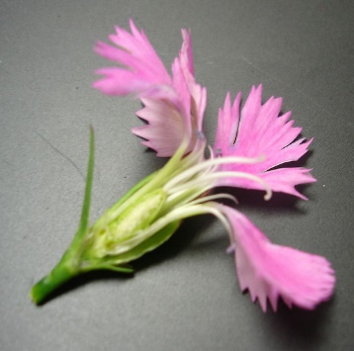
C/ Rosaceous : Five sessile petals with limbs spreading out as in Rosaceae .

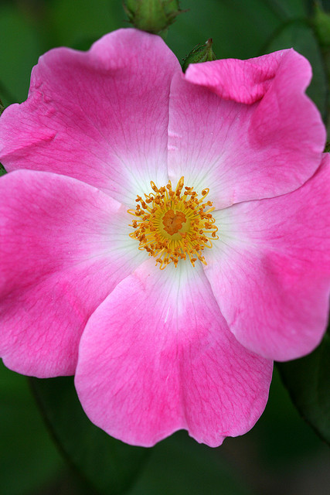
D/ Papillionaceous : Its five petals with single posterior petals (standard ), two lateral petals (wings) and two anterior petals slightly united to form keel, as in Fabaceae.
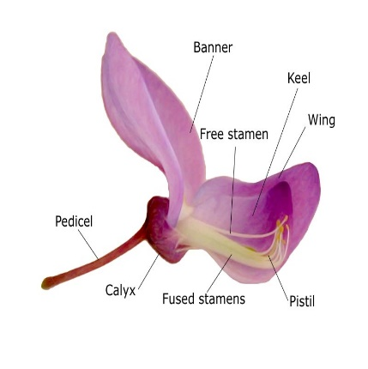

2- Gamopetalous :- Corolla composed of united petals. It may be in variety shapes:
A/ Bilabiate: two- lipped, with two, generally upper and lower segments as in Lamiaceae.
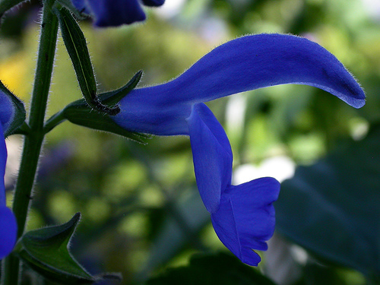
B/ Campanulate : bell-shaped, with a basally round flaring tube about as broad as long plus flaring lobes as in Campanula.

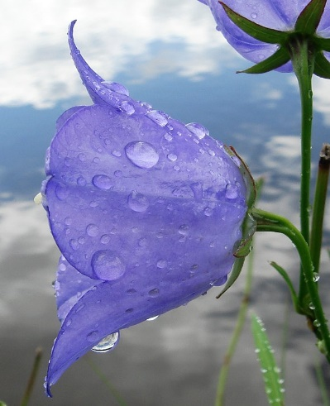
C/ Ligulate or ray: having a short, tubular corolla with a single, elongate, strap-like a pical extension as in some Asteraceae.
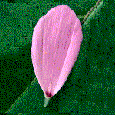
D/ Salverform : Petals united to form salver-like shape as in Vinca.
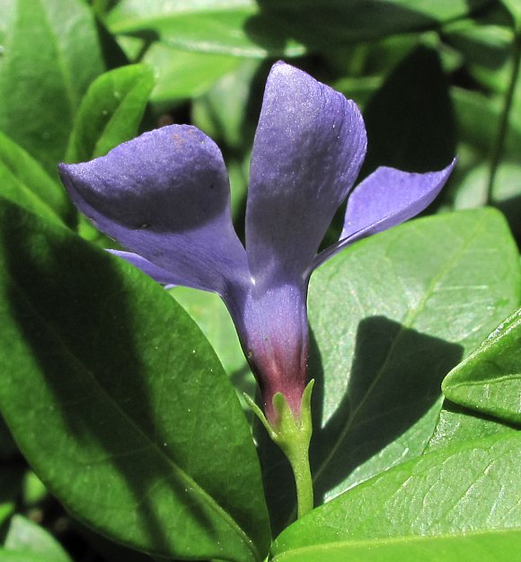
E/ Tubular : Petals united to form tube like shape as in discoid flower of Helianthus.

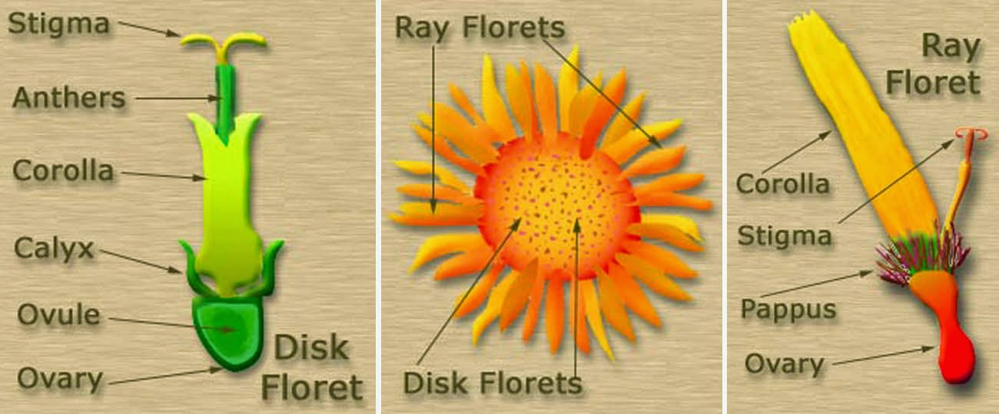

***Androecium :
It consists of all floral male (pollen- producing), the units of which are stamens. Stamens are defined as modified sporangia bearing leaves or microsporophylls.
Stamen type: There are two types of stamens:
1- Laminar S. : It possess a leaf like, dorsiventrally flattened structure bearing two theca. This, typically represent the ancestral type in flowering plants.
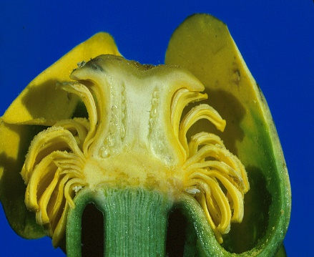
2- Filamentous S. : It has a stalk like, terete filament with a discrete pollen – bearing part, the anther.
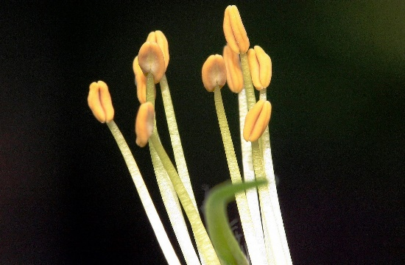

**Stamen structure : each stamen has an:
1- Anther : Its tetra sporangiate with two anther sacs (microsporangia) in each of the two anther lobes.
2- Filament : filiform structure, hollow or solid, helps in settle down of anther; filament might be long as in Lilium, or short in Phoenix dactylifera or absent as in aquatic plants.
** Stamen function :
It refers to whether and how stamens are fused, it could be generally in two forms:
1- Filament fusion: In this form, filaments are united but anthers are free and may be in the following types;
A/ Monadelphous : Filaments of stamens united (connated) into tube as in family malvaceae.
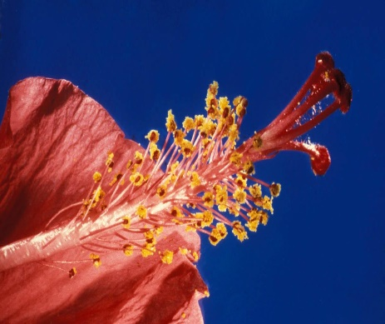
B/ Diadelphous : Filaments of stamens united into two groups, one of them have nine stamens fused and other has only one stamen fused at the base as in many faboidaea (Fabaceae).
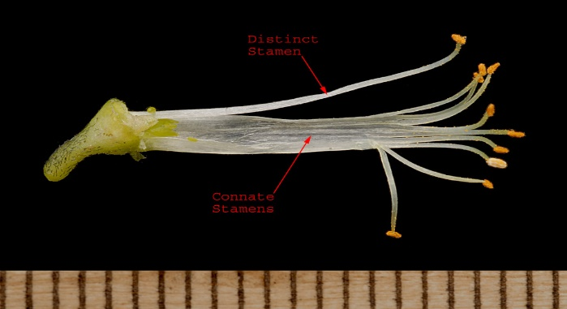
C/ Polyadelphous : filaments united in more than 2 groups as in Citrus.
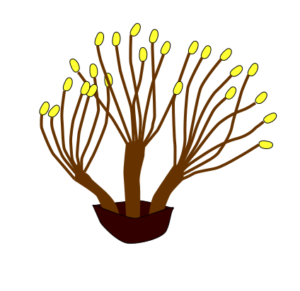

2- Syngenesious : filaments free but anther connate into a tube, as in Asteraceae.

**Stamens lengths :
1- Didymous : stamens in two equal pairs.

2- Didynamous : stamens in two unequal pairs as in many Lamiaceae, plantaginaceae.
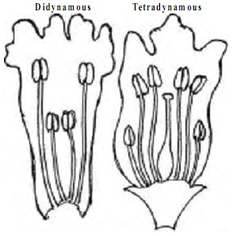
3- Ttetradynamous : stamens in two groups of four longed and short as in Brassicaceae.
**Anther: They are discete pollen containing units, found in the stamens of the great majority of angiosperms. Anthers typically consist of :
1/ thecae: structure containing two microsporangia, anthers typically tetrasporaginate male gametophytes of seed plants.
2/ connective tissue : a tissue between and inter connecting the two thecae.
The typical anther is dithecal, in few taxa such Malvaceae and Cannaceae, anthers are monothecal.
***Pollinium : Dithecal anther in which all the pollen grains of both thecae are fused together as in single mass. It could be found in Asclepias and Orchidaceae.
***Anther dehiscence direction :
It indicates the position of anther opening relative to the center of the flower or to the ground :

1- Extrose: Its dehiscing out ward, away from the flower center.
2- Introse : Its dehiscing inward, toward the flower center.
3- Latrose : Its dehiscing laterally, to the side.
***Type of Anther dehiscence :
1- longitudinal : Its dehiscing along a structure parallel to the long axis of the thecae, it considered the most common in angiosperm.
2- Poricidal : The dehiscene is done by a pore at one end of the thecae such as in the Ericaceae.
3- Transvers : The dehiscing through a pore covered by a flap of tissue as in the Berberidaceae.

