Lecture Four
Permanent tissues: The permanent tissues are derived from meristematic tissue and are composed of cells, which have lost the ability to divide
Types of Permanent Tissue
Simple T. which are parenchyma, collenchyma and sclerenchyma and Complex which are xylem and phloem.

Parenchyma:
Parenchyma is living tissue and is the main representative of ground tissues, found in plant organs forming continuous tissue as in the (cortex of roots, pith and cortex of stems and mesophyll, petiols of leaves besides seeds). This kind of tissue often fills spaces between other tissues or between.

Characters of parenchyma cells:
- Living cells with central nucleus, cytoplasm and vacuoles surrounded by thin cell wall (0.2 to 2 μm in diameter), sometimes is thick in the endosperm of date palm and persimmon.
- These cells keep their ability to divide or to resume (meristematic activity)developmentally, parenchyma cells are relatively undifferentiat (unspecialized morphologically and physiologically) compared with such cells as sieve elements, tracheids, and fibers because, in contrast to these three examples of cell categories, parenchyma cells may change functions or combine several different ones. However, parenchyma cells may also be distinctly specialized, for example, with reference to photosynthesis, storage of specific substances.
- Typically, they are surrounded by intercellular spaces or larger cavities for effective gas exchange.
- They are isodiametric, not spherical with many faces (approximately 14, polyhedral).
- Middle lamellae may or not be distinguishable, plasmodesmata are common.
6- Some parenchyma cells develop secondary walls (lignified) make it difficult to distinguish from sclerenchyma.

Classification of parenchyma tissues according to function
1- Chlorenchyma:
It is specialized parenchyma tissue specialized for photosynthesis contains numerous chloroplasts. The greatest expression of chlorenchyma is represented by the mesophyll of leaves, but chloroplasts may be abundant also in the cortex of a stem. Chloroplasts may occur in deeper stem tissues, including the secondary xylem and even the pith. Typically photosynthesizing cells are conspicuously vacuolated, and the tissue is permeated by an extensive system of intercellular spaces.

2- Storage parenchyma
It is characterized by accumulating specific kinds of substances like starch-storing cells such as those of the potato tuber, the endosperm of cereals, and the cotyledons of many embryos, the abundant starch-containing amyloplasts may virtually obscure all other cytoplasmic components. In many seeds the storage parenchyma cells are characterized by an abundance of protein and/or oil bodies. In various parts of the plant, parenchyma cells may become conspicuous by accumulating anthocyanins or tannins in their vacuoles.
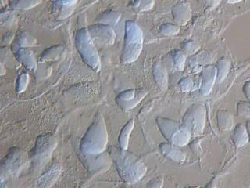

Starch grains in Potato stem

3- Secretory parenchyma:
In contrast, secretory types of parenchyma cells have dense protoplasts,
especially rich in ribosomes, and have either numerous Golgi bodies or a massively developed endoplasmic reticulum, depending on the type of secretory product formed.

4- Aernchyma:
It is type of parenchyma which found in the leaves, stems and roots of some plants like aquatic, the cells are characterized by small size, thin cell wall and air filled large cavities which provide low resistance internal pathway for the exchange of gases between plant organs above the water and submerged tissues.
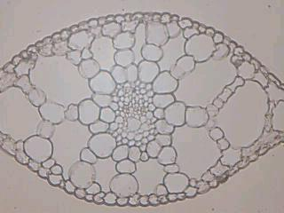

5- Water storage parenchyma:
Parenchyma cells in the tissue system, parenchyma may be rather specialized as a water storage tissue. Many succulent plants, such as the
Cactaceae, Aloe, Agave, contain in their photosynthetic organs chlorophyll free parenchyma cells full of water. This water tissue consists of living cells of particularly large size and usually with thin walls. The cells are often in rows.
Transfer cell, a specialized form of parenchyma cell, is readily identified by elaborate ingrowths of the primary cell wall. The increase in the area of the plasma membrane beneath these walls facilitates the rapid transport of solutes to and from cells of the vascular system. The ingrowths develop relatively late in cell maturation and are deposited on the original primary wall; hence they may be considered a specialized form of secondary wall.
Shapes of parenchyma cells:
1- Columnar p.c., it can be found in the palisade tissue of leaves.
2- Stellate p.c. as in the stem of Juncus effuses.
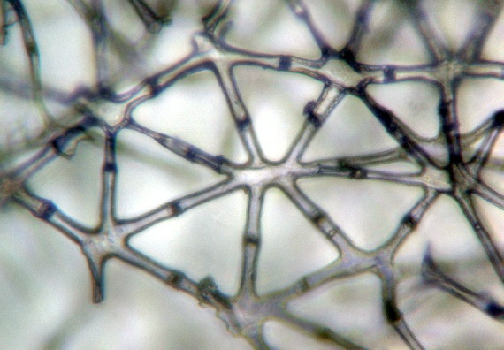

3- Lobbed p.c.as in the spongy tissues of leaves
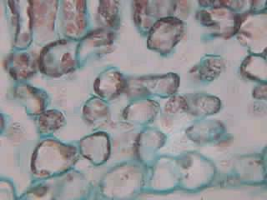

4- Folded p.c. in the mesophyll of pine
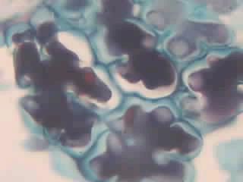
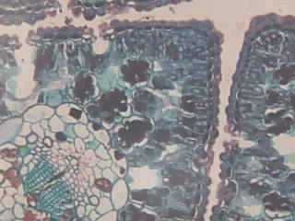

Collenchyma:
It is a living tissue composed of more or less elongated cells with thickened primary walls. It is a simple tissue, for it consists of a single cell type, the collenchyma cell. Collenchyma cells and parenchyma cells are similar to one another both physiologically and structurally. Both have complete protoplasts capable of resuming meristematic activity, and their cell walls are typically primary and nonlignified. The difference between the two lies chiefly in the thicker walls of collenchyma cells; in addition the more highly specialized collenchyma cells are longer than most kinds of parenchyma cells.

Distribution of collenchyma in the plant:
1-It occurs in the peripheral regions of stem and leaf, directly beneath epidermis or a few layers removed from it.
2- Frequently forms a continuous layer around circumference of axis (stem and leaf petiole), may occur in strands
3- In leaf blade occurs in ribs especially the larger one, occurs on both sides or one side of ribs.
4-Roots rarely have collenchyma.

Cell Walls of Collenchyma:
It is the most distinctive characteristic of this tissue which its walls are thick and glistening in fresh sections (Fig. 7.11), and often the thickening is unevenly distributed. They contain, in addition to cellulose, large amounts of pectins and hemicelluloses and no lignin. The distribution of wall thickening in collenchyma shows several patterns:

1- Lamellar or plate collenchyma
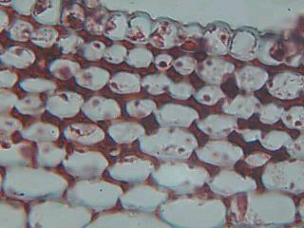
Collenchyma with the thickenings on two opposite sites of the tangential walls. Lamellar collenchyma is especially well developed in the stem cortex of Sambucus nigra

2- Angular collenchyma:
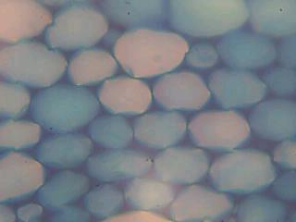
It is with wall thickenings localized in the corners commonly, angular collenchyma are found in the stems of Solanum tuberosum and petioles of Cucurbita, Morus.

3- Lacunar, or lacunate, collenchyma
When collenchyma develops no intercellular spaces, the corners where several cells meet show a thickened middle lamella.
