College of Science Al-Mustanseryea University Dep.: Biology
Academic year: 2015-2016 Subject: Plant Physiology Class: Fourth Grade
By: Dr. Alaa Jabar & Dr. Rana Azeez
Lecture: 5
Photosynthesis
**Introduction:
Photosynthesis is considered the most important process for all living organisms (except for anaerobic bacteria which can fix CO₂ without using hydrogen of H₂O as a source of proton). Photosynthesis is simply a light-driven series of chemical reactions that convert the energy-poor compound, CO₂, to energy-rich sugars. In plants, photosynthesis also splits water and release Oxygen(O₂). The photosynthesis organisms produce about 50 million ton of sugar annually by this process. Photosynthesis needs the following essential requirements:
1-Source of light energy
2-Source of energy capture
3-Means for energy storage
In plants photosynthesis can be summarized into the following general equation:

CO₂ + H₂O light Sugars + O₂
Chlorophyll
Light energy: To understand photosynthesis , we must know a little about the properties of light.
In 1905, Einstein proposed that light consist of packets of energy called photons, which are the smallest divisible units of light. The intensity (i.e. brightness) of light depends on the number of photons. Light intensity is important in photosynthesis because each photon carries a fixed amount of energy that is determined by the photons wavelength. Wavelengths of visible light are measured in nanometers. The longer the wavelength, the less energy per photon. Sunlight consist of a spectrum of colors of light having different wavelengths and energy.
Light energy is defined as waves of fine particles called photons or quantum. Atom of any element requires one quantum for excitation and one molecule of any element requires 6.02 x 10²³ (Avogadro number) of quantum for excitation.

Photosynthetic pigments: Studied conducted by plant physiologists indicated that the pigments absorbed light energy and transfer it to chemical energy are the chlorophylls which occurred in the plastids. The pigments are classified as follow:
1/Chlorophylls: the quantity of chlorophyll is 10 times more than carotenoids and it includes the following types:
a/ chlorophyll a : occurred in all photosynthetic plants and maximum absorption of light appeared at 430 and 660 nm wave lengths.
b/ chlorophyll b : occurred in all higher plants and green algae and maximum absorption of light appeared at 453 and 645 nm wave lengths.
c/ chlorophyll c : occurred in brown algae.
d/ chlorophyll d : occurred in red algae.
e/ chlorophyll e : occurred in some plant species.
**Differences between chlorophyll a and b :
Chlorophyll a | Chlorophyll b
C₅₅H₇₂O₅N₄Mg | C₅₅H₇₀O₆N₄Mg
Molecular weight 892.32 gm | Molecular weight 906.32 gm
Carbon no.3 attach to methane(CH₃) | Carbon no.3 attach to aldehyde(CHO)
Best solvent is Ether | Best solvent is methyl alcohol
Maximum absorption at 120 and 70 nm | Maximum absorption at 160 and 50 nm
Chlorophyll structure:
The chlorophyll structure is roughly resembled a “tennis racket” having a large head called porphyrin and a long handle or tail called phytol. The phytol (the tail) is a long chain alcohol containing one double bond and esterifies with carboxyl group on C₇ atom of the chlorophyll molecule.
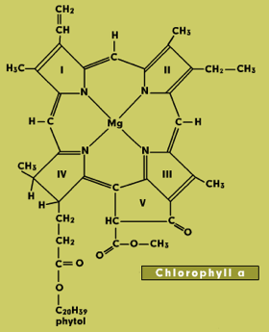
**other pigments:
1-Carotenoids: they are lipid compounds that are distributed widely in both animals and plants and range in color from yellow to purple.
2-Xanthophylls: they are more abundant in nature than carotenes and located in chloroplast. They are carotenes containing oxygen.
The function of carotenoids :
a/protect chlorophylls against photo oxidation in excessive light.
b/absorption of light and transfer it to chlorophylls.
c/causes phototropism in plants.
***Emerson effect and Emerson enhancement: Emerson and his associates found that the efficiency of photosynthesis is significantly decreased in plants exposed to wave length of 680 nm. This phenomenon is called Emerson effect. They also found that the efficiency of photosynthesis is dramatically increased in plants exposed to short wave length followed by long wave length. This phenomenon is called Emerson enhancement. The results of their studies are indicated that light reactions require two photosynthetic units.
***Photosynthetic units and pigments systems:
Studies indicated that the light reactions is conducted in a fine units inside the plastids called photosynthetic units. These units contains chlorophyll molecules arranged in geometric manner to absorb the light and transfer it to the region of utilization. These units called quantosomes. It has been shown that chlorophyll a presents in four types in the quantosome.
1-chlorophyll 673 (maximum absorption at 673 nm).
2-chlorophyll 683( = = =683nm).
3-chlorophyll 703(= = = 703 nm).
4-chlorophyll 680(= = = 680 nm).
Two active pigments systems are found in quantosome : 1/ pigment system 700, which contains chlorophyll 703 and is locates in the photosynthetic I unit. The pigment system 700 is present in a ratio of 1:200 molecules of chlorophylls. The second one is called pigment system 680, which contains chlorophyll 680 and locates in the photosynthetic II unit. These two types of pigment systems are responsible for receiving the light energy and utilize it in dissociation of H₂O and liberate the electrons which become ready to be received by the accepters.

***Electron transfer and photophosphorylation (Z scheme):
When photosystems I and II exposed to light, both of them are excited, photosystem II starts dissociating H₂O and liberating the electrons. The electron is first captured by P680 in photosystem II which transfer them to primary electron accepter called Q which changes to reduced form. The reduced form transfers the electron to another carrier called B which transfers the electron to plasto quinone. Then the electron reaches the active site of photosystem I (P700) through three carriers namely cytochrome b₆ , cytochrome f and plastocyanin respectively. Both cytochromes and plastocynin are located in photosystem I . the electron is transferred from photo system I to primary electron accepter called ferredoxin (Fe-S) and change it to reduced form. The reduced form of ferredoxin reduced NADP⁺ to NADPH₂ by the enzyme ferredoxin-NADP⁺ reductase. The NADPH₂ is used to fix CO₂ in the dark reactions. Therefor we can conclude that ferredoxin is the terminal electron accepter in the photosynthetic light reaction. The light reaction can be diagramed as Z scheme.

***photophosphorylation:
The process by which the plant can produce ATP in the presence of light and it happens in the plastids and through the light reactions. There are two types of photophosphorylation:
1/ Non-cyclic photophosphorylation:
The ATP is produced when the electron transfers from cytochrome b to cytochrome f . The process requires the contribution of both photosystem in order to ensure the flow of the electrons through the carrier system.
2/Cyclic photophosphorylation:
This process happens when the plastids exposed to wave length of light more than 680 nm causing P700 excited only. In this case, non-cyclic photophosphorylation is stopped, NADP⁺ is not available and CO₂ fixation is retarded. Under these circumstances the available electrons in photosystem II transfer through the carriers to photosystem I which transfer them to Fe-S accepter.
The ferredoxin is unable to transfer the electrons to form NADPH₂ due to the absence of NADP⁺. However it was found that the ferredoxin is possibly transferred the electron to cytochrome b₆ which in turn pass the electron back to P700.
**Function of light reactions:
1-production of O₂ which is necessary for life continues.
2-formation of NADPH₂ which is necessary for metabolic reactions including dark reaction.
3-formation of ATP which is very necessary for metabolic reactions including dark reaction.
***Dark reactions:
The famous plant biochemist Dr. Calvin from university of California used the above technique and found that phosphoglyceric acid (PGA) was the first compound produced from the fixation of CO₂ in to 5 carbon compound named Ribulose diphosphate according to the following reaction:

Ribulose diphosphate + CO₂ 2Phosphoglyceric acid(PGA)
The enzyme catalyzed this reaction is Ribulose diphosphate carboxylase which is proved to be biosynthesized in chloroplast. It has been shown that one mole of CO₂ requires 3 moles of ATP and 2 moles of NADPH₂. The dark reactions which known to be a cyclic have collectively named Calvin cycle.

**Methods of CO₂ fixation: studies revealed the presence of 3 kinds of CO₂ fixation in plants. Accordingly, the plants were divided into 3 groups:
1* C₃ plants:
The plants with 3C compound as a primary initial CO₂ fixation product such as wheat, tomato and date palm. The compound is PGA.

Ribulose 1,5 diphosphate carboxylase 3-phospho glyceric acid
Co₂ H₂o H₂O
Triose phosphate dehydrogenase NADPH₂
Ribulose 1,5 diphosphate ATP

Phosphor pento kinase 3-phospho glycer aldehyde
ATP
Ribulose-5- phosphate Trans ketolase
Calvin- Benson cycle (C₃ Plants)

2*C₄ Plants:
The plants with 4C compound as a primary initial CO₂ fixation product such as corn and sugar cane. The compound is oxaloacetate.
CO₂ gas is fixed first in the phosphor phenol pyruvate (PEP) which is present in the chloroplasts of the mesophyll cells forming a 4C compound named oxaloacetate. The oxaloacetate converts into malate which moves to enter the chloroplast of the sheath cells, then converts to pyruvate and CO₂. The CO₂ is re-fixed again in Calvin cycle while the pyruvate enters the chloroplast of the mesophyll cells to convert into PEP.

3*CAM plants:
Means plants with crassulacean acid metabolism. They called CAM since it was first investigated in plants of Crassulacean family which are commonly produced crassulacean acid. Plants of this group open their stomata at night to fix CO₂.
During night, starch breaks down by reaction of glycolysis to form phosphor phenol pyruvate (PEP) . CO₂ is fixed into oxaloacetate by the enzyme PEP carboxylase, then this acid is converted to malate by dehydrogenase enzyme. Malate is stored in the vacuole.
During day-light, malate come out of the vacuole and dehydrogenated to form oxaloacetate again. Oxaloacetate is decarboxylated to form CO₂ and PEP . the CO₂ is re-fixed into Calvin cycle while PEP convert to starch by reverse glycolysis. Some of starch produced by reverse glycolysis and Calvin cycle can be utilized again during night to fix CO₂ again.

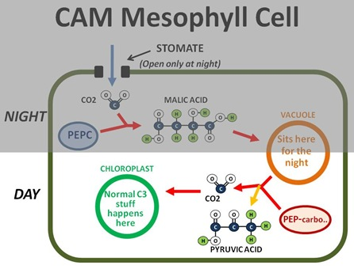

CO₂ fixation in CAM plants:
1-Darkness (stomata opened):
CO₂
glycolysis
Starch PEP OAA malate to vacuole
NAD⁺
NADH+H
NAD⁺

2-Day-light (stomata closed):
a/ malate OAA PEP + CO₂
ATP
ADP
NADPH+H
NADP
NADPH₂
ATP
b/ CO₂ + ribulose diphosphate(RuBP) 3PGA Starch
Calvin-Benson cycle

Reverse glycolysis
c/ PEP Starch + H₂PO₄
NAD
NADH + H

***Photorespiration:
Photorespiration presents in all plants and takes place in the presence of light. The reactions of photorespiration are completed in 3 cellular structures namely chloroplast, perexisome and mitochondria. The first reaction starts with the combination of O₂ with the Ribulose diphosphate carboxylase to form glycolate and 3-phosphoglyceric acid (3-PGA). Both compounds moved from the chloroplast to the peroxisome. The glycolate converts to glyoxylate which converts to glycine. 3-phosphoglyceric acid convert to glyceric acid which converts to hydroxyl pyruvate then to serine. Serine moves to mitochondria to convert to glycine by decarboxylation process. The process is important for biosynthesis of the amino acids (glycine and serine) which are essential for protein biosynthesis.

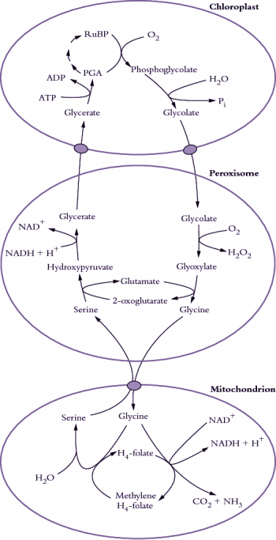
Metabolic path ways of photorespiration

**Factors affecting rate of photosynthesis:
1-CO₂ concentration: both concentration and diffusion affect photosynthesis rate. It has been shown that the diffusion of CO₂ inside the internal leave tissues is controlled by diameter aperture. The diffusion of CO₂ increased with the increasing diameter of the aperture. Photosynthesis is increased with the increased CO₂ concentration up to a define limit after the concentration becomes toxic to plants. the upper limit varied with plant species.
2-O₂ concentration: the increased in O₂ con. significantly decreased the rate of photosynthesis. It has been suggested that the high concentration of O₂ competes with CO₂ on the hydrogen ions of NADPH₂ and combines with them to form H₂O. In this case CO₂ fixation is inhibited (means photosynthesis is inhibited).
3-Water: water is very important factor that affects the rate of photosynthesis under drought conditions, stomata close and diffusion of CO₂ and O₂ inside the leave inhibited and these lead to inhibit the rate of photosynthesis. Excess water also inhibit the rate of photosynthesis. Flooding of plants prevents CO₂ and O₂ and thereby reducing photosynthesis rate.
4-Temperature: extreme temperature is significantly inhibited photosynthesis rate. The low temperature freezes the water inside and outside the cells and thus preventing the movement of CO₂ and O₂ into the cells. It also causes protein denaturation. The high temperature inhibits or destroys enzymes including enzymes of Calvin cycle. Generally the increase temperature increases the activity of the plant to a limit then the increase in temperature harms the plant.
5-Light intensity: It has been shown that rate of photosynthesis increases with increasing light intensity to a limit after which, the increase in light intensity slightly increases the rate of photosynthesis. however at very light intensity, the rate of photosynthesis inhibited due to photooxidation of chlorophylls.

