Lec.11 & 12 Ground Water Pollution 4th class

Groundwater Remediation Techniques

Groundwater remediation is the process that treats polluted groundwater by removing the pollutants and/or converting them into harmless products. The goal of remediation is to make groundwater safe for humans and minimize the negative impact contaminants have on the environment. Additionally, soil or sediment can also be remediated if it’s contaminated as a result of coming in contact with contaminated groundwater.
There are two types of groundwater remediation: in situ (in place or on-site) and ex situ (off-site). The in-situ remediation approach involves cleaning the water where it is presently situated, rather than removing and transferring it elsewhere.

These three groundwater treatment methods are most commonly used by environmental consultants:

Physical:
The most basic type of groundwater remediation, uses air to strip water clean (air sparging). Another method, called pump and treat, physically removes the water from the ground and treats it by way of biological or chemical means. Both of these methods have proven successful in treating contaminated groundwater.

Biological:
This method uses organic matter, microorganisms and plants to clean contaminated water. Bioaugmentation, bioventing, and biosparging are three ways to use biological material to break down certain chemicals and compounds industrial waste in groundwater. Biological methods are convenient because the contaminated water may not even need to be removed to be treated.

Chemical:
This method may take longer to execute and can be costly, but still may be the only option on certain contaminants. Carbon absorption, ion exchange, chemical precipitation, and oxidation are all ways to achieve clean groundwater by way of chemical remediation.

There are some groundwater remediation techniques:

Note: also, these techniques are used for soil remediation.

Pump-and-Treat

Pump-and-Treat is a primary technique for groundwater and soil remediation. In this process, groundwater is pumped to the surface, and contaminants are removed by a variety of treatment methods, including air-stripping, activated carbon, ultraviolet or ozone treatment, precipitation and biodegradation.

This technique is accomplished through one or more pumping wells, with the water being
treated by any one of physical and biological methods or their combinations. Pump and treat systems are relatively easy to design, install and operate using standard hydro-geologic and engineering practices. For successful remediation, surface treatment of pumped groundwater must be in consistence with the type and concentration of contaminants.

Pump-and-treat is typically used for contaminants which are dissolved in groundwater. The pumping systems can accomplish rapid mass-removal from areas of the groundwater plume where contaminants are most heavily concentrated. The technique also allows full capture of a plume at its leading edge, and prevents further migration. For this reason, pump-and-treat will continue to be the principal method of choice for plume containment and control.

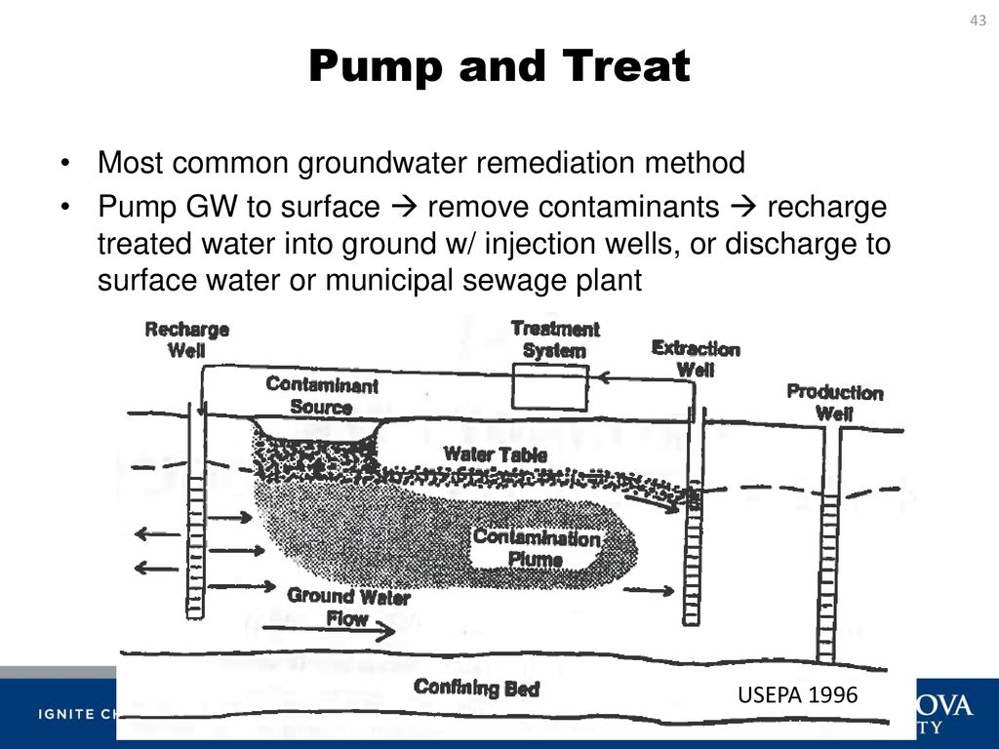
Nevertheless, pump-and-treat is not so effective in area with low permeability soils as clays and silts. Further, long-period operation is often expensive due to the high rate of energy used to pump and treat large volumes of water, and the effluent disposal costs.

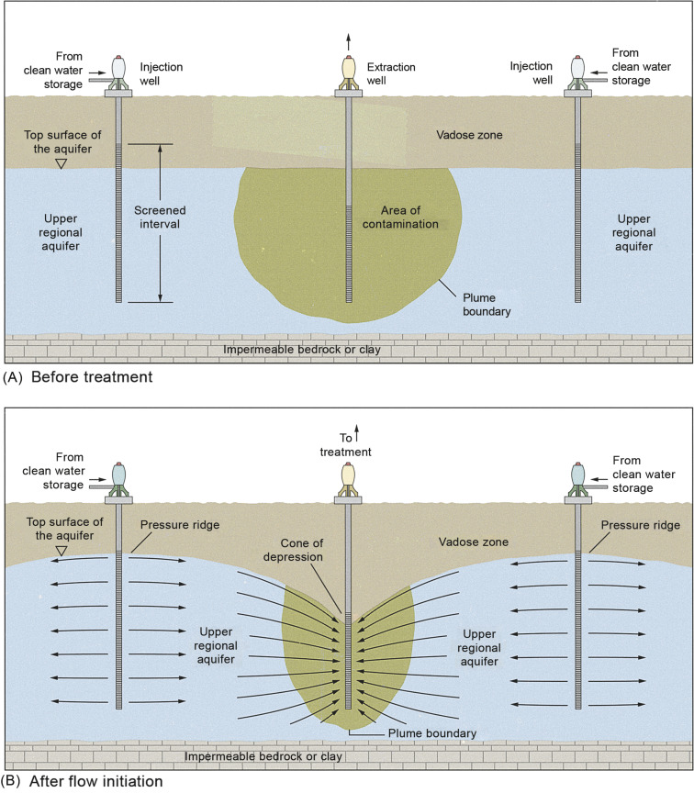

Air Stripping

Air stripping is the process of moving air through contaminated groundwater or surface water in an above-ground treatment system. Air stripping removes chemicals called “volatile organic compounds” or “VOCs.”
VOCs are chemicals that easily evaporate, which means they can change from a liquid to a vapor (a gas). The air passing through contaminated water helps evaporate VOCs faster. After treating the water, the air and chemical vapors are collected, and the vapors are either removed or vented outside if VOC levels are low enough. Air stripping is commonly used to treat groundwater as part of the “pump and treat” cleanup method.
Air stripping uses either an air stripper or aeration tank to force air through contaminated water and evaporate VOCs. The most common type of air stripper is a packed-column air stripper, which is a tall tank filled with pieces of plastic, steel, or ceramic packing material.
Contaminated water is pumped above ground and into the top of the tank and sprayed over the top of the packing material. The water trickles downward through the spaces between the packing material, forming a thin film of water that increases its exposure to air blown in at the bottom of the tank. A sieve-tray air stripper is similar in design but contains several trays with small holes. As water flows across the trays, a fan at the bottom blows air upwards through the holes, increasing air exposure.
Aeration tanks are another type of design that remove VOCs by bubbling air into a tank of contaminated water. Rising air and vapors accumulate at the top of the air stripper or aeration tank where they are collected for release or treatment. Treated water flows to the bottom, where it is collected and tested to make sure it meets cleanup requirements. The water may be further treated, if necessary, to achieve required levels. Clean water may be pumped back underground, into local surface waters, or to the municipal wastewater treatment plant.
Aeration tanks are typically shorter than packed-column or sieve-tray air strippers. The size and type of air stripper used will depend on the types and amounts of contaminants as well as the quantity of water requiring treatment.
The flow of water through an air stripper or aeration tank may take only a few minutes, depending on the size of the device and the rate of water flow through it.
However, cleanup of all the contaminated water at a site can take several months to years. The actual cleanup time will depend on several factors. For example, it will take longer where:
• Contaminant concentrations are high or the source of dissolved contaminants has not been completely removed.
• The amount of water requiring treatment is large.
• Groundwater cannot be pumped at a fast rate.
• Buildup of mineral deposits or algae on the packing material require frequent removal.
These factors vary from site to site.
Air stripping is generally considered to be safe to use. Air strippers may be brought to the site so that contaminated water does not have to be transported to a cleanup facility. Contaminated water is contained throughout cleanup so that there is little chance for people to come into contact with it. The treated water usually may be returned to the groundwater or discharged to surface water. The chemical vapors produced by air stripping are treated, if necessary, to ensure unsafe levels of vapors are not released.

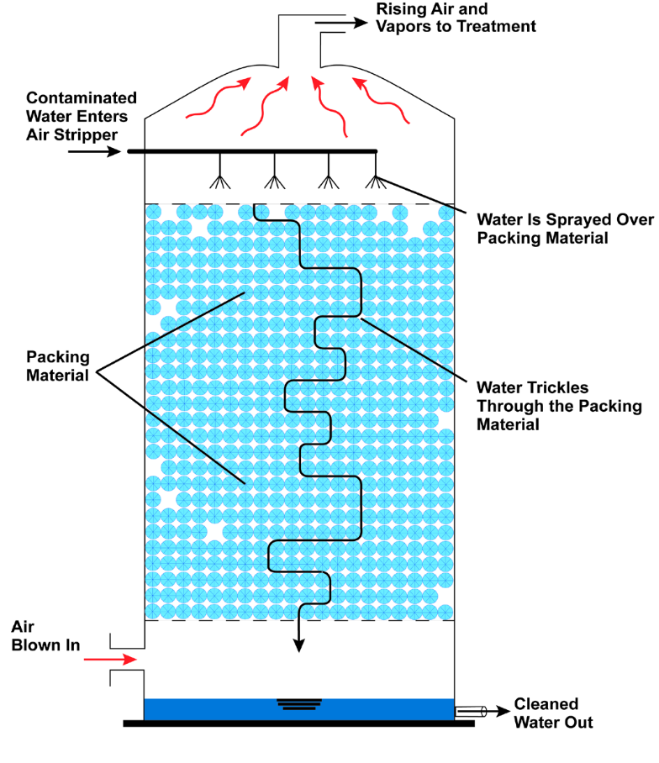

In Situ Chemical Oxidation
Chemical oxidation uses chemicals called “oxidants” to help change harmful contaminants into less toxic ones. It is commonly described as “in situ” because it is conducted in place, without having to excavate soil or pump out groundwater for aboveground cleanup. In situ chemical oxidation, or “ISCO,” can be used to treat many types of contaminants like fuels, solvents, and pesticides. ISCO is usually used to treat soil and groundwater contamination in the source area where contaminants were originally released. The source area may contain contaminants that have not yet dissolved into groundwater. Following ISCO, other cleanup methods, such as pump and treat or monitored natural attenuation, are often used to clean up the smaller amounts of contaminants left behind.
When oxidants are added to contaminated soil and groundwater, a chemical reaction occurs that destroys contaminants and produces harmless byproducts. To treat soil and groundwater in situ, the oxidants are typically injected underground by pumping them into wells. The wells are installed at different depths in the source area to reach as much dissolved and undissolved contamination as possible. Once the oxidant is pumped down the wells, it spreads into the surrounding soil and groundwater where it mixes and reacts with contaminants. To improve mixing, the groundwater and oxidants may be recirculated between wells. This involves pumping oxidants down one well and then pumping the groundwater mixed with oxidants out another well. After the mixture is pumped out, more oxidant is added, and it is pumped back (recirculated) down the first well. Recirculation helps treat a larger area faster. Another option is to inject and mix oxidants using mechanical augers or excavation equipment. This may be particularly helpful for clay soil. The four major oxidants used for ISCO are permanganate, persulfate, hydrogen peroxide and ozone. The first three oxidants are typically injected as liquids. Although ozone is a strong oxidant, it is a gas, which can be more difficult to use. As a result, it is used less often. Catalysts are sometimes used with certain oxidants. A catalyst is a substance that increases the speed of a chemical reaction. For instance, if hydrogen peroxide is added with an iron catalyst, the mixture becomes more reactive and destroys more contaminants than hydrogen peroxide alone. Following treatment, if contaminant concentrations begin to climb back up or “rebound,” a second or third injection may be needed. Concentrations will rebound if the injected oxidants did not reach all of the contamination, or if the oxidant is used up before all the contamination is treated. It may take several weeks to months for the contamination to reach monitoring wells and to determine if rebound is occurring. ISCO may produce enough heat underground to cause the contaminants in soil and groundwater to evaporate and rise to the ground surface. Controlling the amount of oxidant helps avoid excessive heat, and if significant gases are produced, they can be captured and treated
ISCO works relatively quickly to clean up a source area. Cleanup may take a few months or years, rather than several years or decades. The actual cleanup time depends on several factors that vary site to site. For example, ISCO will take longer where:
• The source area is large.
• Contaminants are trapped in hard-to-reach areas like fractures or clay.
• The soil or rock does not allow the oxidant to spread quickly and evenly.
• Groundwater flow is slow.
• The oxidant does not last long underground.
Is ISCO Safe? The use of ISCO poses little risk to the surrounding community. Workers wear protective clothing when handling oxidants, and when handled properly, these chemicals are not harmful to the environment or people. Because contaminated soil and groundwater are cleaned up underground, ISCO does not expose workers or others at the site to contamination. Workers test soil and groundwater regularly to make sure ISCO is working

In Situ Thermal Treatment
In situ thermal treatment methods move or “mobilize” harmful chemicals in soil and groundwater using heat. The chemicals move through soil and groundwater toward wells where they are collected and piped to the ground surface to be treated using other cleanup methods. Some chemicals are destroyed underground during the heating process. Thermal treatment is described as “in situ” because the heat is applied underground directly to the contaminated area. It can be particularly useful for chemicals called “non-aqueous phase liquids” or “NAPLs,” which do not dissolve readily in groundwater and can be a source of groundwater contamination for a long time if not treated. Examples of NAPLs include solvents, petroleum, and creosote (a wood preservative).
In situ thermal treatment methods heat contaminated soil, and sometimes nearby groundwater, to very high temperatures. The heat vaporizes (evaporates) the chemicals and water changing them into gases. These gases, also referred to as “vapors,” can move more easily through soil. The heating process can make it easier to remove NAPLs from both soil and groundwater. High temperatures also can destroy some chemicals in the area being heated. In situ thermal methods generate heat in different ways:
- Electrical resistance heating (ERH) delivers an electrical current between metal rods called “electrodes” installed underground. The heat generated as movement of the current meets resistance from soil converts groundwater and water in soil into steam, vaporizing contaminants.
- Steam enhanced extraction (SEE) injects steam underground by pumping it through wells drilled in the contaminated area. The steam heats the area and mobilizes and evaporates contaminants.
- Thermal conduction heating (TCH) uses heaters placed in underground steel pipes. TCH can heat the contaminated area hot enough to destroy some chemicals.
In situ thermal treatment might take a few months to a few years to clean up a site. The actual cleanup time will depend on several factors. For example, it might take longer where:
• Contaminant concentrations are high.
• The contaminated area is large or deep.
• A variety of soil types are present, causing the ground to heat unevenly.
• The soil has a lot of organic matter, which causes chemicals to stick to the soil and not evaporate easily. These factors vary from site to site.
In situ thermal treatment methods do not pose a threat to site workers or the community when properly operated. For instance, when using ERH, the electrical current is prevented from traveling outside of the treatment area or to aboveground structures by using common electrical grounding techniques. A thermal treatment area is usually covered with an impermeable surface cover (such as concrete, asphalt, or a heavy-duty tarp) to keep the heat and steam underground. Such seals also help prevent the release of chemical vapors to the air. In addition, workers test air samples to make sure that vapors are being captured.

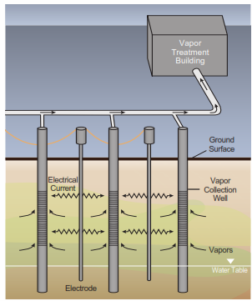

The chemical and water vapors are pulled to collection wells and brought to the ground surface by applying a vacuum.
The vapors are then treated above ground using one of several cleanup methods available.
Or, if concentrations are high, the vapors can be
condensed back to liquid chemicals and reused.

Bioremediation

Bioremediation is the use of microbes to clean up contaminated soil and groundwater. Microbes are very small organisms, such as bacteria, that live naturally in the environment. Bioremediation stimulates the growth of certain microbes that use contaminants as a source of food and energy. Contaminants treated using bioremediation include oil and other petroleum products, solvents, and pesticides.
Some types of microbes eat and digest contaminants, usually changing them into small amounts of water and harmless gases like carbon dioxide and ethene. If soil and groundwater do not have enough of the right microbes, they can be added in a process called “bioaugmentation.”
For bioremediation to be effective, the right temperature, nutrients, and food also must be present. Proper conditions allow the right microbes to grow and multiply—and eat more contaminants. If conditions are not right, microbes grow too slowly or die, and contaminants are not cleaned up.
Conditions may be improved by adding “amendments.” Amendments range from household items like molasses and vegetable oil, to air and chemicals that produce oxygen. Amendments are often pumped underground through wells to treat soil and groundwater in situ (in place).
The conditions necessary for bioremediation in soil cannot always be achieved in situ, however. At some sites, the climate may be too cold for microbes to be active, or the soil might be too dense to allow amendments to spread evenly underground. At such sites, EPA (environmental protection agency) might dig up the soil to clean it “ex situ” (above ground) on a pad or in tanks. The soil may then be heated, stirred, or mixed with amendments to improve conditions.
Sometimes mixing soil can cause contaminants to evaporate before the microbes can eat them. To prevent the vapors from contaminating the air, the soil can be mixed inside a special tank or building where vapors from chemicals that evaporate may be collected and treated.
To clean up contaminated groundwater in situ, wells are drilled to pump some of the groundwater into above ground tanks. Here, the water is mixed with amendments before it is pumped back into the ground.
The groundwater enriched with amendments allows microbes to bioremediate the rest of the contaminated groundwater underground. Groundwater also can be pumped into a “bioreactor” for ex situ treatment. Bioreactors are tanks in which groundwater is mixed with microbes and amendments for treatment. Depending on the site, the treated water may be pumped back to the ground or discharged to surface water or to a municipal wastewater system.

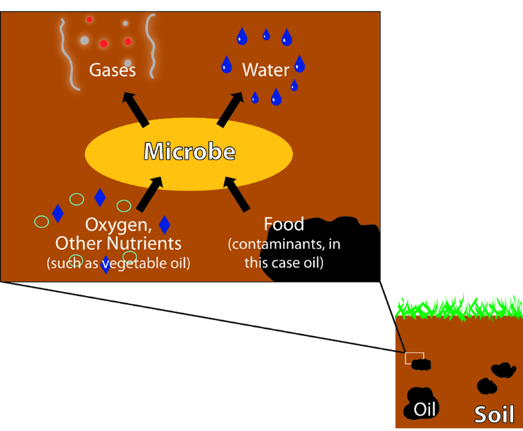

Microbe takes in oil, oxygen, and nutrients and releases
gases and water.

It may take a few months or even several years for microbes to clean up a site, depending on several factors. For example, bioremediation will take longer where:
- Contaminant concentrations are high, or contaminants are trapped in hard-to-reach areas, like rock fractures and dense soil.
- The contaminated area is large or deep.
- Conditions such as temperature, nutrients, and microbe population must be modified.
- Cleanup occurs ex situ.

Bioremediation relies on microbes that live naturally in soil and groundwater. These microbes pose no threat to people at the site or in the community. Microbes added to the site for bioaugmentation typically die off once contamination and the conditions needed for bioremediation are gone. The chemicals added to stimulate bioremediation are safe.
For example, the nutrients added to make microbes grow are commonly used on lawns and gardens, and only enough nutrients to promote bioremediation are added. To ensure that the treatment is working and to measure progress, samples of soil and groundwater are tested regularly.

Bioremediation has the advantage of using natural processes to clean up sites. Because it may not require as much equipment, labor, or energy as some cleanup methods, it can be cheaper. Another advantage is that contaminated soil and groundwater are treated onsite without having to dig, pump, and transport them elsewhere for treatment. Because microbes change the harmful chemicals into small amounts of water and gases, few if any waste byproducts are created.

