Lec.9 & 10 Ground Water Pollution 4th class

Contaminant Fate Processes

The distribution and concentration of contaminants in ground water systems is strongly influenced by interactions between the contaminant and the physical, chemical, and biological components of the subsurface. Collectively, these interactions are referred to as fate processes. In some cases, fate processes result in the alteration of the contaminants chemical structure ultimately resulting in the formation of nonhazardous compounds. Other fate processes result in a phase change, without altering the compounds chemical structure. In other case, fate processes must be considered during the evaluation of contaminant transport to accurately describe or predict the behavior of contaminants in ground water systems.
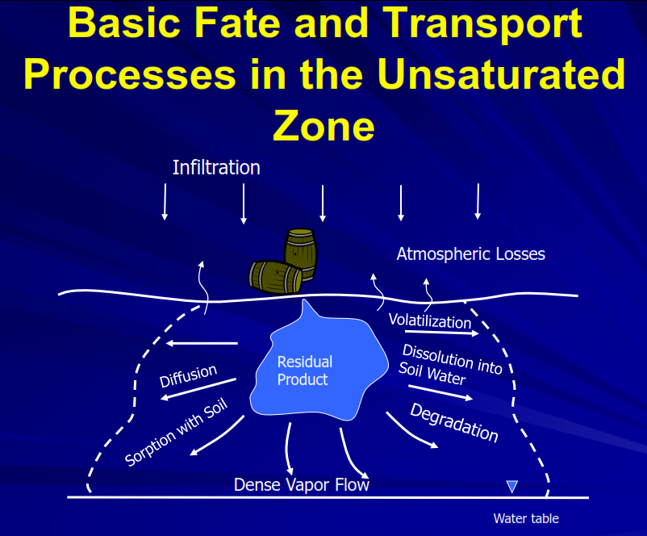

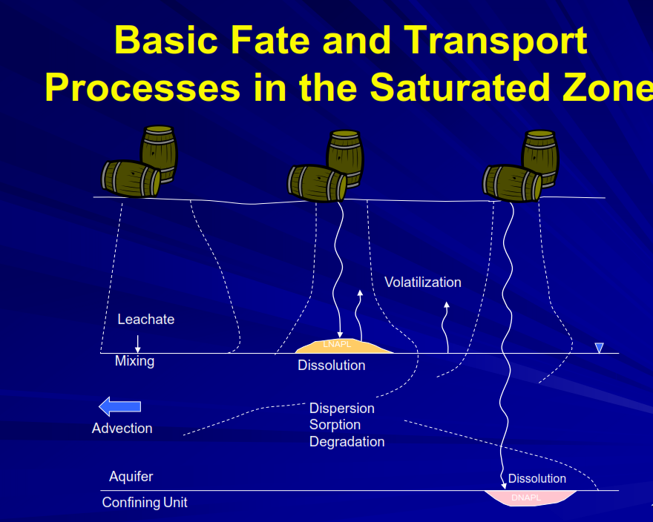

Sorption and Desorption

Most solutes transported with the groundwater will display some interaction with the groundwater medium. Sorption is the process in which solutes partition from the groundwater and adhere to the grain particles of the geological medium. Sorption is caused by a variety of mechanisms including van der Waals forces ( it are the sum of the attractive and repulsive electrical forces between atoms and molecules(, hydrogen bonding ( a chemical bond formed between an electropositive atom (typically hydrogen) and a strongly electronegative atom, such as oxygen or nitrogen. Hydrogen bonds are responsible for the bonding of water molecules in liquid and solid states, and are weaker than covalent and ionic bonds) , hydrophobic forces ( hydrophobic forces reflect the tendency of a polar molecules to partition from an aqueous environment to a hydrophobic one), coulomb forces ( The force exerted by stationary objects bearing electric charge on other stationary objects bearing electric charge. If the charges are of the same sign, then the force is repulsive; if they are of opposite signs, the force is attractive) , ligand exchange (is a type of chemical reaction in which a ligand in a compound is replaced by another. One type of pathway for substitution is the ligand dependent pathway. In organometallic chemistry this can take place via associative substitution or by dissociative substitution) , and covalent bonding (the interatomic linkage that results from the sharing of an electron pair between two atoms. The binding arises from the electrostatic attraction of their nuclei for the same electrons. A covalent bond forms when the bonded atoms have a lower total energy than that of widely separated atoms) between solute and geological medium. The amount of sorption has been shown to be related primarily to the amount of total organic carbon and the amount of iron minerals present in a groundwater medium. Two types of sorption are distinguished: reversible and irreversible. Reversible sorption causes the solute concentration front to trail behind the advective front, while irreversible sorption effectively removes solute concentration from the groundwater. The effect of reversible sorption on solute transport in groundwater is commonly described by the retardation factor, which is defined as the advective velocity of the solute divided by the average linear groundwater velocity.

The reverse of sorption is desorption , a term that describes the dissociation of a sorbed molecule and its return to the aqueous or gaseous phase.

Volatilization
The transfer of a contaminant from the aqueous phase, nonaqueous phase liquid, or sorbed phase directly to the gas phase is a process referred to as volatilization. The rate and extent to which volatilization occurs is strongly influenced by a number of parameters including the contaminant phase, the contaminant’s vapor pressure, environmental factors ( e.g., temperature, and others).

Biodegradation
The biodegradation of contaminants refers to the complete conversion of a contaminant to mineralized end products ( i.e. CO₂, H₂O, and salts) through metabolism by living organisms. In ground water systems, the organisms that carry out this process are bacteria indigenous to the aquifer. In some cases, metabolic activity does change the chemical form of the contaminant but does not result in the mineralization. In the cases, the term biotransformation is typically used to describe the processes occurring.
The metabolism of ground water contaminants is an extremely important fate process since it has the potential to impact the fate of all organic ground water contaminants and is a process that has the potential to yield nonhazardous products.

