Performance of Bus Facility
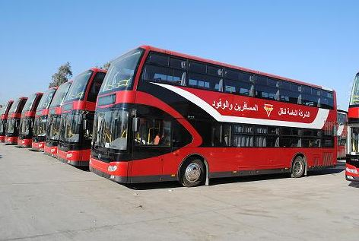
Introduction
Regardless of the kind of bus facility—loading area, bus stop, or bus lane—being analyzed, there are some fundamental components common to each that are required to calculate the facility’s vehicle and person capacity.
Dwell time is the most important of these, but all have some effect on capacity. This section presents procedures for calculating each of these components.

Dwell Time
Dwell time is the amount of time a bus spends while stopped to serve passengers. When buses operate in mixed traffic and stop in a travel lane, the reduction in the roadway capacity is directly related to the amount of time the buses stop.
It is the time required to serve passengers at the busiest door plus the time required to open and close the doors. A value of 2 to 5 s for door opening and closing is reasonable for normal operations.
Dwell time, t_{d}, can be measured in the field. Field measurement of dwell time is best suited for determining:
- the capacity
- and LOS of an existing transit line.
In the absence of other information, dwell time can be assumed to be
- 60 s for central business district (CBD), transit center, major on-line transfer point, or major park-and-ride stops;
- 30 s for major outlying stops; and
- 15 s for typical outlying stops.

Equation (1) can be used to compute dwell time:

$t_{d}=P_{a}t_{a}+P_{b}t_{b}+t_{oc}$ .......................................(1)

where:
$t_{d}$ = dwell time (s),
$P_{a}$ = alighting passengers per bus through busiest door during peak 15 min (p),
$t_{a}$ = passenger alighting time (s/p),
$P_{b}$ = boarding passengers per bus through busiest door during peak 15 min (p),
$t_{b}$ = passenger boarding time (s/p), and
$t_{oc}$ = door opening and closing time (s).

Peak Passenger Volumes
Estimates of hourly passenger volume are required for the highest-volume stops. The peak-hour factor is used to adjust hourly passenger volumes to reflect 15-min conditions ,see Equations (2) and (3):

$PHF=\frac{P}{4P_{15}}$ .............................(2)

$P_{15}=\frac{P}{4(PHF)}$ ..............................(3)

where:
PHF = peak-hour factor,
P = passenger volume during peak hour (p), and
$P_{15}$ = passenger volume during peak 15 min (p).

If buses operate at frequencies longer than four buses/h scheduled, the denominator of Equations (3) and (4) should be adjusted accordingly.
Typical PHFs range from 0.60 to 0.95 for transit service.

Boarding and Alighting Times
Boarding and alighting times for base conditions are determined using the values in Table (1). Note that if standees are present, 0.5 s should be added to the boarding times shown. For certain special conditions, the base values are multiplied by 1.2 or, 0.6, and or 0.9 for heavy two-way flow through a single door or double-stream door and for a low-floor bus, respectively.

Table (1):Typical Bus Passenger Boarding and Alighting Service Times for Selected Bus Types and Door Configurations.

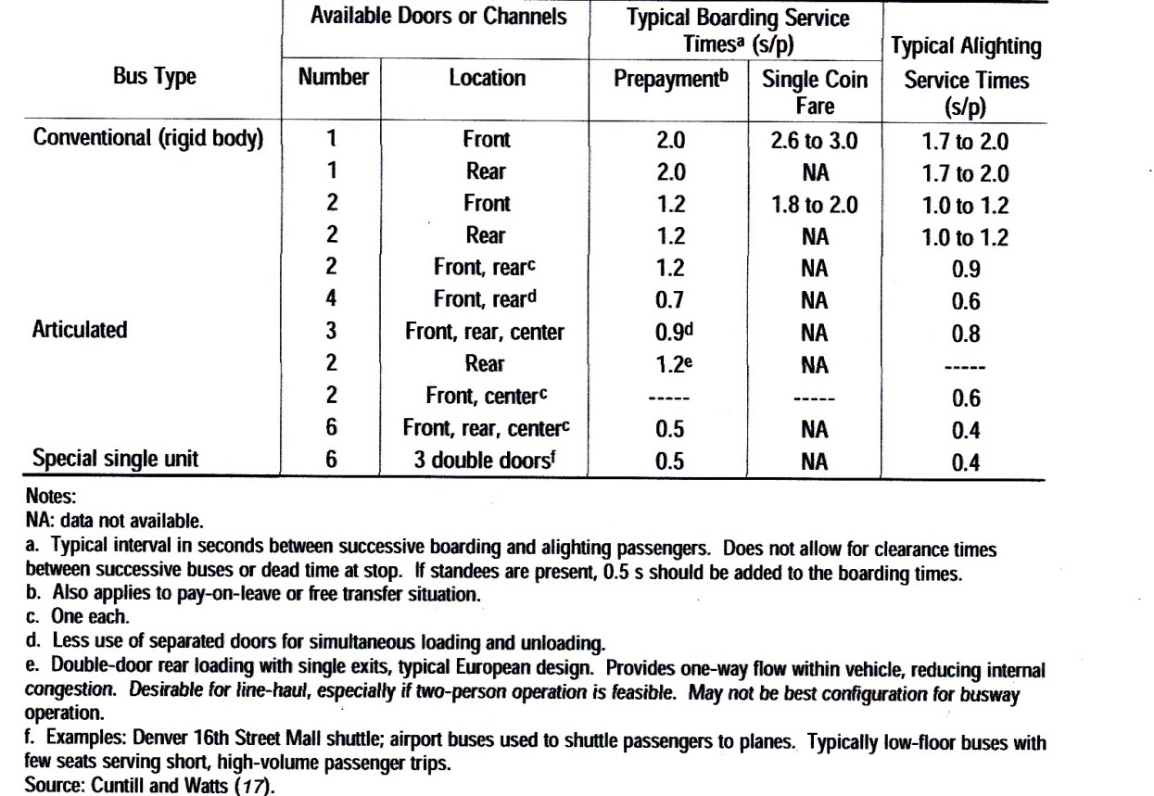

Wheelchair Accessibility Adjustment
All new transit buses in the United States are equipped with wheelchair lifts or ramps. When a lift is in use, the door is blocked from use by other passengers.
Typical wheelchair lift cycle times are 60 to 200 s, and the ramps used in low-floor buses reduce the cycle times to 30 to 60 s (including the time required to secure the wheelchair inside the bus).
The higher cycle times relate to a minority of inexperienced or severely disadvantaged users. When wheelchair users regularly use a bus stop to board or alight, the wheelchair lift time should be added to the dwell time.

Bicycle Adjustment
Some transit systems provide folding bicycle racks on buses. When no bicycles are loaded, the racks typically fold upright against the front of the bus. When bicycles are loaded, passengers deploy the bicycle rack and load their bicycles into one of the available loading positions (typically two are provided). The process takes approximately 20 to 30 s.
Coefficient of Variation of Dwell Times
The effect of variability in bus dwell times is reflected by the coefficient of variation of dwell times, which is the standard deviation of dwell time observations divided by the mean. On the basis of reported field observations of bus dwell times in several U.S. cities, the coefficient of variation of dwell times typically ranges from 40 to 80 percent, with 60 percent suggested as an appropriate value in the absence of field data.

Clearance Time
Clearance time includes two components:
- the time for a bus to start up and travel its own length while exiting a bus stop and (for off-line stops only)
- the reentry delay associated with the wait for a sufficient gap in traffic to allow a bus to pull back into the travel lane.

Various studies have looked at these factors, either singly or together. Research has found that:
- bus start-up times range from 2 to 5 s .
- The time for a bus to travel its own length after stopping is approximately 5 to 10 s, depending on acceleration and traffic conditions.
Other research recommends a range of 10 to 15 s for clearance time . Start-up and exiting time may be assumed to be 10 s. Reentry delay can be measured in the field or, at locations where buses reenter a traffic stream, may be estimated from Table (2) on the basis of traffic volumes in the adjacent travel lane.
If buses must wait for a queue from a signal or for traffic to clear before they can reenter the street or if traffic arrives randomly, values from Table(2) should not be used; instead, reentry delay should be estimated using the average queue length (in vehicles), the saturation flow rate, and the start-up lost time.

Table (2): Average Bus Reentary Delay into Adjustment Traffic Stream (Random Arrival Vehicles).
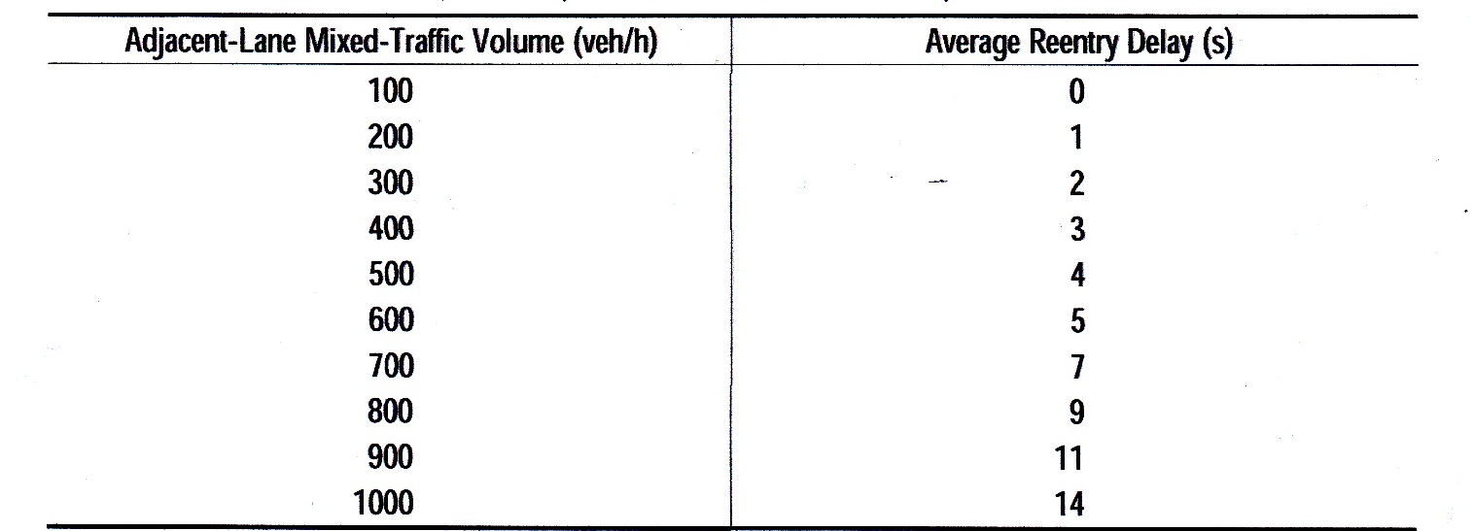
Failure Rate
The probability that a queue of buses will not form behind a bus stop, or failure rate, a can be derived from basic statistics. Z_{a} represents the area under one tail of the normal curve beyond the acceptable levels of probability that a queue will form at a bus stop.
Typical values of Z_{a} for various failure rates are listed in Table (3). A design failure rate should be chosen for use in calculating a loading area capacity. Higher design failure rates increase bus stop capacity at the expense of schedule reliability. Capacity occurs under normal conditions at a 25 percent failure rate.
Table(3): Values of Percent Failure Associated with $Z_{a}$.
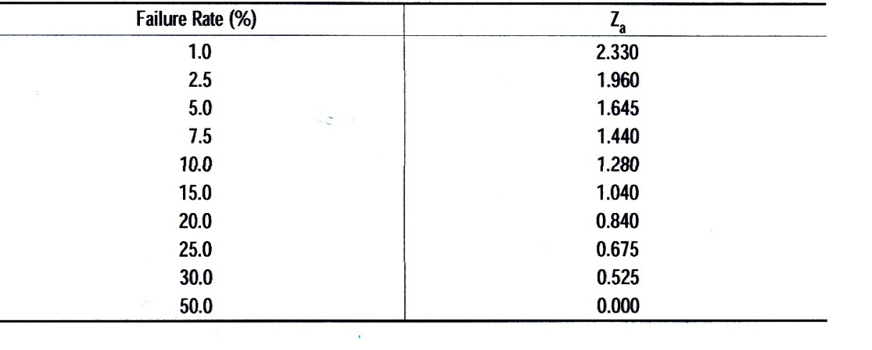
Suggested values of Za are the following :
• CBD stops: $Z_{a}$ values of 1.440 down to 1.040 should be used. They result in probabilities of 7.5 to 15 percent, respectively, that queues will develop.
• Outlying stops: A $Z_{a}$ value of 1.960 should be provided wherever possible, especially when buses must pull into stops from the travel lane.

Passenger Loads
Passenger loads: are the number of passengers in a single transit vehicle.
The occupancy of the vehicle: is typically related to the number of seats, expressed as a load factor.
A factor of 1.0 means that all of the seats are occupied.
The importance of vehicle loading varies by the type of transit service.
In general, bus transit provides a load factor at or below 1.0 for long-distance commute trips and high-speed, mixed-traffic operations. Inner-city service can approach a load factor of 1.5 to 2.0.
Crush loads, typically loads above 150 percent of seating capacity, subject standees and other passengers to unreasonable discomfort. Such loads are unacceptable to passengers.

Crush loads prevent circulation of passengers at intermediate stops, induce delay, and reduce vehicle capacity. Although crush loading represents the theoretically offered capacity, it cannot be sustained on every bus for any given period, and it exceeds the maximum utilized capacity. Therefore, crush loads should not be used for transit capacity calculations.
Design guidelines for seats and passenger areas in transit vehicles are based on human factors. For buses, comfortable loading for design should provide at least 0.50 m²/passenger and maximum schedule loads should provide a minimum of 0.40 m²/p where relatively short trips allow standees.

Skip- Stop Operation
When buses stop at every curbside bus stop in an on-line loading area arrangement, use of the adjacent lane becomes necessary only to pass obstructions in the curb lane. The ability to spread out stops, alternating route stop patterns along an urban street, can substantially improve bus speeds and capacities.
Many large transit systems have instituted two- or three-block stop patterns for bus stops along urban streets. This block-skipping pattern allows for a faster trip through the section and reduces the number of buses stopping at each bus stop.

Determining Loading Area Capacity
The maximum number of buses per loading area per hour, $B_{bb}$, is given by Equation (4):

$B_{bb}=\frac{3,600 (\frac{g}{c})}{t_{c}+\left(\frac{g}{c}\right)t_{c}+Z_{a}c_{v}t_{d}}$ ............................. (4)

where:
$B_{bb}$ = maximum number of buses per berth per hour (buses/h),
g/c = effective green time per signal cycle (1.0 for a stop not at a signalized intersection),
$t_{c}$ = clearance time between successive buses (s),
$t_{d}$ = average dwell time (s),
$Z_{a}$ = one-tail normal variety corresponding to probability that queues will
form behind bus stop, and
$c_{v}$ = coefficient of variation of dwell times.

Determining Bus Stop Capacity
As shown in Table(4), increasing the number of linear loading areas at a bus stop has an ever-decreasing effect on capacity as the number of loading areas increases. Doubling the number of linear loading areas at a bus stop does not double capacity because the linear loading areas of multiple-berth stops typically are not used equally. When more than three loading areas are required, sawtooth, pull-through, or other nonlinear designs should be considered.
The vehicle capacity of a bus stop in buses per hour is given by Equation (5):

$B_{s}=N_{eb}B_{bb}=N_{eb}\frac{3,600 (\frac{g}{c})}{t_{c}+\left(\frac{g}{c}\right)t_{c}+Z_{a}c_{v}t_{d}}$ ........................... (5)

where:
$B_{s}$ = maximum number of buses per bus stop per hour, and
$N_{eb}$ = number of effective loading areas, from Table(4).

Table(4): Efficiency of Multiple Linear Loading Areas at Bus Stops.
